Supporting Information:
A 3-Phase Electrostatic Clutch with Variable Mechanical Impedance Control for Soft Robots

Dongyoung Lee, Heejin Yu, Joonbum Bae*

School of Mechanical Engineering, Korea University, Seoul, Korea
*Email Address: jbbae@korea.ac.kr

In this supplementary document, we provide (Supplementary Note 1) the open loop control system, and (Supplementary Fig. 1-5)

Supplementary Note 1 : Linear capacitance sensor and compensated voltage modeling and for open loop control

ES clutch force (F) follows the Maxwell pressure model.
 | $$F=\frac{ε_{0}ε_{r}AV^{2}}{d^{2}}$$ | (S1)
F varies with the contact area (A) and voltage (V).
 | $$F_{0}=F_{1}$$ | (S2)
F should maintain a constant force during the tensile test.
 | $$\frac{ε_{0}ε_{r}A_{0}V_{0}^{2}}{d^{2}}=\frac{ε_{0}ε_{r}A_{1}V_{1}^{2}}{d^{2}}$$  $$V_{1}=V_{0}\sqrt{\frac{A_{0}}{A_{1}}}$$ | (S3)
Given A₀ and V₀ as initial values, if A₁ is reduced due to a change in length, and if V₁ is applied to compensate for this, the equation for V₁ is organized in terms of A.
 | $$C=\frac{ε_{0}ϵ_{r}A}{d}$$  $$V=V_{0}\sqrt{\frac{C_{max}-C_{min}}{C-C_{min}}}$$ | (S4)
A linear capacitance sensor can measure the capacitance (C) value and calculate the contact area. By converting A to a value for C, an equation for V can be calculated.
 | $$V_{0}=\sqrt{\frac{F_{0}d^{2}}{ε_{0}ε_{r}A}}$$ | (S5)
V₀ can be calculated via the initial target force F₀.

Supplementary Figures
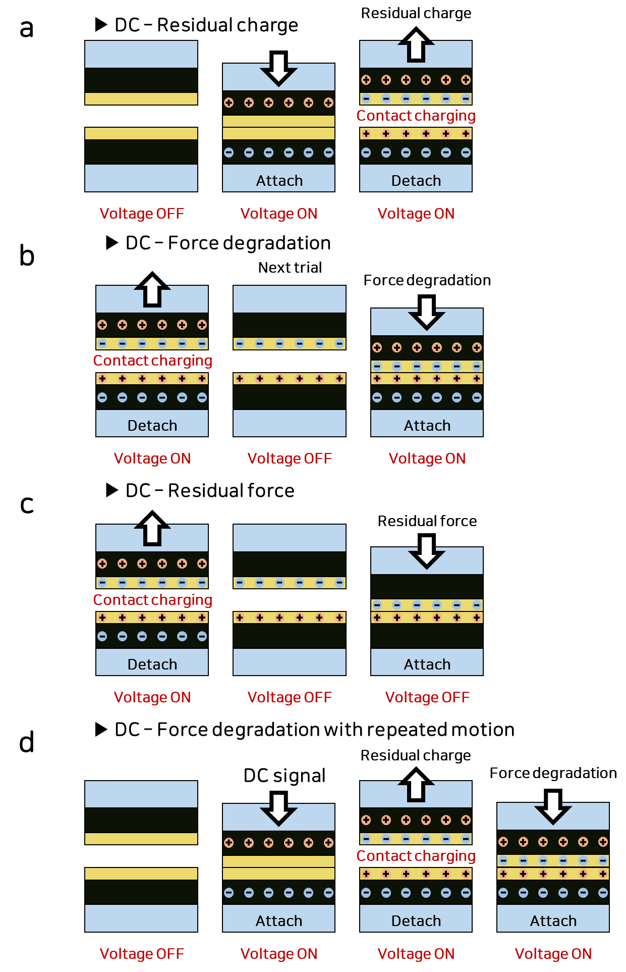
Supplementary Fig. 1. Contact charging mechanism with DC voltage application. (a) Residual charge issue. ES clutch generate residual charge when detached while voltage ON state. (b) Force degradation issue. ES clutch show reduced electrostatic force due to existing residual charge which caused force degradation issue. (c) Residual force issue. ES clutch show unexpected interact force due to the residual charge while voltage OFF state. (d) Force degradation with repeated motion. ES clutch accumulate the residual charge for repeated test which cause the amplify force degradation issue.
The non-linear characteristics observed during the operation of the ES clutch can be attributed to the presence of residual charges. Existing research has established that these residual charges typically originate from leakage currents. However, the influence of these charges is often mitigated as a result of the substantial time constants involved. Experimental evidence has indicated that the occurrence of residual charges is predominantly due to the phenomenon of contact charging. This phenomenon becomes more pronounced when an external electric field is applied, facilitating easier charge mobility during contact. Under normal circumstances, identical materials tend to have similar energy levels, which prevents charge transfer. However, alteration of energy levels in the presence of an external electric field creates conditions more favorable for contact charging.

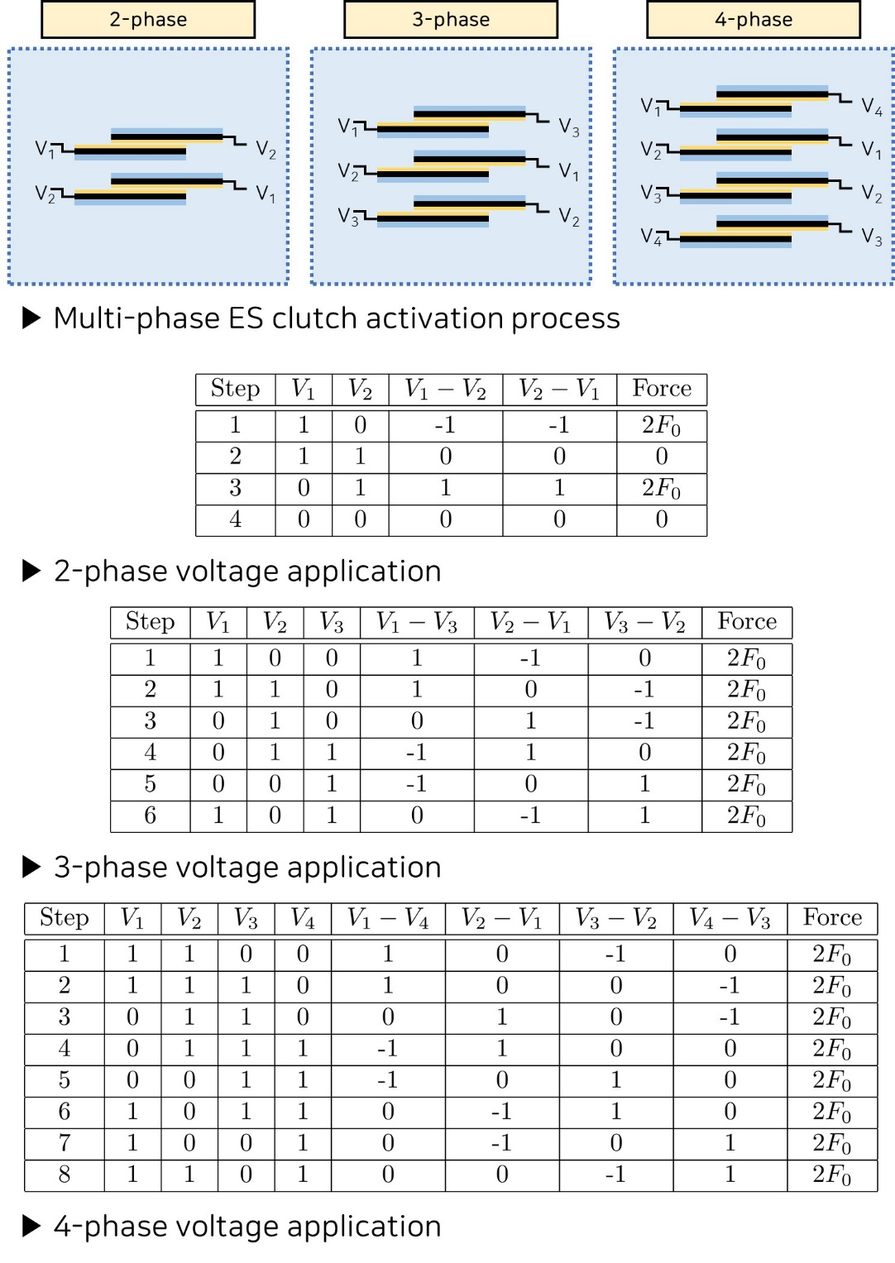
Supplementary Fig. 2. Multi-phase ES clutch. A separate voltage can be applied to each layer. In the case of a 2-phase system, even with applied voltage, no potential difference may occur, resulting in the absence of electrostatic force in certain cases. However, a 3-phase ES clutch consistently generates electrostatic force even when the voltage is switched. As a 4-phase ES clutch shares a structure similar to the 3-phase system, it does not offer additional force benefits. Therefore, employing a 3-phase actuator is considered the most rational choice.

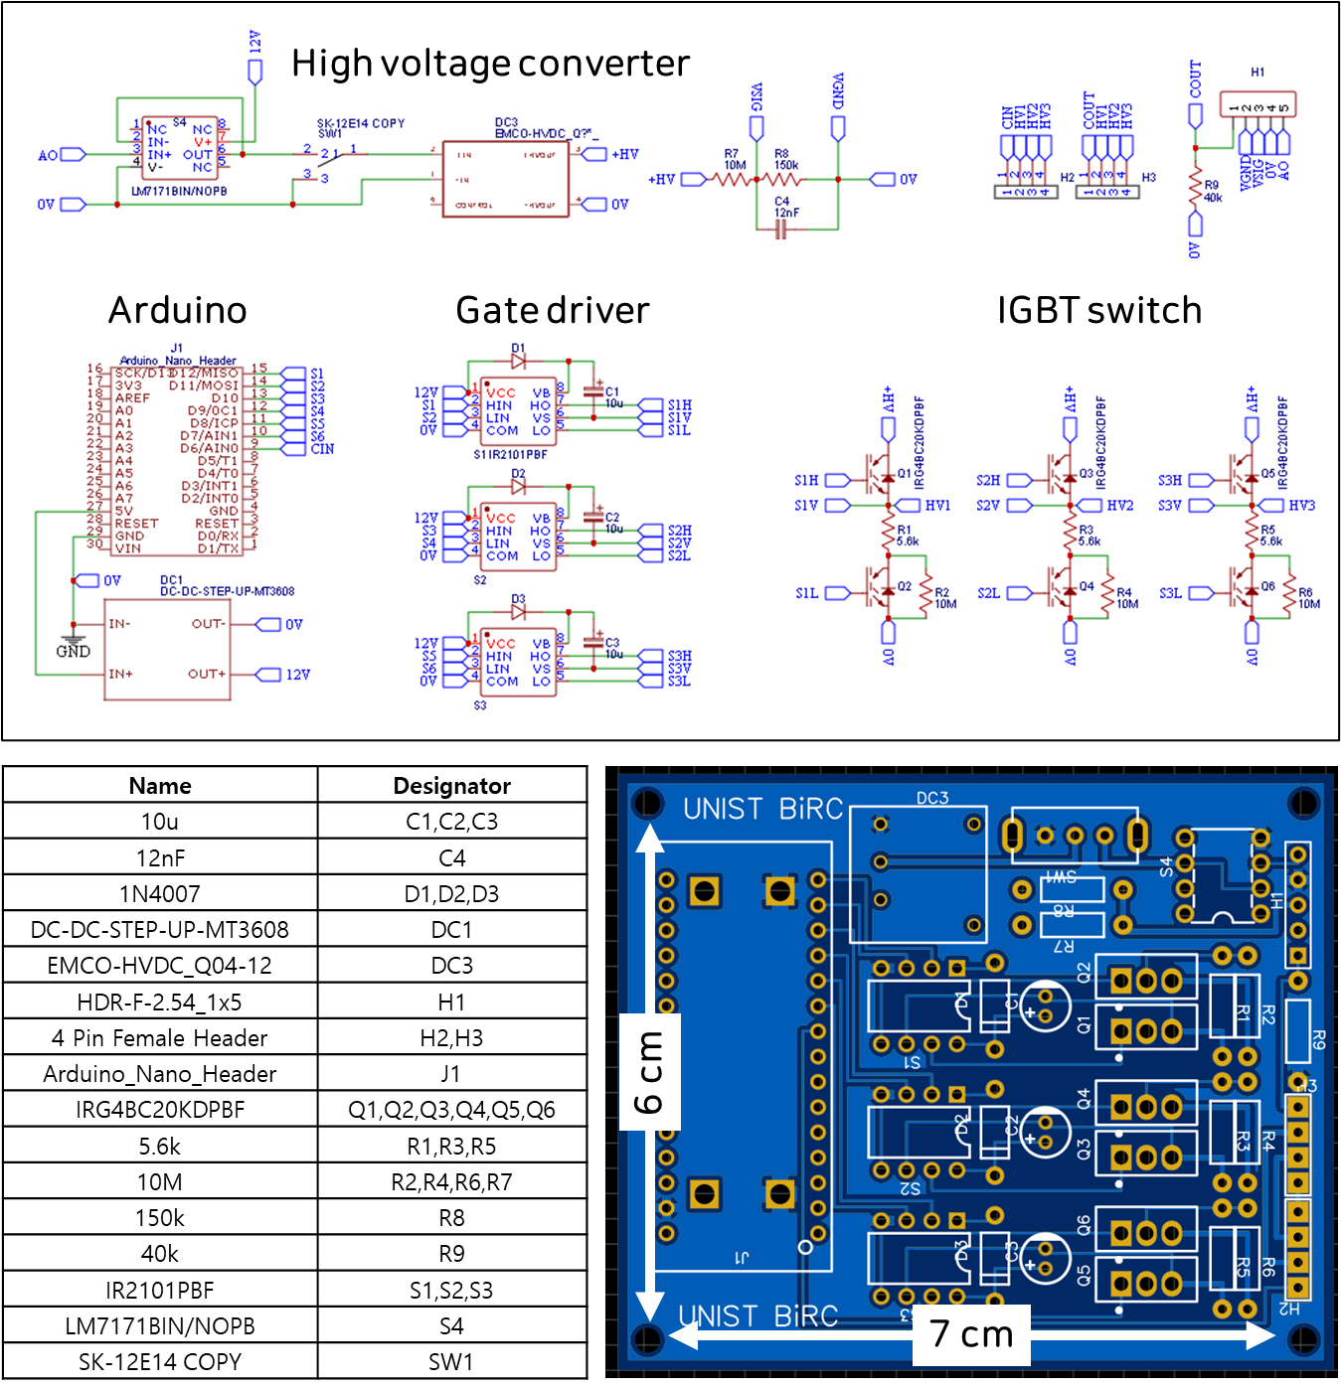
Supplementary Fig. 3. Schematic circuit for 3-phase voltage application with 3-phase inverter and high voltage converter

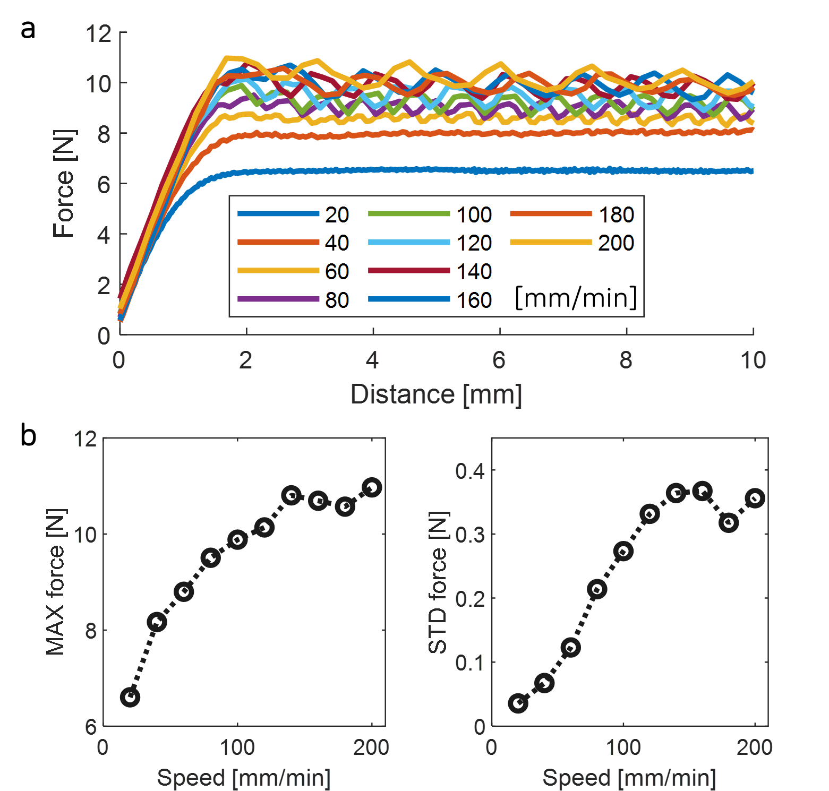
Supplementary Fig. 4. 3-phase ES force affected by external force speed
The response of the actuator to varying AC voltage frequencies presents a challenge, primarily due to the pulling speed of the CNC (Computer Numerical Control) machine. The rate at which the CNC pulls to its maximum force is outpaced by the frequency changes of the actuator, making it difficult to analyze the maximum force of the actuator. Consequently, the CNC must be pulled faster to reach its maximum force in a shorter time frame. However, the rapid speed of the CNC leads to fluctuating maximum forces, resulting in inconsistent force measurements and an increased error.

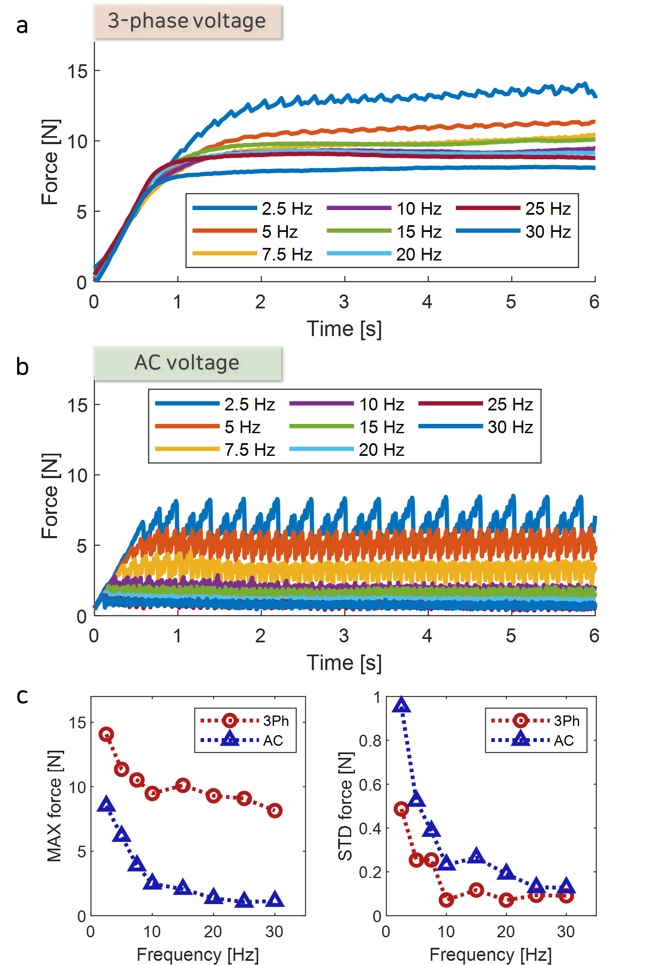
Supplementary Fig. 5. ES force affected by 3-phase and AC voltage frequency
As the frequency increases, there is a noticeable reduction in the maximum force exerted by the actuator. At 1 Hz, variations in the magnitude of the force can be observed depending on the direction of the applied voltage. At 30 Hz, the actuator behaves like a filter, resulting in a decrease in the applied voltage. Furthermore, the electrostatic force dissipates before reaching its maximum, leading to an even further reduction in force.
When a frequency of 30 kHz is applied, the high frequency creates a low-pass filter effect due to the actuator. This results in a lower voltage output and insufficient time for the actuator to fully charge and discharge. Therefore, high-frequency signals are not suitable for actuation, as they do not provide adequate charging and discharging periods for the actuator.

