Appendix 1
Deep Learning for Tissue Region Identification
Tumor classification
We utilized 195 WSIs at 40X magnification from The Cancer Genome Atlas and corresponding annotation masks provided by Angel Cruz-Roa et al. [1]. Initially, we converted WSIs to tile images, setting the image size to 350*350*3. Otsu’s thresholding method was employed to remove non-essential tissue regions by discarding tiles with a tissue pixel fraction below 26%. Tumor regions were annotated using mask images, which delineate tumor areas. The non-tumor region refers to the tissue area outside the mask, excluding fat. By mapping the spatial coordinates of the mask images onto the WSIs, we assigned each Tile a "tumor" or "non-tumor" label accordingly. This process yielded approximately 2.26 million tiles. Subsequently, we divided the 195 patient WSIs into training, validation, and test sets. The training set comprised 157 patients (about 1.76 million tiles), the validation set included 18 patients (about 200,000 tiles), and the test set contained 20 patients (about 300,000 tiles). To enhance model training efficiency, we randomly sampled 20% of the 157 patients in the training set, resulting in a training set of approximately 350,000 tiles. To improve training efficiency and model performance, we employed the Xception model for tumor and non-tumor classification, based on transfer learning principles[2]. We modified the Xception model by replacing the fully connected layer with a global maximum pooling layer, followed by two neurons for the classification layer (with a SoftMax activation function). This approach facilitates the input of images with varying tile specifications while reducing model parameters and enhancing model generalization. The model hyperparameters were configured using the Stochastic Gradient Descent optimizer with a learning rate of 0.01, a momentum value of 0.9, a batch size of 128, and the cross-entropy loss function.
Necrosis classification
Due to the potential similarity between cell nuclei in necrosis and TILs, we developed a CNN model to identify necrosis, which aids in reducing false positives in the classification process. The dataset, comprising 2237 samples of LUAD at 20× magnification with an image size of 500×500×3, was obtained from a public dataset in the literature[3]. To enhance model fit and generalization, we employed a small window sliding approach for sampling and augmenting the dataset, utilizing a window size of 100×100 pixels and a stride of 100 pixels. A Tile was labeled as "Necrosis" if necrotic regions occupied more than 20% of its pixels[4]. We implemented fine-tuned transfer learning using the VGG-16 model, then trained and evaluated it using the stratified 5-fold cross-validation method[5]. To optimize the model's performance, we modified its structure by replacing the fully connected layers with a global max pooling layer, a dropout layer (dropout rate = 0.5), a fully connected layer (128 neurons, ReLU activation function), and a classification layer (SoftMax activation function). For the model's hyperparameter configuration, we utilized the Adam optimizer with a learning rate of 0.0001, a batch size of 16, and 100 epochs.
Lymphocytes classification
We utilized a deep learning model to identify lymphocytes, providing insights into the tumor immune microenvironment (TIME). The model was trained and evaluated using public datasets from the literature, comprising data from LUAD (10 patients) and BRCA (18 patients) at 20× magnification, totaling 34,404 samples with image dimensions of 500×500×3[5]. Lymphocyte classification was determined by analyzing the central 100×100pixel region within each Tile. If this central region contained visible lymphocytes, the Tile was labeled as lymphocyte-infiltrated; otherwise, it was considered non-infiltrated. We employed a stratified 5-fold cross-validation method for model training and evaluation, maintaining the same hyperparameter configuration as the necrosis model.
Tissue region identification results
During the generation of TS-images, we developed and trained three distinct models, each designed to perform specific functions. The following section outlines the modeling process for each of these models in detail.
In the tumor classification model training and evaluation stage, the Xception model undergoes full network layer fine-tuning, employing an early-stop training strategy to mitigate overfitting. The model training concluded at the 25th epoch. Subsequent evaluation on the validation and test sets yielded classification accuracies of 0.865 and 0.860, respectively, with corresponding AUC values of 0.927 and 0.917. The comparable performance across validation and test sets demonstrates the model's generalization capability and validates the data sampling approach. Due to magnification disparities between the Yale Response and IMPRESS HER2+ datasets (20×) and the classification model's requirements (40×), the NAC dataset was upsampled from 175×175×3 to 350×350×3 using bidirectional interpolation.
During the training and evaluation phase of the necrosis classification model, the VGG-16 architecture underwent full network layer fine-tuning. The experimental methodology employed a stratified 5-fold cross-validation approach. The model achieved an average accuracy of 0.964 ± 0.035. For necrosis classification, an ensemble scheme was implemented, utilizing the mean predicted probability from the 5-fold cross-validation models as the final prediction outcome.
For the training and evaluation of the lymphocytes classification model, we employed identical experimental tools as those used for the necrosis classifier. The model ultimately demonstrated a mean accuracy of 0.914 ± 0.031. We utilized an ensemble classification approach for lymphocyte identification, with the final prediction result derived from the average predicted probabilities of the 5-fold cross-validated model.

Relative Feature
Tumor-to-Non-Tumor Ratio (TNR)
$$\begin{aligned}TNR=\frac{Tumor Tile Counts}{Non‐Tumor Tile Counts+Tumor Tile Counts}\#\left(1\right)\end{aligned}$$
Intratumoral-Lymphocytes-to-Tumor Ratio (ILTR)
$$\begin{aligned}ILTR=\frac{Intratumoral Lymphocytes Tile Counts}{Tumor Tile Counts+Intratumor Lymphocytes Tile Counts}\#\left(2\right)\end{aligned}$$
Non-Tumor-to-Lymphocyte Ratio (NTLR)
$$\begin{aligned}NTLR=\frac{Non–Tumor Lymphocytes Tile Counts}{Non‐Tumor Tile Counts+Non‐Tumor Lymphocytes Tile Counts}\#\left(3\right)\end{aligned}$$
Lymphocyte-to-Non-Tumor Ratio (LNTR)
$$\begin{aligned}LNTR=\frac{Lymphocytes Tile Counts}{Lymphocytes Tile Counts+Non−TILs Counts}\#\left(4\right)\end{aligned}$$
Lymphocyte Density (LD)
$$\begin{aligned}LD=\frac{Lymphocytes Tile Counts}{ToTal Tissue Counts}\#\left(5\right)\end{aligned}$$

Table S1 Feature weight information for the non-tumor and non-TILs of the Yale Response Dataset. s represents for significance, L represents for largest, and A represents for ALL.
Cohort | Favorable Features |  |  | Adverse Features
Cohort | Rank | Feature Name | Coef. | Rank | Feature Name | Coef.
Non-TILs | 1 | S_number | 0.101 | 1 | HER2/CEP17 ratio | -0.089
Non-TILs | 2 | S__area_filled_mean | 0.088 | 2 | L_eccentricity | -0.016
Non-TILs | 3 | S_area_convex_mean | 0.028 | 3 | S_ eccentricity_mean | -0.011
Non-tumor | 1 | L_area | 0.193 | 1 | S_euler_number_std | -0.170
Non-tumor | 2 | L_area_convex | 0.131 | 2 | L_axis_minor_length | -0.158
Non-tumor | 3 | S_area_convex_mean | 0.092 | 3 | HER2/CEP17 ratio | -0.101

Table S2. Comparison of the generalization performance of morphological features for five tissue types under different significant region thresholds in the external validation set (IMPRESS_HER2+).
Region | Sign. thresholds | AUC | F1 score | PPV | Recall | NPV
Tumor | 1% | 0.637 | 0.783 | 0.667 | 0.947 | 0.700
Tumor | 3% | 0.657 | 0.756 | 0.705 | 0.816 | 0.600
Tumor | 5% | 0.656 | 0.656 | 0.808 | 0.553 | 0.526
Tumor | 10% | 0.658 | 0.756 | 0.654 | 0.895 | 0.583
Non-tumor | 1% | 0.639 | 0.804 | 0.685 | 0.974 | 0.800
Non-tumor | 3% | 0.689 | 0.783 | 0.667 | 0.947 | 0.700
Non-tumor | 5% | 0.746 | 0.843 | 0.761 | 0.946 | 0.857
Non-tumor | 10% | 0.667 | 0.746 | 0.688 | 0.815 | 0.571
TILs | 1% | 0.521 | 0.766 | 0.643 | 0.947 | 0.625
TILs | 3% | 0.548 | 0.719 | 0.582 | 0.941 | 0.400
TILs | 5% | 0.562 | 0.719 | 0.639 | 0.821 | 0.625
TILs | 10% | 0.567 | 0.632 | 0.600 | 0.667 | 0.553
Non-TILs | 1% | 0.689 | 0.767 | 0.673 | 0.892 | 0.615
Non-TILs | 3% | 0.671 | 0.750 | 0.652 | 0.882 | 0.615
Non-TILs | 5% | 0.766 | 0.817 | 0.763 | 0.879 | 0.750
Non-TILs | 10% | 0.565 | 0.467 | 0.583 | 0.389 | 0.571
Lym. | 1% | 0.582 | 0.750 | 0.660 | 0.868 | 0.571
Lym. | 3% | 0.607 | 0.729 | 0.608 | 0.912 | 0.556
Lym. | 5% | 0.625 | 0.716 | 0.632 | 0.828 | 0.600
Lym. | 10% | 0.616 | 0.703 | 0.591 | 0.867 | 0.700
Best-performed values are highlighted in boldface. Sign.: significance, TILs: tumor infiltrating lymphocytes, non-TILs: non-tumor infiltrating lymphocytes, Lym.: lymphocytes.

Correlation analysis between features
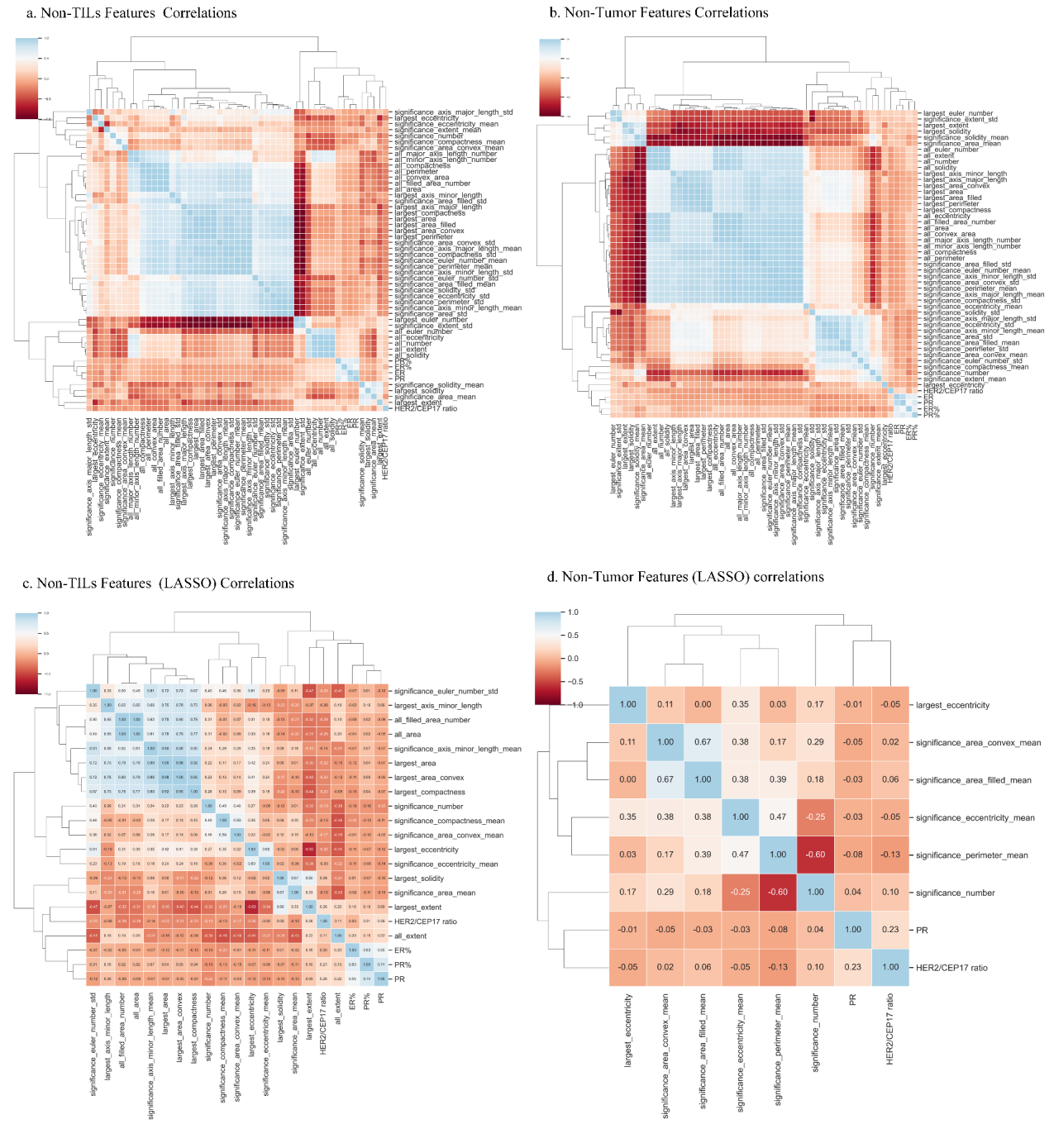
Figure S1. Spearman correlation analysis of the features of non-tumor and non-TILs features. a. Correlation plot of combined non-TILs morphological and clinical features. b. Correlation plot of fused non-tumor morphological and clinical features. c. Correlation plot of combined non-TILs morphological and clinical features selected by Lasso. d. Correlation plot of combined non-tumor morphological and clinical features selected by Lasso. non-TILs: non-tumor infiltrating lymphocytes, Mor.: Morphological Features. This picture is recommended for viewing in color.

References
1. Janowczyk A, Madabhushi A: Deep learning for digital pathology image analysis: A comprehensive tutorial with selected use cases. Journal of pathology informatics 2016, 7:29-29.
2. Chollet F: Xception: Deep learning with depthwise separable convolutions. In: Proceedings of the IEEE conference on computer vision and pattern recognition: 2017; 2017: 1251-1258.
3. Saltz J, Gupta R, Hou L, Kurc T, Singh P, Vu N, Samaras D, Shroyer KR, Zhao T, Batiste R et al: Spatial Organization and Molecular Correlation of Tumor-Infiltrating Lymphocytes Using Deep Learning on Pathology Images. Cell Reports 2018, 23(1):181-+.
4. Dagher J, Delahunt B, Rioux‐Leclercq N, Egevad L, Coughlin G, Dunglison N, Gianduzzo T, Kua B, Malone G, Martin B: Assessment of tumour‐associated necrosis provides prognostic information additional to World Health Organization/International Society of Urological Pathology grading for clear cell renal cell carcinoma. Histopathology 2019, 74(2):284-290.
5. Simonyan K, Zisserman A: Very deep convolutional networks for large-scale image recognition. arXiv preprint arXiv:14091556 2014.

