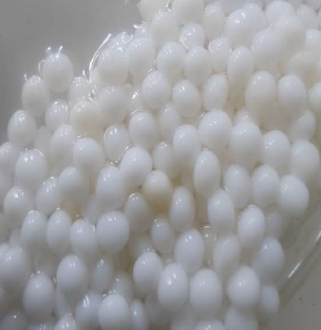

Figure 1. PVA Gel Beads

