Polyphasic taxonomic analysis of Snuella sedimenti sp. nov., isolated from isolated from marine sediment

Jong-Hwa Kim¹, Veeraya Weerawongwiwat¹, Jung-Hoon Yoon², Jung-Sook Lee³, Ampaitip Sukhoom⁴, Wonyong Kim¹*

¹Department of Microbiology, Chung-Ang University College of Medicine, Seoul, Republic of Korea
²Department of Food Science and Biotechnology, Sungkyunkwan University, Suwon, Republic of Korea
³Korean Collection for Type Cultures, Korea Research Institute of Bioscience and Biotechnology, Jeongeup, Republic of Korea
⁴Division of Biological Science, Faculty of Science, Prince of Songkla University, Thailand

*Corresponding author: kimwy@cau.ac.kr, ORCID Id: 0000-0001-9649-3919

Running title: Snuella sedimenti CAU 1569^{T} sp. nov.

Genome sequencing data: The GenBank/EMBL/DDBJ accession number for the 16S rRNA gene sequence of strain CAU 1569T is MN544292 and the whole genome accession number is NZ_JAELVQ000000000.

Supplementary Information

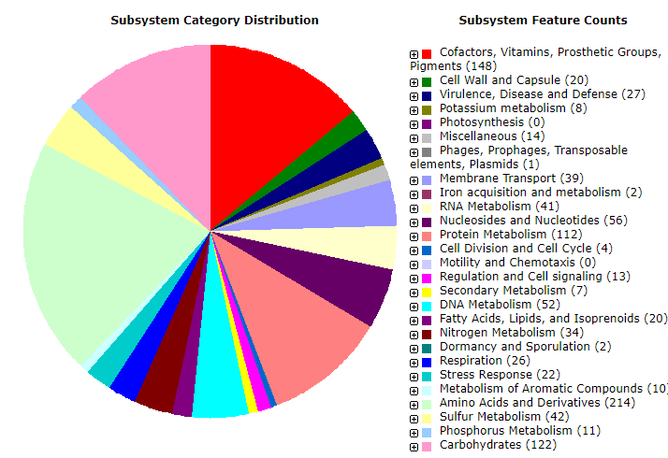

Fig. S1. The subsystem category distribution of Snuella sedimenti CAU 1569^{T}.

Fig. S2. Transmission electron micrograph showing the cell morphology of Snuella sedimenti CAU 1569^{T}. Cells were grown on MA agar for 1 day at 30°C. Bar, 0.5 µm.

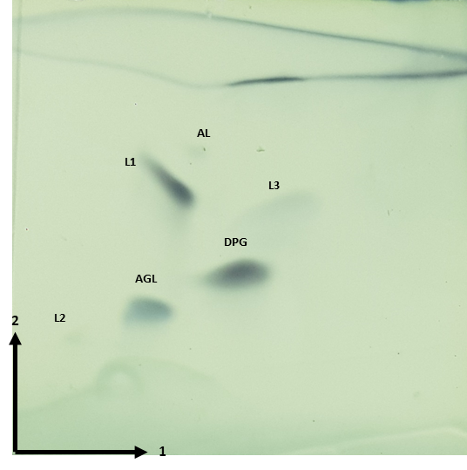
Fig. S3. Polar lipids of Snuella sedimenti CAU 1569^{T} after two-dimensional TLC and detection with phosphomolybdic acid solution reagent and heating at 150 °C for 5 minutes (total lipids). DPG; diphosphatidylglycerol; AGL, aminoglycolipid; AL, unidentified aminolipid; L, unidentified lipid

