The Interaction between Population Age Structure and Policy Interventions on the Spread of COVID-19

Hao Yin^{1,2}, Zhu Liu¹, Daniel M. Kammen²

1 Department of Earth System Science, Tsinghua University, China
2 Energy and Resources Group and Goldman School of Public Policy, University of California, Berkeley, CA, USA. ORCID: https://orcid.org/0000-0003-2984-7777
Hao Yin email: haoyin@tsinghua.edu.cn;
Zhu Liu email: zhuliu@tsinghua.edu.cn;
Daniel M. Kammen: kammen@berkeley.edu
Appendix 1

- Population age structure
Compared with New York, Los Angeles and Daegu, the population in Nairobi was much younger (Figure 1a).
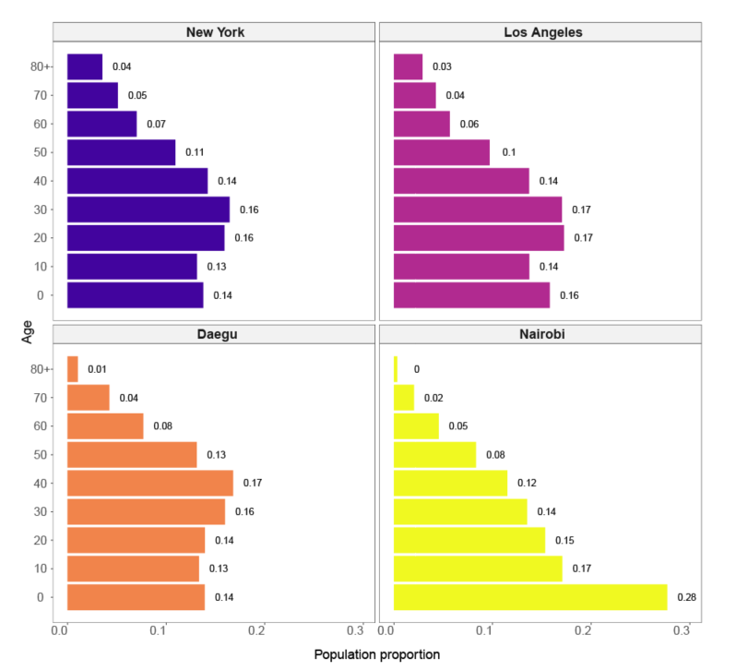
Figure 1a Population age structure in four cities
- Birth and death rates
Table 1a Birth rates in the four cities
City | New York | Los Angeles | Daegu | Nairobi
Birth rate per 1000 people/year | 11.8 | 11.8 | 7.4 | 29.3
In our simulation we also consider the dynamics of population birth and death rates without the risks of COVID-19. The population will leave from one age group to another over time of the simulation. Therefore, we assumed that each population in each age group will grow at the same rate by averaged the newborn population to 9 age groups.
Table 2a Death rates by age in the four cities¹
City  Age | New York | Los Angeles | Daegu | Nairobi
0-9 | 0.0013 | 0.0013 | 0.0003 | 0.0036
10-19 | 0.0004 | 0.0004 | 0.0003 | 0.0017
20-29 | 0.0010 | 0.0010 | 0.0005 | 0.0036
30-39 | 0.0016 | 0.0016 | 0.0010 | 0.0064
40-49 | 0.0030 | 0.0030 | 0.0023 | 0.0103
50-59 | 0.0064 | 0.0064 | 0.0050 | 0.0185
60-69 | 0.0126 | 0.0126 | 0.0133 | 0.0407
70-79 | 0.0266 | 0.0266 | 0.0460 | 0.0930
80+ | 0.0709 | 0.0709 | 0.0853 | 0.1346

- Hospitalization rate and fatality rate
To simulate the age-specific hospitalization, we applied aged-specific hospitalization rate
Table 3a Hospitalization rate by age in the four cities²
Age group | 0-9 | 10-19 | 20-29 | 30-39 | 40-49 | 50-59 | 60-69 | 70-79 | 80+
Hospitalization rate | 0.001 | 0.003 | 0.012 | 0.032 | 0.049 | 0.102 | 0.166 | 0.243 | 0.273

Table 4a Fatality rate by age in the four cities
Age group | 0-9 | 10-19 | 20-29 | 30-39 | 40-49 | 50-59 | 60-69 | 70-79 | 80+
Hospitalization rate | 2.6E-05 | 1.5E-04 | 6.0E-04 | 1.5E-03 | 3.0E-03 | 1.3E-02 | 4.0E-02 | 8.6E-02 | 1.3E-01

- Effects of population ageing on the transmissibility
From Table 5a, it shows that the transmissibility of epidemic will decrease with younger population age structure.
Table 5a Age-specific transmissibility in different population age structure
Age structure  Age group | New York | Los Angeles | Daegu | Nairobi
0-9 | 0.00232 | 0.00230 | 0.00228 | 0.00209
10-19 | 0.00232 | 0.00230 | 0.00228 | 0.00209
20-29 | 0.00232 | 0.00230 | 0.00228 | 0.00209
30-39 | 0.00184 | 0.00182 | 0.00180 | 0.00165
40-49 | 0.00184 | 0.00182 | 0.00180 | 0.00165
50-59 | 0.00184 | 0.00182 | 0.00180 | 0.00165
60-69 | 0.00152 | 0.00150 | 0.00149 | 0.00136
70-79 | 0.00152 | 0.00150 | 0.00149 | 0.00136
80+ | 0.00152 | 0.00150 | 0.00149 | 0.00136

- Transmission rates
Tables 6a-9a list the age-specific transmission rate matrices in the four cities.
Table 6a Transmission rates by age in New York
Transmission rate | 0-9 | 10-19 | 20-29 | 30-39 | 40-49 | 50-59 | 60-69 | 70-79 | 80+
0-9 | 0.191 | 0.045 | 0.035 | 0.076 | 0.038 | 0.020 | 0.011 | 0.004 | 0.004
10-19 | 0.053 | 0.444 | 0.057 | 0.056 | 0.071 | 0.024 | 0.007 | 0.003 | 0.003
20-29 | 0.027 | 0.077 | 0.217 | 0.100 | 0.077 | 0.048 | 0.007 | 0.003 | 0.003
30-39 | 0.051 | 0.043 | 0.069 | 0.131 | 0.080 | 0.040 | 0.011 | 0.003 | 0.003
40-49 | 0.030 | 0.069 | 0.058 | 0.084 | 0.111 | 0.045 | 0.009 | 0.004 | 0.004
50-59 | 0.034 | 0.063 | 0.065 | 0.068 | 0.079 | 0.084 | 0.018 | 0.005 | 0.005
60-69 | 0.020 | 0.018 | 0.021 | 0.031 | 0.025 | 0.026 | 0.035 | 0.007 | 0.007
70-79 | 0.011 | 0.018 | 0.008 | 0.014 | 0.021 | 0.015 | 0.017 | 0.019 | 0.019
80+ | 0.011 | 0.018 | 0.008 | 0.014 | 0.021 | 0.015 | 0.017 | 0.019 | 0.019

Table 7a Transmission rates by age in Los Angeles
Transmission rate | 0-9 | 10-19 | 20-29 | 30-39 | 40-49 | 50-59 | 60-69 | 70-79 | 80+
0-9 | 0.123 | 0.029 | 0.022 | 0.049 | 0.025 | 0.013 | 0.007 | 0.002 | 0.002
10-19 | 0.034 | 0.285 | 0.037 | 0.036 | 0.046 | 0.015 | 0.004 | 0.002 | 0.002
20-29 | 0.017 | 0.050 | 0.139 | 0.064 | 0.050 | 0.031 | 0.005 | 0.002 | 0.002
30-39 | 0.032 | 0.028 | 0.045 | 0.084 | 0.052 | 0.026 | 0.007 | 0.002 | 0.002
40-49 | 0.019 | 0.044 | 0.037 | 0.054 | 0.072 | 0.029 | 0.006 | 0.002 | 0.002
50-59 | 0.022 | 0.041 | 0.041 | 0.043 | 0.051 | 0.054 | 0.012 | 0.003 | 0.003
60-69 | 0.013 | 0.011 | 0.013 | 0.020 | 0.016 | 0.016 | 0.022 | 0.005 | 0.005
70-79 | 0.007 | 0.011 | 0.005 | 0.009 | 0.014 | 0.010 | 0.011 | 0.012 | 0.012
80+ | 0.007 | 0.011 | 0.005 | 0.009 | 0.014 | 0.010 | 0.011 | 0.012 | 0.012

Table 8a Transmission rates by age in Daegu
Transmission rate | 0-9 | 10-19 | 20-29 | 30-39 | 40-49 | 50-59 | 60-69 | 70-79 | 80+
0-9 | 0.096 | 0.022 | 0.016 | 0.041 | 0.026 | 0.011 | 0.006 | 0.002 | 0.002
10-19 | 0.034 | 0.364 | 0.036 | 0.036 | 0.056 | 0.020 | 0.004 | 0.003 | 0.003
20-29 | 0.015 | 0.049 | 0.150 | 0.073 | 0.059 | 0.042 | 0.007 | 0.002 | 0.002
30-39 | 0.038 | 0.030 | 0.052 | 0.110 | 0.066 | 0.034 | 0.011 | 0.003 | 0.003
40-49 | 0.024 | 0.055 | 0.043 | 0.068 | 0.096 | 0.037 | 0.008 | 0.004 | 0.004
50-59 | 0.022 | 0.049 | 0.050 | 0.054 | 0.065 | 0.068 | 0.013 | 0.005 | 0.005
60-69 | 0.011 | 0.011 | 0.015 | 0.027 | 0.021 | 0.019 | 0.022 | 0.005 | 0.005
70-79 | 0.008 | 0.013 | 0.007 | 0.013 | 0.018 | 0.013 | 0.013 | 0.014 | 0.014
80+ | 0.008 | 0.013 | 0.007 | 0.013 | 0.018 | 0.013 | 0.013 | 0.014 | 0.014

Table 9a Transmission rates by age in Nairobi
Transmission rate | 0-9 | 10-19 | 20-29 | 30-39 | 40-49 | 50-59 | 60-69 | 70-79 | 80+
0-9 | 0.154 | 0.041 | 0.027 | 0.030 | 0.012 | 0.006 | 0.003 | 0.001 | 0.0009
10-19 | 0.049 | 0.228 | 0.032 | 0.021 | 0.017 | 0.005 | 0.002 | 0.001 | 0.0008
20-29 | 0.023 | 0.043 | 0.086 | 0.037 | 0.022 | 0.010 | 0.003 | 0.000 | 0.0004
30-39 | 0.029 | 0.021 | 0.027 | 0.037 | 0.024 | 0.009 | 0.002 | 0.000 | 0.0003
40-49 | 0.019 | 0.026 | 0.018 | 0.026 | 0.026 | 0.010 | 0.002 | 0.000 | 0.0003
50-59 | 0.015 | 0.019 | 0.014 | 0.016 | 0.018 | 0.010 | 0.003 | 0.000 | 0.0004
60-69 | 0.010 | 0.008 | 0.006 | 0.008 | 0.006 | 0.005 | 0.002 | 0.001 | 0.0005
70-79 | 0.006 | 0.009 | 0.002 | 0.002 | 0.003 | 0.002 | 0.002 | 0.001 | 0.0009
80+ | 0.006 | 0.009 | 0.002 | 0.002 | 0.003 | 0.002 | 0.002 | 0.001 | 0.0009

- Real-time infected cases in 8 scenarios
In Figure 2a, we present the estimates of 8 intervention scenarios. It shows that combined interventions curb the infection effectively in Daegu, Los Angeles, Nairobi, while it needs stricter social distancing policy in New York to flatten the curve of epidemic.
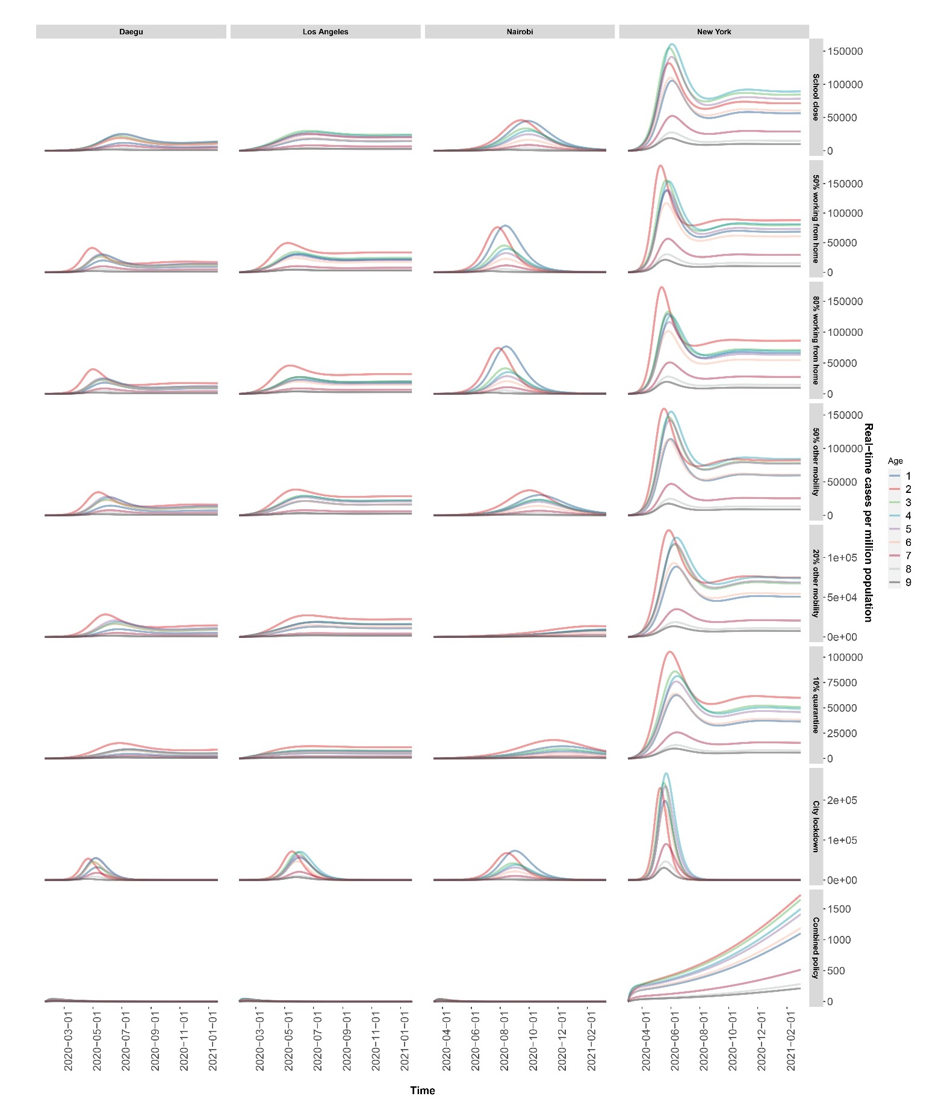
Figure 2a The infected cases of four cities in 8 intervention scenarios

- Policy database in each city
Table 10a illustrates the some of the important interventions that might effectively contain the infection.
Country | City | Date | event | Detail | reference
USA | Los Angeles | 1/26/2020 | First case report |  | https://coronavirus.jhu.edu/map.html
USA | Los Angeles | 3/4/2020 | Declare local emergency |  | https://www.lamayor.org/COVID19Orders
USA | Los Angeles | 3/4/2020 | State order | All residents of the state to stay home exept essential needs | https://www.gov.ca.gov/wp-content/uploads/2020/03/EO-N-33-20-COVID-19-HEALTH-ORDER-03.19.2020-002.pdf
USA | Los Angeles | 3/5/2020 | Californians for free test |  | https://www.cdph.ca.gov/Programs/OPA/Pages/NR20-012. aspx
USA | Los Angeles | 3/12/2020 | City guidelines | 1. Self-quarantine for employees with symptoms; 2. Respiratory etiquette, social distancing and hand hygiene; 3. Thorough cleaning of commonly touched surfaces; 4. Disseminate updates in work spaces; 5. Cancel all non-essential public community events; 6. Avoid close contact of vulnerable individuals; 7. stagger visitors in public gathering places; 8. Hand washing and sanitizer available. 8. Cancel non-essential travels; 9. Develop telecommuting plans | https://www.lamayor.org/sites/g/files/wph446/f/article/files/Mayor%20Memo%20-COVID-19%20LA%20City%20Guidelines.pdf
USA | Los Angeles | 3/15/2020 | New city measures | 1. All bars and nightclubs were closed; 3. All restaurants and retail food facilities were prohibited; 4. All movie theaters, live performance venues, arcades, gyms were closed. 5. Violation fines or imprisonment | https://www.lamayor.org/sites/g/files/wph446/f/article/files/Mayor%20Garcetti%20Emergency%20Order%20-%20March%2015%202020.pdf
USA | Los Angeles | 3/16/2020 | School closed |  | https://www.lamayor.org/COVID19Orders
USA | Los Angeles | 3/17/2020 | Public order | 1. No landlord shall evict a residential or commercial tenant during this local emergency period if the tenant is able to show an inability to pay rent due to COVID-19; 2. parking enforcement was relaxed for manufacturing or healthcare activities | https://www.lamayor.org/sites/g/files/wph446/f/page/file/CommercialEvictionMoratoriumFINAL.pdf
USA | Los Angeles | 3/19/2020 | State stay home order | Stay at home except for essential goods or jobs; keep social distancing for 6 feet. | https://www.lamayor.org/sites/g/files/wph446/f/page/file/SAFER%20AT%20HOME%20ORDER%202020.03.19%20%28REV%202020.04.01%29.pdf
USA | Los Angeles | 3/21/2020 | Non-essential cross-border travel suspended |  | https://www.dhs.gov/news/2020/03/23/fact-sheet-dhs-measures-border-limit-further-spread-coronavirus?utm_source=hp_slideshow&utm_medium=web&utm_campaign=dhsgov
USA | Los Angeles | 3/25/2020 | Emergency guideline | Relaxing contracting and vehicle restrictions | https://www.lamayor.org/sites/g/files/wph446/f/page/file/20200325MemotoCityDepts.pdf
USA | Los Angeles | 4/1/2020 | Public order | Safter at home | https://covid19.ca.gov/
USA | Los Angeles | 4/3/2020 | Facemasks |  | https://www.hhs.gov/about/news/2020/04/03/secretary-azar-statement-on-new-cdc-face-covering-guidance.html
USA | Los Angeles | 4/7/2020 | State executive order | Continuing Temporary Suspension and Modification of Laws Relating to the Disaster Emergency | https://www.governor.ny.gov/news/no-20214-continuing-temporary-suspension-and-modification-laws-relating-disaster-emergency
USA | Los Angeles | 4/16/2020 | Guidelines for Opening Up America Again, a three-phased approach based on the advice of public health experts. |  | https://www.whitehouse.gov/openingamerica/
USA | Los Angeles | 5/18/2020 | Resources for control and prevention | The Department of Health and Human Services (HHS) is delivering $11 billion in new funding to support testing for COVID-19. The Centers for Disease Control and Prevention (CDC) will provide $10.25 billion to states, territories, and local jurisdictions through CDC’s existing Epidemiology and Laboratory Capacity for Prevention and Control of Emerging Infectious Diseases (ELC) cooperative agreement. The Indian Health Service (IHS) will provide $750 million to IHS, tribal, and urban Indian Health programs to expand testing capacity and testing-related activities | https://www.hhs.gov/about/news/2020/05/18/hhs-delivers-funding-to-expand-testing-capacity-for-states-territories-tribes.html
USA | Los Angeles | 6/4/2020 | FDA Publicly Shares Antibody Test Performance Data from Kits as Part of Validation Study |  | https://www.fda.gov/news-events/press-announcements/coronavirus-covid-19-update-fda-publicly-shares-antibody-test-performance-data-kits-part-validation
USA | New York | 3/2/2020 | First case report |  | https://coronavirus.jhu.edu/map.html
USA | New York | 3/5/2020 | City public order | The vulnerable are required to stay home; educators, first responders, and healthcare workers are subject to be tested for COVID-19 | https://www1.nyc.gov/assets/doh/downloads/pdf/imm/order-of-the-commissioner-to-all-educators-first-responders-healthcare-covid19.pdf
USA | New York | 3/6/2020 | Guidance for testing and quarantine |  | https://www.governor.ny.gov/news/statement-new-york-state-department-health-commissioner-doctor-howard-zucker
USA | New York | 3/10/2020 | Guidance for cleaning and disinfection of public and private facilities | Instructions for hand hygiene, respiratory hygine, routine cleaning | https://www.agcnys.org/wp-content/uploads/cleaning_guidance_general_building-NYSDOH.pdf
USA | New York | 3/7/2020 | State of disaster emergency |  | https://www.governor.ny.gov/news/no-20214-continuing-temporary-suspension-and-modification-laws-relating-disaster-emergency
USA | New York | 3/16/2020 | School closed |  | https://www.governor.ny.gov/news/governor-cuomo-signs-executive-order-closing-schools-statewide-two-weeks
USA | New York | 3/17/2020 | Bars and restaurant closed; mandatory workforce reduce by 75% |  | https://www.governor.ny.gov/news/video-audio-photos-rush-transcript-governor-cuomo-signs-executive-order-mandating-businesses
USA | New York | 3/21/2020 | Non-essential cross-border travel suspended |  | https://www.dhs.gov/news/2020/03/23/fact-sheet-dhs-measures-border-limit-further-spread-coronavirus?utm_source=hp_slideshow&utm_medium=web&utm_campaign=dhsgov
USA | New York | 3/22/2020 | State Pause' Executive Order | 1. 100% closure of non-essential businesses statewide; 2. Provide new protections for vulnerable populations; 3. 90-day moratorium on residential or commercial evictions; 4. Encourage companies to produce PPE products | 1. https://www1.nyc.gov/assets/home/downloads/pdf/executive-orders/2020/eeo-98.pdf; 2. https://coronavirus.health.ny.gov/new-york-state-pause
USA | New York | 3/25/2020 | Car-free streets |  | https://nyc.streetsblog.org/2020/03/25/here-are-the-four-streets-de-blasio-will-close-to-cars-for-four-days/
USA | New York | 3/27/2020 | Guidance to shut down a business | 1. workforce reduction; 2. shut down non-essential construction | https://esd.ny.gov/guidance-executive-order-2026
USA | New York | 3/28/2020 | Travel recommendation | CDC Issues Domestic Travel Advisory for New York, New Jersey, and Connecticut | https://www.cdc.gov/media/releases/2020/s038-travel-advisory.html
USA | New York | 4/3/2020 | City calls for medical essentials | 1. Face covering; 2. Expanding DOE meal hubs; 3. Loans for small business; 4. Get notification from government on the latest developments | https://coronavirus.health.ny.gov/system/files/documents/2020/03/cleaning_guidance_general_building.pdf
USA | New York | 4/7/2020 | State executive order | Continuing Temporary Suspension and Modification of Laws Relating to the Disaster Emergency | https://www.governor.ny.gov/news/no-20214-continuing-temporary-suspension-and-modification-laws-relating-disaster-emergency
USA | New York | 4/16/2020 | Guidelines for Opening Up America Again, a three-phased approach based on the advice of public health experts.
USA | New York | 5/18/2020 | Resources for control and prevention | The Department of Health and Human Services (HHS) is delivering $11 billion in new funding to support testing for COVID-19. The Centers for Disease Control and Prevention (CDC) will provide $10.25 billion to states, territories, and local jurisdictions through CDC’s existing Epidemiology and Laboratory Capacity for Prevention and Control of Emerging Infectious Diseases (ELC) cooperative agreement. The Indian Health Service (IHS) will provide $750 million to IHS, tribal, and urban Indian Health programs to expand testing capacity and testing-related activities
USA | New York | 6/4/2020 | FDA Publicly Shares Antibody Test Performance Data From Kits as Part of Validation Study |  | https://www.fda.gov/news-events/press-announcements/coronavirus-covid-19-update-fda-publicly-shares-antibody-test-performance-data-kits-part-validation
South Korea | Daegu | 1/20/2020 | First case report
South Korea | Daegu | 1/28/2020 | All-out measures for COVID-19 | 1. Third-level emergency; 2. full inspection on all travellers who entered from Wuhan; 3. Detail of the fourth patient's epidemiological investigation was revealed to the public. 4. Encourage face masks | https://www.mohw.go.kr/eng/nw/nw0101vw.jsp?PAR_MENU_ID=1007&MENU_ID=100701&page=3&CONT_SEQ=352623
South Korea | Daegu | 2/7/2020 | Free diagnostic testing | testing capacity increased to 15000 per day in March | http://ncov.mohw.go.kr/en/baroView.do?brdId=11&brdGubun=111&dataGubun=&ncvContSeq=&contSeq=&board_id=
South Korea | Daegu | 2/12/2020 | Control measures for incoming passengers from abroad | All passengers are tested, and positive ones will be transferred to a hospital or living center; negative people will be quarantined for 14 days. | http://ncov.mohw.go.kr/en/baroView.do?brdId=11&brdGubun=111&dataGubun=&ncvContSeq=&contSeq=&board_id=
South Korea | Daegu | 2/20/2020 | City government asked people to stay at home. | 1. Cancel all non-essential gatherings; 2. Stay home except to purchase necessities, to get medical care, or to go to work; 3. keep 2-meter distance; 4. disinfect home
South Korea | Daegu | 2/21/2020 | School and public spaces closed
South Korea | Daegu | 2/23/2020 | Declared highest alert of COVID-19 |  | https://www.bbc.com/news/world-asia-51603251
South Korea | Daegu | 2/25/2020 | Epidemic survey when positive cases are detected |  | http://ncov.mohw.go.kr/en/baroView.do?brdId=11&brdGubun=111&dataGubun=&ncvContSeq=&contSeq=&board_id=
South Korea | Daegu | 3/7/2020 | Regular briefing of Central Disaster and Safety Countermeasure Headquarters on COVID-19 |  | http://ncov.mohw.go.kr/en/baroView.do?brdId=11&brdGubun=111&dataGubun=&ncvContSeq=&contSeq=&board_id=
South Korea | Daegu | 3/25/2020 | Enhanced social distancing campaign |  | https://www.mohw.go.kr/eng/nw/nw0101vw.jsp?PAR_MENU_ID=1007&MENU_ID=100701&page=1&CONT_SEQ=353989
South Korea | Daegu | 4/1/2020 | Stronger quarantine inspection measures for incoming passengers | 1. preventive measures for the vulnerable; 2. plan to conduct additional nationwide investigation on designated hospitals; 3. Release the list of community treatment centers and hospitals; 4. provide social emergency service | https://www.mohw.go.kr/eng/nw/nw0101vw.jsp?PAR_MENU_ID=1007&MENU_ID=100701&page=2&CONT_SEQ=353495
South Korea | Daegu | 4/4/2020 | Extending Intensive "Social Distancing" for Another 2 Weeks |  | https://www.mohw.go.kr/eng/nw/nw0101vw.jsp?PAR_MENU_ID=1007&MENU_ID=100701&page=1&CONT_SEQ=353953
South Korea | Daegu | 4/9/2020 | Supporting online school opening and religious activities | 1. Delaying start of new school year; 2. Measures to block inflow in response of the epidemic; 3. Avoid cluster transmission, sufficient communication with religious community; 4. supporting masks for the vulnerable. | https://www.mohw.go.kr/eng/nw/nw0101vw.jsp?PAR_MENU_ID=1007&MENU_ID=100701&page=2&CONT_SEQ=353618
South Korea | Daegu | 4/11/2020 | stronger infectious disease prevention and control management for high-risk communities will be prepared by Friday, 10 April, and will begin to take effect starting Saturday, 11 April.
South Korea | Daegu | 4/20/2020 | phase-out measure | Following the end (19 April) of the previous Enhanced Social Distancing campaign, KCDC is leading a slightly relaxed form of social distancing campaign until 5 May. | https://www.cdc.go.kr/board/board.es?mid=a30402000000&bid=0030&act=view&list_no=366956&tag=&nPage=1
South Korea | Daegu | 5/4/2020 | recommend mask wearing for everyone in specified situations |  | https://www.cdc.go.kr/board/board.es?mid=a30402000000&bid=0030&act=view&list_no=367074&tag=&nPage=1
South Korea | Daegu | 5/6/2020 | Distancing in daily life' takes effect. Does not mean we will return to the same routine as before, but to the "new normal life" which people will practice infectious disease prevention rules on a regular basis. |  | https://www.cdc.go.kr/board/board.es?mid=a30402000000&bid=0030&act=view&list_no=367086&tag=&nPage=1
South Korea | Daegu | 5/22/2020 | High school attendance status and measures |  | http://www.mohw.go.kr/react/al/sal0301vw.jsp?PAR_MENU_ID=04&MENU_ID=0403&page=5&CONT_SEQ=354660
South Korea | Daegu | 5/25/2020 | electronic contact tracing | a system of “electronic access list (QR code)” that utilizes information technology (IT) to secure the accuracy of the visitor list in the course of epidemiological investigation of the risk facility for collective infection | http://www.mohw.go.kr/react/al/sal0301vw.jsp?PAR_MENU_ID=04&MENU_ID=0403&page=4&CONT_SEQ=354681
South Korea | Daegu | 5/28/2020 | close public facilities | Suspension of operation of public facilities located in the metropolitan area used by a large number of unspecified persons indoors and outdoors | http://www.mohw.go.kr/react/al/sal0301vw.jsp?PAR_MENU_ID=04&MENU_ID=0403&page=2&CONT_SEQ=354773
South Korea | Daegu | 6/3/2020 | quarantine | Kindergarten quarantine management plans | http://www.mohw.go.kr/react/al/sal0301vw.jsp?PAR_MENU_ID=04&MENU_ID=0403&page=1&CONT_SEQ=354849
Kenya | Nairobi | 3/13/2020 | First case report
Kenya | Nairobi | 3/15/2020 | Suspended entry into Kenya by people from all countries affected by the Covid-19 disease for 30 days. Only Kenyan nationals or those with a permit will be allowed to enter; Limiting hospital visits, churches, meetings, weddings, etc. |  | https://www.bbc.com/news/world-africa-51917920
Kenya | Nairobi | 3/16/2020 | Self-quarantine is required after entering the country |  | https://www.aljazeera.com/news/2020/03/kenya-blocks-entry-residents-virus-response-200315154944348.html
Kenya | Nairobi | 3/23/2020 | school closure | From Monday the 23/03/2020, primary schools will be shut down. Boarding schools are expected to send pupils back home by mid-week, while higher education institutions are to close by week’s end (27/03/2020). | https://africa.cgtn.com/2020/03/15/kenya-announces-2-new-covid-19-cases-school-closures-travel-bans/
Kenya | Nairobi | 3/26/2020 | International flights suspension | Kenya has suspended all international flights. | http://www.health.go.ke/wp-content/uploads/2020/03/COVID19_Press-Statment-March-23-2020.pdf
Kenya | Nairobi | 3/27/2020 | curfew | Kenya is instating a curfew from 7pm - 5am for all citizens. Only medical professionals and critical and essential service providers will be exempt from the curfew. Kenyatta also announced a series of tax breaks to assist residents affected by the outbreak. | https://twitter.com/MOH_Kenya/status/1243525430147235843
Kenya | Nairobi | 4/6/2020 | City lockdown/facemask | There will be a cessation of movement by road, rail or air, in and out of Nairobi Metropolitan Area for an initial containment period of 21 days; with effect from 7:00 pm on Monday, 6th April 2020. These additional measures do not in any way vary the existing restrictions and measures, including the daily Nationwide Curfew from 7:00 P.M. to 5:00 A.M., in the entire territory of the Republic of Kenya. | https://www.president.go.ke/2020/04/06/17505/
Kenya | Nairobi | 4/7/2020 | Stop traveling in and out Nairobi area; wearing face masks; stop shaking hands |  | https://www.president.go.ke/2020/04/07/president-kenyatta-urges-kenyans-to-observe-government-directives-on-coronavirus/
Kenya | Nairobi | 4/15/2020 | Mandatory facemask wearing | People not wearing face masks in public will be fined 20,000 Kenyan shillings ($190; £150) or face a six-month jail term, starting on Wednesday. | https://www.bbc.com/news/world/africa/live
Kenya | Nairobi | 4/25/2020 | Domestic travel restrictions |  | https://www.capitalfm.co.ke/news/2020/04/covid-19-nairobi-mombasa-and-kilifi-containment-order-extended-for-21-days/
Kenya | Nairobi | 4/26/2020 | Border test | Testing of truck drivers to start immediately at all border crossing points | https://twitter.com/MOH_Kenya/status/1254450494342410241?s=20
Kenya | Nairobi | 5/12/2020 | Surveillance and monitoring | Four East African States (Kenya, Uganda, Rwanda, South Sudan) agreed to enforce digital surveillance and tracking system to monitor truck drivers and crews of cross border cargo drivers to help curb covid-19 spread. | https://africatimes.com/2020/05/12/eac-states-to-monitor-truck-drivers-borders-in-response-to-covid/
Kenya | Nairobi | 5/20/2020 | close public facilities | Malls, eateries, restaurants to remain closed and hawking prohibited until Saturday 6th June | https://twitter.com/MOH_Kenya/status/1263094103417540615?s=20
Kenya | Nairobi | 1/9/2020 | Schools to reopen in September. |  | https://twitter.com/MOH_Kenya/status/1269246097932812292?s=20

