Supplementary Data

Supplementary Table 1
List of genes used as seed for Parkinson’s Disease use case. The genes were selected based on a genetic evidence score > 0.5, estimated by the Open Targets Platform.

No. | ENSG ID | Gene | Description
1 | ENSG00000170989 | S1PR1 | sphingosine-1-phosphate receptor 1
2 | ENSG00000109743 | BST1 | bone marrow stromal cell antigen 1
3 | ENSG00000116991 | SIPA1L2 | signal induced proliferation associated 1 like 2
4 | ENSG00000078579 | FGF20 | fibroblast growth factor 20
5 | ENSG00000054983 | GALC | galactosylceramidase
6 | ENSG00000077943 | ITGA8 | integrin subunit alpha 8
7 | ENSG00000143772 | ITPKB | inositol-trisphosphate 3-kinase B
8 | ENSG00000272414 | FAM47E-STBD1 | FAM47E-STBD1 readthrough
9 | ENSG00000260230 | FRRS1L | ferric chelate reductase 1 like
10 | ENSG00000152214 | RIT2 | Ras like without CAAX 2
11 | ENSG00000145335 | SNCA | synuclein alpha
12 | ENSG00000164182 | NDUFAF2 | NADH:ubiquinone oxidoreductase complex assembly factor 2
13 | ENSG00000203805 | PLPP4 | phospholipid phosphatase 4
14 | ENSG00000178177 | LCORL | ligand dependent nuclear receptor corepressor like
15 | ENSG00000131374 | TBC1D5 | TBC1 domain family member 5
16 | ENSG00000071054 | MAP4K4 | mitogen-activated protein kinase kinase kinase kinase 4
17 | ENSG00000141431 | ASXL3 | ASXL transcriptional regulator 3
18 | ENSG00000136235 | GPNMB | glycoprotein nmb
19 | ENSG00000066827 | ZFAT | zinc finger and AT-hook domain containing
20 | ENSG00000069275 | NUCKS1 | nuclear casein kinase and cyclin dependent kinase substrate 1
21 | ENSG00000204287 | HLA-DRA | major histocompatibility complex, class II, DR alpha
22 | ENSG00000127419 | TMEM175 | transmembrane protein 175
23 | ENSG00000188906 | LRRK2 | leucine rich repeat kinase 2
24 | ENSG00000153086 | ACMSD | aminocarboxymuconate semialdehyde decarboxylase
25 | ENSG00000170745 | KCNS3 | potassium voltage-gated channel modifier subfamily S member 3
26 | ENSG00000152128 | TMEM163 | transmembrane protein 163
27 | ENSG00000120071 | KANSL1 | KAT8 regulatory NSL complex subunit 1
28 | ENSG00000136531 | SCN2A | sodium voltage-gated channel alpha subunit 2
29 | ENSG00000103460 | TOX3 | TOX high mobility group box family member 3
30 | ENSG00000168916 | ZNF608 | zinc finger protein 608
31 | ENSG00000197360 | ZNF98 | zinc finger protein 98
32 | ENSG00000198133 | TMEM229B | transmembrane protein 229B
33 | ENSG00000140030 | GPR65 | G protein-coupled receptor 65
34 | ENSG00000145214 | DGKQ | diacylglycerol kinase theta
35 | ENSG00000164181 | ELOVL7 | ELOVL fatty acid elongase 7
36 | ENSG00000107295 | SH3GL2 | SH3 domain containing GRB2 like 2, endophilin A1
37 | ENSG00000080854 | IGSF9B | immunoglobulin superfamily member 9B
38 | ENSG00000108379 | WNT3 | Wnt family member 3
39 | ENSG00000010810 | FYN | FYN proto-oncogene, Src family tyrosine kinase
40 | ENSG00000162692 | VCAM1 | vascular cell adhesion molecule 1
41 | ENSG00000263715 | LINC02210-CRHR1
42 | ENSG00000130787 | HIP1R | huntingtin interacting protein 1 related
43 | ENSG00000164733 | CTSB | cathepsin B
44 | ENSG00000151229 | SLC2A13 | solute carrier family 2-member 13
45 | ENSG00000145349 | CAMK2D | calcium/calmodulin dependent protein kinase II delta
46 | ENSG00000188153 | COL4A5 | collagen type IV alpha 5 chain
47 | ENSG00000198648 | STK39 | serine/threonine kinase 39
48 | ENSG00000148123 | PLPPR1 | phospholipid phosphatase related 1

Supplementary Table2
Pathway enrichment of all the genes in the network

No. | Geneset | Overlap | P-value | Adjusted P-value | Odds Ratio | Combined Score
1 | Pathways of neurodegeneration | 64/475 | 1.25e-39 | 1.95e-06 | 8.14 | 316.73
2 | Parkinson disease | 45/249 | 1.45e-33 | 3.56e-01 | 10.92 | 358.6
3 | Cell adhesion molecules | 36/148 | 7.38e-32 | 3.29e-02 | 14.7 | 457.56
4 | Proteoglycans in cancer | 40/205 | 2.89e-31 | 4.45e-05 | 11.79 | 360.06
5 | Alzheimer disease | 48/369 | 5.51e-29 | 7.96e-03 | 7.86 | 222.11
6 | Antigen processing and presentation | 25/78 | 9.19e-26 | 8.81e-08 | 19.37 | 484.87
7 | Pathways in cancer | 49/531 | 8.41e-23 | 1.49e-01 | 5.58 | 123.09
8 | Viral myocarditis | 21/60 | 9.28e-23 | 6.70e-09 | 21.15 | 465.95
9 | Tuberculosis | 31/180 | 1.05e-22 | 1.64e-06 | 10.41 | 228.74
10 | Diabetic cardiomyopathy | 32/203 | 3.54e-22 | 4.61e-03 | 9.52 | 204.31
11 | Focal adhesion | 31/201 | 3.18e-21 | 1.64e-16 | 9.32 | 191.02
12 | Regulation of actin cytoskeleton | 31/218 | 3.74e-20 | 2.60e-27 | 8.59 | 166.92
13 | Epstein-Barr virus infection | 30/202 | 4.33e-20 | 2.33e-06 | 8.97 | 173.76
14 | Kaposi sarcoma-associated herpesvirus infection | 29/193 | 1.34e-19 | 2.36e-11 | 9.08 | 171.36
15 | Rap1 signaling pathway | 30/210 | 1.35e-19 | 6.72e-14 | 8.63 | 162.88
16 | Retrograde endocannabinoid signaling | 26/148 | 1.90e-19 | 3.62e-24 | 10.61 | 198.72
17 | Prion disease | 33/273 | 3.69e-19 | 1.18e-06 | 7.3 | 134.63
18 | Hematopoietic cell lineage | 22/99 | 5.85e-19 | 1.29e-02 | 13.43 | 244.82
19 | Non-alcoholic fatty liver disease | 26/155 | 6.38e-19 | 1.11e-05 | 10.14 | 184.42
20 | Phagosome | 25/152 | 5.02e-18 | 4.21e-01 | 9.94 | 171.92
21 | Huntington disease | 33/306 | 1.23e-17 | 5.14e-15 | 6.52 | 110.19
22 | Allograft rejection | 15/38 | 1.53e-17 | 1.35e-15 | 23.85 | 401.06
23 | Leishmaniasis | 19/77 | 1.83e-17 | 3.68e-05 | 14.91 | 249.57
24 | PI3K-Akt signaling pathway | 35/354 | 1.92e-17 | 1.35e-11 | 5.97 | 99.86
25 | Thermogenesis | 29/232 | 2.30e-17 | 2.59e-07 | 7.55 | 125.66
26 | Endocytosis | 30/252 | 2.52e-17 | 2.42e-15 | 7.19 | 119.4
27 | Lipid and atherosclerosis | 28/215 | 2.81e-17 | 9.96e-04 | 7.87 | 130.25
28 | Neurotrophin signaling pathway | 22/119 | 3.91e-17 | 1.37e-03 | 11.17 | 183.28
29 | Graft-versus-host disease | 15/42 | 9.19e-17 | 4.62e-01 | 21.58 | 346.06
30 | Human papillomavirus infection | 33/331 | 1.31e-16 | 1.32e-02 | 6.02 | 95.69

Supplementary Figure 1

Subgraph of the full network with highlighted novel candidates based on their overall target score from the Open Target Platform. Different communities are represented by colors enriched for specific pathways, as shown in Figure 3.

Supplementary Figure 1 A

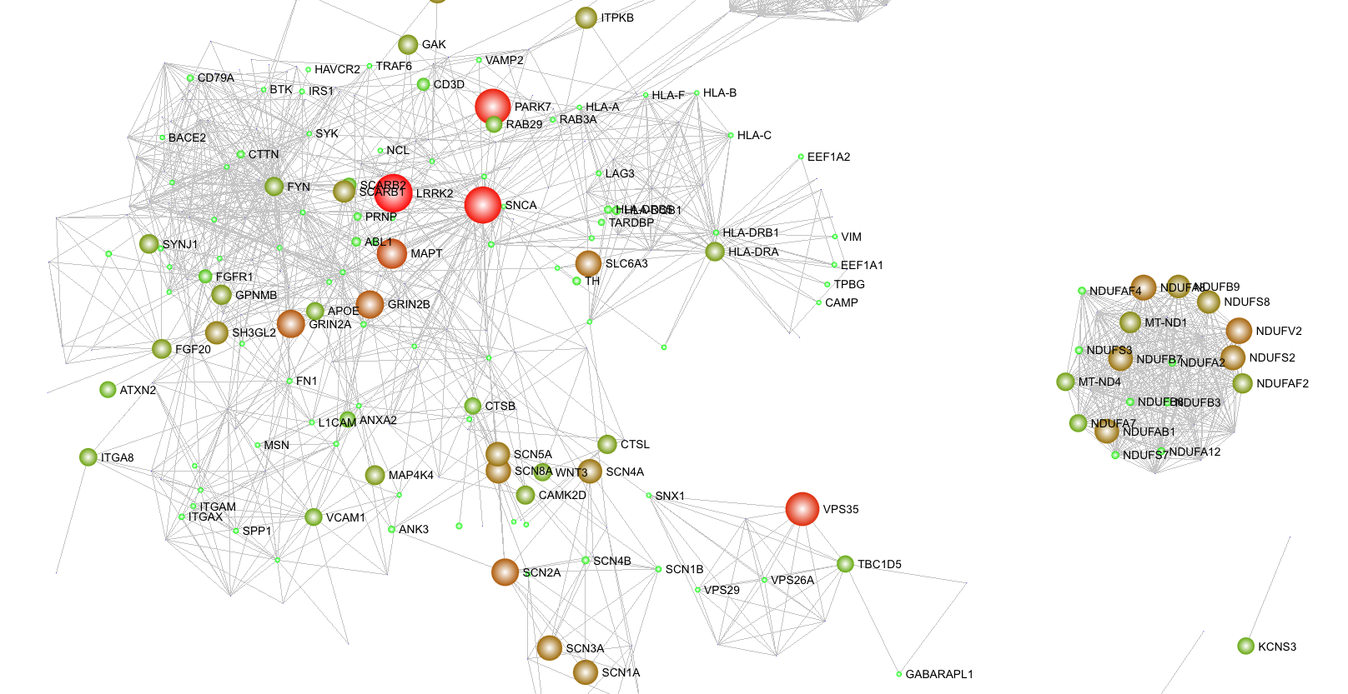

Supplementary Figure 1B

