Table 1: Genome assembly statistics of O. surinamensis PRJNA992804.
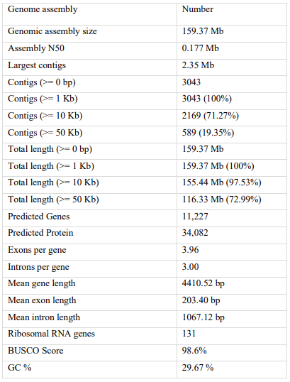
Table 2: Identified SSRs in the genome of O. surinamensis.
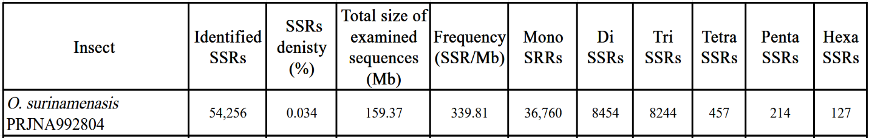

Table 3: Comparison between average query protein length and average reference protein length in several annotation databases of proteins and metabolic pathways for O. surinamensis.
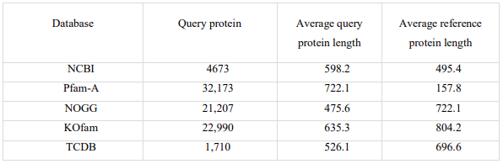

Table 4: Protein families of pesticide resistance for O. surinamensis PRJNA992804.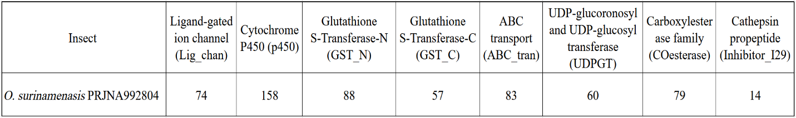

Table 5: Pfam-A annotation of protein families identified in O. surinamensis.
