Supplementary Information

CO₂ Reduction with High Bulk Turnover Numbers at Small Overpotentials by a fac-Mn(bpy)(CO)₃L Complex with a Redox-Active, Electron Reservoir Ligand.

Andy Galvez-Rodriguez¹, Octavio Martinez-Perez¹ and Steven H. Bergens¹
¹Department of Chemistry, University of Alberta. Edmonton, AB T6G 2G2, Canada
*Corresponding Author: sbergens@ualberta.ca

SI.1 Materials
Chemicals were used without any further treatment unless mentioned otherwise. The following compounds were purchased from Sigma Aldrich (Oakville, ON, Canada): tetrabutylammonium hexafluorophosphate (TBAPF6; for electrochemical analysis, ≥ 99.0%); acetone (ACS reagent, ≥ 99.5%), distilled; acetonitrile, distilled (for HPLC, gradient grade, ≥99.9%); dichloromethane, distilled (DCM; ACS reagent, ≥ 99.5%); D₂O (99.8 atom % D); carbazole (≥ 95%); NaH (60% dispersion in mineral oil); NaCl (ACS reagent, ≥ 98.0%); deuterated chloroform (99.8 atom % D); Cs₂CO₃ (Reagent Grade, 99%); AgBF₄ (98%) and calcium hydride (reagent grade, 95%). Hydrochloric acid (ACS grade, 12 M); Na₂SO₄ (ACS grade, > 99%); CH₃OH, distilled (> 99.8%) and Mn(CO)₅Br (98%) were purchased from Fisher Scientific. Tetrafluoroisophthalonitrile (> 98.0%) was purchased from TCI chemicals (Portland, OR, USA). Imidazole was purchased from J.T. Baker Chemicals Corporation (New Jersey, United States). 1,2-bipyridyl was purchased from Terachem Laboratories (Edmonton, Canada). Deuterated acetonitrile (99.8 atom %D) was purchased from Cambridge Isotope Laboratories (Quebec, Canada). Lithium perchlorate trihydrate was purchased from The G. Frederick Smith Chemical Co. (Columbus, Ohio, USA). The solvents tetrahydrofuran (Na/benzophenone), diethyl ether (Na/benzophenone), DCM (CaH₂), acetone (3Å molecular sieves), and acetonitrile (CaH₂) were dried by distillation from the appropriate drying agent under N₂. Triple-distilled water was used for all glassware cleaning and preparation of aqueous solutions for electrochemistry experiments.
SI.2 Extended synthetical procedures of relevant compounds.
5-fluoro-2,4,6-tri(9H-carbazol-9-yl)benzene-1,3-dicarbonitrile (3CzFIPN)

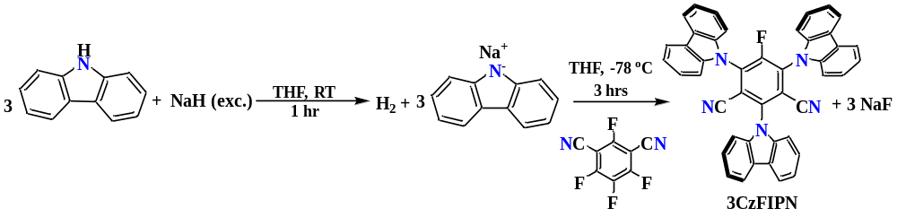
NaH (60% dispersion in mineral oil, 4.788 g, 119.6 mmol, Sigma Aldrich, Lot. 1003423283) was weighed out and loaded into a side-arm flask. The flask was then connected to a Schlenk line, evacuated, and refilled with N₂. The NaH was washed with freshly distilled THF (3x 30 mL) to remove mineral oil. NaH was suspended in 20 mL of THF, and the flask was cooled down to 0 °C, with an ice-water bath, under N₂. Carbazole (3.999 g, 23.9 mmol, TCI >99%, white needles, Lot. CXVAG-FN) was completely dissolved in 30 mL of distilled THF at room temperature, forming a white transparent solution, and cannula transferred into the flask containing NaH. The beginning of the reaction was noted by the appearance of bubbles (H₂) in the reaction mixture. Additional THF (2x 5 mL) was used for quantitative transfer and the reaction flask was held at room temperature for 1 hour while stirring to deprotonate the carbazole. The resulted mixture became a light green opaque solution once the reaction was completed with a gray powder at the bottom. In the meantime, tetrafluoroisophthalonitrile, 4FIPN, (1.594g, 7.81 mmol, TCI 98%, Lot. TAJGD-NC, white crystals) was dissolved in THF (15 mL) at room temperature and then cooled down to -78 °C under N₂ atmosphere, using a dry-ice-acetone bath. The flask containing 4FIPN was ~60% submerged into the bath. The sodium carbazolyl (NaCz) compound was cannula filtrated into a separate flask and placed in the –78 ºC bath. NaCz was cannula transferred through the walls of the flask containing tetrafluoroisophthalonitrile over a period of 30 min. Quantitative transfer was achieved with additional THF (2 x 10 mL) washings. The NaCz compound will precipitate as a white solid, it is necessary to redissolve it with THF, cool it, and continue the transfer. Running the deprotonated carbazole down the walls ensures it cools down before it reacts with tetrafluoroisophthalonitrile. The resulted solution became yellow upon addition of the deprotonated carbazole. The reaction flask was held at -78 °C with stirring and an aliquot collected after 2.5 hours showed the product of interest with no starting material. The reaction mixture was let warm up overnight under N₂ atmosphere while stirring it. The reaction was quenched by adding 2 mL of distilled water drop wise under N₂ atmosphere at room temperature. The precipitate formed after addition of water was removed by gravity filtration and washed with DCM several times. The filtrate was then concentrated using the rotavap to yield a yellow solid product. The solid product was then dissolved in 50 mL of DCM and washed with water (3x 50 mL) in an extraction funnel. While washing, the water layer was neutralized with hydrochloric acid solution (0.1 M), the pH was measured with pH paper. Then the product was washed with brine solution. Afterward, the organic phase was dried over Na₂SO₄, gravity filtrated, and then concentrated under reduced pressure using rotavap to yield a yellow product. The crude product mass obtained was 5.3 g. This yellow solid was dissolved in 16 mL of a DCM: Acetone (1:1) mixture. The resulting yellow-orange solution was warmed under 40 ºC water bath for 3 min, 2 mL of diethyl ether were added to the mixture and the flask was placed inside the fridge, while hot, overnight. The crystals formed were separated from solution and dried under high vacuum. The solution is transferred to another flask and the solvents evaporated, redissolved in DCM: Acetone (1:1) (4 mL) plus 1 mL of diethyl ether added. The first batch of yellow crystals gave 3.9176 g of 3CzIPN-F, the second batch gave 0.9917 g. A total of 4.9094 g, or 96% yield.
Mass Spectrometry Analysis: (M⁺Cl⁻) theoretical mass: 676.1715; observed mass: 676.171
¹H NMR (498 MHz, CDCl₃) δ 8.19 (dt, J = 7.7, 1.0 Hz, 1H), 8.15 (dt, J = 7.7, 1.0 Hz, 2H), 7.61 (ddd, J = 8.4, 7.4, 1.2 Hz, 1H), 7.55 (ddd, J = 8.4, 7.4, 1.2 Hz, 2H), 7.47 – 7.38 (m, 4H), 7.37 – 7.33 (m, 2H).
¹⁹F NMR (376 MHz, CDCl₃) δ -111.10.

1-imidazole-2,4,6-tri(carbazole-9-yl)benzene-1,3-dicarbonitrile (Imdye)

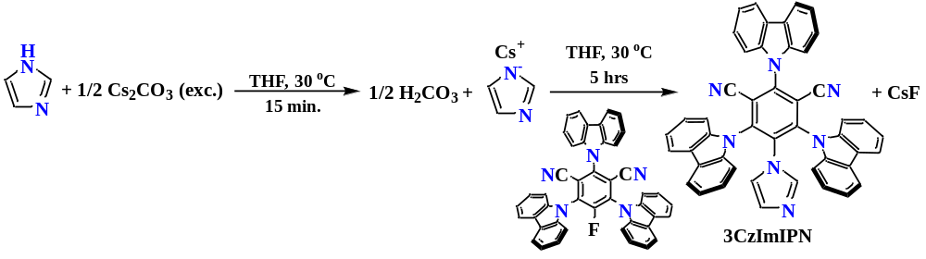
Imidazole (0.187 g, 2.75 E ⁻³ mol) and cesium carbonate (2.69 g, 8.25 E ⁻³ mol) were weighed out and loaded into a side-arm flask. The flask was then connected to an Schlenk line, evacuated, and refilled with N₂ for 3 cycles. Freshly distilled acetonitrile (40 ml) was added to the flask and the resulted suspension was stirred at 30 °C for 15 minutes to deprotonate the imidazole. Meanwhile, the previously synthesized monofluoro compound (3CzFIPN, 1.764 g, 2.75 E ⁻³ mol) was completely dissolved in freshly distilled acetonitrile (20 mL) and added drop wise to the flask containing deprotonated imidazole at room temperature. Additional acetonitrile (2x10 mL) was used for quantitative transfer and then the reaction flask was heated at 30 °C for 4 hours under N₂ while stirring. An aliquot after this time showed the completion of the reaction with no starting material remaining. The reaction mixture was then put on the fridge and let overnight to stop the reaction. Afterwards, the reaction mixture was warmed to room temperature and then gravity filtrated and washed with DCM (3x). The filtrate was then concentrated under reduced pressure using rotavap to give an orange solid product. The concentrated product was then dissolved in DCM and washed with water (50 mL) and brine solution (3x50 mL) using a 250 mL extraction funnel. The organic layer was dried over Na₂SO₄ for an hour, gravity filtrated, and then concentrated again using rotavap to yield the target product (1.8 g, 94.6% yield).
Mass Spectrometry Analysis: (M⁺Cl⁻) theoretical mass: 724.2028; observed mass: 724.2022
¹H NMR (498 MHz, CDCl₃) δ 8.19 (dt, J = 7.7, 1.0 Hz, 2H), 8.07 (dt, J = 7.7, 1.0 Hz, 4H), 7.64 (ddd, J = 8.3, 7.2, 1.2 Hz, 2H), 7.51 – 7.39 (m, 9H), 7.34 (td, J = 7.5, 1.0 Hz, 4H), 7.15 (dt, J = 8.1, 0.9 Hz, 4H), 6.54 (t, J = 1.1 Hz, 1H), 6.14 (dd, J = 1.5, 0.8 Hz, 1H), 5.86 (t, J = 1.4 Hz, 1H).

[Mn(bpy)(CO)₃Br]
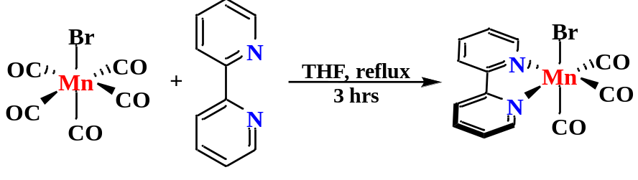
[Mn(CO)₅Br] (1.79 g, 6.55 E⁻³ mol) was weighted out and loaded into a side-arm Schlenk flask, then connected to line. The flask was evacuated and refilled with nitrogen for 3 cycles. 1,2 bipyridyl (bpy, 1.0 g, 6.55 E⁻³ mol) was completely dissolved in freshly distilled THF (30 mL) and canulated into the flask containing the Mn precursor. Additional THF (2x10 mL) was added to the flask containing bpy for quantitative transfer. The reaction flask was set up in a reflux system at 66 °C while stirring for 3 hours. The reaction mixture was light orange in colour in the beginning of the reaction but became dark orange after 3 hours. ¹H-NMR (solvent: distilled CD₃CN) after this time showed the completion of reaction with any starting material remaining. The solution containing the product was pumped down and washed with freshly distilled diethyl ether (5x) to remove impurities. The product (orange in colour) was then pumped down to get rid of remaining diethyl ether and stored in an oxygen and moisture-free environment (2.15 g, 88% yield).
Mass Spectrometry Analysis: (M⁺) theoretical mass: 295.2814; observed mass: 295.2841
¹H NMR (600 MHz, CD₃CN) δ 9.25 – 9.21 (m, 1H), 8.34 (d, J = 8.0 Hz, 1H), 8.14 – 8.08 (m, 1H), 7.61 (dd, J = 7.6, 5.4 Hz, 1H).
Liquid FTIR CO stretches (solvent is acetonitrile): 1924.6, 1934.1, 2026.8 cm⁻¹
[Mn(bpy)(CO)₃(Imdye)]BF₄
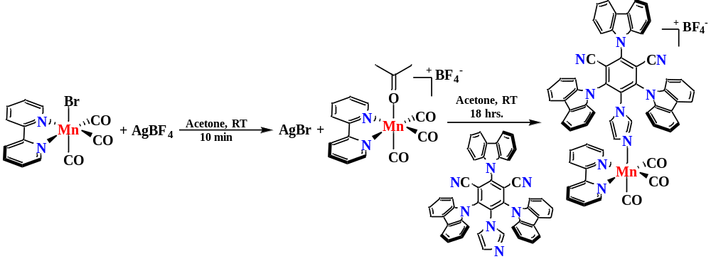
[Mn(bpy)(CO)₃Br] (0.4462 g, 1.19 E⁻³ mol) weighted out and loaded into a side-arm flask, then connected to line to be evacuated and refilled with N₂ for 3 cycles. Mn-precursor was completely dissolved in freshly distilled acetone (30 mL) and then canulated into a side-arm flask containing AgBF₄ (0.212 g, 1.068 E⁻³ mol). A white solid (AgBr) instantly came out from the previous reaction and the solution was filtrated using a 10 mL syringe under N₂ filled with celite into another flask containing Imdye (0.7 g, 1.015 E⁻³ mol). Additional distilled acetone (2x10 mL) was added to the celite to remove the product stuck in the celite filtration system. The mixture was let react overnight under nitrogen and vigorous stirring at room temperature. ¹H-NMR (CD₃CN) was taken the next morning, showing no starting material. The reaction mixture was pumped down under reduced pressure and washed (3x) with freshly distilled ether. Afterwards, the product was pumped down again and stored in an oxygen and moisture-free environment (0.72 g, 65.6% yield).
Mass Spectrometry: (M⁺) theoretical mass: 984.2243, observed mass: 984.2238
¹H NMR (600 MHz, CD₃CN) δ 8.65 – 8.56 (m, 1H), 8.26 (d, J = 7.8 Hz, 1H), 8.18 – 8.12 (m, 2H), 8.06 (td, J = 7.9, 1.5 Hz, 1H), 7.96 (d, J = 8.1 Hz, 1H), 7.74 (d, J = 8.3 Hz, 1H), 7.69 (ddd, J = 8.3, 7.1, 1.2 Hz, 1H), 7.52 – 7.47 (m, 1H), 7.46 – 7.38 (m, 8H), 6.51 (t, J = 1.4 Hz, 1H), 6.21 (t, J = 1.7 Hz, 1H), 5.92 (t, J = 1.5 Hz, 1H).
Liquid FTIR CO stretches (solvent is acetonitrile): 1941.1, 1951.6, 2042.3 cm⁻¹

SI.3 UV-vis spectroelectrochemistry (SEC) experiments under N₂.
UV-vis SEC experiments were carried out to better understand the reduction mechanism of Mn-Imdye and characterize the intermediates involved in the process. Furthermore, this technique was employed along with CV studies to demonstrate that the Imdye remains bound upon reduction of the complex under study. Experiments were carried out with a Honeycomb Spectroelectrochemical Cell Kit purchased from Pine Research and a Cary 5000 UV/UV-vis/NIR instrument. The principal components of this kit are a 19-holes honeycomb patterned electrode card that contains both, the counter and working electrode (Au or Pt) and a thin-layer quartz cuvette. The thin-layer quartz cuvette features a slot near to the bottom designed to accept the electrode card. A low profile, Ag reference electrode specifically made to operate with this cell was also purchased from Pine Research. Experiments were performed with 1 mM solution of compounds under study and 0.1 M of TBAPF₆ as the supporting electrolyte in freshly distilled acetonitrile unless otherwise specified. In a typical experiment, 2-4 minutes of bulk electrolysis at the potential where intermediates are generated was carried out while the UV-vis instrument recorded the changes in absorption in the wavelength region of interest (300-900 nm). Absorption spectra of 0.1 M solution of TBAPF₆ at different electrolysis potentials was employed as the baseline. UV-vis spectra of complexes under study were generated by mathematically subtracting the spectra of TBAPF₆ solution from their spectra at different electrolysis potentials.
SI.4 Construction of calibration curves to quantify the products of CPE experiments.
The homemade electrocatalytic cell used in CPE experiments (Supplementary Figure S1) was employed for the construction of calibration curves. It was loaded with CO₂-saturated acetonitrile solution containing the proton source and electrolyte and flushed for 5 minutes with CO₂ before the addition of 50 μL of C₂H₆ as the internal standard. The added gas was allowed to equilibrate for 45 minutes under stirring before an aliquot was taken and analysed in the Gas Chromatograph.
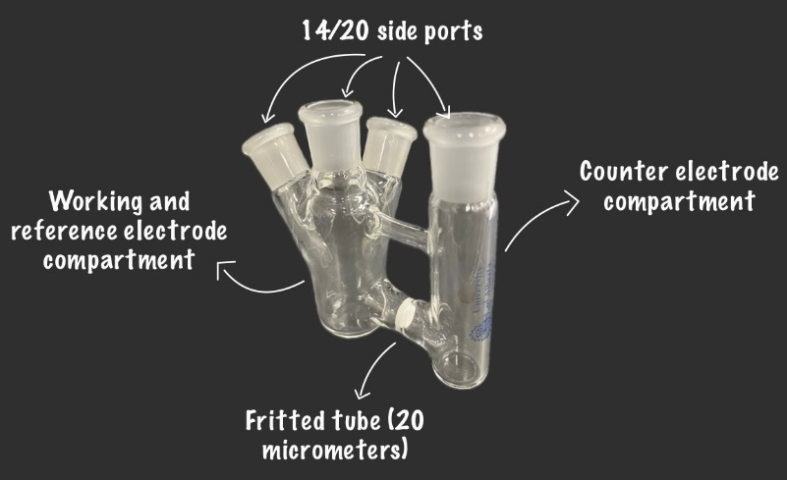
Supplementary Figure S1. Homemade electrocatalytic cell employed in CPE experiments with Mn-Imdye.

Calibration curves were constructed by adding known volumes of CO or H₂ and then plotting the peak area ratio (CO or H₂)/C₂H₆ vs. the volume of CO or H₂ in μL. 30 minutes of resting were allowed between each injection to the Gas Chromatograph. A linear fit analysis allowed the determination of the linear function that was then employed for calculating the volume of CO or H₂ in the CPE experiments. The number of moles of CO or H₂ were determined as follow:
From the linear fit analysis:$y=mx+b,$ where $y=Peak Area Ratio \left(\frac{z}{ethane}\right)$ with z being CO or H₂, x is the volume of z in μL, m is the slope and b is the intercept with the y-axis. At a given time of the reduction reaction y is obtained and then x is calculated using the fitting function: $x=\frac{(y-b)}{m}$. Then, the number of moles is calculated:
$n\left(z\right)=\frac{(y-b)}{m*\frac{24.8mol}{L}*{10}^{6}} (eq. 1)$
Note that m and b are used for CO or H₂ as if their value were the same for both gases but each gas to be analysed possesses its own fitting curve. They were only treated as indistinguishable for explanation purposes.
a) | b)
c)
Supplementary Figure S2. Calibration curves for the quantification of a) CO (low volumes) b) CO (high volumes) and b) H₂.

SI.5 Normalization of Current Density in Cyclic Voltammograms
CV experiments under catalytic conditions (CO₂ and proton source) were recorded after stepwise addition of the proton source to a 0.55 mM solution of Mn-Imdye in freshly distilled acetonitrile. The current density from those CVs were normalized to account for the effect of dilution by the added volumes of additives. It was determined in a previous experiment that mixtures containing the acid source and acetonitrile were additives in the range of volumes used in this work (10-30 mL). For instance, if to a 20 mL solution of 0.55 mM Mn-Imdye in acetonitrile 2.0 mL of acid source is added, then the current density is multiplied by a dilution factor of $\frac{V_{f}}{V_{i}}=\frac{22 mL}{20 mL}$, where $V_{f}$ is the final volume and $V_{I}$ is the initial volume of the solution.
SI.6 Foot of the Wave Analysis (FOWA) and determination of the Kinetic Isotope Effect (KIE).
Foot of the Wave Analysis (FOWA, eq. 3) was implemented to determine the value of $k_{obs}$at different concentrations of the acid, catalyst and CO₂. This analysis allows the determination of kinetic data in systems where side reactions such as catalyst degradation and consumption of substrate are present. It implies that those side reactions can be neglected if the analysis is restrained to the foot of the wave region of CV responses^{1,2}. Theoretical details, chemical assumptions and determination of equations in FOWA can be found in pioneer work of Costentin and Savéant³. In our case, the base model involving an electrochemical step (single or multielectron) and a homogeneous chemical reaction (may involve multiple elementary steps) was used:
$P+ne ⇆Q E_{\frac{P}{Q}}^{°}$ Scheme 1
$$Q+A→P+C k_{cat}$$

$\frac{i_{cat}}{i_{p}}=\frac{2.24\sqrt{\frac{{n^{'}k}_{obs}}{fv}}}{1+\exp\left[nf\left(E-E_{\frac{cat}{2}}\right)\right]}$ (eq. 2)
In eq. 2:
- $i_{cat}$ is the current achieved under catalytic conditions.
- $i_{p}$ is the peak current achieved under non catalytic conditions.
- $n^{'}$ is the number of electrons involved in the catalytic reaction (2 for carbon dioxide reduction reaction)
- $k_{obs}$ is the observed rate constant for the catalytic reaction.
- $f$ is determined as F/RT where F is the Faraday constant, R in the gas constant and T is the temperature in K.
- $v$ is the scan rate in V/sec.
- $n$ is the number of electrons involved in the P/Q reduction step.
- E is the voltage in V.
- $E_{\frac{cat}{2}}$ is the voltage in V at which half the catalytic current is achieved.
FOWA plots are obtained by plotting $\frac{i_{cat}}{i_{p}}$ vs $\frac{1}{1+\exp\left[nf\left(E-E_{\frac{cat}{2}}\right)\right]}$ in which $k_{obs}$ results from the slope of Eq. 2: $2.24\sqrt{\frac{{n^{'}k}_{obs}}{fv}}$. To ensure acceptable results, the following restrictions were applied to our FOWA plots⁴:
- FOWA plots were constructed beginning with an $\frac{i_{cat}}{i_{p}}≈1$, which indicates the start of the catalytic response.
- Data points included in the analysis were those that ensured $R^{2}>0.97$.
The KIE for Mn-Imdye at low and high overpotential regimes were determined by cyclic voltammetry experiments with H₂O and D₂O as the proton source. In a separate experiment was determined that the rate of the catalytic reaction is second order in H₂O and D₂O before saturation conditions. Therefore, plotting the observed rate of reaction (k_{obs}) vs. [acid]² allows the direct determination of KIE as follows:
$KIE= \frac{k_{H}}{k_{D}}=\frac{{slope}_{H}}{{slope}_{D}}$ (eq. 3)
Where $k_{H}$ and $k_{D}$ are the second order rate constants for H₂O and D₂O, respectively, determined as the slope of the following linear relationship:
$k_{obs}=k_{\frac{H}{D}}{\left[acid\right]}^{2}$ (eq. 4)
SI.7 Determination of CRR overpotential.
The overpotential (η) is one of the most important figures of merit in electrocatalysis and can be defined as the additional potential, beyond the thermodynamic requirements, that must be provided to drive a specific electrocatalytic reaction⁵. In the case of CO₂ to CO reduction reaction, η can be calculated as:
$η=E_{applied}-E_{{CO}_{2}→CO}^{0} (eq. 5)$
where $E_{applied}$ is the applied potential to drive the reaction and $E_{{CO}_{2}→CO}^{0}$ is the standard CO₂ to CO reduction potential that depends on the specific conditions at which the reaction is carried out. This term can be further determined using the following equation:
$E_{{CO}_{2}→CO, CH_{3}CN, HA}^{0}=0.349-\left(\frac{2.303RT}{F}\right)pK_{a,HA, CH_{3}CN } V vs NHE$ (eq. 6)
where R is the gas constant, T is the temperature in K, F is the Faraday constant and $pK_{a,HA, CH_{3}CN }$is the pKa of the proton source in acetonitrile¹. Taking CV scans under catalytic conditions with added water as the proton source, the strongest proton source is the carbonic acid (H₂CO₃, pKa = 17.03 in MeCN) that originates from the hydration of dissolved carbon dioxide⁶. Substitution of pKa = 17.03 in eq. 1 results in a standard CO₂ to CO reduction potential of -0.635 V vs NHE (approximately -1.27 V vs Fc⁷)
SI.8 CPE experiments using Pt and graphite felt as CE: comparison.
CPE experiments with 1 mM solution of catalyst were carried out as described in section SI.1.4 using Pt and graphite felt as CE for comparison. 120 TON in CO were achieved in 300 minutes of reaction with Pt being used as the CE before the HER took place. In the contrary, only 30 TON in CO were reached when graphite felt was used as the CE in 80 minutes of electrolysis before HER took place.
Supplementary Note 1
Electrochemistry of 1, 2 and 3 under inert atmosphere. Extended results.
Supplementary FigureS3 shows the CVs of 2 recorded with glassy carbon disk electrodes in MeCN under N₂ (0.1 M [N(n-Bu)₄⁺](PF₆⁻) (TBAPF₆)). Supplementary Figure1 from main manuscript shows the CV of the Mn-Imdye complex 3 (0.5 mM) recorded at 25, 50, and 100 mV s⁻¹.
Supplementary Figure S3. Cyclic voltammogram of 2 (N₂, MeCN, 0.1 M TBAPF₆, 5 mm GC working, Pt counter and Ag pseudo reference electrode at 100 mV/s.

Supplementary Figure S4, S5 show the CVs of the parent Mn-Br complex 1 and the Mn-Imdye complex 3 recorded under identical conditions for comparison. The reversible 1 e⁻ wave for reduction of coordinated 2 occurs at E_{redox} = -1.52 V in the CV of 3 (as can be seen in Figure 1 from main manuscript), close to the redox potential for the free ligand 2. Thus, the π cloud of the dicyanobenzene moiety does not significantly interact with the π orbitals on Mn in 3. This lack of direct interaction is expected for imidazole ligands.⁸ Further, the solid-state structure of 2⁹ shows that the dihedral angles between the dicyanobenzene and the imidazole or carbazole rings range from 55-65° due to steric crowding. These angles are too high to allow appreciable overlap between their π systems, minimizing direct π-electronic communication between the dicyanobenzene and Mn through the imidazole ring in 3.
Supplementary Figure S4. CV of MnBr at 25 mV/s recorded in freshly distilled acetonitrile containing 0.1 M of TBAPF₆.

a)
b)
Supplementary Figure S5. CVs of a) MnBr and b) Mn-Imdye in a solution of 0.1 M TBAPF₆ in acetonitrile after the first reduction peak. The first reduction process results in formation of dimeric species in both cases, as demonstrated by the oxidation peak near -0.6 V for Mn-Imdye and -0.4 V for MnBr.

The reversible 1 e⁻ reduction of the Imdye ligand 2 in 3 provides an internal charge integration standard. The reductive wave in the cathodic sweep at ~ -1.5 V integrates to 2 e⁻ (peak A in Figure 1 from main manuscript), and results from the overlapping reductions of the dicyanobenzene ring and of Mn¹ to Mn⁰. As shown in Figures S4 and S5 the potentials of the 1 e⁻ Mn¹ to Mn⁰ reductive waves in the CVs of 3 and 1 are close in our experiments, suggesting the energies of the Mn-based LUMOs in the neutral Mn-Br and the cationic [Mn-(2)]⁺ moieties are similar¹⁰. Attempts to separate this 2-electron reduction peak by performing the CV of 3 at low temperatures failed.
Sweeping to more negative potentials reveals a 1e⁻ reduction peak at -1.9 V (peak B in Figure 1 from main manuscript). There is a similar peak in the CV of the parent compound 1 that, as been discussed in the literature, is assigned to reductive cleavage of the Mn⁰ dimer [Mn⁰(bpy)(CO)₃]₂ to give the anionic monomer [Mn(bpy)(CO)₃]⁻. Taken together, these results suggest that the first 2e⁻ reduction of the Imdye complex 3 forms the anionic, 19 e⁻ tricarbonyl [Mn⁰(bpy)(CO)₃(2⁻)]⁻ (4 from main manuscript) containing the reduced imidazole dye 2⁻. Based upon similarities with the CV of the parent compound 1, we propose that CO dissociation from 4 is rapid on the timescale of these experiments, forming the Mn⁰, 17 e⁻ monomer [Mn⁰(bpy)(CO)₂(2⁻)]⁻ (5 from main manuscript) that undergoes rapid dimerization¹¹ via Mn-Mn bond formation to give the 18 e⁻ dianionic dimer [(Mn⁰(bpy)(CO)₂(2⁻))₂]²⁻ (6 from main manuscript). This behavior arises from the presence of the electron-donating Imdye ligand located trans to the CO dissociation site, as demonstrated by Miller and collaborators with Ru-based electrocatalysts¹². The same dissociation sequence is reported for the cationic, 18 e⁻ tetracarbonyl complex [Mn(bpy)(CO)₄]⁺: 1e⁻ reduction forms the 19 e⁻ complex [Mn(bpy)(CO)₄] that undergoes rapid CO dissociation to form the neutral 17 e⁻ monomer [Mn(bpy)(CO)₃] followed by dimerization via Mn-Mn bond formation¹³. Indeed, CPE experiments at -1.6 V of the Imdye complex 3 in MeCN (under N₂) results in the release of ~ 1 equivalent of CO as determined by Gas Chromatography (Supplementary Figure S10) further demonstrating CO dissociation (1 equiv) upon 2 e⁻ reduction of 3 (Scheme 2).
The net 1 e⁻ reduction peak at -1.9 V in the CV of 3 then corresponds to the reductive cleavage of the dimer 6 to form 2 equiv of the dianionic monomer [Mn(bpy)(CO)₂(2⁻)]²⁻ 7 .The potential for the reductive cleavage of the dimer 6 is 200 mV more negative than the dimer formed from the parent bromide complex, [Mn(bpy)(CO)₃]₂. As expected, the dianionic dimer 6 is more difficult to reduce than the neutral dimer [Mn(bpy)(CO)₃]₂. The difference in reduction potential between 6 and [Mn(bpy)(CO)₃]₂ is strong evidence that 2 remains coordinated to Mn during the cathodic (negative going) scan.
There is evidence for a broad oxidative peak at ~ -1.8 V in the positive going (anodic) sweep in the CV of 3 at 100 mV s⁻¹(peak C in Figure 1 from main manuscript). The wave is resolved into a well-defined 1 e⁻ oxidative peak (based upon internal integration using the 2/2⁻ redox couple) when the sweep rate is lowered to 25 mV s⁻¹. This wave therefore corresponds to a 1 e⁻ oxidation of the dianionic monomer 7 ([Mn(bpy)(CO)₂(2⁻)]²⁻) to give the 17 e⁻ anionic monomer 5 ([Mn⁰(bpy)(CO)₂(2⁻)]⁻) that then undergoes the rapid dimerization via Mn-Mn bond formation to give the 18 e⁻ dimer 6 ([(Mn⁰(bpy)(CO)₂(2⁻))₂]²⁻) (scheme 2):
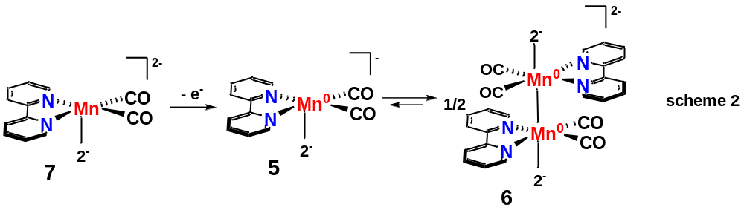
There is a similar peak, albeit at ~ 175 mV higher potentials, in the CV of the parent Mn-Br compound 1 recorded at 25 mV s⁻¹. Based upon analogy with 6, this peak in the CV of the parent compound corresponds to a 1e⁻ oxidation of the anionic monomer [Mn(bpy)(CO)₃]⁻ to give the 17 e⁻ monomer [Mn⁰(bpy)(CO)₃], followed by rapid dimerization to the 18 e⁻ dimer [Mn⁰(bpy)(CO)₃]₂^{14,15}. The difference in potentials between the oxidative waves in the CVs of 7 and [Mn(bpy)(CO)₃]⁻ show that as expected, it is easier to oxidize the dianionic monomer 7 ([Mn(bpy)(CO)₂(2⁻)]²⁻). Reported DFT, spectroscopic, and solid-state studies into the nature of the parent anionic monomer [Mn(bpy)(CO)₃]⁻ and related compounds conclude that there is substantial electron density on the bpy ligand with large amounts of π-donation from the reduced bpy to Mn, as well as from Mn to the CO ligands. The solid-state structure resembles a system with a Mn⁰ centre coordinated to a bpy⁻ ligand. Calculations indicate that the unpaired electrons are spin coupled, and the compound is a singlet¹⁶. Our results show that the 1 e⁻ oxidation of monomer 7 ([Mn(bpy)(CO)₂(2⁻)]²⁻) and the parent monomer [Mn(bpy)(CO)₃]⁻ are both slow, indicating that the overlap between the orbitals on bpy, Mn, and CO, as well as the electron coupling give rise to a kinetic barrier to oxidation. Detailed, extensive investigations are required to provide insight into the origins of this kinetic barrier. Such extensive investigations are beyond the scope of the present study.
The peak corresponding to the net 1 e⁻ oxidation of coordinated reduced Imdye 2⁻ in the dianionic dimer 6 ([(Mn⁰(bpy)(CO)₂(2⁻))₂]²⁻) occurs at -1.48 V in positive going sweep at 100 mV s⁻¹ (peak D in Figure 1 from main manuscript), showing that 2 remained coordinated to Mn during these experiments (scheme 3). As expected, this peak is absent in the CV of the parent compound 1. The peak for the net 1 e⁻ oxidation of the resulting neutral dimer [Mn⁰(bpy)(CO)₂(2)]₂ (8) to give the cationic solvento Mn^{I} complex [Mn¹(bpy)(CO)₂(2)(MeCN)]⁺ occurs at -0.6 V (peak E in Figure 1 from main manuscript), ~200 mV more negative than the corresponding oxidation of [Mn⁰(bpy)(CO)₃]₂ to [Mn¹(bpy)(CO)₃(MeCN)]⁺, indicating the Imdye-containing dimer is easier to oxidize.
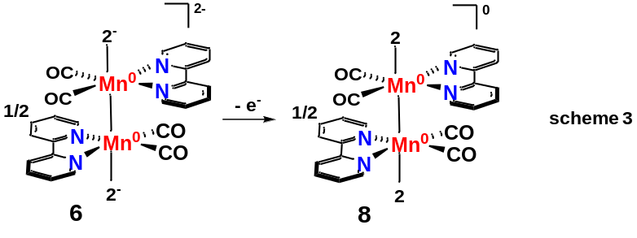

The peaks for the oxidation of the dimers to the cationic MeCN complexes are both greatly diminished in the CVs of 3 and 1 recorded at 25 mV s⁻¹ because diffusion decreased the concentration of the dimers near the electrode surfaces on the timescales of these slow sweep rate experiments.
Supplementary Note 2
UV-vis Spectroelectrochemistry of 1, 2 and 3 under inert atmosphere.
Supplementary Figure S6 (red curve) shows the UV-vis spectrum of the free ligand 2 and the Imdye complex 3 (black curve) in MeCN. The UV-vis spectrum and steady-state photoluminescence spectra of 2 have been investigated with TD-DFT calculations⁹, and as is typical for polycarbazole-dicyanobenzene dyes, the broad absorbance at ~ 400-460 nm consists of overlapping S₀ to S_{1,2,3..} charge transfer excitations from the HOMO, largely comprised of filled π orbitals on the carbazole rings to empty orbitals largely comprised of the π* orbitals on the dicyanobenzene ring. The S₀ to S₁ transition involves excitation from the HOMO to the LUMO and occurs at the longest wavelengths under the broad peak. The UV-vis spectrum of 3 shows that coordination of 2 to Mn appears to blue shift these longest wavelength absorptions. There are Mn-based transitions that also occur at these wavelengths as reported for similar compounds in the literature^{17,18}.
Supplementary Figure S6 b shows the spectra before and after CPE of 2 for 2-4 min at ~ - 1.6 V, the potential for the first 1 e⁻ reduction in the CV of 2 (Supplementary Figure S3). As expected, the charge transfer absorbances in the region 400-460 nm are largely quenched by the presence of an electron in the π* orbitals on the dicyanobenzene ring of 2⁻. There are two new, smaller absorbances at ~ 475 and 565 nm. To our knowledge, this is the first reported UV-vis spectrum of a reduced polycarbazole-dicyanobenzene dye.
a) | b)
Supplementary Figure S6. a) In situ UV-Vis SEC of 2 and 3 in acetonitrile under a nitrogen atmosphere. b) In situ UV-Vis SEC of 2 before and after 2-4 minutes of CPE at -1.6 V. UV-Vis SEC experiments were carried out under N₂ with a Pine Research UV-Vis SEC kit¹⁹.

Supplementary Figure S7 compares the UV-vis spectra of the Imdye 2 (red) and of 3 (black) after CPE at -1.6 V for 2-4 min, forming the proposed dianionic dimer 6 ([(Mn⁰(bpy)(CO)₂(2⁻))₂]²⁻).
a) | b)
Supplementary Figure S7. a) In situ UV-Vis SEC spectra acquired after CPE at -1.6 V for 2-4 minutes with 2 (red) and 3 (black). b) In situ UV-Vis SEC spectra acquired after CPE at different potentials with 3 in acetonitrile under a nitrogen atmosphere. The order of electrolysis was performed as indicated in the image: from resting state to 0 V electrolysis.

The spectrum of 6 contains a peak at ~ 465 nm that is not in the spectrum of [Mn⁰(bpy)(CO)₃]₂ (vide infra) that we assign to coordinated 2⁻. This peak is blue shifted by ~10 nm from the absorption by the free reduced ligand 2⁻. The spectrum of 6 also contains new peaks at 807 and 633 nm. These peaks are in good agreement with peaks in previous studies^{17,20} on the neutral dimer [Mn⁰(bpy)(CO)₃]₂ prepared from the parent Mn-Br complex 1 (Supplementary FigureS8 shows our UV-vis spectra of [Mn⁰(bpy)(CO)₃]₂ prepared in house for direct comparisons), and they provide further strong evidence that the dianionic dimer 6 ([(Mn⁰(bpy)(CO)₂(2⁻))₂]²⁻) forms under these conditions. There is a peak at ~ 575 nm in the visible region of the spectrum of 6 that overlaps with similar peaks in the spectra of free reduced ligand 2⁻ and the parent dimer [Mn⁰(bpy)(CO)₃]₂. Supplementary Figure S7 b (blue curve) shows that CPE at -1.9 V for 2-4 min, the potential where the dimer 6 is reduced to the monomeric dianion 7 ([Mn(bpy)(CO)₂(1⁻)]²⁻) in CV studies, resulted in the disappearance of the absorption peak at ~ 800 nm and the formation of a new broad absorption peak at ~ 560 nm. Broad absorptions in this region are characteristic of 5-coordinate anions like [Mn(bpy)(CO)₃]⁻, and stem from a combination of metal to ligand charge transfer (MLCT) and ligand to ligand charge transfer (LLCT) bands involving the Mn-carbonyl centre and the bpy ligand, according to theoretical and experimental studies carried out by Harlt and collaborators¹⁶ on [Mn(bpy)(CO)₃]⁻. Supplementary Figure S8 shows this feature in the UV vis spectrum of the parent anion [Mn(bpy)(CO)₃]⁻ generated in CPE experiments done in our labs for comparison. The UV-Vis spectra of monomeric dianion 7 ([Mn(bpy)(CO)₂(2⁻)]²⁻) (Supplementary Figure S7) also features the absorption peak in the 450-500 nm region assigned to the coordinated, reduced Imdye 2⁻. This absorption is absent in the UV-vis spectrum of [Mn(bpy)(CO)₃]⁻ (Supplementary Figure S8). Supplementary FigureS7 b also shows the UV-vis spectrum (green curve) after CPE of the solution of the dianion 7 at -1.3 V for 2-4 min (green curve). As determined in our CV experiments, the formation of the neutral Imdye-containing dimer [Mn⁰(bpy)(CO)₃(2)]₂ is expected at this potential. Indeed, the absorption peaks at 807 and 633 nm reappear upon CPE at -1.3 V, whereas the peak at ~ 560 nm, arising from the presence of coordinated 2⁻ are absent. These UV-Vis studies demonstrate that the electronic communication between the ligand 2 and the Mn centre is poor on the timescale of these experiments, as previously seen in our electrochemical experiments. Taken together, these results corroborate our mechanistic interpretation from the electrochemical studies.
Supplementary Figure S8. UV-Vis SEC of MnBr in an acetonitrile solution under nitrogen atmosphere. Peaks at around 800 and 640 nm on the red curve are attributed to the formation of dimeric complex at -1.6 V^{17,18}. The blue curve featuring a broad absorption with centre in 560 nm is characteristic of the formation of five-coordinated [Mn(bpy)(CO)₃]⁻ anion¹⁶. The order of electrolysis was performed as indicated in the image: from resting state to -1.9 V electrolysis.

Supplementary Note 3
Mathematical demonstration that at lower concentrations of [Mn(bpy)(CO)₃Im-dye]⁺, the association (α) of [Mn⁰(bpy)(CO)₃Im-dye⁻]⁻ into the dimeric form [(Mn⁰(bpy)(CO)₃Im-dye⁻)]²⁻ is lower.
After the first reduction of [Mn(bpy)(CO)₃Im-dye]⁺, the following chemical equilibrium takes place:
$${\left[{Mn}^{+}\left(bpy\right){\left(CO\right)}_{3}Im-dye\right]}^{+}+2e →{\left[{Mn}^{0}\left(bpy\right){\left(CO\right)}_{3}{Im-dye}^{-}\right]}^{-}⇌{0.5{\left[{Mn}^{0}\left(bpy\right){\left(CO\right)}_{3}{Im-dye}^{-}\right]}_{2}}^{2-}$$
This dimerization process is spontaneous ($∆G<0$) at room temperature, then $K_{eq}>1$ according to the mathematical relation between $∆G$ and $K_{eq}$. Given $x$ molecules of ${\left[{Mn}^{+}\left(bpy\right){\left(CO\right)}_{3}Im-dye\right]}^{+}$, $x$ molecules of ${\left[{Mn}^{0}\left(bpy\right){\left(CO\right)}_{3}{Im-dye}^{-}\right]}^{-}$ are formed via reduction at the working electrode. Once the equilibrium is stablished, $y$ molecules of ${\left[{Mn}^{0}\left(bpy\right){\left(CO\right)}_{3}{Im-dye}^{-}\right]}^{-}$ are converted to dimeric form. Then:
$$K_{eq}=\frac{{\left(0.5y\right)}^{0.5}}{x-y} \left(eq. 7\right)$$
As the volume of the solution (V) stays constant, if numerator and denominator of (1) are divided by V, then x and y can be expressed as mol/L as well. In this demonstration, $x=0.0001\frac{mol}{L}$ and $x=0.00001\frac{mol}{L}$ will be used as these concentration values were used in our CPE experiments.
For $x=0.0001\frac{mol}{L}$:
$$K_{eq}=\frac{{\left(0.5y\right)}^{0.5}}{0.0001-y} \left(eq. 8\right)$$
$$K_{eq}^{2}y^{2}-\left(0.0002K_{eq}^{2}+0.5\right)y+{1*10}^{-8}K_{eq}^{2}=0 \left(eq. 9\right)$$
For $x=0.00001\frac{mol}{L}$:
$$K_{eq}=\frac{{\left(0.5y\right)}^{0.5}}{0.00001-y} \left(eq. 10\right)$$
$$K_{eq}^{2}y^{2}-\left(0.00002K_{eq}^{2}+0.5\right)y+{1*10}^{-10}K_{eq}^{2}=0 \left(eq. 11\right)$$
From (9):
$${a=K}_{eq}^{2};b=-\left(0.0002K_{eq}^{2}+0.5\right) and c={1*10}^{-8}K_{eq}^{2}$$
Then $b^{2}-4ac$ is positive thus $y$ has 2 different solutions in $R$:
$$y_{+,-}=\frac{{(2*10}^{-4}K_{eq}^{2}+0.5)±\sqrt{{\left({2*10}^{-4}K_{eq}^{2}+0.5\right)}^{2}-4*{10}^{-8}K_{eq}^{4}}}{{2K}_{eq}^{2}} \left(eq. 12\right)$$
Let’s analyze if y(+) and y(-) possess chemically meaningful values. From (12):
$y_{+}=1*{10}^{-4}+\frac{0.5}{2K_{eq}^{2}}+\frac{\sqrt{2*{10}^{-4}K_{eq}^{2}+0.25}}{2K_{eq}^{2}} \left(eq. 13\right)$
All the terms in (13) are positive then $y_{+}>1*{10}^{-4}$. This solution does not a possess chemically meaningful value as the starting concentration of species is already 0.0001 M.
$y_{-}=1*{10}^{-4}+\frac{0.5}{2K_{eq}^{2}}-\frac{\sqrt{2*{10}^{-4}K_{eq}^{2}+0.25}}{2K_{eq}^{2}} \left(eq. 14\right)$
To satisfy $y_{-}<1*{10}^{-4}$, $\sqrt{2*{10}^{-4}K_{eq}^{2}+0.25}$ must be higher that 0.5. Note that this is always true because $2*{10}^{-4}K_{eq}^{2}+0.25$ is always higher than 0.25 for all $K_{eq}>1.$ Therefore $y_{-}$ is a solution with a chemically meaningful value. A similar approach can be used to analyze the solutions for (11), leading to the same results.
From (9) and (11):
$$\frac{y_{-,0.0001M}}{y_{-,0.00001M}}=\frac{{(2*10}^{-4}K_{eq}^{2}+0.5)-\sqrt{2*{10}^{-4}K_{eq}^{2}+0.25}}{{(2*10}^{-5}K_{eq}^{2}+0.5)-\sqrt{2*{10}^{-5}K_{eq}^{2}+0.25}} (eq. 15)$$
Note that ${(2*10}^{-5}K_{eq}^{2}+0.5)$ is closer to 0.5 than ${(2*10}^{-4}K_{eq}^{2}+0.5)$ is. Also, $2*{10}^{-5}K_{eq}^{2}+0.25$ is closer to 0.25 than $2*{10}^{-4}K_{eq}^{2}+0.25$ is. Therefore $\sqrt{2*{10}^{-5}K_{eq}^{2}+0.25}$ is closer to 0.5 than $\sqrt{2*{10}^{-4}K_{eq}^{2}+0.25}$ is. Thus, $y_{-,0.00001M}$ is closer to zero than $y_{-,0.0001M}$ is for all $K_{eq}>1$, so (15) is always higher than 1. As a result, there are more dimer molecules at 0.0001 M that there is at 0.00001 M.
The association (α) is defined as:
$$α=\frac{y}{x} (eq. 16)$$
For $x=0.0001\frac{mol}{L}$:
$$α(0.0001 M)=1+\frac{2500}{K_{eq}^{2}}-\frac{5000}{K_{eq}^{2}}\sqrt{2*{10}^{-4}K_{eq}^{2}+0.25} (eq. 17)$$
For $x=0.00001\frac{mol}{L}$:
$$α(0.00001 M)=1+\frac{25000}{K_{eq}^{2}}-\frac{50000}{K_{eq}^{2}}\sqrt{2*{10}^{-5}K_{eq}^{2}+0.25} (eq. 18)$$
If $\lim_{K_{eq}→∞}{α}$ is determined for both concentration values, their asymptotes with y-axis can be found.
$\lim_{K_{eq}→∞}{α(0.0001 M)}=\lim_{K_{eq}→∞}{1}+\lim_{K_{eq}→∞}{\frac{2500}{K_{eq}^{2}}-\lim_{K_{eq}→∞}{\frac{5000}{K_{eq}^{2}}\sqrt{2*{10}^{-4}K_{eq}^{2}+0.25}}}=1+0+\frac{∞}{∞}$
$$\lim_{K_{eq}→∞}{α(0.0001 M)}=\lim_{K_{eq}→∞}{1}+\lim_{K_{eq}→∞}{\frac{25000}{K_{eq}^{2}}-\lim_{K_{eq}→∞}{\frac{50000}{K_{eq}^{2}}\sqrt{2*{10}^{-5}K_{eq}^{2}+0.25}}}=1+0+\frac{∞}{∞}$$
L’Hospital’s Rule lets us determine the limit of indeterminations like $\frac{∞}{∞}$ as follows:
$$\lim_{x→∞}{\frac{f\left(x\right)}{g\left(x\right)}=\lim_{x→∞}}\frac{f^{'}\left(x\right)}{g^{'}\left(x\right)} (eq. 19)$$
Then both limits are equal to 1, thus $α=1$ is a y-axis asymptote for both concentration values. However, $α(0.0001 M)$ approaches 1 faster that $α(0.00001 M)$ does, as the graph below shows.
$α\left(0.00001 M\right)<α(0.0001 M)$ for values of $K_{eq}>1$, leading to a higher ratio of ${\left[{Mn}^{0}\left(bpy\right){\left(CO\right)}_{3}{Im-dye}^{-}\right]}^{-}/Mn-Imdye$ (${\left[{Mn}^{0}\left(bpy\right){\left(CO\right)}_{3}{Im-dye}^{-}\right]}^{-}$ is the active species for CO₂RR) at lower concentrations of catalyst.

Supplementary Figure S9. Liquid phase FTIR of parent complex MnBr and Mn-Imdye in acetonitrile. Lower CO stretches for MnBr demonstrates higher backbonding effects due to Br⁻ π donation.

Supplementary Figure S10. Quantification of CO generated by bulk reduction of catalyst Mn-Imdye under inert conditions. TON_{CO} close to 1 proves that a CO ligand is released after bulk reduction of the catalyst.

Supplementary Figure S11. CVs of Mn-Imdye (0.55 mM) and the parent complex MnBr (0.55 mM) in a solution of 0.1 M TBAPF₆ in acetonitrile under catalytic conditions at 100 mV/s ([MeOH] = 2.98 M). The different catalytic activities constitute a proof for the presence of chemically different active species upon reduction.

a)
b)
Supplementary Figure S12. a) Catalytic response recorded at 100 mV/s with varying concentration of Mn-Imdye and constant [MeOH] (2.35 M) and [CO₂] (0.28 M). b) Linear fit showing a first order dependence of catalytic current on [Mn-Imdye] at HO electrocatalytic regime. The catalytic current density shown in the image was chosen at E = E_{cat/2} because this E lies in the foot region of the catalytic wave in which complications from ideal voltammograms are minimized. In this region j-cat is proportional to [cat]_{bulk} as follows: $j-cat=\frac{nF{[cat]}_{bulk}{(D_{cat}Fv/RT)}^{0.5}}{1+exp⁡[F/RT(E-E_{cat/2})]}$. The definition of all the terms can be found in section SI.6.

a)
b) | c)
Supplementary Figure S13. a) Linear Sweep Voltammograms of 0.55 mM Mn-Imdye with varying concentration of methanol at HO electrocatalytic regime. Experiments were carried out at a scan rate of 100 mV/s. b) FOWA plots for methanol in the region of concentrations at which k_{obs} varies linearly with [MeOH]² at HO electrocatalytic regime. X-axis has the following form: $\frac{1}{1+\exp\left[nf\left(E-E_{\frac{cat}{2}}\right)\right]}$ (the definition of all the terms can be found on section SI.6) c) Dependence of k_{obs} in [MeOH]² as determined by FOWA (See section SI.6) Data points included in this graph belong to the region at which k_{obs} varies linearly with [MeOH]² as a saturation point is reached at much higher [MeOH]. This behavior indicates second order dependence on [water]. Current density is normalized to account for dilution factors resulted from adding the proton source.

a)
b) | c)
Supplementary Figure S14. a) Linear Sweep Voltammograms of 0.55 mM Mn-Imdye with varying concentration of water at HO electrocatalytic regime. Experiments were carried out at a scan rate of 100 mV/s. b) FOWA plots for water in the region of concentrations at which k_{obs} varies linearly with [water]² at HO electrocatalytic regime. X-axis has the following form: $\frac{1}{1+\exp\left[nf\left(E-E_{\frac{cat}{2}}\right)\right]}$ (the definition of all the terms can be found on section SI.6) c) Dependence of k_{obs} in [water]² as determined by FOWA (See section SI.6). Data points included in this graph belong to the region at which k_{obs} varies linearly with [water]² as a saturation point is reached at much higher [water]. This behavior indicates second order dependence on [water]. Current density is normalized to account for dilution factors resulted from adding the proton source.

a)
b) | c)
Supplementary Figure S15. a) Linear Sweep Voltammograms of 0.55 mM Mn-Imdye, 7.08 M water with varying concentration of CO₂ at HO electrocatalytic regime. Experiments were carried out at a scan rate of 100 mV/s. b) FOWA plots for CO₂ at HO electrocatalytic regime. X-axis has the following form: $\frac{1}{1+\exp\left[nf\left(E-E_{\frac{cat}{2}}\right)\right]}$ (the definition of all the terms can be found on section SI.6) c) Dependence of k_{obs} in [CO₂] as determined by FOWA (See section SI.6). This behavior indicates first order dependence on [CO₂]. Current density is normalized to account for dilution factors resulted from adding the proton source.

a) | b) | c)
Supplementary Figure S16. a) and b) correspond to the FOWA plots for water and deuterated water in the region of concentrations at which kobs varies linearly with [water]² at HO electrocatalytic regime. X-axis on a) and b) has the following form: $\frac{1}{1+\exp\left[nf\left(E-E_{\frac{cat}{2}}\right)\right]}$ (the definition of all the terms can be found on section SI.6 as well as determination of KIE). c) Variation of observed rate constant with [acid]², which demonstrates second order dependence on [water]. CVs were recorded at 100 mV/s with a solution of 0.1 M electrolyte in acetonitrile containing 0.55 mM of Mn-Imdye.

a) | b)
Supplementary Figure S17. a) Catalytic response recorded at LO regimes (25 mV/s) with varying concentration of Mn-Imdye and constant [MeOH] (2.35 M) and [CO₂] (0.28 M). b) Linear fit showing a first order dependence of catalytic current on [Mn-Imdye] at LO electrocatalytic regime. The catalytic current density shown in the image was chosen at E = E_{1/2} because this E lies in the foot region of the catalytic wave in which complications from ideal voltammograms are minimized. In this region j-cat is proportional to [cat]_{bulk} as follows: $j-cat=\frac{nF{[cat]}_{bulk}{(D_{cat}Fv/RT)}^{0.5}}{1+exp⁡[F/RT(E-E_{cat/2})]}$. The definition of all the terms can be found in section SI.6

a)
b) | c)
Supplementary Figure S18. a) Linear Sweep Voltammograms of 0.55 mM Mn-Imdye with varying concentration of methanol at LO electrocatalytic regime. Experiments were carried out at a scan rate of 25 mV/s. b) FOWA plots for methanol in the region of concentrations at which k_{obs} varies linearly with [MeOH]² at LO electrocatalytic regime. X-axis has the following form: $\frac{1}{1+\exp\left[nf\left(E-E_{\frac{cat}{2}}\right)\right]}$ (the definition of all the terms can be found on section SI.6) c) Dependence of k_{obs} in [MeOH]² as determined by FOWA (See section SI.6) Data points included in this graph belong to the region at which k_{obs} varies linearly with [MeOH]² as a saturation point is reached at much higher [MeOH]. This behavior indicates second order dependence on [water]. Current density is normalized to account for dilution factors resulted from adding the proton source.
a)
b) | c)
Supplementary Figure S19. a) Linear Sweep Voltammograms of 0.55 mM Mn-Imdye with varying concentration of water at LO electrocatalytic regime. Experiments were carried out at a scan rate of 25 mV/s. b) FOWA plots for water in the region of concentrations at which k_{obs} varies linearly with [water]² at LO electrocatalytic regime. X-axis has the following form: $\frac{1}{1+\exp\left[nf\left(E-E_{\frac{cat}{2}}\right)\right]}$ (the definition of all the terms can be found on section SI.6) c) Dependence of k_{obs} in [water]² as determined by FOWA (See section SI.6) Data points included in this graph belong to the region at which k_{obs} varies linearly with [water]² as a saturation point is reached at much higher [water]. This behavior indicates second order dependence on [water]. Current density is normalized to account for dilution factors resulted from adding the proton source.

a)
b) | c)
Supplementary Figure S20. a) Linear Sweep Voltammograms of 0.55 mM Mn-Imdye, 7.08 M water with varying concentration of CO₂ at LO electrocatalytic regime. Experiments were carried out at a scan rate of 25 mV/s. b) FOWA plots for CO₂ at LO electrocatalytic regime. X-axis has the following form: $\frac{1}{1+\exp\left[nf\left(E-E_{\frac{cat}{2}}\right)\right]}$ (the definition of all the terms can be found on section SI.6) c) Dependence of k_{obs} in [CO₂] as determined by FOWA (See section SI.6) This behavior indicates first order dependence on [CO₂]. Current density is normalized to account for dilution factors resulted from adding the proton source.

a) | b) | c)
Supplementary Figure S21. a) and b) correspond to the FOWA plots for water and deuterated water in the region of concentrations at which the catalytic current varies linearly with [water] at LO electrocatalytic regime. X-axis on a) and b) has the following form: $\frac{1}{1+\exp\left[nf\left(E-E_{\frac{cat}{2}}\right)\right]}$ (the definition of all the terms can be found on section SI.6 as well as determination of KIE). c) Variation of observed rate constant with [acid]², which demonstrates second order dependence on [water]. CVs were recorded at 25 mV/s with a solution of 0.1 M electrolyte in acetonitrile containing 0.55 mM of Mn-Imdye.

a)
b)
Supplementary Figure S22. CPE curves from entries 1 and 2 (a and b, respectively) of Table 1 from main manuscript.

a)
b)
Supplementary Figure S23. Charge generated from entries 1 and 2 (a and b, respectively) of Table 1 from main manuscript.

Supplementary Figure S24. Moles of CO and Hydrogen generated in CPE experiments from Table 1 main manuscript (top: entry 1, bottom: entry 2).

Characterization data.
NMR Spectra
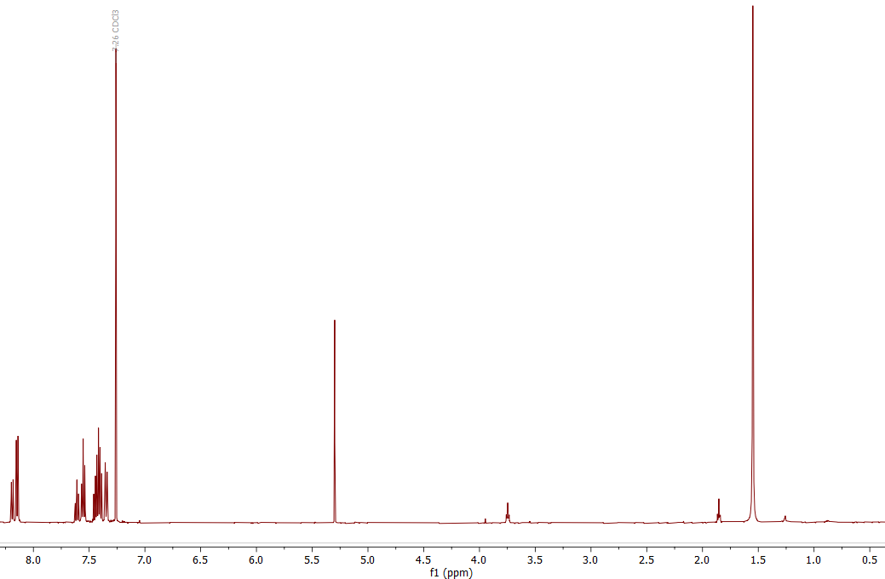
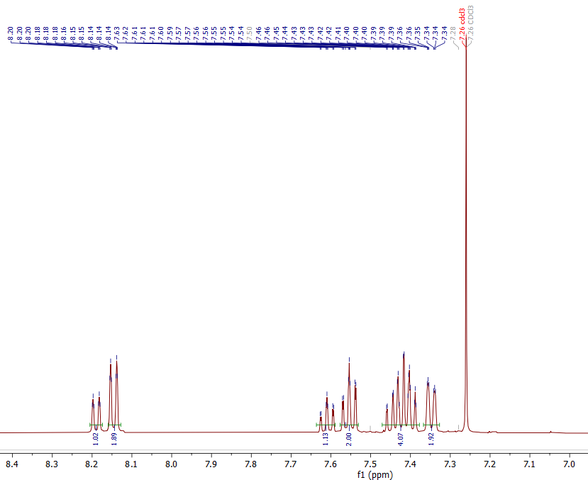
Supplementary Figure S25. ¹H NMR spectra (full and zoomed in) of 3CzFIPN in CDCl₃

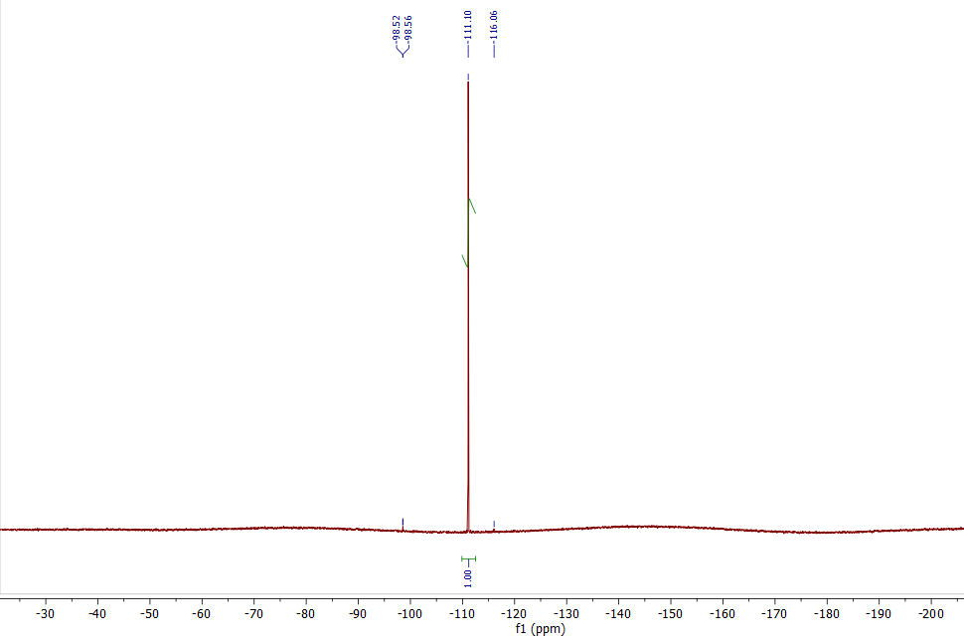
Supplementary Figure S26. ¹⁹F NMR spectra of 3CzFIPN in CDCl₃

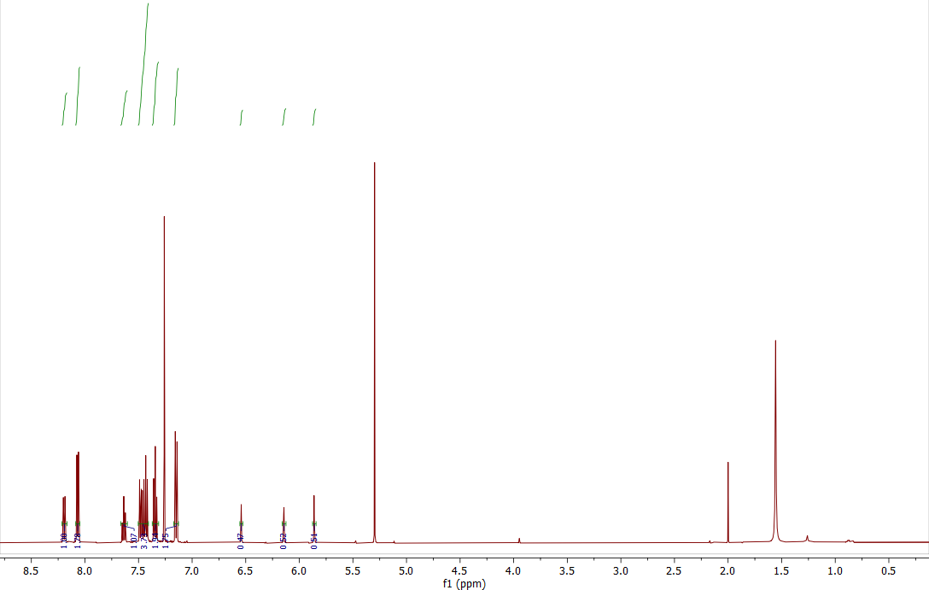
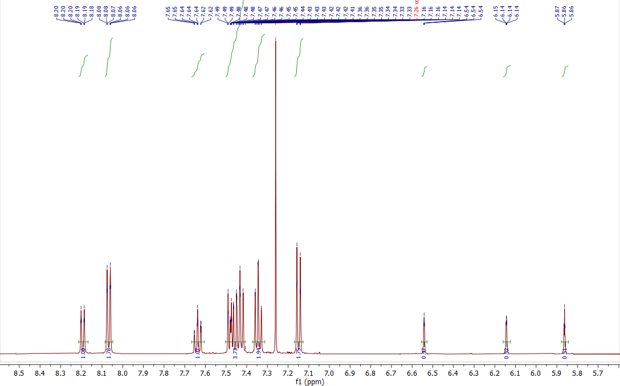
Supplementary Figure S27. ¹H NMR spectra (full and zoomed in) of Imdye in CDCl₃

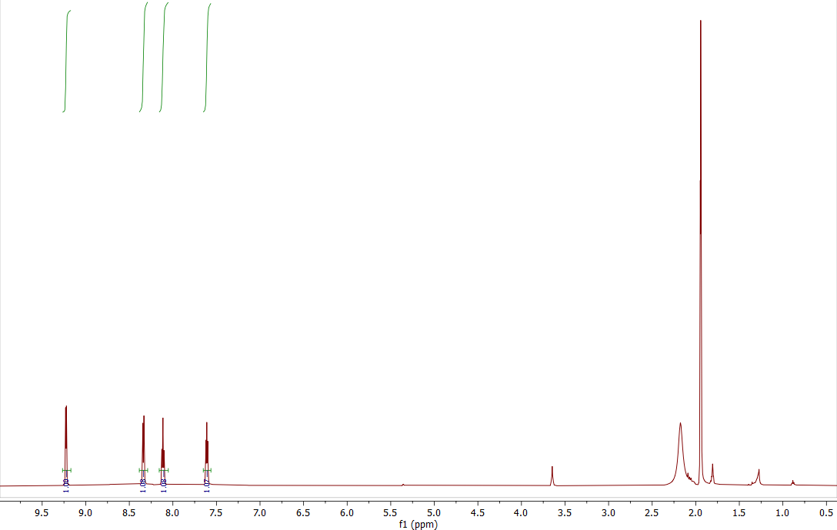
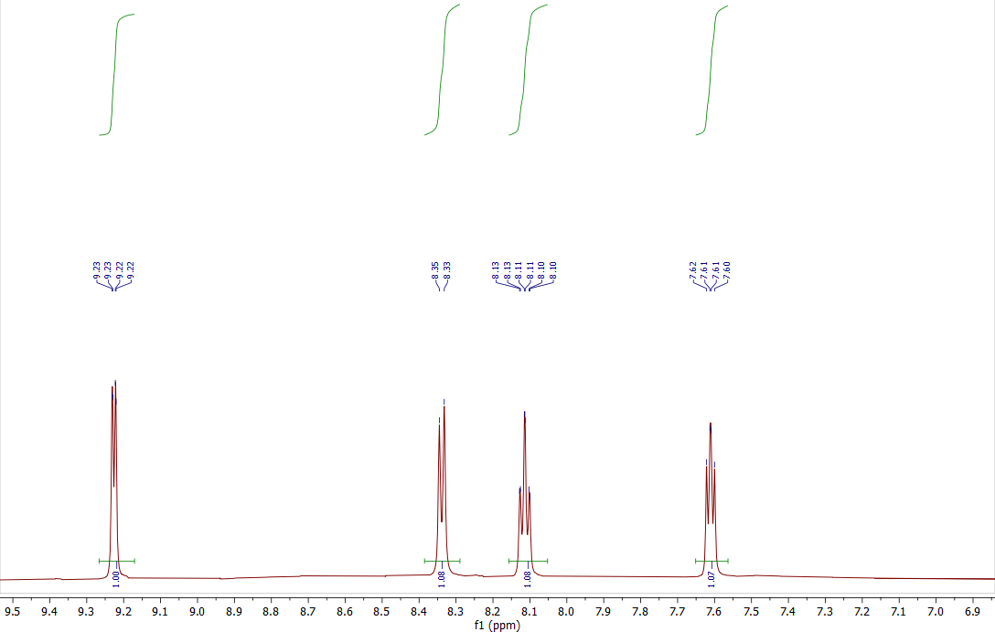
Supplementary Figure S28. ¹H NMR spectra (full and zoomed in) of Mn(bpy)(CO)₃Br in CD₃CN

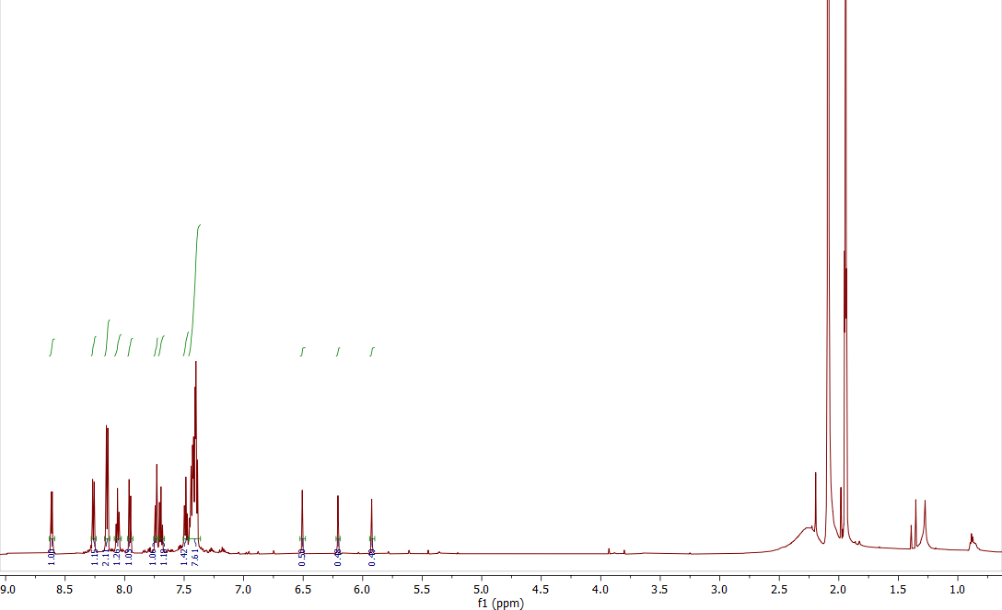
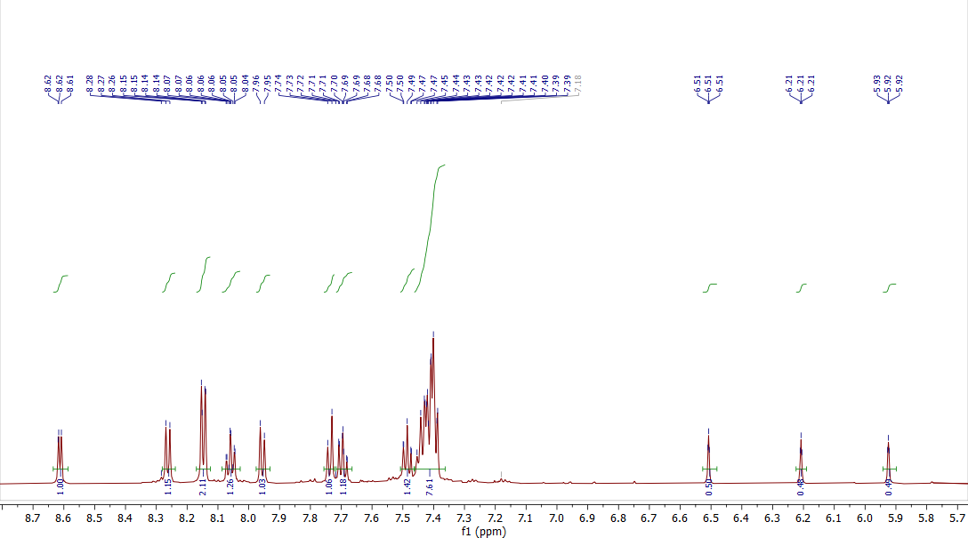
Supplementary Figure S29. ¹H NMR spectra (full and zoomed in) of [Mn(bpy)(CO)₃(Imdye)]BF₄ in CD₃CN

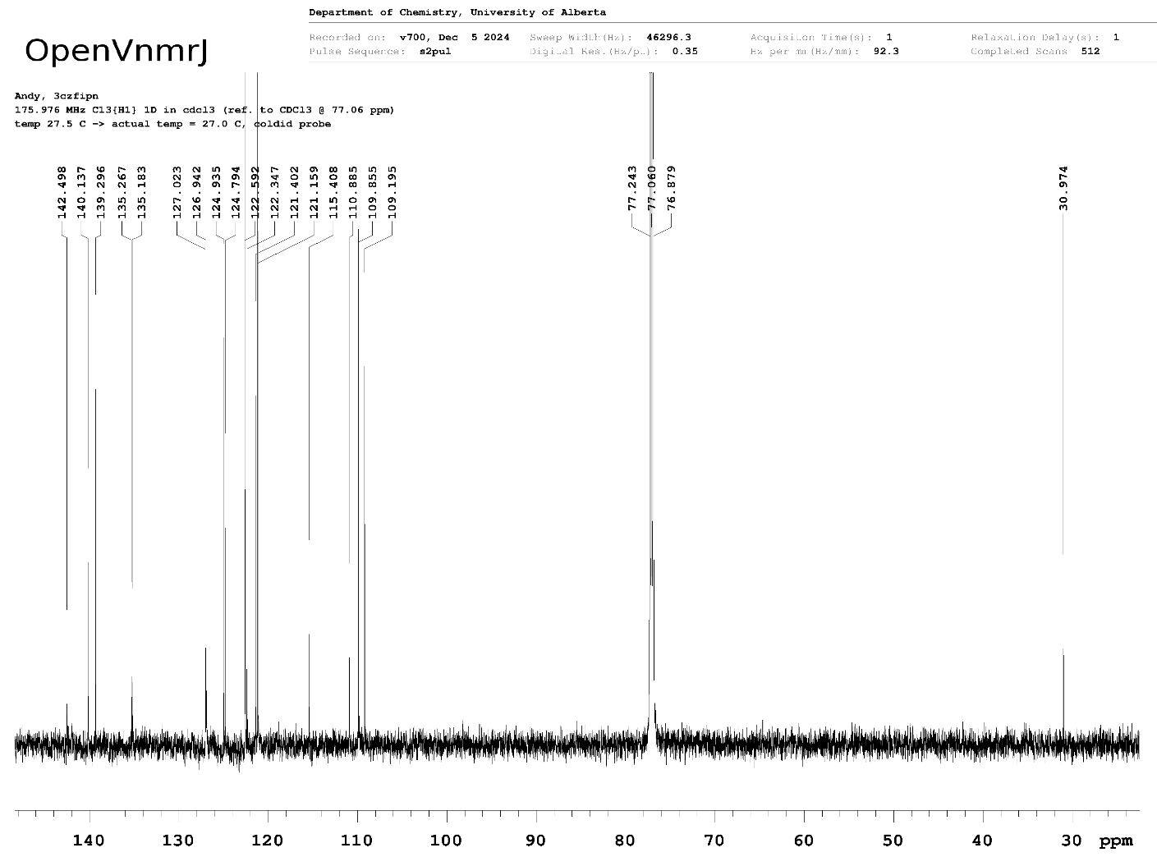
Supplementary Figure S30. ¹³C{¹H} NMR spectra of 3CzFIPN in CDCl₃

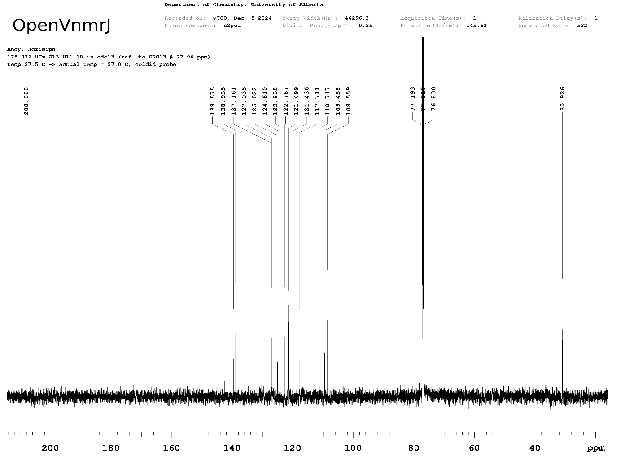
Supplementary Figure S31. ¹³C{¹H} NMR spectra of Imdye in CDCl₃

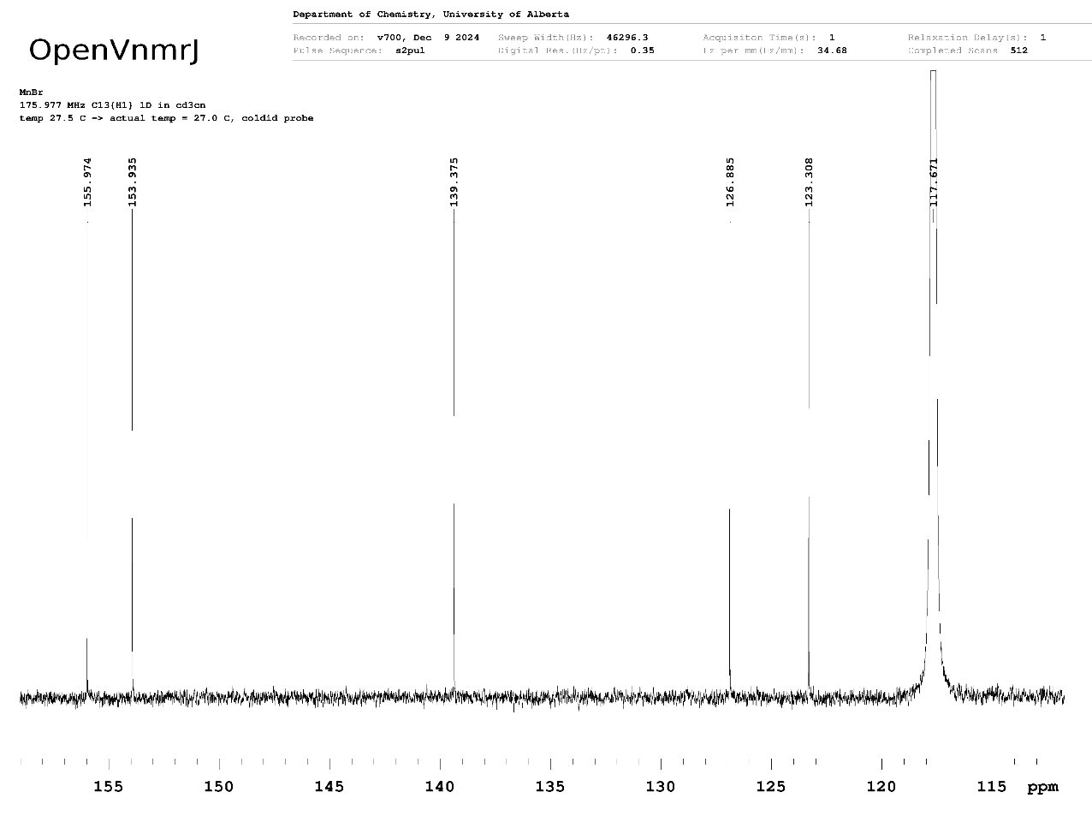
Supplementary Figure S32. ¹³C{¹H} NMR spectra of Mn(bpy)(CO)₃Br in CD₃CN

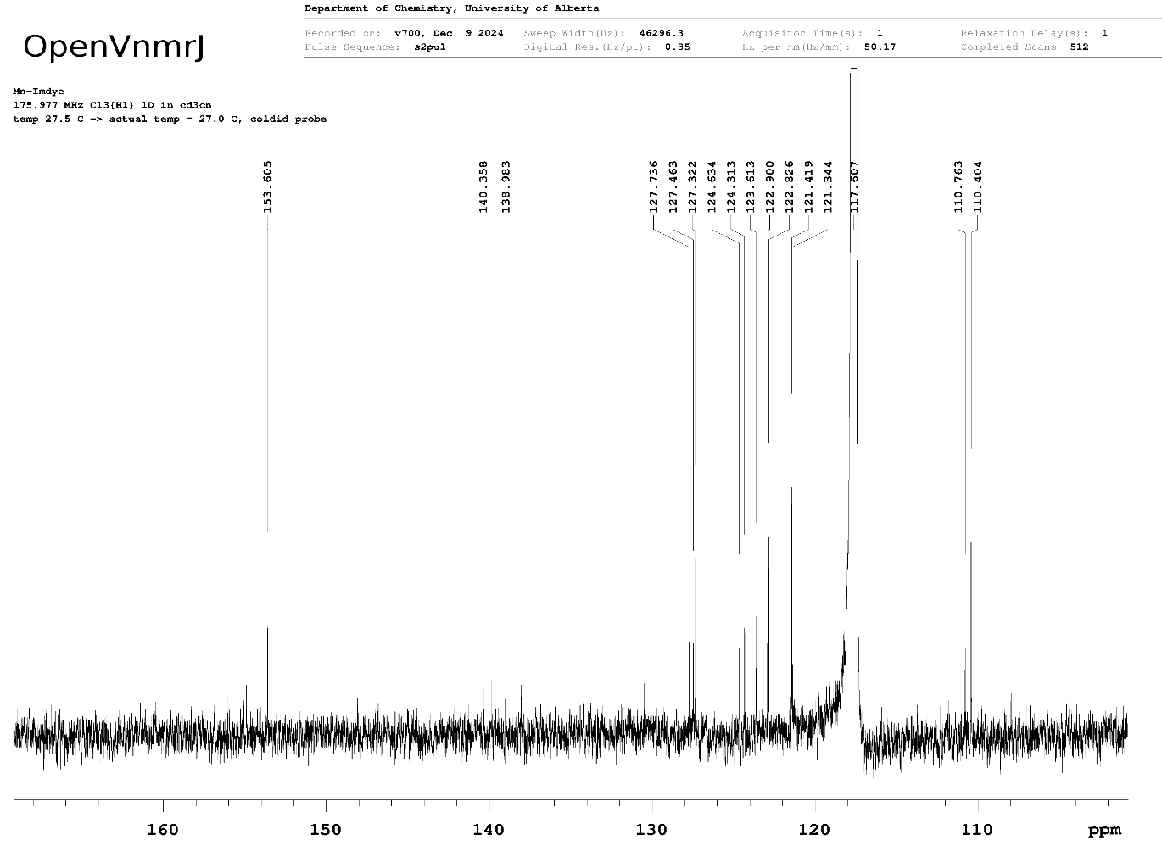
Supplementary Figure S32. ¹³C{¹H} NMR spectra of [Mn(bpy)(CO)₃(Imdye)]BF₄ in CD₃CN

Supplementary References
(1) Rountree, E. S.; McCarthy, B. D.; Eisenhart, T. T.; Dempsey, J. L. Evaluation of Homogeneous Electrocatalysts by Cyclic Voltammetry. Inorg. Chem. 2014, 53 (19), 9983–10002. https://doi.org/10.1021/ic500658x.
(2) Lee, K. J.; Elgrishi, N.; Kandemir, B.; Dempsey, J. L. Electrochemical and Spectroscopic Methods for Evaluating Molecular Electrocatalysts. Nat Rev Chem 2017, 1 (5), 1–14. https://doi.org/10.1038/s41570-017-0039.
(3) Costentin, C.; Savéant, J.-M. Multielectron, Multistep Molecular Catalysis of Electrochemical Reactions: Benchmarking of Homogeneous Catalysts. ChemElectroChem 2014, 1 (7), 1226–1236. https://doi.org/10.1002/celc.201300263.
(4) Wasylenko, D. J.; Rodríguez, C.; Pegis, M. L.; Mayer, J. M. Direct Comparison of Electrochemical and Spectrochemical Kinetics for Catalytic Oxygen Reduction. J. Am. Chem. Soc. 2014, 136 (36), 12544–12547. https://doi.org/10.1021/ja505667t.
(5) Turnover Numbers, Turnover Frequencies, and Overpotential in Molecular Catalysis of Electrochemical Reactions. Cyclic Voltammetry and Preparative-Scale Electrolysis | Journal of the American Chemical Society. https://pubs.acs.org/doi/full/10.1021/ja303560c (accessed 2023-01-26).
(6) Costentin, C.; Drouet, S.; Robert, M.; Savéant, J.-M. A Local Proton Source Enhances CO2 Electroreduction to CO by a Molecular Fe Catalyst. Science 2012, 338 (6103), 90–94. https://doi.org/10.1126/science.1224581.
(7) Pavlishchuk, V. V.; Addison, A. W. Conversion Constants for Redox Potentials Measured versus Different Reference Electrodes in Acetonitrile Solutions at 25°C. Inorganica Chimica Acta 2000, 298 (1), 97–102. https://doi.org/10.1016/S0020-1693(99)00407-7.
(8) Sundberg, R. J.; Bryan, R. F.; Taylor, I. F. Jr.; Taube, H. Nitrogen-Bound and Carbon-Bound Imidazole Complexes of Ruthenium Ammines. J. Am. Chem. Soc. 1974, 96 (2), 381–392. https://doi.org/10.1021/ja00809a011.
(9) Liu, J.; Perez, O. M.; Lavergne, D.; Rasu, L.; Murphy, E.; Galvez-Rodriguez, A.; Bergens, S. H. One-Step Electropolymerization of a Dicyanobenzene-Carbazole-Imidazole Dye to Prepare Photoactive Redox Polymer Films. Polymers 2023, 15 (16), 3340. https://doi.org/10.3390/polym15163340.
(10) Kurtz, D. A.; Dhakal, B.; McDonald, L. T.; Nichol, G. S.; Felton, G. A. N. Inter-Ligand Intramolecular through-Space Anisotropic Shielding in a Series of Manganese Carbonyl Phosphorous Compounds. Dalton Trans. 2019, 48 (39), 14926–14935. https://doi.org/10.1039/C9DT03100F.
(11) Neri, G.; M. Donaldson, P.; J. Cowan, A. In Situ Study of the Low Overpotential “Dimer Pathway” for Electrocatalytic Carbon Dioxide Reduction by Manganese Carbonyl Complexes. Physical Chemistry Chemical Physics 2019, 21 (14), 7389–7397. https://doi.org/10.1039/C9CP00504H.
(12) Gonell, S.; Massey, M. D.; Moseley, I. P.; Schauer, C. K.; Muckerman, J. T.; Miller, A. J. M. The Trans Effect in Electrocatalytic CO2 Reduction: Mechanistic Studies of Asymmetric Ruthenium Pyridyl-Carbene Catalysts. J. Am. Chem. Soc. 2019, 141 (16), 6658–6671. https://doi.org/10.1021/jacs.9b01735.
(13) Kuo, H.-Y.; Tignor, S. E.; Lee, T. S.; Ni, D.; Park, J. E.; Scholes, G. D.; Bocarsly, A. B. Reduction-Induced CO Dissociation by a [Mn(Bpy)(CO)4][SbF6] Complex and Its Relevance in Electrocatalytic CO2 Reduction. Dalton Trans. 2020, 49 (3), 891–900. https://doi.org/10.1039/C9DT04150H.
(14) Machan, C. W.; Sampson, M. D.; Chabolla, S. A.; Dang, T.; Kubiak, C. P. Developing a Mechanistic Understanding of Molecular Electrocatalysts for CO2 Reduction Using Infrared Spectroelectrochemistry. Organometallics 2014, 33 (18), 4550–4559. https://doi.org/10.1021/om500044a.
(15) Bhattacharya, M.; Sebghati, S.; VanderLinden, R. T.; Saouma, C. T. Toward Combined Carbon Capture and Recycling: Addition of an Amine Alters Product Selectivity from CO to Formic Acid in Manganese Catalyzed Reduction of CO2. J. Am. Chem. Soc. 2020, 142 (41), 17589–17597. https://doi.org/10.1021/jacs.0c07763.
(16) Hartl, F.; Rosa, P.; Ricard, L.; Le Floch, P.; Záliš, S. Electronic Transitions and Bonding Properties in a Series of Five-Coordinate “16-Electron” Complexes [Mn(CO)3(L2)]− (L2 = Chelating Redox-Active π-Donor Ligand). Coordination Chemistry Reviews 2007, 251 (3), 557–576. https://doi.org/10.1016/j.ccr.2006.09.003.
(17) Bourrez, M.; Molton, F.; Chardon-Noblat, S.; Deronzier, A. [Mn(Bipyridyl)(CO)3Br]: An Abundant Metal Carbonyl Complex as Efficient Electrocatalyst for CO2 Reduction. Angewandte Chemie International Edition 2011, 50 (42), 9903–9906. https://doi.org/10.1002/anie.201103616.
(18) Singh, K. K.; Gerke, C. S.; Saund, S. S.; Zito, A. M.; Siegler, M. A.; Thoi, V. S. CO2 Activation with Manganese Tricarbonyl Complexes through an H-Atom Responsive Benzimidazole Ligand. Chemistry – A European Journal 2023, 29 (58), e202300796. https://doi.org/10.1002/chem.202300796.
(19) Shova, S.; Vlad, A.; Cazacu, M.; Krzystek, J.; Ozarowski, A.; Malček, M.; Bucinsky, L.; Rapta, P.; Cano, J.; Telser, J.; Arion, V. B. Dinuclear Manganese(III) Complexes with Bioinspired Coordination and Variable Linkers Showing Weak Exchange Effects: A Synthetic, Structural, Spectroscopic and Computation Study. Dalton Trans. 2019, 48 (18), 5909–5922. https://doi.org/10.1039/C8DT04596H.
(20) Franco, F.; Cometto, C.; Nencini, L.; Barolo, C.; Sordello, F.; Minero, C.; Fiedler, J.; Robert, M.; Gobetto, R.; Nervi, C. Local Proton Source in Electrocatalytic CO2 Reduction with [Mn(Bpy–R)(CO)3Br] Complexes. Chemistry – A European Journal 2017, 23 (20), 4782–4793. https://doi.org/10.1002/chem.201605546.

