Supporting Information

High-Throughput Machine Learning and Experimental Validation Unveils Giant Responsivity for Extreme Ultraviolet Detectors
R. A. W. Ayyubi^{1,9}, Mei Xian Low², Salar Salimi³, Majid Khorsandi^{3,9}, M. Mosarof Hossain⁴, Hurriyat Arooj^{1,5}, Shoaib Masood¹, M. Husnain Zeb⁶, Nasir Mahmood⁷, Qiaoliang Bao⁸, Sumeet Walia², Babar Shabbir ^{7, 9}*

¹Department of Physics, University of Illinois at Chicago, Chicago, Illinois 60607, USA
²School of Engineering, RMIT University, Melbourne, Victoria 3001, Australia
³Radiation Application Department, Shahid Beheshti University, Tehran, 1983969411, Iran
⁴Department of Material Science and Engineering, Monash University, Clayton, Victoria, 3800 Australia
⁵Department of Physics and Applied Mathematics, Pakistan Institute of Engineering and Applied Sciences, Islamabad 45650, Pakistan
⁶Department of Electrical and Computer Engineering, Concordia University, 1455 Boul. de Maisonneuve Ouest, Montréal, Quebec, H3G 1M8 Canada
⁷School of Science, RMIT University, Victoria 3001, Australia
⁸Institute of Energy Materials Science (IEMS), University of Shanghai for Science and Technology, Shanghai, 200093 China
⁹Department of Nuclear, Plasma and Radiological Engineering, University of Illinois at Urbana–Champaign, Urbana, IL 61801 USA
*Corresponding address: Dr. Babar Shabbir (babar.shabbir@rmit.edu.au)

SECTION A: Machine Learning-Enhanced Modeling for Material Prediction and Optimization of α-MoO₃ Characteristics

i. | Workflow for Training and Testing Machine Learning Models for Predictive Analysis | 3
ii | Training Data Set | 4
iii. | Feature Selection Using Pearson Correlation Coefficient and Correlation Heatmap Analysis | 5
iv. | Comparative Analysis of Machine Learning Models for Prediction and Performance Evaluation | 7
v. | Optimization of Device Thickness for Enhanced α-MoO₃ Responsivity at 13.5 nm | 12
vi. | Factors Contributing to Discrepancies Between Predicted and Experimental Values | 12
SECTION B: Characterization of the α-MoO₃ Device

i. | Attenuation Characteristics in EUV Range | 14
ii. | Characteristics of α-MoO₃ based detector | 15
iii. | Performance of α-MoO₃ based detector | 16
iv. | Detectivity and EQE of α-MoO₃ based detector | 18
SECTION C: Characterization of the ReS₂ Device

i. | Attenuation Characteristics and Responsivity of ReS₂ in EUV Range | 21
References 23

SECTION A: Machine Learning-Enhanced Modeling for Material Prediction and Optimization of α-MoO₃ Characteristics
- Workflow for Training and Testing Machine Learning Models for Predictive Analysis
Figure S1 illustrates the comprehensive workflow for machine learning-based analysis, encompassing four key stages: Data Aggregation, Feature Engineering, Model Appraisal, and Model Application. The process begins with data aggregation from experiments, theoretical studies, publications, and data repositories such as Materials Project API. This is followed by feature engineering, which involves dimensionality reduction, combination, and iterative refinement to ensure a robust representation of the dataset. The next phase, model appraisal, focuses on algorithm selection, optimization, and validation to identify the most effective predictive model. Finally, the selected model is deployed for inference and outcome generation in the model application phase, ensuring practical utility and integration into real-world scenarios.
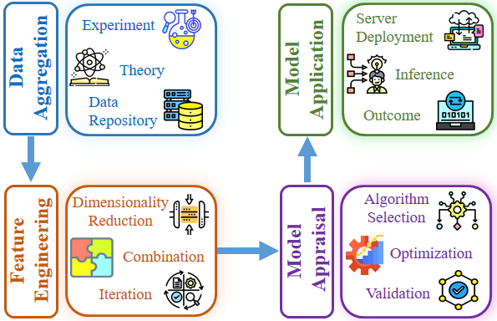
Figure S1: Schematic representation of the four main stages in the model development process: Each step outlines critical actions and transformations essential to enhance model accuracy and predictive capabilities.

- Training Data Set
The dataset used in this study consists of 1385 samples, each characterized by 16 distinct input features and a target variable, responsivity, primarily aggregated from 22 experimental research articles centered on the fabrication of photodetectors.^{[1–20]} Additional features were sourced from the periodic table, the Materials Project database, the NIST database, and theoretical studies.^{[21–28]} This dataset encapsulates comprehensive information on both the active layer and substrate materials for each fabricated photodetector, encompassing the feature attributes listed in Table S1.
Table S1. Names, detailed descriptions, and sources of features used for responsivity prediction. Features marked with an asterisk (*) were excluded following correlation analysis.
Feature Number | Feature Name | Feature Description | Source
1 | AL(Z) | The summation of atomic numbers for all constituent elements within a single formula unit of the material (active layer) | Periodic Table
2 | Avg_Z | AL(Z) divided by the total number of atoms present in a single formula unit of the material (active layer) | Periodic Table
3 | AL(Z_sq)* | Square of AL(Z) | Periodic Table
4 | AL(A)* | The summation of atomic masses for all constituent elements within a single formula unit of the material (active layer) | Periodic Table
5 | AL_Mob(cm^2/Vs) | The experimental mobility of the active layer expressed in units of $cm^{2}/Vs$ | Publications
6 | AL_Den(g/cm^3) | The density of the active layer expressed in units of $g/cm^{3}$ | Materials Project
7 | Avg_Val_e | The sum of valence electrons for all constituent elements in a single formula unit of the material (active layer), divided by the total number of atoms in that formula unit. | Periodic Table
8 | AL_Eg(eV) | Experimental band gap of the active layer measured in units of eV | Publications
9 | AL_Th_Eg(eV) | Theoretical band gap of the active layer measured in units of eV | Publications/Materials Project
10 | S_Eg(eV) | Experimental band gap of the substrate measured in units of eV | Publications
11 | S_Th_Eg(eV)* | Theoretical bandgap of the substrate measured in units of eV | Materials Project
12 | Thickness(nm) | Thickness of the active layer measured in units of nm | Tunable Parameter
13 | E(eV)* | The energy of the incident radiation on the active layer, measured in units of electron volts (eV) | Tunable Parameter
14 | Wave_L(nm) | The wavelength of the incident radiation on the active layer, measured in units of nanometers (nm) | Tunable Parameter
15 | P_Int(um/cm2) | The power intensity of the incident radiation on the active layer, measured in units of $μm/cm^{2}$ | Tunable Parameter
16 | Bias | The bias voltage applied across the device, measured in units of volts | Tunable Parameter
17 | Res(A/W)  (Target Variable) | Experimental responsivity of the active layer measured in units of A/W | Publications

- Feature Selection Using Pearson Correlation Coefficient and Correlation Heatmap Analysis
The Pearson correlation coefficient is a widely used statistical measure for feature selection in machine learning and statistical analysis. It quantifies the strength and direction of the linear relationship between two variables, typically represented by X (independent variable or feature) and Y (dependent variable or target). In the context of feature selection, the objective is to identify features that demonstrate a significant correlation with the target variable, while simultaneously minimizing inter-feature correlation to reduce redundancy. This approach is advantageous because:
- It assesses how strongly each feature is linearly associated with the target variable.
- It identifies pairs of features with high correlation, which may indicate multicollinearity and redundancy, thereby helping to streamline the feature set by removing less informative features.
The Pearson correlation coefficient, $r_{X},_{Y}$, between two variables X and Y is defined as:
$$r_{X},_{Y}=\frac{\sum_{i=1}^{n}{(X_{i}-\overline{X})(Y_{i}-\overline{Y})}}{\sqrt{\sum_{i=1}^{n}{{\left(X_{i}-\overline{X}\right)}^{2}}}.\sqrt{\sum_{i=1}^{n}{{\left(Y_{i}-\overline{Y}\right)}^{2}}}}$$
Where $X_{i}$ and $Y_{i}$​ represent individual sample values for $X$ and $Y$, respectively; $\overline{X}$ and $\overline{Y}$ are the mean values of $X$and $Y$; and $n$ is the number of observations.
A threshold of $\left|r\right|>0.9$ was applied to exclude features exhibiting high inter-feature correlation, as such correlations suggest overlapping information that can introduce multicollinearity. The correlation coefficients of all features, both with one another and with the target variable (responsivity), are displayed in the correlation heatmap matrix shown in Figure S1. Following the application of the threshold, features demonstrating a strong correlation with the target variable (responsivity) and low inter-feature correlation were retained, as illustrated in Figure S2.
Retaining features that are highly correlated with the target variable while maintaining low inter-feature correlations enhances the diversity of predictive information integrated into the machine learning models, thereby improving model robustness and interpretability.

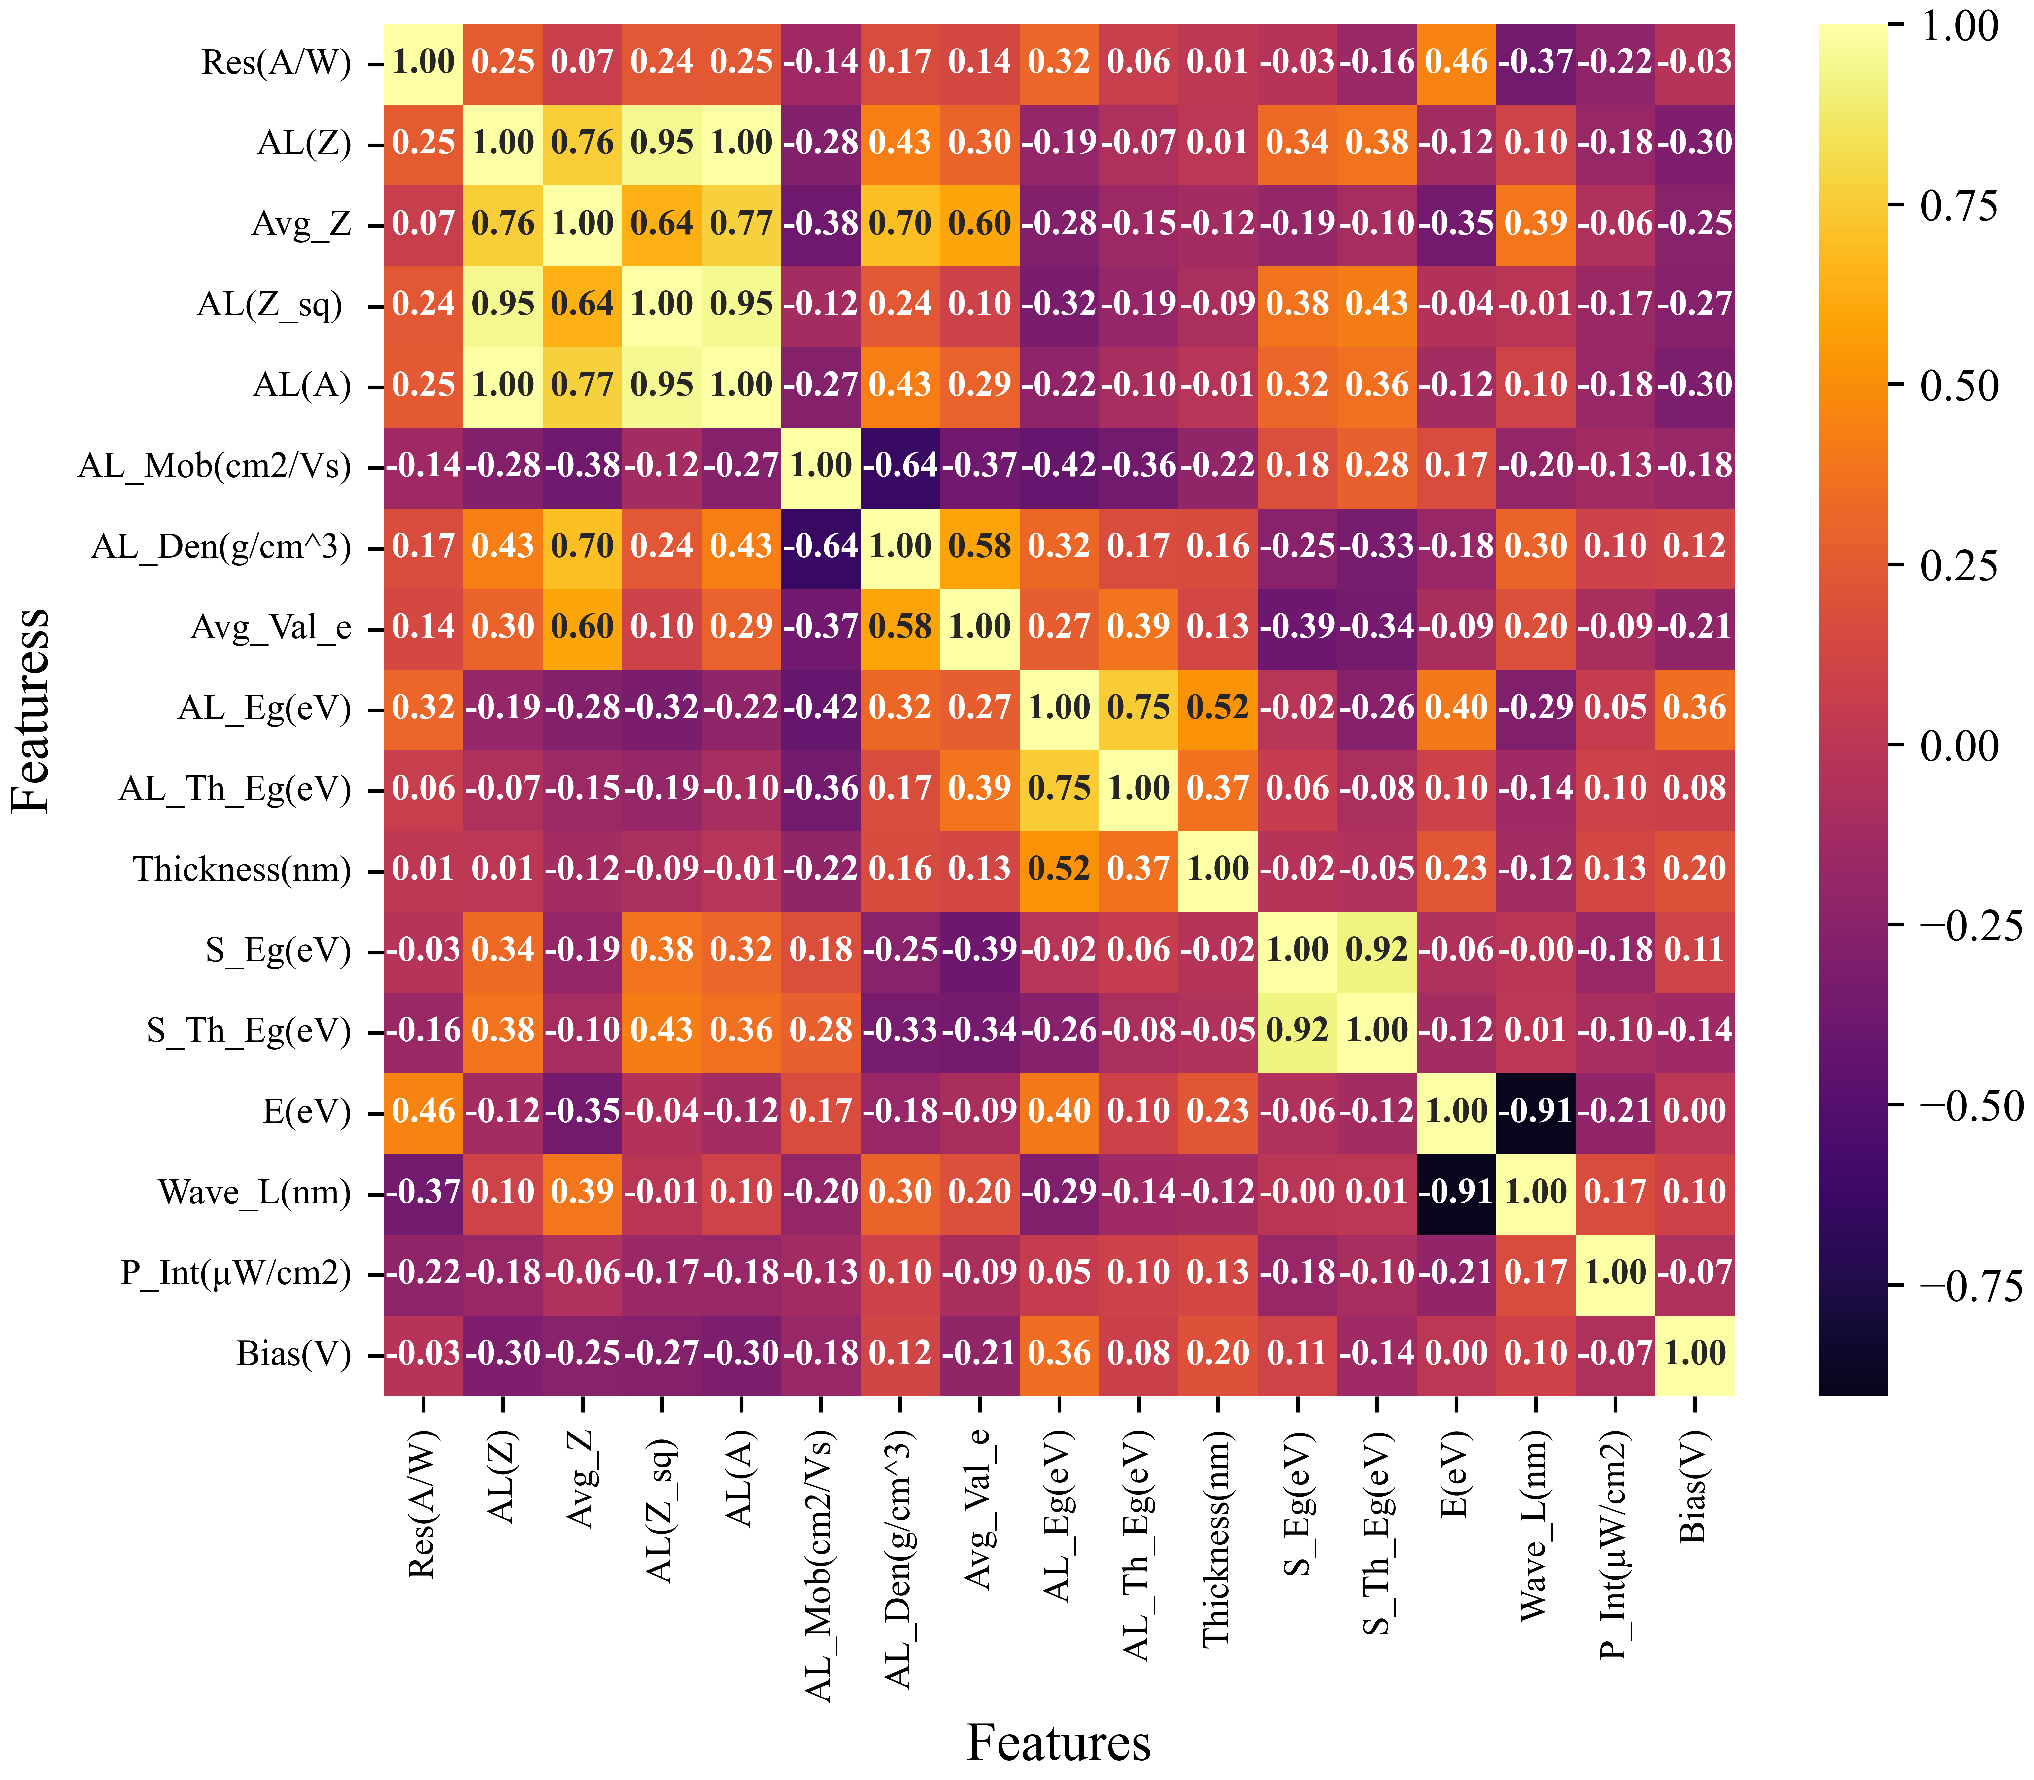
Figure S2: Correlation heatmap matrix before correlation analysis: Depicting the correlations of all initial features with each other and with the target variable, responsivity (A/W), before the removal of redundant features.

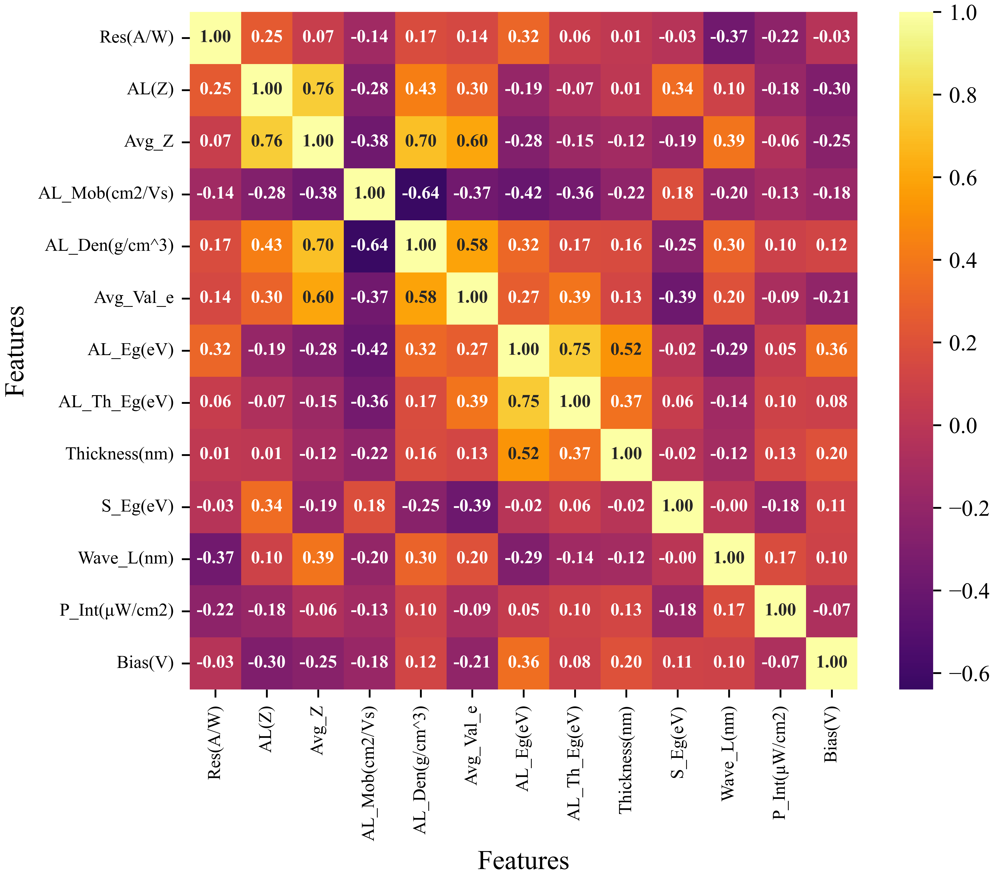
Figure S3: Correlation heatmap matrix after correlation analysis: Displaying the top-performing features for predicting the target variable, responsivity (A/W), after excluding redundant features. A Pearson correlation coefficient threshold of ±0.9 is applied for feature selection and to optimize model performance.

- Comparative Analysis of Machine Learning Models for Prediction and Performance Evaluation
Machine Learning Models:
We applied the following seven machine learning regression models in our study, with brief descriptions provided below.
1-Extra Trees: Extra Trees is an ensemble learning technique that constructs multiple decision trees in a highly randomized manner. Unlike Random Forests, Extra Trees selects cut points at random and uses the
entire dataset (rather than bootstrap samples) for training. This approach can lead to reduced variance and often results in a faster training process.
2-SGBoost (Stochastic Gradient Boosting): SGBoost is a variation of gradient boosting that incorporates stochastic elements by randomly subsampling the data before training each base learner. This stochastic approach helps in reducing overfitting and can lead to better generalization, especially in large and complex datasets. It balances the bias-variance tradeoff more effectively than standard gradient boosting.
3-Random Forest Regression: Random Forest Regression is an ensemble learning method that builds multiple decision trees during training and outputs the mean prediction of the individual trees. It reduces overfitting by averaging multiple decision trees trained on various subsets of the data, thereby enhancing prediction accuracy and robustness.
4-CatBoost: CatBoost is a gradient boosting algorithm that handles categorical features natively and efficiently without requiring extensive preprocessing. It is designed to be less prone to overfitting and provides high accuracy and speed, particularly in datasets with categorical variables. CatBoost's key innovations include ordered boosting and categorical feature support, making it competitive with other gradient boosting methods.
5-Decision Trees: A Decision Tree is a non-parametric supervised learning method used for classification and regression. It splits the data into subsets based on the most significant attribute at each node, forming a tree structure. The goal is to create a model that predicts the value of a target variable by learning simple decision rules inferred from the data features.
6-XGBoost (Extreme Gradient Boosting): XGBoost is an advanced implementation of gradient boosting that is designed to be highly efficient, flexible, and portable. It utilizes decision trees as base learners and iteratively improves predictions by minimizing a loss function. XGBoost includes optimizations such as regularization and parallel processing, which make it faster and more accurate compared to traditional gradient boosting methods.
7-LightGBM (Light Gradient Boosting Machine): LightGBM is a gradient boosting framework that uses tree-based learning algorithms, optimized for speed and memory efficiency. It achieves faster training times and lower memory usage by using a leaf-wise tree growth strategy and histogram-based decision trees. LightGBM is particularly well-suited for large datasets and can handle large numbers of features with high accuracy.
Each model was trained and evaluated on the dataset using standard regression metrics like Mean Squared Error (MSE), Mean Absolute Error (MAE), and R² Score. Additionally, cross-validation was performed to assess the models’ generalization performance. Feature standard scaling was also applied to meet the specific requirements of each model. Model sensitivity analysis was conducted to identify the most influential features in the models’ predictions. These regression algorithms provide a comprehensive exploration of different modeling techniques, aiming to identify the most accurate and reliable approach to predict photodetector responsivity effectively.

Table S2: Comparative performance analysis of seven machine learning regression models based on performance metrics including Root Mean Squared Error (RMSE), Mean Absolute Error (MAE), and Coefficient of Determination (R²) values for both training and testing data sets, providing a comprehensive assessment of each model. Furthermore, the predicted responsivity (A/W) values generated by all seven models for a 168 nm thick α-MoO₃ active layer device in the EUV region (at 13.5 nm or 91.85 eV), operating under a 1 mV bias voltage, are displayed in the rightmost column.

Method | Training RMSE | Training MAE | Training R² | Test RMSE | Test MAE | Test R²
Extra Trees | $$4.80×{10}^{-13}$$ | $$1.87×{10}^{-13}$$ | 1.0000 | 0.4880 | 0.1183 | 0.9998
SGBoost | $$1.80×{10}^{-3}$$ | $$1.27×{10}^{-3}$$ | 1.0000 | 1.1185 | 0.4092 | 0.9993
Random Forest | $$0.92$$ | $$0.25$$ | 0.9995 | 1.1835 | 0.4292 | 0.9974
Decision Tree | $$8.62×{10}^{-2}$$ | $$2.00×{10}^{-2}$$ | 0.9999 | 1.7130 | 0.6963 | 0.9984
CatBoost | $$0.72$$ | $$0.39$$ | 0.9997 | 1.8563 | 0.8550 | 0.9982
XGBoost | $$1.32$$ | $$0.49$$ | 0.9991 | 2.3174 | 0.8759 | 0.9972
LightGBM | $$4.37$$ | $$1.21$$ | 0.9907 | 5.6350 | 1.8993 | 0.9834

Figure S4: The comparative performance of various machine learning models: presented in descending order based on performance and illustrated through plots of actual (experimental) versus predicted responsivity for previously unseen data, alongside the respective feature importances of each model. (a) and (b) depict the SGBoost regression model, (c) and (d) illustrate the Random Forest model, and (e) and (f) show the Decision tree model. Insets detail the associated performance metrics, including Root Mean Squared Error (RMSE), Mean Absolute Error (MAE), and R² values, providing a comprehensive assessment of each model's predictive efficacy.

Figure S5: The comparative performance of various machine learning models: presented in descending order based on performance and illustrated through plots of actual (experimental) versus predicted responsivity for previously unseen data, alongside the respective feature importances of each model. (a) and (b) depict the CatBoost model, (c) and (d) illustrate the XGBoost model, and (e) and (f) show the LightGBM regression model. Insets detail the associated performance metrics, including Root Mean Squared Error (RMSE), Mean Absolute Error (MAE), and R² values, providing a comprehensive assessment of each model's predictive efficacy.

- Optimization of Device Thickness for Enhanced α-MoO₃ Responsivity at 13.5 nm
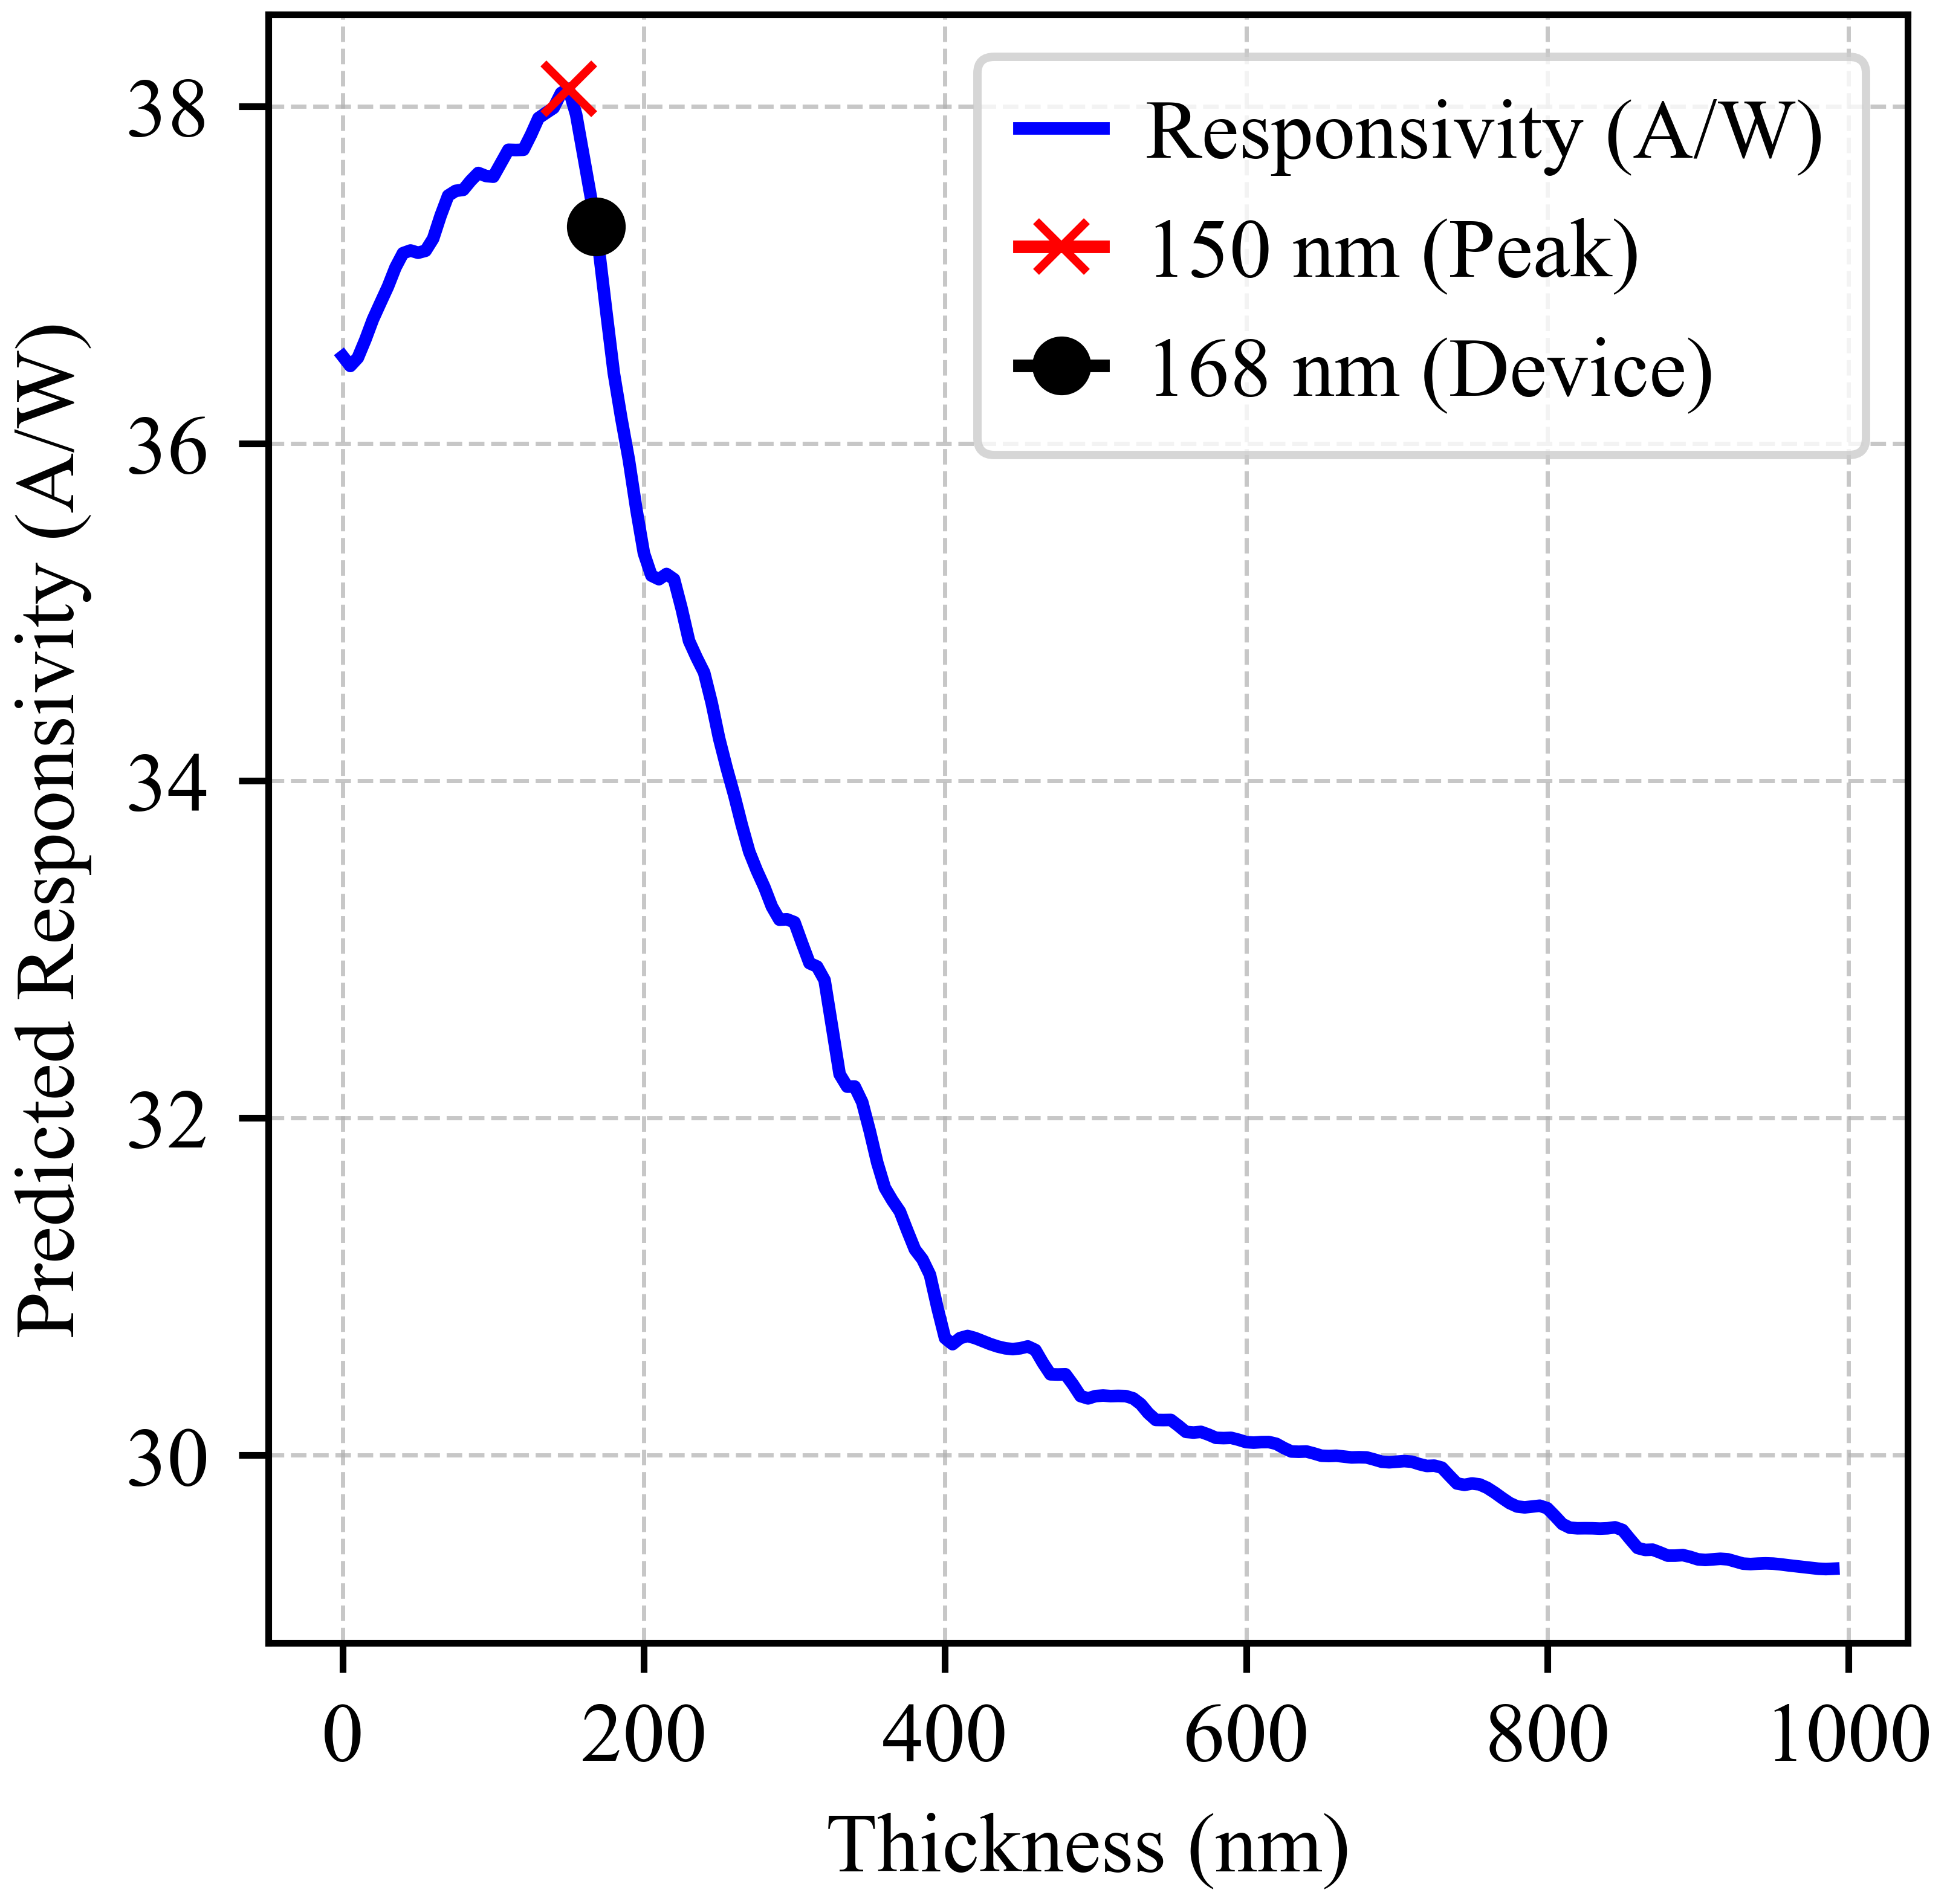
After identifying the optimal material for sensing within the EUV range, the subsequent challenge involved optimizing the thickness of the active layer to maximize responsivity at 13.5 nm (or 91.85 eV). Since the machine learning (ML) model training dataset includes active layer thickness as a crucial input feature, one that significantly influences the target variable, responsivity, the same ML model (in this case, the Extreme Gradient Tree Regressor, or ETR, identified as the most effective model) was utilized to predict device responsivity across a range of thicknesses. By plotting responsivity as a function of active layer thickness, we identified the optimal thickness range while maintaining other experimental variables, such as bias voltage, power intensity, and EUV wavelength, constant. The model predicted the highest responsivity for an active layer thickness of 150 nm, as illustrated in Figure S6.
Figure S6: Optimization of α-MoO₃ Device Thickness: The thickness of the active layer of α-MoO₃ was simulated over a range from 0 to 1000 nm in the EUV region (at 13.5 nm or 91.85 eV), operating under a 1 mV bias voltage. The highest responsivity (38.10 A/W) was predicted for an active layer thickness of 150 nm. The analysis revealed that the maximum predicted responsivity of $38.10 A/W±2.5 \%$ was achieved within optimal thickness range of $130 nm to 170 nm$. The fabricated device has an actual thickness of 168 nm, which lies in the optimal region. The cross and dot signs represent the predicted peak responsivity value and the predicted responsivity value for the 168 nm-thick device in this study, respectively.

- Factors Contributing to Discrepancies Between Predicted and Experimental Values
In any machine learning endeavor, the quality and scope of the dataset are paramount. Our initial dataset was compiled from experimental data drawn exclusively from 22 published studies, which, while valuable, could benefit from expansion. Increasing the predictive power of our model would require the inclusion of a more extensive and diverse dataset, encompassing a broader range of experimental conditions. Additionally, variations in material properties, such as mobility and bandgap, necessitated the use of averaged values due to discrepancies reported across different sources. Theoretical parameters, including bandgaps derived from Density Functional Theory (DFT) calculations available in databases such as the Materials Project, inherently diverge from experimental values due to methodological assumptions and approximations intrinsic to DFT. These discrepancies introduce deviations in model predictions, even when employing high-performance machine learning models.

SECTION B: CHARACTERIZATION OF THE α-MoO₃ DEVICE
- Attenuation Characteristics in EUV Range

To evaluate the potential of α-MoO₃ as an EUV detector, the attenuation coefficients of α-MoO₃ and silicon were calculated using the National Institute of Standards and Technology (NIST) photon cross-section database, facilitating a comparative performance analysis in the EUV photon range (Figure S8). The attenuation coefficient measures the extent to which incident radiation flux diminishes as it traverses a material. At the typical photon energy used in EUV lithography patterning (i.e., 92 eV or 13.5 nm), the attenuation coefficient of α-MoO₃ is approximately an order of magnitude higher than that of silicon (Figure S8(a)), suggesting that α-MoO₃ is capable of detecting EUV radiation with significantly reduced material thickness. Containing high Z element ($Z^{Mo}=42 \&{ Z}^{Si}=14)$, this layered structure of α-MoO₃ supports a high density of $4.69g/{{cm}^{3}}$ than Si ($D^{Si}=2.69g/{{cm}^{3})}$, rendering it an efficient attenuator of EUV radiation.
To illustrate EUV radiation penetration in α-MoO₃, the average photon range was calculated, which is inversely related to the attenuation rate (Figure S8(b)). For 13.5 nm EUV photons, the average range was determined to be 70 nm in α-MoO₃, demonstrating the average distance travelled in a material before interaction. This distinct attenuation characteristic is also reflected in the half-value layer (HVL) of 50 nm for 92 eV (or 13.5nm) EUV radiation, denoting the thickness of α-MoO₃ required to reduce radiation by half, computed as HVL = 0.693 × Average Range. α-MoO₃’s attenuation coefficient decreases sharply at higher photon energies, enhancing EUV penetration.
This efficiency is further elucidated by comparing their attenuation efficiencies which can be used to determine the material’s thickness for percentage attenuation; for instance, a 290 nm thick α-MoO₃ layer attenuates over 99% of 13.5 nm EUV photons, while silicon achieves only ~35% attenuation at this thickness (Figure S8(c)). While thinner materials enhance carrier extraction, thicker materials necessitate higher EUV exposures and bias voltages, and an increased active material thickness can also detrimentally affect image resolution. These distinctive characteristics make α-MoO₃ a promising material for efficient EUV radiation detection.

Figure S8: Attenuation Characteristics (a) Attenuation curves of α-MoO₃ and Silicon, indicating a significantly higher attenuation coefficient of α-MoO₃ compared to Silicon at 13.5 nm radiations by an order of a magnitude, thus an attenuation result of Silicon can easily be achieved using a relatively much lower thickness of α-MoO₃ and along with high resolution. (b) Theoretically derived Half Value Layer ‘HVL’ and average photon range ‘APR’ values of α-MoO₃ as a function of EUV photon energies. The HVL and APR of α-MoO₃ for 92 eV (or 13.5 nm) energy is 50 nm and 70 nm respectively, suggesting strong potential use of α-MoO₃ for EUV sensing and detection. (c) Attenuation efficiencies as a function of the material’s thickness are presented for 13.5 nm radiations. This shows a 290 nm thick α-MoO₃ and Silicon can attenuate the same EUV radiation energy by 99% and 35% respectively.
- Characteristics of α-MoO₃ based detector.

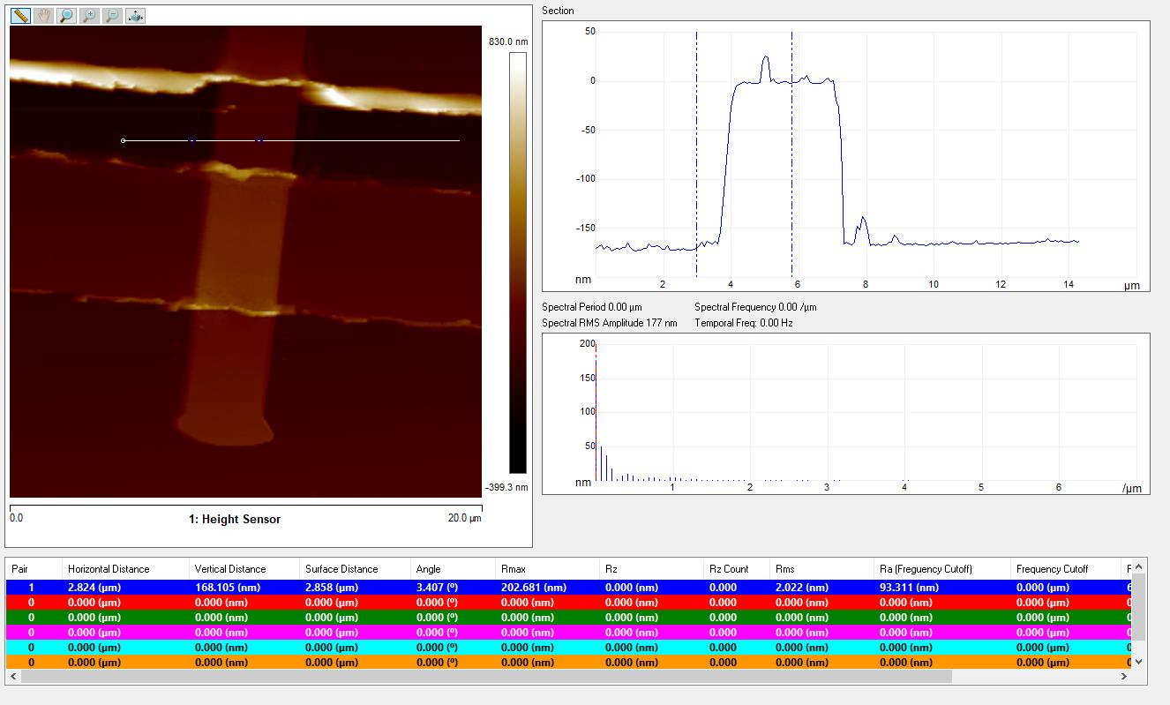
Figure S9: AFM details of the α-MoO₃ Device: α-MoO₃ with thickness of ~168nm is exfoliated and transferred on Si/SiO₂ substrate.
Figure S10: Device Characteristics: (a) Actual photo of a device. Scale bar shows 5microns. We used area between the electrodes for the calculation of responsivity as areas showcased in yellow boxes doesn’t contribute to the transport properties. Also, area under gold is not considered because EUV cannot penetrate through the gold due to its high density and thickness. (b) Schematic diagram of a device under synchrotron EUV radiations. EUV detection was subsequently achieved by exposing the active area of a device to synchrotron EUV radiations and monitoring the change in the device photocurrent ΔI (= I_{ON} – I_{OFF}) where ON and OFF show the EUV illumination and dark current respectively. (c) schematic band diagram of a α-MoO₃. The bottom panel describes the carrier transport under EUV radiations.

- Performance of α-MoO₃ based detector.
The current response to sequential increases in photon flux at different photon energies demonstrates no saturation or degradation, even when detecting extremely high fluxes of ~10¹² photons/s. This shows the detector stability at elevated photon fluxes (Figure S11(a))
Furthermore, we also measured the response speed of the EUV detector (Figure S11(b)), defined as the time required for the detector to extract the generated carriers under EUV exposure to an external circuit as output current. This was calculated by measuring the change in output signal from $10\%$ to $90\%$ of the peak output value. Response time depends on material quality; polycrystalline materials often exhibit lower response times due to grain boundary-induced trap levels within the bandgap, which create potential barriers between adjacent grains.[Reference] The α-MoO₃-based EUV detector demonstrated average rise ($τ_{rise}$) and fall times ($τ_{fall}$) of $60 ms$ and $30 ms$, respectively, over photon energies from $90$ to $150 eV$. The high detector speed, on the order of milliseconds, and slow rise times compared to decay times, are due to the high crystalline quality, low defects, and high carrier mobilities, enabling effective carrier replenishment.
Figure S11: Device Performance: (a) The current response to sequentially increase in photon flux at a different photon energy, indicating no saturation or degradation in detecting extremely high fluxes of ~ 10¹² Ph/s. Note: The indicated flux values are at 90eV. These values are higher at other photon energies. (b) The response speed of a detector indicating an average rise and fall time of ~ 60 ms and 30 ms, respectively. Owing to the high millisecond response speed, the detector can detect EUV radiation almost instantaneously, enabling rapid responses in high-speed electronics.
Figure S12: Current as a function of photon energies at different bias voltages. Inset shows the slope of the current deviation with respect to bias.

- Detectivity and EQE of MoO₃ based detector.

Figure S13: Figures of Merit for α-MoO₃ EUV Detector: (a, b) Operating at bias voltages of 1 mV and 5 V, the detector demonstrates a detectivity ranging from 6–8 × 10¹² Jones and 0.15–4 × 10¹² Jones in the EUV range, respectively. The peak responsivity at ~92 eV (or 13.5 nm) corresponds to a detectivity of 8 × 10¹² Jones at 1 mV, highlighting the device's suitability for detecting weak signals and effectively converting them into measurable values. (c, d) The external quantum efficiency (EQE) as a function of photon energies shows an almost linear trend at both 1 mV and 5 V bias voltages, with peak EQE values observed at higher photon energies. At 1 mV bias, the EQE achieves up to 10⁶ % for incident photon energy of 150 eV. For 92 eV (or 13.5 nm), the calculated EQE values exceed 10⁵ %, indicating an exceptionally high conversion rate of absorbed EUV photons into generated carriers via the photoelectric effect.
Detectivity, which is used to distinguish a weak EUV signal from noise, is defined as $D={R\sqrt{S}}/{\sqrt{2eI_{d}}}$ , where $R$ is responsivity, $S$ is the active area, e is the electron charge, and $I_{d}$ is the dark current. For the device operating at biases of $1 mV$ and $5 V$, the detector demonstrates detectivity values ranging from $6-8 (×{10}^{12} Jones)$ and $0.15-4 (×{10}^{12} Jones)$, respectively, in the EUV range, as shown in Figures S13-a and and 13-b. The effect of the large bandgap in α-MoO₃ is clearly observed in the high values of specific detectivity. Compared to $1 mV$, the relatively lower detectivity values at high bias are attributed to the relatively high dark currents, on the order of tens of nanoamperes, obtained in α-MoO₃ at $5 V$. These calculated detectivity values on the order of ${10}^{11}-{10}^{12} Jones$ for the α-MoO₃-based EUV detector surpass those of silicon or silicon-derived EUV detectors. In Figure 4-d, the peak responsivity at $\sim 95 eV$ (or $13.5 nm$) corresponds to a detectivity of $8×{10}^{12} Jones$ at $1 mV$, indicating the detector's suitability for detecting weak signals and converting these signals into measurable values. Increasing the bias, as shown in Figure 13-b, results in comparatively lower detectivity values; however, the calculated values remain on the order of $0.3 (×{10}^{12} Jones)$, indicating the detector's overall performance.
We further calculated the external quantum efficiency (EQE) of the detector, defined as the ratio of the number of absorbed photons in a material to the total number of incident photons at a given energy or wavelength. This photoconversion ability of the detector can be expressed as:
$$EQE=hcR/eλ$$
where $h$ is Planck's constant, $c$ is the speed of light, $R$ is the responsivity of the detector, e is the electron charge, and $λ$ is the wavelength of the incident radiation. The EQE at bias voltages of both $1 mV$ and $5 V$, shown in Figure S13c and 13d, respectively, exhibits an almost linear trend, with peak EQE values calculated at higher photon energies. Compared to the device operating at a bias of $5 V$, the EQE at $1 mV$ reaches ${10}^{6}\%$ when the incident photon energy is $150 eV$. At $92 eV$(or $13.5 nm$), the calculated EQE values exceed ${10}^{5}\%$, indicating an extremely high conversion rate from absorbed EUV photons to generated carriers via the photoelectric effect. These values gradually increase by an order of magnitude, with peak values exceeding $2×{10}^{6}\%$ at $150 eV$ when the device operates at $5 V$. The comparison of different parameters are shown in Table S3.

Table S3: Comparison of sensitivities in EUV region. Some data is not available and marked as NA. T = Thickness, R = Responsivity, D= Detectivity, RS = Response speed and I_{d} = Dark Current. This comparative analysis underscores key performance parameters, including responsivity, detectivity, and response speed, highlighting the significant advancements offered by our α-MoO₃-based detector.
Material/  Active layer | T | λ (nm)/ Light Intensity (uW/cm²) | R (A/W) | Bias (V) | D (Jones) | Gain/EQE | RS | I_{d} | Ref
Pt/n-type GaN Schottky photodiode | 4.105 um | 13.5/ | 0.01 | 0.8, 0V | 3.28×10¹¹ | 0.4 (e/ photons) at 13.5nm | unknown | 2.7 nA | ^{[29]}
Si based Boron-doped  p⁺n diode |  | 13.5 | 0.266 | NA | NA | NA | 100 ns pulsed response time | 50 pA at 10 V | ^{[30]}
PtSi-n-Si Schottky photodiode | 10 nm | 120 nm | 0.03 | NA | NA | NA | NA | NA | ^{[31]}
Si np (UVG-100) |  | 120 nm | 0.04 | NA | NA | NA | NA | NA | ^{[32]}
Si with DLC, PtSi, Ti-SiN top layers | $\sim$200 um | 1-25 nm | 0.05-0.25 | NA | NA | NA | NA | NA | ^{[33]}
α-MoO₃ | 168 nm | 13.5 | 60 | 0.001 | $$6.1×{10}^{12}$$ | $$5.2×{10}^{5}$$ | 60ms/30 ms | NA | This work
α-MoO₃ | 168 nm | 10.8 | 145 | 5 | $$3.2×{10}^{11}$$ | $$6×{10}^{5}$$ | 60ms/30 ms | NA | This work

SECTION C: Performance of the ReS₂ Device

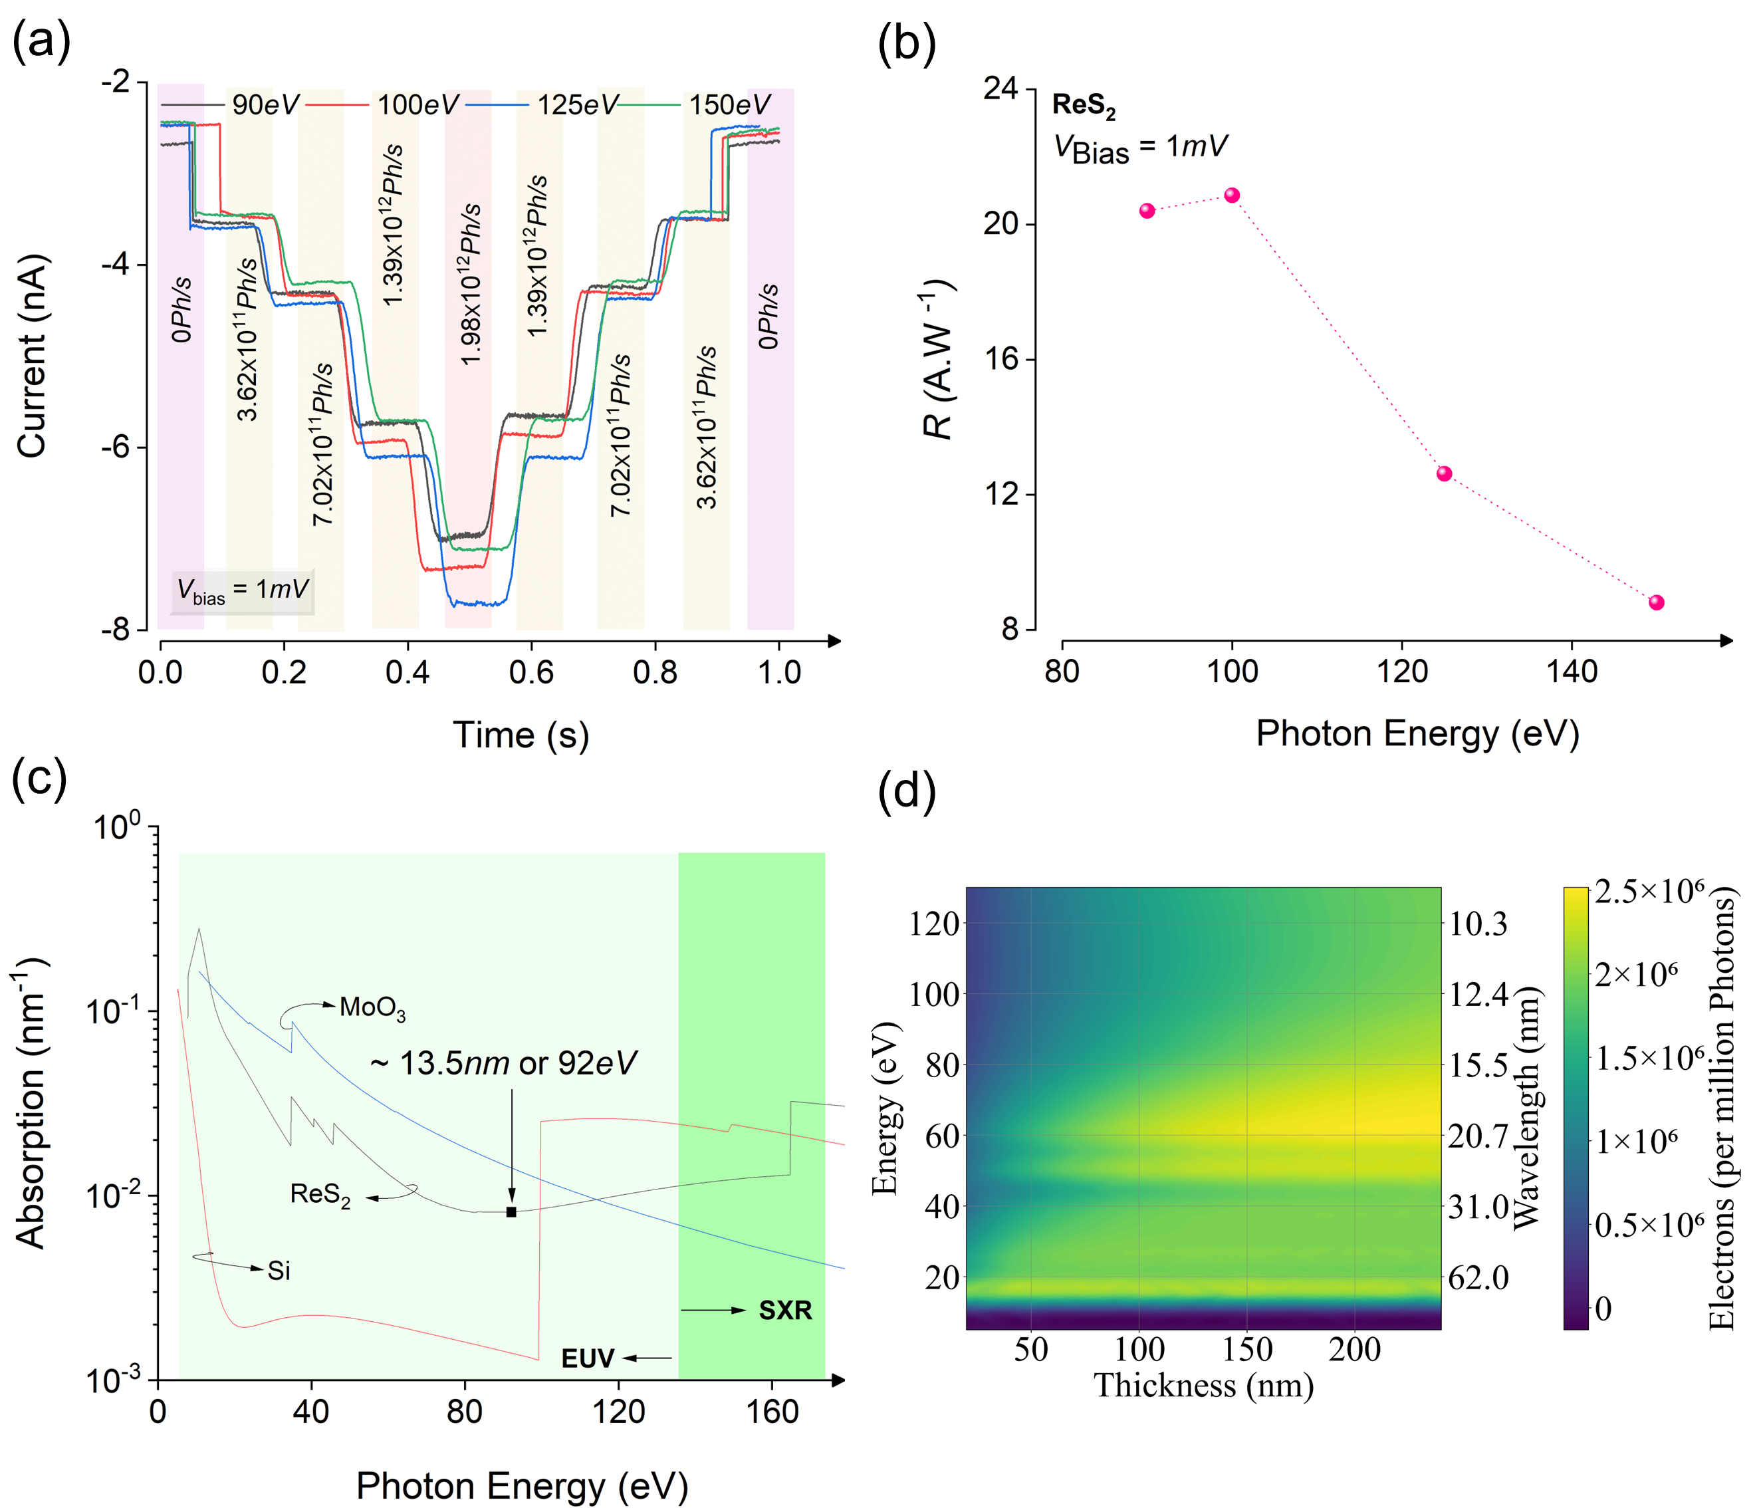
Figure S14: Characterization of ReS₂: (a) The current response to sequentially increase in photon flux at a different photon energy, indicating no saturation or degradation in detecting extremely high fluxes of ~ 10¹² Ph/s. Note: The indicated flux values are at 90eV. These values are higher at other photon energies. (b) At bias voltages of 1 mV, the device demonstrates an exceptionally high responsivity of ~22 to 8 A/W, depending on the photon energy. The peak responsivity is approximately 22 A/W at 1mV bias and EUV radiation of energy 103 eV. (c) Attenuation curves of ReS₂, α-MoO₃ and Silicon, indicating a significantly higher attenuation coefficient of ReS_{2,} and α-MoO₃ compared to Silicon at 13.5 nm radiations by an order of a magnitude, thus an attenuation result of Silicon can easily be achieved using a relatively much lower thickness of α-MoO₃ or ReS₂ and along with high resolution. (d) The Monte Carlo simulations depict electron generation in ReS₂ within the EUV region. Electron generation is presented as a function of EUV photon energy (or wavelength) and the thickness of the active layer. The results demonstrate that the ReS₂ active layer exhibits nearly uniform electron generation efficiency across the majority of the EUV region but less in magnitude as compared to α-MoO₃ and Si.

References
[1] P. Chauhan, A. B. Patel, G. K. Solanki, K. D. Patel, V. M. Pathak, C. K. Sumesh, S. Narayan, P. K. Jha, Appl Surf Sci 2021, 536, DOI 10.1016/j.apsusc.2020.147739.
[2] M. A. Jabr, A. M. Ali, R. A. Ismail, Ceram Int 2023, 49, 11442.
[3] F. Yıldırım, S. Khalili, Z. Orhan, H. M. Chenari, Aydoğan, J Alloys Compd 2023, 935, DOI 10.1016/j.jallcom.2022.168054.
[4] Y. H. Lee, H. L. Lu, J. J. Tao, J. Jiang, S. N. Zhao, Y. Zhang, X. X. Li, X. Fang, P. Wang, W. Hu, D. W. Zhang, ACS Nano 2021, 15, 3241.
[5] T. Yang, S. Park, T. G. Kim, D. S. Shin, K. Suh, J. Park, Opt Express 2017, 25, 30843.
[6] A. B. Patel, P. Chauhan, K. Patel, C. K. Sumesh, S. Narayan, K. D. Patel, G. K. Solanki, V. M. Pathak, P. K. Jha, V. Patel, ACS Sustain Chem Eng 2020, 8, 4809.
[7] A. Sharma, A. K. Srivastava, T. D. Senguttuvan, S. Husale, Sci Rep 2017, 7, DOI 10.1038/s41598-017-18166-4.
[8] Y. Liu, G. Tai, C. Hou, Z. Wu, X. Liang, ACS Appl Mater Interfaces 2023, DOI 10.1021/acsami.2c23234.
[9] Z. Lu, Y. Xu, Y. Yu, K. Xu, J. Mao, G. Xu, Y. Ma, D. Wu, J. Jie, Adv Funct Mater 2020, 30, DOI 10.1002/adfm.201907951.
[10] Z. Yue, H. Shen, Y. Xu, Z. Wang, Y. Li, J. Zhang, H. Li, J. Zheng, J. Chen, H. Bai, J. Zeng, Surfaces and Interfaces 2023, 38, DOI 10.1016/j.surfin.2023.102854.
[11] S. Fu, R. Song, Y. F. Wang, Y. Han, C. Gao, J. Ma, H. Xu, B. Li, A. Shen, Y. Liu, Adv Mater Interfaces 2023, 10, DOI 10.1002/admi.202202488.
[12] S. Kapatel, C. K. Sumesh, Opt Mater (Amst) 2022, 129, DOI 10.1016/j.optmat.2022.112537.
[13] X. Li, S. Ruan, H. Zhu, Mater Sci Semicond Process 2022, 151, DOI 10.1016/j.mssp.2022.106991.
[14] Y. Hu, L. Zhang, T. Chen, Y. Ma, W. Tang, Z. Huang, B. T. Li, K. Xu, D. H. Mudiyanselage, H. Fu, X. Zhang, Z. Zeng, B. Zhang, Vacuum 2023, 213, DOI 10.1016/j.vacuum.2023.112130.
[15] A. K. Jehad, M. Fidan, Ö. Ünverdi, C. Çelebi, Sens Actuators A Phys 2023, 355, DOI 10.1016/j.sna.2023.114309.
[16] D. Hu, Y. Wang, Y. Wang, W. Huan, X. Dong, J. Yin, J. Zhu, Optik (Stuttg) 2021, 245, DOI 10.1016/j.ijleo.2021.167708.
[17] D. Xiang, C. Han, J. Zhang, W. Chen, Sci Rep 2015, 4, DOI 10.1038/srep04891.
[18] A. B. U. Rahman, S. Begum, N. M. S. Kaawash, M. Y. H. Thabit, D. I. Halge, P. M. Khanzode, V. N. Narwade, K. A. Bogle, in Mater Today Proc, Elsevier Ltd, 2023, pp. 775–778.
[19] V. Q. Dang, G. S. Han, T. Q. Trung, L. T. Duy, Y. U. Jin, B. U. Hwang, H. S. Jung, N. E. Lee, Carbon N Y 2016, 105, 353.
[20] S. S. Singh, B. Shougaijam, in Micro and Nanoelectronics Devices, Circuits and Systems (Eds.: T. R. Lenka, D. Misra, L. Fu), Springer, Singapore, 2022, pp. 131–140.
[21] W. B. Zhang, Q. Qu, K. Lai, ACS Appl Mater Interfaces 2017, 9, 1702.
[22] C. T. Chantler, J Phys Chem Ref Data 1995, 24, 71.
[23] C. T. Chantler, J Synchrotron Radiat 2001, 8, 1124.
[24] D. Xiang, C. Han, J. Zhang, W. Chen, Sci Rep 2015, 4, DOI 10.1038/srep04891.
[25] J. Chen, W. Ouyang, W. Yang, J. H. He, X. Fang, Adv Funct Mater 2020, 30, DOI 10.1002/adfm.201909909.
[26] C. Fan, B. Dai, H. Liang, X. Xu, Z. Qi, H. Jiang, H. Duan, Q. Zhang, Adv Funct Mater 2021, 31, DOI 10.1002/adfm.202010263.
[27] A. Jain, S. P. Ong, G. Hautier, W. Chen, W. D. Richards, S. Dacek, S. Cholia, D. Gunter, D. Skinner, G. Ceder, K. A. Persson, APL Mater 2013, 1, DOI 10.1063/1.4812323.
[28] A. K. Singh, L. Zhou, A. Shinde, S. K. Suram, J. H. Montoya, D. Winston, J. M. Gregoire, K. A. Persson, Chemistry of Materials 2017, 29, 10159.
[29] S. Aslam, R. E. Vest, D. Franz, F. Yan, Y. Zhao, B. Mott, Nucl Instrum Methods Phys Res A 2005, 539, 84.
[30] L. Shi, F. Sarubbi, S. N. Nihtianov, L. K. Nanver, T. L. M. Scholtes, F. Scholze, in IECON Proceedings (Industrial Electronics Conference), 2009, pp. 1877–1882.
[31] K. Solt, H. Melchior, U. Kroth, P. Kuschnerus, V. Persch, H. Rabus, M. Richter, G. Ulm, Appl Phys Lett 1996, 69, 3662.
[32] P. Kuschnerus, H. Rabus, M. Richter, F. Scholze, L. Werner, G. Ulm, Characterization of Photodiodes as Transfer Detector Standards in the 120 Nm to 600 Nm Spectral Range, n.d.
[33] F. Scholze, R. Klein, T. Bock, Irradiation Stability of Silicon Photodiodes for Extreme-Ultraviolet Radiation, 2003.

-The End-

