SUPPLEMENTAL MATERIAL
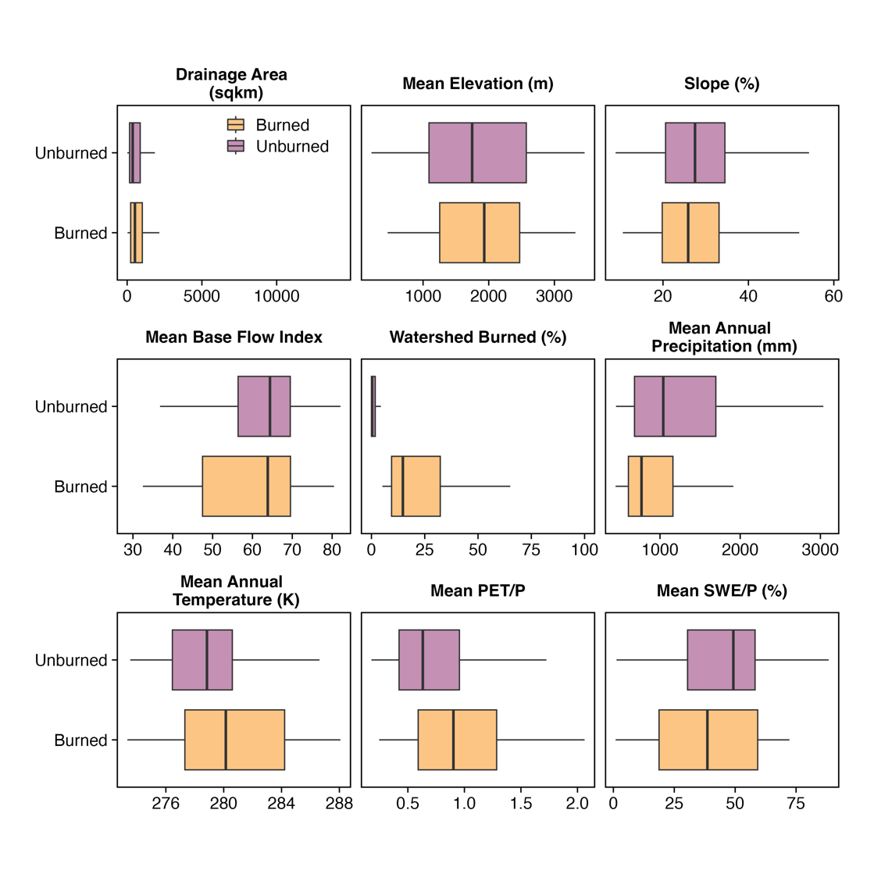
Supplementary Figure 1. Climatic and physiographic characteristics for burned watersheds. Drainage area (km²), mean elevation (m), slope (%), mean base flow index, mean SWE/P, and mean PET/P are derived from the USGS Gages II dataset¹. The percent watershed burned was calculated from MTBS. Mean Annual precipitation (mm), and temperature (K) was calculated from the time period 1990 – 2020 using the GridMET dataset².

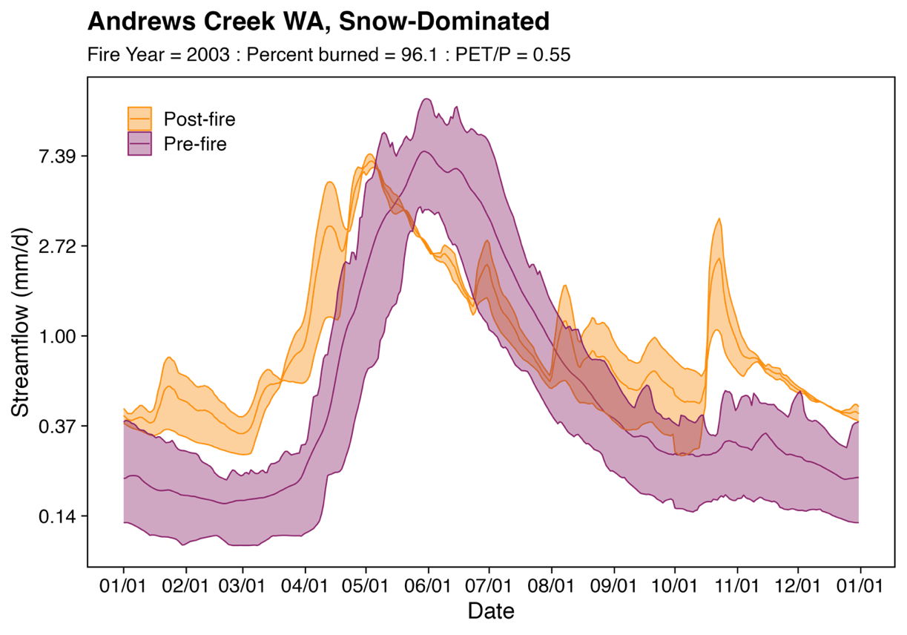
Supplementary Figure 2. The annual hydrograph for the Andrew’s Creek watershed near Mazama, WA. The pre-fire annual hydrograph (purple) is compared with the post-fire annual hydrograph (orange). The solid line on each hydrograph shows the mean annual streamflow whereas the shaded areas show 80% of streamflow variability. This snow-dominated watershed burned in 2003 and is energy-limited with PET/P < 0.55.
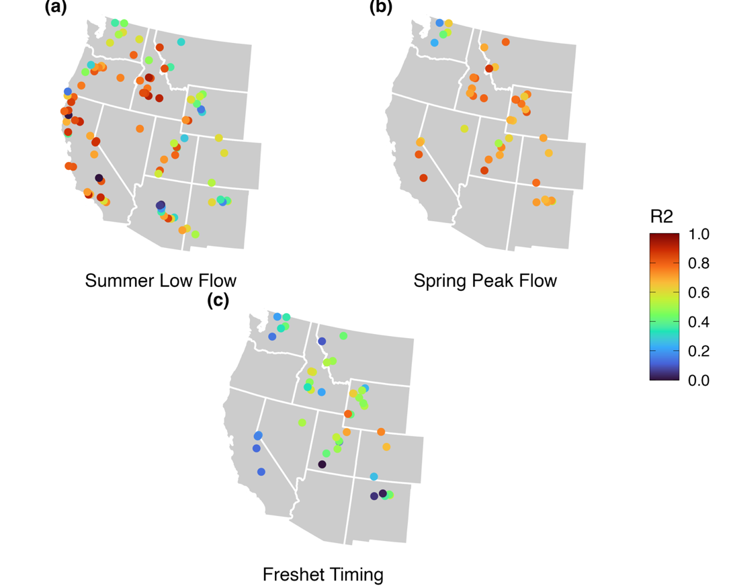
Supplementary Figure 3. Predictive model performance for streamflow metrics during pre-fire period for burned watersheds. Model selection used leave-one-out cross-validation for (a) Summer Low Flows, (b) Spring Peak Flows, and (c) Freshet Timing.

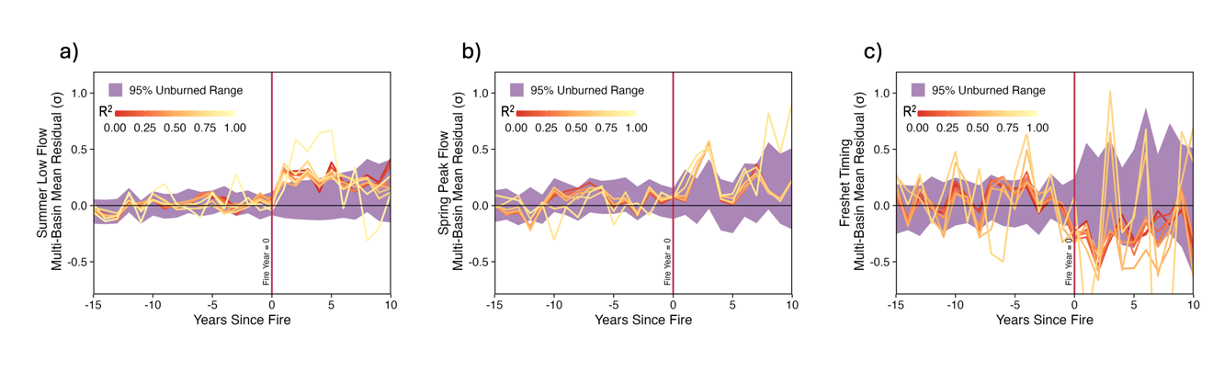
Supplementary Figure 4. The multi-basin mean residual across burned watershed where watersheds grouped by individual model performance calculated by adjusted R². The vertical red line represents the year of fire occurrence. The shaded area shows the 95% unburned residual distribution.

Supplementary Table 1. The number of burned watersheds that fall within an adjusted R² model performance metric thresholds. The adjusted R² was calculated from individual model regressions the were training during the pre-fire period.
R² | Summer Low Flow  (number of gages) | Spring Peak Flow  (number of gages) | Freshet Timing  (number of gages)
≥ 0.0 | 96 | 44 | 44
≥ 0.1 | 92 | 44 | 40
≥ 0.2 | 89 | 42 | 34
≥ 0.3 | 84 | 42 | 30
≥ 0.4 | 75 | 37 | 26
≥ 0.5 | 68 | 23 | 15
≥ 0.6 | 57 | 6 | 5
≥ 0.7 | 44 | -- | 2
≥ 0.8 | 26 | -- | --
≥ 0.9 | 4 | -- | --

Supplementary Table 2. Mean model performance for each streamflow metric. NSE, R², and RMSE represent the mean value across all burned modeled watersheds.
Streamflow Metric | NSE | R² | RMSE
Summer Low Flow | 0.60 | 0.61 | 0.59
Spring Peak Flow | 0.68 | 0.68 | 0.54
Freshet Timing | 0.37 | 0.39 | 0.77

Supplementary Table 3. The number of watersheds with a net number of significant years where the streamflow metric residual is significant from 95% of the unburned streamflow metric residuals during the post-fire time period. We calculated the net number of significant years to understand the overall post-fire trend. For example, if a watershed had 3 years of significant positive residuals, and 1 year so significant negative residual, the net years of residuals would be positive 2 years. The number of watersheds for a set of years is the sum of the individual watershed’s net residual years.

 | Watersheds with significant total negative residuals years |  | Watersheds with no total significant residual years | Watersheds with a significant total positive residuals years
Streamflow Metric | ≥3 years | 1 – 2 years | No change | 1 – 2 years | ≥3 years
Summer Low Flows | 0 | 7 | 57 | 14 | 3
Spring Peak Flows | 0 | 3 | 36 | 3 | 0
Freshet Timing | 1 | 5 | 36 | 1 | 1

Supplementary Table 4. The post-fire years in which the burned streamflow metric mean residual is different from 95% of the 10,000 simulations of unburned streamflow metric mean residual (P < 0.05). We selected burned and unburned watersheds that had individual adjusted R² ≥ 0.3. We calculate the cumulative year significance by calculating the running mean residual for each year following a fire. We excluded post-fire years with >10 burned watersheds because of the small sample size.
Streamflow Metrics | Single Year Significance | Cumulative Years Significance
Summer Low Flows | 1, 2, 3, 5 | 1 – 19
Spring Peak Flows | 2, 3 | 3– 7
Freshet Timing | 2, 3 | 2 – 15

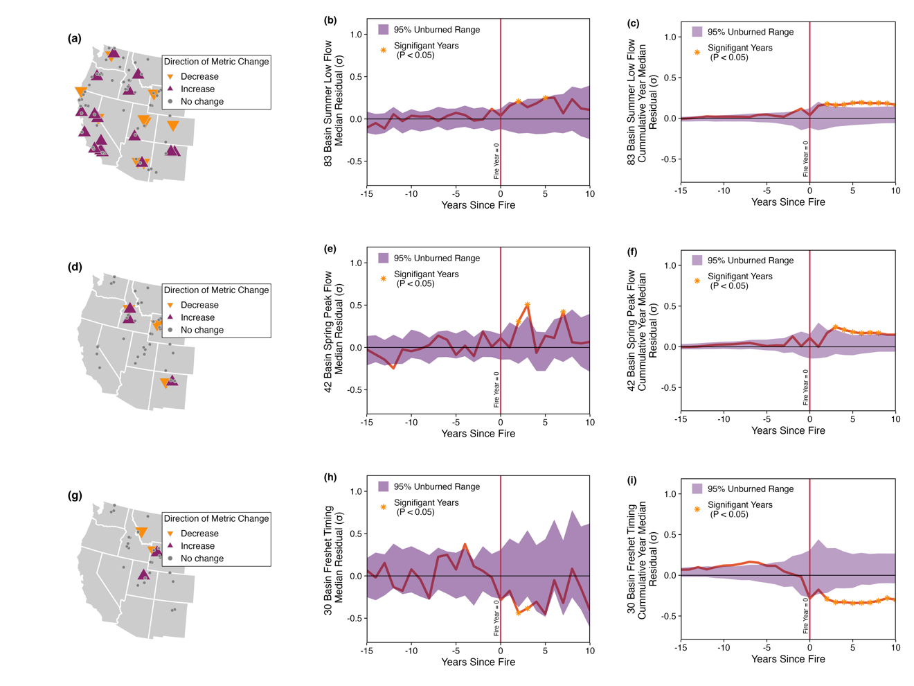

Supplementary Figure 5. The median effect of forest fire on each streamflow metric across the western U.S. through multilinear analysis. (a, d, g) A map of the watersheds post-fire residuals. The color shows positive, negative, or no residual change. Symbol size reflects the number of years of significant residual change from 95% of the unburned watershed residual distribution. (b, e, h) The median residuals across selected burned watersheds. The vertical red line represents the year of fire occurrence. The shaded area shows the 95% unburned residual distribution. (c, f, i). The cumulative (multi-year) residual median represents the median residual across all watersheds and for years preceding the fire. The stars in the time series plots (b, c, e, f, h, i) are years where the burned watershed residual median is significantly different from 95% unburned watershed distribution (P < 0.05).

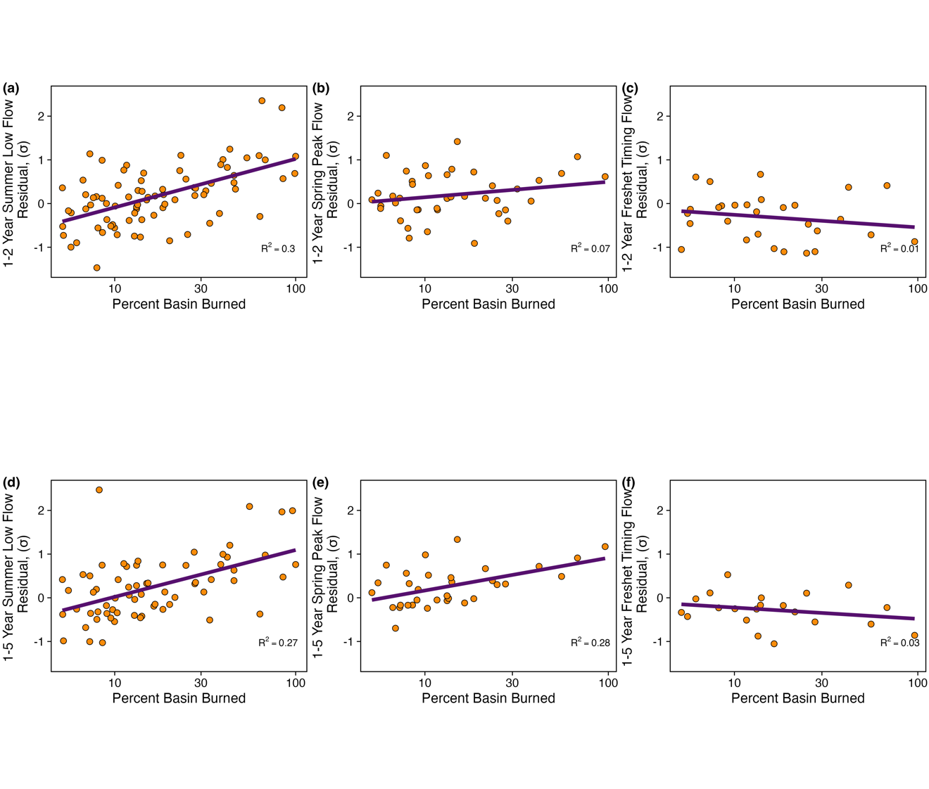
Supplementary Figure 6. The relationship with the percent of the watershed burned and each streamflow metric: summer low flow (a, d), spring peak flow (b, e), and timing of freshet (c, f). (a) – (c) show the 1-2 year mean residual, standard deviations (σ) and (d) – (f) show the 1-5 year mean residual. The orange points are the mean residual for each watershed and the purple line signifies the linear relationship between the percent watershed burned (log-scale).

Supplementary Table 5. Linear regression results of residual mean and percent basin burned.
 | 1-2 year residual mean |  |  | 1-5 year residual mean
Streamflow metrics | Slope | R² | p-value | Slope | R² | p-value
Summer Low Flow | 0.021 | 0.27 | >0.001 | 0.016 | 0.27 | >0.001
Spring Peak Flow | 0.0082 | 0.084 | 0.0057 | 0.012 | 0.28 | 0.0016
Freshet Timing | -0.0018 | >0.001 | 0.64 | -0.0033 | 0.027 | 0.47

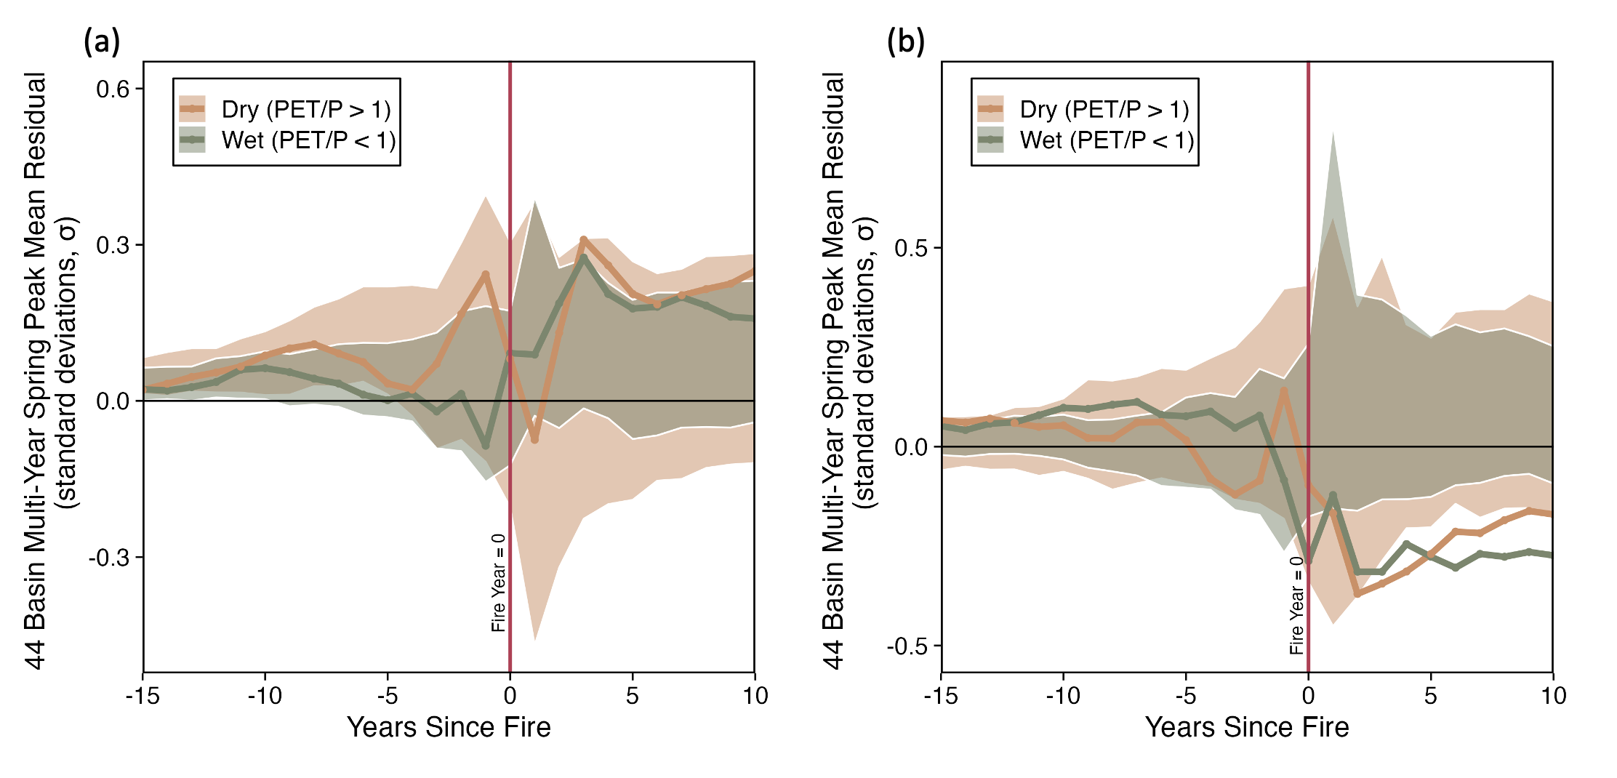
Supplementary Figure 7. Aridity does not appear to control spring peak flow and freshet timing post-fire response. Wetter, energy-limited watersheds where PET/P < 1 are shown in green and whereas drier, water-limited watersheds where PET/P > 1 are shown in brown. The vertical red line represents the fire year. The shaded area shows the 95% unburned range for both wet and dry watersheds.

Supplemental References

1. Falcone, J. A. GAGES-II: Geospatial Attributes of Gages for Evaluating Streamflow. (2011) doi:10.3133/70046617.
2. Abatzoglou, J. T. Development of gridded surface meteorological data for ecological applications and modelling. Int. J. Climatol. 33, 121–131 (2013).

