An in vitro one-pot synthetic biology approach to simulating diverging Golgi O-glycosylation of tumor-associated MUC1 from normal tissue MUC1

Abdullateef Nashed^{1,2}, Kyllen Dilsook^{1,2}, Tharindu Senapathi¹, and Kevin J. Naidoo^{1,2*}.
¹Scientific Computing Research Unit Address, University of Cape Town, Rondebosch 7701, ²Department of Chemistry, University of Cape Town, Rondebosch 7701.
*To whom correspondence should be addressed
KEYWORDS: In vitro synthetic biology, Cancer, MUC1 antigens, systems chemical glycobiology, reaction dynamics.

Supporting Information

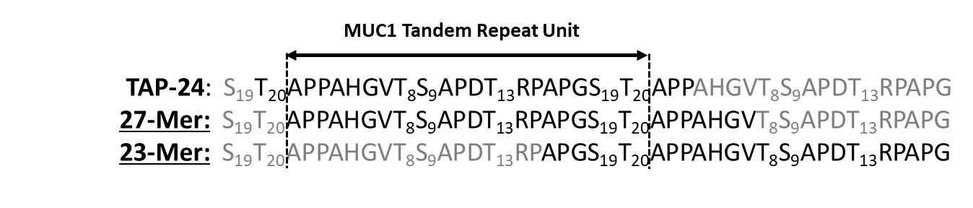  A | 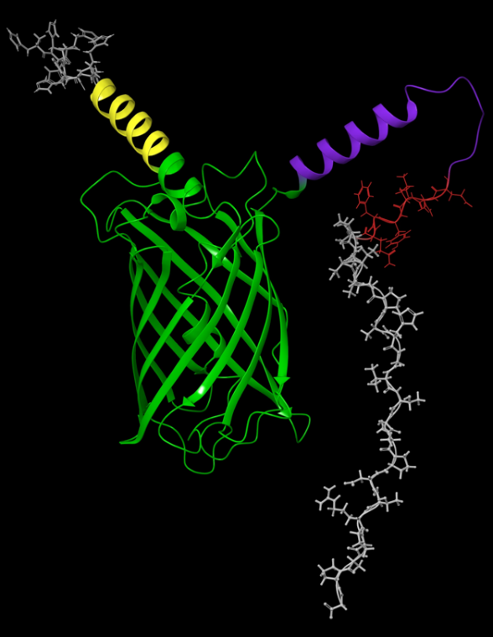  C
B
Figure S1. Sequence of MUC1 peptides and the fusion proteins. A. sequence alignment of the different MUC1 peptides (bold) showing the frame of each sequence compared to the tandem repeat unit. B. Sequence of the fusion protein. This sequence consists of, from N to C terminals: Methionine (red font), Histidine-tag (grey highlight), rigid linker 1 (yellow highlight), superforlder GFP (green highlight), rigid-flexible mixed linker 2 (purple highlight), a TEV site (red highlight), and lastly the amino acid sequence of MUC1 tandem repeat (23 mer sequence). C. the structure of the fusion protein as predicted by AlphaFold color coded according to the sequence in panel B.

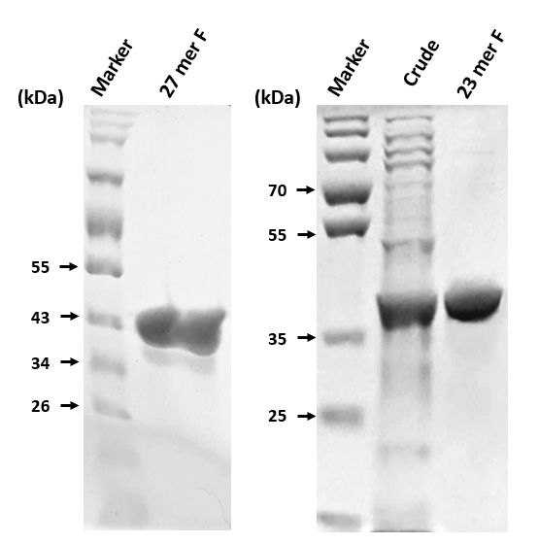
A
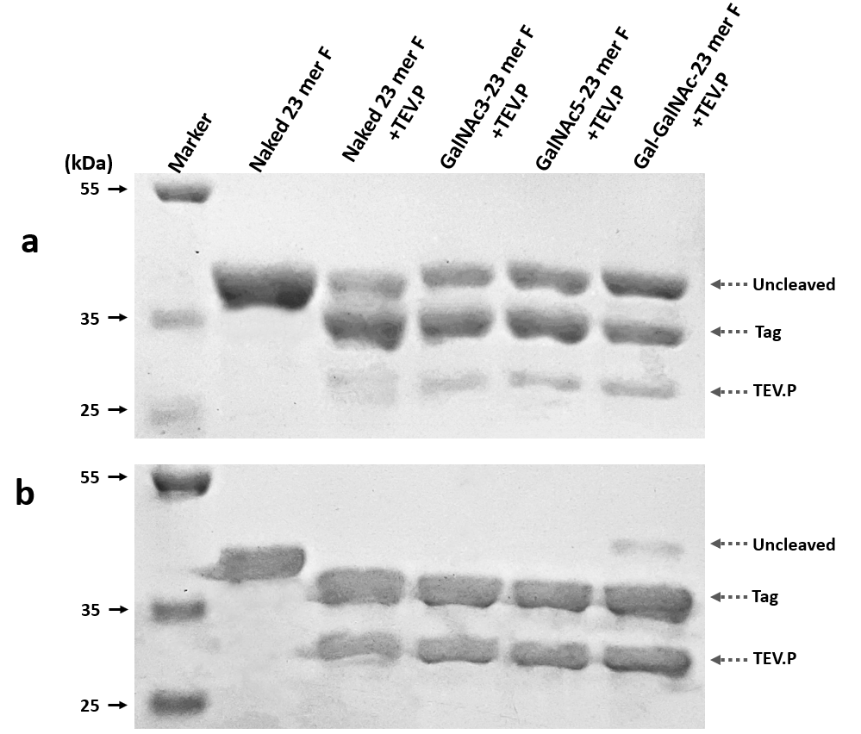
B

Figure S2. SDS-PAGE images of the Fusion protein showing the purity and cleavage of the tag. A. Purity and size of the 23-mer and 27mer fusion proteins. B. Cleavgae of the 23-mer fusion protein in its unglycosylated (naked) form or after glycosylation. Effect of TEV protease concentration is shown in two cases, when TEV to protin concentration (µg/ml) ratio was used at 1:10 or at 1:5, panels a and b, respectively.

LC-MS analysis

Sample Preparation: The peptide obtained from collecting the flow-through fractions of the IMAC purification of the TEV protease reaction was used for LC-MS analysis. The peptide concentration was estimated from the initial amount of the fusion protein used in the protease reaction and the final volume of the flow-through. Some precipitation was observed at the end of the protease reaction and was mainly due to denaturation of the TEV peotease not the fusion protein. This was concluded by measuring the GFP fluorescence of the reaction mixture before and after completion of the reaction (Data not shown). To maximize the recovery of the peptide, the flow-through of the protease reaction’s IMAC was collected including one column volum after sample loading was complete and the UV absorbance at 220 nm was used to confirm the distribution of the peptide across the fractions. As mentioned in the method section, the final solution of the peptide was adjusted to contain 0.1% (v/v) formic acid (FA) and 2% (v/v) acetonitrile (ACN) and around 10 nM of the peptide. Approximately 50 fmol of peptide was injected per sample. The LC-MS analysis was performed using either Q-Exactive quadrupole-Orbitrap mass spectrometer (Thermo Fisher Scientific, USA), or SYNAPT G2 MassSpectrometry System (Waters, USA).
Q-Exactive quadrupole-Orbitrap mass spectrometer protocol and results

Chromatography: Samples were initially trapped on a C18 trap column (PepMap100, 9027905000, 300 μm × 5 mm × 5 μm) and washed for 3 minutes before being eluted onto the analytical column. Chromatographic separation was achieved using a ReproSil-Pur 120 C-18-AQ column (Dr Maisch, r119.aq.n150.075, 75 μm × 15 cm × 1.9 μm). The solvent system consisted of:
- Solvent A: LC water (Burdick and Jackson BJLC365) with 0.1% (v/v) FA
- Solvent B: ACN with 0.1% (v/v) FA
The multi-step gradient employed was as follows:
- 0 - 3 min: 2% Solvent B at 300 nL/min
- 3 - 4.4 min: 2 – 5% Solvent B, flow rate at 300 nL/min
- 4.5 - 20 min: 5 – 18% Solvent B, flow rate at 300 nL/min
- 20 - 23 min: 18 – 30% Solvent B, flow rate at 300 nL/min
- 23 - 25 min: 30 – 80% Solvent B, flow rate increased to 450 nL/min
- 25 - 30 min: Hold at 80% Solvent B
- 30 - 35 min: Return to 2% Solvent B
Proxeon stainless steel emitters (Thermo Fisher TFES523) were used for all data acquisition.
Mass Spectrometry: The mass spectrometer was operated in positive ion mode with a capillary temperature of 320°C and an applied electrospray voltage of 1.95 kV. The detailed settings for data acquisition are listed below:
Data Acquisition Details:
Parameter | Full Scan | Data-dependent MS/MS
Resolution | 70000 (@ m/z 200) | 35000
AGC target value | 3e6 | 1e5
Scan range | 350-1750 m/z
Maximal injection time (ms) | 100 | 100
Inclusion | Off
Loop Count |  | 9
Isolation window width (m/z) |  | 2
NCE (%) |  | 27
Underfill ratio (%) |  | 1
Charge exclusion |  | Unassigned, 1, 5-8, >8
Peptide match |  | Preferred
Exclusion isotopes |  | On
Dynamic exclusion (s) |  | 20
The Xcalibur Qual Browser was utilized to determine MS1 and MS2 m/z distributions from the various samples.

Results:
27-mer peptide (Naked)
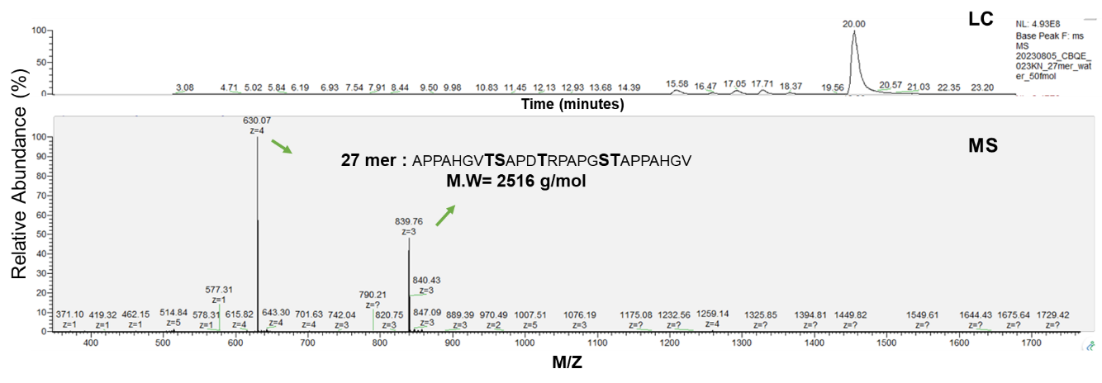

23-mer peptide (Naked)
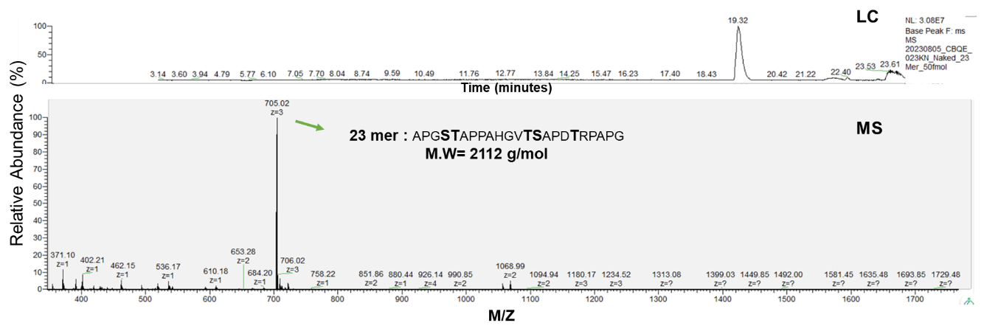
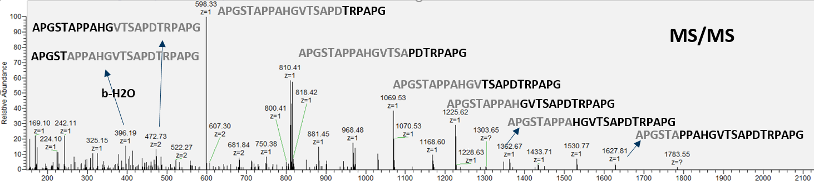

23-mer + GALNT1
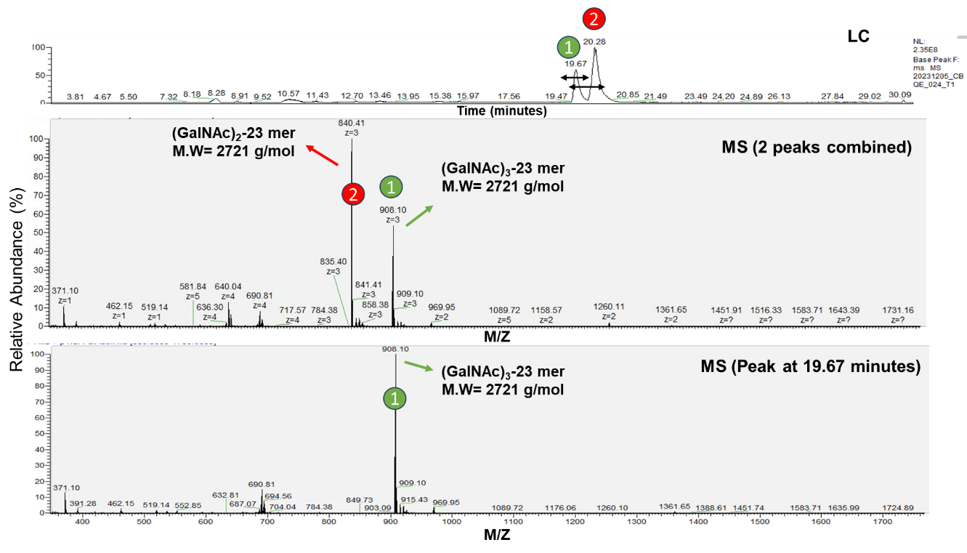

23-mer + GALNT2
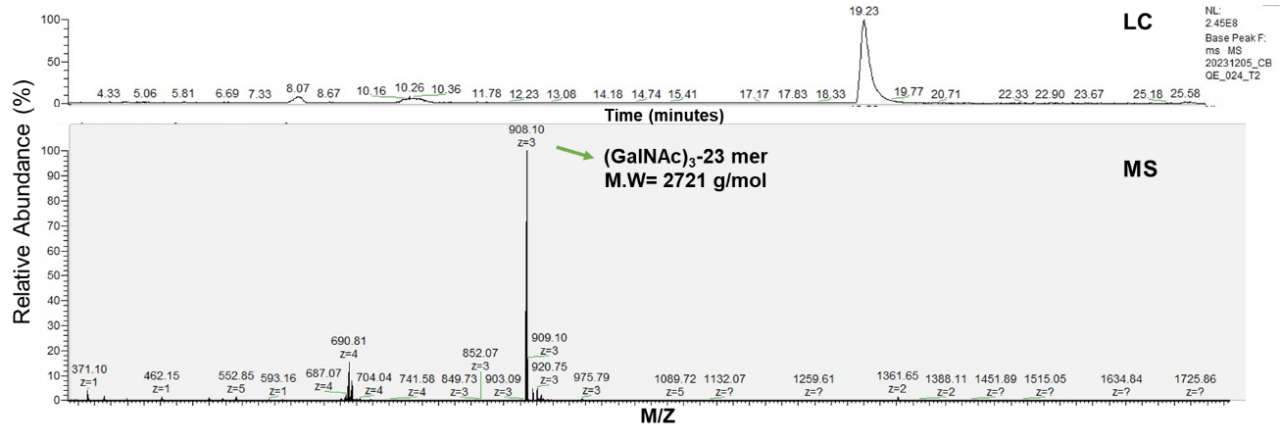

23-mer + GALNT1 + GALNT2
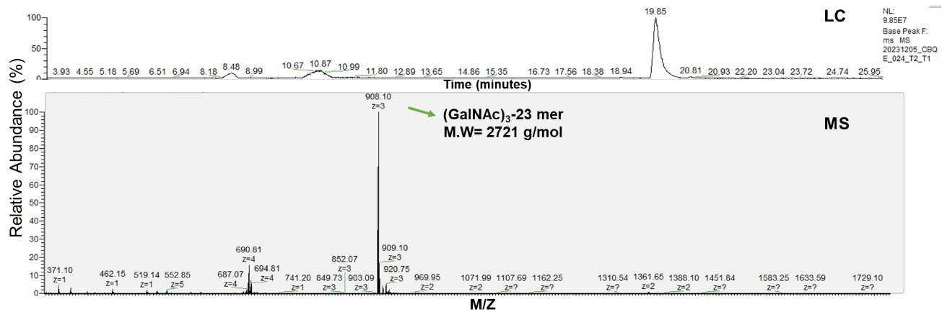
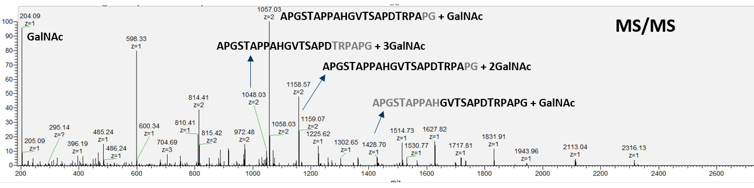

23-mer + GALNT1 + GALNT2à GALNT4
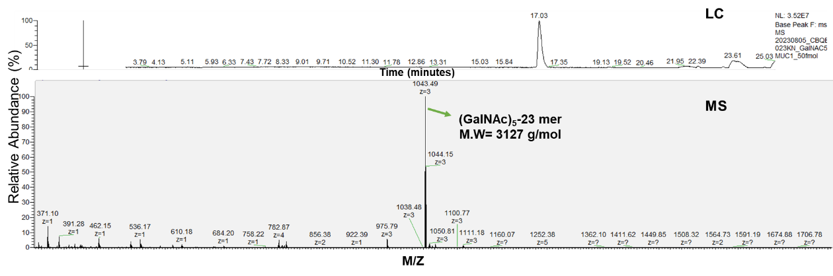

23-mer + GALNT1 + C1GALT1
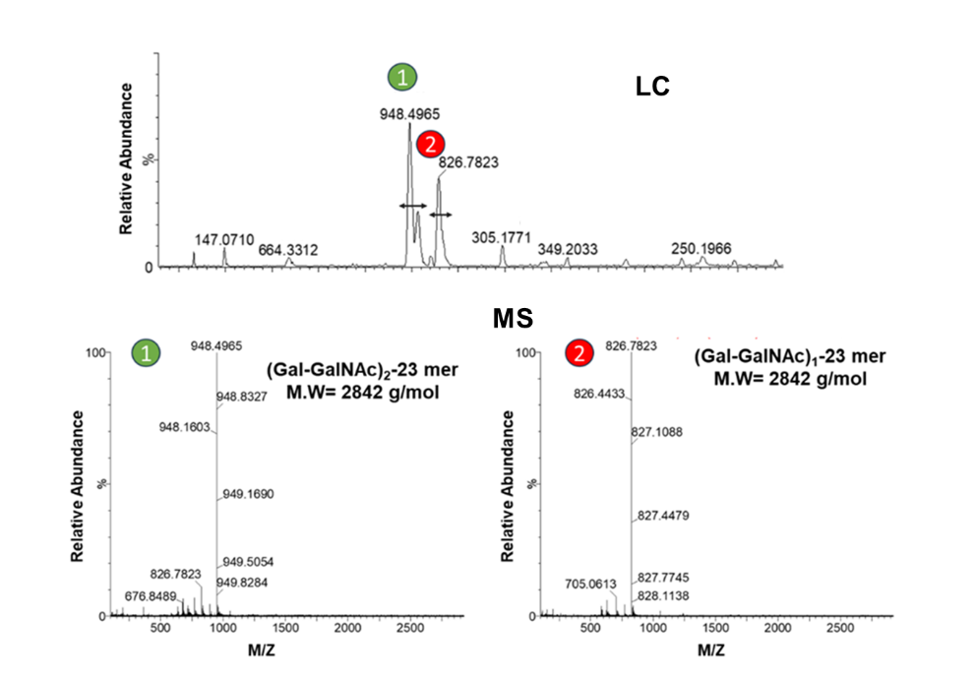

23-mer + GALNT2 + C1GALT1
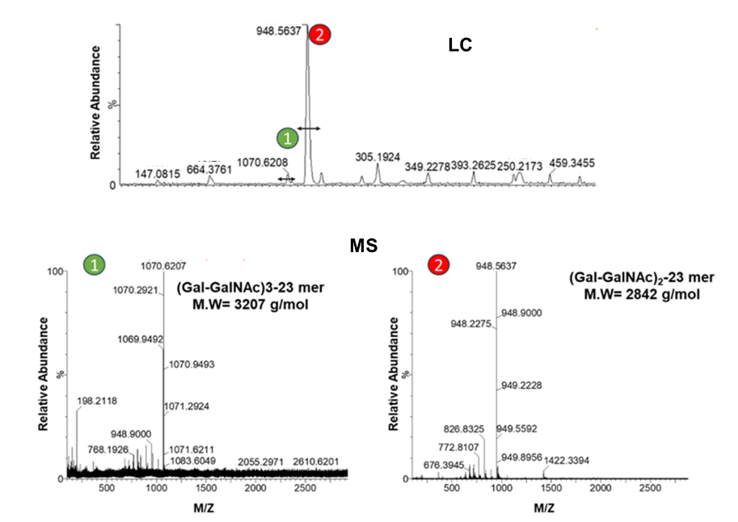

23-mer + GALNT1 + GALNT2 + C1GALT1
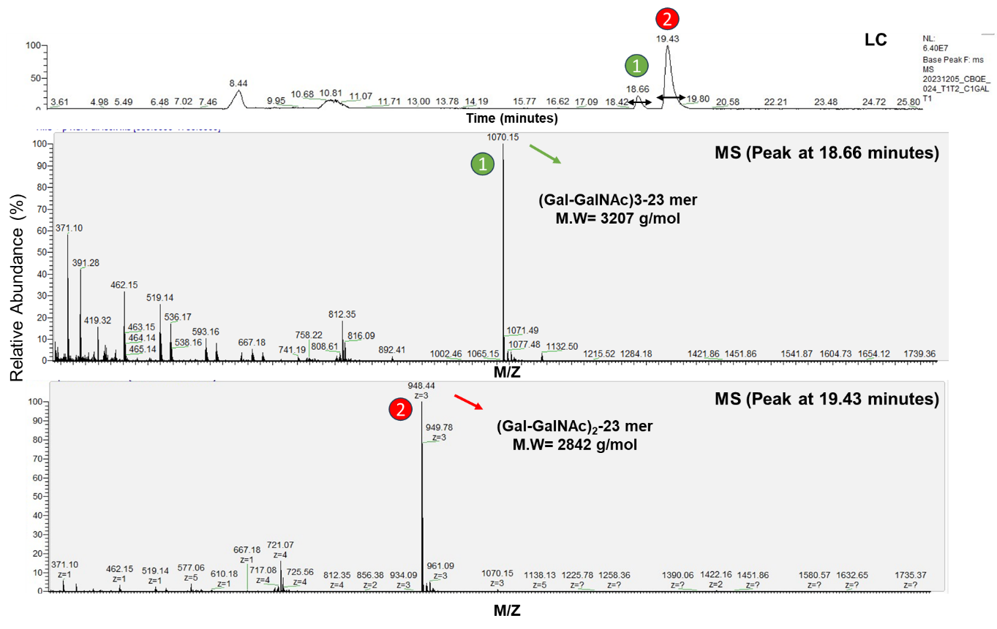

23-mer + GALNT1 + GALNT à GALNT4 + C1GALT1
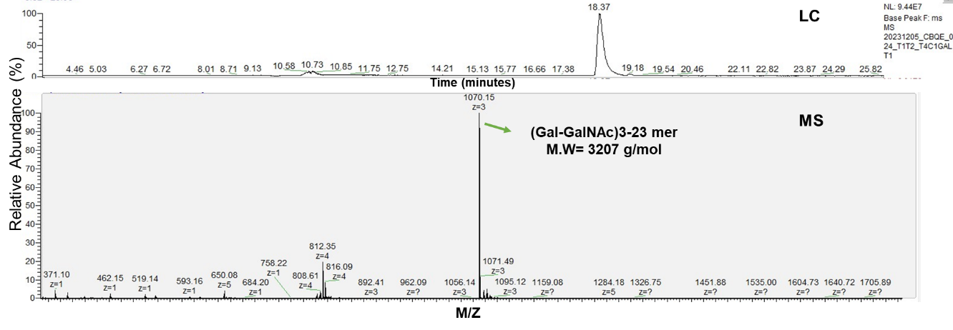

23-mer + GALNT1 + GALNT + GALNT4 à C1GALT1
