Supplemental information

Machine Learning Decision Support Model Construction for Craniotomy Approach of Pineal Region Tumors Based on MRI Images

Chen et al.

Supplementary Methods
MRI acquisition
All patients enrolled in our study went through MRI scan in different scanners of our hospital including 1.5T(Siemens Sonata, Siemens Area, Philips Prodiva CS and Alltech Centauri) and 3.0T (Siemens Prisma, GE Signa HDxt, GE Signa Premier, GE MR750w and TOSHIBA MRT200SP3) machines. Among them, 91 patients underwent 3.0T MRI scans, while 82 patients underwent 1.5T MRI scans. Specifically, here is the table that provides the basic information of the respective machines and the number of patients scanned on each machine. Despite the variations in scanning parameters across different machines and patients, we did not select images based on specific parameters to simulate real-world usage scenarios. All MRI data we used have their corresponding radiological reports by experienced radiologists, and have been evaluated by neurosurgeons with sufficient qualities for surgical approach determination.
Manufacturer | ScannerName | MagneticFieldStrength | Patient number
Siemens | Sonata | 1.5 | 53
 | Aera | 1.5 | 20
 | Prisma | 3 | 6
GE | Signa HDxt | 3 | 33
 | Signa Preimer | 3 | 1
 | Discovery MR750w | 3 | 6
Alltech | Centauri | 1.5 | 17
TOSHIBA | MRT200SP3 | 3 | 36
Philips | Prodiva CS | 1.5 | 1

Supplementary Figure Captions

Fig. S1 The diagram of pineal region tumor approaches.

Fig.S2 Feature importance scores of Random Forest (A), AdaBoost Classifier (B) and XGBoost Classifier (C) for radiological and clinical information.

Fig.S3 (A), (C) and (E) showed the training and validation loss curves of ResNet-50, EfficientNetV2-m and ViT for MRI images of all planes, respectively. (B), (D) and (F) showed the training and validation accuracy curves of ResNet-50, EfficientNetV2-m and ViT, respectively. Among those curves, EfficientNetV2-m has a relatively reliable and stable curve of loss function and accuracy in validation set.

Fig.S1
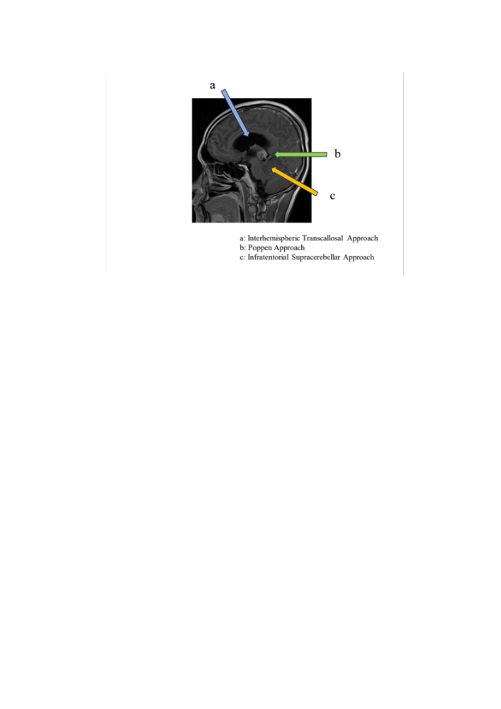

Fig. S2
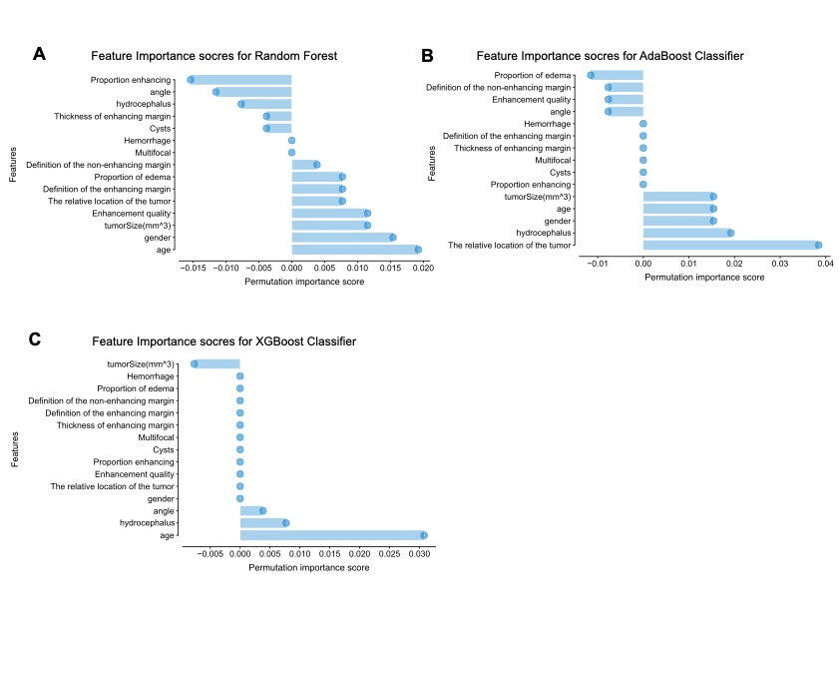

Fig.S3
