Additional Materials
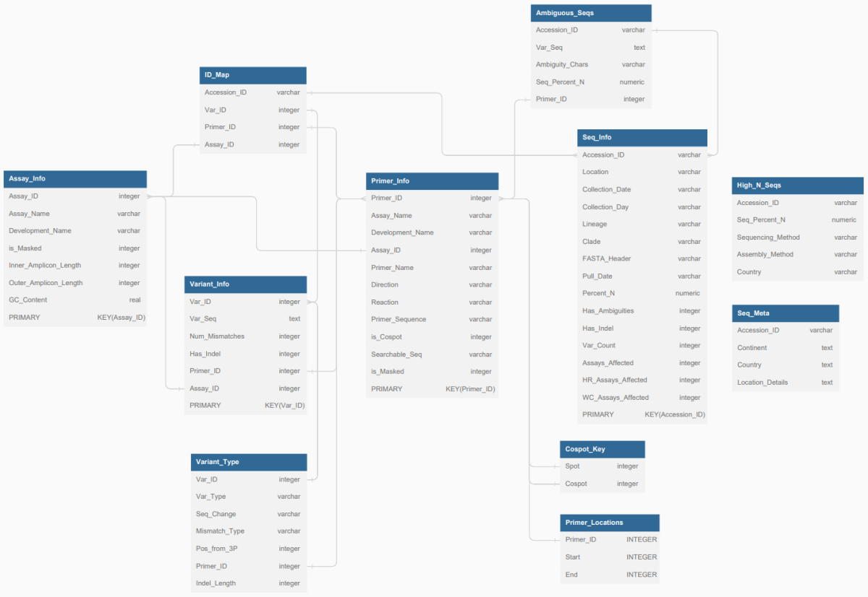
Additional File 1. Database Schema for the CoMIT Pipeline.

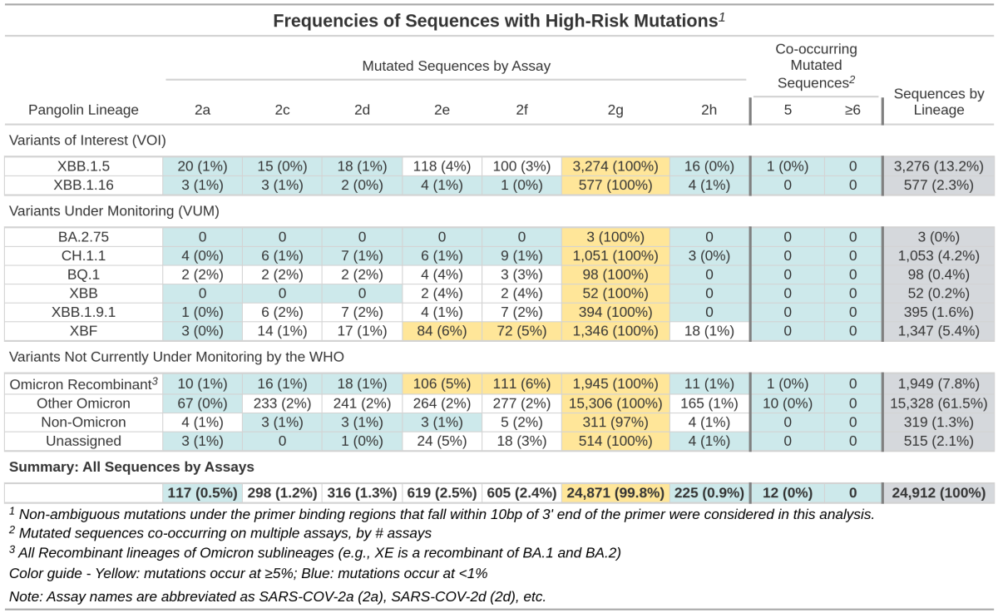
Additional File 2. Summary Table of Sequences Containing Identifiable High-Risk Mutations across Multiple Assays.

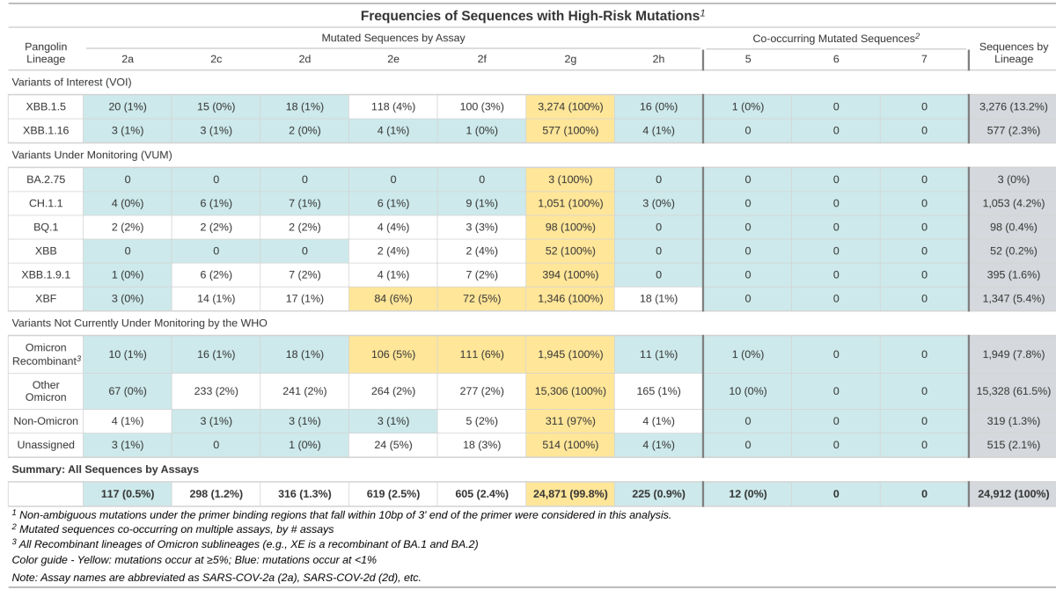
Additional File 3. Summary Table of Sequences Containing Identifiable Mutations across Multiple Assays (Elongated Version).

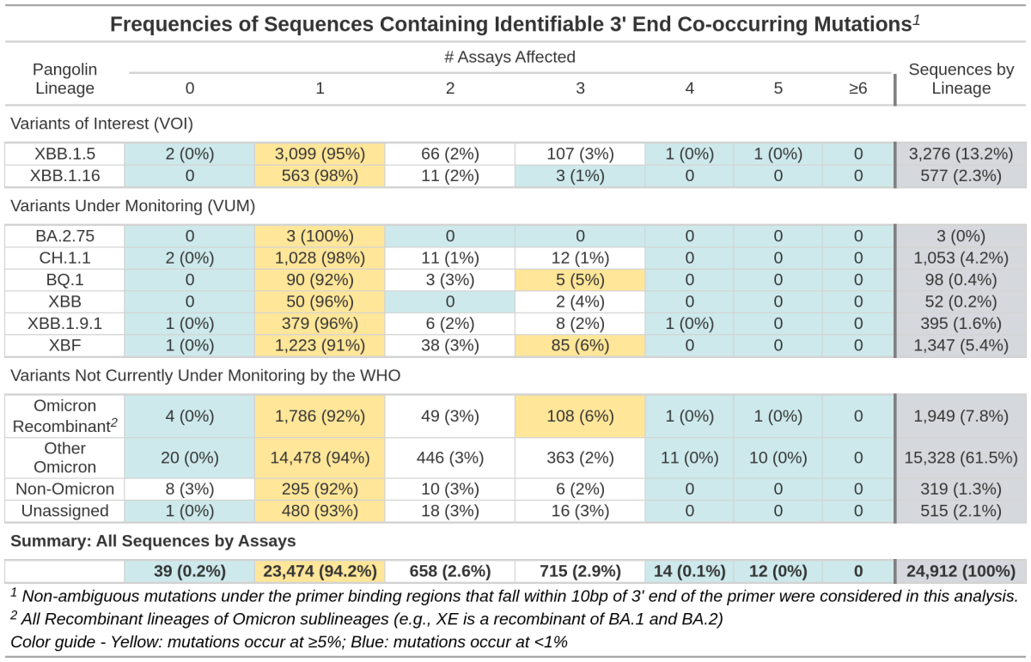
Additional File 4. Summary Table of Sequences Containing Identifiable Co-occurring High-Risk Mutations.

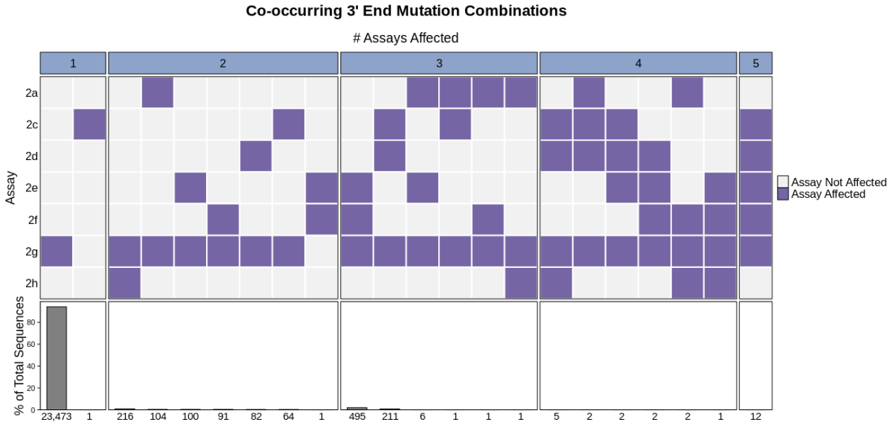
Additional File 5. Heatmap of High-Risk Primer Variant Combinations.

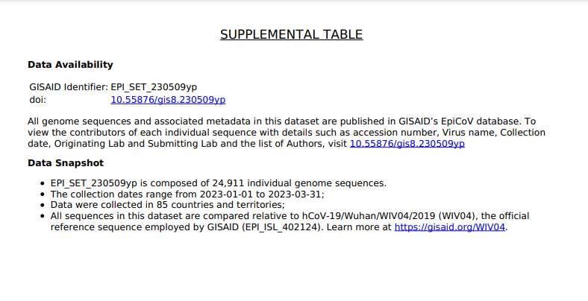
Additional File 6. Supplemental Table from GISAID EpiCoV™ Database.

