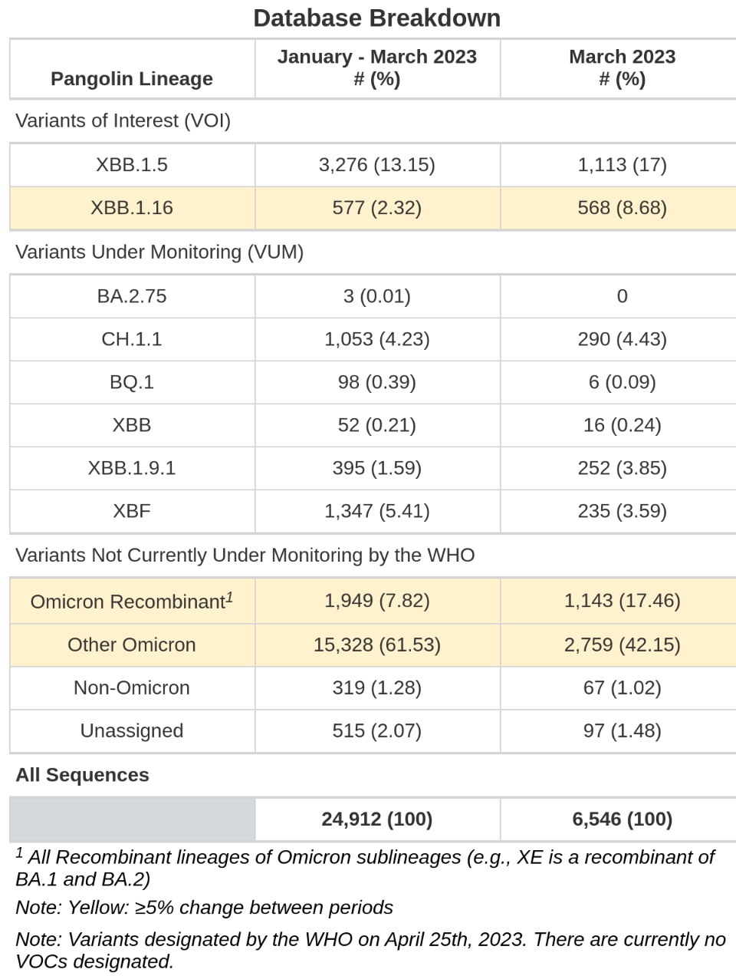
Table 1. Sequence Dataset Representation for a Typical in silico Inclusivity Evaluation.

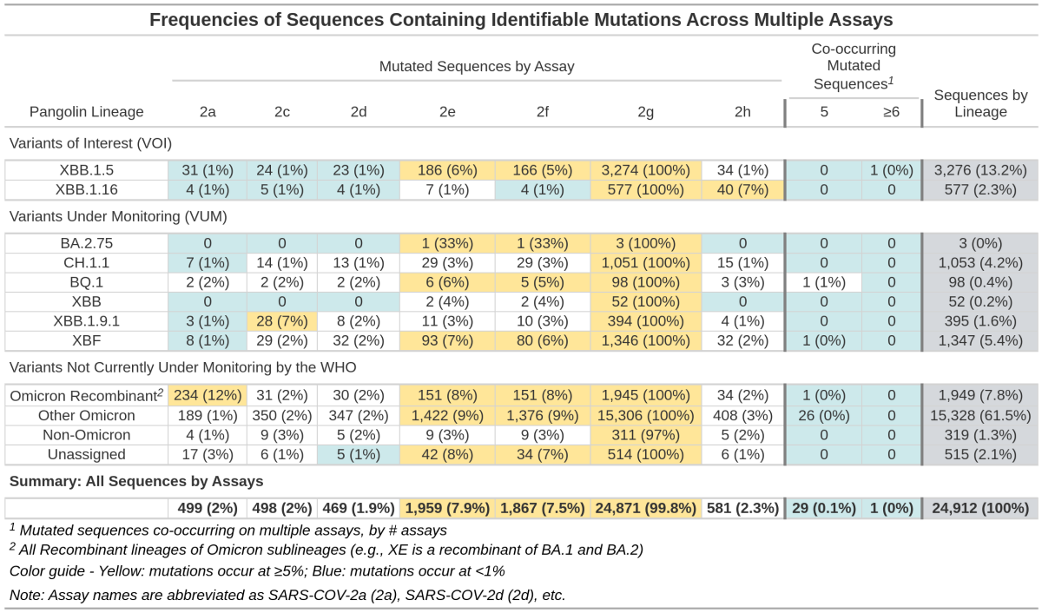
Table 2. Summary Table of Sequences Containing Identifiable Mutations across Multiple Assays.

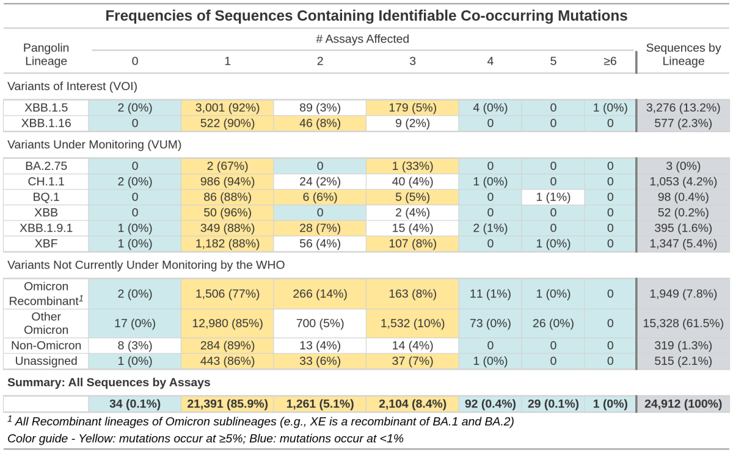
Table 3. Summary Table of Sequences Containing Identifiable Co-occurring Mutations.

