Intrinsic, room temperature quantum resistance memristor for next generation zero-chain traceability SI standard – Supplementary Information
Gianluca Milano*¹, Xin Zheng², Fabio Michieletti³, Giuseppe Leonetti^{1,3}, Gabriel Caballero^{4,5}, Ilker Oztoprak⁶, Luca Boarino¹, Özgür Bozat⁷, Luca Callegaro⁸, Natascia De Leo¹, Isabel Godinho⁹, Daniel Granados⁴, Itir Koymen^{7,10}, Mariela Menghini⁴, Enrique Miranda¹¹, Luís Ribeiro⁹, Carlo Ricciardi³, Jordi Suñe¹¹, Vitor Cabral*⁹, Ilia Valov*^{2,12}

¹Advanced Materials Metrology and Life Sciences Division, INRiM (Istituto Nazionale di Ricerca Metrologica), Strada delle Cacce 91, 10135 Torino, Italy.
²Forschungszentrum Jülich, Peter Grünberg Institute (PGI-7), WilhelmJohnen-Straße, 52428, Jülich, Germany.
³Department of Applied Science and Technology, Politecnico di Torino, C.so Duca degli Abruzzi 24, 10129 Torino, Italy.
⁴IMDEA Nanociencia, Cantoblanco, 28049 Madrid, Spain
⁵Facultad de Ciencias Físicas, Universidad Complutense de Madrid, 28040, Madrid
⁶Department of Physics, Gebze Technical University, 41400, Gebze, Kocaeli, Turkey
⁷TUBITAK National Metrology Institute (UME), 41470 Gebze, Turkey
⁸Quantum Metrology and Nanotechnologies Division, INRiM (Istituto Nazionale di Ricerca Metrologica), Strada delle Cacce 91, 10135 Torino, Italy.
⁹Instituto Português da Qualidade, Rua António Gião 2, 2829-513 Caparica, Portugal
¹⁰Department of Electrical and Electronics Engineering, TOBB University of Economics and Technology, 06510 Ankara, Turkey
¹¹Departament d’Enginyeria Electrònica, Universitat Autònoma de Barcelona, 08193 Cerdanyola del Valles, Spain
¹²Institute of Electrochemistry and Energy Systesms, Bulgarian Academy of Sciences (BAS), Acad. G. Bonchev Str., Block 10, 1113 Sofia, Bulgaria
1. Conventional resistance standard based on Quantum Hall Effect
An example of the experimental setup required for the practical realization of the conventional resistance standard are reported in Figure S1a. Here, a low temperature measurement of the QHE device is performed by means of a cryostat that, connected to the vacuum system, can reach a temperature of ~1 K by liquid helium (⁴He). A superconducting magnet placed inside the cryostat is exploited to generate the required magnetic field (e.g., 6 T to 12 T) for operating QHE devices. Associated instrumentation to this system includes a variable current source to control the value of the magnetic field, temperature sensors, low-pressure sensors, voltmeter to measures the Hall voltage, $V_{H}$ and horizontal Voltage, $V_{xx}$ (see panel c), high stable current source to drain the QHR sample. Costs associated to a typical ⁴He system relies in the amount of liquid helium (≈ 200 L per one week of operation) each time it is operated and the needed time in its preparation (cooling down from room temperature to the operating temperature) and routine test verification to assure that the required conditions of minimization/elimination of error sources are fulfilled.
An example of QHE device based on a quantum heterostructure of GaAs/AlGaAs and related schematization are reported in Figure S1b and c, respectively. Here, the working principle is based on the formation of a two-dimensional electron gas (2DEG) at the interface between GaAs and AlGaAs that lead to quantum confinement effects, with the formation of a set of discrete energy levels.¹ As a consequence, when the device is driven by a constant current $I$, the quantum Hall effect is observed when the Hall Voltage $V_{H}$ is constant for an interval of the applied value of the magnetic field $B$ and the longitudinal voltage $V_{xx}$ has values very close to zero.
The level of the expanded uncertainty reached with this primary system is in the order of some parts in 10⁹ as has been demonstrated in level of agreement of these systems resulting from on-site bilateral comparisons performed between BIPM (Bureau International des Poids et Mesures) and different National Metrology Institutes around the World.²
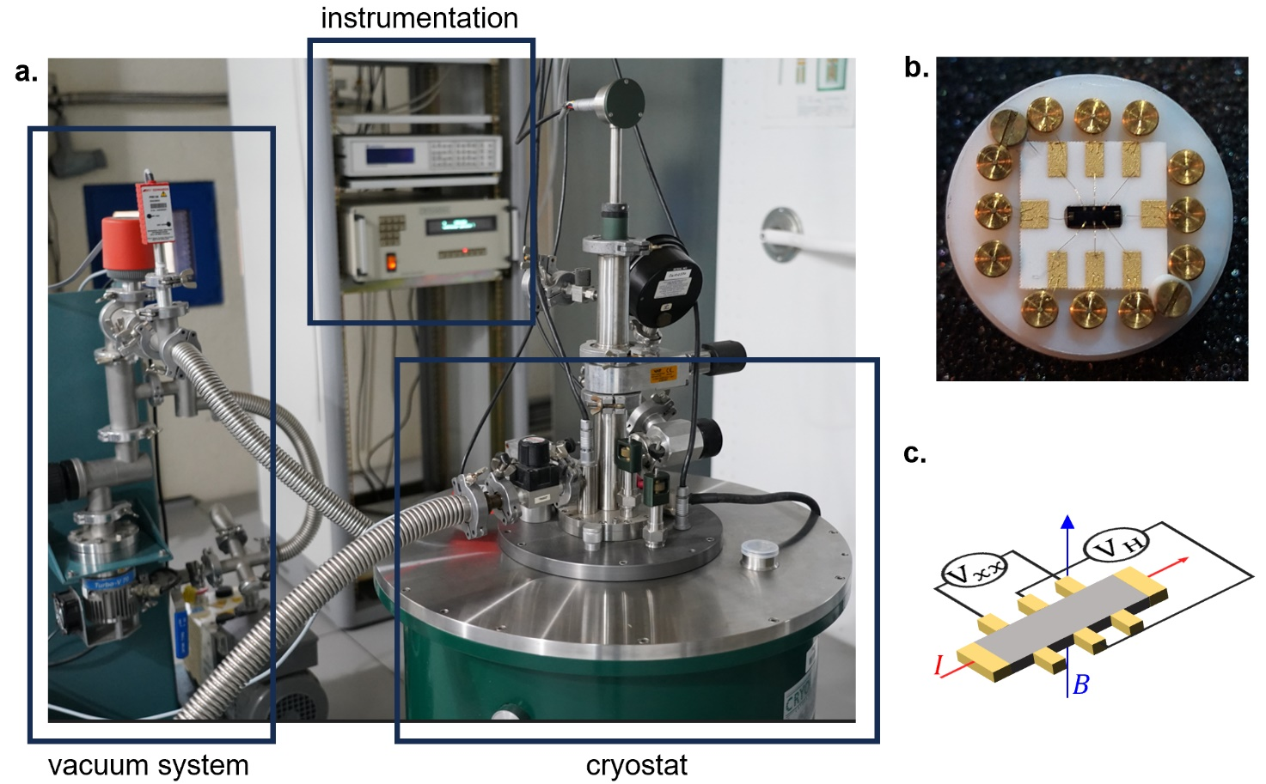
Supplementary Figure S1 | Experimental setup required for the conventional resistance standard based on QHE. a. Experimental setup at the Portuguese National Metrological Institute (Instituto Português da Qualidade) exploited for the practical realization of the conventional QHE resistance standard, b. Image of the QHE device based on a GaAs/AlGaAs heterostructure, and c. the equivalent circuital representation of the QHE device.

2. Literature survey on programming memristive devices in the quantum regime
Quantized conductance has been observed in air at room temperature in both SET^{3–9} and RESET^{3–5,8,10} operations. The specific methods reported to obtain controllable quantum conductance levels and corresponding stability of quantized conductance levels can be summarized as follows:
Slow voltage sweep mode;^{6–8,10–13} A suitable low voltage sweep rate ($≈$ mV∙s⁻¹) is applied to slower the growth of the filament to observe conductance quantization in SET process.^{6,7,11,12} The quantized conductance < 10 $G_{0}$ obtained by this method has a stability of some tens to thousands of seconds, but the retention failure comes earlier with decreased conductance.¹² Some works also reported conductance quantization during RESET process with slow voltage sweep mode,^{5,8,10} but there is still no detailed study about the stability and reproducibility of quantum conductance levels obtained in this operational regime. Banerjee and Hwang¹⁴ demonstrated an electrically controllable break junction (ECBJ) with a structure Cu/Ti/HfO₂/TiN, which revealed a controllable conductance at high temperature. However, such a type of VCM and ECM combined cell is expected to be more sensitive to oxygen and humidity^{15,16} compared to the here reported SiO₂ based ECM cell with a pure metal Ag filament.
Current-controlled SET process;^{17–22} By controlling the current under low current sweep rate^{17–19} or with different current compliance^{20,21}, multiple conductance levels were observed in SET process. The quantized conductance < 10 $G_{0}$ obtained by this method has a stability of some hundreds to thousands of seconds,^{17,21} but the retention failure accelerates with decreased conductance²¹. It is worth noticing that this operational regime is not feasible to study the quantized conductance in memristors during RESET process, because the RESET process starts from high conductance state and the corresponding positive feedback of device voltage.²³

Stop voltage mode in RESET process;^{24,25} Chen et al.²⁴ and Xue et al.²⁵ reported another method to obtain controllable quantized conductance with VCM cells by varying the stopping voltage during RESET process. Nevertheless, use of STM-tip system²⁴ makes it difficult to be used as a component of actual devices. Importantly, the work of Xue et al.²⁵ reported low control of conductance levels < 5$G_{0}$, since the high RESET voltage induces SET processes in the opposite polarity.
Voltage pulse stimuli operation method;^{3,4,8,10,25} By tuning the voltage pulse amplitude, pulse width (width $≈$ μs to ms) and pulse intervals appropriately, quantized conductance can be obtained. The reported quantized conductance levels obtained in SET voltage pulse mode are not stable and decay rapidly after the pulse voltage is removed,^{4,8} especially with small voltage amplitude to obtain low conductance, e.g., 1 G₀. Furthermore, short pulse width and intervals (several seconds) are hard to guarantee that the filament is in equilibrium condition, which also limits the stability of the conductance level. Due to stochasticity of filament growth, this method cannot guarantee the reproducibility of quantized conductance in both SET and RESET operational regimes.⁸
Constant voltage mode;^{3,4,26,27} A constant voltage (typically some tens of mV to hundreds of mV) is applied to a resistive switch to observe evolution of quantum conductance levels. An electrochemical stimulus resulting from the applied constant voltage induces a conductivity change. Such conductance levels have a record stability with several hundred seconds.²⁶
To conclude, slow voltage sweep mode in RESET process represents a promising strategy to get a stable and reproducible quantized conductance level. But such method applied in Ag/SiO₂ based ECM cell is still not reported, which has shown great potential for high retention stability (> 10⁴ s), low power consumption (low SET/RESET voltage) and reproducibility.

3. Electrochemical polishing effect in resistive switching devices
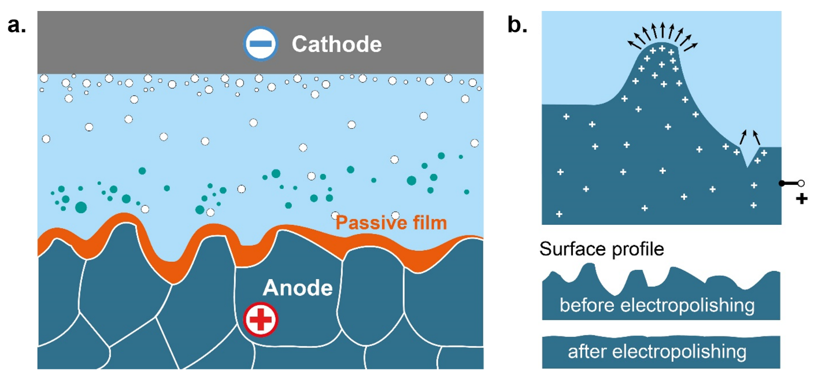
Electrochemical polishing is a process developed for improving the surface quality of conductive materials. This is an approach widely used in the field of electrochemical technologies where high precision and quality of the surfaces is required.^{28,29} Typically, the employed electrode process is oxidation, i.e. the material aimed to be polished is the anode. The basic principle is shown in Figure S2.
Supplementary Figure S2 | Basic principles of electrochemical polishing. a. General scheme of an electrochemical cell for electropolishing. b. Electric field distribution and surface profiles of the samples before and after polishing procedure.

The initially rough anode surface is oxidized, if using materials prone to passive film formation (such as Ti, Ta, Ti, etc.). Increasing the anodic potential leads to selective dissolution of the protruded metallic peaks, due to the local increase of the electric field, and correspondingly to enhanced rate of the electrochemical dissolution in these locations. The electrochemical polishing technology results in formation of smooth surfaces of high quality. The process, and respectively the shape and quality of the anode, can be controlled by variation of the current density, applied voltage, electrolyte composition/concentration and the temperature. In case that materials should be polished not forming oxides in the selected voltage region (i.e., noble metals) one can use additives that adsorb at the electrode surface to form a passive film, similarly to the effect of the oxidation of non-noble metals. Figure S3 illustrates the effect of electropolishing in memristive devices. When comparing the current-voltage behaviour during SET and RESET it becomes obvious that the formation of the filament (SET) is an abrupt process that cannot be controlled. The growth of the filament occurs at conditions of high electric fields and current densities. As the filament is growing the electric filed even increases, due to the decreasing distance between filament and electrode (at same applied voltage). Despite the main charges determining the measured currents are electrons, ionic current cannot be neglected. Electrochemical reactions and ion transport are field accelerated and exponentially dependent on the field. These conditions lead to situation where the growth of the filament cannot be effectively controlled and tailored.
In contrast, the process of dissolution of the filament is not abrupt and nearly gradual. Despite the initial total currents are comparable to the SET currents, they are practically almost purely electronic. This leads to a pronounced heating (Joule effects), however no exponential acceleration of the redox reactions and ionic transport is present. Exploiting the principle of electrochemical polishing, the electrochemical oxidation/dissolution first starts with the atoms/clusters from the filament that are less stable and with high surface free energy (the process is supported by the locally increased temperature, lowering the required oxidation potential) and then continues to the more stable core of the filament, until it finally breaks the contact.
Analysing this behaviour, we concluded that filament strength and size, can be much better controlled during the RESET (dissolution), using the electropolishing effect. Limiting the RESET voltage to less negative values lead only to removing of unstable atoms and needles from the filament but not dissolving its core.

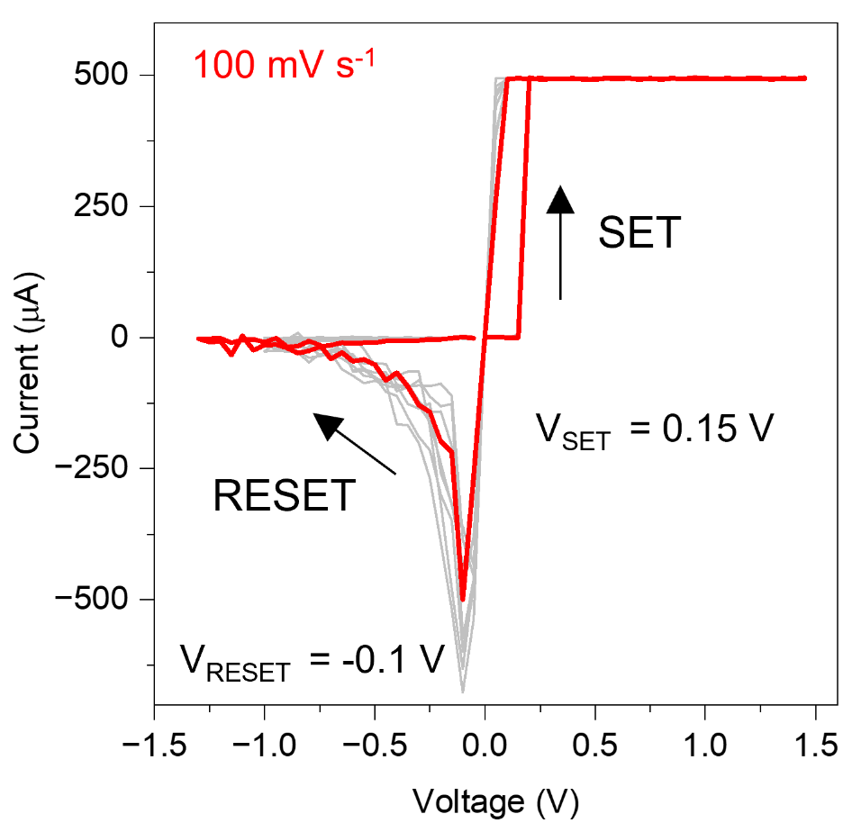
Supplementary Figure S3 | Typical resistive switching characteristics of Ag/SiO₂/Pt memristive devices. The hysteretic I-V resistive switching curve under voltage sweep stimulation is characterized by an abrupt current transition during SET process (here a current compliance of 500 µA is applied to prevent hard breakdown of the device) and by a gradual current transition during RESET process exampling the electrochemical polishing effect.

4. Modeling approach
The stochastic resistive switching model is based on Chua’s approach³⁰ to memristors and it is based on two equations, one for the current and one for the internal memory variable. In our case, the memory state variable is the number of conducting channels, $n_{ch}$, each of these channels contributing with ${\sim G}_{0}$ to the filament conductance. In a naïve interpretation, each of these channels can be considered either as “atomic chains” or as “quantized quantum transport modes” in the filament constriction. This is a simple implementation of the Landauer theory for ballistic transport through an atomic-size constriction³¹. We consider that the set/reset transitions occur by successive discrete conductance jumps (events) corresponding to the creation/destruction of single conduction channels. For simplicity, we assume that each switching event increases or decreases the conductance by the same amount. However, this might not be completely realistic because several channels can be created/destroyed at the same time. During the reset transition we will consider that each jump is ${ΔG=G}_{0}$. Given the experimental results, we impose that the first set event is abrupt so that the device reaches the compliance limit in a single conductance jump. The creation/destruction of single channels will occur at random times during the application of the external electrical signal (voltage/current). For the sake of generality, we limit the number of channels to $n_{max}$. This parameter is related to the maximum area of the filament created during electroforming. Under these conditions, the proposed memory equation is:
$\frac{dn_{ch}}{dt}=\frac{n_{max}-n_{ch}}{τ_{S}}-\frac{n_{ch}}{τ_{R}}$ (1)
where the two terms of the Right-Hand Side (RHS) represent the set and reset transitions, and $τ_{S}$ and $τ_{R}$ are the set and reset characteristic times, respectively. Since the set transition resembles the dielectric breakdown process and it is strongly accelerated by the electric field, an exponential voltage dependence for $τ_{S}$is assumed:

$τ_{S}(V)=τ_{S0}exp\left[-γ_{S}(V-IR_{S})\right]$ (2)

where $γ_{S}$ is the acceleration factor, $τ_{S0}$ the time scale prefactor and $R_{S}$ the series resistance. On the other hand, consistently with the electropolishing interpretation, the reset transition is assumed to be controlled by the oxidation/reduction dynamics and/or by the out diffusion of species to the filament surroundings. Since both processes are strongly accelerated by temperature, we neglect voltage acceleration (as discussed within the electropolishing interpretation) and we only consider the local temperature rise related to the power dissipated in the filament, $P=I\left(V-IR_{S}\right)$. Assuming an Arrhenius temperature dependence as a first order approximation, the characteristic reset time, $τ_{R}$, can be described as:

$τ_{R}\left(V\right)=τ_{R0}exp\left[\frac{E_{a}}{K_{B}(T+R_{TH}P)}\right]$ (3)

where $τ_{R0}$ is the reset scale prefactor, $E_{a}$the activation energy, $T$ the external temperature and $R_{TH}$ the thermal resistance. The thermal resistance has been described in the literature in terms of two parallel paths for heat evacuation.³² The longitudinal thermal resistance, $R_{L}$, corresponding to heat transport along the channel (related to the electrical conductivity) and the transversal resistance, $R_{T}$, associated to heat transport towards the surrounding material. The latter is independent of the filament size to the first order, while $R_{L}$ is inversely proportional to the filament area, represented here by $n_{ch}$, which is proportional to the area. Thus, we can write $R_{L}=K_{L}/n_{ch}$, where $K_{L}$ is a constant. The total thermal resistance is given by the parallel combination of $R_{L}$ and $R_{T}$, so that $R_{TH}=\left(K_{L}R_{T}\right)/\left(n_{ch}R_{T}+K_{L}\right)$.
Since $τ_{S}$ has a strong exponential dependence on voltage it comes out that $τ_{S}≪$ $τ_{R}$ for positive voltages and $τ_{S}≫$ $τ_{R}$ for negative voltages. Because of this, we can separately consider the set and reset transitions with two separate differential equations. One for the set:
$\frac{dn_{ch}}{dt}=\frac{n_{max}-n_{ch}}{τ_{S}}$ (4)
And one for the reset:
$\frac{dn_{ch}}{dt}=-\frac{n_{ch}}{τ_{R}}$ (5)
As far as the current is concerned, we have considered:

$I\left(V\right)={\frac{n_{ch}G_{0}}{1+n_{ch}G_{o}R_{S}}V+I}_{B} sinh\left[η\left(V-IR_{S}\right)\right]$ (6)
where $η$ is a shape parameter related to the potential barrier at the constriction when there are no conducting channels. The first term corresponds to the conduction through the $n_{ch}$channels, and the second to the background tunneling regime, i.e. when the filament has a gap. Although the considered voltage dependence of the background current can be discussed, this is not relevant to our work because we focus on situations where there is at least one conducting channel with a conductance which is generally much larger than that of the background. Finally, notice that $n_{ch}$ couples the current and memory equations.
For the generation of random events, we follow an “on-the-fly” method. If the number of events (conductance jumps) is $n\left(t\right)$, the event generation rate is $λ\left(t\right)={dn\left(t\right)}/{dt}$. During the set transition, $n_{ch}=n\left(t\right)$ so that $λ\left(t\right)={dn_{ch}}/{dt}$ while during reset $n_{ch}=n_{max}-n\left(t\right)$, so that $λ\left(t\right)={-dn_{ch}}/{dt}.$Thus, the event generation rates can be obtained from (4) and (5) so that $λ_{S}={{(n}_{max}-n_{ch})}/{τ_{S}}$ and $λ_{R}={n_{ch}}/{τ_{R}}$ during set and reset, respectively. Since $n_{max}>n_{ch}$ at any time, both generation rates are always positive as they must be. For the reset transition, we will depart from an initial number of channels, $n_{init}$ which are the ones generated during the previous set transition.
The events are generated with a random number $u$ uniformly distributed between 0 and 1 along the simulation time. The simulation time is discretized in steps $Δt$ which are small enough so that $λ$(t) can be assumed to be constant during $Δt$. It can be shown that under these conditions, the random time to a subsequent event at time $t$ is $Δt_{u}=-{Ln(u)}/{λ(t)}$. During the simulation, if $Δt_{u}<Δt$ an event is generated at time $t$, otherwise, the event is rejected.

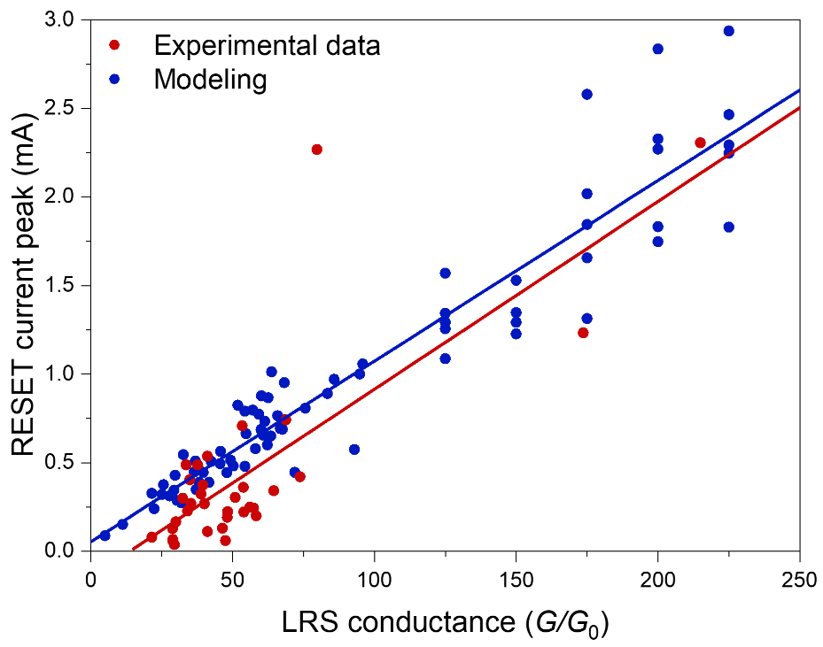
With this model, the experimental I-V SET/RESET loops and the conductance reset transients of Figures 3c and 3d can be simulated, showing a very good agreement between theory and experimental data. By considering selected I-V loops obtained by different partners during the interlaboratory comparison (with the same measurement protocol characterized by stimulation of the device with a voltage sweep rate of ~ 100 mV/s and 2 mV/s during the SET and RESET sub cycles, respectively, and current compliance of 500 µA during SET operation), a strong correlation between the conductance reached at the end of the set transition and the shape of the reset transition is observed. This correlation can be represented by the dependence of the reset current peak on the conductance at the beginning of the reset cycle. Figure S4 demonstrates that the model can capture this experimental correlation by changing the value of $n_{init}$. This gives strong support to our modelling approach.

Supplementary Figure S4 | Correlation between current peak during RESET and low resistance state (LRS) of the device after SET. Comparison of experimental results and modeling.
5. Experimental and modeling RESET characteristics
Figure S5 a shows examples of experimental I-V RESET characteristics obtained during the interlaboratory comparison (data from different labs), while Figure S5 b shows results from the stochastic modeling. As can be observed, the model can reproduce the variability of experimental results.
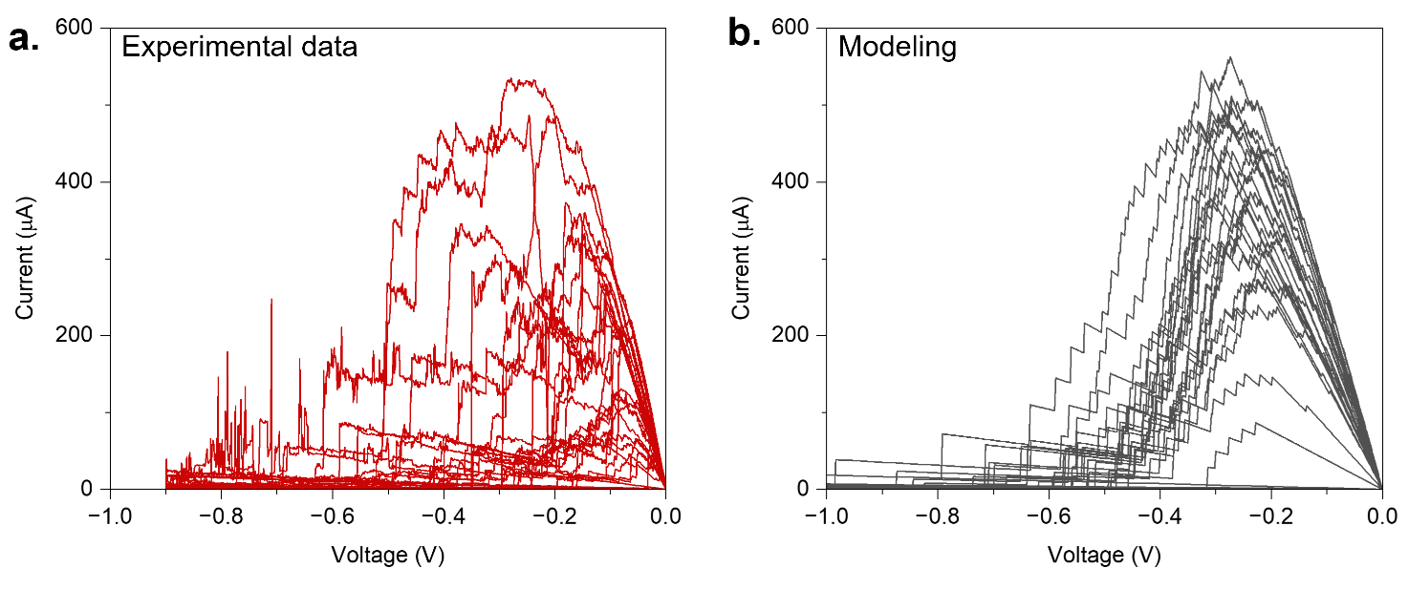
Supplementary Figure S5 | Experimental and modeling RESET characteristics. a. Selected experimental curves obtained during the interlaboratory comparison (curves from different labs) and b. Results obtained by modeling, here a Gaussian distribution of $n_{init}$ was employed to cover the full range of situations at the beginning of the reset cycle. In both panels, current is represented in absolute value.

To complement the results shown in Figure 3c and 3d, we report in Figure S6 examples of experimental and modeling curves for the I-V RESET transition and the related conductance transients at the final stage of the RESET. Of course, being a stochastic approach, the exact values of conductance and the time location of the conductance jumps cannot be matched to experiments. However, these results show that the model can capture the main trends of the experimental RESET transitions.

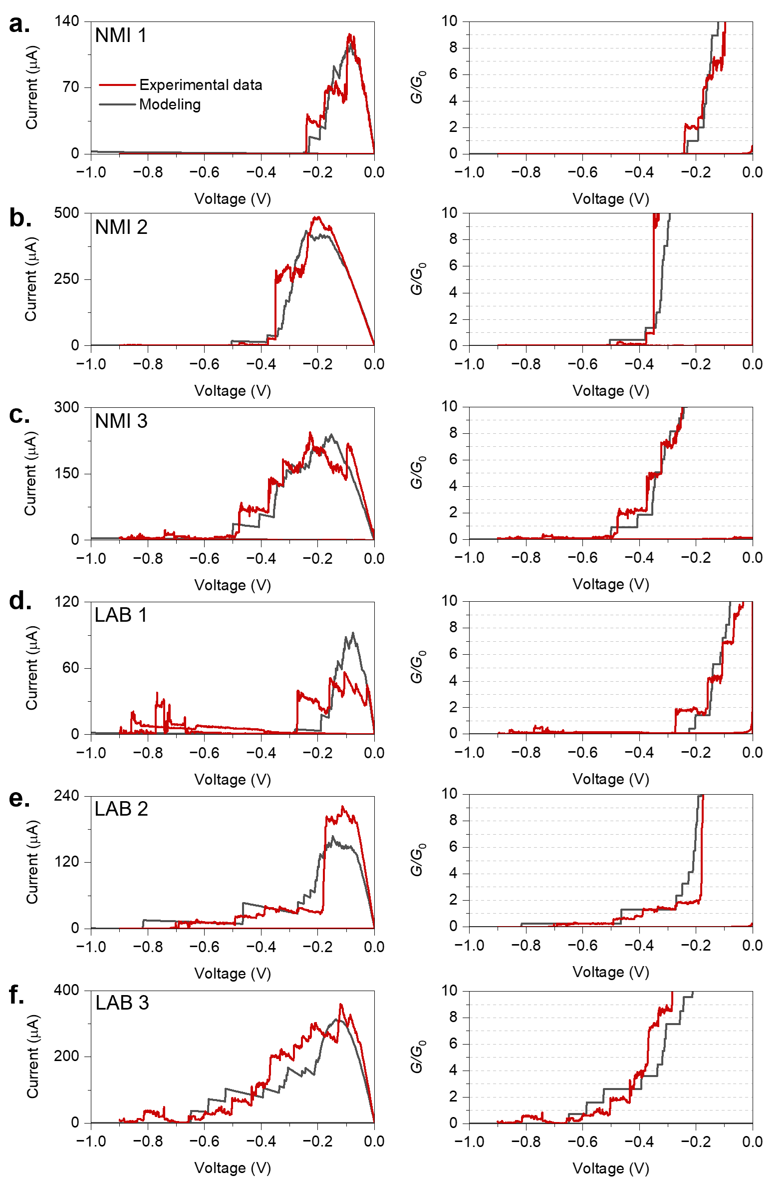
Supplementary Figure S6 | Fitting RESET transitions from different laboratories. a-f. Fitting of selected experimental I-V characteristics obtained by different labs with the same measurement protocol. Red lines are experimental results, black lines are model simulations. Left panels show the RESET I-V characteristics, right panels the evolution of conductance at the end of the RESET process.
6. “Program and verify” approach
The “program and verify approach” was exploited to program the device in a desired quantum conductance level. An example of device programing with this approach is reported in Figure S7. This approach consists in the following steps: i) SET of the device through a positive voltage sweep cycles in between 0 and 1.5 V (sweep rate of 96 mV/s, compliance current of 500 µA externally controlled to avoid hard breakdown of the device); ii) RESET the device through a negative slow voltage sweep (2 mV/s) from 0 down to -0.9 V to achieve a step-like decrease of device conductance due to quantum conductance effects; iii) READ of the desired quantum level with a continuous constant voltage, if the exit condition has been satisfied during the RESET step, the RESET cycle is interrupted and the control changes to a continuously positive read voltage of 10 mV. The exit condition is considered satisfied if the device exhibit during the time series at least 5 consecutive conductance measurements in the desired quantum level ± 0.5 $G_{0}$. Note that the device is continuously cycled until the desired quantum level has been obtained.

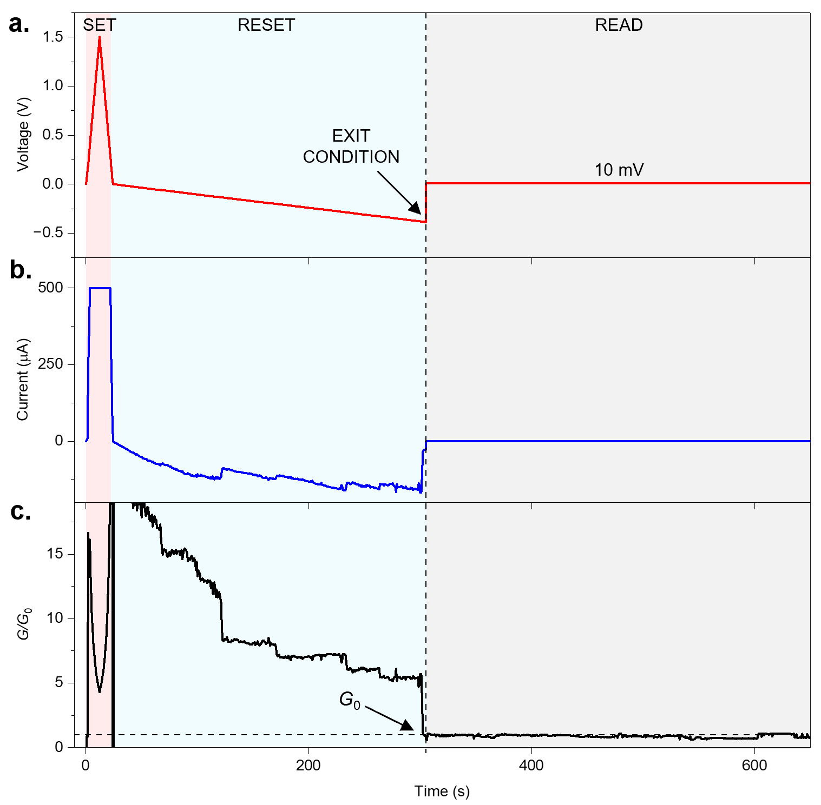
Supplementary Figure S7 | Program and verify approach to program the device to desired quantum conductance levels. This includes the SET of the device (red shadowed region), gradual RESET of the device to achieve quantum conductance levels (grey shadowed region), and READ the device with a constant voltage (10 mV) after that an exit condition is satisfied (i.e., after that the device is programmed in the desired quantum conductance level.).

7. “Program and verify” approach for practical realization of a voltage standard based on Josephson effect
DC Voltage standards based on Josephson effect have been used as voltage primary standard for decades.³³ Its operation relies in the activation of junctions of superconductor-insulator-superconductor materials in an array. The generated dc voltage across the array correspond to quantum values multiples of the Josephson constant (K_{J} = 2e/h), V_{n} = n f / K_{J}, where n is an integer related to the number of activated junctions and f is the microwave frequency applied to the device. The process to activate the junctions is achieved through the application of a sweep voltage between zero and the desired voltage step value V_{n} for several cycles. The amplitude of the sweep voltage will control the number n of activated junctions and therefore the desired quantum voltage step. When this sweep signal is stopped, a number n of junctions will remain activated, and the corresponding voltage is fixed at the device terminals. To confirm the success of the process and the right number of activated junctions, the voltage at the device terminals is roughly measured to identify the corresponding nearest integer $n$ which easily reveals the exact Josephson Voltage step. For example, if f = 70.0 GHz, V_{n+1} - V_{n} ≈ 145 µ V and this means that a measure of V_{n} with a resolution of half of 145 µV is enough to allow the identification of the achieved step. If that does not correspond to the desired step, the process of activation is repeated and checked again.

8. Stability of programmed quantum conductance levels
Figure S8 reports an example of a quantum conductance level programmed with the program and verify approach that have been observed to be stable for > 2000 s when read with a continuous constant voltage of 10 mV.
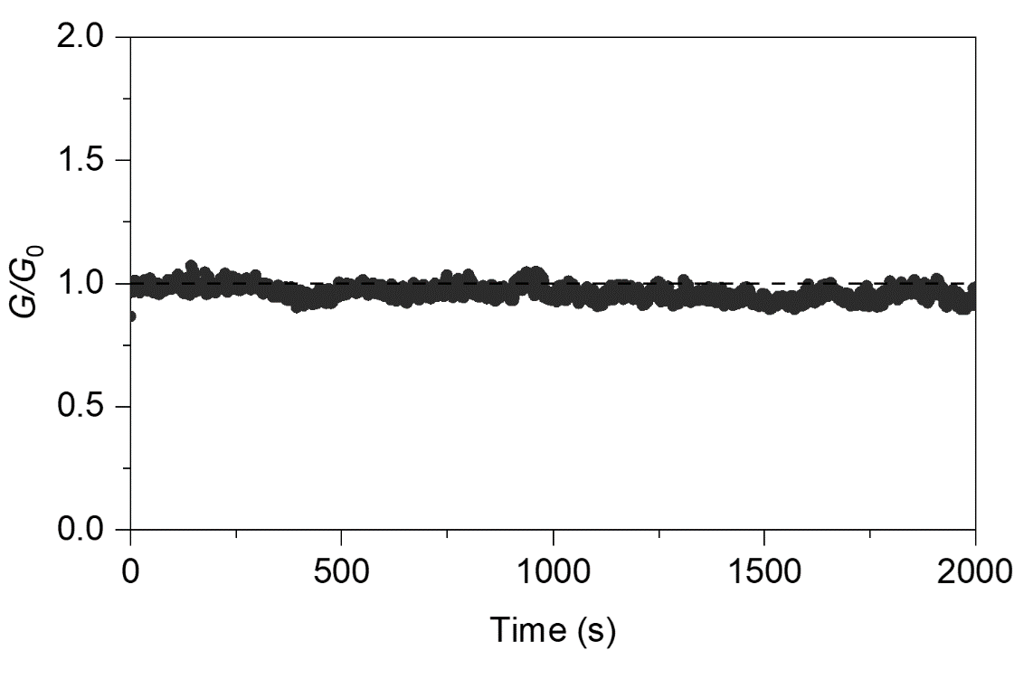
Supplementary Figure S8 | Stability of programmed quantum conductance levels. Example of a quantum conductance level observed to be stable for > 2000 s under constant voltage reading of 10 mV (initial data are reported in Figure 3a). Dashed line represents the $G_{0}$ reference value.

9. Evaluation of repeatability of the quantum conductance value
The conductance value for each quantum level has been evaluated using an average of multiple consecutive measurements, after an initial stabilization period of 10 measurements. For this purpose, 30 to 100 consecutive measurements were considered. Depending on the experimental setup and measurement parameters, the acquisition of consecutive data is in the range ~ 10 – 120 s. The variability over these consecutive measurements have been exploited to evaluate repeatability of the quantum conductance level.
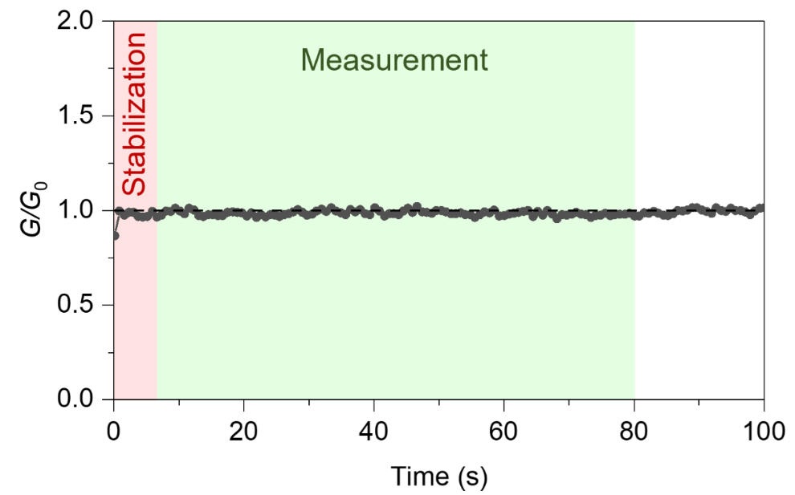
Supplementary Figure S9 | Evaluation of repeatability of the quantum conductance value. The repeatability has been evaluated based on consecutive measurements (from 30 to 100 measurements) while applying a constant reading voltage of the device of 10 mV, discarding initial 10 measurements where device stabilization can occur.

10. Specification of equipment and corresponding measurement accuracy.
Table T1 reports instrument specifications in the measurement conditions exploited for the measurement of quantum conductance level values, and the corresponding measurement accuracy exploited for the evaluation of the measurement uncertainty related to the measurement equipment.

Supplementary Table T1 | Specification of equipment and corresponding measurement accuracy.
Participant | Equipment | Voltage accuracy  ± (%reading + volts) | Current accuracy  ± (%reading + amps)
Specification corresponding to 1 µA range used in the $G_{1}$ group of measurements
LAB 1 | Keithley 6430 | 0.012 % + 350 µV | 0.05 % + 300 pA
LAB2 | Keithley 4200 SCS-AC | 0.012 % + 100 µV | 0.05 % + 100 pA
NMI 1 | Keithley 4200 SCS-AC | 0.012 % + 100 µV | 0.05 % + 100 pA
LAB 3 | Keithley 4200 SCS-AC | 0.012 % + 100 µV | 0.05 % + 100 pA
NMI 2 | Keithley 2400 | 0.012 % + 300 µV | 0.029 % + 300 pA
NMI 3 | Keysight B1500A | 0.01 % +120 µV | 0.05 % + 100 pA + 0.1%V₀
Specification corresponding to the 10 µA range used in the $G_{2}$ group of measurements
LAB 1 | Keithley 6430 | 0.012 % + 350 µV | 0.05 % + 2 nA
LAB2 | Keithley 4200 SCS-AC | 0.012 % + 100 µV | 0.05 % + 600 pA
NMI 1 | Keithley 4200 SCS-AC | 0.012 % + 100 µV | 0.05 % + 600 pA
LAB 3 | Keithley 4200 SCS-AC | 0.012 % + 100 µV | 0.05 % + 600 pA
NMI 2 | Keithley 2400 | 0.012 % + 300 µV | 0.027 % + 700 pA
NMI 3 | Keysight B1500A | 0.01 % +120 µV | 0.04 % + 2 nA + 1%V₀

11. Quantum conductance levels measured in the interlaboratory comparison
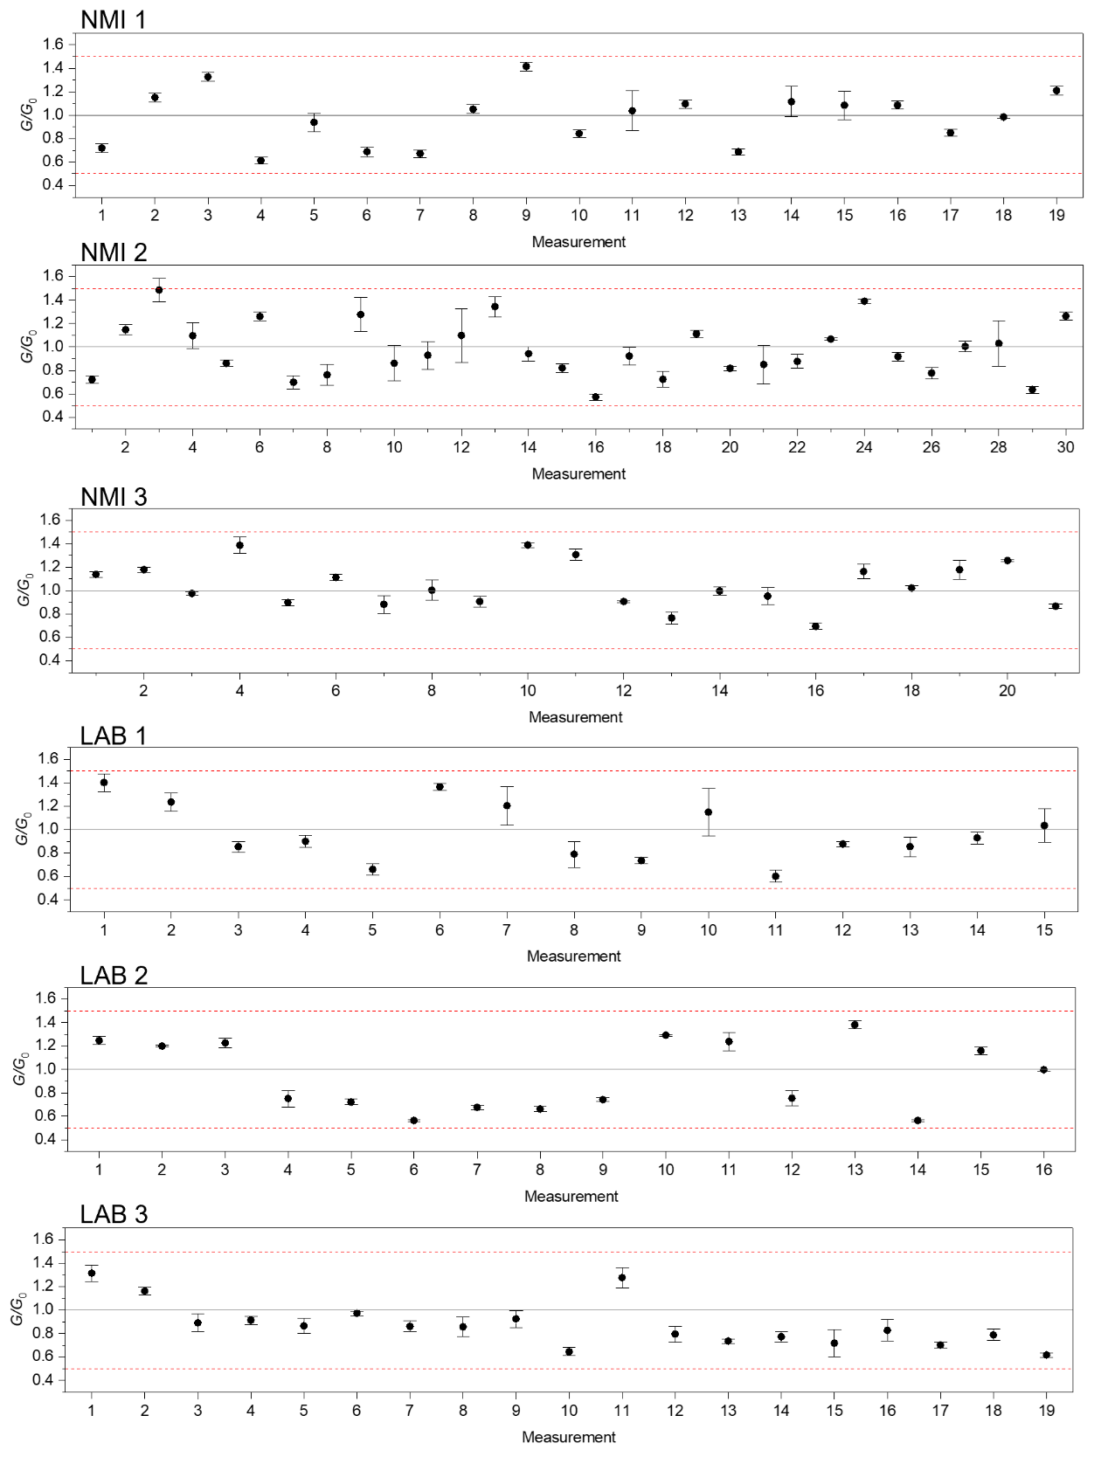
Figure S10 and S11 reports the complete set of quantum levels measured with a program and verify approach for each participant of the interlaboratory comparison.
Supplementary Figure S10 | $G_{1}$ conductance plateaus related to the $G_{0}$ quantum level from the interlaboratory comparison. For each data point, the standard deviation represents the repeatability evaluated over repeated measurements of the same conductance value. Red dashed lines represent boundaries of the exit condition of the program and verify approach, while grey line represents the $G_{0}$ reference line.
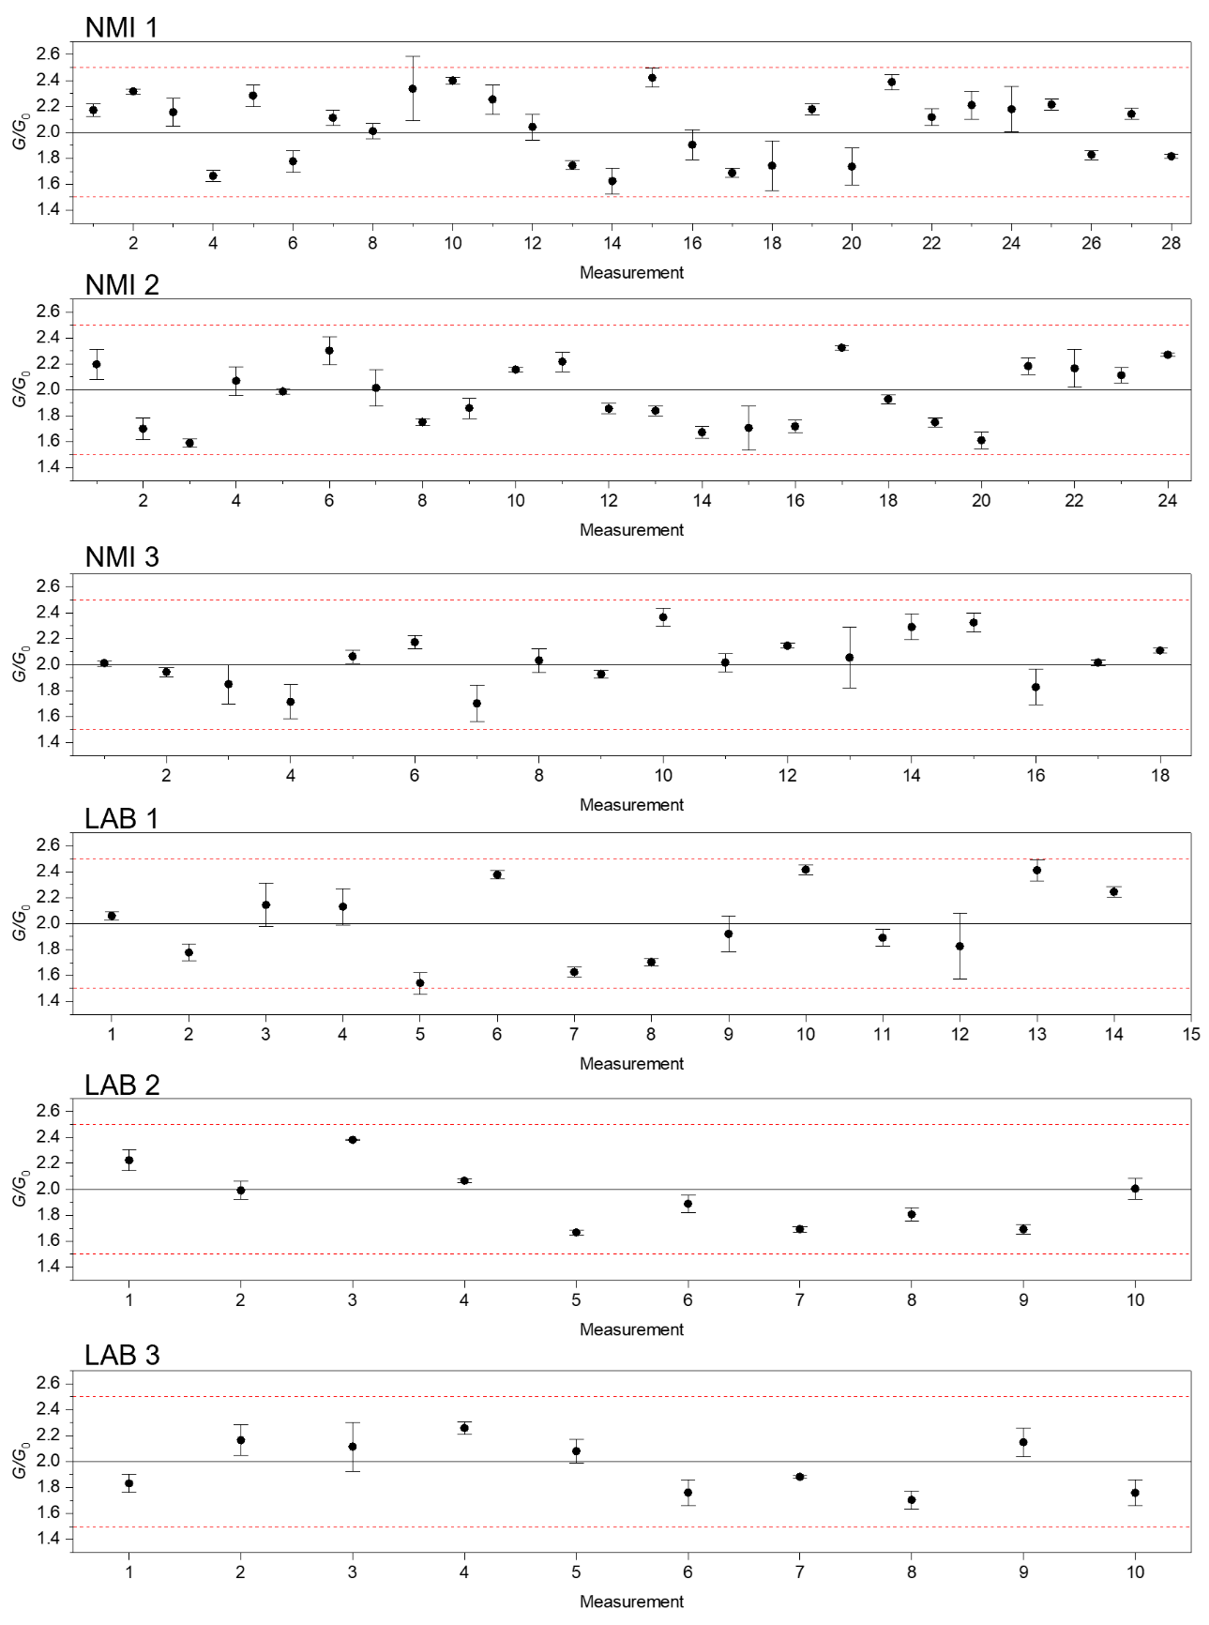
Supplementary Figure S11 | $G_{2}$ conductance plateaus related to the 2 $G_{0}$ quantum level from the interlaboratory comparison. For each data point, the standard deviation represents the repeatability evaluated over repeated measurements of the same conductance value. Red dashed lines represent boundaries of the exit condition of the program and verify approach, while grey line represents the 2$G_{0}$ reference line.

12. Statistical validation of the programming methodology
A key claim of this work is that there are stable conductance states related to the quantum of conductance $G_{0}$and that these states can be programmed to implement a standard of resistance only related to universal constants of nature. To this purpose, a read & verify procedure has been proposed which selects only a conductance state $G$ in the $0.5G_{0}<G<1.5G_{0}$ range. However, this procedure needs to be statistically validated. In the present discussion, we focus on the analysis of the quantum conductance level related to $G_{0}$ state, but we have checked that the case of the quantum conductance plateaus related to ${2G}_{0}$ is fully equivalent. Our aim is to analyze the measured statistical data (117 stable conductance values related to $G_{0}$ obtained in different laboratories, refer to Figure S10) to confirm that there is a preferred conductance state around $G_{0}$.
The main objection that can be made to the methodology of programming the conductance states with a read & verify procedure is that it will always select conductance states in the established range no matter whether there is real conductance peak around $G_{0}$ or not. The question is that even in the extreme case of a uniform distribution of conductance in the considered range, the mean of the statistical distribution would be $G_{0}$.
Let us assume, for the time being, that there are preferred atomic-size configurations of the filament with a conductance $\sim G_{0}$. Of course, a dispersion around this value is expected because slightly different structural dispositions of the filament atoms would give rise to different transmission coefficients. We will make the analysis in terms of the normalized conductance $x=G/G_{0}$ and we start with the hypothesis that there is an intrinsic gaussian distribution (the parent distribution) with mean value $\overline{x_{p}}=1$ and standard deviation $σ_{p}$. The terms “intrinsic” or “parent” mean that no external selection constraints (no “program and verify” process) are applied.
Assuming that there is an intrinsic gaussian peak and applying a read & verify procedure that establishes lower and upper conductance boundaries $(1-Δx<1<1+Δx)$, we expect to find a truncated gaussian distribution in the experimental results, $Δx$ being the truncation or censoring interval. If $σ_{p}≪Δx$, the experimental distribution would be equal to the parent distribution but, otherwise, the truncated distribution would not be Gaussian and, in the limit $σ_{P}≫Δx$, it would converge to the uniform distribution. This is illustrated in Figure S12 where the parent probability density function is compared with that of the truncated distribution for three different values of $σ_{p}$ which almost cover the full range from the gaussian to the uniform distributions.
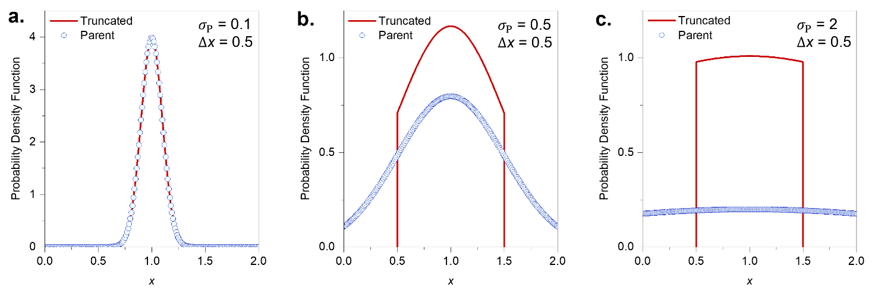Supplementary Figure S12 | Comparison of parent and truncated distributions. a-c. Comparison of parent and truncated distribution for different values of the standard deviations and the same truncation interval $\overline{x}±0.5$ .

In the experiments, we have considered $Δx=0.5$, and the mean and standard deviation directly obtained from the data are ${\overline{x}}_{exp}=0.96$ and $σ_{exp}=0.23$. The analysis in terms of the Gaussian distribution, $Φ(x)$ can be performed with the normalized $Φ^{-1}\left(F\right)$ versus $x$ plot, and the extracted parameters are $\overline{x_{G}}=1$ and $σ_{G}=0.24$. On the other hand if the distribution were uniform, the expected parameters would be $\overline{x_{u}}=1$ and $σ_{u}={2Δx}/{\sqrt{12}}$ so that, for $Δx=0.5$, $σ_{u}=1/\sqrt{12} \sim 0.29.$ While the parameters extracted from the gaussian analysis coincide with the experimental results, there is a discrepancy between $σ_{u}$ and $σ_{exp}$. This discrepancy is consistently observed in the data of the different laboratories and for the conductance state related to $2G_{0}$, as shown in Figure S13a.
On the other hand, we have randomly simulated the truncated distribution by emulating the “program and verify” procedure as a function of $σ_{p}$. In Figure S13 we show the standard deviation of the parent distribution as a function of $σ_{p}$ and we compare the results with those expected for purely gaussian and purely uniform distributions. According to these results, the experimental value, $σ_{exp}=0.23,$would correspond to a gaussian distribution with $σ_{p}=0.3$. Notice that, consistently to what is qualitatively shown in Figure S12, the truncated distribution converges to the uniform/gaussian distributions for wide/narrow parent distributions, respectively. Moreover, it is also evident that our experiments are in the transition region between these two limits.
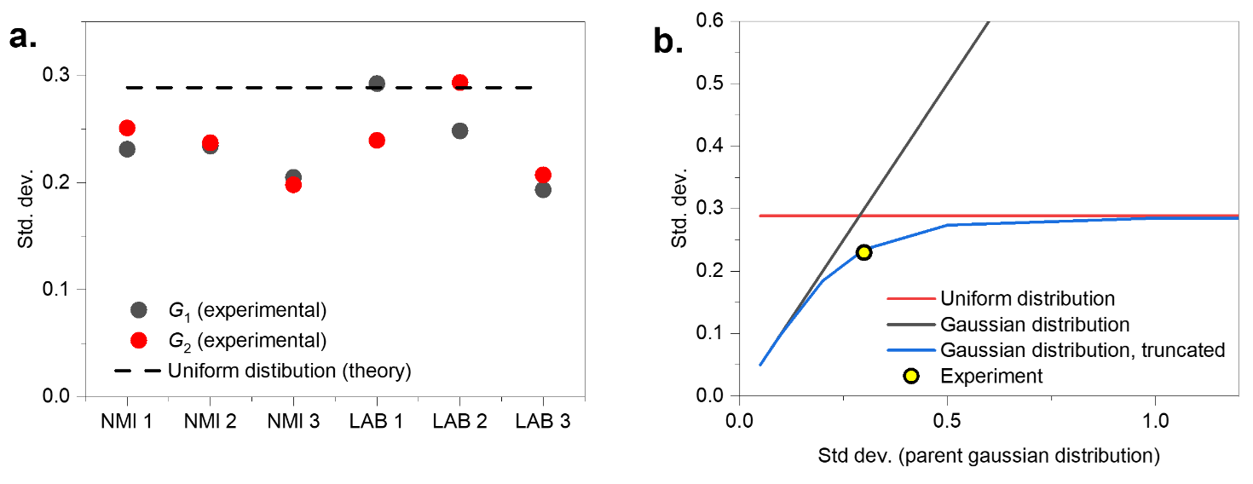
Supplementary Figure S13 | Comparison of experimental results with gaussian and uniform distributions. a. Comparison of the values of the standard deviation $σ_{exp}$ obtained in all the laboratories involved in the interlaboratory experiment with the value expected for a uniform distribution. b. Standard deviation of the truncated distribution as a function of the standard deviation of the assumed gaussian parent distribution. The limits of purely gaussian (narrow parent distribution) and purely uniform (wide parent distribution) are also shown for comparison. The experimental point is found in the transition between the two limits.

Having concluded that the experiments are consistent with a gaussian parent distribution with $σ_{p}\sim 0.3$, we can now study the impact of the censoring interval $Δx$ through simulations of the truncated distribution. This is a complementary way to look at the same subject represented in Figure S13b. Now, $σ_{p}$ is kept fixed at 0.3 and $Δx$ is the independent variable. As shown in Figure S14a, the truncated distribution converges to a purely gaussian at large values of $Δx$ and to a uniform distribution for small values of $Δx$. Again, the experimental results are in the transition region between both limits. As previously mentioned, although the difference between $σ_{exp}$ and $σ_{u}$ is not very large, it is consistent with our analysis of the truncated distribution and can be assumed to be significant to confirm that the probability density distribution has a peak in the considered conductance range.
While we cannot change the standard deviation of the parent distribution because it is an intrinsic property of the conductance statistics, we can decide which the truncation interval is. However, there are limits related to programming efficiency and overlapping between conductance peaks. If $Δx$ is increased, the overlapping with the following peak (in our case with the $2G_{0}$ peak) increases. We have estimated that the overlapping with the $2G_{0}$ peak is about 5% for $Δx=0.5$, a value that is very reasonable given the rather large value of the standard deviation of the parent distribution as compared with the separation between the conductance peaks. Moreover, increasing the censoring interval would increase the standard deviation of the experimental results which is undesirable for the application of a resistance standard. On the other hand, if $Δx$ is decreased, the standard deviation of the experimental distribution would decrease (something that is good for the resistance standard) but the number of reset cycles required to reach the desired level would increase. It can be demonstrated that this number of cycles scales with $1/{(Φ\left(1+Δx\right)-Φ\left(1-Δx\right))}$ and this explodes below $Δx=0.25,$as also shown in Figure S14. Thus, there is still room to decrease the standard deviation of the resistance standard by choosing $Δx<0.5$. However, as shown in Figure S14a, the discrimination between the gaussian and the uniform distributions would be even more difficult for smaller values of $Δx$. Thus, $Δx=0.5$ is a rather optimal choice to obtain a reasonable standard deviation of the experimental results, to keep the programming efficiency under control and to discriminate between gaussian and uniform distribution, providing evidence of the existence of the intrinsic $G_{0}$ (and $2G_{0}$) conductance peaks.
Finally, Figure S14 shows the parent and truncated distributions for the case of $σ_{P}=0.3$. Notice that, in this case, the truncated distribution is close to gaussian. This is the reason why the analysis of the experiments in terms of a gaussian distribution provides very good results.

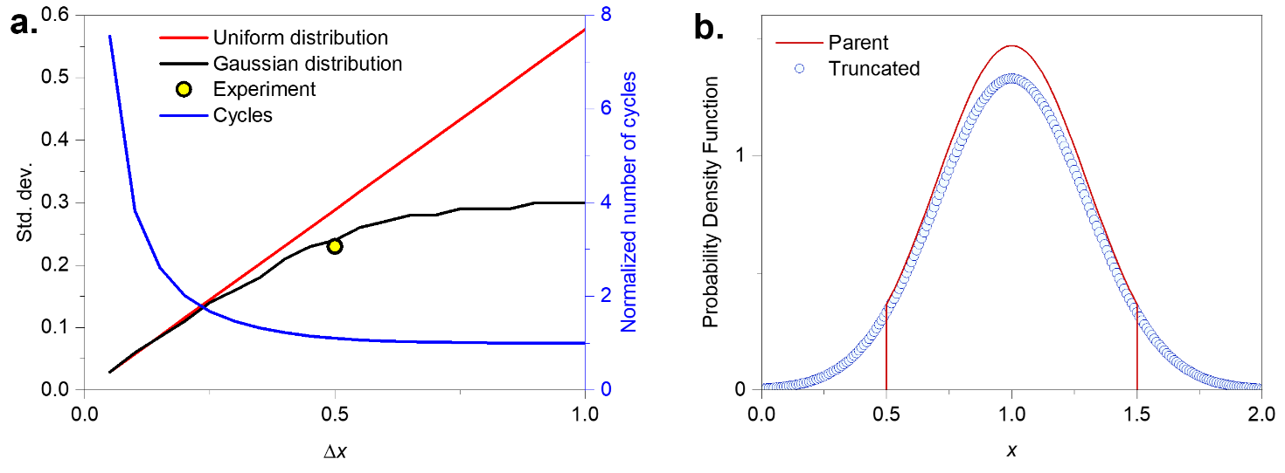Supplementary Figure S14 | Effect of the censoring interval in the program and verify approach. a. Standard deviation of the truncated distribution as a function of the censoring interval $Δx$: gaussian parent distribution with $σ_{p}=0.3$ (red); uniform distribution (blue); experimental result (yellow dot) and normalized number of programming cycles (black). b. Truncated and parent distributions for $σ_{p}=0.3$.

In conclusion, the analysis of the experimental results in terms of a gaussian distribution truncated by the censoring interval of the program and verify protocol has allowed us to show that there is an intrinsic conductance state centered at $G_{0}$. This validates our experimental protocol and confirms that the obtained results can be traced back to the quantum of conductance which only depends on universal constants of nature.

13. Measurement repeatability and time interval of consecutive measurements
Figure S15a and b report the repeatability of $G_{2}$ and $G_{1}$ evaluated in terms of standard deviation of consecutive measurements of conductance values (30 to 100 consecutive measurements). In case of equal number of consecutive measurements, different measurement time intervals arise from different sample rate of measurement arising from different experimental equipment and parameters exploited for the interlaboratory comparison. As can be observed, no significant trend can be observed in the standard deviation as a function of the measurement time interval, suggesting that the repeatability can be evaluated based on consecutive measurements performed on a small-time interval.
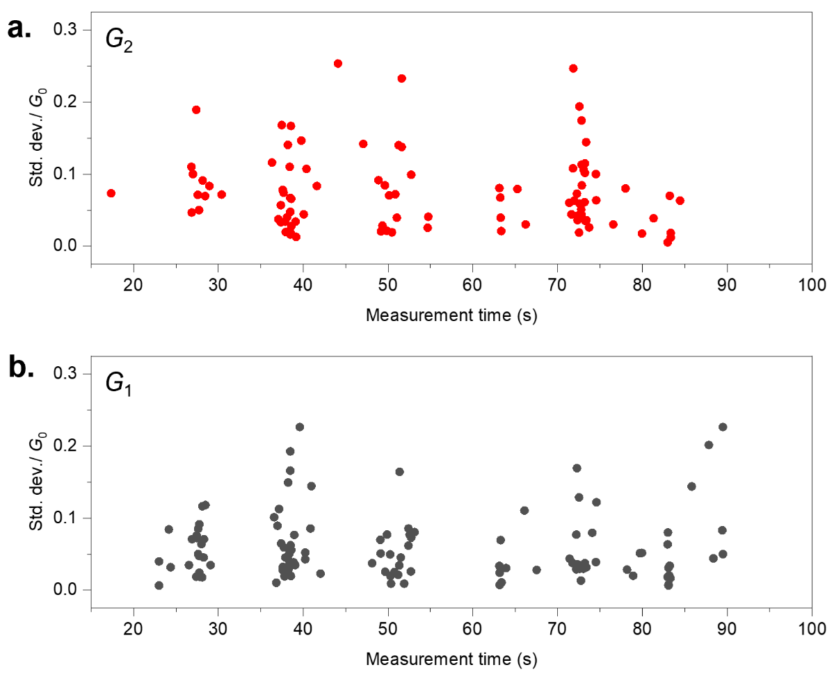
Supplementary Figure S15 | Measurement repeatability and time interval of consecutive measurements. Repeatability in terms of standard deviation of consecutive measurements evaluated for conductance levels related to 2$G_{0}$ (panel a.) and to $G_{0}$ (panel b.). Each point has been evaluated by programming the device to a desired programmed quantum level and then evaluating the standard deviation of consecutive measurements of the conductance step. Graphs have been obtained through aggregated data analysis of results obtained by different labs in the interlaboratory comparison.

14. Cycle-to-cycle and device-to-device variability
The results reported in the interlaboratory comparison by each participant come from sets of mixed measurements of cycles made in the same device and in several devices. The analysis of variability through the standard deviation of the measurements mixed the variability from cycle-to-cycle (different cycles taken the same device) and device-to-device (different cycles from various devices). To distinguish these two sources of variability, the results corresponding to a number of cycles taken in just a single device were compared with the results mixing up several devices. For this purpose, Table T2 compares the standard deviation obtained over multiple cycles of the same device that reflect only the cycle-to-cycle variability (measurements performed by NMI 3 and LAB 3), with results obtained by considering measurements performed over different devices.
For the cases $G_{1}$-NMI 3 and $G_{2}$-LAB 3 the standard deviation has similar value, 0.20 $G_{0}$ and 0.21 $G_{0}$, respectively. In the other case 1G0-LAB 3 and 2G0-NMI 3, the standard deviation values decreased slightly to 80 % and 88 %, respectively, of the standard deviation for the total number of cycles. It is worth noticing that for all the cases, the difference between the corresponding mean values is fully covered by the combined standard uncertainties of the mean which shows that the random process still to be estimated adequately by the calculated standard deviations.
Comparing the observed values of 0.20 $G_{0}$ for $G_{1}$ and 0.21 $G_{0}$ for $G_{2}$ with the other values of the table obtained by the other participants we can find a comparative base where the measurements result from a higher number of different devices. For example, the 0.20 $G_{0}$ could be compared with 0.23 $G_{0}$ from NMI 1 obtained from 10 devices and the 0.21 $G_{0}$ could be compared with the 0.24 $G_{0}$ from NMI 2 obtained from 12 devices or the same value 0.24 $G_{0}$ of LAB 1 obtained from 8 devices.
We can conclude that small differences (13 % and 11 %) are observed between the variability of the quantized conductance values obtained from measurements where both random effects of cycle-to-cycle and device-to-device are present, and the measurement are mainly affected by cycle-to-cycle effect. This means that the dominant effect of variability is related to stochastic effects during the formation of the conductive filament.
Supplementary Table T2 | Evaluation cycle-to-cycle and device-to-device variability.
Participant | Mean value  ${G̿}_{j}$ / G0 | Std. Dev.  S / G0 | Nbr. of values  N | Nbr. of values  N
$$G_{1}$$
NMI 1 | 0.98 | 0.23 | 19 | 10
NMI 2 | 0.98 | 0.23 | 30 | 10
NMI 3 | 1.04 | 0.20 | 18 | 2
NMI 3 (single device) | 1.02 | 0.20 | 15 | 1
LAB 1 | 0.95 | 0.29 | 16 | 10
LAB 2 | 0.97 | 0.25 | 15 | 5
LAB 3 | 0.88 | 0.19 | 19 | 3
LAB 3 (single device) | 0.83 | 0.15 | 16 | 1
$$G_{2}$$
NMI 1 | 2.05 | 0.25 | 28 | 9
NMI 2 | 1.96 | 0.24 | 24 | 12
NMI 3 | 2.07 | 0.20 | 12 | 2
NMI 3 (single device) | 2.13 | 0.17 | 9 | 1
LAB 1 | 1.94 | 0.24 | 10 | 8
LAB 2 | 2.00 | 0.29 | 14 | 4
LAB 3 | 1.99 | 0.21 | 12 | 3
LAB 3 (single device) | 2.05 | 0.21 | 8 | 1

15. Uncertainty budget – absolute values
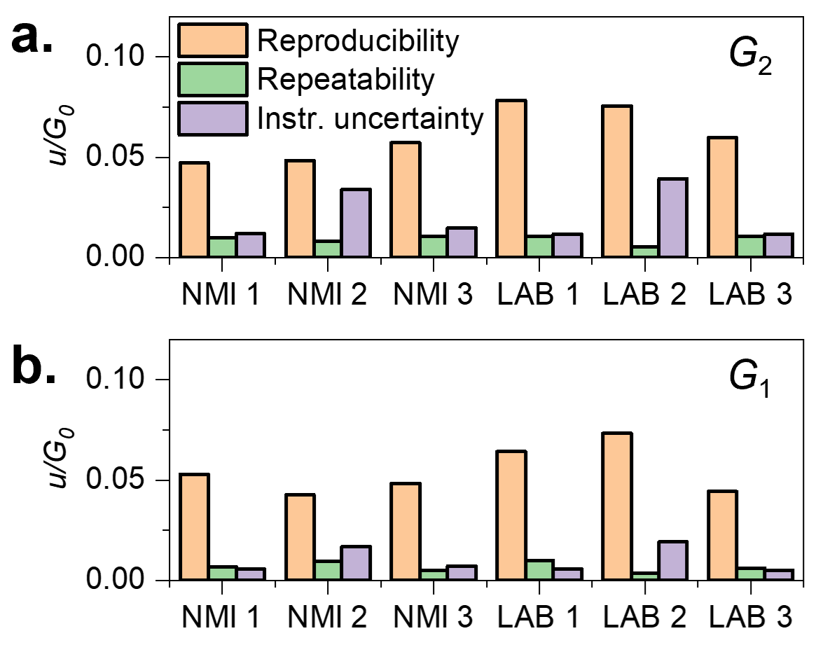
Supplementary Figure S16 | Uncertainty budget – absolute values. Absolute standard uncertainty components related to reproducibility, repeatability, and measurement equipment for each participant.

Methods
Device fabrication
Memrsitive devices were fabricated by sandwiching a SiO₂ insulator in between a Pt bottom electrode and an Ag top electrode. The pad structure devices were fabricated on a thermally oxidized silicon substrate starting with the direct current (DC) magnetron sputtering deposition (power of 200 W) of TiO₂ (10 nm) adhesion layer and a Pt (100 nm) bottom electrode. The homogeneous SiO₂ film (20 nm) with purity of 8N was deposited by radio frequency (RF) magnetron sputtering with a sputtering power of 150 W in a processing gas mixture of 9 sccm argon and 1 sccm oxygen at 150 °C. Following switching layer (SL) deposition, feature sizes of 50×50 μm² were patterned by negative photolithography. Then Ag (20 nm) active top electrode was deposited by e-beam evaporation with a deposition rate of 0.01 nm/s, followed by a DC-sputtered Pt (50 nm) capping layer (CL). A standard lift-off process was utilized for the final cleaning of devices, obtaining a Ag/SiO₂/Pt cells with top electrode size of 50×50 μm².
Device modeling
Departing from the experimental observation of well-defined conductance jumps and states, we model the reset transition (the set transition is also considered for generality) as a random generation of events related to the destruction of single quantum mode channels with conductance $\sim G_{0}$. This is a stochastic version of a continuous model³⁴ which has been successfully applied to memristors with different material systems, different switching modes (bipolar, unipolar, complementary, and threshold switching) and for the SPICE simulation of neuromorphic circuits. The stochastic version of the model presented here was recently applied to Valence Change Memory devices which show variability, but not quantized conductance jumps.³⁵ Details on device modeling can be found in Supplementary Section 4.

Interlaboratory comparison
An interlaboratory comparison involving 6 participants was carried out for the electrical characterization of quantum conductance levels in memristive devices, finalized to the realization of an intrinsic standard for electrical conductance (or resistance) and for evaluating lab-to lab variability. For this purpose, samples assumed to be identical were distributed among participants and a common measurement protocol was defined. The participants were the following institutions: Istituto Nazionale di Ricerca Metrologica (Italian Institute of Metrology, NMI 1), Instituto Português da Qualidade (Portugues Institute of Metrology, NMI 2), Turkiye Bilimsel ve Teknolojik Arastirma Kurumu (Turkish Institute of Metrology, NMI 3), Forschungszentrum Juelich GmbH (LAB 1), Fundación IMDEA Nanociencia (LAB 2), Politecnico di Torino (LAB 3).
Measurement protocol
The measurement protocol is based on a “program and verify” methodology where two sequential operations allow the generation of a desired quantized state and its verification, followed by its stabilization and measurement (Supplementary Section 6, Supplementary Figure S7). The generation of the quantized states is achieved by running sequential SET/RESET cycles where an applied voltage to the two terminals of the device is swept between +1.5 V and -0.9 V. The positive part of the sweep (SET cycle) has a sweep rate of 96 mV/s (voltage steps of 50 mV). The negative sweep (RESET cycle) has a slower sweep rate of 2 mV/s (voltage step of 1 mV). The current compliance was established as 500 µA and 10 mA for the positive and negative cycles, respectively. The voltage at the terminals of the device and the current that flows through it are continuously measured over SET/RESET cycles, and the corresponding conductance state is obtained for each applied voltage step. The formation of the quantized conductance steps during the RESET is continuously verified and a criterion to detect and accept $G_{1}$ and $G_{2}$ conductance states related to $G_{0}$ and 2$G_{0}$ quantum values, respectively, was established. If the last five consecutive measurements of the conductance state lay within either $G_{0}$ $±$ 0.5 $G_{0}$ or 2$G_{0}$ $±$ 0.5 $G_{0}$ (censoring interval), the sweep RESET cycle is interrupted, and a continuous read voltage of 10 mV is applied. The measurement of the step conductance value starts under this fixed applied control voltage and continues as long as remains in the intervals [0.5 $G_{0}$; 1.5 $G_{0}$] or [1.5 $G_{0}$; 2.5 $G_{0}$]. The measurements were made at room temperature and in normal ambient conditions. The equipment used was a Source Meter (different equipment were used by the participants, see Supplementary Section 10 and Supplementary Table T1) in auto-range mode. The above-described methodology enables dealing with the stochasticity of the conductive filament formation process establishing an initial limit to the variability around the nominal values of the desired quantized conductance steps (the validation of this programming methodology is discussed in Supplementary Section 12 and related Supplementary Figure S12, S13 and S14).
Evaluation of results and uncertainty budget
The evaluation of the average value and the variability of the programmed quantized steps was made from the observation of the measurements taken in repeatability and reproducibility conditions.³⁶ Here, repeatability conditions are understood as measurements of a specific device taken consecutively, while reproducibility is considered as the variability of the measurements taken from cycle-to-cycle operation of a specific device and programmed state as well as from device-to-device operations.
For each participant, j, the arithmetic mean and the experimental standard deviation were calculated for each series $i$ of $n_{i}$ values:
${\overline{G}}_{j,i}= \frac{1}{n_{i}}\sum_{a=1}^{n_{i}}{G_{i,a}}$ (1)

$s_{j,i}=\sqrt{\frac{1}{n_{i}-1}\sum_{a=1}^{n_{i}}{{\left(G_{i,a}-{\overline{G}}_{j,i}\right)}^{2}}}$ (2)

The standard deviation given by equation (2) is the estimation of the repeatability^{37,38} associated with series $i$ of a programmed quantized state measured by participant j. As each participant measured $N_{j}$ series and there are series with different number of values, a polled standard deviation³⁹ $s_{p,j}^{2}$ is calculated based on the following equation for its variance:
$s_{p,j}^{2}=\frac{\sum_{i=1}^{N_{j}}{\left(n_{i}-1\right)×s_{j,i}^{2}}}{\sum_{i=1}^{N_{j}}{\left(n_{i}-1\right)}}$ (3)

$s_{p,j}$ is therefore a weighted average of the $N_{j}$ standard deviation where the number of degrees of freedom $\left(n_{i}-1\right)$ is the weight of each series.
For each participant, an average of the mean values obtained from the $N_{j}$ series and the experimental standard deviation is calculated as:
${\overset{̿}{G}}_{j}= \frac{1}{N_{j}}\sum_{i=1}^{N_{j}}{{\overline{G}}_{j,i}}$ (4)

$S_{j}=\sqrt{\frac{1}{N_{i}-1}\sum_{i=1}^{N_{j}}{{\left({\overline{G}}_{j,i}-{\overset{̿}{G}}_{j}\right)}^{2}}}$ (5)
The evaluation of the reproducibility of the programmed quantized conductance steps was based on the standard deviation^{37,38} given by equation (5). As the values obtained by each participant for each step are from different cycles and different devices, the reproducibility obtained is the result of cycle-to-cycle and device-to-device variability.
The measurement of the quantized conductance states associated to each participant is expressed by the following measurement equation:
${G_{j}={\overset{̿}{G}}_{j}+S_{j}+s_{p,j}+e}_{j}$ (6)
Where ${\overset{̿}{G}}_{j}$ is the mean value calculated by participant j, $S_{j}$ is the related experimental standard deviation according to equations (4) and (5) respectively, $s_{p,j}$is the repeatability of the measurements accordingly equation (3), and $e_{j}$ is the error related to the accuracy of the measurement equipment used. It is assumed that these input variables are statistically random variables where $S_{j}$, $s_{p,j}$ and $e_{j}$ have an expectation value equal to zero and a standard deviation estimated based on the experimental values presented before ($S_{j}$ and $s_{p,j}$) and in the manufacturing specifications of the equipment used (for $e_{j}$).
The measuring uncertainty of $G_{j}$ can be estimated applying the law of propagation of uncertainties³⁹ to the equation (5):
$u^{2}\left(G_{j}\right)=u^{2}\left(S_{j}\right)+u^{2}\left(s_{p,j}\right)+u^{2}\left(e_{j}\right)$ (7)

Where $u^{2}\left(x\right)$ is the variance (square of standard uncertainty) associated with the variable $x$ and $u^{2}\left(G_{j}\right)$ is the square of the combined uncertainty of $G_{j}$.
The standard uncertainties of $e_{j}$ and $s_{p,j}$ are estimated by the corresponding standard deviation of the mean:
$u\left(S_{j}\right)=\frac{1}{\sqrt{N_{j}}} S_{j}$ (8)
$u\left(s_{p,j}\right)=\frac{1}{\sqrt{\sum_{i=1}^{N_{j}}{\left(n_{i}\right)/N_{j}}}} s_{p,j}$ (9)
The relative standard uncertainty of $e_{j}$ is calculated from the combined uncertainty of the measurement of the voltage, $u_{r}^{2}\left(U\right)$, and current, $u_{r}^{2}\left(I\right)$:
$u_{r}\left(e\right)=\sqrt{u_{r}^{2}\left(U\right)+u_{r}^{2}\left(I\right)}$ (10)

The relative uncertainties of the measured voltage U and current I are estimated assuming a rectangular probability distribution for the voltage and the current measuring error with the ± limits given by the manufacturing specifications of the equipment usually identified as “accuracy” (see Supplementary Table T1):
$u_{r}\left(U\right)=\frac{1}{\sqrt{3}} \frac{U_{accuracy}}{U}$ (11)

$u_{r}\left(I\right)=\frac{1}{\sqrt{3}} \frac{I_{accuracy}}{I}$ (12)

Following the international recommendation to express the final measuring uncertainty with a coverage probability of approximately 95 %^{40,41}, the expanded uncertainty $U\left(G_{j}\right)$ is calculated following the equation:
$U\left(G_{j}\right)=k×u\left(G_{j}\right)$ (13)

Where $k$ is the coverage factor calculated according to Annex G of ref.³⁹.

Evaluation of consensus value
The evaluation of the results achieved by the participants was done by comparing individual results with a consensus value.^{42,43} The consensus value is established based on all results from the participants⁴³, using a weighted average of their values⁴⁴:
$G_{cons}=\left(\sum_{j=1}^{6}{w_{j}×G_{j}}\right)/\left(\sum_{j=1}^{6}{w_{j}}\right)$ (14)

Where the weighting factors are given by:
$w_{j}=1/{ u}^{2}\left(G_{j}\right)$ (15)

The combined uncertainty of the consensus value is estimated based on the participant uncertainties as follows:
$u\left(G_{cons}\right)= \sqrt{1/\sum_{j=1}^{6}{w_{j}}}$ (16)

And the related expanded uncertainty is given assuming a coverage factor k = 2 (ref.⁴⁴):
$U\left(G_{cons}\right)= 2×u\left(G_{cons}\right)$ (17)

To identify an overall consistency of the results produced by this approach, a chi-square test was applied to the input values⁴⁴:
${}_{Obs}^{2}=\sum_{j=1}^{n}{{ [ \left(G_{j}-G_{cons}\right)}^{2}/} u^{2}\left(G_{j}\right) ]$ (18)

The result of the test is considered to fail if $Pr\left\{{}^{2}\left(ν\right) > {}_{Obs}^{2}\right\} <0.05$ where $Pr$ is the “probability of” and $ν$ is the degrees of freedom that are the number of input values $n$ minus 1 (in this case was 5). If the consistency check did not fail, then $G_{cons}$ can be accepted as the consensus value and $U\left(G_{cons}\right)$ can be accepted as its expanded uncertainty. The tests done for the results of this comparison proved to be consistent.
To qualify the result of each participant related to the consensus value, the normalized error^{43,44}, $E_{n,j}$, was calculated by:
$E_{n,j}= \left(G_{j}- G_{cons}\right) /\sqrt{U^{2}\left(G_{j}\right) {- U}^{2}\left(G_{cons}\right)}$ (19)

The value of $E_{n,j}$ has the following meaning: $E_{n,j}≤1.0$ the result is consistent (passed); $E_{n,j}>1.0$, the result is inconsistent (failed). For all participants, results were observed to be consistent with the established consensus value.

Supplementary References
1. Jeckelmann, B. & Jeanneret, B. The quantum Hall effect as an electrical resistance standard. Meas Sci Technol 14, 1229–1236 (2003).
2. Goebel, R., Fletcher, N., Rolland, B., Götz, M. & Pesel, E. Final report on the on-going comparison BIPM.EM-K12: Comparison of quantum Hall effect resistance standards of the PTB and the BIPM. Metrologia 51, 01011–01011 (2014).
3. Tsuruoka, T., Hasegawa, T., Terabe, K. & Aono, M. Conductance quantization and synaptic behavior in a Ta 2O 5-based atomic switch. Nanotechnology 23, (2012).
4. Wagenaar, J. J. T., Morales-Masis, M. & Van Ruitenbeek, J. M. Observing quantized conductance steps in silver sulfide: Two parallel resistive switching mechanisms. J Appl Phys 111, (2012).
5. Li, Y. et al. Conductance Quantization in Resistive Random Access Memory. Nanoscale Res Lett 10, 420 (2015).
6. Zhu, X. et al. Observation of conductance quantization in oxide-based resistive switching memory. Advanced Materials 24, 3941–3946 (2012).
7. Mehonic, A. et al. Quantum conductance in silicon oxide resistive memory devices. Sci Rep 3, 1–8 (2013).
8. Chen, C. et al. Conductance quantization in oxygen-anion-migration-based resistive switching memory devices. Appl Phys Lett 103, 043510 (2013).
9. Terabe, K., Hasegawa, T., Nakayama, T. & Aono, M. Quantized conductance atomic switch. Nature 433, 47–50 (2005).
10. Gao, S. et al. Conductance quantization in a Ag filament-based polymer resistive memory. Nanotechnology 24, 335201 (2013).
11. Younis, A., Chu, D. & Li, S. Voltage sweep modulated conductance quantization in oxide nanocomposites. J. Mater. Chem. C 2, 10291–10297 (2014).
12. Krishnan, K., Muruganathan, M., Tsuruoka, T., Mizuta, H. & Aono, M. Highly Reproducible and Regulated Conductance Quantization in a Polymer-Based Atomic Switch. Adv Funct Mater 27, 1605104 (2017).
13. Song, M. et al. Self-Compliant Threshold Switching Devices with High On/Off ratio by Control of Quantized Conductance in Ag Filaments. Nano Lett 23, 2952–2957 (2023).
14. Banerjee, W. & Hwang, H. Quantized Conduction Device with 6‐Bit Storage Based on Electrically Controllable Break Junctions. Adv Electron Mater 5, 1900744 (2019).
15. Tsuruoka, T. et al. Effects of moisture on the switching characteristics of oxide-based, gapless-type atomic switches. Adv Funct Mater 22, 70–77 (2012).
16. Valov, I. & Tsuruoka, T. Effects of moisture and redox reactions in VCM and ECM resistive switching memories. J Phys D Appl Phys 51, 413001 (2018).
17. Nandakumar, S. R., Minvielle, M., Nagar, S., Dubourdieu, C. & Rajendran, B. A 250 mV Cu/SiO2/W Memristor with Half-Integer Quantum Conductance States. Nano Lett 16, 1602–1608 (2016).
18. Tappertzhofen, S. et al. Modeling of Quantized Conductance Effects in Electrochemical Metallization Cells. IEEE Trans Nanotechnol 14, 505–512 (2015).
19. Maudet, F., Hammud, A., Wollgarten, M., Deshpande, V. & Dubourdieu, C. Insights on the variability of Cu filament formation in the SiO ₂ electrolyte of quantized-conductance conductive bridge random access memory devices. Nanotechnology 34, 245203 (2023).
20. Deswal, S., Malode, R. R., Kumar, A. & Kumar, A. Controlled inter-state switching between quantized conductance states in resistive devices for multilevel memory. RSC Adv 9, 9494–9499 (2019).
21. Zhao, X. et al. Natural Acidic Polysaccharide‐Based Memristors for Transient Electronics: Highly Controllable Quantized Conductance for Integrated Memory and Nonvolatile Logic Applications. Advanced Materials 33, 2104023 (2021).
22. Tappertzhofen, S., Valov, I. & Waser, R. Quantum conductance and switching kinetics of AgI-based microcrossbar cells. Nanotechnology 23, 145703 (2012).
23. Xue, W. et al. Recent Advances of Quantum Conductance in Memristors. Adv Electron Mater 5, 1800854 (2019).
24. Chen, Q. et al. Controlled Construction of Atomic Point Contact with 16 Quantized Conductance States in Oxide Resistive Switching Memory. ACS Appl Electron Mater 1, 789–798 (2019).
25. Xue, W. et al. Controllable and Stable Quantized Conductance States in a Pt/HfO _{x} /ITO Memristor. Adv Electron Mater 6, (2020).
26. Yi, W. et al. Quantized conductance coincides with state instability and excess noise in tantalum oxide memristors. Nat Commun 7, 11142 (2016).
27. Long, S. et al. Quantum-size effects in hafnium-oxide resistive switching. Appl Phys Lett 102, (2013).
28. Mu, J. et al. Application of electrochemical polishing in surface treatment of additively manufactured structures: A review. Prog Mater Sci 136, 101109 (2023).
29. Kim, U. S. & Park, J. W. High-Quality Surface Finishing of Industrial Three-Dimensional Metal Additive Manufacturing Using Electrochemical Polishing. International Journal of Precision Engineering and Manufacturing-Green Technology 6, 11–21 (2019).
30. Chua, L. Resistance switching memories are memristors. Applied Physics A 102, 765–783 (2011).
31. Landauer, R. Spatial Variation of Currents and Fields Due to Localized Scatterers in Metallic Conduction. IBM J Res Dev 1, 223–231 (1957).
32. Russo, U., Ielmini, D., Cagli, C. & Lacaita, A. L. Filament Conduction and Reset Mechanism in NiO-Based Resistive-Switching Memory (RRAM) Devices. IEEE Trans Electron Devices 56, 186–192 (2009).
33. Benz, S. P. & Hamilton, C. A. Application of the Josephson effect to voltage metrology. Proceedings of the IEEE 92, 1617–1629 (2004).
34. Miranda, E. & Sune, J. Memristive State Equation for Bipolar Resistive Switching Devices Based on a Dynamic Balance Model and Its Equivalent Circuit Representation. IEEE Trans Nanotechnol 19, 837–840 (2020).
35. Suñé, J., Bargalló-González, M., Saludes, M., Campabadal, F. & Miranda, E. Event-driven Stochastic Compact Model for Resistive Switching Devices. Authorea Preprint (2024).
36. BIPM - Bureau International des Poids et Mesures. The International System of Units (SI Brochure) [9th Edition]. SI brochure - Appendix 2 www.bipm.org (2019).
37. ISO 5725-1: 2023-07 - Accuracy (Trueness and Precision) of Measurement Methods and Results — Part 1: General Principles and Definitions.
38. ISO 3534-2: 2006 - Statistics — Vocabulary and Symbols — Part 2: Applied Statistics.
39. JCGM 100: 2008 - Evaluation of measurement data — Guide to the expression of uncertainty in measurement.
40. International Laboratory Accreditation Cooperation, ILAC-G17:01/2021 - ILAC Guidelines for Measurement Uncertainty in Testing.
41. International Laboratory Accreditation Cooperation, ILAC-P14:09/2020 - ILAC Policy for Measurement Uncertainty in Calibration.
42. ISO/IEC 17043: 2023-05, Ed.2 Conformity Assessment — General Requirements for the Competence of Proficiency Testing Providers.
43. ISO 13528: 2022-08, Ed.3 - Statistical Methods for Use in Proficiency Testing by Interlaboratory Comparison.
44. Cox, M. G. The evaluation of key comparison data. Metrologia 39, 589–595 (2002).

