Supplementary tables

Table S1. List of antibodies
Primary antibodies
Target | Dilution |  |  |  | Host | Supplier | Cat. Number
Target | Immunofluorescence |  | Western blot |  | Host | Supplier | Cat. Number
GAPDH | - |  | 1:5000 |  | Mouse | Invitrogen | MA5-15738
PABPN1 | 1:1000 |  | 1:4000 |  | Rabbit | Homemade | -
FLAG | 1:1000 |  |  |  | Mouse | Sigma-Aldrich | F1804
P62 | 1:250 |  |  |  | Rabbit | Cell Signaling | SQSTM1/p62
SC35 | 1:250 |  |  |  | Mouse | Sigma-Aldrich | S4045
Histon2B (H2B) | - |  | 1:1000 |  | Rabbit | Proteintech | 15857-1-AP
MyHC | 1:250 |  | - |  | Mouse | DSHB | MF20
Secondary antibodies
Target | Fluorophore | Dilution |  | Supplier
Anti-Rabbit | Cy5 | 1:2000 |  | ThermoFisher Scientific
Anti-Mouse | Alexa488 | 1:2000 |  | ThermoFisher Scientific
Anti-Mouse | Alexa594 | 1:2000 |  | ThermoFisher Scientific
WB anti-Rb/M | 800/680 | 1:10000 |  | IRDye 800CW or IRDye 680RD (LI-COR)

Table S2. List of primers for RT-qPCR
Target | Forward 5’ – 3’ | Reverse 5’ – 3’
HPRT1 | TGGTCAGGCAGTATAATCCAAAGA | TCAAATCCAACAAAGTCTGGCTTA
PABPN1_exon 3-4 | ATGTTGGCAATGTGGACTATG | ACACGGTTGACTGAACCACA
PABPN1_3’-UTR | ATGGACACGTCTCAACTGCG | ACGGAGGGAAGGTAACAAGC

Table S3: Proteome differential analysis
Table S4: Proteome cluster enrichment analysis
Table S5: APA shift analysis
Table S6: mRNA differential expression analysis
Table S7: mRNA cluster enrichment analysis

Supplementary figures

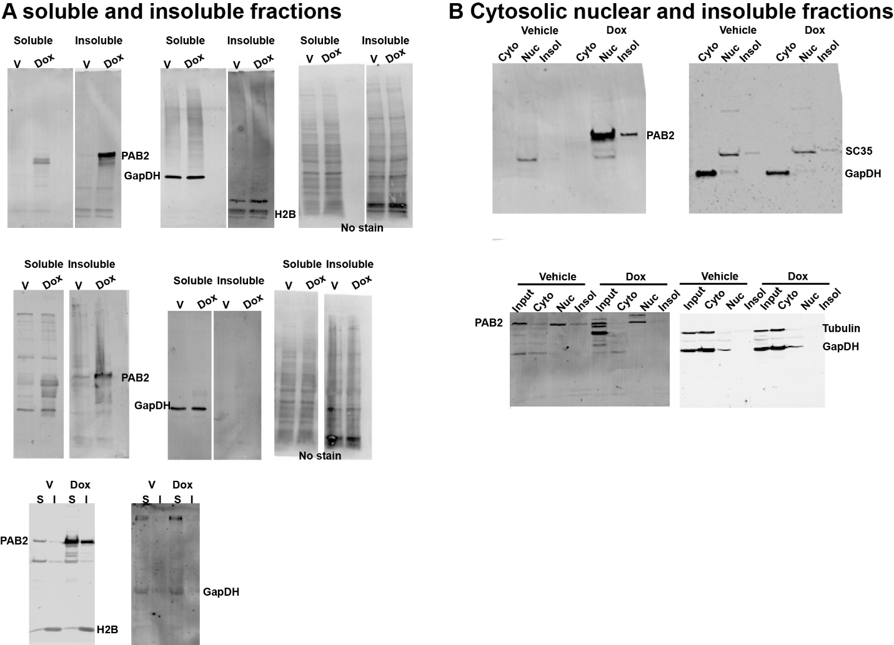
Figure S1. Full images western blots
A. Soluble vs insoluble fractions; B. Subcellular fractionation Proteins that are detected by the antibodies are indicated. No-stain is a bulk protein staining. SC35 is a nuclear protein. H2B is an insoluble protein, and GapDH a soluble cytosolic protein.

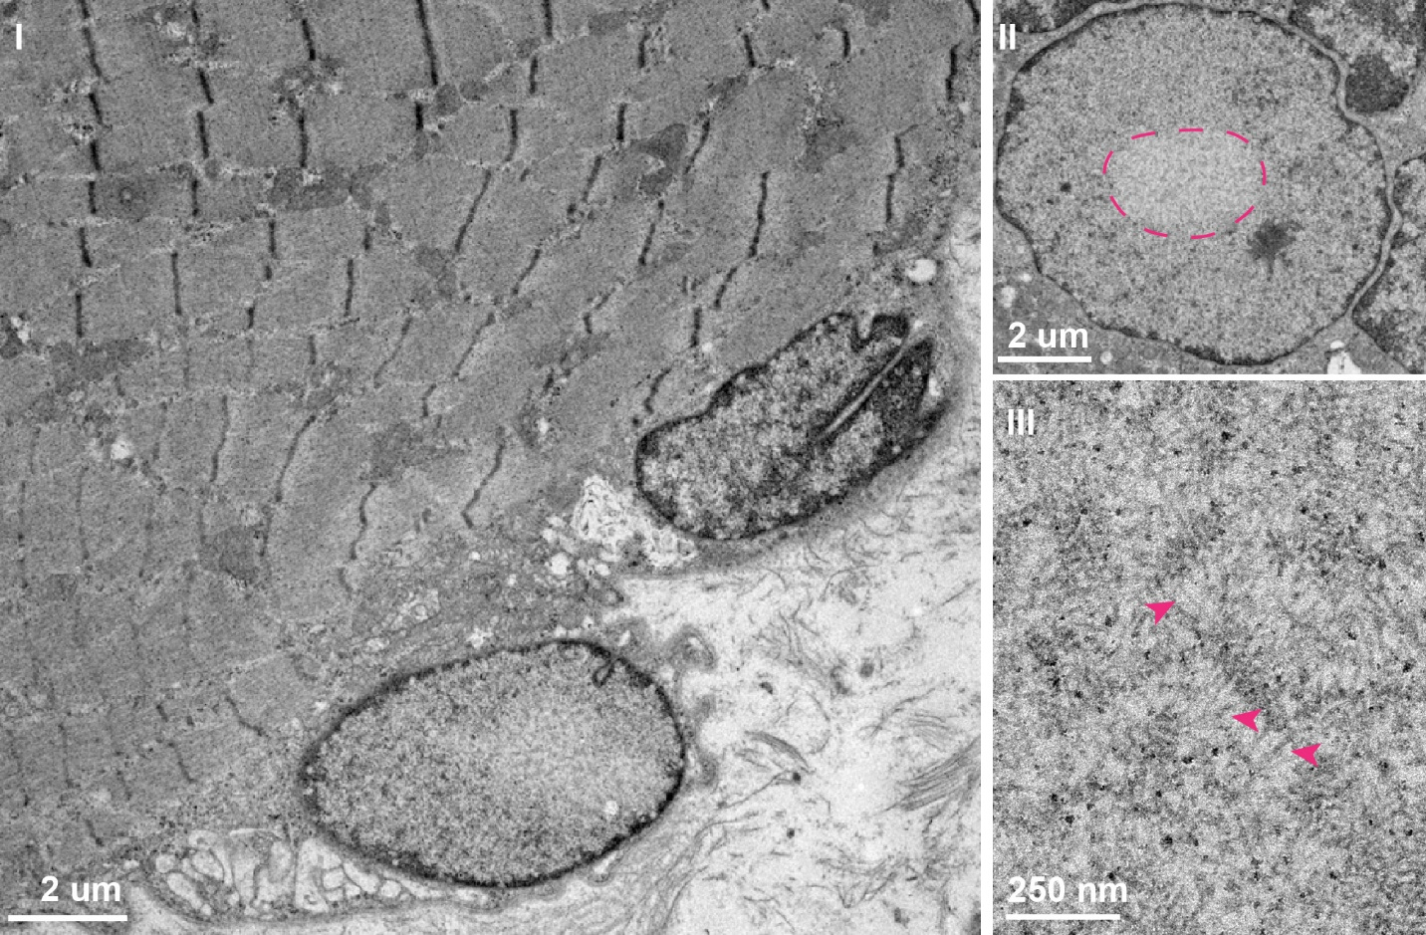
Figure S2. Electron microscopy of muscle from an OPMD patient. I. Image of myofibers and myonuclei. II. A myonucleus with a lucent area (dashed line). III. A magnified area of the lucent region showing fibrils (arrows).

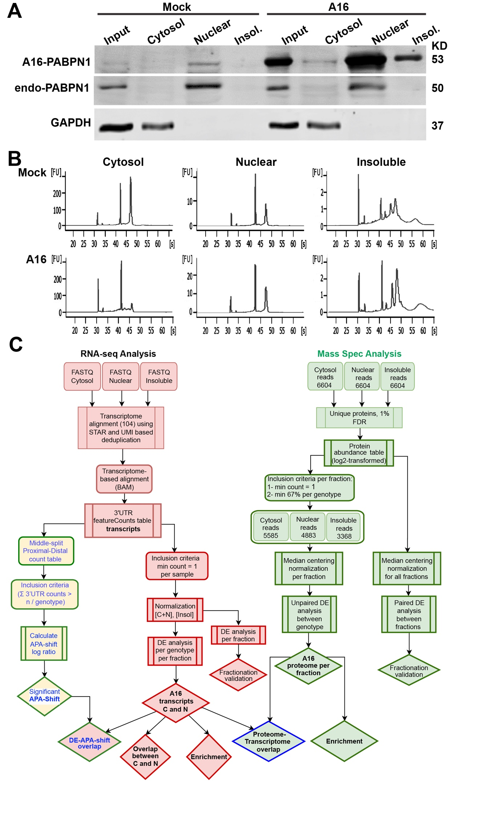
Figure S3. Subcellular fractionation A. Western blot analysis: A16-PABPN1; endogenous PABPN1 (endo-) and GAPDH in vehicle-treated and Dox-treated cells in cytoplasmic, nuclear, and insoluble fractions. Input is before fractionation. B. Bioanalyzer RNA output showing cytosolic, nuclear, and insoluble fractions. C. Detailed flowchart of A16 subcellular fractions and data analysis. The green color is the pipeline used for protein data analysis. Red is used for RNA and yellow is used for APA calculation.

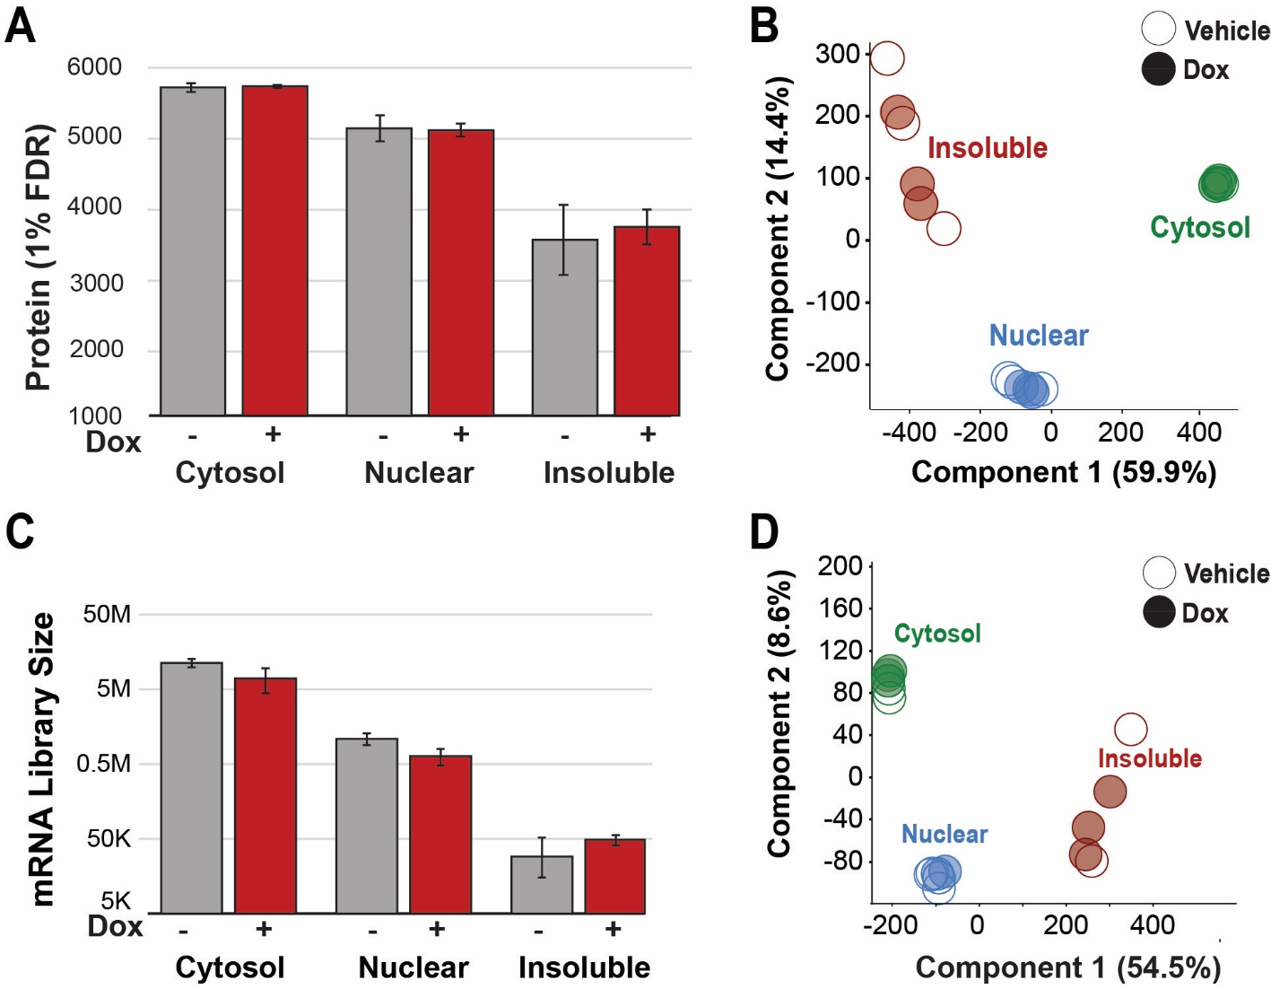
Figure S4. QC RNA sequencing and mass spectrometry. A. and C. Bar graphs show the sum of reads per fraction. After filtering, the number of proteins (A) or mRNA library size (C) per fraction was used for downstream analysis. The mean and standard deviation are from N=3. For insoluble vehicle-treated, N=2. B. and D. Principal component analysis plots of proteins (B) or mRNAs (D) show the main variants and the percentage of variation for component 1 and component 2.

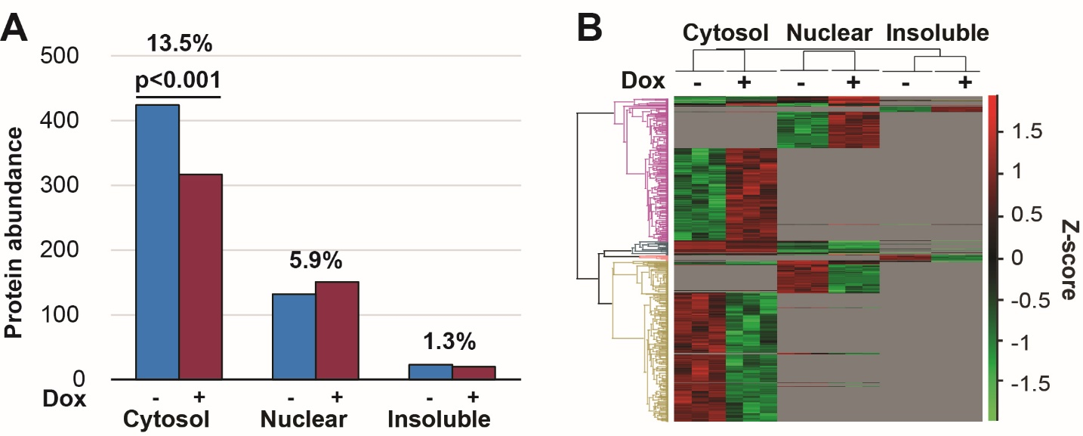
Figure S5: The A16 proteome: additional analysis. A. A bar graph of differentially accumulated proteins per fraction. The percentage of differentially accumulated proteins per fraction is derived from the total proteins in the mass spectrometry. A difference between high and low protein abundance was assessed with a chi-squared test. B. Clustering of the A16 proteome. Heatmap of significant differential protein abundant in all fractions in vehicle-treated or Dox-induced conditions. Relative expression intensity is indicated on a green to red scale. No value is available for the proteins in the gray area per fraction.

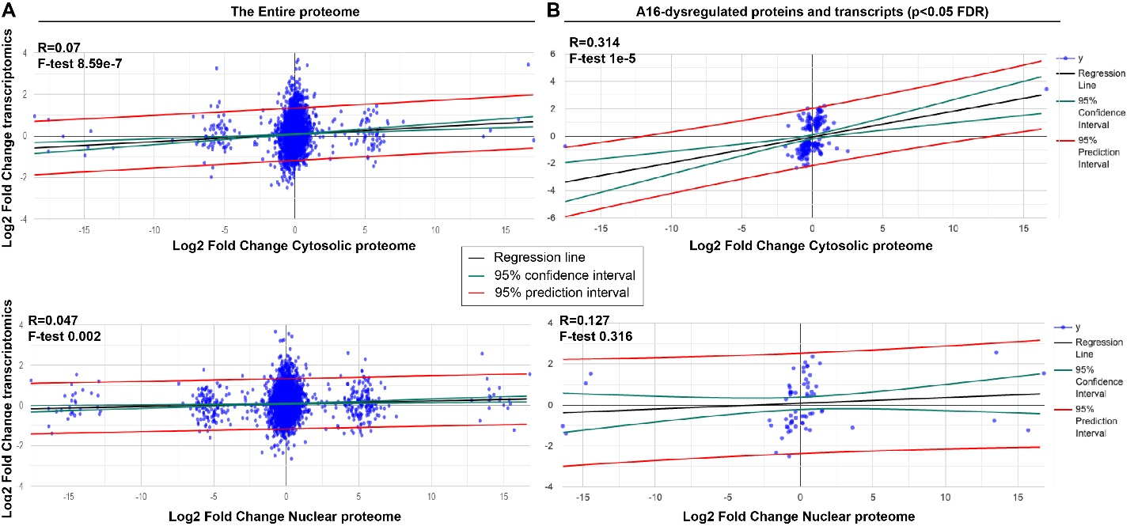
Figure S6. A16 Correlation between A16 proteome and transcriptome. A. A linear correlation analysis of the cytosolic transcriptome with the entire cytosolic (upper plot) or nuclear (lower plot) proteome. B. A linear correlation analysis of the significant cytosolic transcriptome with the significant cytosolic (upper plot) or nuclear (lower plot) proteome. The regression line is shown in black, the 95% confidence interval in green, and the 95% prediction interval in red. The correlation coefficient (R) and the F-test p-value of the regression lines are shown. The number of up- or down-regulated proteins (and the percentage) correlating with the transcript direction are given.

