Table 1 Optimizing of different parameters for the model reaction in the synthesis of pyrrole derivative 5aª
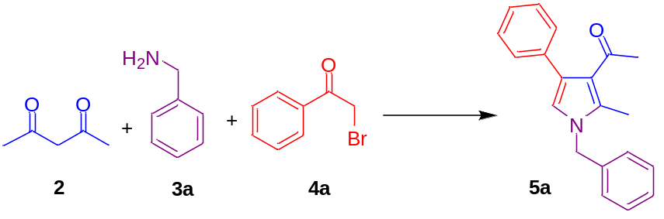
Entry | Catalyst | Catalyst loading (mg) | Solvent | Temp.  ($℃)$ | Time  (h) | Yield^{b}  (%)
1 | - | - | Toluene | 110 | 43 | 19
2 | Chitosan | 10 | Toluene | 110 | 17 | 58
3 | CS-g-PAN (1) | 10 | Toluene | 110 | 8 | 70
4 | CS-g-PAN (1) | 10 | THF | 60 | 12 | 31
5 | CS-g-PAN (1) | 10 | CH₃CN | 80 | 8 | 65
6 | CS-g-PAN (1) | 10 | EtOH | 75 | 18 | 20
7 | CS-g-PAN (1) | 10 | DMF | 120 | 10 | 43
8 | CS-g-PAN (1) | 10 | Toluene | 110 | 10 | 81
9 | CS-g-PAN (1) | 10 | Toluene | 110 | 14 | 67
10 | CS-g-PAN (1) | 10 | Toluene | 110 | 24 | 22
11 | CS-g-PAN (1) | 5 | Toluene | 110 | 8 | 83
12 | CS-g-PAN (1) | 15 | Toluene | 110 | 8 | 91
13 | CS-g-PAN (1) | 15 | Toluene | 110 | 6 | 69
14 | CS-g-PAN (1) | 15 | Toluene | 110 | 12 | 72
15 | CS-g-PAN (1) | 15 | Toluene | 90 | 8 | 74
16 | CS-g-PAN (1) | 15 | Toluene | 80 | 8 | 67
17 | CS-g-PAN (1) | 15 | Toluene | 70 | 8 | 64
18 | CS-g-PAN (1) | 20 | Toluene | 110 | 8 | 89
ªReaction conditions: acetylacetone (2, 1.0 mmol), benzyl amine (3a, 1.50 mmol) and phenacyl bromide (4a, 1.0 mmol) in the presence of CS-g-PAN (1) and solvent (2.5 mL) unless otherwise stated. ^{b}Yields refer to the isolated products.

Table 2 Synthesis of pyrrole derivatives 5a–o from acetylacetone (2), different amines 3a-l and phenacyl bromides 4a-c catalyzed by the CS-g-PAN (1) under the optimized conditionsª
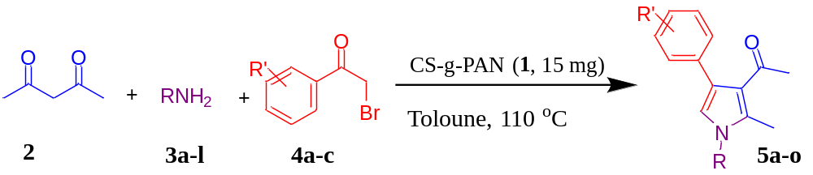
Entry | RNH₂ 2 | R’C₈H₆OBr 3 | Time  (h) | Product 5 | Yield^{b}  (%) | M.P (°C) found | M.P (°C) Lit
1 | 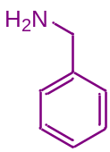2a | 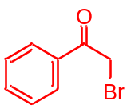  3a | 8 | 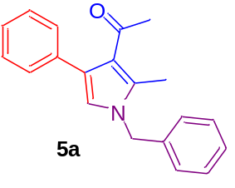 | 91 | 48-50 | 50-52³⁹
2 | 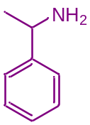2b | 3a | 10 | 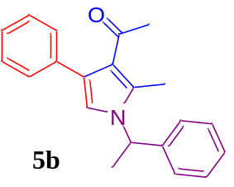 | 65 | 48-51 | 52-54³⁹
3 | 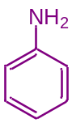2c | 3a | 8 | 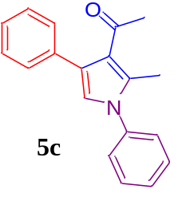 | 81 | Liquid | Liquid^{39,35}
4 | 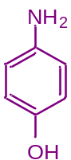2d | 3a | 9 | 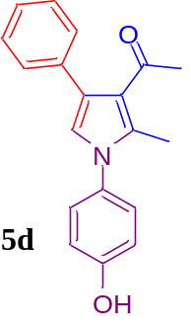 | 82 | 140-143 | 143-144³⁹
5 | 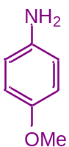2e | 3a | 8 | 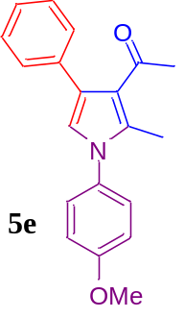 | 64 | 85-86 | 87-88³⁴,⁴⁰
6 | 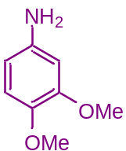2f | 3a | 7.5 | 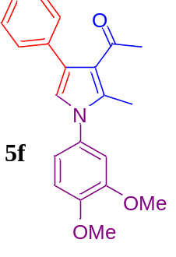 | 81 | 126-127 | 127-128³⁹
7 | 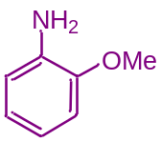  2g | 3a | 8.5 | 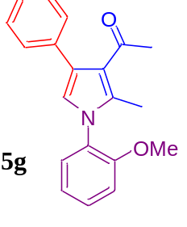 | 58 | Liquid | Liquid³⁹
8 | 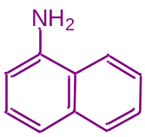  2h | 3a | 7 | 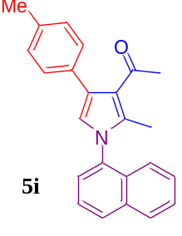 | 53 | Liquid | Liquid³⁹
9 | 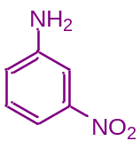2i | 3a | 8 | 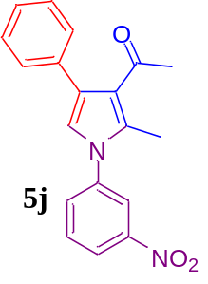 | 74 | 113-116 | 115-116^{39,35}
10 | 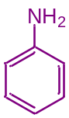2c | 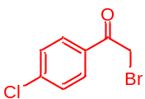3b | 7 | 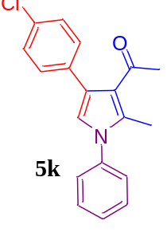 | 85 | 146-147 | 148-149⁴⁰
11 | 2c | 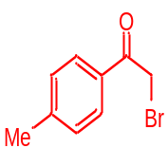3c | 9 | 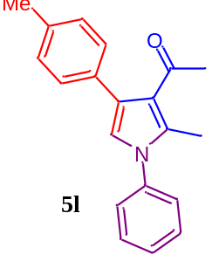 | 74 | 78-79 | 80-81⁴⁰
12 | 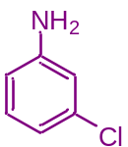  2j | 3a | 7 | 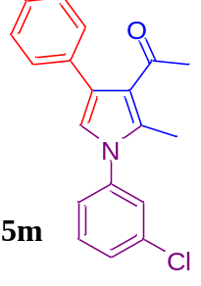 | 60 | Liquid | Liquid³⁹,³⁵
13 | 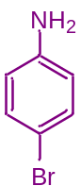2k | 3a | 7.5 | 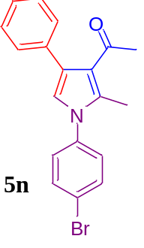 | 62 | 137-138 | 138-139³⁹
14 | 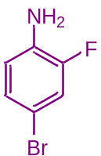2l | 3a | 9 | 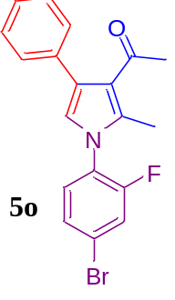 | 70 | Liquid | Liquid³⁹,³⁵
ªReaction conditions: acetylacetone (2, 1.0 mmol), benzyl amine (3a-l, 1.50 mmol) and phenacyl bromide (4a-c, 1.0 mmol) in the presence of CS-g-PAN (1, 15.0 mg) in toluene (2.5 mL). ^{b}Yields refer to the isolated products.

