Supplementary files.
Linear and quadratic regression of each table assistant between Docking time and procedures

File 1. Resident A
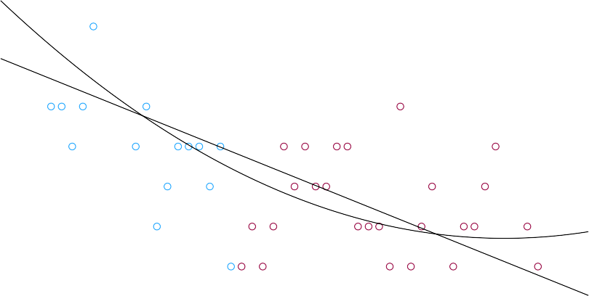
phase1
1.00
2.00
R2 Linear = 0.455
R2 Quadratic =0.498
P < 0.001

docking1

Case_number

File 2. Resident B

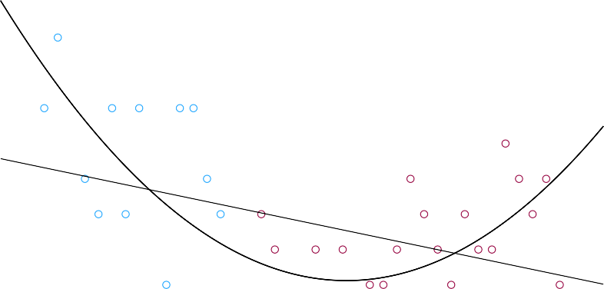
Phase2
1.00
2.00
R2 Linear = 0.129
R2 Quadratic =0.433
docking2
P = 0.025

Case_number

File 3. Resident C
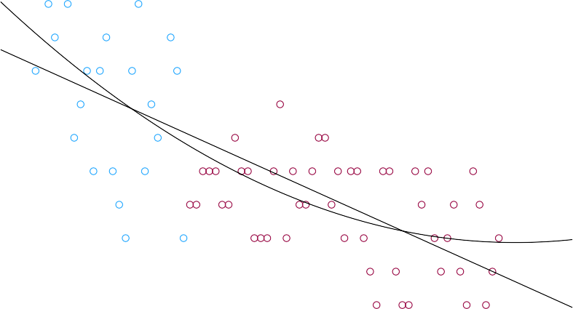
Phase3
1.00
2.00
R2 Linear = 0.516
R2 Quadratic =0.546
P < 0.001

docking3

Case_number

File 4. Resident D Phase4
1.00
2.00
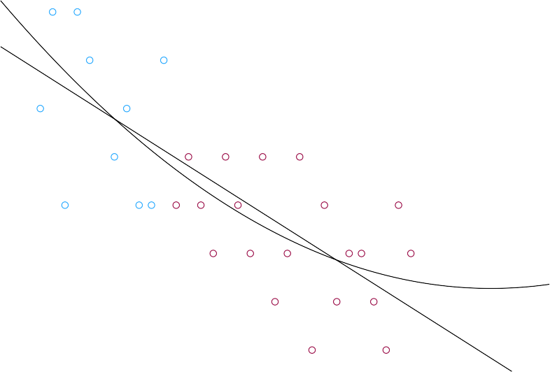
R2 Linear = 0.542 R2 Quadratic =0.561
P < 0.001

docking4

Case_number

