Supplementary Information

Interpretable prediction of drug synergy for breast cancer by random forest with features from Boolean modeling of signaling pathways
Kittisak Taoma, Marasri Ruengjitchatchawalya, Kanthida Kusonmano, Teerasit Termsaithong, Thana Sutthibutpong, Monrudee Liangruksa, Teeraphan Laomettachit

Supplementary Files
Supplementary File S1. The dataset of 574 drug pairs in five breast cancer cell lines used in this study.
Supplementary File S2. ALE analysis of all proteins.
Supplementary File S3. Protein contributions for MCF-7 AKT-GoF treated with AZD5363 + Fulvestrant.
Supplementary File S4. Protein contributions for MDA-MB-468 PTEN-GoF treated with 391210-10-9 + Stattic.

Supplementary Figures

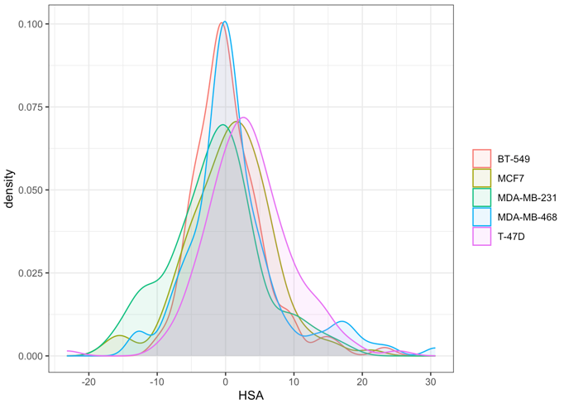

Supplementary Figure S1. The distribution of the HSA scores of 574 drug pairs in five breast cancer cell lines.

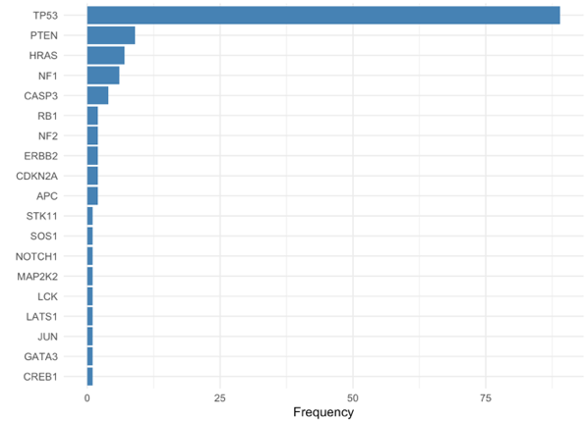

Supplementary Figure S2. The frequency of damaging mutations across 92 breast cancer cell lines from the DepMap database.
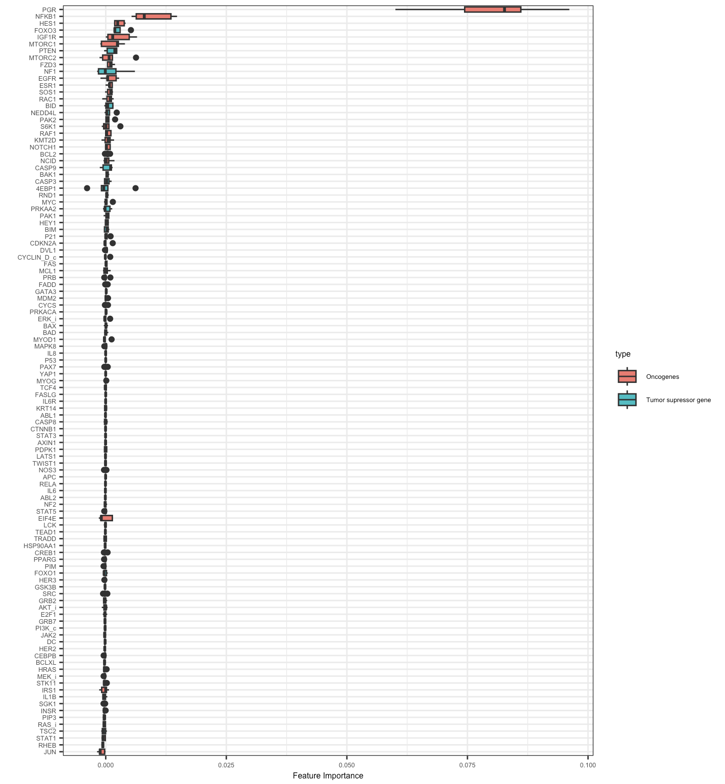

Supplementary Figure S3. The complete list of proteins and their importance scores.

Supplementary Figure S4. The KEGG enrichment¹ of the top 30 important proteins from Fig. 5A. (A) Enrichment analysis of oncogenic proteins. (B) Enrichment analysis of tumor suppressor proteins.

Supplementary Figure S5. Four oncogenic proteins show an inconsistent trend between their activities and the HSA scores, where a large increase in the HSA is observed when the protein activity increases.

Supplementary Figure S6. The scatter plot between the predicted HSA from our random forest model and the actual HSA from DrugComb. The dots represent all drug pairs that contain an AKT or mTORC1 inhibitor, or PGR agonist. Combining a drug with an AKT or mTORC1 inhibitor mainly produces a synergistic effect (blue and orange). In contrast, combining a drug with a PGR agonist often results in an antagonistic effect (green).

Supplementary Figure S7. The percentile of gene expression levels of seven direct drug target proteins in five cell lines compared with all other breast cancer cell lines from the DepMap database.

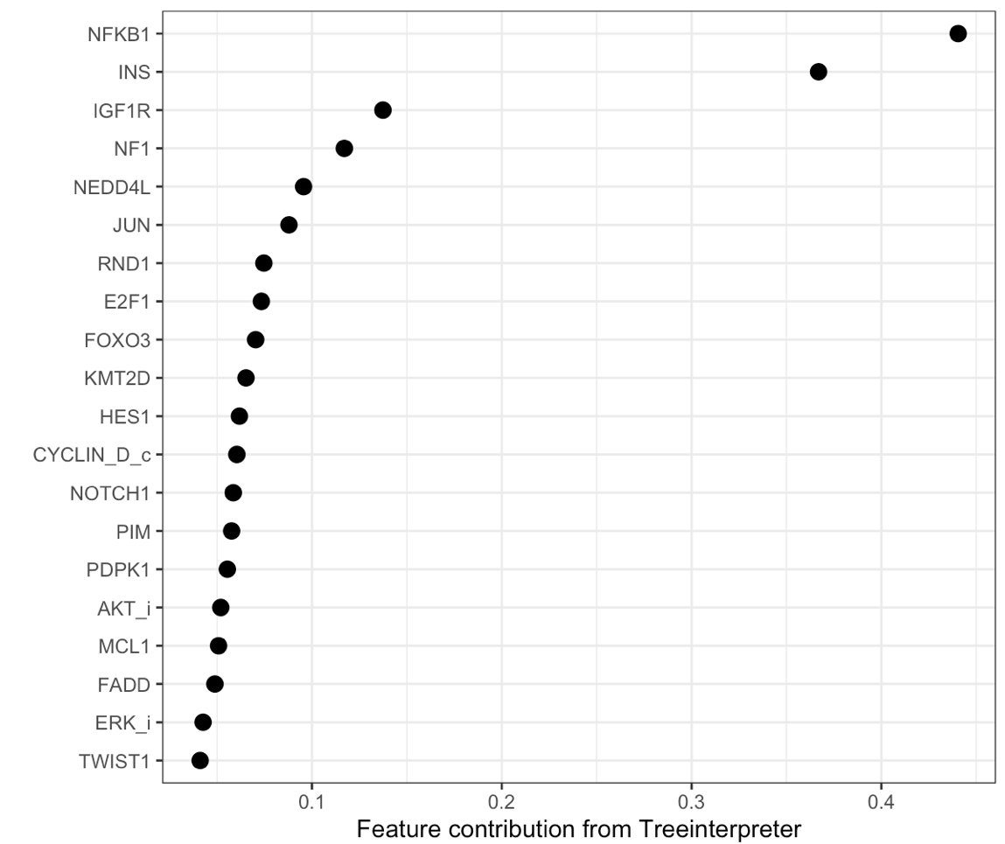
Supplementary Figure S8. The top 20 protein contributors identified by our model that do not overlap with TranSynergy for the drug combination between BEZ-235 and erlotinib in T-47D.

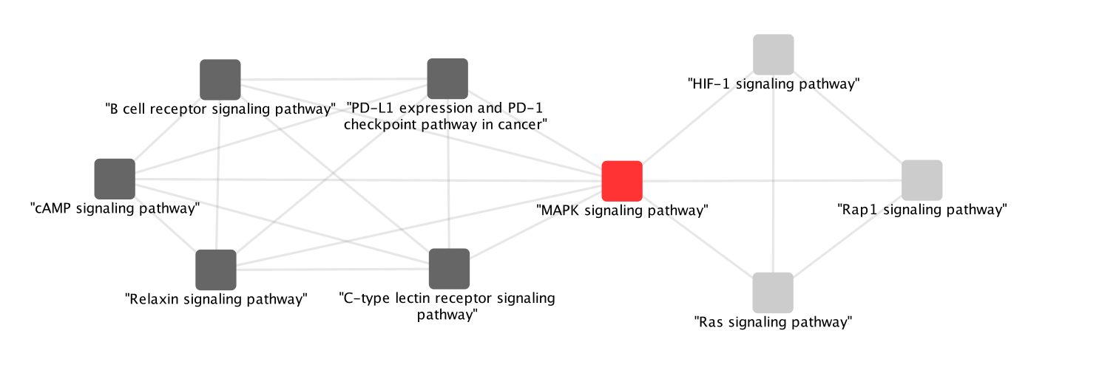Supplementary Figure S9. The crosstalk of the MAPK signaling pathway with other breast cancer-related pathways enriched from the top 20 contributors in the present model. The red node represents the enriched pathway previously captured by TranSynergy. Dark and light grey represent the proposed modules in the immune response-related pathway and the metastasis and proliferation-related pathways, respectively. The edges indicate the agreement of protein members enriched between KEGG pathways¹ with Cohen's kappa score over 0.6².

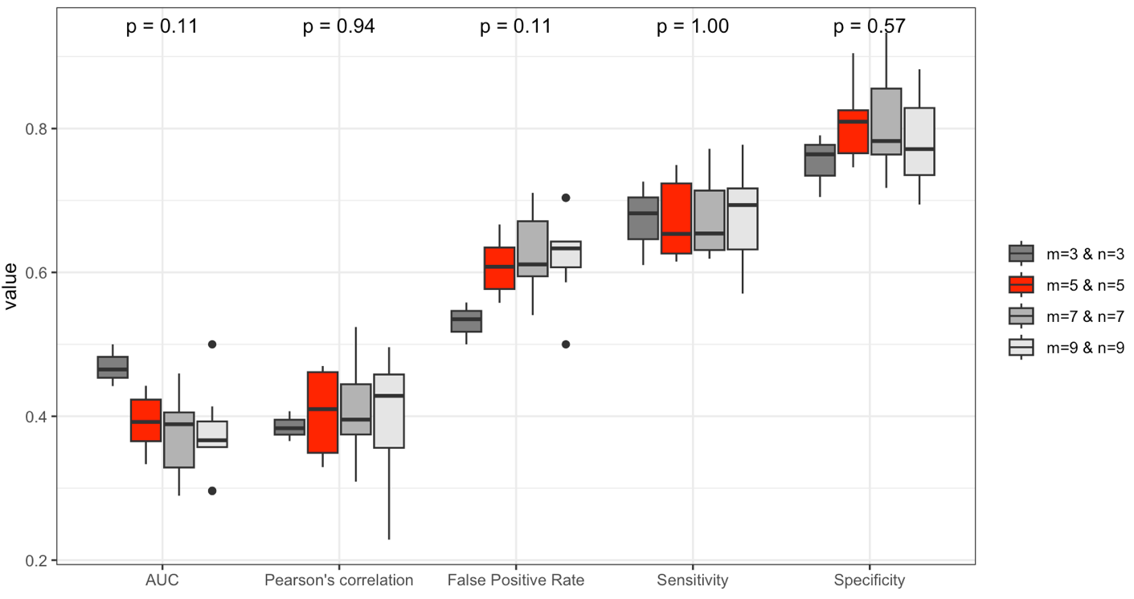

Supplementary Figure S10. The comparison of model performance across m×n-fold nested cross-validation. The statistical analysis across the four groups was tested using the Kruskal–Wallis test.

Supplementary Tables

Supplementary Table S1. A comparison of the interpretability characteristics of models for predicting drug synergy in cancer.
Type | Study (dataset) | Interpretability of the model | Interpretable level of the study* | Model performance
Traditional machine learning | Jeon et al. (2018)³  (O’Neil) | The study extracted frequent decision paths from the Random Forest model and generated potential synergistic rules from the paths. | Global | Pearson’s correlation = 0.738  F1 = 0.954
Traditional machine learning | Celebi et al. (2019)⁴  (DREAM) | The study used information gain from XGBoost to select relevant features from both drug and cell line data. | Global | Weighted average Pearson correlations = 0.36
Traditional machine learning | ForSyn⁵  (DrugComb+DrugCombDB+  AstraZeneca-Sanger) | ForSyn determined the feature importance value for each drug and cell line feature from each layer in a hybrid deep forest model. The top important genes from drug-induced gene expression data were analyzed for biological interpretation. | Global | F1=0.57
Traditional machine learning | TreeCombo⁶  (O’Neil) | TreeCombo used TreeSHAP to calculate the importance of features for individual predictions. The feature importance can be averaged across all predictions to obtain a global level of feature importance. | Local | Rank correlation=0.70  MSE = 0.52
Traditional machine learning | Present study  (DrugComb) | We use the TreeInterpreter package to calculate individual protein contributions to the synergy of a given drug combination on a given cell line. | Local | Pearson’s correlation = 0.40  AUC = 0.67
Deep learning | AuDNNsynergy⁷  (O’Neil) | The study investigated the importance of features using the ‘iNNvestigate’ package to identify important genes. The list of genes was then analyzed for biological interpretation through a literature review. | Global | Pearson’s correlation = 0.74  AUC = 0.91
Deep learning | DeepDDS⁸  (O’Neil) | DeepDDS explored the interpretability of its attention mechanism by analyzing the correlation patterns of atomic features, revealing important chemical substructures that contribute to the prediction of synergistic drug combinations. | Global | AUC = 0.93  TPR = 0.85
Deep learning | DeepSignalingSynergy⁹  (NCI ALMANAC ) | DeepSignalingSynergy used the iNNvestigate package to extract the importance of individual inputs (signaling pathways and genes) at different layers. | Global | Pearson’s correlation = 0.64
Deep learning | GraphSynergy¹⁰  (DrugCombDB+  Oncology-Screen) | The attention mechanism in GraphSynergy assigned contribution weights to different proteins within the protein-protein interaction network to indicate their importance in predicting drug synergy for a given drug combination in each cell line. Therefore, for a given drug pair and cell line, the attention mechanism highlights key proteins that are most important in determining the predicted synergy score. | Local | ACC = 0.75  AUC = 0.83
Deep learning | DTSyn¹¹  (O’Neil) | The study utilized transformer attention scores to identify genes that significantly interact with each drug pair in a specific cell line. This identification provides insights into possible mechanisms of drug actions. | Local | AUC = 0.73–0.82
Deep learning | TranSynergy¹²  (O’Neil) | The study calculated the Shapley additive value to determine individual feature contributions for each prediction instance. Genes with the highest Shapley values were selected for Gene Set Enrichment Analysis to facilitate biological interpretation. | Local | Pearson’s correlation = 0.746  AUC = 0.908
* The interpretable level of the study is classified as 'Local' when the study discusses the contribution of features assessed for individual samples. In contrast, it is classified as 'Global' if the study addresses the contribution of features evaluated by considering all samples in the dataset or within the same class.

Supplementary Table S2. The model performance in classification and regression modes averaged from five random forests across all split folds from the stratified nested 5×5-fold cross-validation.
 | Training Dataset  (Mean ± SD) | Validating Dataset  (Mean ± SD) | Testing Dataset  (Mean ± SD)
Pearson's correlation | 0.61 ± 0.02 | 0.38 ± 0.02 | 0.40 ± 0.06
Mean squared error | 29.34 ± 0.82 | 36.76 ± 0.89 | 36.33 ± 3.55
AUC | 0.78 ± 0.01 | 0.67 ± 0.009 | 0.67 ± 0.06
Sensitivity | 0.85 ± 0.02 | 0.79 ± 0.01 | 0.81 ± 0.06
Specificity | 0.52 ± 0.01 | 0.41 ± 0.01 | 0.39 ± 0.04
False Positive Rate | 0.47 ± 0.01 | 0.58 ± 0.01 | 0.60 ± 0.04
MCC | 0.40 ± 0.02 | 0.23 ± 0.01 | 0.22 ± 0.12

Supplementary Table S3. Evidence supporting the interactions shown in Fig. 7 of the main text (MCF-7).
Interaction | Direct regulation in the Boolean model | Reference(s) | Note
AKT —| FOXO3 | Yes | PMID: 19951971 | AKT phosphorylates FOXO3a, creating binding sites for the 14-3-3 chaperone proteins and leading to the export of FOXO3a to the cytoplasm, where it is targeted for degradation by the proteasome.
AKT → ESR1 | Yes | PMID: 11108261 | AKT enhances estrogen receptor activity through the amino-terminal activation function-1 (AF-1).
FOXO3 → ESR1 | Yes | PMID: 25877889 | Inhibition of PI3K with BYL719 resulted in a greater than 5-fold accumulation of FOXO3A at the ESR1 promoter, as demonstrated by the ChIP assay.
AKT → mTORC1 | No  AKT —| TSC2 —| RHEB → mTORC1 | PMID: 15249583  PMID: 17604717 | PMID: 15249583  See Fig. 8.  PMID: 17604717  See Fig. 1.
mTORC1 —| 4EBP1 | Yes | PMID: 9204908 | mTOR phosphorylates PHAS-I, inhibiting the binding of PHAS-I to eIF-4E.
4EBP1 —| EIF4E | Yes | PMID: 23584478 | Eukaryotic translation initiation factor 4E (eIF4E) is negatively regulated by eIF4E-binding protein 1 (4E-BP1).
mTORC1 → S6K1 | Yes | PMID: 15249583  PMID: 17604717 | PMID: 15249583  See Fig. 8.  PMID: 17604717  See Fig. 1.
AKT → NF-κB | No  AKT → MDM2 → NOTCH1 → NF-κB | PMID: 17604717  PMID: 15169778  PMID: 23252402  PMID: 11591772 | PMID: 17604717  AKT signaling activates the NF-κB transcription factor downstream of a variety of stimuli.  PMID: 15169778  The stabilization of MDM2 occurs through reduced ubiquitination, which is regulated by AKT.  PMID: 23252402  Interaction between Notch1 and Mdm2 results in the activation of the intracellular domain of Notch1.  PMID: 11591772  NF-κB activity is regulated by Notch1.
AKT → HES1 | No  AKT → MDM2 → NOTCH1 → HES1 | PMID: 15169778  PMID: 23252402  PMID: 19165418 | PMID: 15169778  The stabilization of MDM2 occurs through reduced ubiquitination, which is regulated by AKT.  PMID: 23252402  Interaction between Notch1 and Mdm2 results in the activation of the intracellular domain of Notch1.  PMID: 19165418  The hes1 gene is a direct target of Notch and can be activated by a constitutively active form of Notch1.
AKT —| NF1 | No  AKT → TWIST1 —| NF1 | PMID: 20400976  PMID: 19051271 | PMID: 20400976  AKT phosphorylates Twist-1, ensuring functional activation of the protein.  PMID: 19051271  NF1 was up-regulated after TWIST depletion
AKT → PRKACA | Yes | PMID: 16537363 | AKT positively influences Sonic Hedgehog (Shh) signaling by regulating the inactivation of Gli through PKA (PRKACA).
PRKACA —| NEDD4L | Yes | PMID: 15328345 | Nedd4-2 was phosphorylated by PKA (PRKACA) in vitro and in cells, which necessitates the inhibition of Nedd4-2.

Supplementary Table S4. Evidence supporting the interactions shown in Fig. 9 of the main text (MDA-MB-468).
Interaction | Direct regulation in the Boolean model | Reference(s) | Note
PTEN —| EGFR | No  PTEN —| PIP3 → AKT → CTNNB1 → EGFR | PMID: 15249583  PMID: 17287208  PMID: 32457491  PMID: 16012954 | PMID: 15249583  See Fig. 8.  PMID: 17287208  AKT promotes beta-catenin transcriptional activity by phosphorylation.  PMID: 32457491  The small molecule (KYA1797K) caused the destabilization of β-catenin and RAS, resulting in the inhibition of their respective pathways and EGFR expression.  PMID: 16012954  EGFR is a direct target of the Wnt/β-catenin pathway. The promoter of EGFR contains a TCF-binding site that serves as a binding cofactor for β-catenin, effectively supporting transcriptional activation.
EGFR → STAT3 | Yes | PMID: 22693070  PMID: 15950906 | PMID: 22693070  The expression of the STAT1 gene is increased by nuclear EGFR and HER2 through collaboration with STAT3.  PMID: 15950906  EGFR interacts physically with signal transducers and activators of STAT3 within the nucleus.
EGFR → MEK | No  EGFR → RAS → RAF → MEK | PMID: 29113345 | EGFR and HER2 are involved in promoting tumor cell proliferation and survival via the Ras-Raf-MEK-ERK (Ras-MAPK) pathway.
PTEN —| MEK | No  PTEN —| PIP3 → RAS → RAF → MEK | PMID: 19225459 | See Fig. 6 in the reference.
PTEN —| NF-κB | No  PTEN —| PIP3 → AKT → MDM2 → NOTCH1 → NF-κB | PMID: 17604717  PMID: 15169778  PMID: 23252402  PMID: 11591772 | PMID: 17604717  AKT signaling activates the NF-κB transcription factor downstream of a variety of stimuli.  PMID: 15169778  The stabilization of MDM2 occurs through reduced ubiquitination, which is regulated by AKT.  PMID: 23252402  Interaction between Notch1 and Mdm2 results in the activation of the intracellular domain of Notch1.  PMID: 11591772  NF-κB activity is regulated by Notch1.
PTEN —| HES1 | No  PTEN —| PIP3 → AKT → MDM2 → NOTCH1 → HES1 | PMID: 15169778  PMID: 23252402  PMID: 19165418 | PMID: 15169778  The stabilization of MDM2 occurs through reduced ubiquitination, which is regulated by AKT.  PMID: 23252402  Interaction between Notch1 and Mdm2 results in the activation of the intracellular domain of Notch1.  PMID: 19165418  The hes1 gene is a direct target of Notch and can be activated by a constitutively active form of Notch1.
PTEN —| mTORC1 | No  PTEN —| PIP3 → AKT —| TSC2 —| RHEB → mTORC1 | PMID: 15249583  PMID: 17604717 | PMID: 15249583  See Fig. 8.  PMID: 17604717  See Fig. 1.
mTORC1 —| 4EBP1 | Yes | PMID: 9204908 | mTOR phosphorylates PHAS-I, inhibiting the binding of PHAS-I to eIF-4E.
4EBP1 —| EIF4E | Yes | PMID: 23584478 | Eukaryotic translation initiation factor 4E (eIF4E) is negatively regulated by eIF4E-binding protein 1 (4E-BP1).
mTORC1 → S6K1 | Yes | PMID: 15249583  PMID: 17604717 | PMID: 15249583  See Fig. 8.  PMID: 17604717  See Fig. 1.
PTEN —| mTORC2 | No  PTEN —| PIP3 → mTORC2 | PMID: 26293922 | PIP3 interacts with SIN1-PH, which releases its inhibition on the mTOR kinase domain, thereby triggering the activation of mTORC2.
mTORC2 —| NEDD4L | No  mTORC2 → SGK1 —| NEDD4L | PMID: 18925875  PMID: 15677482 | PMID: 18925875  mTORC2 is essential for the phosphorylation and activity of SGK1.  PMID: 15677482  The function of NEDD4-2 is negatively regulated by phosphorylation by the glucocorticoid-inducible protein kinase (SGK1).

References

1. Kanehisa, M., Furumichi, M., Sato, Y., Matsuura, Y. & Ishiguro-Watanabe, M. KEGG: biological systems database as a model of the real world. Nucleic Acids Res 53, D672–D677 (2025).
2. McHugh, M. L. Interrater reliability: the kappa statistic. Biochem Med (Zagreb) 22, 276–82 (2012).
3. Jeon, M., Kim, S., Park, S., Lee, H. & Kang, J. In silico drug combination discovery for personalized cancer therapy. BMC Syst Biol 12, (2018).
4. Celebi, R., Bear Don’t Walk, O., Movva, R., Alpsoy, S. & Dumontier, M. In-silico prediction of synergistic anti-cancer drug combinations using multi-omics data. Sci Rep 9, 8949 (2019).
5. Wu, L. et al. A hybrid deep forest-based method for predicting synergistic drug combinations. Cell reports methods 3, 100411 (2023).
6. Janizek, J. D., Celik, S. & Lee, S.-I. Explainable machine learning prediction of synergistic drug combinations for precision cancer medicine. Preprint at https://doi.org/10.1101/331769 (2018).
7. Zhang, T., Zhang, L., Payne, P. R. O. & Li, F. Synergistic drug combination prediction by integrating multiomics data in deep learning models. Methods Mol Biol 2194, 223–238 (2021).
8. Wang, J., Liu, X., Shen, S., Deng, L. & Liu, H. DeepDDS: deep graph neural network with attention mechanism to predict synergistic drug combinations. Brief Bioinform 23, 1–11 (2022).
9. Zhang, H., Feng, J., Zeng, A., Payne, P. & Li, F. Predicting tumor cell response to synergistic drug combinations using a novel simplified deep learning model. AMIA Annu Symp Proc 2020, 1364–1372 (2020).
10. Yang, J., Xu, Z., Wu, W. K. K., Chu, Q. & Zhang, Q. GraphSynergy: a network-inspired deep learning model for anticancer drug combination prediction. Journal of the American Medical Informatics Association 28, 2336–2345 (2021).
11. Hu, J. et al. DTSyn: a dual-transformer-based neural network to predict synergistic drug combinations. Brief Bioinform 23, (2022).
12. Liu, Q. & Xie, L. TranSynergy: mechanism-driven interpretable deep neural network for the synergistic prediction and pathway deconvolution of drug combinations. PLoS Comput Biol 17, e1008653 (2021).

