Enhanced stability and efficacy of a lyophilized mRNA SARS-CoV-2 vaccine incorporating novel Ionizable lipids after one year storage at 25ºC

Supplementary Information

Supplementary Figures
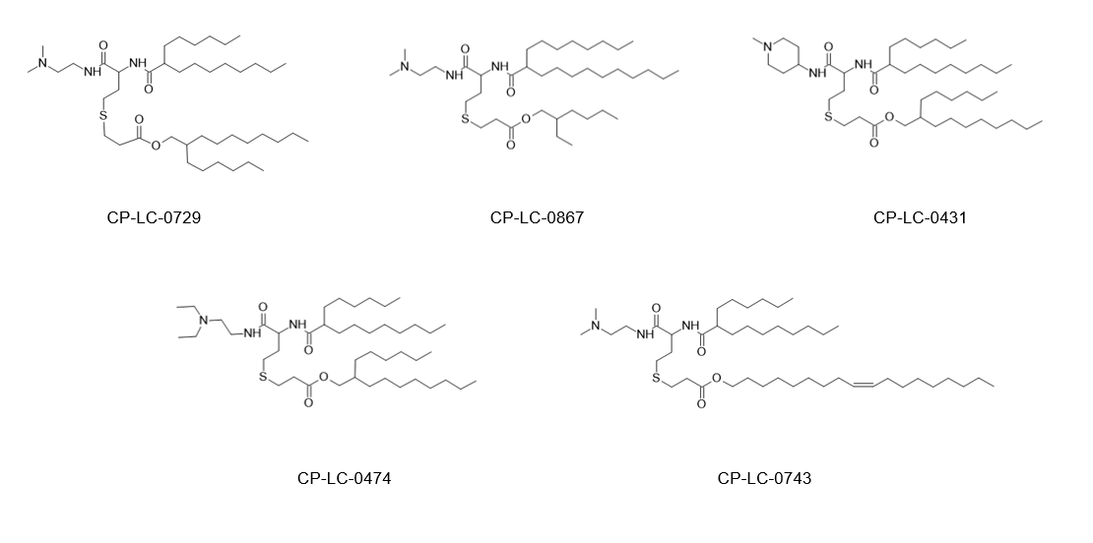
Supplementary Figure 1. Molecular structures of the ionizable lipids used as part of the evaluated vaccine candidate formulations.

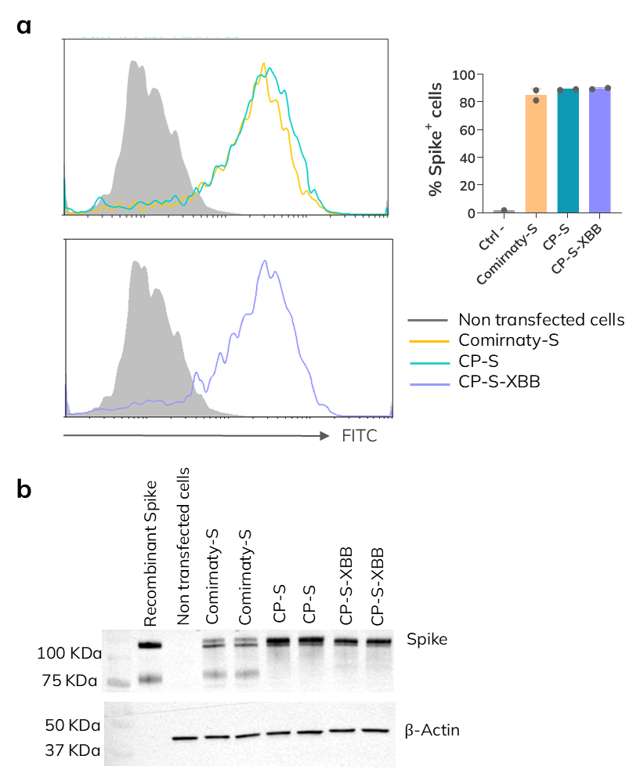
Supplementary Figure 2. In vitro mRNA expression of mRNA sequence designs used in the presented experiments. (a) Flow cytometry analysis of HEK293T cells transfected with the indicated mRNAs and intracellularly labeled with anti-Spike antibody followed by secondary FITC-conjugated antibody. Histograms representing FITC fluorescence intensity (left) and percentage of transfected Spike+ cells (right). (b) Western Blot detection of Spike and β-actin (loading control) proteins in HEK293T cell lysates transfected with the indicated mRNAs.

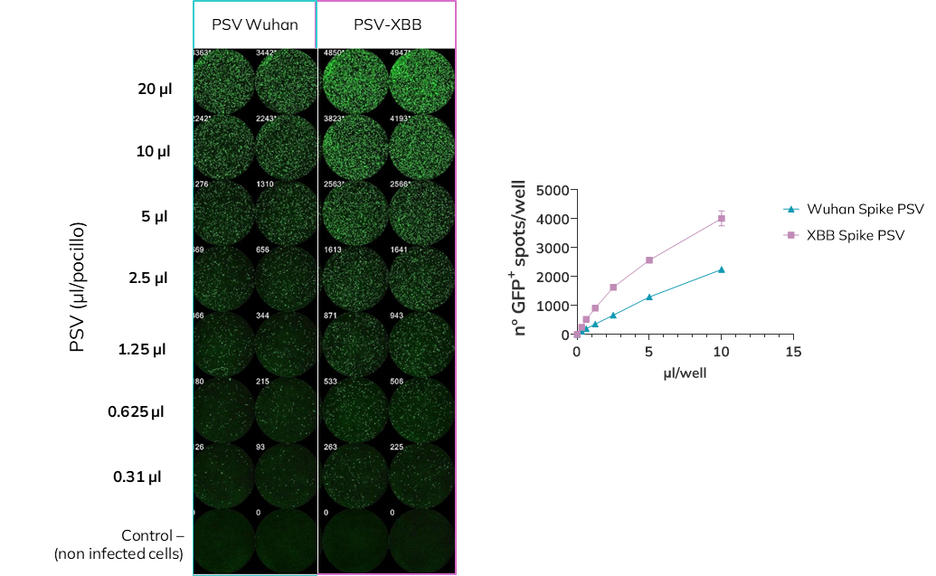
Supplementary Figure 3. Infectivity of Spike pseudotyped lentivirus used in neutralization assays. HEK293T-ACE2-TMPRSS2 cells were infected with different doses of GFP-expressing Wuhan and XBB pseudotyped-lentivirus to assess their infectivity and optimal infection dose for neutralization assays. Images of GFP fluorescence acquisition on Immunospot reader (left) and quantification of the number of GFP spots (right).

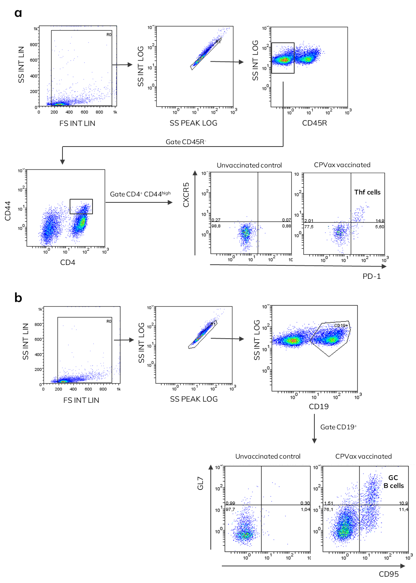
Supplementary Figure 4. Gating strategy for Thf and GC B cells analysis in lymph nodes by flow cytometry. (a) Dot plots of Thf cells analysis in lymph nodes. Representative dot plots of non-vaccinated control mouse and CPVax-CoV vaccinated mouse are shown. (b) Dot plots of GC B cells analysis in lymph nodes. Representative dot plots of non-vaccinated control mouse and CPVax-CoV vaccinated mouse are shown.

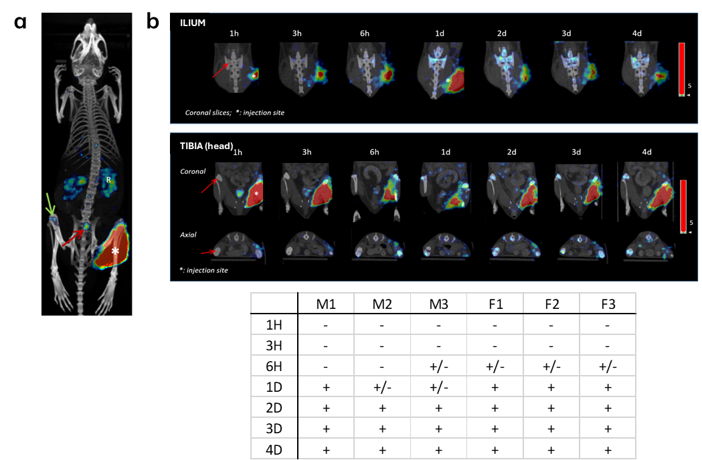
Supplementary Figure 5. Visual detection of radiolabeled-LNP signal in the bone marrow after intramuscular administration of CPVax-CoV. (a) Representative 3D image of the LNP distribution 1 day after administration. *: injection site; R: kidneys; red arrow: sacral ganglion; green arrow: femoral head (b) Representative images of an animal showing the appearance of the signal in the bone marrow of the ilium (coronal section) and tibial head (coronal and axial sections), indicated with a red arrow. Table summarizing the time of signal appearance in the bone marrow of different animals (M: males; F: females). –: no signal; +: positive signal; +/-: weak signal.

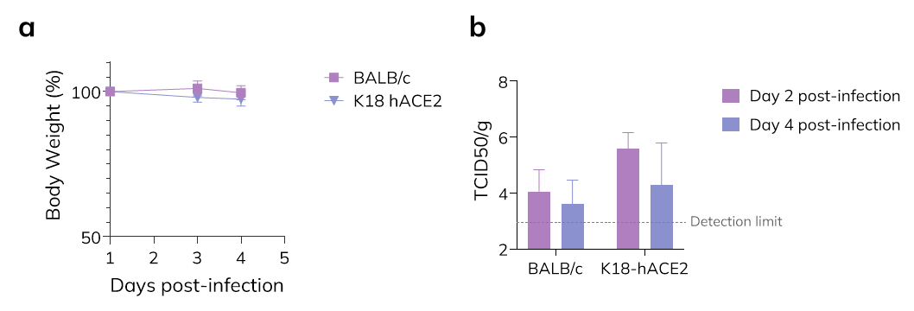
Supplementary Figure 6. Infection of XBB strain in BALB/c and K18 hACE2 mouse models. (a) Body weight monitoring after XBB intranasal challenge with 5x103 TCID50 of SARS-CoV-2 XBB1.5 strain. (b) Lung viral load determined by virus titration assay in VERO E6 cells at day 2 and 4 post-infection. Graphs are represented as mean ± SD.
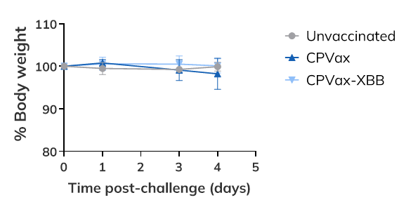
Supplementary Figure 7. Body weight monitoring of K18 hACE2 mice after XBB infection. Graph is represented as mean ± SD.

Supplementary Figure 8. Serum anti-RBD antibodies after boost immunization with one-year stored lyophilized CPVax-CoV. IgG anti-RBD titers were determined by ELISA in serum obtain at day 42 post-prime prior to SARS-CoV-2 challenge. Graph is represented as mean ±SD. **p<0.01; ***p< 0.001; ****p<0.0001 as determined by two-way ANOVA with Tukey post-test.

Supplementary Tables
Table S1. Physicochemical properties of LNPs used in the presented in vivo experiments
Figure | RNA | Ionizable lipid | Diameter | PDI | Z potential | %EE
1 | Comirnaty-S | ALC-0315 | 92.18 | 0.3870 | -8.524 | 94.13
1 | Comirnaty-S | CP-LC-0729 | 84.33 | 0.1456 | -9.021 | 95.38
1 | Comirnaty-S | CP-LC-0867 | 102.80 | 0.0757 | -9.505 | 88.98
1 | Comirnaty-S | CP-LC-0431 | 108.20 | 0.3175 | -7.791 | 99.80
1 | Comirnaty-S | CP-LC-0743 | 106.90 | 0.1982 | -4.658 | 97.96
1 | Comirnaty-S | CP-LC-0474 | 93.99 | 0.1955 | -6.283 | 97.60
2, 3 | Comirnaty-S | ALC-0315 | 84.06 | 0.1110 | -10.490 | 86.48
2, 3 | Comirnaty-S | CP-LC-0729 | 98.50 | 0.2168 | -10.880 | 92.34
2, 3 | CP-S | CP-LC-0729 | 91.19 | 0.1450 | -9.445 | 92.47
4 | Comirnaty-S | ALC-0315 | 84.79 | 0.2118 | -9.857 | 83.68
4 | CP-S | CP-LC-0729 | 96.41 | 0.1961 | -6.511 | 97.36
5 | Comirnaty-S | ALC-0315 | 85.20 | 0.2337 | -11.800 | 85.01
5 | CP-S | CP-LC-0729 | 91.64 | 0.2210 | -7.819 | 95.46
6, 8f | CP-S | CP-LC-0729 | 91.64 | 0.2210 | -7.819 | 95.46
6, 8f | CP-SXBB | CP-LC-0729 | 88.39 | 0.1948 | -9.527 | 91.35

Table S2. Physicochemical parameters of LNPs used in the stability study
Figure | LNP | RNA | Ionizable lipid | Condition | Storage Tª | Time of storage | Diameter | PDI | Z potential | %EE
7 | Comirnaty | Comirnaty-S | ALC-0315 | Liquid | N/A | 0 | 90.94 | 0.3039 | -7.567 | 88.3
7 | CPVax-CoV | CP-S | CP-LC-0729 | Liquid | N/A | 0 | 101.80 | 0.1081 | -5.479 | 97
7 | CPVax-CoV | CP-S | CP-LC-0729 | Lyophilized | N/A | 0 | 197.70 | 0.1518 | -5.935 | 94.6
7 | Comirnaty | Comirnaty-S | ALC-0315 | Liquid | -80 ºC | 3 months | 89.06 | 0.3019 | -4.350 | 78.9
7 | CPVax-CoV | CP-S | CP-LC-0729 | Liquid | -80 ºC | 3 months | 99.43 | 0.0567 | -0.959 | 95
7 | CPVax-CoV | CP-S | CP-LC-0729 | Lyophilized | 4 ºC | 3 months | 181.10 | 0.0723 | -2.593 | 90.1
7 | CPVax-CoV | CP-S | CP-LC-0729 | Lyophilized | 25 ºC | 3 months | 214.70 | 0.0989 | -0.289 | 89.3
7 | Comirnaty | Comirnaty-S | ALC-0315 | Liquid | -80 ºC | 6 months | 102.7 | 0.3278 | -14.48 | 75.7
7 | CPVax-CoV | CP-S | CP-LC-0729 | Liquid | -80 ºC | 6 months | 115.7 | 0.1731 | -3.818 | 93.1
7 | CPVax-CoV | CP-S | CP-LC-0729 | Lyophilized | 4 ºC | 6 months | 221.70 | 0.1593 | -5.669 | 95.8
7 | CPVax-CoV | CP-S | CP-LC-0729 | Lyophilized | 25 ºC | 6 months | 270.60 | 0.1321 | -5.656 | 95
7 | Comirnaty | Comirnaty-S | ALC-0315 | Liquid | -80 ºC | 9 months | 92.46 | 0.2039 | -9.099 | 71.6
7 | CPVax-CoV | CP-S | CP-LC-0729 | Liquid | -80 ºC | 9 months | 107.60 | 0.1249 | -6.346 | 94.1
7 | CPVax-CoV | CP-S | CP-LC-0729 | Lyophilized | 4 ºC | 9 months | 222.00 | 0.1269 | -4.647 | 86.5
7 | CPVax-CoV | CP-S | CP-LC-0729 | Lyophilized | 25 ºC | 9 months | 279.60 | 0.2169 | -3.931 | 85.1
7 | Comirnaty | Comirnaty-S | ALC-0315 | Liquid | -80 ºC | 12 months | 92.66 | 0.2509 | -8.152 | 83
7 | CPVax-CoV | CP-S | CP-LC-0729 | Liquid | -80 ºC | 12 months | 106.90 | 0.0726 | -8.837 | 95.1
7 | CPVax-CoV | CP-S | CP-LC-0729 | Lyophilized | 4 ºC | 12 months | 225.30 | 0.1569 | -6.660 | 89
7 | CPVax-CoV | CP-S | CP-LC-0729 | Lyophilized | 25 ºC | 12 months | 234.60 | 0.08014 | -5.933 | 89.2
7 | CPVax-CoV | CP-S | CP-LC-0729 | Lyophilized, resuspended | 4º C | 24 h | 179.10 | 0.0670 | -4.930 | 95.02
7 | CPVax-CoV | CP-S | CP-LC-0729 | Lyophilized, resuspended | 4 ºC | 96 h | 156.60 | 0.0989 | -4.254 | 92.75
8 | Comirnaty | Comirnaty-S | ALC-0315 | Liquid | Freshly prepared control | 0 | 72.19 | 0.1803 | -10.840 | 78.78
8 | CPVax-CoV | CP-S | CP-LC-0729 | Liquid | Freshly prepared control | 0 | 108.60 | 0.1000 | -8.024 | 94.64

Supplementary methods
Production of SARS-CoV-2 pseuodytped lentivirus for neutralization assays
The viral particles were synthesized using an HIV-based second-generation lentiviral system, characterized by the utilization of three plasmids: a transfer plasmid, a packaging plasmid, and an envelope plasmid. The transfer plasmid (pwGFP), which serves as the foundation for constructing the lentiviral vector, housed the viral particle's genome (eGFP). The packaging plasmid (EMP0) was used to encode essential viral proteins crucial for lentiviral particle assembly and efficient gene expression within target cells, including Gag (structural proteins), Pol (polymerase), Rev (gene expression regulator), and Tat (transcriptional activator). The envelope plasmid, which dictates viral tropism, encoded the envelope glycoprotein responsible for recognizing specific cell surface receptors and mediating viral entry, in this case the full-length S protein of SARS-CoV-2. Three envelope plasmids (ENV2, ENV3, ENV4) were employed to pseudotype viral particles with the S protein variants of T and XBB strains of SARS-CoV-2, respectively.
To produce the viral particles, 2.75 x 10⁶ HEK293T cells were seeded in a T75 flask containing 13 mL of complete DMEM. The following day, the cells were transfected with 12.5 µg each of pwGFP and EMP0 plasmids, along with 2.5 µg of the different ENV plasmids, using FuGENE® transfection reagent (Promega) according to the manufacturer's instructions. After 48 h the viral supernatant was collected and filtered through an Acrodisc® Supor® 0.45 µm filter before being stored at -80°C.
The capacity of each pseudovirus variant produced to infect ACE2-TMPRSS2 cells was determined empirically with an infectivity assay. To perform this assay, 2x10⁵ cells/mL HEK293T-ACE2-TMPRSS2 cells were infected with an equal volume of serially diluted pseudovirus in DMEM. The cells were seeded in black 96-well microplate (Thermo Scientific) and incubated at 37 °C and 5% CO₂ for 48 h. Following incubation, cells were fixed with 4% paraformaldehyde in PBS for 1 h. The plates were washed twice with PBS and dried. The fluorescent spots were counted using a C.T.L. S6 Ultra-V analyzer with the FluoroSpot-X suite selected. The dilution of pseudovirus chosen was the one which yielded 500-1000 infected cells per well (Figure S3).

