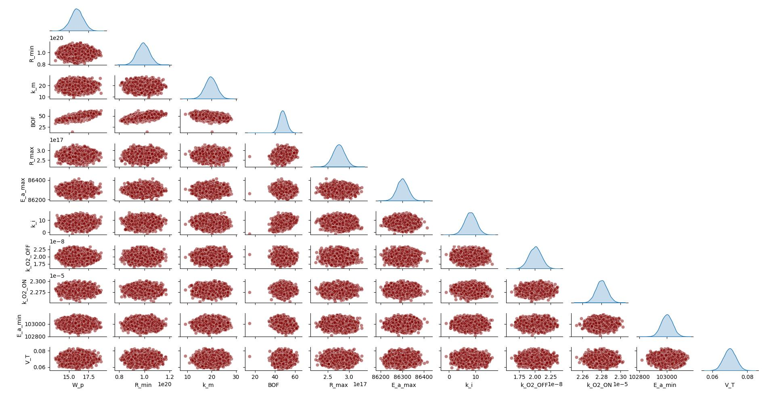
Figure S1. Sensitivity analysis results showing the pairwise scatter plots highlighting the relationship and interaction between all model parameters and Blower ON Time (BOF). The interactions between BOF and the parameters such as $W_{p}, R_{min} and { k}_{m}$showed a meaningful correlation with each other, than the other parameters.

