Supporting Information

for
Global mangrove loss footprint mappings across space and time.

Pages: 8
Figures: 2
Tables:8

SI-Figure 1: Mangrove loss footprint flows (km2) between mangrove-holding and consumer countries in 2000-2016.
SI-Figure 2: Maps of Mangrove loss footprints (km2) in 65 mangrove-holding countries driven by USA’s consumption.

SI-Table 1: 65 mangrove holding countries and their country attributes.
SI-Table 2:Adjacent countries of China, Thailand,and India.
SI-Table 3:Indonesia, top 20, and all mangrove-holding countries’ mangrove loss percentage driven by domestic, adjacent, and distant consumptions (%).
SI-Table 4:List of 12 Southeast countries
SI-Table 5: 12 Southeast countries’ mangrove loss percentage compared to other areas worldwide driven by China’s consumption.
SI-Table 6: 12 Southeast countries’ mangrove loss percentage compared to other areas worldwide driven by USA’s consumption.
SI-Table 7: Literature review between mangrove loss footprint and other spatial explicit footprint
SI-Table 8: Concept clarification of mangrove loss footprint and mangrove loss.

The supporting information provides supplemental Figures and Tables supporting the main text.

SI-Figure 1:Mangrove loss footprint flows (km2) between mangrove-holding and consumer countries in 2000-2016
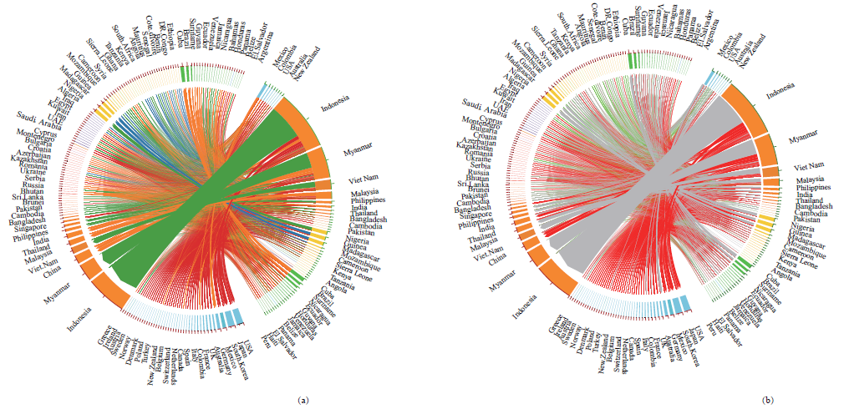
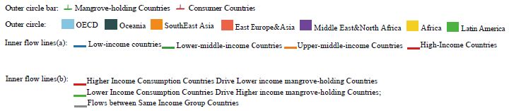
Mangrove loss footprint flows (km2) between mangrove-holding and consumer countries in 2000-2016 with two visualization ways. (a) the flow color represents the consumer country’s economic status, and (b) the flow color represents how mangrove forest resources flow between countries of different economic statuses. Mangrove-holding countries are marked by green in their outer circle bar, and consumer countries by red. The arc length of the circle indicates the sum of consumption exported and imported between the mangrove-holding and consumer countries. The arc color of the circle indicates the region of countries, which is ordered by their geographic location.

SI-Figure 2:Maps of Mangrove loss footprints (km2) in 65 mangrove-holding countries driven by USA’s consumption
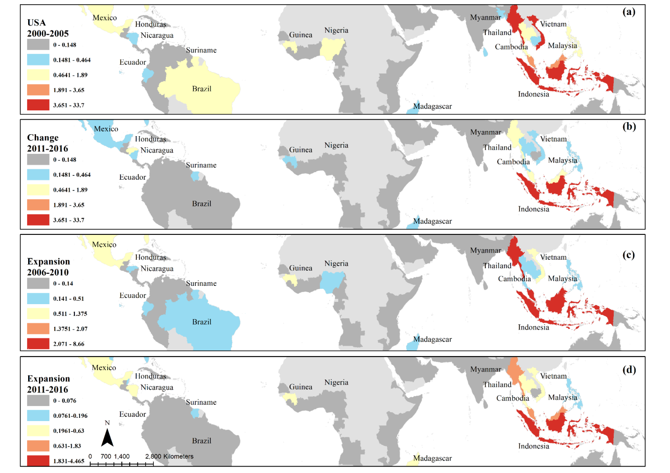
Maps of Mangrove loss footprints (km2) in 65 mangrove-holding countries driven by USA’s consumption to compare the changes (a) and (b) and expansion (a), (c), and (d) in three epochs (2000-2005, 2006-2010, 2011-2016) at the country level.

SI-Table 1:65 mangrove holding countries and their country attributes.

country | Country | Region | IncomeGroup
IDN | Indonesia | E_S_Asia | LMIC
MMR | Myanmar | E_S_Asia | LMIC
VNM | Vietnam | E_S_Asia | LMIC
MYS | Malaysia | E_S_Asia | UMIC
CUB | Cuba | LAC | UMIC
NGA | Nigeria | Africa | LMIC
MDG | Madagascar | Africa | LIC
GIN | Guinea | Africa | LIC
MEX | Mexico | OECD | UMIC
BRA | Brazil | LAC | UMIC
PHL | Philippines | E_S_Asia | LMIC
THA | Thailand | E_S_Asia | UMIC
SUR | Suriname | LAC | UMIC
IND | India | E_S_Asia | LMIC
MOZ | Mozambique | Africa | LIC
BGD | Bangladesh | E_S_Asia | LMIC
COL | Colombia | OECD | UMIC
AUS | Australia | OECD | HIC
CMR | Cameroon | Africa | LMIC
SLE | Sierra Leone | Africa | LIC
GUY | Guyana | LAC | UMIC
KHM | Cambodia | E_S_Asia | LMIC
GHA | Ghana | Africa | LMIC
ECU | Ecuador | LAC | UMIC
VEN | Venezuela, RB | LAC | UMIC
NIC | Nicaragua | LAC | LMIC
JAM | Jamaica | LAC | UMIC
TZA | Tanzania | Africa | LMIC
USA | United States | OECD | HIC
HND | Honduras | LAC | LMIC
KEN | Kenya | Africa | LMIC
PAN | Panama | LAC | UMIC
BLZ | Belize | LAC | LMIC
GAB | Gabon | Africa | UMIC
AGO | Angola | Africa | LMIC
SLV | El Salvador | LAC | LMIC
HTI | Haiti | LAC | LMIC
PNG | Papua New Guinea | Oceania | LMIC
LKA | Sri Lanka | E_S_Asia | LMIC
PAK | Pakistan | E_S_Asia | LMIC
DOM | Dominican Republic | LAC | UMIC
NZL | New Zealand | OECD | HIC
CRI | Costa Rica | OECD | UMIC
ARE | United Arab Emirates | MENA | HIC
TTO | Trinidad and Tobago | LAC | HIC
SAU | Saudi Arabia | MENA | HIC
PER | Peru | LAC | UMIC
SEN | Senegal | Africa | LMIC
BEN | Benin | Africa | LMIC
GMB | Gambia, The | Africa | LIC
GTM | Guatemala | LAC | UMIC
CIV | Cote d'Ivoire | Africa | LMIC
ZAF | South Africa | Africa | UMIC
OMN | Oman | MENA | HIC
SOM | Somalia | Africa | LIC
LBR | Liberia | Africa | LIC
DJI | Djibouti | Africa | LMIC
QAT | Qatar | MENA | HIC
IRN | Iran, Islamic Rep. | MENA | LMIC
SGP | Singapore | E_S_Asia | HIC
TGO | Togo | Africa | LIC

SI-Table 2:Adjacent countries of China, Thailand,and India.
 | Adjacent countries with mangrove forests
China | Myanmar, Vietnam, Laos, India,
Thailand | Laos, Cambodia,Malaysia, Myanmar
India | China, Bangladash, Myanmar

SI-Table 3:Indonesia, top 20, and all mangrove-holding countries’ mangrove loss percentage driven by domestic, adjacent, and distant consumptions (%).
 | domestic | adjacent | distant
IDN | 65.93899147 | 0.839378932 | 33.2216296
Top20 | 66.61403321 | 6.903647849 | 26.48231894
All countries | 67.0574219 | 6.748637976 | 26.19394012

SI-Table 4:List of 12 Southeast countries
BGD | Bangladesh
IDN | Indonesia
IND | India
KHM | Cambodia
LKA | Sri Lanka
MMR | Myanmar
MYS | Malaysia
PAK | Pakistan
PHL | Philippines
PNG | Papua New Guinea
THA | Thailand
VNM | Vietnam

SI-Table 5:12 Southeast countries’ mangrove loss total amount (km2) and percentage(%) compared to other areas driven by China’s consumption.
Loss area (km2) | 2000-2005 | 2011-2016 | 2000-2016
Southeast Asia | 46.40657184 | 17.58190439 | 117.6745104
Worldwide | 47.34787596 | 18.21361591 | 120.3088447
Percentage (%) | 2000-2005 | 2011-2016 | 2000-2016
Southeast Asia | 98.01194012 | 96.53165234 | 97.81035696
Other areas | 1.988059878 | 3.46834766 | 2.189643044

SI-Table 6:12 Southeast countries’ mangrove loss total amount (km2) and percentage(%) compared to other areas driven by USA’s consumption.
Loss area (km2) | 2000-2005 | 2011-2016 | 2000-2016
Southeast Asia | 63.09021299 | 8.676726461 | 74.28828018
Worldwide | 72.02784934 | 11.72575288 | 90.59779764
Percentage (%) | 2000-2005 | 2011-2016 | 2000-2016
Southeast Asia | 87.59141578 | 73.99717994 | 81.99788749
Other Areas | 12.40858422 | 26.00282006 | 18.00211251

SI-Table 7:Literature review between mangrove loss footprint and other spatial explicit footprints
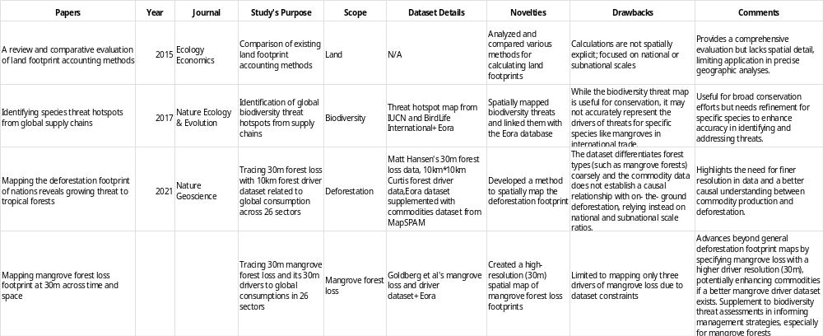

SI-Table 8: Concept clarification of mangrove loss footprint and mangrove loss.
Concepts | Definitions | Description | Method | References
Mangrove loss | Direct mangrove loss from the ground through remote sensing data. ‘Mangrove loss’ is measured as the complete removal of tree cover exceeding a height threshold of 5 meters within the mangrove habitat. Countries with mangrove forest coverage are mangrove-holding countries. | The final products include pixel-level raster data (30m*30m) in 39 countries for every driver in three epochs (2000-2005, 2005-2010, and 2010-2016). Its country-level statistics are also provided for 72 countries. | Remote Sensing | Goldberg et al. (2022)
Human-induced mangrove loss | Mangrove loss from the ground due to direct human-related conversion: commodities, human settlement, and non-productive conversion | same as above. | Remote Sensing | Goldberg et al. (2022)
Mangrove loss footprint (Trade-adjusted mangrove loss) | Mangrove loss that is consumed to meet a country’s final demand, such as local mangrove conversion to commodities exported and consumed abroad. It is the loss caused by final demand through the global supply chain. | Mangrove loss footprint is measured for 189 countries in the Eora database for three periods: 2000-2005, 2005-2010, and 2010-2016. The Eora sectors are aggregated to link with mangrove loss’s anthropogenic drivers and then connected to spatially explicit human-induced loss to calculate the mangrove loss footprint. | MRIO+Remote sensing+GIS mapping | Wiedmann & Lenzen. (2018)  Hoang et al. (2021)

