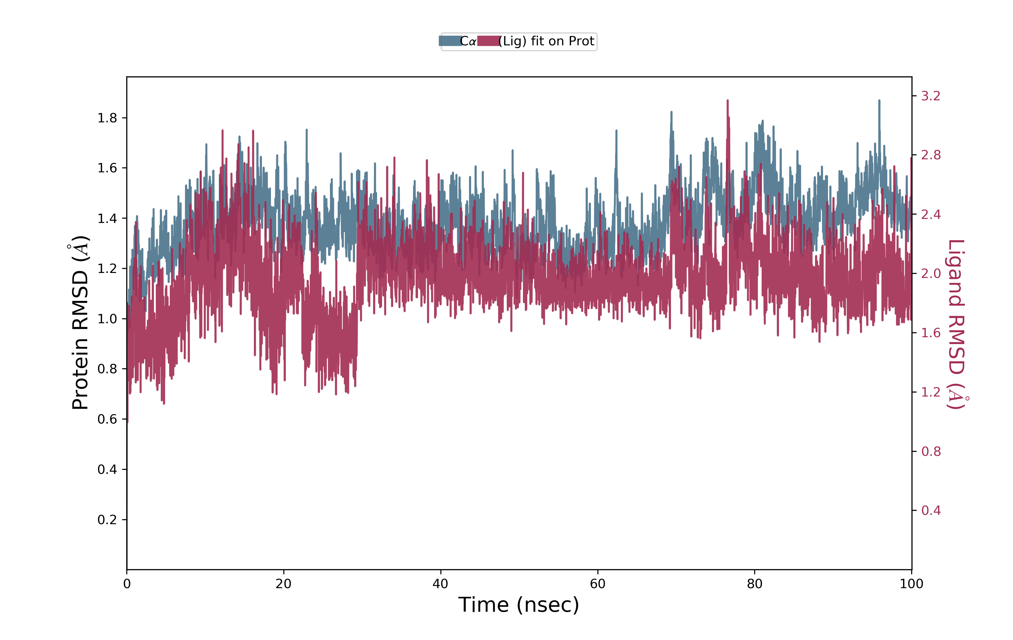

Figure S13: The RMSD trajectories and interaction of DPP4 protein-ligand (Catechin 5-O-gallate).

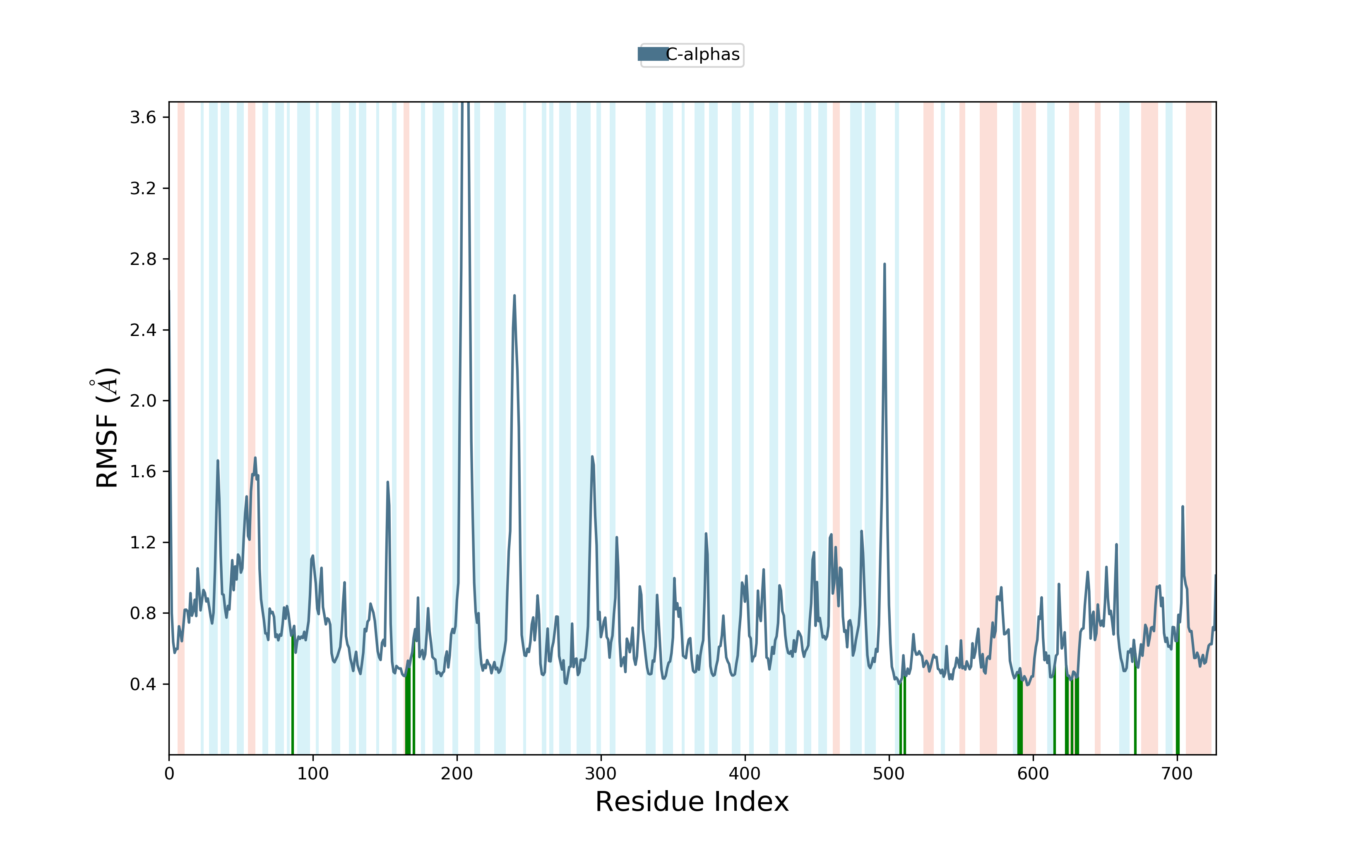

Figure S14: The RMSF trajectories and interaction of DPP4 protein-ligand (Catechin 5-O-gallate).

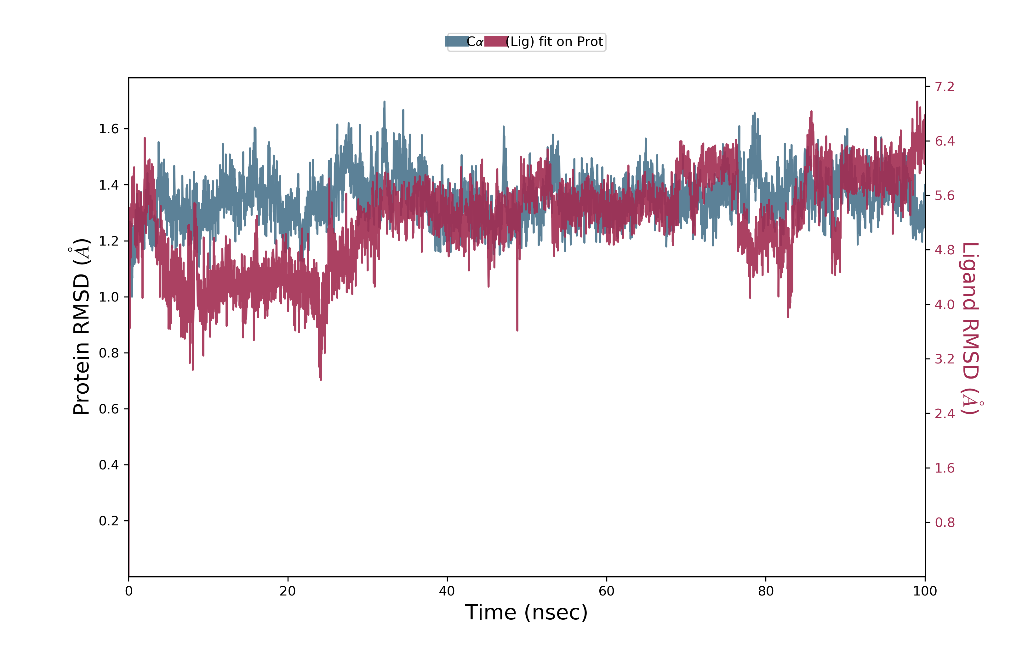
Figure S15: The RMSD trajectories and interaction of DPP4 protein-ligand (Crosatoside B).

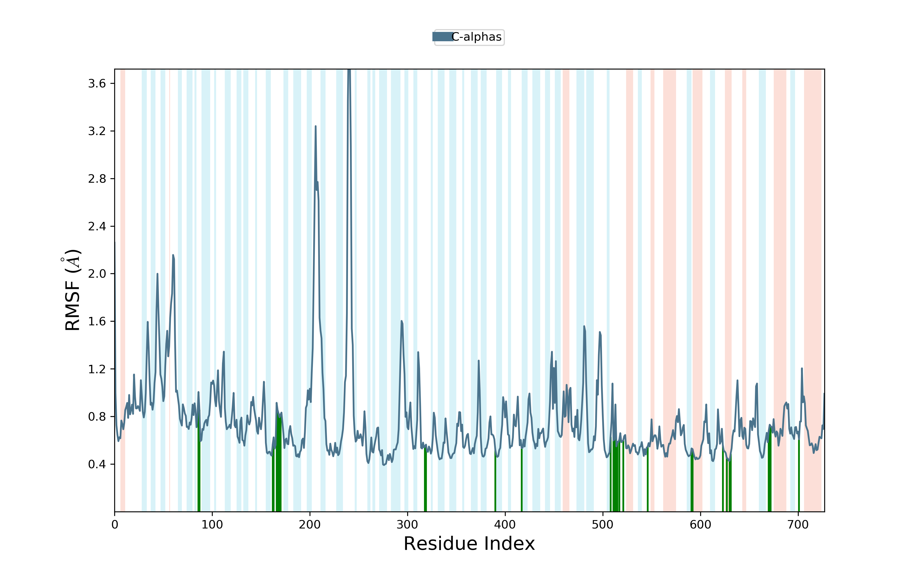
Figure S16: The RMSF trajectories and interaction of DPP4 protein-ligand (Crosatoside B).

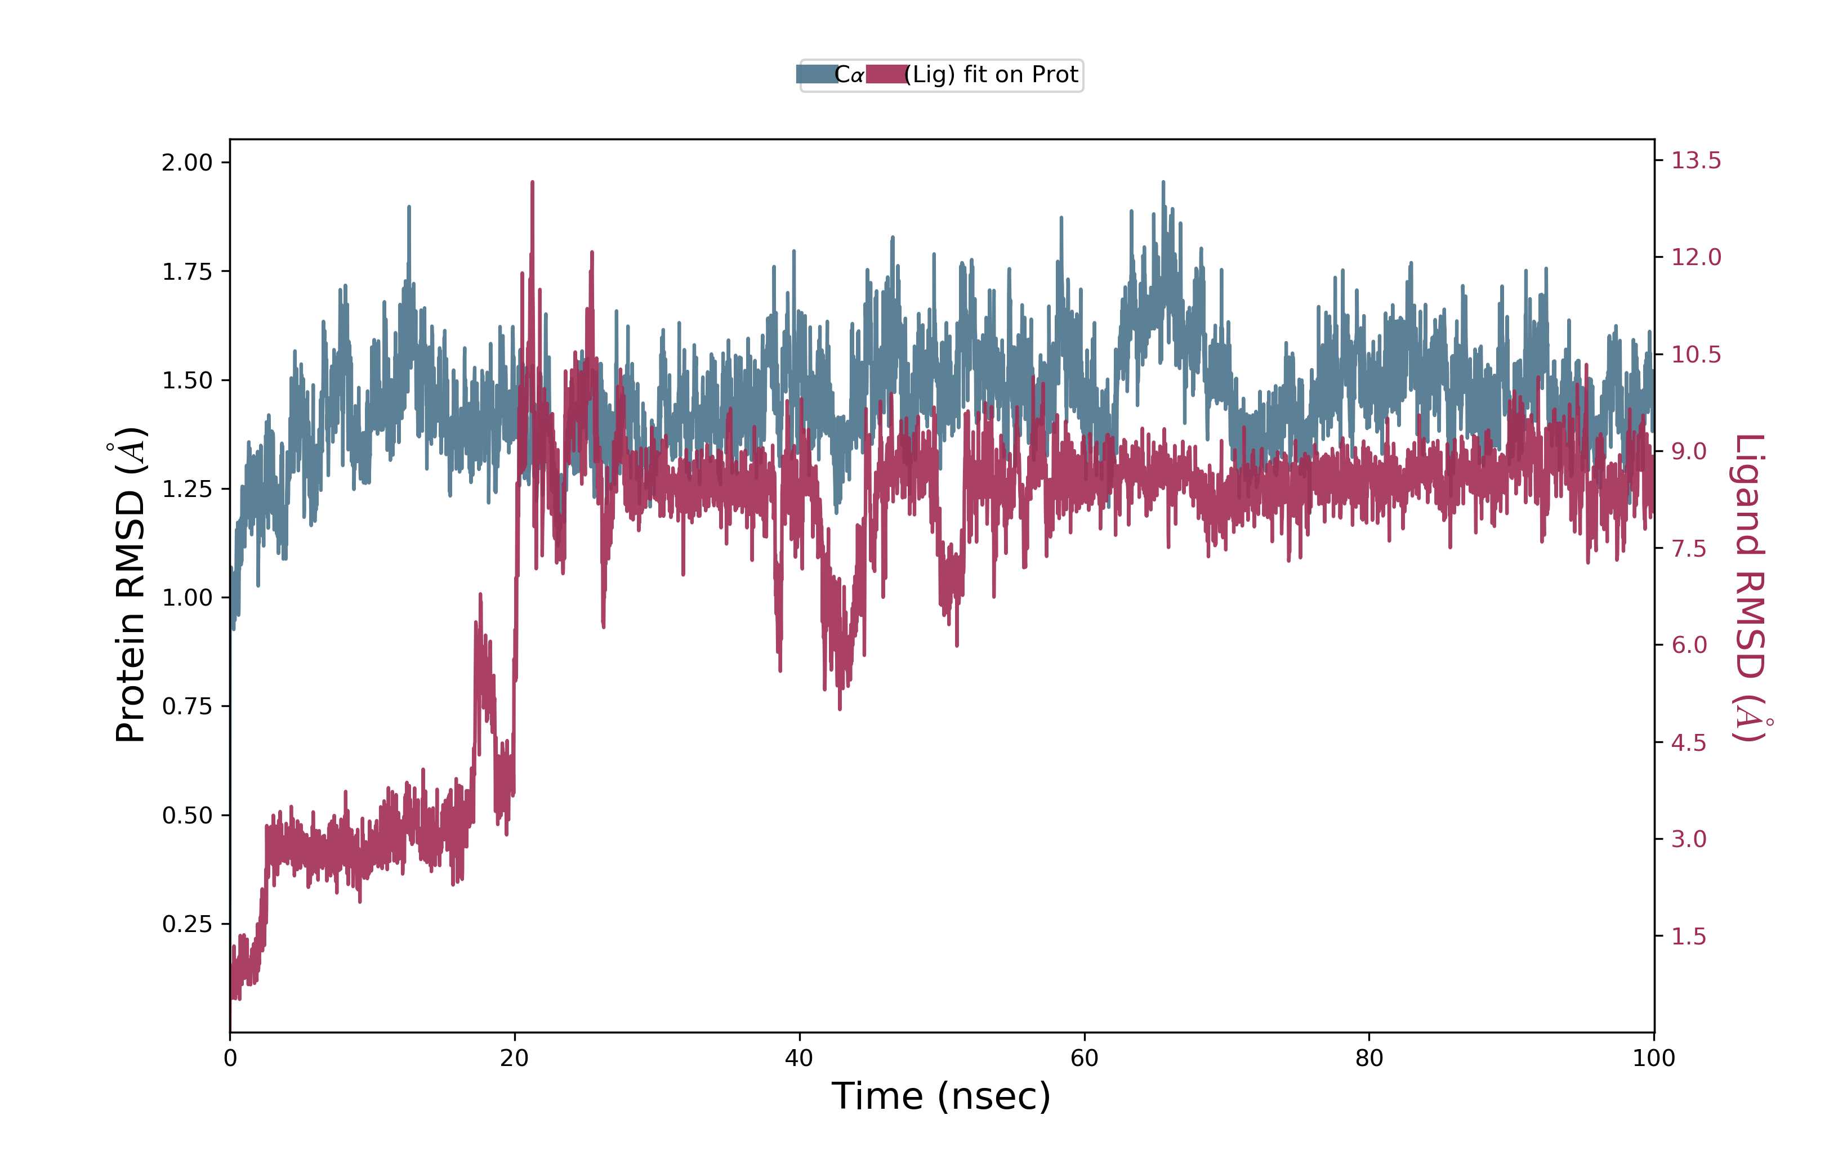
Figure S17: The RMSD trajectories and interaction of DPP4 protein-ligand Hypoglycin

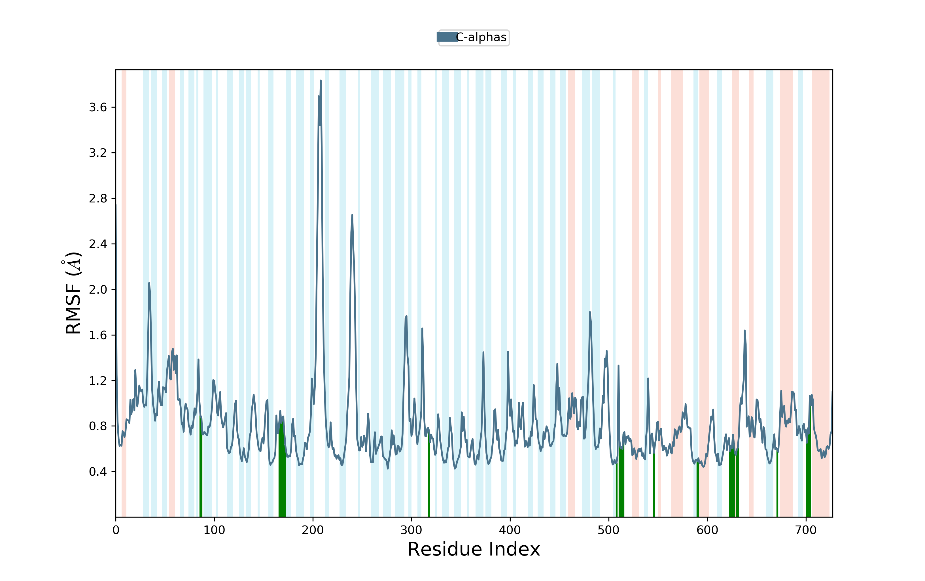

Figure S18: The RMSF trajectories and interaction of DPP4 protein-ligand Hypoglycin

