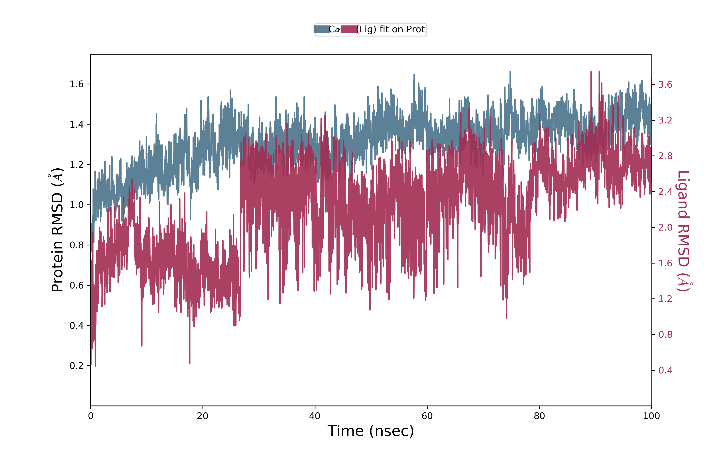

Figure S7: The RMSD trajectories and interaction of α-amylase (3DHP) protein-ligand (Catechin 5-O-gallate).

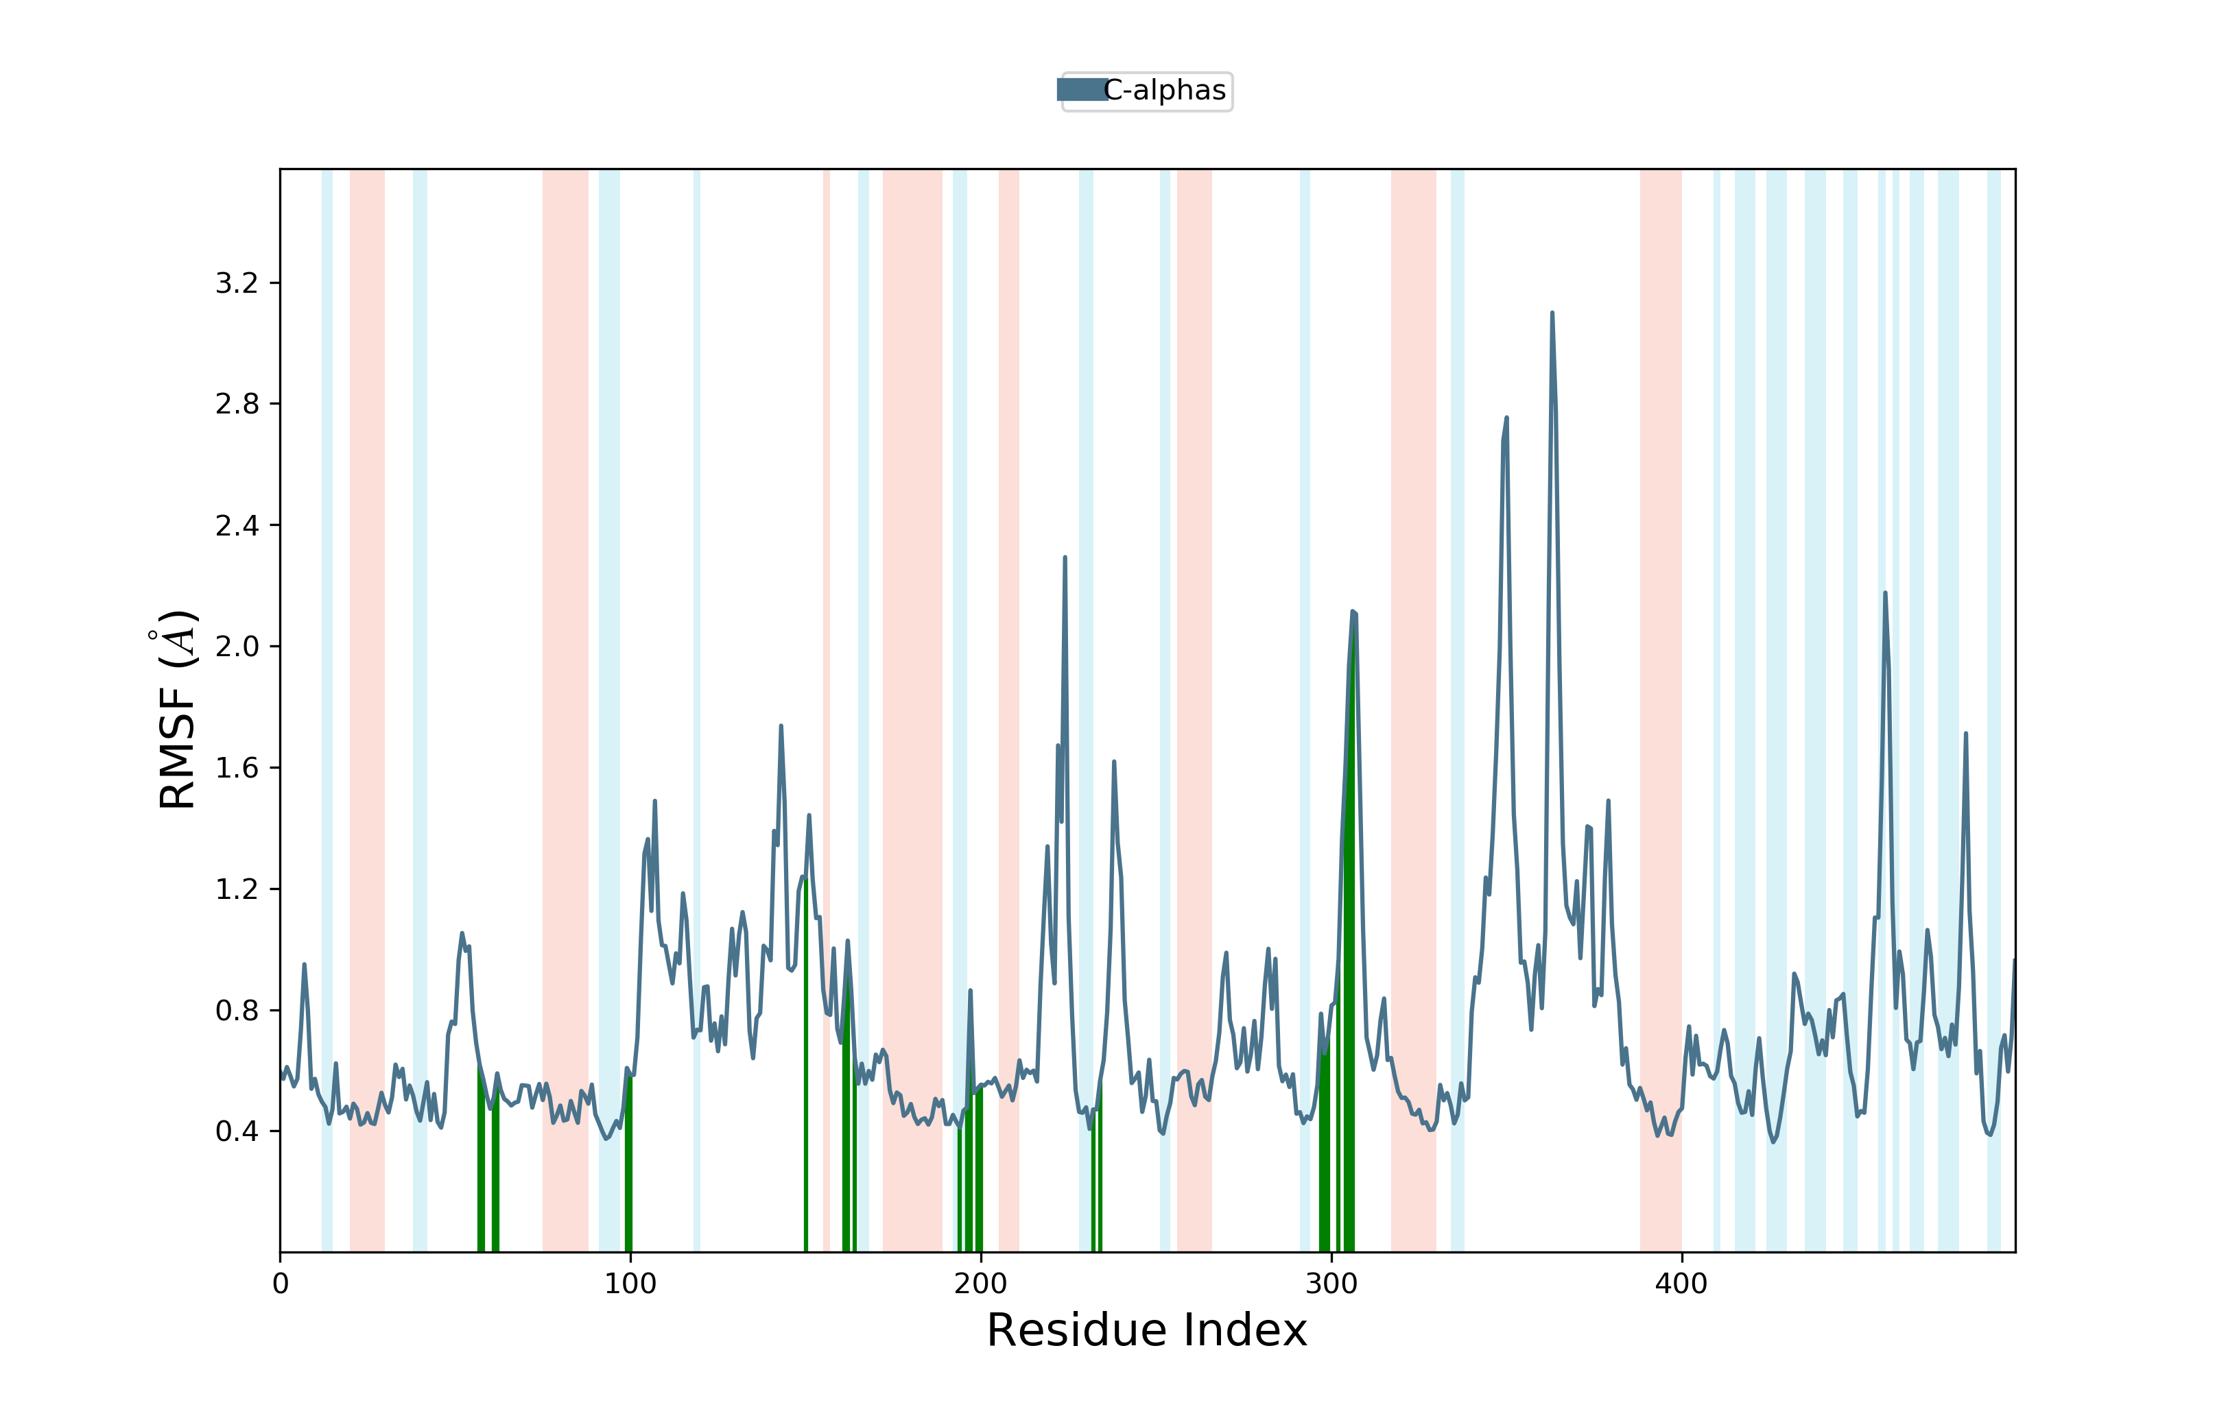

Figure S8: The RMSF trajectories and interaction of α-amylase (3DHP) protein-ligand (Catechin 5-O-gallate).
Catechin 5-O-gallate

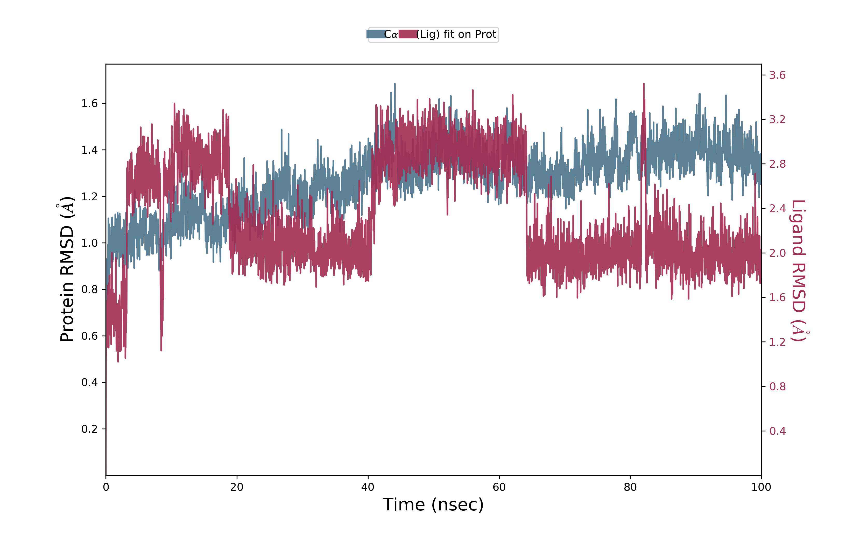
Figure S9: The RMSD trajectories and interaction of α-amylase (3DHP) protein-ligand Crosatoside B

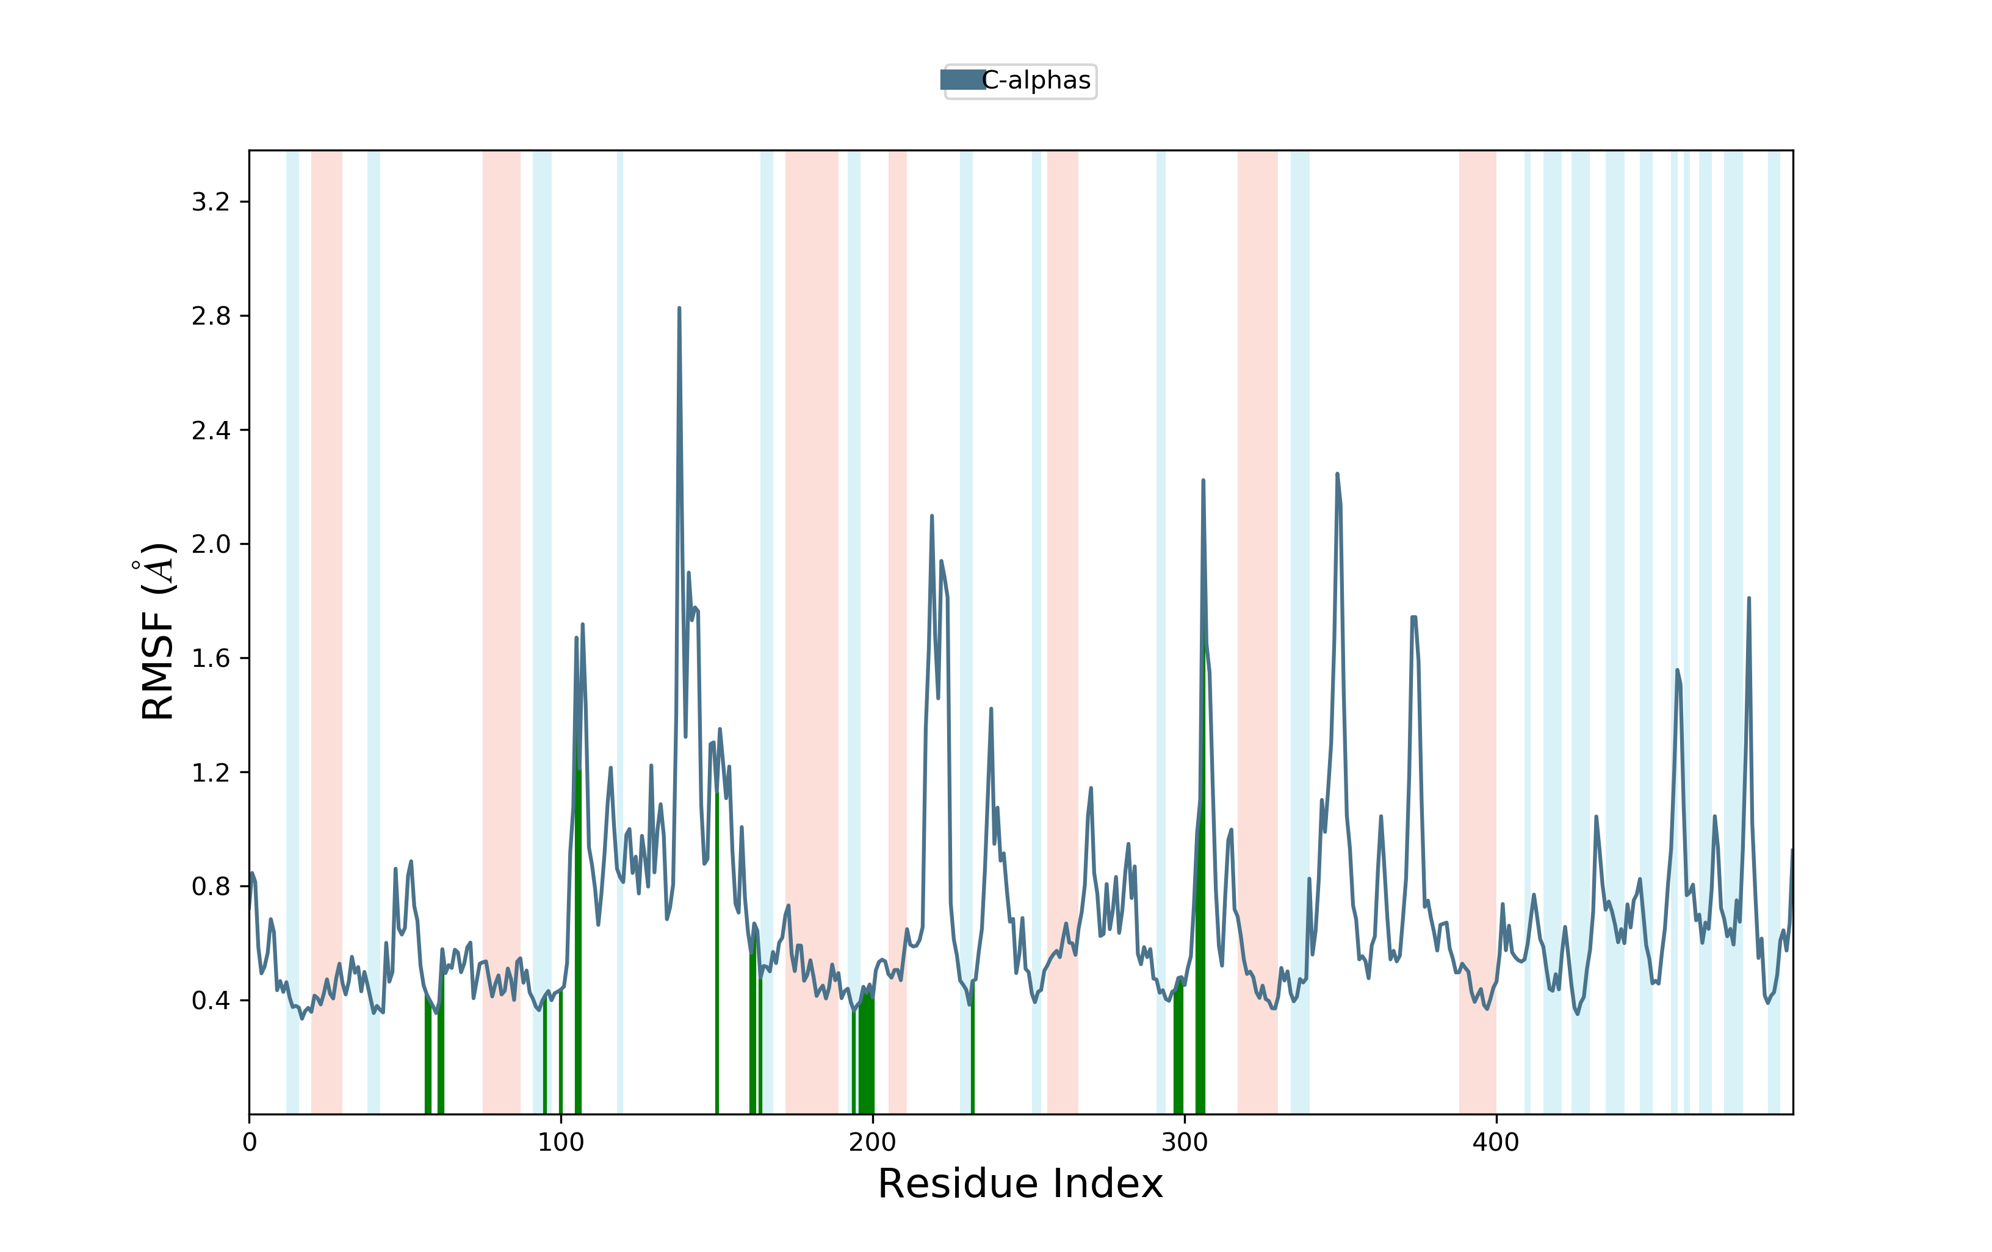
Figure S10: The RMSF trajectories and interaction of α-amylase (3DHP) protein-ligand Crosatoside B

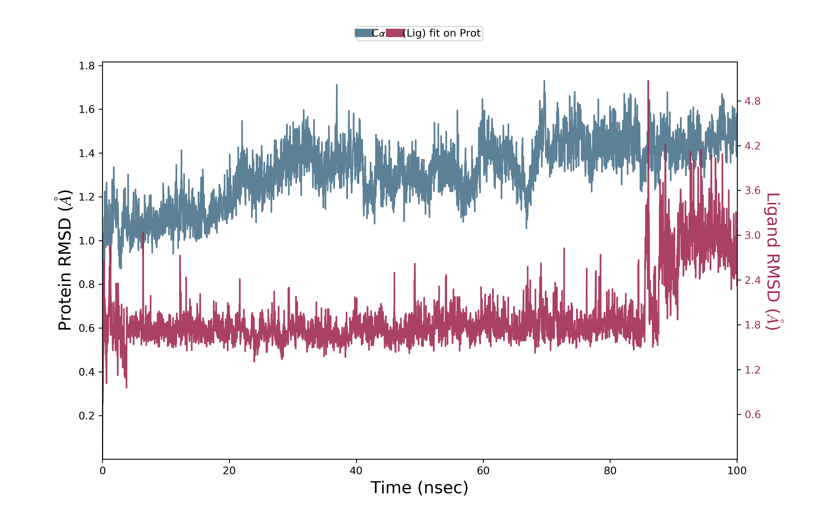
Figure S11: The RMSD trajectories and interaction of α-amylase (3DHP) protein-ligand Hypoglycin

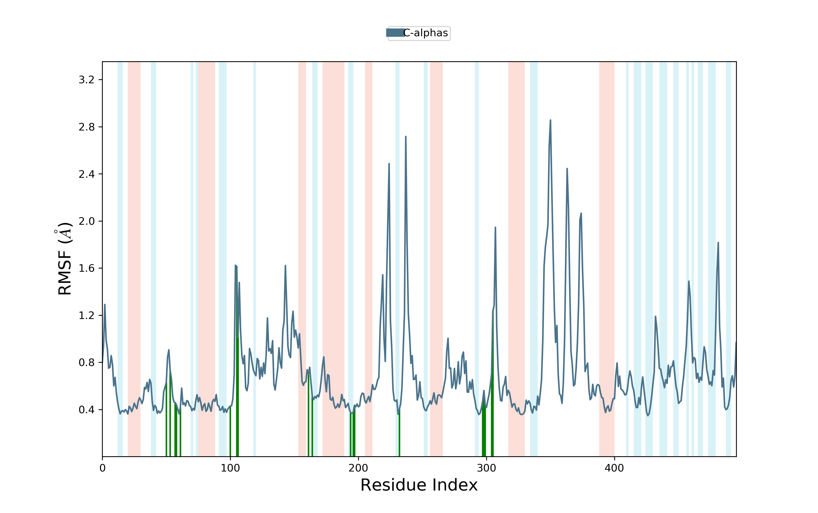

Figure S8: The RMSF trajectories and interaction of α-amylase (3DHP) protein-ligand Hypoglycin

