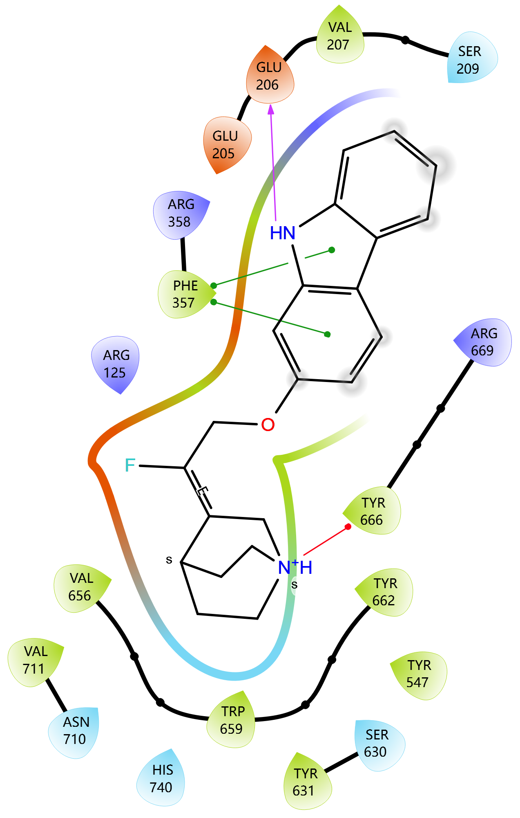

Figure S1:Ligand Interaction Diagram of [Catechin 5-O-gallate] in the Binding Pocket of [3DHP]
Legend: The diagram shows 2D interactions between the ligand and surrounding amino acid residues in the protein's active site.

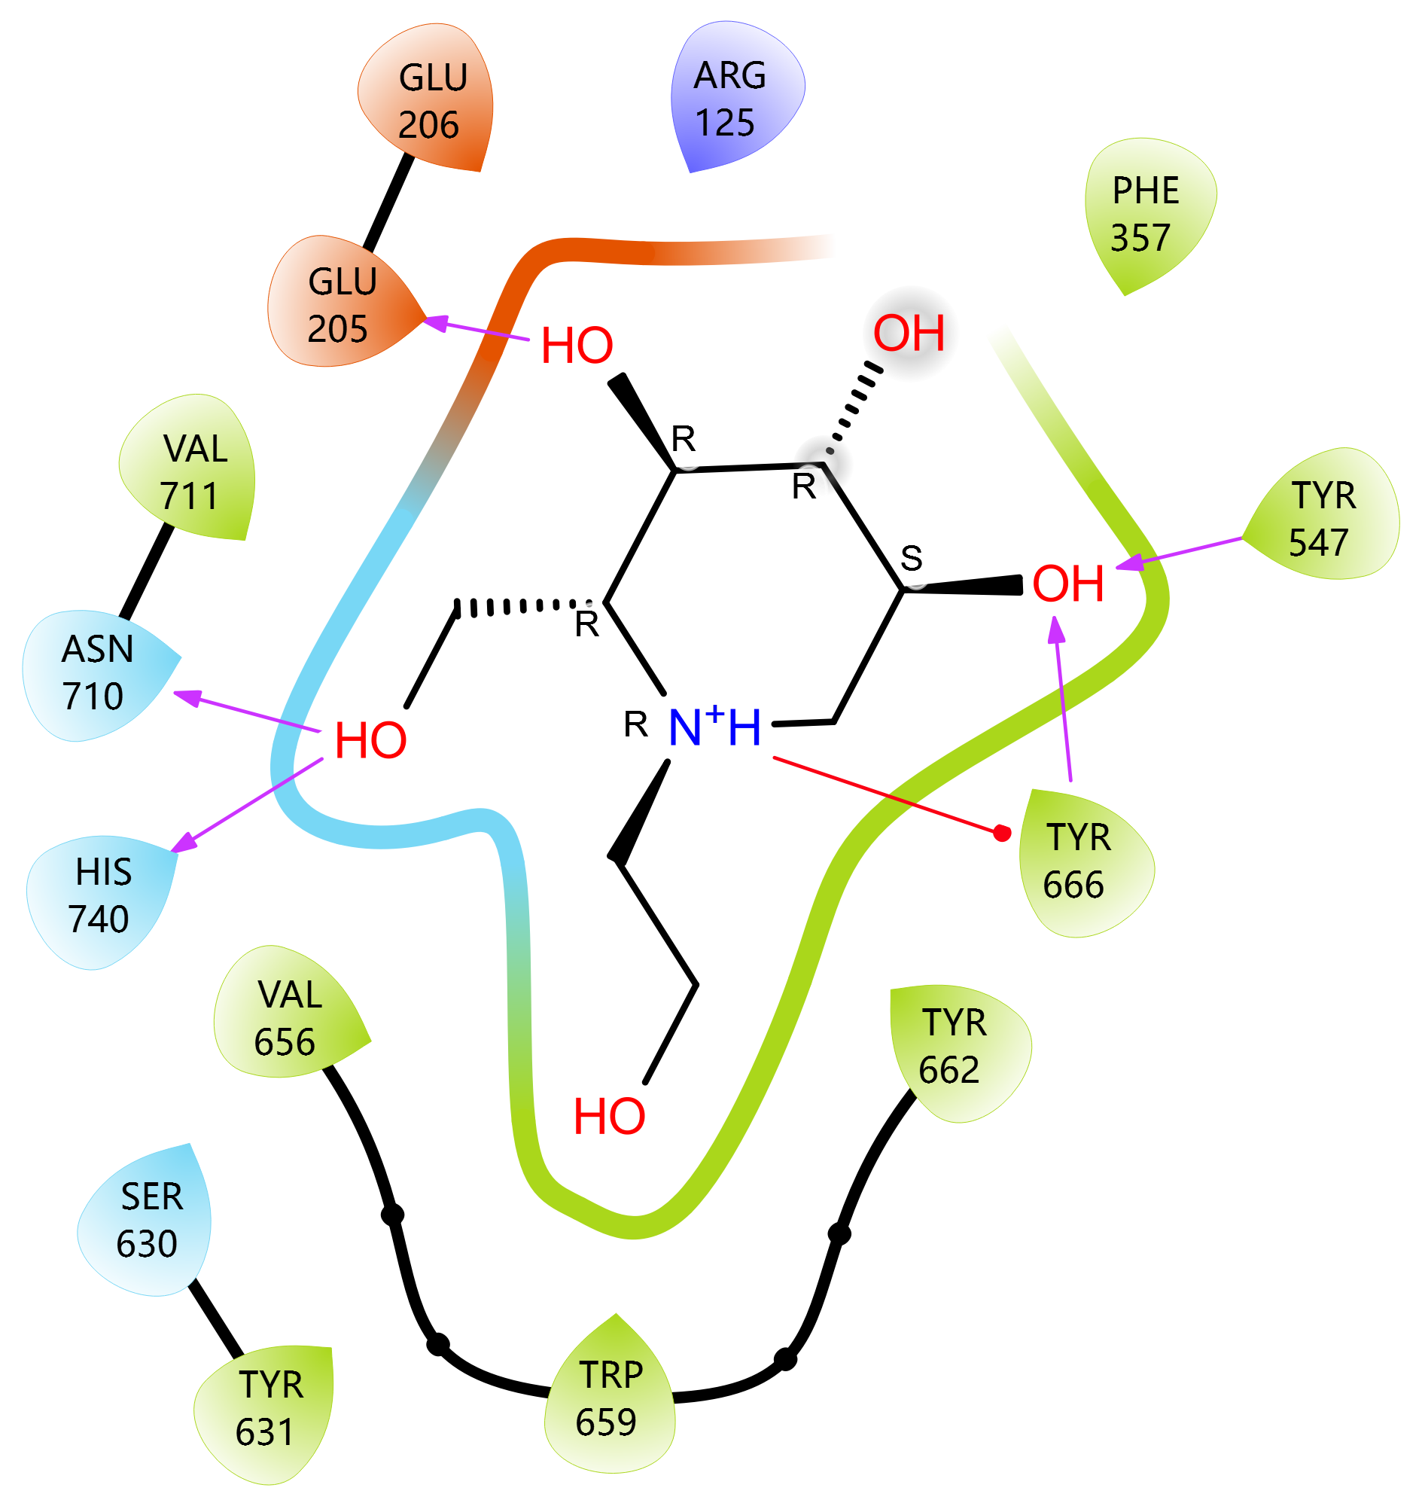

Figure S2: Ligand Interaction Diagram of [Crosatoside B] in the Binding Pocket of [3DHP]
Legend: The diagram shows 2D interactions between the ligand and surrounding amino acid residues in the protein's active site.

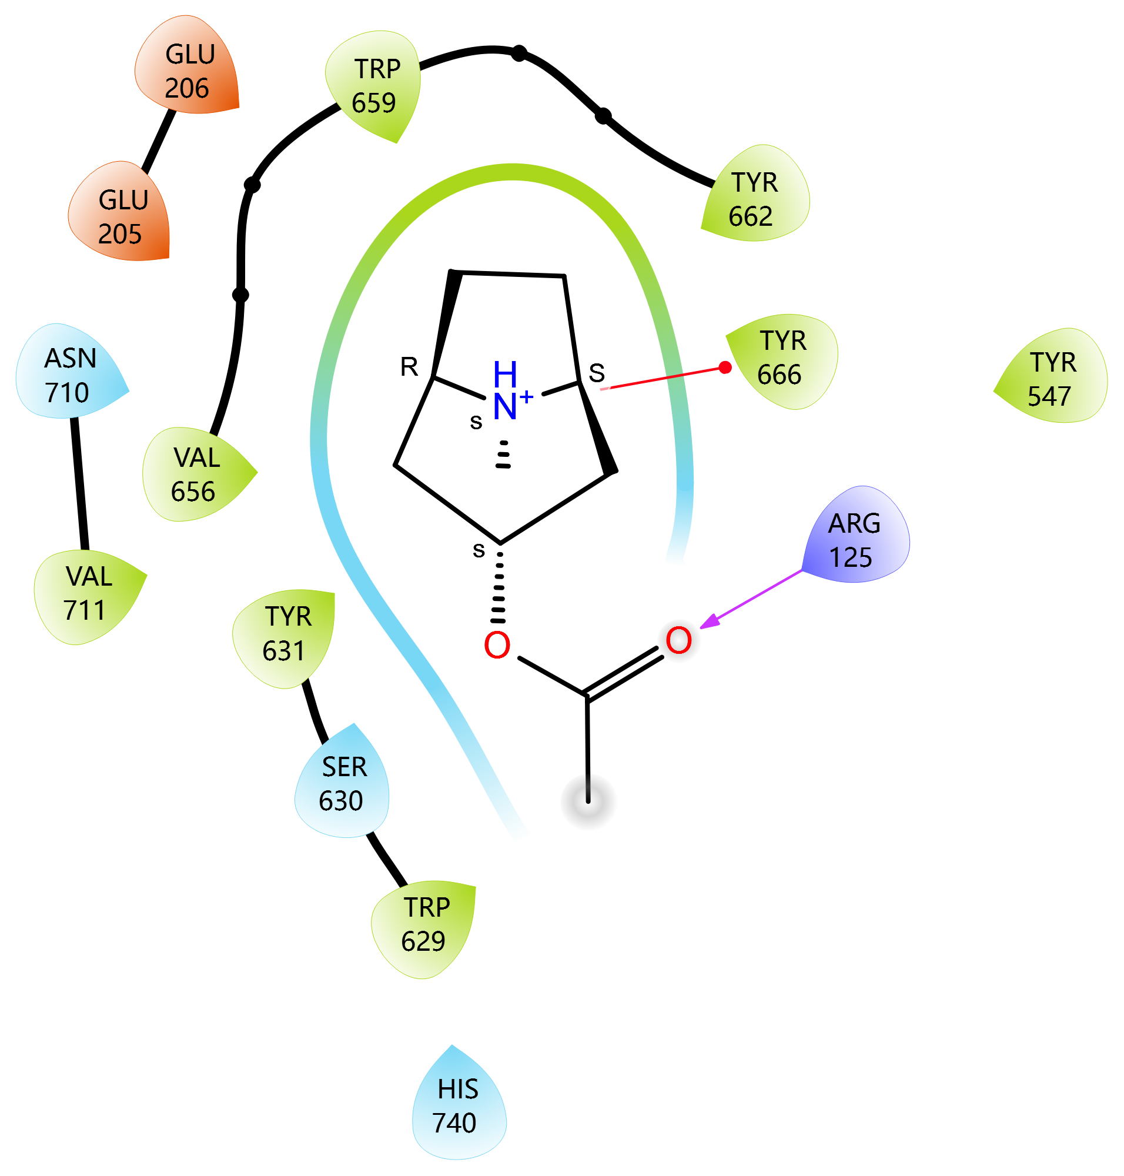

Figure S3: Ligand Interaction Diagram of [Hypoglycin] in the Binding Pocket of [3DHP].
Legend: The diagram shows 2D interactions between the ligand and surrounding amino acid residues in the protein's active site.

