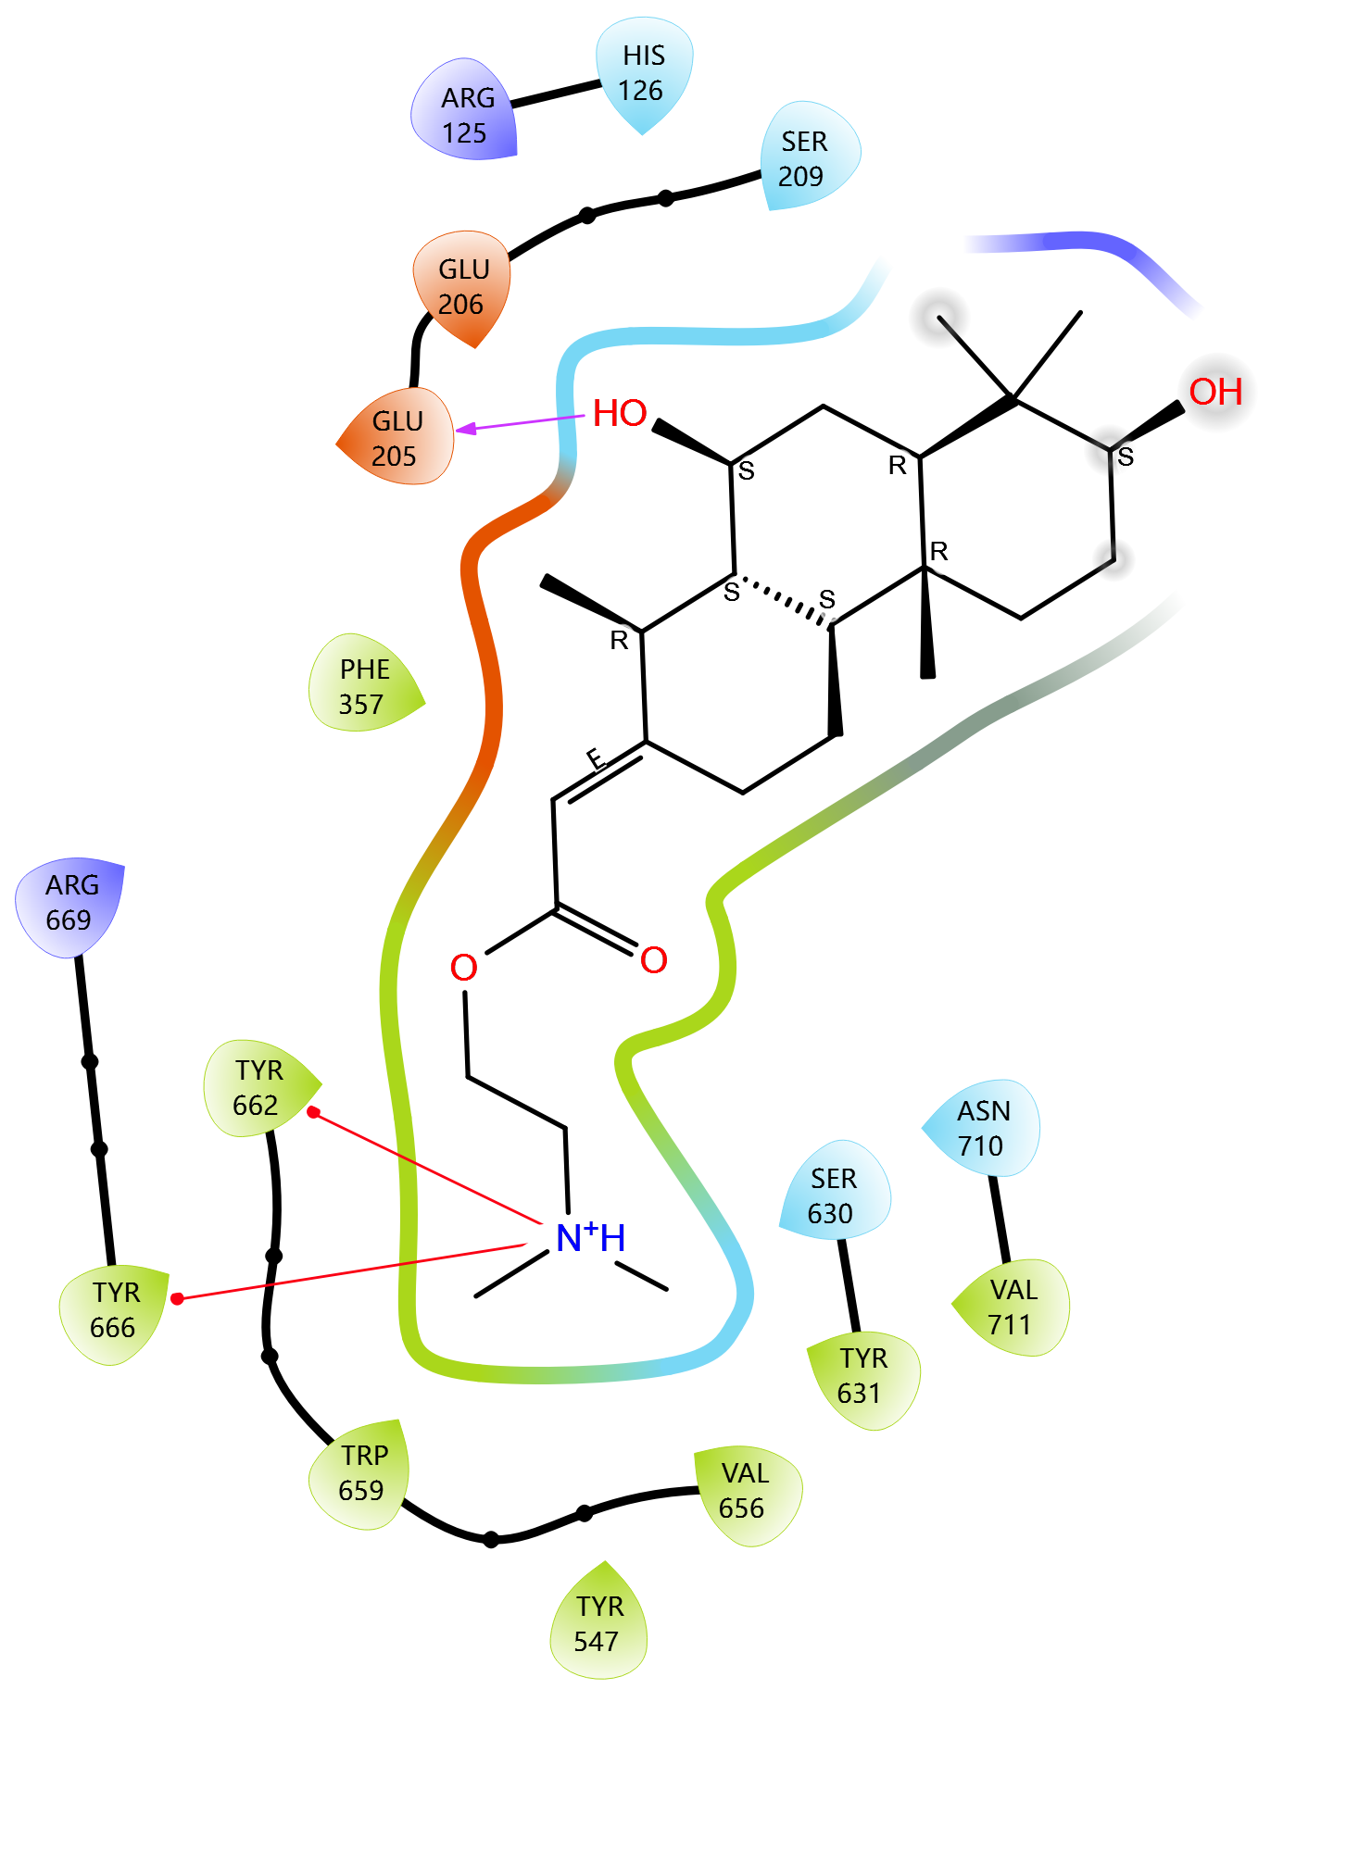

Figure S4: Ligand Interaction Diagram of [Catechin 5-O-gallate] in the Binding Pocket of [DPP-4 protein (6B1E Chain A)]
Legend: The diagram shows 2D interactions between the ligand and surrounding amino acid residues in the protein's active site.

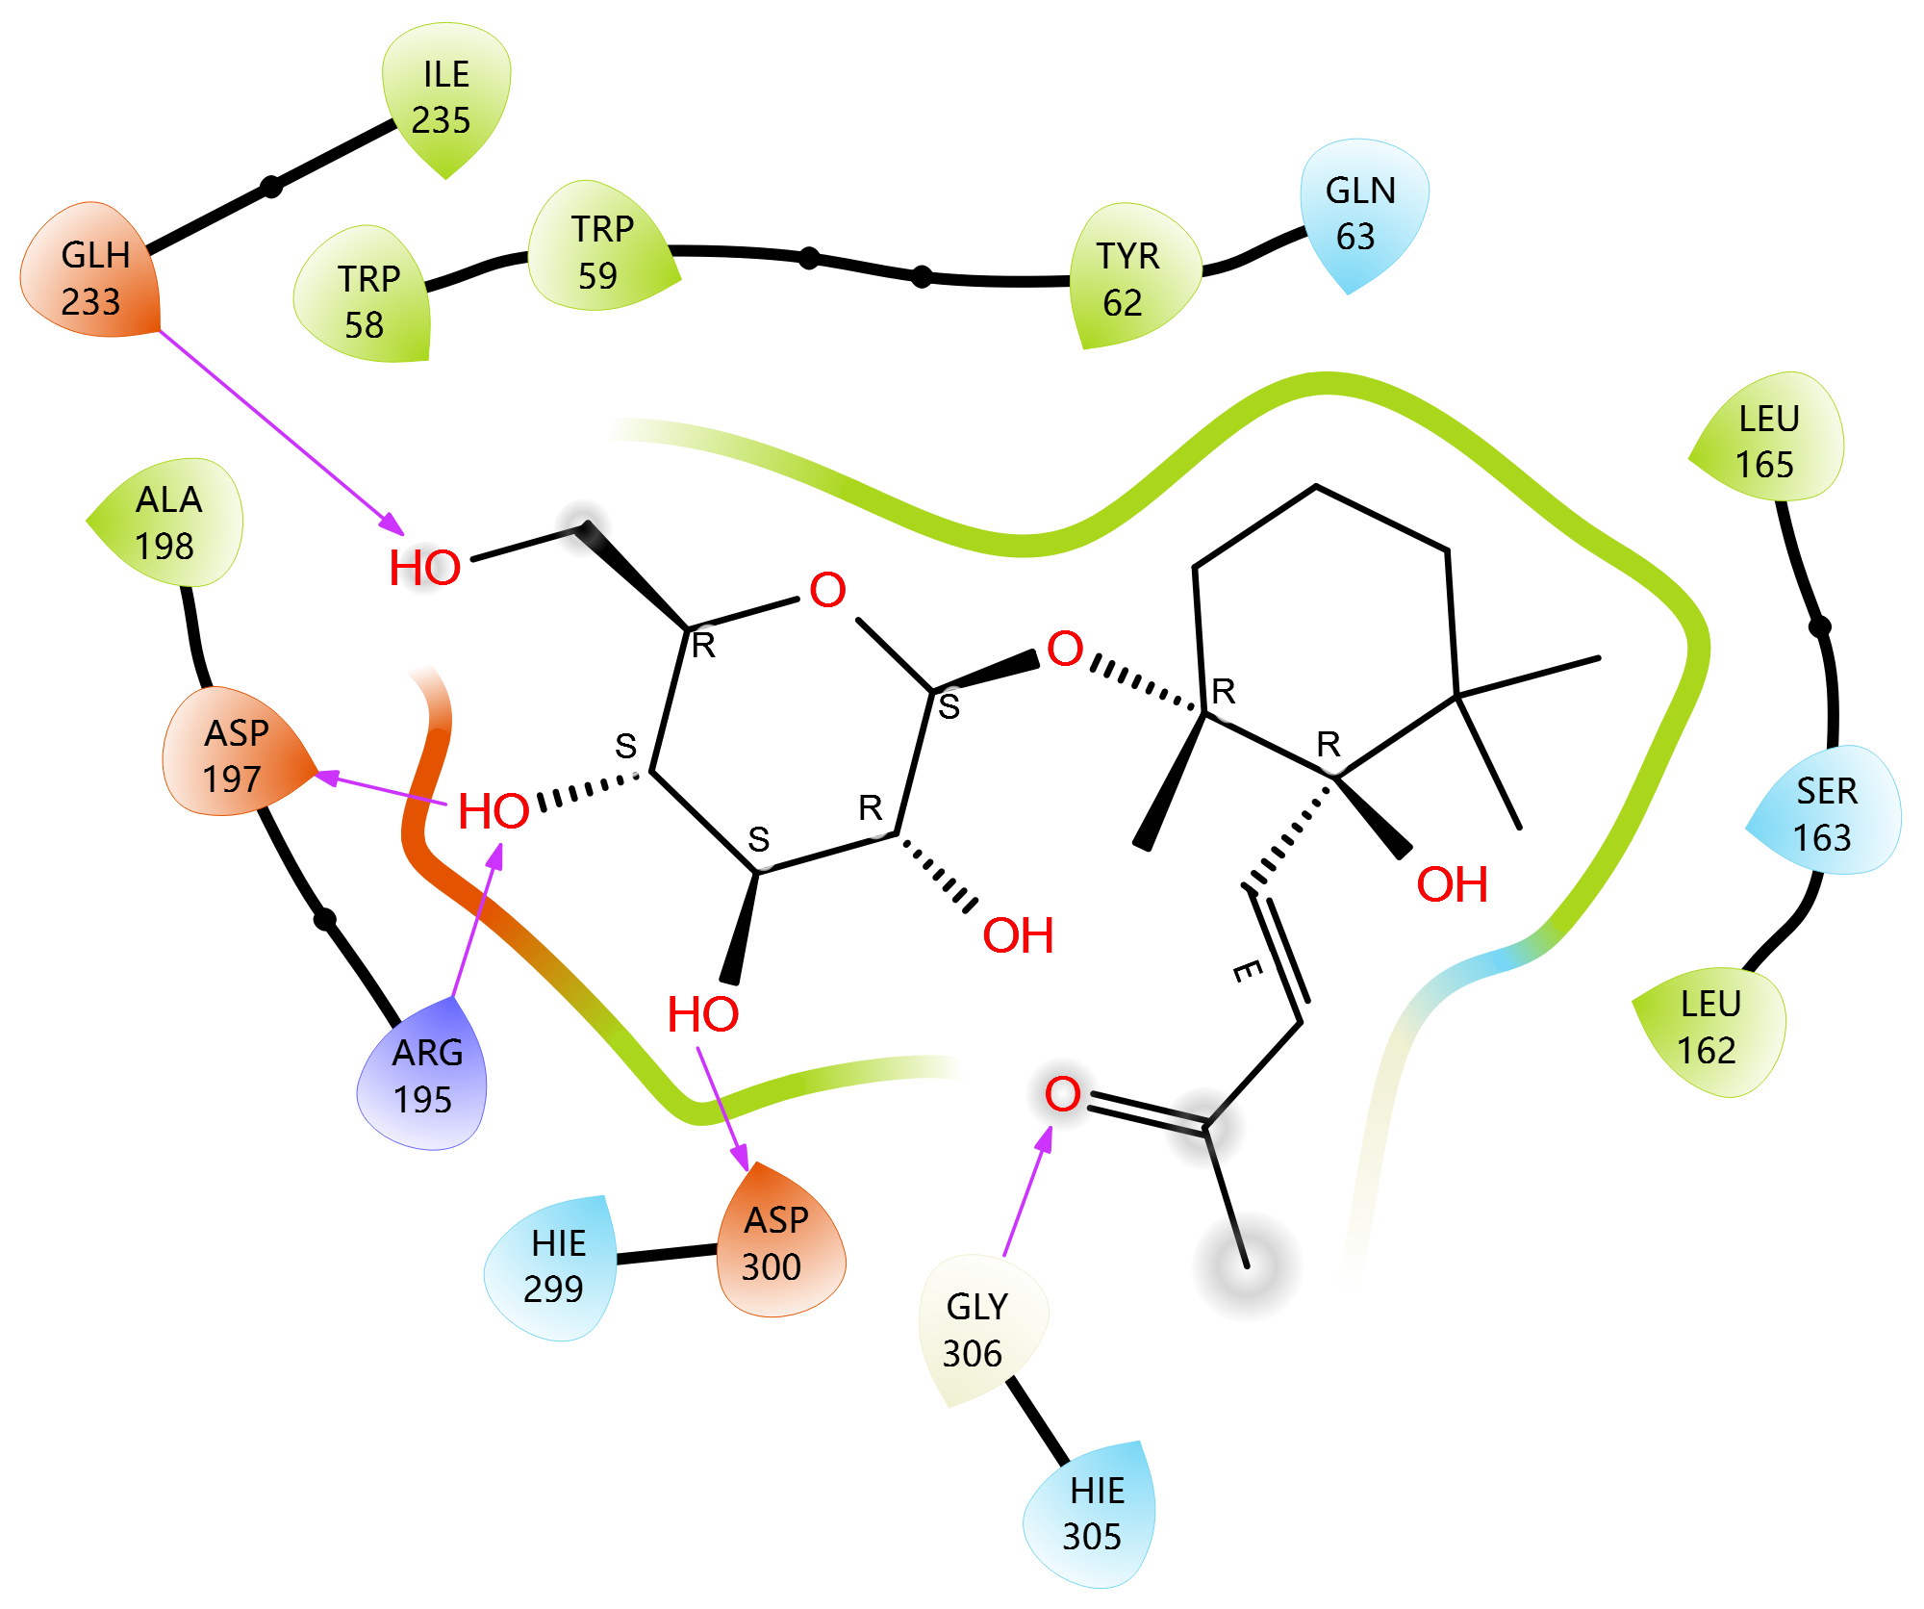

Figure S5: Ligand Interaction Diagram of [Crosatoside B] in the Binding Pocket of [DPP-4 protein (6B1E Chain A)]
Legend: The diagram shows 2D interactions between the ligand and surrounding amino acid residues in the protein's active site.

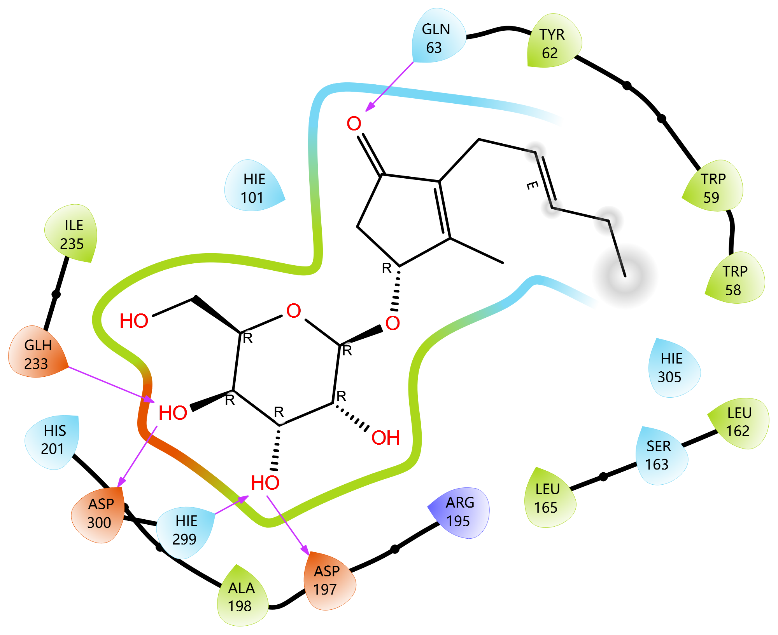

Figure S6: Ligand Interaction Diagram of [Hypoglycin] in the Binding Pocket of [DPP-4 protein (6B1E Chain A)]
Legend: The diagram shows 2D interactions between the ligand and surrounding amino acid residues in the protein's active site.

