Accuracy and Reliability of 3D Cephalometric Landmark Detection
with Deep Learning
Boyan Liu, Chang Liu, Yutao Xiong, Hailin Zhu, Wei Zeng, Jinglong Chen, Jixiang Guo, Wei Liu, Wei Tang
Supplemental Appendix
1 Materials and Methods
1.1 Landmark selection and definition
SCT features 41 landmarks divided into individual (21) and paired (10, with L for left and R for right). CBCT included 14 bone and dental landmarks: eight individual bones and six paired dental landmarks. (Table A.1).
Table A.1. Landmark Selection and Definition (Swennen et al. 2005)
Landmarks |  | Definition
Bone tissue
Single | N, nasion | The midpoint of the frontonasal suture
Single | Ba, basion | The most anterior point of the great foramen (foramen magnum)
Single | S, sella | The center of the hypophyseal fossa (sella turcica)
Single | ANS, anterior nasal spine | The most anterior midpoint of the anterior nasal spine of the maxilla
Single | PNS, posterior nasal spine | The most posterior midpoint of the posterior nasal spine of the palatine bone
Single | A, subspinale | The point of maximum concavity in the midline of the alveolar process of the maxilla
Single | B, supramental | The point of maximum concavity in the midline of the alveolar process of the mandible
Single | Pog, pogonion | The most anterior midpoint of the chin on the outline of the mandibular symphysis
Single | Me, menton | The most inferior midpoint of the chin on the outline of the mandibular symphysis
Single | Gn, gnathion | The midpoint halfway between Pog and Me
Paired | Or, orbitale | The most inferior point of each infraorbital rim
Paired | Po, porion | The most superior point of each external acoustic meatus
Paired | Go, gonion | The point at each mandibular angle that is defined by dropping a perpendicular from the intersection point of the tangent lines to the posterior margin of the mandibular vertical ramus and inferior margin of the mandibular body or horizontal ramus
Paired | Co, condylion | The most postero-superior point of each mandibular condyle in the sagittal plane
Paired | Pmp, posterior maxillary point | The point of maximum concavity of the posterior border of the palatine bone in the horizontal plane at both sides
Paired | Zy, zygion | The most lateral point on the outline of each zygomatic arch
Paired | Fz, frontozygomatic | The most medial and anterior point of each frontozygomatic suture at the lateral orbital rim
Paired | Mx, jugal process | The intersection of the zygomatic process of the maxilla and the alveolar process
Dental tissue
Single | UI, upper incisor | The most midpoint of the crown tip of the right upper central incisor
Single | LI, lower incisor | The most midpoint of the crown tip of the right lower central incisor
Pair | U6, upper molar cusp | The most inferior point of the mesial cusp of the crown of each first upper molar
Pair | L6, lower molar cusp | The most superior point of the mesial cusp of the crown of each first lower molar
Soft tissue
Single | Ns, nasion of soft tissue | The midpoint on the soft tissue contour of the nasal root base at the frontonasal suture level
Single | Prn, pronasale | The most anterior midpoint of the nasal tip
Single | Sn, subnasale | The midpoint on the nasolabial soft tissue contour between the columella crest and the upper lip
Single | Ls, labrale superius | The midpoint of the vermilion line of the upper lip
Single | Lis, labrale inferius | The midpoint of the vermilion line of the lower lip
Single | Si, mentolabial sulcus | The most posterior midpoint on the labiomental soft tissue contour that defines the border between the lower lip and the chin
Single | Pogs, pogonion of soft tissue | The most anterior midpoint of the chin
Single | Mes, soft tissue menton | The most inferior midpoint of the chin
Single | Gns, gnathion of soft tissue | The midpoint halfway between Pogs and Mes
1.2 Data annotation and reference standards
SCT and CBCT images were saved as DICOM files and processed using MIMICS 16.0. (Materialize the Interactive Medical Image Control System, Belgium). Thresholds were set for bone (226–2619 HU) and soft tissue (-700 to 225 HU) in SCT and a specific range (720+ HU) for CBCT to generate 3D models. In the software's "Measurement and Analysis" module, a custom landmark annotation tool is created. Two reference observers marked these sequentially, starting with the approximate positions of the 3D model. The location of the midline landmarks was refined on the sagittal images to align with the tissue surface. For paired bone landmarks, the horizontal images were adjusted to match the tissue surfaces. Dental landmarks were positioned at the tooth apices using both sagittal and horizontal CT images. Reviewers adjust following the same order.
1.3 Model training process
1.3.1 Data Preprocessing
CT images for training underwent random cropping and scaling to augment the data, enabling network training independent of image size and position.
- Random Scaling
A random scaling factor R (R_{c (number of channels)}, R_{w (width)}, and R_{h (height)}) was determined, where R = random (R_{min}, R_{max}). To ensure minimal resolution loss, R_{min} was set to 0.6. The size of the randomly cropped 3D image was defined as S (S_{c}, S_{w}, S_{h}), and the landmark area was L (L_{c}, L_{w}, L_{h}). To ensure that the landmark area remained entirely within the 3D image after cropping, the maximum scaling factor, R_{max}, was set to S/L. Therefore, R = random (0.6, S/L). After generating a random scaling factor R, the 3D image was scaled according to this factor. The landmark coordinates x (x_{c}, x_{w}, x_{h}) were scaled to obtain the new scaled landmark coordinates x’, which were calculated as x’=x×R.
- Random Cropping
A random cropping box was determined using its top-left corner coordinates c (c_{c}, c_{w}, c_{h}) in the 3D image. The coordinates were randomly set to c = (c_{min}, c_{max}). The minimum boundary point of the cropping box must not be less than 0, and the maximum boundary point must not exceed the maximum boundary point of the landmark area L_{max} (L_{maxc}, L_{maxw}, L_{maxh}); that is, c_{min}=max (0, L_{max}-L). The maximum boundary point of the cropping box must not exceed the size of the 3D image IS (IS_{c}, IS_{w}, IS_{h}), and the minimum boundary point must not be greater than the minimum boundary point of the landmark area Lmin (L_{minc}, L_{minw}, L_{minh}); that is, c_{min}=max (IS-S, L_{min}). Thus, c = random (max (0, L_{max}-L), max (IS-S, L_{min})). The size of the cropping box, and thus the size of the image input to the model, was set to [128, 128, 64]. The image was scaled using different ratios in each dimension to calculate the minimum cuboid area containing the coordinates. A random cropping box position was selected such that all landmarks were within the box, thus completing the cropping operation. The coordinates of all corresponding landmarks in the image were adjusted by subtracting the top-left corner point of the cropping box to obtain the new coordinates x’’ of the landmarks in the cropped image, calculated as follows: x’’= x’-c.
(3) Voxel Normalization
To accelerate the convergence of the network, voxel normalization is performed on the image voxels, adjusting the voxels to the range [0, 1].
(4) Gaussian heat map.
Gaussian functions were used to transform the coordinates of each landmark into corresponding Gaussian heat maps to assist in network training. For the landmark coordinates (c_{L}, w_{L}, h_{L}), the value of the corresponding Gaussian heatmap was
$G\left(c,w,h\right)=e^{−\frac{{\left(c−c_{L}\right)}^{2}+{\left(h−h_{L}\right)}^{2}+{\left(h−h_{L}\right)}^{2}}{2σ^{2}}}$（σ is set to 20）.
1.3.2 Model Training
During each round of model training, the image was input to the model after preprocessing. The model then computes and outputs predicted Gaussian heat maps. The loss between the predicted and true Gaussian heat maps of the network was calculated using a loss function. A loss function is a mathematical function that measures the degree of deviation between the predictions of a model and the actual values. Mean squared error (MSE) was used to represent this, and the loss function for this model was as follows:
$MSE=\frac{1}{m}\sum_{i=1}^{m}{{(y_{i}−f\left(x_{i}\right))}^{2}}$
The obtained loss value is used to calculate the gradients for each weight parameter through backpropagation. An Adaptive Moment Estimation (Adam) optimizer was used to optimize the model weights. This process continually refines the predicted Gaussian heat maps generated by the model during training to fit the true Gaussian heat maps, thereby achieving an optimal automatic landmarking effect.
1.3.3 Model Validation
To identify the optimal model, hyperparameters, such as the learning rate and number of iterations, were adjusted to train multiple models with different parameters. The loss of each model on the validation set was calculated, and the model with the smallest loss was selected as the optimal model.
1.3.4 Model Testing
During the testing phase, data augmentation was no longer performed. The main steps of model training and testing are illustrated in main text Figure 1.
1.4 Selection of network backbone
To obtain baseline data for three-dimensional skull landmarking model, 3D U-Net, V-Net (Zhao et al. 2022), FC-DenseNet (Chim et al. 2019), and Hourglass (Huang Y and Huang H 2023) were selected as CNN models for automatic landmarking of skull CT scans.
1.5 Definition of the metrics
Mean Radial Error, MRE
$$MRE=\frac{\sum_{i=1}^{N}{R_{i}}}{N}$$
$R=\sqrt{∆x^{2}+{∆y}^{2}+{∆z}^{2}}$ ）
R: radial difference; N: number of samples; △x is the horizontal distance between automatic and gold standard landmark positions. y denotes the sagittal distance. where z denotes vertical distance.
Standard Deviation, SD
$$SD=\sqrt{\frac{\sum_{i=1}^{N}{{\left(R_{i}−MRE\right)}^{2}}}{N−1}}$$
Success Detection Rate, SDR _{2mm、3mm、4mm}
$${SDR}_{2mm、3mm、4mm}=\frac{Number of detections within 2mm, 3mm, and 4mm}{Total number of detections}$$
Dental Landmark Accuracy, DL-ACC
$$DL−ACC=\frac{TP+TN}{TP+FP+TN+FN}$$
Dental Landmark Precision, DL-PRE
$$DL−PRE=\frac{TP}{TP+FP}$$
TP: Landmark present in both manual and automatic detection.
TN: Landmark absent in both manual and automatic detection.
FN: Landmark present in manual but absent in automatic detection.
FP: Landmark absent in manual but present in automatic detection.
Intraclass Correlation Coefficient，ICC
$$ICC=\frac{{MS}_{A}−{MS}_{e}}{{MS}_{A} +（n−1）{MS}_{e}}$$
MS_{A} stands for the mean square among observers, MS_{e} stands for the mean square within observers, and n represents the number of repeated measurements (n=2 in this study).
Table A.2 Relationship between Intraclass Correlation Coefficient (ICC) and degree of consistency (Silverman. 1968)
ICC | Degree of Consistency
＜0.2 | Poor consistency
0.2–0.4 | Fair consistency
0.4–0.6 | Moderate consistency
0.6–0.8 | Good consistency
0.8–1.0 | Excellent consistency
2 Results
2.1 Reference observers consistency in landmarking
Two reference observers with different backgrounds annotated the landmarks, which were reviewed by a chief physician. After a two-week gap, the annotators repeated the process. The landmarking errors on the x-, y-, and z-axes from the two sessions were analyzed to test the internal consistency of senior oral and maxillofacial surgeons and senior orthodontists, showing high internal consistency (ICC=0.965).
Table A.3. ICC assessment by reference observers
Landmarks | Intraclass ICC |  |  |  |  |  | Interclass ICC
Landmarks | The senior maxillofacial surgeon |  |  | The senior orthodontist
Landmarks | X -axis | Y -axis | Z -axis | X -axis | Y -axis | Z -axis | X -axis | Y -axis | Z -axis
N | 0.976 | 0.973 | 0.994 | 0.974 | 0.995 | 0.970 | 0.968 | 0.970 | 0.966
Ba | 0.977 | 0.976 | 0.986 | 0.987 | 0.974 | 0.977 | 0.977 | 0.961 | 0.972
S | 0.980 | 0.975 | 0.971 | 0.976 | 0.970 | 0.996 | 0.969 | 0.971 | 0.963
ANS | 0.977 | 0.972 | 0.996 | 0.985 | 0.972 | 0.977 | 0.974 | 0.972 | 0.962
PNS | 0.971 | 0.976 | 0.979 | 0.981 | 0.987 | 0.994 | 0.971 | 0.968 | 0.966
A | 0.983 | 0.990 | 0.994 | 0.989 | 0.989 | 0.974 | 0.961 | 0.973 | 0.972
B | 0.980 | 0.971 | 0.995 | 0.972 | 0.984 | 0.989 | 0.955 | 0.969 | 0.967
Pog | 0.982 | 0.990 | 0.977 | 0.993 | 0.991 | 0.987 | 0.964 | 0.977 | 0.973
Me | 0.973 | 0.974 | 0.977 | 0.991 | 0.992 | 0.982 | 0.972 | 0.982 | 0.972
Gn | 0.974 | 0.977 | 0.971 | 0.984 | 0.985 | 0.972 | 0.961 | 0.965 | 0.986
UI | 0.971 | 0.990 | 0.992 | 0.983 | 0.987 | 0.990 | 0.977 | 0.975 | 0.976
LI | 0.974 | 0.984 | 0.976 | 0.993 | 0.996 | 0.991 | 0.961 | 0.960 | 0.964
OrL | 0.974 | 0.978 | 0.982 | 0.979 | 0.995 | 0.978 | 0.965 | 0.966 | 0.975
OrR | 0.970 | 0.970 | 0.990 | 0.970 | 0.972 | 0.972 | 0.962 | 0.972 | 0.975
GoL | 0.976 | 0.971 | 0.994 | 0.972 | 0.990 | 0.974 | 0.961 | 0.963 | 0.962
GoR | 0.978 | 0.978 | 0.982 | 0.970 | 0.986 | 0.981 | 0.963 | 0.962 | 0.966
PoL | 0.972 | 0.996 | 0.975 | 0.974 | 0.977 | 0.984 | 0.975 | 0.976 | 0.971
PoR | 0.974 | 0.970 | 0.990 | 0.989 | 0.971 | 0.974 | 0.977 | 0.972 | 0.976
CoL | 0.988 | 0.975 | 0.978 | 0.970 | 0.975 | 0.996 | 0.953 | 0.960 | 0.964
CoR | 0.974 | 0.996 | 0.970 | 0.974 | 0.996 | 0.970 | 0.952 | 0.953 | 0.962
PmpL | 0.972 | 0.972 | 0.995 | 0.972 | 0.972 | 0.995 | 0.963 | 0.960 | 0.964
PmpR | 0.978 | 0.974 | 0.980 | 0.977 | 0.987 | 0.979 | 0.962 | 0.973 | 0.972
ZyL | 0.995 | 0.989 | 0.981 | 0.992 | 0.993 | 0.972 | 0.951 | 0.972 | 0.967
ZyR | 0.975 | 0.996 | 0.990 | 0.991 | 0.979 | 0.994 | 0.961 | 0.969 | 0.968
FzL | 0.997 | 0.972 | 0.992 | 0.995 | 0.971 | 0.990 | 0.971 | 0.968 | 0.976
FzR | 0.978 | 0.981 | 0.997 | 0.989 | 0.982 | 0.972 | 0.971 | 0.973 | 0.972
MxL | 0.975 | 0.976 | 0.970 | 0.974 | 0.990 | 0.982 | 0.975 | 0.969 | 0.967
MxR | 0.976 | 0.989 | 0.970 | 0.977 | 0.991 | 0.977 | 0.971 | 0.968 | 0.966
U6L | 0.986 | 0.989 | 0.979 | 0.991 | 0.977 | 0.972 | 0.962 | 0.970 | 0.971
U6R | 0.986 | 0.973 | 0.974 | 0.970 | 0.986 | 0.988 | 0.955 | 0.964 | 0.962
L6L | 0.973 | 0.979 | 0.980 | 0.987 | 0.993 | 0.977 | 0.975 | 0.971 | 0.963
L6R | 0.995 | 0.972 | 0.996 | 0.982 | 0.984 | 0.995 | 0.972 | 0.963 | 0.962
Ns | 0.976 | 0.983 | 0.970 | 0.995 | 0.970 | 0.972 | 0.964 | 0.971 | 0.972
Prn | 0.972 | 0.974 | 0.979 | 0.995 | 0.981 | 0.992 | 0.956 | 0.964 | 0.967
Sn | 0.979 | 0.997 | 0.980 | 0.988 | 0.972 | 0.992 | 0.963 | 0.962 | 0.965
Ls | 0.977 | 0.979 | 0.983 | 0.981 | 0.984 | 0.972 | 0.975 | 0.971 | 0.974
Lis | 0.973 | 0.974 | 0.988 | 0.972 | 0.974 | 0.991 | 0.972 | 0.974 | 0.976
Si | 0.970 | 0.972 | 0.984 | 0.975 | 0.987 | 0.986 | 0.961 | 0.960 | 0.964
Pogs | 0.988 | 0.970 | 0.972 | 0.978 | 0.986 | 0.986 | 0.958 | 0.963 | 0.962
Mes | 0.984 | 0.995 | 0.973 | 0.978 | 0.972 | 0.977 | 0.962 | 0.948 | 0.975
Gns | 0.983 | 0.972 | 0.994 | 0.991 | 0.988 | 0.989 | 0.951 | 0.962 | 0.967
Note: ICC = intraclass correlation coefficient
2.2 Model Hyperparameters and model training loss graph
Figure A.1 shows the training loss graphs for the automatic landmarking model when utilizing the four different network backbones.
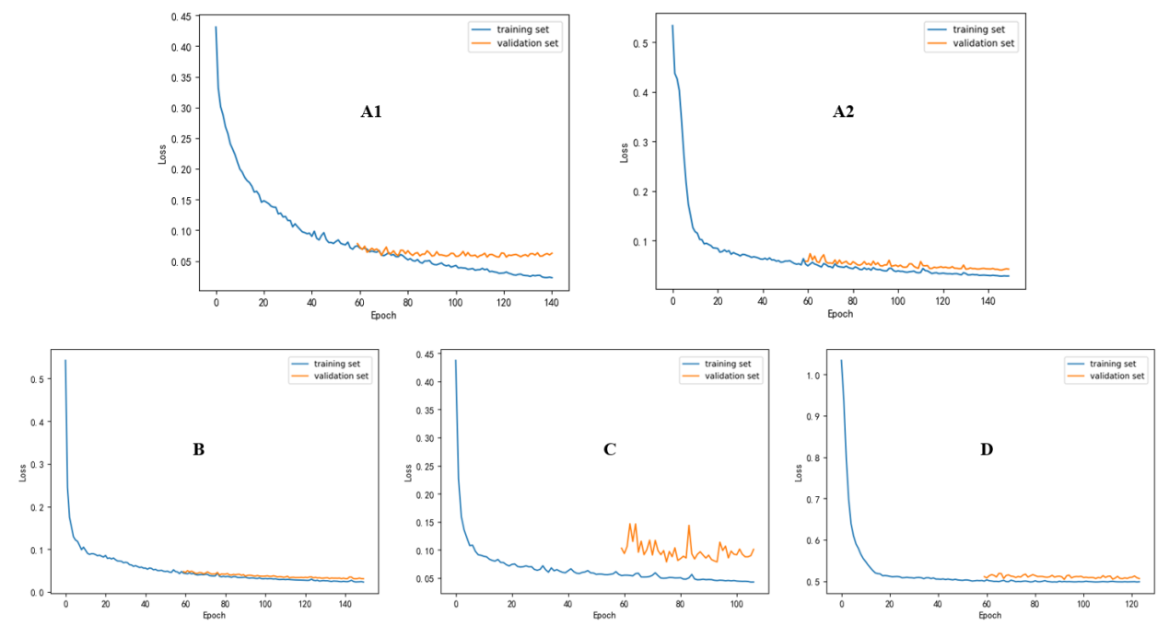
Figure A.1. Model Training Loss Graph
A1 is the CBCT 3D U-Net, A2 is the SCT 3D U-Net, B is the SCT V-Net, C is the SCT FC-DenseNet, and D is the SCT Hourglass. The x-axis represents the training iterations, and the y-axis represents the training loss. In A1, A2, B, D, the validation and training losses were similar, suggesting a good generalization. In C, the discrepancy indicates poor generalization.
2.3 Results of the four neural networks
Table A.4. MRE of landmarks in SCT's test set for 3D U-Net, V-Net, FC-DenseNet, Hourglass (MRE ± SD, mm)
Landmarks | 3D U-Net | V-Net | FC-DenseNet | Hourglass
N | 1.122±0.536 | 1.464±0.884 | 1.392±0.710 | 1.669±0.722
Ba | 1.248±0.562 | 1.496±0.780 | 1.177±0.502 | 1.350±0.468
S | 1.237±0.554 | 1.491±0.778 | 1.175±0.500 | 1.348±0.463
ANS | 1.375±0.863 | 1.412±1.050 | 1.457±0.551 | 1.651±1.751
PNS | 0.956±0.806 | 1.197±1.032 | 1.017±0.376 | 0.926±0.375
A | 1.191±0.687 | 1.076±0.721 | 1.334±0.775 | 1.204±1.044
B | 1.077±0.599 | 1.280±0.895 | 1.894±0.961 | 1.085±0.562
Pog | 0.909±0.797 | 1.172±1.473 | 1.171±0.548 | 0.964±0.553
Me | 0.939±0.514 | 0.880±0.529 | 1.131±0.637 | 1.098±0.557
Gn | 0.714±0.443 | 1.712±0.488 | 0.961±0.600 | 0.933±0.521
UI | 1.337±0.588 | 1.416±0.955 | 1.554±0.626 | 1.264±0.573
LI | 1.223±0.688 | 1.999±0.853 | 1.810±0.791 | 1.192±0.549
OrL | 0.807±0.452 | 1.052±0.605 | 0.870±0.355 | 0.782±0.406
OrR | 0.771±0.363 | 1.012±0.670 | 0.873±0.394 | 1.049±0.447
GoL | 0.981±0.556 | 1.176±0.882 | 1.435±0.824 | 1.430±0.709
GoR | 0.957±0.530 | 1.230±0.915 | 1.581±0.991 | 1.456±0.915
PoL | 1.034±0.394 | 1.135±0.564 | 1.011±0.466 | 1.147±0.512
PoR | 1.068±0.592 | 1.210±0.905 | 1.170±0.569 | 1.351±0.603
CoL | 0.975±0.488 | 1.160±0.712 | 1.225±0.607 | 1.245±0.601
CoR | 1.108±0.707 | 1.203±0.755 | 1.250±0.702 | 1.305±0.625
PmpL | 0.825±0.473 | 1.156±0.762 | 0.980±0.323 | 0.918±0.407
PmpR | 0.772±0.497 | 1.049±0.748 | 0.898±0.433 | 0.852±0.337
ZyL | 1.303±0.581 | 1.201±0.580 | 1.093±0.411 | 1.275±0.657
ZyR | 1.354±0.986 | 1.105±1.046 | 1.058±0.586 | 1.330±0.505
FzL | 1.097±0.547 | 1.231±0.610 | 1.373±0.414 | 1.572±0.654
FzR | 1.120±0.505 | 1.370±0.760 | 1.750±0.474 | 1.621±0.718
MxL | 0.954±0.529 | 0.923±0.521 | 1.350±0.651 | 1.082±0.589
MxR | 1.115±0.703 | 1.107±0.648 | 1.364±0.508 | 1.318±0.604
U6L | 0.944±0.612 | 1.083±0.900 | 1.256±0.573 | 1.112±0.603
U6R | 1.025±0.649 | 1.221±0.348 | 1.478±0.673 | 1.467±0.797
L6L | 1.102±0.703 | 1.142±0.826 | 1.409±0.679 | 1.490±0.846
L6R | 1.052±0.548 | 1.141±0.829 | 1.227±0.637 | 1.374±0.892
Ns | 1.132±0.855 | 1.169±0.567 | 1.589±0.555 | 0.925±0.374
Prn | 1.039±0.923 | 1.410±0.655 | 1.105±0.485 | 1.104±0.485
Sn | 1.206±0.908 | 1.956±0.613 | 1.029±0.487 | 1.167±0.633
Ls | 1.439±0.868 | 1.572±1.029 | 1.400±0.885 | 1.552±0.767
Lis | 1.821±0.911 | 1.405±1.112 | 1.385±0.803 | 1.222±0.464
Si | 1.121±0.587 | 1.357±0.764 | 1.349±0.642 | 1.339±0.494
Pogs | 1.006±0.522 | 2.384±0.998 | 2.138±2.785 | 1.575±1.743
Mes | 1.362±0.602 | 2.604±0.883 | 3.184±5.592 | 2.635±3.914
Gns | 1.072±0.531 | 1.503±0.581 | 2.486±4.616 | 2.349±4.976
Average | 1.091±0.306 | 1.335±0.358 | 1.381±0.884 | 1.319±0.847
Note: MRE = mean radial error, SD = standard deviation
Table A.5. MRE of the four network architectures in SCT and CBCT's test set
Network Framework | SCT MRE±SD，mm | CBCT MRE±SD，mm
Modified 3D U-Net | 1.091±0.306 | 0.924±0.830
V-Net | 1.335±0.358 | 1.553±1.358
FC-DenseNet | 1.381±0.884 | 1.681±1.109
Hourglass | 1.319±0.847 | 1.585±1.047
Note: MRE (Mean Radial Error), SD (Standard Deviation)
From the results in Table A.4 and A.5, it is evident that the 3D U-Net has the smallest MRE among the four network skeletons (SCT: 1.091±0.306 mm, CBCT: 0.924±0.83 mm). The MRE of 3D U-Net was compared with those of V-Net, FC-DenseNet, and Hourglass using the Mann–Whitney U test, as shown in Figure A.2, indicating a statistically significant difference in MRE between 3D U-Net and the other three network skeletons. The analysis indicates that when 3D U-Net was used as the model network, it had the highest accuracy.
Figure A.2. Boxplot of landmark error statistical tests for various network architectures
A: SCT network architecture test outcomes; B: CBCT network architecture test outcomes. **** denotes P < 0.0001, * denotes P < 0.05. Note: MRE (mean radial error)
2.4 Landmark positioning results in the external test set
Table A.6. MRE and SDR of landmarks in SCT's external test set
Landmarks | MRE±SD，mm | SDR，%
Landmarks | MRE±SD，mm | 2mm | 3mm | 4mm
N | 1.454±0.835 | 91.6 | 99.1 | 99.1
Ba | 1.165±0.593 | 97.5 | 99.1 | 100
S | 1.161±0.595 | 97.5 | 99.1 | 100
ANS | 1.156±0.739 | 93.1 | 97.4 | 99.1
PNS | 0.804±0.509 | 98.3 | 100 | 100
A | 1.006±0.476 | 96.8 | 100 | 100
B | 1.187±0.736 | 89.1 | 98.3 | 100
Pog | 1.047±0.689 | 93.3 | 99.1 | 100
Me | 1.114±0.708 | 94.9 | 98.3 | 99.1
Gn | 0.951±0.503 | 98.3 | 100 | 100
UI | 1.374±1.215 | 89.0 | 98.3 | 99.1
LI | 1.745±0.849 | 69.8 | 93.9 | 99.1
OrL | 0.923±0.499 | 99.1 | 100 | 100
OrR | 0.924±0.499 | 99.1 | 100 | 100
GoL | 1.229±1.366 | 88.3 | 99.1 | 99.1
GoR | 1.261±0.922 | 90.0 | 95.8 | 99.1
PoL | 1.193±0.674 | 94.1 | 99.1 | 99.1
PoR | 1.151±0.582 | 97.5 | 99.1 | 100
CoL | 1.236±0.589 | 93.1 | 100 | 100
CoR | 1.354±0.794 | 95.0 | 98.3 | 99.1
PmpL | 0.860±0.718 | 99.1 | 99.1 | 99.1
PmpR | 0.868±0.558 | 98.3 | 99.1 | 100
ZyL | 1.359±0.679 | 90.0 | 98.3 | 99.1
ZyR | 1.264±0.720 | 90.7 | 98.3 | 99.1
FzL | 1.241±0.705 | 90.0 | 100 | 100
FzR | 1.416±0.758 | 80.8 | 100 | 100
MxL | 1.187±0.623 | 95.7 | 99.1 | 100
MxR | 1.237±0.599 | 93.3 | 99.1 | 100
U6L | 1.347±0.600 | 90.7 | 99.1 | 100
U6R | 1.327±0.695 | 91.5 | 99.1 | 100
L6L | 1.430±0.766 | 83.3 | 95.0 | 99.1
L6R | 1.333±0.592 | 90.0 | 98.3 | 100
Ns | 0.993±0.674 | 95.0 | 99.1 | 99.1
Prn | 0.794±0.475 | 100 | 100 | 100
Sn | 1.448±0.724 | 92.5 | 98.3 | 99.1
Ls | 1.268±0.796 | 90.8 | 97.5 | 99.1
Lis | 1.487±1.228 | 83.3 | 95.0 | 99.1
Si | 1.365±0.650 | 91.6 | 99.1 | 100
Pogs | 1.421±0.778 | 80.0 | 98.0 | 100
Mes | 1.714±0.989 | 76.1 | 94.2 | 99.0
Gns | 1.297±0.809 | 89.5 | 97.1 | 99.0
Note: MRE (mean radial error), SDR (success detection rate), SD (standard deviation)
Table A.7. MRE and SDR of landmarks in CBCT's external test set
Landmarks | MRE±SD, mm | SDR，%
Landmarks | MRE±SD, mm | 2mm | 3mm | 4mm
S | 1.118±0.712 | 86.4 | 97.7 | 100
A | 0.997±0.650 | 92.9 | 97.6 | 100
B | 1.122±0.726 | 84.1 | 97.7 | 100
Pog | 1.121±0.699 | 86.4 | 97.7 | 100
Me | 0.996±0.744 | 81.8 | 97.7 | 97.7
Gn | 1.183±0.718 | 84.1 | 97.7 | 100
UI | 0.922±0.813 | 83.7 | 93.6 | 97.7
LI | 0.917±0.732 | 88.1 | 94.7 | 100
GoL | 1.275±0.585 | 88.1 | 97.6 | 100
GoR | 1.491±0.741 | 80.5 | 88.1 | 95.2
U6L | 0.946±0.832 | 84.1 | 93.2 | 100
U6R | 0.939±1.181 | 84.1 | 93.2 | 97.7
L6L | 1.008±1.184 | 80.3 | 93.2 | 93.2
L6R | 1.006±1.082 | 88.6 | 93.2 | 95.5
Note: MRE (mean radial error), SD (standard deviation), SDR (success detection rate)
2.5 The landmark's positioning errors along each coordinate axis
The MRE for landmarks on three-dimensional images were composed of their respective errors along the x-, y-, and z-axes. The average positioning errors of the landmarks along each coordinate axis in the test set were calculated, and listed in Table A.8 and Figure A.3.
Table A.8. SCT landmark localization errors on each coordinate axis
Landmarks | △x±SD, mm | △y±SD, mm | △z±SD , mm
N | 0.58±0.36 | 1.07±0.84 | 0.79±1.02
Ba | 0.41±0.24 | 0.73±0.61 | 0.82±0.56
S | 0.39±0.22 | 0.85±0.68 | 0.81±0.56
ANS | 0.47±0.30 | 0.64±0.49 | 0.87±0.68
PNS | 0.21±0.10 | 0.33±0.26 | 0.74±0.55
A | 0.38±0.14 | 0.28±0.16 | 0.89±0.72
B | 0.59±0.49 | 0.78±0.72 | 0.68±0.66
Pog | 0.48±0.33 | 0.59±0.54 | 0.71±0.47
Me | 0.49±0.41 | 0.39±0.28 | 0.90±0.85
Gn | 0.64±0.52 | 0.51±0.44 | 0.47±0.65
UI | 1.14±1.13 | 0.53±0.51 | 0.56±0.82
LI | 0.64±0.53 | 0.70±0.65 | 1.39±1.02
OrL | 0.75±0.51 | 0.38±0.26 | 0.41±0.28
OrR | 0.76±0.55 | 0.38±0.27 | 0.40±0.25
GoL | 0.58±0.57 | 0.64±0.61 | 0.88±0.91
GoR | 0.29±0.26 | 0.37±0.31 | 1.19±0.97
PoL | 0.67±0.66 | 0.47±0.59 | 0.89±0.70
PoR | 0.65±0.59 | 0.43±0.60 | 0.89±0.67
CoL | 0.89±0.78 | 0.60±0.46 | 0.59±0.47
CoR | 0.92±0.89 | 0.61±0.54 | 0.61±0.50
PmpL | 0.53±0.68 | 0.30±0.28 | 0.59±0.51
PmpR | 0.53±0.46 | 0.31±0.28 | 0.61±0.52
ZyL | 1.21±0.76 | 0.46±0.36 | 0.52±0.71
ZyR | 0.55±0.31 | 0.64±0.45 | 0.91±0.93
FzL | 0.47±0.38 | 0.91±0.71 | 0.73±0.60
FzR | 0.56±0.46 | 1.13±0.89 | 0.72±0.66
MxL | 0.57±0.47 | 0.63±0.46 | 0.79±0.62
MxR | 0.65±0.50 | 0.59±0.44 | 0.87±0.86
U6L | 0.80±0.46 | 0.54±0.30 | 0.91±0.96
U6R | 0.78±0.67 | 0.51±0.31 | 0.90±0.75
L6L | 0.68±0.54 | 0.41±0.28 | 1.18±0.85
L6R | 0.70±0.49 | 0.38±0.26 | 1.16±0.73
Ns | 0.36±0.25 | 0.52±0.51 | 0.79±0.77
Prn | 0.47±0.30 | 0.61±0.49 | 0.30±0.22
Sn | 0.46±0.26 | 0.41±0.24 | 1.29±0.81
Ls | 0.42±0.27 | 0.55±0.52 | 1.06±0.88
Lis | 0.47±0.38 | 1.19±1.01 | 0.76±0.77
Si | 0.56±0.26 | 0.93±0.80 | 0.88±0.40
Pogs | 0.53±0.49 | 0.86±0.66 | 1.01±0.81
Mes | 0.57±0.33 | 0.64±0.41 | 1.49±1.26
Gns | 0.53±0.51 | 0.49±0.33 | 1.07±1.28
Average | 0.81±0.23 | 0.81±0.69 | 1.14±0.30
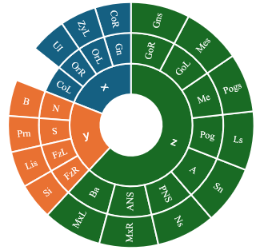
Figure A.3. The landmarks with the largest positioning errors on different axes.
2.6 Comparison of related studies
Table A.9. Comparison of CT landmarking with state-of-the-art research
 |  | This study | Dot research
Sample size |  | 1190 (800 SCT, 300 CBCT) | 198 (SCT)
Data source |  | 3 centers, 3 SCT types  5 CBCT types. | 1 center, 5 SCT types
Sample Characteristics | M | Present/ Analyzed | Present/ Analyzed
Sample Characteristics | MDL | Present/ Analyzed | Not Mentioned/ Not Analyzed
Sample Characteristics | MA | Present/ Analyzed | Present/ Not Analyzed
Number of landmarks |  | 41(SCT), 14(CBCT) | 33(SCT)
MRE±SD (mm) |  | 1.22±0.72 (SCT)  1.012±0.530 (CBCT) | 1.0±1.3 (SCT)
SDR_{2mm} |  | 90.5% (SCT)  93.3% (CBCT) | 90.4% (SCT)
SDR_{3mm} |  | 98.9% (SCT)  98.3% (CBCT) | 95.4% (SCT)
Note: n = number of cases, M = malocclusion, MDL = missing dental landmarks, MA = metal artifacts, MRE = mean radial error, SD = standard deviation, SDR = success detection rate
2.7 Other visualization presentations
Red landmarks represent the reference standard, and green ones are the predicted landmarks.
Figure A.4. List landmarks on a 3D plane across soft tissues
This study incorporated nine facial soft tissue landmarks in the SCT that are vital for symmetry assessment. Influenced by factors like body position and muscle pull, these landmarks are less distinct and more difficult to automatically localize than hard tissues. Despite a slightly higher MRE than that of the bones, this study shows the potential for automated localization of maxillofacial soft tissue landmarks.
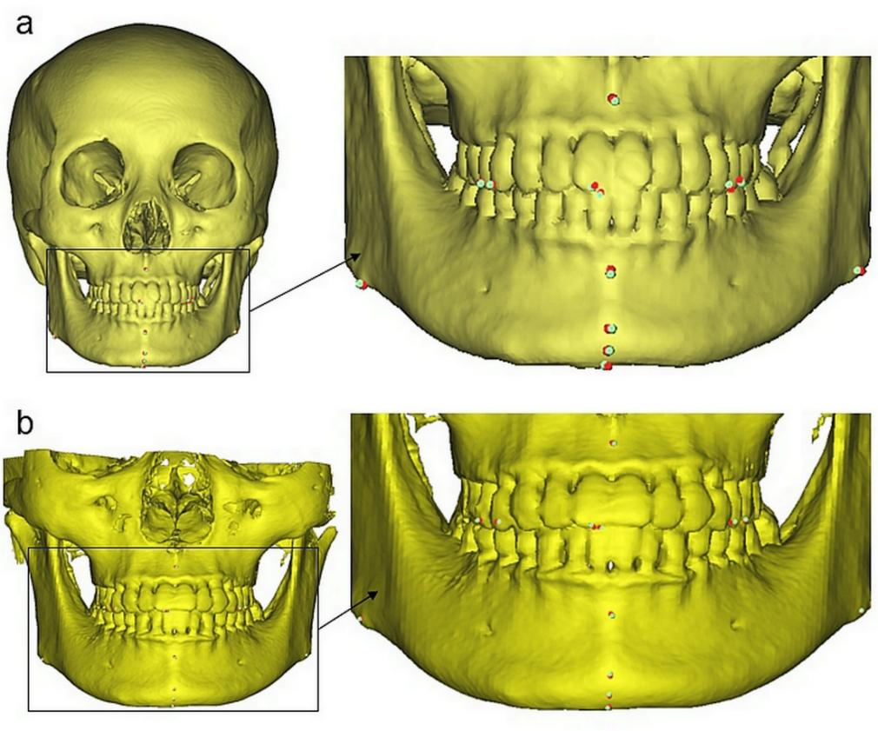
Figure A.5. Comparative localization of landmarks using SCT and CBCT at different time periods. A 40-year-old woman underwent CBCT for dental issues in 2021 and SCT for TMJ issues in 2022. 3D landmarking from SCT (panel a) showed lower MREs (1.221 mm) than CBCT (panel b, 1.334 mm) for bone landmarks, except for A. CBCT had lower errors for dental landmarks, except for L6L. The largest MRE difference was for GoR (1.158 mm) and the smallest for A (0.006 mm).
References
1. Swennen GR, Schutyser FA, Hausamen JE. 2005. Three-dimensional cephalometry: a color atlas and manual. Berlin Heidelberg: Springer Science & Business Media.
2. Zhao Y, Zeng K, Zhao Y, et al. 2022. Deep learning solution for medical image localization and orientation detection. Medical Image Analysis. 81.
3. Chim S, Lee JG, Park HH. 2019. Dilated Skip Convolution for Facial Landmark Detection. Sensors. 19(24).
4. Huang Y, Huang H. 2023. Stacked attention hourglass network based robust facial landmark detection. Neural Netw. 157:323-335.
5. Silverman, F. H. 1968. Intraclass Correlation Coefficient as an Index of Reliability of Median Scale Values for Sets of Stimuli Rated by Equal-Appearing Intervals. Perceptual and Motor Skills. 26(3): 878-878.

