Supplementary Information
Selective Manipulation of L-Cysteine Crystal Polymorphs Using Focused Laser Beams

Hozumi Takahashi¹*, Hiroshi Y. Yoshikawa¹, Teruki Sugiyama^{2,3}*

¹Department of Applied Physics, Graduate School of Engineering, Osaka University, 2-1 Yamada-oka, Suita, Osaka 565-0871, Japan.
²Department of Applied Chemistry and Center for Emergent Functional Matter Science, National Yang Ming Chiao Tung University, Hsinchu 300093, Taiwan
³Division of Materials Science, Nara Institute of Science and Technology, Ikoma 630-0192, Japan

*Corresponding authors: takahashi@mp.ap.eng.osaka-u.ac.jp, sugiyama@nycu.edu.tw

Table of Contents
- Supplementary Notes
- Theoretical treatment of laser trapping S3
- Estimation of solubility of L-Cys crystals in D₂O S4
- Measurement of Raman spectra of L-Cys crystals in D₂O S5
- Estimation of temperature elevation by 1064 nm-laser irradiation S6
- Solubility of L-Cys crystal in H₂O S7

- Supplementary Figures
- Crystallization behavior of L-Cys under various concentrations S8
- Raman spectra of α-form and β-form of L-Cys crystals S9
- Influence of polarization mode of CW laser on L-Cys crystallization S10
- Raman spectra of L-Cys/D₂O solution S11
- Transmittance of L-Cys/D₂O solutions as a function of optical path length S12
- Re-switching to HRR fs laser irradiation after sufficient growth of the α-form crystals S13
- Sample cell used for laser irradiation experiments S14
- Image and Raman spectrum of cystine crystals S15
- Optical setups for laser trapping experiments S16

- Supplementary References S17

Supplementary Note 1: Theoretical treatment of laser trapping
Because the targets (possibly clusters) in this study should be much smaller than the wavelength of the trapping laser (λ = 800 or 1064 nm), they can be regarded as electric dipoles according to Rayleigh scattering theory. In this case, the optical force (F_{opt}) that acts for the electric dipoles can be calculated using Lorentz force.¹ Assuming that the targets are transparent to the laser wavelength, F_{opt} is expressed as follows:
$$\begin{aligned}F_{opt}=\frac{1}{2}α∇E^{2}+α\frac{∂}{∂t}\left(E×B\right)\#\left(S1\right)\end{aligned}$$
Here, E and B are the electric field and magnetic flux density, and α is a polarizability of the target, described as follows:
$$\begin{aligned}α=4πε_{0}ε_{m}r^{3}\frac{{\left(\frac{n_{s}}{n_{m}}\right)}^{2}-1}{{\left(\frac{n_{s}}{n_{m}}\right)}^{2}+2},\#\left(S2\right)\end{aligned}$$
where, r is the radius of the targets, n_{s} and n_{m} are the refractive indices of the targets and the surrounding medium, ε₀ and ε_{m} are the permittivity of vacuum and the relative permittivity of the surrounding medium, respectively.
The first term, eq.(S1), is the gradient force, which acts towards the focal spot, while the second term is the scattering force, acting in the direction of the laser propagation. To achieve stable laser trapping inside solutions, the magnitude of the gradient force must exceed that of the scattering force. Empirically, stable trapping within the solution occurs when the optical potential created by gradient force (-α/2·|E|²) becomes 10 times larger than the energy of Brownian motion (k_{B}T, k_{B}: Boltzmann constant, T: temperature).^{1, 2} Meanwhile, in the laser trapping-induced crystallization experiments, the laser beam was focused at the air/solution interface, where both gradient and scattering forces contribute to the laser trapping. In this scenario, the optical potential required for stable trapping is expected to be lower than that in the solution.

Supplementary Note 2: Estimation of solubility of L-Cys crystals in D₂O
Since the solubility of L-Cys in D₂O is not well-established, we conducted solubility estimations. Our group had previously measured solubility using saturated solutions prepared by extended incubation (e.g., 1 week).^{3, 4} however, this method is not suitable for L-Cys, because prolonged incubation of L-Cys in aqueous solutions (e.g., 1 day) leads to the precipitation of "cystine" (Supplementary Figure 7a) due to oxidization.⁵ This oxidation likely contributes to the wide range of reported solubilities of L-cysteine (L-Cys) in H₂O (0.027–1.4 mol/kg at 20–25 °C).^{6, 7, 8} Therefore, we estimated the solubility of L-Cys in D₂O as follows:
- We prepared several L-Cys/D₂O solutions with varying concentrations.
- A single L- Cys crystal was added to each solution.
- Crystallization behavior was observed for 2 hours.
Supplementary Figure 1 shows the crystallization behavior of L-Cys in solutions with concentrations of 1.13, 1.16, and 1.20 mol/kg. The crystal dissolved in the 1.13 mol/kg solution and grew in the 1.20 mol/kg solution. At the intermediate concentration of 1.16 mol/kg, the appearance of crystals remained unchanged. Based on these observations, we estimated the saturation concentration of L-Cys in D₂O to be 1.16 mol/kg. To avoid “cystine” contamination, solutions were used within 5 hours of preparation. Under this condition, Raman peaks corresponding to "cystine" (Supplementary Figure 7b) were not detected during laser trapping experiments.

Supplementary Note 3: Measurement of Raman spectra of L-Cys crystals in D₂O.
L-Cys has two polymorphs under ambient pressure: a stable form denoted as the β-form and a metastable form described as α-form.^{9, 10} To investigate laser trapping-induced polymorphism, we first characterized the Raman spectra of L-Cys crystals in D₂O without laser exposure, as these spectra have not been previously reported to our knowledge. Previous studies have shown that two polymorphs of L-Cys can be crystallized from H₂O solutions at different temperatures,^{11, 12} although the exact transition temperature of two polymorphs remains unknown. To prepare these two polymorphs in D₂O, we prepared supersaturated solutions with a concentration of 2.63 mol/kg (supersaturation ratio = 2.26 at 25 °C) at 90 °C and incubated them at 32 and 42 °C for 5 hours. At 32 °C, two types of crystals initially formed: rectangular and hexagonal. The rectangular crystals gradually grew while the hexagonal crystals dissolved, with the rectangular crystals eventually becoming dominant in solution. Conversely, at 42 °C, only hexagonal crystals grew. These crystals exhibited distinct Raman spectra, as shown in Supplementary Figure 2, indicating that the rectangular and hexagonal crystals are the stable and metastable phases at room temperature (~25 °C), respectively. Our results also indicate that the transition temperature in D₂O is above 32 °C. This finding is plausible considering that some amino acids have transition temperatures around 40 °C.^{13, 14, 15}

Supplementary Note 4: Estimation of temperature elevation by 1064 nm-laser irradiation
Several studies have reported methods for estimating local temperature elevation at the laser focus during laser trapping experiments.^{4, 16, 17, 18, 19} Here, we briefly summarize one such method. The local temperature elevation coefficient (ΔT/ΔP [K·W⁻¹]) is known to be proportional to the ratio of the absorption coefficient (α [m⁻¹]) and thermal conductivity (κ [W·K⁻¹·m⁻¹]) of the solution.²⁰
$$\begin{aligned}\frac{∆T}{∆P}∝\frac{α}{κ}\#\left(S3\right)\end{aligned}$$
The absorption coefficient of the solution at the wavelength of the trapping laser (1064 nm) can be determined by measuring the dependence of transmittance (T_{trans} [%]) on the optical path length (l [m]).
$$\begin{aligned}T_{trans}=e^{-αl}\#\left(S4\right)\end{aligned}$$
Supplementary Figure 5 shows the transmittance of the L-Cys/D₂O solution (0.97 mol/kg) at 1064 nm as a function of optical path length, measured using an absorption spectrometer (V-670, JASCO). From the exponential fitting curve, the absorption coefficient was determined to be 0.79 m⁻¹, which is comparable to that of neat D₂O.^{4, 17, 18} Assuming that ΔT/ΔP is proportional to α/κ and κ corresponds to that of neat H₂O (0.59 W·K⁻¹·m⁻¹), ΔT/ΔP is estimated to be ~ 1.3 K/W.

Supplementary Note 5: Solubility of L-Cys crystal in H₂O
The solubility of L-Cys crystals (C_{e} [mol/kg]) in H₂O as a function of temperature (T [°C])⁶ was well fitted by a quadratic function in the temperature range of 10 °C to 50 °C.
$$\begin{aligned}C_{e} \left[{mol}/{kg}\right]=0.000184T^{2}+0.0173T+0.997 \left(R^{2}=0.999\right)\#\left(S5\right)\end{aligned}$$
From this fitted curve, the solubility at 25 °C and 27 °C is calculated to be 1.55 mol/kg and 1.61 mol/kg, respectively. Therefore, the increase in solubility between these temperatures is 4%.

Supplementary Figure 1: Morphological evolution of β-form of L-Cys crystals in undersaturated solutions
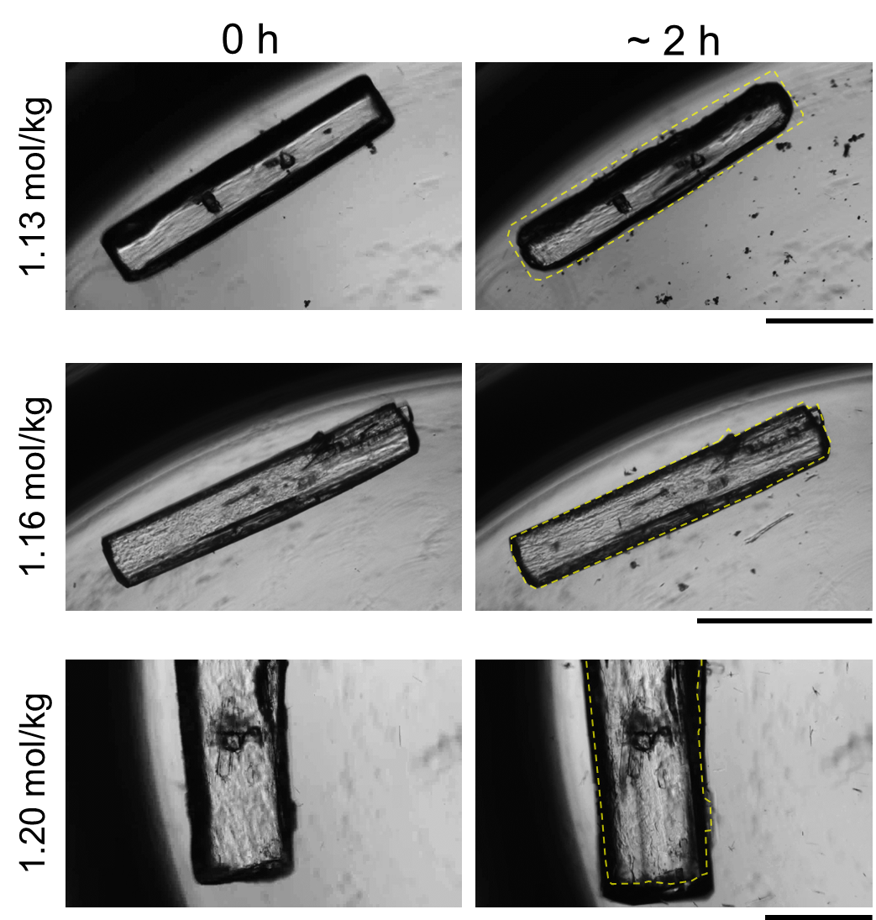
Supplementary Figure 1. Time-lapse images showing the behavior of β-form of L-Cys crystals in D₂O solutions with concentrations of 1.13, 1.16 and 1.19 mol/kg. The yellow dashed lines indicate the initial crystal morphology at 0 h. Scale bar: 1 mm.

Supplementary Figure 2: Raman spectra of α-form and β-form of L-Cys crystals in D₂O
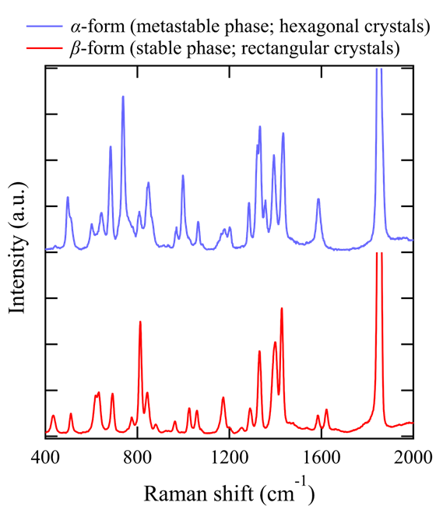
Supplementary Figure 2. Raman spectra of rectangular and hexagonal crystals in D₂O solutions.

Supplementary Figure 3: Influence of CW laser polarization mode on L-Cys crystallization
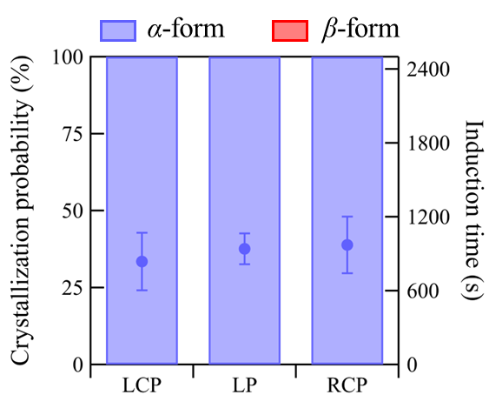
Supplementary Figure 3. Dependence of crystallization probability, induction time, and polymorph on the polarization mode of a CW laser. The laser intensity was set to 61 MW/cm². Eight samples were tested for each condition.

Supplementary Figure 4: Raman spectra of L-Cys in D₂O solution
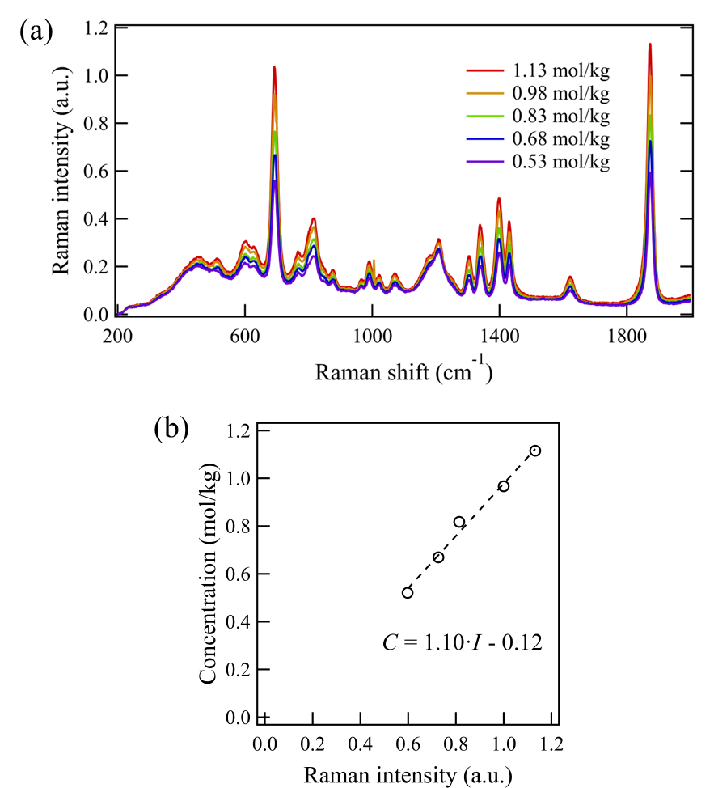
Supplementary Figure 4. (a) Raman spectra of L-Cys in D₂O solutions at various concentrations. The spectra were normalized to the peak intensity at ~ 1870 cm⁻¹ observed for the 0.97 mol/kg. (b) Calibration curve showing the relationship between Raman intensity at ~ 1870 cm⁻¹ and L-Cys concentration.

Supplementary Figure 5: Transmittance of L-Cys/D₂O solutions as a function of optical path length
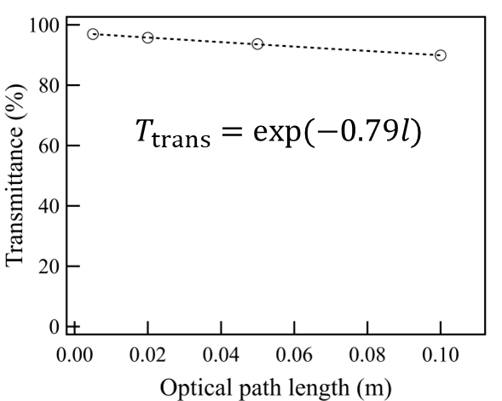
Supplementary Figure 5. The transmittance of the L-Cys/D₂O solution (0.97 mol/kg) measured at 1064 nm as a function of optical path length.

Supplementary Figure 6: Re-switching to HRR fs laser irradiation after sufficient growth of the α-form crystals
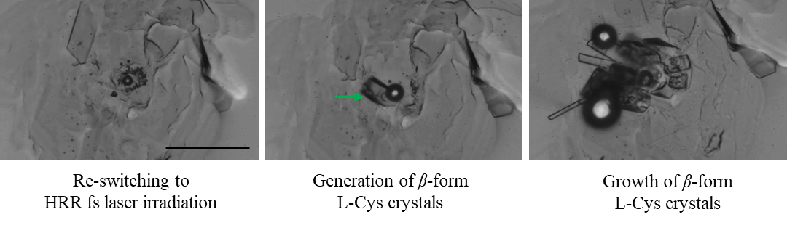
Supplementary Figure 6. Crystallization behavior induced by re-switching to HRR fs laser irradiation after sufficient growth of the α-form crystals. The entire images are filled with α-form crystals. The green arrow indicates the β-form crystals. Scale bar: 50 μm.

Supplementary Figure 7: Sample cell used for laser irradiation experiments
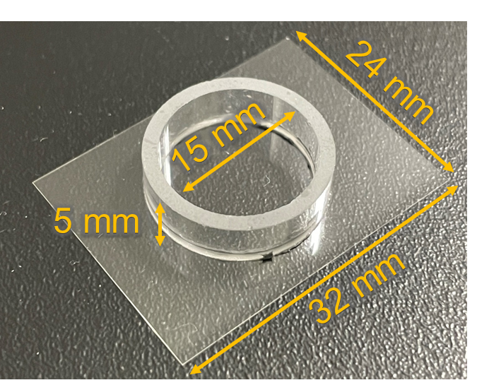
Supplementary Figure 7. A sample cell used for laser irradiation experiments. The cell was assembled from a glass ring (5 mm in height, 15 mm in inner diameter) and a cover glass (32 × 24 × 0.17 mm).

Supplementary Figure 8: Image and Raman spectrum of cystine crystals
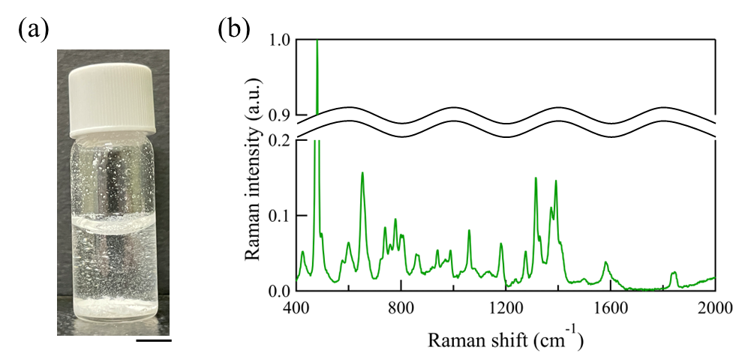
Supplementary Figure 8. (a) Image of cystine crystals obtained from the solution incubated for 1 day. The scale bar represents 5 mm. (b) Raman spectrum of cystine crystals. The strong peak at 497 cm⁻¹ is characteristic of cystine and is attributed to the S-S stretching mode.^{21, 22, 23}

Supplementary Figure 9: Optical setups for laser trapping experiments
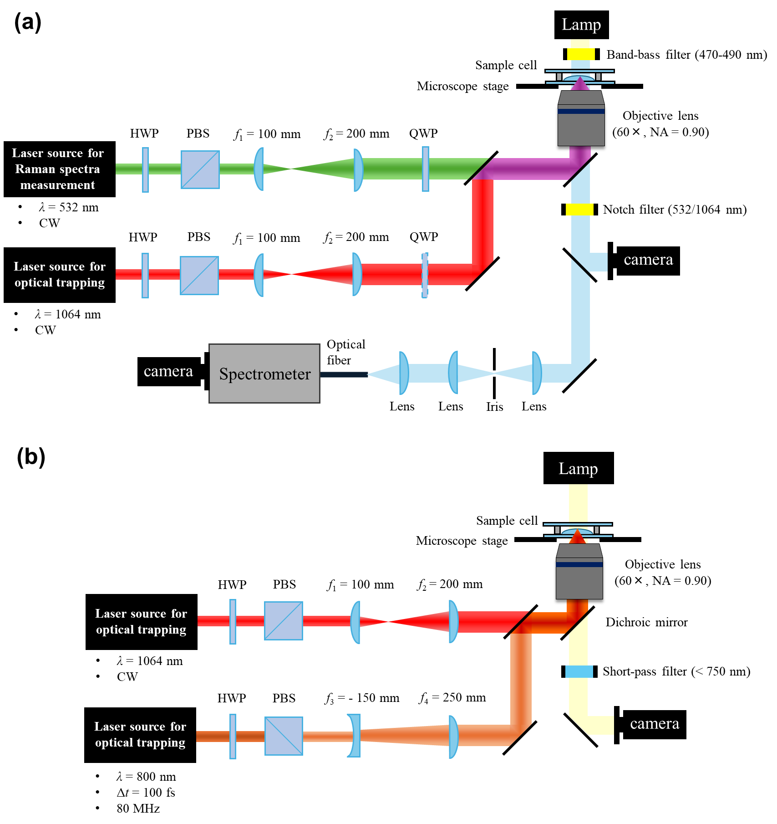
Supplementary Figure 9. Optical setup for (a) continuous-wave (CW) laser trapping coupled with Raman spectroscopy measurement system. (b) Optical setup for high repetition-rate femtosecond (HRR fs) laser trapping and CW laser trapping. HWP: half-wave plate; QWP: quarter-wave plate; PBS: polarizing beam splitter.

Supplementary references
1. Harada Y, Asakura T. Radiation forces on a dielectric sphere in the Rayleigh scattering regime. Opt Commun 124, 529-541 (1996).

2. Ashkin A, Dziedzic JM, Bjorkholm JE, Chu S. Observation of a single-beam gradient force optical trap for dielectric particles. Opt Lett 11, 288-290 (1986).

3. Wang W-C, Wang S-F, Sugiyama T. L-serine polymorphism controlled by optical trapping with high-repetition-rate femtosecond laser pulses. J Chin Chem Soc 69, 200-210 (2022).

4. Wang W-C, Okano K, Yoshikawa HY, Sugiyama T. Optical Trapping Controlled Cocrystallization Dynamics of Acetaminophen and l-Phenylalanine. Cryst Growth Des 24, 6028-6035 (2024).

5. Ejgenberg M, Mastai Y. Biomimetic Crystallization of l-Cystine Hierarchical Structures. Cryst Growth Des 12, 4995-5001 (2012).

6. Han J, et al. Determination and Correlation of the Solubility of l-Cysteine in Several Pure and Binary Solvent Systems. J Chem Eng Data 65, 2649-2658 (2020).

7. Chakraborty J, et al. Exploring the solubility and intermolecular interactions of biologically significant amino acids l-serine and L-cysteine in binary mixtures of H2O + DMF, H2O + DMSO and H2O + ACN in temperature range from T = 288.15 K to 308.15 K. Biophys Chem 311, 107272 (2024).

8. Yalkowsky SH, He Y, Jain P. Handbook of aqueous solubility data (CRC press, 2016).

9. Kerr K, Ashmore J. Structure and conformation of orthorhombic L-cysteine. Acta Crystallographica Section B: Structural Crystallography and Crystal Chemistry 29, 2124-2127 (1973).

10. Görbitz C, Dalhus B. l-Cysteine, monoclinic form, redetermination at 120K. Acta Crystallogr Sect C: Cryst Struct Commun 52, 1756-1759 (1996).

11. Harding Mt, Long H. The crystal and molecular structure of L-cysteine. Acta Crystallographica Section B: Structural Crystallography and Crystal Chemistry 24, 1096-1102 (1968).

12. Minkov VS, Goryainov SV, Boldyreva EV, Görbitz CH. Raman study of pressure‐induced phase transitions in crystals of orthorhombic and monoclinic polymorphs of L‐cysteine: dynamics of the side chain. J Raman Spectrosc 41, 1748-1758 (2010).

13. Luk C-wJ, Rousseau RW. Solubilities of and transformations between the anhydrous and hydrated forms of l-Serine in water− methanol solutions. Cryst Growth Des 6, 1808-1812 (2006).

14. Anuar N, Daud WRW, Roberts KJ, Kamarudin SK, Tasirin SM. An examination of the solution chemistry, nucleation kinetics, crystal morphology, and polymorphic behavior of aqueous phase batch crystallized L-isoleucine at the 250 mL scale size. Cryst Growth Des 9, 2853-2862 (2009).

15. Lu J, Lin Q, Li Z, Rohani S. Solubility of l-Phenylalanine Anhydrous and Monohydrate Forms: Experimental Measurements and Predictions. J Chem Eng Data 57, 1492-1498 (2012).

16. Wu C-S, Hsieh P-Y, Yuyama K-i, Masuhara H, Sugiyama T. Pseudopolymorph Control of l-Phenylalanine Achieved by Laser Trapping. Cryst Growth Des 18, 5417-5425 (2018).

17. Chen T, Toyouchi S, Sugiyama T. Spectroscopic Analysis of Concentration Dynamics and Crystallization of Hen Egg-White Lysozyme under Optical Trapping Conditions. J Phys Chem C 127, 23340-23348 (2023).

18. Sugiyama T, Lin T-M, Su H-T, Cheng A-C, Sasaki K. Enantioselective control in chiral crystallization of ethylenediamine sulfate using optical trapping with circularly polarized laser beams. J Chem Phys 160, 064502 (2024).

19. Shih T-W, et al. Optical trapping-driven supramolecular photochirogenesis via higher-order complexation. Cell Rep Phys Sci 4, 101216 (2023).

20. Ito S, Sugiyama T, Toitani N, Katayama G, Miyasaka H. Application of Fluorescence Correlation Spectroscopy to the Measurement of Local Temperature in Solutions under Optical Trapping Condition. J Phys Chem B 111, 2365-2371 (2007).

21. Suzuki T, Yano T-a, Hara M, Ebisuzaki T. Cysteine and cystine adsorption on FeS2(100). Surface Science 674, 6-12 (2018).

22. Brandt N, et al. Terahertz time-domain and Raman spectroscopy of the sulfur-containing peptide dimers: Low-frequency markers of disulfide bridges. Vib Spectrosc 47, 53-58 (2008).

23. Su Y, et al. Crystalline structures of l-cysteine and l-cystine: a combined theoretical and experimental characterization. Amino Acids 54, 1123-1133 (2022).

