Supporting Information
Unexpectedly efficient ion desorption of graphene–based materials
Xinming Xia^{1,#}, Feng Zhou^{2,#}, Jing Xu^{1,#}, Zhongteng Wang¹, Jian Lan³, Yizhou Yang⁴, Yan Fan¹, Zhikun Wang¹, Wei Liu¹, Junlang Chen¹, Shangshen Feng^{1,3}, Liang Chen^{1,}* and Haiping Fang^{4,}*
¹Department of Optical Engineering, Zhejiang Prov Key Lab Carbon Cycling Forest Ecosy, College of Environmental and Resource Sciences, Zhejiang A&F University, Hangzhou 311300, China.
²Radiation Monitoring Technical Center of Ministry of Environmental Protection, State Environmental Protection Key Laboratory of Radiation monitoring, Key Laboratory of Radiation Monitoring of Zhejiang Province, Hangzhou 310012, China.
³College of Pharmaceutical Chemistry and Materials Engineering, Taizhou University, Taizhou, Zhejiang 317000, China.
⁴Department of Physics, East China University of Science and Technology, Shanghai, 200237, China.
#These authors contributed equally to this work
*Corresponding author. E-mail: fanghaiping@ecust.edu.cn (H.-P. F.); liangchen@zafu.edu.cn (L. C.)

Contents
PS1: Materials and methods 3
Preparation of GO 3
Preparation of M–GO 3
Characterization methods 4
PS2: The experimental operations and Correlation calculation equations 4
Adsorption and Desorption of Co²⁺, Mn²⁺, and Sr²⁺ 4
Adsorption and Desorption of radioactive ⁶⁰Co for enrichment 6
PS3: XRD patterns and Raman spectra for GO and M–GO 7
PS4: XPS spectra for GO and M–GO 7
PS5: Equilibrium adsorption capacity of M–GO for Co²⁺, Mn²⁺, Sr²⁺, and Al³⁺. 8
PS6: Ultraviolet (UV) absorption spectral experiments 9
References 10

PS1: Materials and methods

Preparation of GO
Graphene oxide (GO) was prepared from natural graphite powder using a modified Hummers method^{S1}. Graphite powders was concentrated in H₂SO₄ containing K₂S₂O₈ and P₂O₅, and stirred continuously for several hours. Then the mixture was washed and filtered in deionized water (DI). After vacuum drying, pre–oxidized graphite was obtained. Pre–oxidized graphite was oxidized in concentrated H₂SO₄ and KMnO₄, diluted with DI water and further oxidized with H₂O₂ (30%). Then, the product was centrifuged and washed using HCl aqueous solution and DI water. Finally, the GO was obtained and placed in water for further use.

Preparation of M–GO
Magnetite–graphene oxide (M–GO) was prepared through chemical co–precipitation of magnetic iron oxide nanoparticles by coating GO with Fe³⁺ and Fe²⁺ under alkaline conditions^{S2, S3}. Under 353K and N₂ protection, an acidic mixed aqueous solution of 0.8g FeCl₂·4H₂O and 2.2g FeCl₃·6H₂O was slowly added into the solution containing 0.5g GO. At 358K, ammonia solution was quickly added to adjust pH to about 12 and the mixture was stirred vigorously for 60 min. Then, the suspension was cooled to room temperature. By magnetic separation, the solid phase was washed to neutral with DI water, after which it was washed with DI water and ethanol. Finally, M–GO was obtained and placed in water for further use.

Characterization methods
GO and M–GO were characterized using Raman spectroscopy, XRD, and XPS. The magnetic properties of M–GO were determined using a vibration magnetometer (VSM). The morphology of M–GO was characterized using TEM. The concentrations of the ions (Mn²⁺, Sr²⁺, Co²⁺, and Al³⁺) were determined using ICP–OES. The detailed parameters for all instrument characterization are as follows: Raman spectroscopy (horiba evolution), XRD (X' Pert Powder), XPS (Thermo Scientific K–Alpha), VSM (Quantum Design PPMS DynaCool), and TEM (JEOL JEM 2100).

PS2: The experimental operations and Correlation calculation equations

Adsorption and Desorption of Co²⁺, Mn²⁺, and Sr²⁺
In the adsorption and desorption kinetics study of Co²⁺, Mn²⁺, and Sr²⁺, the prepared M–GO (200 mg) was added to 200 mL solutions of 10 mg/L Co²⁺, Mn²⁺, and Sr²⁺, which were prepared using MnCl₂·4H₂O, SrCl₂·6H₂O, CoCl₂·6H₂O, and AlCl₃·6H₂O, respectively. Subsequently, these mixtures were stirred at 298 K for 125 min. A negligible volume of highly concentrated Al³⁺ solutions was subsequently added such that the concentration of Al³⁺ in the mixtures was 10 mg/L, followed by stirring at 298 K for another 125 min. At designated time intervals ranging from 0 to 250 min, 5 mL of the solution was taken each time for filtration separation and the measurements of residual ion concentration. The adsorption capacity (q_{t}) at time t was calculated according to equation (1).
$q_{t}=\frac{\left(C_{0}-C_{t}\right)V}{m}$ (1)
Where C₀ and C_{t} (mg/L) are the initial and t time concentrations of Co²⁺, Mn²⁺, Sr²⁺, or Al³⁺ in the mixed solution, respectively, V (L) is the total volume of the solution, and m (g) is the solid mass of the adsorbent in the aqueous mixture.
In the adsorption and desorption study of Co²⁺, Mn²⁺, Sr²⁺, and Al³⁺, the prepared M–GO (30 mg) was added to 30 mL solutions of 10 mg/L Co²⁺, Mn²⁺, Sr²⁺, and Al³⁺. These mixtures were shaken at 160 rpm for 1 h to reach adsorption equilibrium and thereafter separated through magnetic separation and filtration. The ions in the filtrates were determined using ICP–OES. The equilibrium adsorption capacity (q_{e}, mg/g) of Co²⁺, Mn²⁺, Sr²⁺, or Al³⁺ were calculated from the concentration of initial and equilibrium solutions according to the following equations (2).
$q_{e}=\frac{\left(C_{0}-C_{e}\right)V}{m}$ (2)
Where C₀ and C_{e} (mg/L) are the initial and equilibrium concentrations of Co²⁺, Mn²⁺，Sr²⁺, or Al³⁺ in the mixed solution during adsorption, respectively, V (L) is the total volume of the solution, and m (g) is the solid mass of the adsorbent in the aqueous mixture.
The mixture solutions containing 30 mg M–GO and 10 mg/L Co²⁺, Mn²⁺, and Sr²⁺ were shaken at 160 rpm and 298 K for 1 h, respectively, which is a continuation of the adsorption experiments. A negligible volume of Al³⁺ solution was thereafter added such that the concentration of Al³⁺ in each ion mixture ranged from 2 to 10 mg/L. After shaking for another 1 h, the mixtures were separated through magnetic separation and filtration, and the ions in the filtrates were determined using ICP–OES. The equilibrium adsorption capacity of Al³⁺ was calculated according to equation (2) during desorption. Meanwhile, desorption rate (D %) of Co²⁺, Mn²⁺, and Sr²⁺ were calculated according to equation (3).
$D \left(\%\right)=\frac{C_{e}^{'}-C_{e}}{C_{0}-C_{e}}×100\%$ (3)
Where C₀ and C_{e} (mg/L) are the initial and equilibrium concentrations of Co²⁺, Mn²⁺, or Sr²⁺ in the mixed solution during adsorption, respectively. $C_{e}^{'}$ (mg/L) is the equilibrium concentration of Co²⁺, Mn²⁺, or Sr²⁺ during desorption.

Adsorption and Desorption of radioactive ⁶⁰Co for enrichment
The enrichment multiple (n) was calculated from the activity concentrations of the initial and desorbed solutions according to equation (4).
$n=\frac{C_{3}}{C_{1}}$ (4)
Where C₁ and C₃ (Bq/L) are the activity concentrations of ⁶⁰Co of initial and desorbed solution, respectively.

PS3: XRD patterns and Raman spectra for GO and M–GO
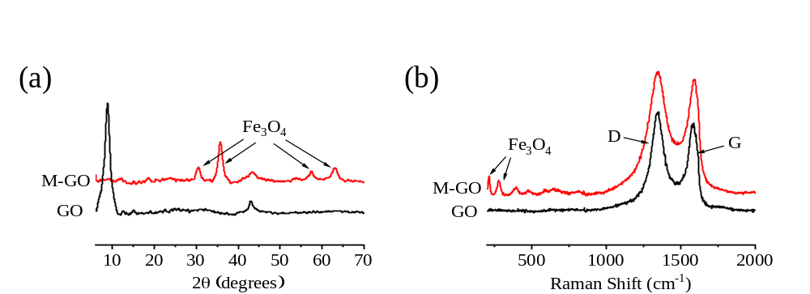
Fig. S1 (a) XRD pattern of GO and M–GO, and (b) Raman spectra (λ=532 nm) of GO and M–GO.

PS4: XPS spectra for GO and M–GO
Fig. S2 XPS spectra: (a) wide scan of GO and M–GO, (b) Fe2p spectra of GO and M–GO, (c) C1s spectra of GO, and (d) C1s spectra of M–GO.

PS5: Equilibrium adsorption capacity of M–GO for Co²⁺, Mn²⁺, Sr²⁺, and Al³⁺.
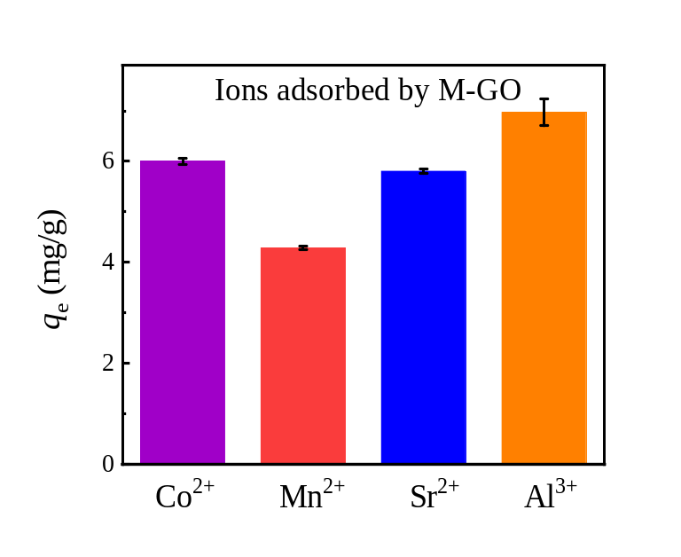
Fig. S3 Equilibrium adsorption capacity of M–GO for Co²⁺, Mn²⁺, Sr²⁺, and Al³⁺.

The experimental operation of equilibrium adsorption capacity of M–GO for Co²⁺, Mn²⁺, Sr²⁺, and Al³⁺ can be found in section PS2. As shown in Fig. S3, the equilibrium adsorption capacities of M–GO for Co²⁺, Mn²⁺, Sr²⁺, and Al³⁺ solutions were 6.0 ± 0.1, 4.2 ± 0.1, 5.8 ± 0.1, and 7.0 ± 0.3 mg/g, respectively, which is consistent with those of previous reports^{S2–S4}. This demonstrates the efficient ion removal effect of M–GO, indicating that the M–GO adsorbed ions can be conveniently separated from the aqueous solution through magnetic solid/liquid separation, consistent with previous reports^{S5}.

PS6: Ultraviolet (UV) absorption spectral experiments
The UV absorption spectra of GO and GO in CoCl₂ and AlCl₃ solution are showed in Fig. S3. The UV spectrum of GO at ~ 230 nm, which is assigned to a conjugate double bond of the aromatic group that easily generated π–π* transition^{S6–S8}. Compared with the UV intensity of GO in CoCl₂ solution, the intensity of GO in AlCl₃ solution markedly decreased, indicating that the conjugate double bonds of the aromatic group in GO are greatly affected in AlCl₃ solution.
Fig. S4 UV absorption spectra of GO suspension (50 mg/L) mixed in a 1:1 ratio with 0.4 M CoCl₂ and AlCl₃ solutions (blue and red solid line) together with GO suspension in pure water (black solid line), and pure 0.4 M CoCl₂ and AlCl₃ salt solution (blue and red dashed line).

References
S1. Hummers, et al. Preparation of Graphitic Oxide. J. Am. Chem. Soc. 80, 1339 (1958).
S2. Liu, M., Chen, C., Hu, J., Wu, X. & Wang, X. Synthesis of Magnetite/Graphene Oxide Composite and Application for Cobalt (II) Removal. J. Phys. Chem. C 115, 25234–25240 (2011).
S3. Yan, H. et al. Rapid Removal and Separation of Iron (II) and Manganese (II) from Micropolluted Water Using Magnetic Graphene Oxide. ACS Appl. Mater. Interfaces 6, 9871–9880 (2014).
S4. Minitha, C. R. et al. Magnetite Nanoparticle Decorated Reduced Graphene Oxide Composite as an Efficient and Recoverable Adsorbent for the Removal of Cesium and Strontium Ions. Ind. Eng. Chem. Res. 57, 1225–1232 (2018).
S5. Lingamdinne, L. P., Koduru, J. R. & Karri, R. R. A comprehensive review of applications of magnetic graphene oxide based nanocomposites for sustainable water purification. Journal of Environmental Management 231, 622–634 (2019).
S6. Shi, G. et al. Unexpectedly Enhanced Solubility of Aromatic Amino Acids and Peptides in an Aqueous Solution of Divalent Transition-Metal Cations. Phys. Rev. Lett. 117, 238102 (2016).
S7. Chuang, C. H. & Chen, Y. T. Raman scattering of L-tryptophan enhanced by surface plasmon of silver nanoparticles: vibrational assignment and structural determination. J. Raman Spectrosc. 40, 150-156 (2009).
S8. Yorita, H. et al. Evidence for the cation-π interaction between Cu²⁺ and tryptophan. J. Am. Chem. Soc. 130, 15266-15267 (2008).

