Supplementary information for

G2PDeep-v2: a web-based deep-learning framework for phenotype prediction and biomarker discovery using multi-omics data

Shuai Zeng^{1,2}, Trinath Adusumilli¹, Sania Zafar Awan³, Manish Sridhar Immadi¹, Dong Xu^{1,2,3} and Trupti Joshi^{1,2,3,4,*}
¹ Department of Electrical Engineering and Computer Science, University of Missouri, Columbia, MO, 65211, USA
² Christopher S. Bond Life Sciences Center, University of Missouri, Columbia, MO, 65211, USA
³ MU Institute for Data Science and Informatics, University of Missouri-Columbia, Columbia, MO, 65211, USA
⁴ Department of Biomedical Informatics, Biostatistics and Medical Epidemiology, University of Missouri, Columbia, MO, 65211, USA
* To whom correspondence should be addressed. Tel: +1 (573) 884-5963; Email: joshitr@health.missouri.edu

Email:
Shuai Zeng, zengs@missouri.edu
Trinath Adusumilli, tafbr@missouri.edu
Sania Zafar Awan, sah2p@missouri.edu
Manish Sridhar Immadi, mizy9@missouri.edu
Dong Xu, xudong@missouri.edu
Trupti Joshi, joshitr@health.missouri.edu

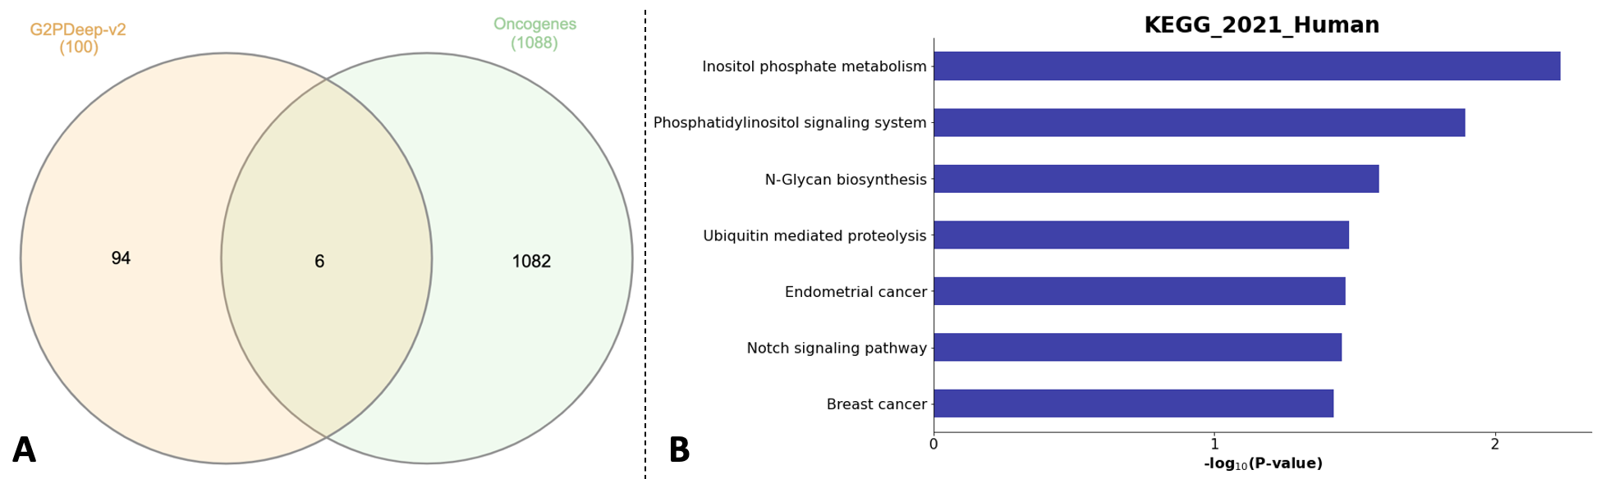
Supplementary Fig. 1. Plots for significant biomarkers. (A) Venn diagram of 100 most significant biomarkers and oncogenes. (B) Enriched seven pathways associated with breast cancer.

