Supplementary Information:

Title
Introduction of multiple disulfide bonds increases the thermostability of transglutaminase

Takuto Ono†, Kazutoshi Takahashi†*, Yoshinori Hirao, Yasuhiro Mihara, Isao Abe, Masayuki Sugiki
Research Institute for Bioscience Products & Fine Chemicals, Ajinomoto Co., Inc., 1-1 Suzuki-cho, Kawasaki-ku, Kawasaki-shi, Kanagawa-ken 210-8681, Japan
†These authors contributed equally to this work
Correspondence:
Name: Kazutoshi Takahashi
Address: Research Institute for Bioscience Products & Fine Chemicals, Ajinomoto Co., Inc., 1-1 Suzuki-cho, Kawasaki-ku, Kawasaki-shi, Kanagawa-ken 210-8681, Japan
Email: *kazutoshi.takahashi.pu7@asv.ajinomoto.com

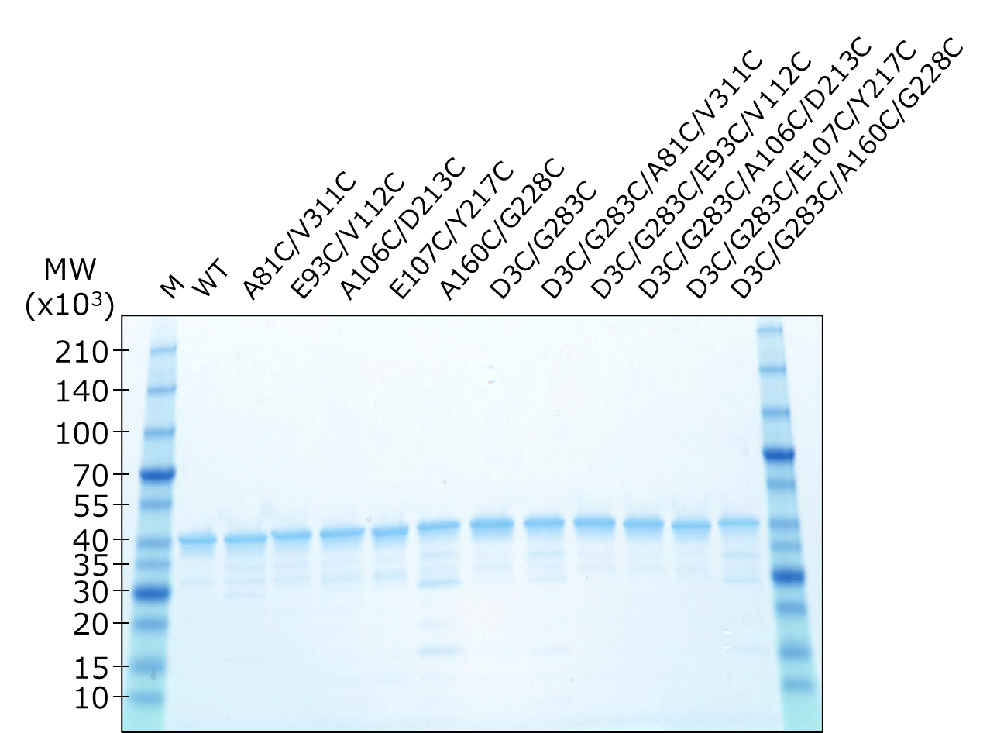
Supplementary Figure S1: Purity verification of the prepared enzyme by SDS-PAGE.
Lane M represent the protein marker.

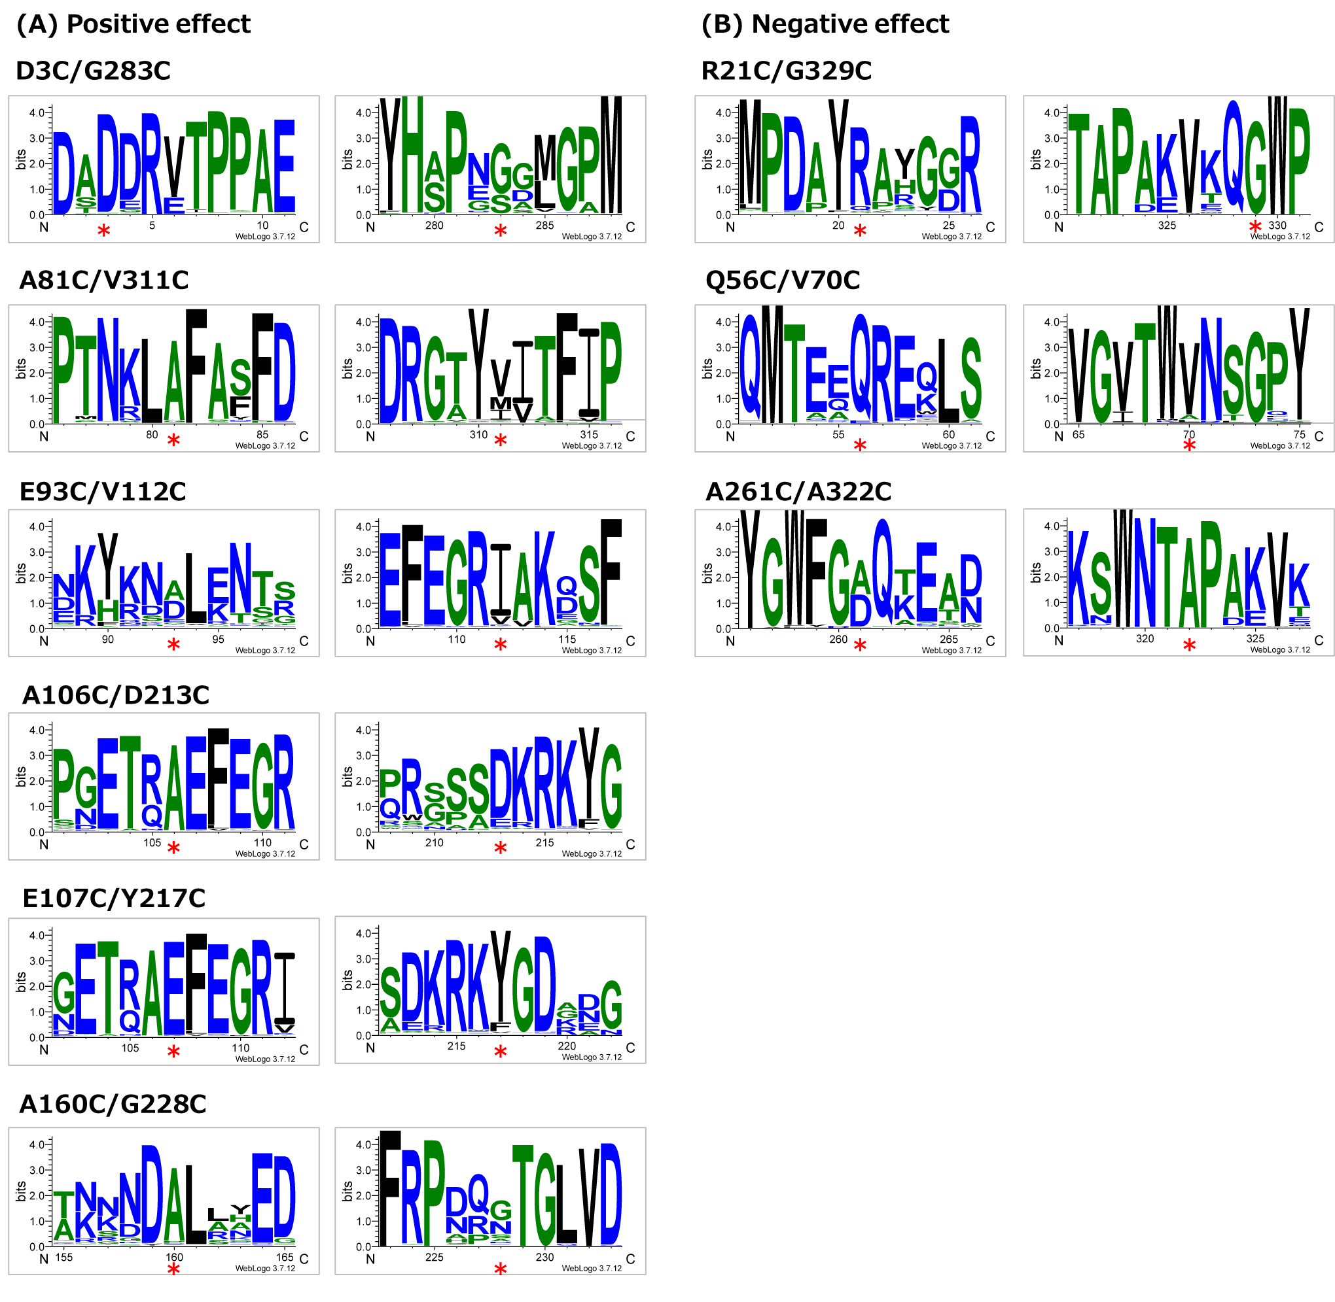
Supplementary Figure S2: Sequence logos of Microbial Transglutaminase
Amino acid frequencies of 11 residues around the mutation points are represented as sequence logos. The logos were prepared using the WebLogo3 software^{[34]}.

