Isolating the Primary Drivers of Fire Risk to Structures in WUI regions in California

Maryam Zamanialaei¹, Daniel San Martin², Maria Theodori¹, Dwi Marhaendro Jati Purnomo¹, Ali Tohidi³, Chris Lautenberger⁴, Yiren Qin⁵, Arnaud Trouvé⁵, Michael Gollner¹

¹ Department of Mechanical Engineering, University of California, Berkeley, USA
² Departamento de Informática, Universidad Técnica Federico Santa María, Valparaíso, Chile
³ Department of Mechanical Engineering, San Jose State University, San Jose, USA
⁴ CloudFire Inc., 985 Lincoln Way, Suite 207 Auburn, CA 95603, USA
⁵ Department of Fire Protection Engineering, University of Maryland, College Park, MD 20742, USA

Supplementary Materials
We employed several classification models to analyze the Stacked WUI data and individual fires. In this section, we present the results of the Logistic Regression and Random Forest models applied to the Stacked WUI data and individual fires. Each of these models provides unique advantages and approaches for evaluating feature contributions through SHAP values. The results of the Logistic Regression (Figure S1) and the Random Forest (Figure S2) are shown below.
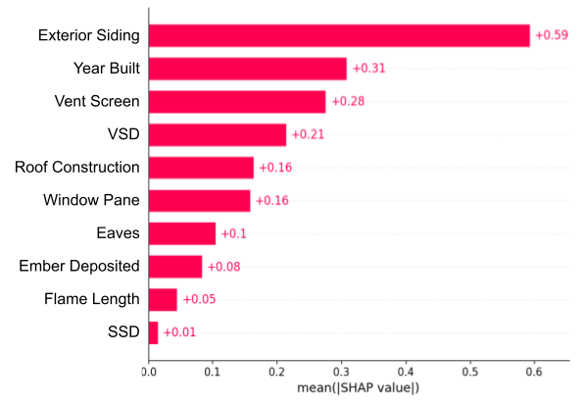
Logistic Regression- Stacked WUI data
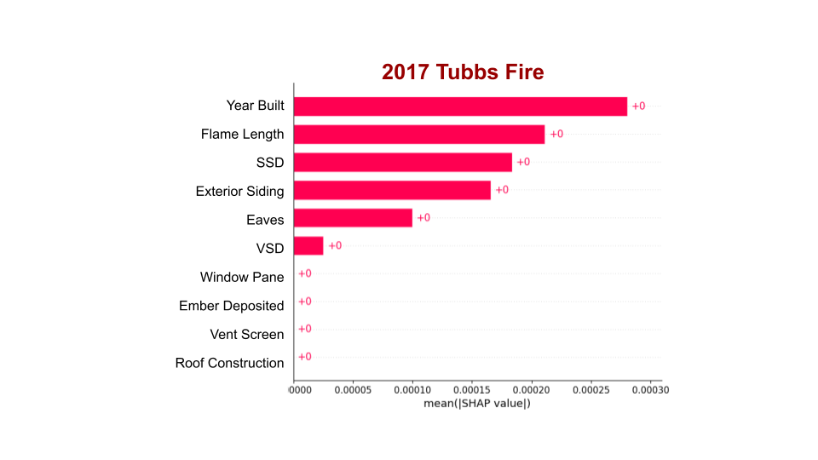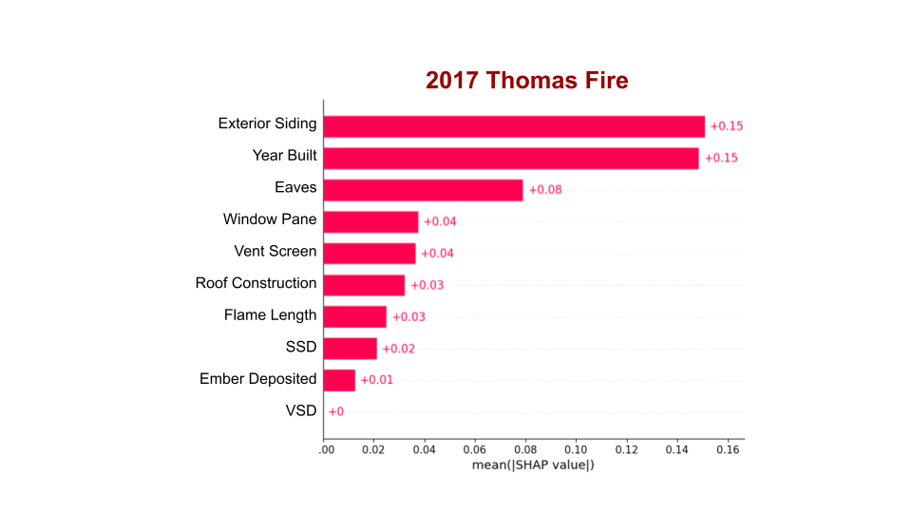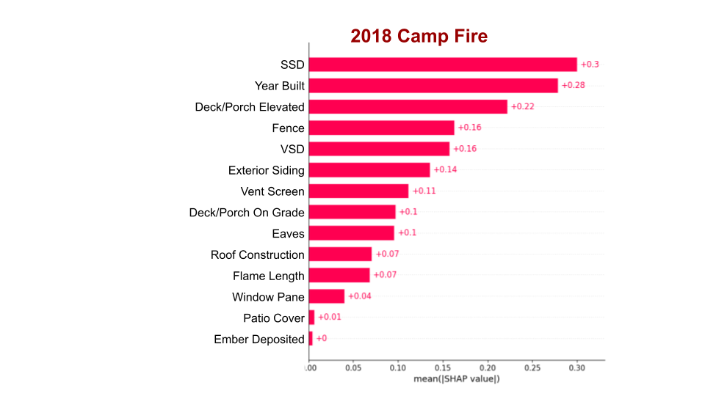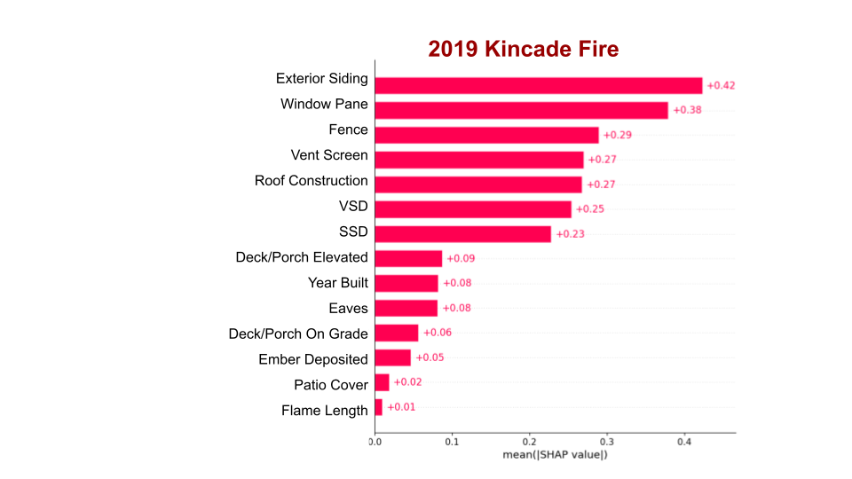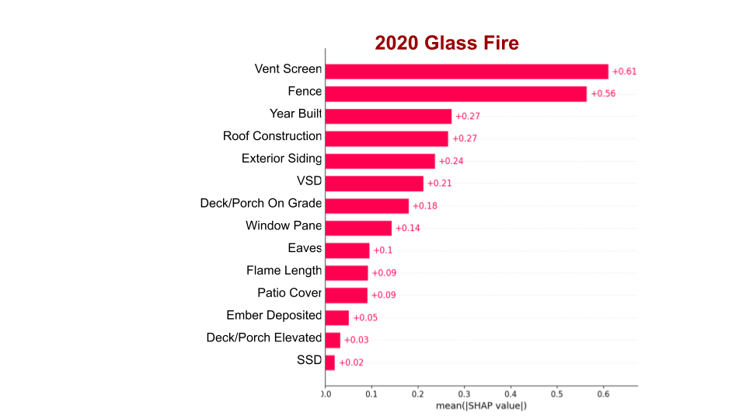
Logistic Regression- Individual Fires
Logistic Regression
Figure S1- SHAP results with Logistic Regression
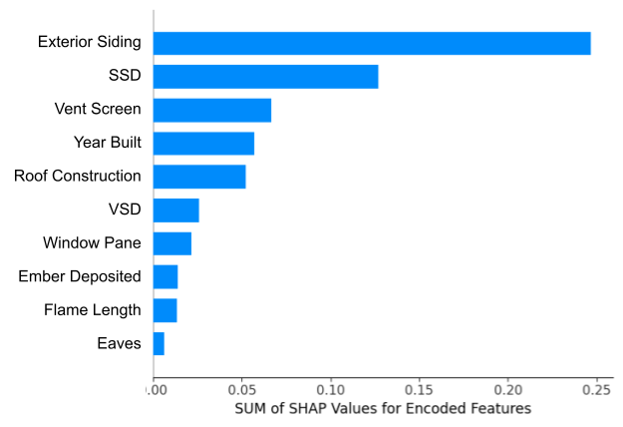
Random Forest- Stacked WUI data
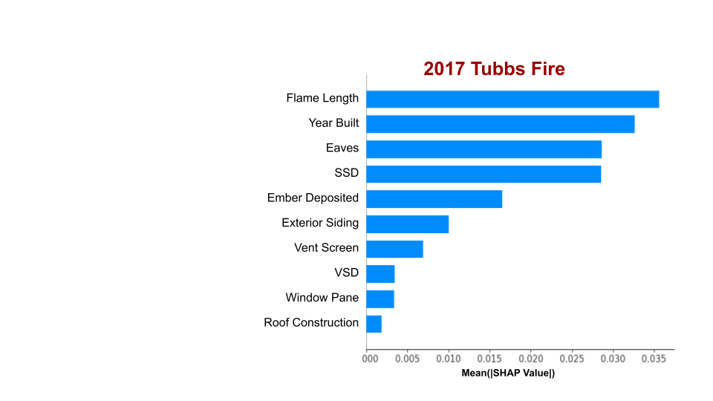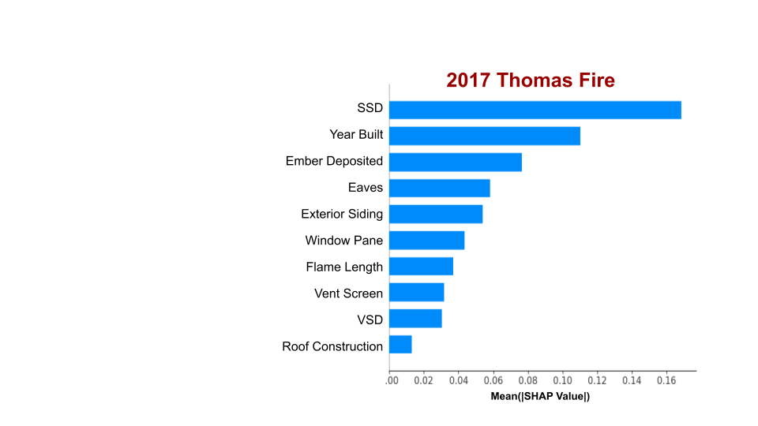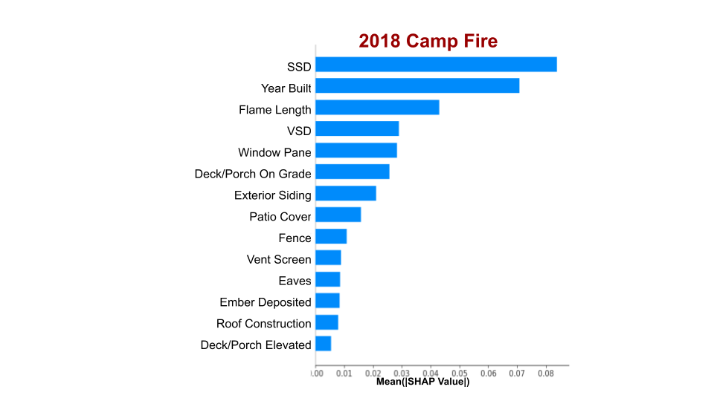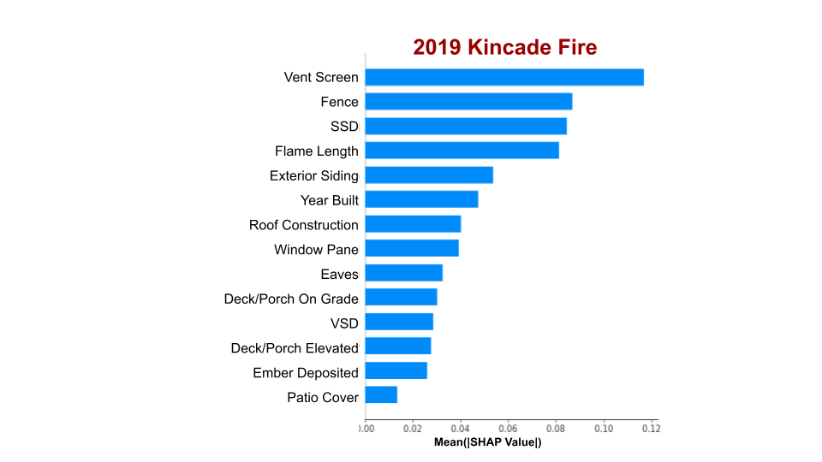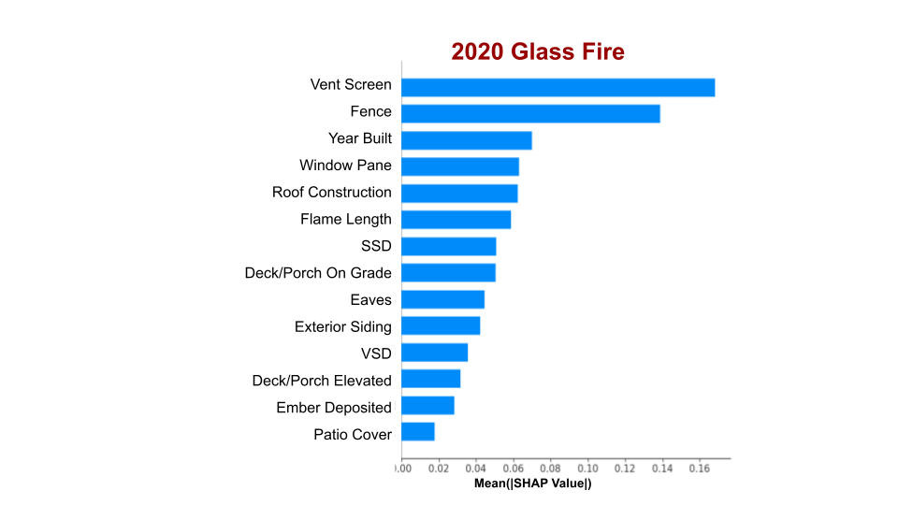
Random Forest- Individual Fires
Figure S2- SHAP results with Random Forest

The ROC Curves and Confusion Matrices for the XGBoost model applied to the five fires are shown in Figure S3. The ROC Curves provide insight into the model's ability to discriminate between different classes, with the area under the curve (AUC) serving as a measure of its overall performance. The Confusion Matrices offer a detailed breakdown of the model’s predictions, highlighting the number of true positives, false positives, true negatives, and false negatives for each fire scenario.
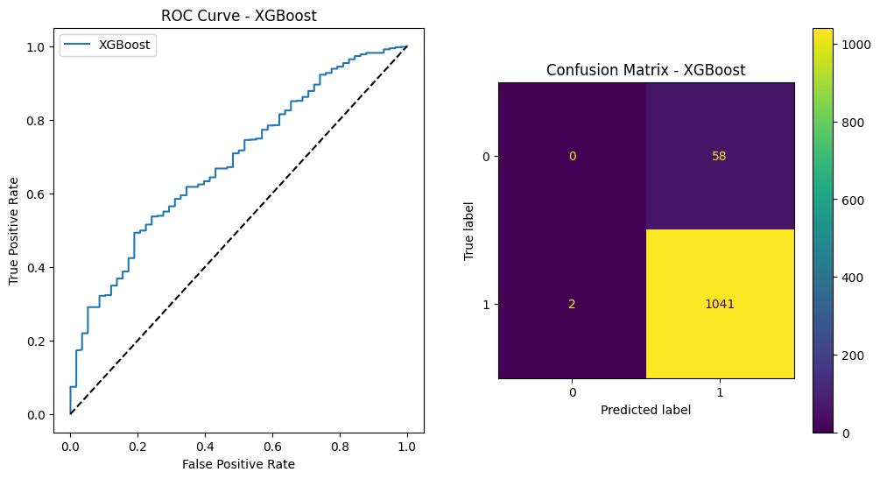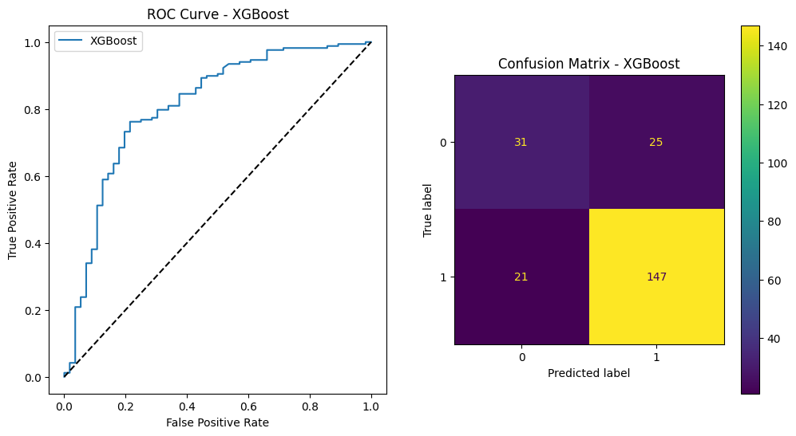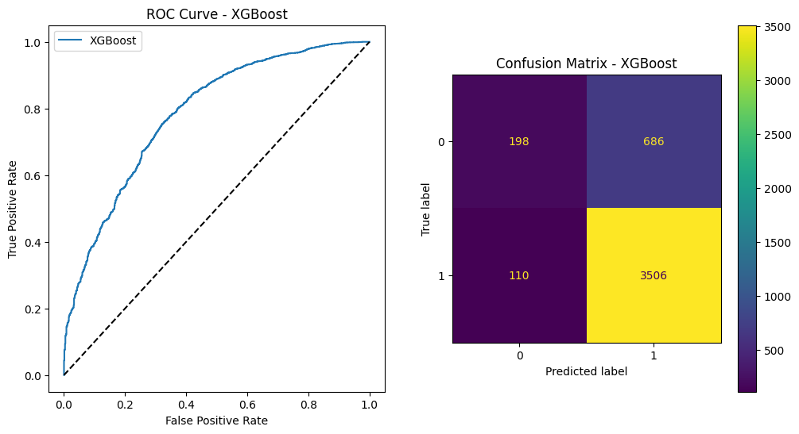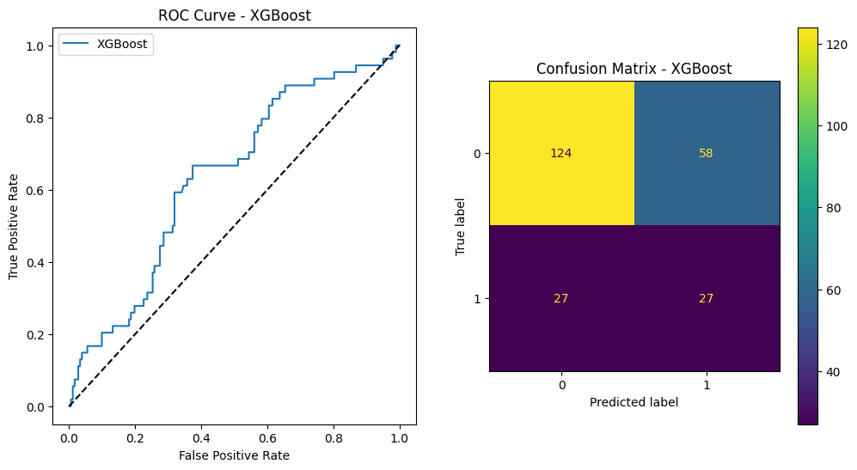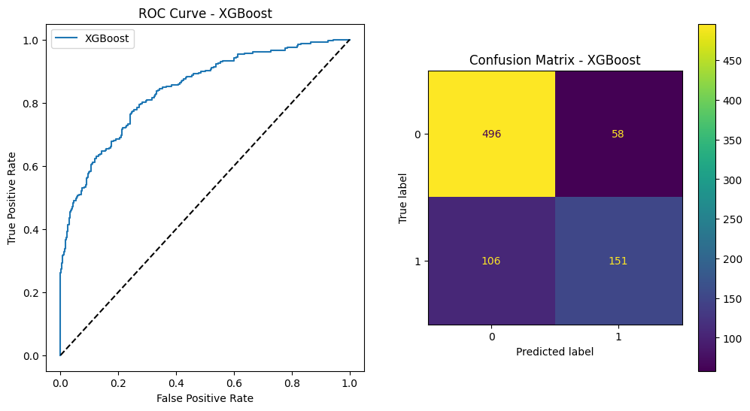
2017 Tubbs Fire

2017 Thomas Fire

2018 Camp Fire

2019 Kincade Fire
2020 Glass Fire

Figure S3- ROC Curves and Confusion Matrices for the XGBoost model

Figures S4-S7 illustrate the results of different mitigation strategies tested using our model, which examines the impact of home hardening and defensible space clearing on structure loss and survivability. In the No-Mitigation Scenario (Figure S4), structure loss is 80%, with a survivability rate of 20%. In Scenario 1 (Figure S5), home hardening measures, including non-flammable siding, fine mesh over vents, and non-flammable roofs, were applied. This resulted in a 25% survival rate and 75% structure loss. Scenario 2 (Figures S6) combined home hardening with clearing defensible space in Zone 0 (0-5 feet), which improved the survival rate to 40% and reduced structure loss to 60%. Finally, in the extreme mitigation scenario (Figures S7), both home hardening and defensible space clearing in Zones 0 (0-5 feet) and 1 (5-30 feet) were implemented, leading to a 48% survival rate and a 52% reduction in structure loss.
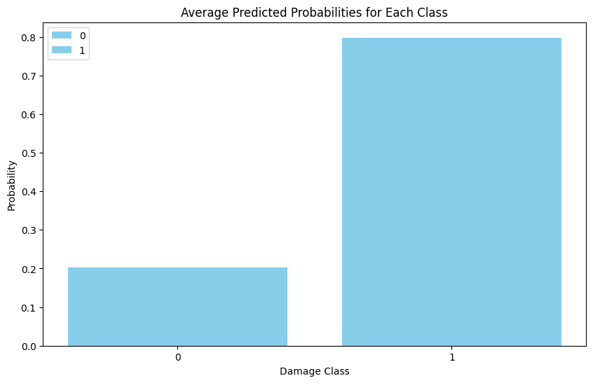
Figure S4- Predicting probabilities of structural destruction for entire WUI data

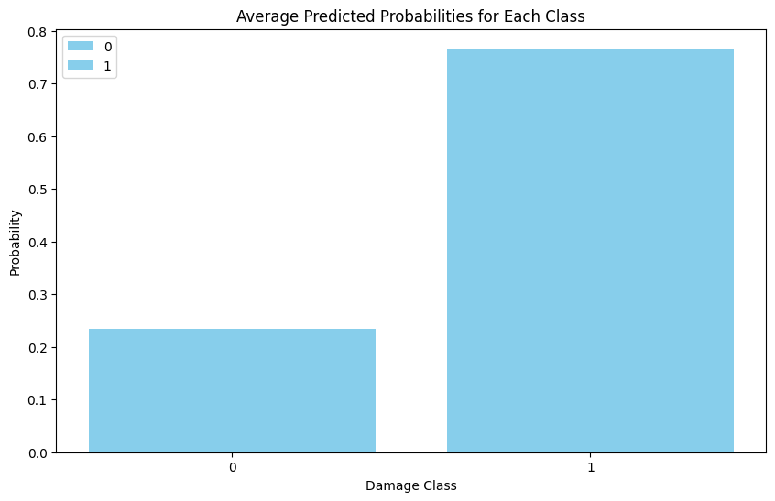
Figure S5- Predicting probabilities of structural destruction with home hardening scenario

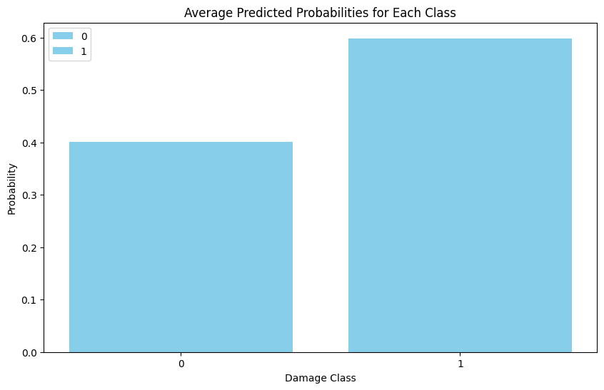
Figure S6- Predicting probabilities of structural destruction with home hardening and defensible space (clearing Zone 0)

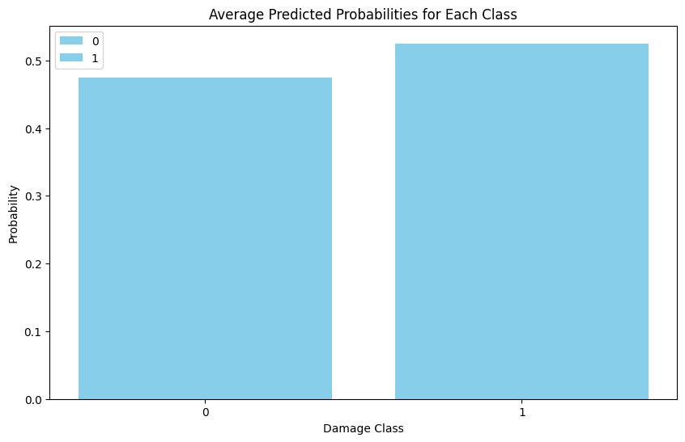
Figure S7- Predicting probabilities of structural destruction with home hardening and defensible space (clearing Zone 0 and Zone 1)

