Supplementary Materials for

Interface-mediated dc electro-optic instability in lithium niobate nanophotonics

Matthew Yeh^{1,†}, David R. Barton III^{1,†}, Gavin Smith¹, Aaron M. Day¹, Alexander Raun¹, Dylan Renaud¹, Daniel R. Assumpcao¹, Evelyn L. Hu^{1,*}, Marko Lončar^{1,*}
¹John A. Paulson School of Engineering and Applied Sciences, Harvard University, Cambridge, MA 02138, USA.
†These authors contributed equally.
*Corresponding author. E-mail: ehu@seas.harvard.edu, loncar@g.harvard.edu

This PDF file includes:

Materials and Methods
Supplementary Text
Supplementary Figs. 1 to 10
References (56-57)

Materials and Methods
Device Fabrication
All samples were fabricated from commercial ion-sliced x-cut thin-film lithium niobate on insulator wafers (NanoLN) with 600 nm LN, 4.7 µm thermally grown buried silicon dioxide, and 525 µm high resistivity silicon. All samples undergo cleaning in acetone and isopropanol prior to further processing.
- Photonic devices
Electron-beam lithography with hydrogen silsesquioxane (HSQ) resist followed by Ar+-based reactive ion etching (300 nm etch depth) is used to pattern the waveguides. Silicon nitride deposited by PECVD is used as the HSQ adhesion layer to piranha-cleaned TFLN. The waveguide width tapers to 3 µm for ring resonators. After etching, a wet chemical process involving the RCA clean (SC-1—5:1:1 deionized water: 29 wt % NH₄OH: 30 wt % H₂O₂ at 57 ºC), hydrofluoric acid, and piranha (3:1 H₂SO₄: H₂O₂) is used to clean the resist and redeposited material. As measured by reflectometry, this chemical cleaning process removes the top 6-10 nm of the TFLN surface. A two-hour anneal at 520 ºC in an O2 atmosphere may follow at this point (“LN anneal”). If the device is air-cladded, the electrode deposition steps follow here. Otherwise, the device is clad with 900 nm of SiO₂ deposited using plasma-enhanced chemical vapor deposition (high-frequency PECVD, 13.56 MHz). A separate two-hour anneal (“oxide anneal”) with identical conditions to the LN anneal may then be included here to improve oxide quality.
Electrode locations are defined using photolithography with a bilayer resist stack (LOR-3A, SPR-700-1.0) intended for metal lift-off in 80 ºC Remover PG. The electrode gap is 7.5 µm edge-to-edge for rings. If air-cladded, the contact region may undergo additional treatment with photoresist-compatible processes, using the bilayer resist stack as an etch mask. In the main text, the baseline samples undergo a gentle O₂ plasma cleaning (75W, 20 sccm) to clean off residual resist after developing, otherwise the contact regions are treated with a brief etch in either a C₃F₈+Ar⁺ gas chemistry (20 seconds) or a pure Ar⁺ etch (30 seconds). These processes etch away the top 20-25 nm of the TFLN contact region. The electrodes are then immediately deposited with electron-beam evaporation (15 nm Ti, 200 nm Au, base pressure <2E-6 torr).
If employing a top-cladded geometry, additional steps are taken prior to metallization to ensure intimate contact of the electrode with TFLN. Direct electrode contact has been used to greatly improve low-frequency roll-off by circumventing leakage through the oxide buffer^{20,24}. Reactive ion etching with a C₃F₈ chemistry is used to create windows with near vertical sidewalls in the PECVD cladding that expose the lithium niobate surface. If the etch terminates with the fluorine chemistry, the sample is said to be “fluorine-terminated”, otherwise if the etch is switched to a purely physical Ar⁺ plasma etch at the end it is said to be “Ar-terminated.” In theory this creates a SiO₂ hard mask that allows for a wider range of possible chemical contact treatments not possible with photoresist, although this would necessitate chemical stripping of the photoresist. In practice we find there to be challenges with precisely aligning a duplicate optical lithography step to redefine the electrode region for lift-off, effectively negating the advantage of using a self-aligned etch and lift-off mask.
- Electrical test, XPS, and SIMS samples
Photolithography is used to define the electrodes (10 mm long, 150 µm wide) before 15 nm/200nm of Ti/Au are deposited with electron-beam evaporation. Annealing and blanket surface treatments occur prior to electrode deposition. Etch chemistries (C₃F₈, Ar) are investigated with a 30 s blanket etch. RCA cleaning after Ar etching is done for 10 minutes. XPS and SIMS samples are produced in an identical manner to electrical test samples for the relevant thermal/chemical processing steps, without the addition of electrode patterning and deposition.
The I-V characteristics in the main text (Fig. 2) were measured on Mach-Zehnder modulators patterned using the corresponding full photonic device fabrication process. In this case the waveguide width tapers to 1.2 µm in the electrode region, which has an edge-to-edge gap of 5.5 µm.
Device Characterization
- Electro-optical measurements
Time-domain measurements of the electro-optic response are conducted by monitoring the transmission spectra of a double ring device with a tunable C-band laser (TSL-510) and 125 MHz photoreceiver (NewFocus 1811) and extracting the optical mode splitting as a function of time using a simple peak-finding algorithm (Supplementary Fig. 1). Laser light is vertically coupled into and out of the device using grating couplers with insertion loss ~5 dB per facet. In between transmission spectra acquisitions, the laser is parked at a non-resonant wavelength. Especially with the low power the probe laser is held at (~10 µW in the waveguide), photorefractive contributions should be negligible at telecommunication wavelengths. This was verified experimentally by comparing the transmission spectra when the laser wavelength is swept red vs. blue and confirming that the characteristic photorefractive resonance narrowing and broadening, respectively, does not occur.
The step voltage is applied to a single ring with a ground-signal probe, sourced from a DC power supply (Keithley 2200). Immediately after the voltage is applied, the optical transmission is sampled every ~1.6 s for 60 samples to capture fast rise time dynamics. After this time, the sampling rate decreases to once every ~10.6 s for the remainder of the experiment. When the experiment concludes, the device is held explicitly at 0 V to discharge the device. We note that the temporal response changes dramatically after the first long measurement, and therefore for consistency all measurements presented in the main text of this work are the initial measurement of the given device.
The short-time voltage dependence is measured using the same experimental setup. The sampling rate is once every ~1.6 s, and the applied voltage waveform follows a staircase pattern interleaved with periods of 0 V to discharge the device and more accurately capture the step response. Each period is 30 samples long. After extracting the splitting as a function of time, the voltage dependence is extracted by averaging a few samples at the start or end of the applied voltage period (Supplementary Fig. 1c). The initial samples before any voltage is applied are taken as the initial V=0 V splitting, due to level shifts that may occur after voltage application (Supplementary Fig. 9,d-f). These measurements are performed before and after each long-term drift measurement. Unless otherwise specified, EO voltage dependence is extracted using a 5-point average immediately after applying voltage to best correspond with I-V measurement delay times.
- Electrical measurements
I-V characteristics are taken using a Signatone probe station attached to a semiconductor parameter analyzer (Agilent B4156C). The delay time is set between 1 and 3 seconds to account for the settling time incurred by the high impedance device load. To counteract the large initial displacement current if the sweep were to start at a large negative(positive) voltage, the sweeps are instead conducted starting from 0 V, e.g. 0 V to 15 V, then 0 V to -15 V.
- XPS measurements
High-resolution XPS spectra were taken using a commercial tool (Thermo Scientific K-Alpha+). No initial sputter cleaning was performed as Ar+ sputtering in ultra-high vacuum is known to reduce metal oxides. Instead of calibrating to unreliable sources such as adventitious carbon or a fitted line such as Nb 3d (207.3 eV in LiNbO₃), we elect to leave the binding energy scale unreferenced. Spectra fitting was constrained to set all linewidths and Lorentz/Gaussian mix products equal for different peaks in the same scan, except for the Li 1s/Nb 4s peaks. In that case, Li 1s was set to be Gaussian and Nb 4s was set to be asymmetric Lorentz/Gaussian, with the peak widths and mix products allowed to vary.
- SIMS measurements
SIMS data was collected with Cs sputtering using a commercial time-of-flight SIMS (IONTOF M6). The Ar background pressure was set to a high 2E-6 torr to reduce charging, which was a significant issue for samples with unannealed cladding oxide. The total Li intensity was extracted by summing the contributions from all the Li-containing lines in the mass spectra, and then normalized to the total collected counts at each time point.

Supplementary Text
Diode Circuit Model
The core assumption we make is that the diode is exponential, i.e.
$I_{D}=I_{0}\left(e^{\frac{qV_{D}}{k_{B}T}}-1\right)$ (1)
where I₀ is the saturation current, q is the magnitude of the electron charge, k_{B} is the Boltzmann constant, T is the temperature, and V_{D} is the voltage across the diode. Commonly we abbreviate the value k_{B}T/q as the thermal voltage V_{th}, which is approximately 25 mV at room temperature. At this point we make no assumptions about where the exponential behavior arises from or the origin of the saturation current.
Taking the circuit model of Supplementary Fig. 4a, if the bulk leakage resistance R_{leakage} is set to 0 then the circuit can be solved analytically. The solution is
$I=\frac{V}{R_{surf}}+I_{0}\tanh{\frac{V}{2V_{th}}}$ (2)
where I is the current drawn by the voltage source V. If the bulk resistance is included, the voltage as a function of current is given by
$V=IR_{bulk}+V_{th}\ln{ \frac{I_{0}+I}{I_{0}-I}}$ (3)
which is not well defined if I=I₀ and therefore not invertible, complicating determination of the I-V relation. Note that we have neglected the contribution of the surface conductivity at this point since its only role is to add a linear current I=V/R_{surf} on top of the final expression.
However, we can Taylor expand in the I ≪ I₀ regime to obtain
$V≈IR_{bulk}+\frac{2I}{I_{0}}V_{th}$ (4).
This expression can be inverted,
$I≈I_{0}\frac{V}{{2V}_{th}}\frac{1}{1+\frac{I_{0}R_{bulk}}{2V_{th}}}=I_{0}\frac{V}{2nV_{th}}$ (5)
with n=1+I₀R_{bulk}/2V_{th}.
The desire is to find a function that can be linearly expanded for small V and saturates to 1 for large V. Taking inspiration from the analytical form for the R_{bulk}=0 limit, this is in fact obeyed by the hyperbolic tangent. Thus, we obtain our approximate I-V relation
$I≈\frac{V}{R_{surf}}+I_{0}\tanh{ \frac{V}{2nV_{th}}}$ (6)
which behaves as expected in the small V, large V, and n=1 (R_{bulk}=0) limits.
Finally, we make some remarks on the physical justification for this circuit model. Rectification in lithium niobate, and more broadly leakage conduction phenomena, can occur through ionic or electronic means. In either case, the potential barrier occurs at the contact interface, hence the modeling of the metal-LN junctions as diodes. To elicit more insight, we note that at low temperatures electronic conduction dominates via polaron hopping, while at elevated temperatures ions are the primary charge carrier⁴⁵. Certainly, at the room temperature (T~293 K) in which all our measurements are conducted, we expect conduction to be electronic in nature. We therefore view the transmission of electrons across the metal-LN junction through the lens of a Schottky diode with Schottky barrier height $Φ_{B}$:
$I_{0}∝T^{2}e^{-qΦ_{B}/k_{B}T}$ (7).
The proportionality is carried by geometric factors. Indeed, Schottky diodes follow an exponential I-V as expected by Eq. 1.
Linear deviations past saturation are captured by a surface shunt conductance (Supplementary Fig. 4b). This can be justified by previous work that indicated surface conductivity may partially account for electro-optic relaxation phenomena observed in frequency-domain measurements of Mach-Zehnder modulators²⁴. We note several other electronic processes may also cause deviations from saturation, including Schottky emission (image force barrier lowering), Fowler-Nordheim tunneling emission, and Poole-Frenkel conduction⁴⁸. These typically occur at field strengths comparable to the breakdown field of LN (E_{coerc} ~21 V/µm, E_{breakdown} ~75-80 V/µm), much higher than what we apply here (E_{ext} ~4 V/µm)^{56,57}. Still, we cannot exclude their contribution since the exact distribution of the electric field will depend on the particular device geometry. For example, if the conduction is contact-limited then most of the voltage is dropped along the interface, possibly leading to large fields across a very thin region as is surmised for Fig. 1f. Moreover, these effects are expected to become more salient as electro-optic devices scale down, trading off device length for larger bias fields. As such, further electronic studies are currently under way to disentangle the contributions from each of these possible mechanisms.
In summary, I-V data can be interpreted using this model through the following conclusions:
- For a fixed temperature, the Schottky barrier height determines the saturation current.
- Bulk conductivity relative to the saturation current determines the onset of saturation.
- Surface conductivity determines the slope past saturation.
In any case, proper preparation of electrode material and TFLN surface chemistry are imperative for efficient transmission of the relevant charge carrier.
RC-Ladder Network Circuit Model
RC-ladder network models are well-studied in the literature. Here we follow the method of Ref. ²³ to provide a simplified but intuitive understanding of the origin of different drift timescales.
For illustrative purposes, in Supplementary Fig. 5a we first consider the simplest possible model: a series RC ladder with only two unique blocks (R_{z}-C_{z}, R_{x}-C_{x}). For consistency we have employed the labelling of the literature, which attributes the different impedance elements to the material anisotropy in the x-axis vs z-axis (c-axis) directions. In that case, the relevant electric field that couples to the optical mode is E_{z} (E in the main text). For our actual ridge waveguide device geometry, we note that most of the relevant electric field coupling to the optical mode goes through the LN slab⁷, providing some justification for a purely series RC-ladder network.
The transient response can be readily solved with the boundary conditions that at time t→0 the circuit is a capacitive voltage divider, and at time t→∞ the circuit is a resistive voltage divider.
$\frac{E_{z}\left(t\right)}{E_{0}}=\frac{R_{z}}{R_{z}+2R_{x}}\left(1-e^{-\frac{t}{τ}}\right)+\frac{C_{x}}{C_{x}+2C_{z}}e^{-\frac{t}{τ}}$ (1)
$τ=\frac{R_{x}R_{z}}{R_{z}+2R_{x}}\left(C_{x}+2C_{z}\right)$ (2)
This network is supported by a single time constant that depends on the interplay between the individual RC blocks and their respective time constants.
If an additional RC block is added in series, e.g. stemming from the contact resistance, then the exact expressions become far more cumbersome. Although an analytical solution can be found using Laplace methods, we only reproduce the main result here:
$\frac{E_{z}\left(t\right)}{E_{0}}=Ae^{-t/τ_{1}}+Be^{-t/τ_{2}}+C$ (3).
A full treatment including the functional forms of A, B, C, τ₁, and τ₂ can be found in Salvestrini, et al.²³ Suffice to say, it is difficult to identify any individual term with a particular RC block. Rather, the lifetime formulas reflect interactions between the different electronic regions abstracted by the RC blocks – in other words, interfaces.
We may ascertain general rules of thumb:
- Every additional electrical inhomogeneity in series with the sensed layer (e.g., from defects, material anisotropy, surfaces and interfaces) imposes an additional time constant.
- The short-time behavior is determined by capacitive voltage division.
- The steady-state behavior is determined by resistive voltage division.
This allows us to adopt a more phenomenological interpretation of measured dc drift that does not necessarily seek to identify every time constant with a specific microscopic origin, but rather highlights changes in the functional form. That is, the inclusion or omission of time constants can be corresponded with measured changes in the material structure. Importantly, the multiexponential behavior and subsequent interpretations all arise from a linear system analysis. If any nonlinear elements are included, e.g. a diode arising from a contact potential barrier, then the observed behavior may be less intuitive.
For simplicity, in our treatment here we have neglected to include the top cladding or layers below the LN stack (i.e. the BOX and Si handle). Parallel elements to the sensed layer E_{z} can simply be lumped into an equivalent leakage impedance in a circuit model, and do not affect the number of time constants. They do, however, affect the duration of the time constants.
Linearity of EO Response for Coupled Ring Resonators
Technically, the EO response is not linear over the free spectral range (FSR) of the reference (unbiased) ring due to the anti-crossing that arises. In this section we explore the regime in which this nonlinearity is significant.
The Hamiltonian for a coupled ring system is given by
$H=ω_{1}a_{1}^{+}a_{1}+ω_{2}a_{2}^{+}a_{2}+μ\left(a_{1}^{+}a_{2}+a_{1}a_{2}^{+}\right)$ (1).
where ω_{j} is the cavity resonance frequency of ring j, a_{j} is the corresponding annihilation operator, and µ is the coupling strength between the two optical cavities. Diagonalizing to obtain the hybridized energies, the optical mode splitting Δ is given by
$Δ=\sqrt{4μ^{2}+δ^{2}}$ (2)
where δ=ω₁-ω₂ is the splitting if the modes were uncoupled (µ=0). This treatment of course assumes that we are operating in the limit of a two-level system. We will account for the fact that ring resonators have a FSR by truncating the domain to 0 ≤ δ ≤ FSR/2 and assuming the behavior follows symmetrically for FSR/2 ≤ δ ≤ FSR. We want to determine the region that is approximately linear. Taylor expanding about δ=FSR/2, we define the fractional splitting error as
$ϵ_{Δ}\left(δ\right)=\frac{\left[Δ^{'}\left(\frac{FSR}{2}\right)\left(δ-\frac{FSR}{2}\right)+Δ\left(\frac{FSR}{2}\right)\right]-Δ\left(δ\right)}{Δ\left(δ\right)}$ (3).
For the parameters of our ring resonators (FSR=40 GHz, 2µ=6 GHz), the error is only 11.7% if the resonances are kept 2µ away.
It can easily be seen graphically that the behavior is essentially linear mid-FSR (Supplementary Fig. 10). Indeed, we intentionally measure devices with small initial splittings such that we expect the transients to stay ±2µ away from the reference ring resonances. In the case that the EO response is stronger than expected, we lower the applied voltage to stay mid-FSR. This was the case for the main text LN+oxide anneal sample, which was measured under 22.5 V bias (Fig. 4e). Given that our data is well-fit by our exponential models without obvious distortion, we conclude that the avoided crossing has a negligible effect on our measurements.
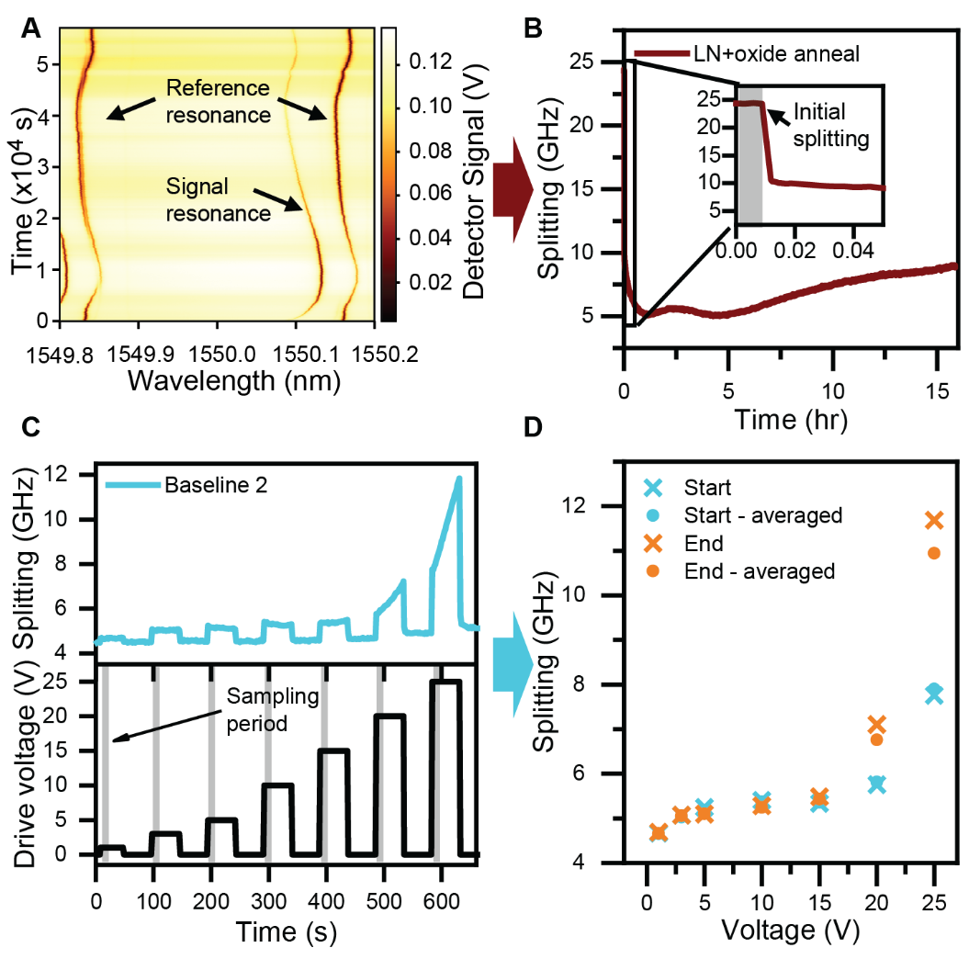
Supplementary Figure 1. Measuring EO response as a function of time and voltage. (A) Raw transmission spectra as a function of time for an example device, showing resonance movement on the unbiased reference resonance(s), likely stemming from room temperature changes (thermo-optic drift). (B) Extracted splitting as a function of time showing this extrinsic common-mode drift can be cancelled out. Here the time axis is shifted to show the initial sampling of the splitting before any bias is applied (inset). For illustrative purposes the higher wavelength reference resonance was used; this makes no difference in the normalized EO response since reference resonances only differ by multiples of the free-spectral range. (C) Concept of measuring EO voltage dependence. (Bottom) drive signal waveform, showing interleaved periods of 0 V to attempt to compensate for memory effects; (top) the corresponding optical mode splittings. At each transition point, a few samples are averaged to extract the splitting. The initial samples before any voltage is applied are taken as the initial splitting. (D) Different EO voltage dependences when sampling at the start or end of a voltage application period, using either a single point estimate or an average (here, over 5 points).
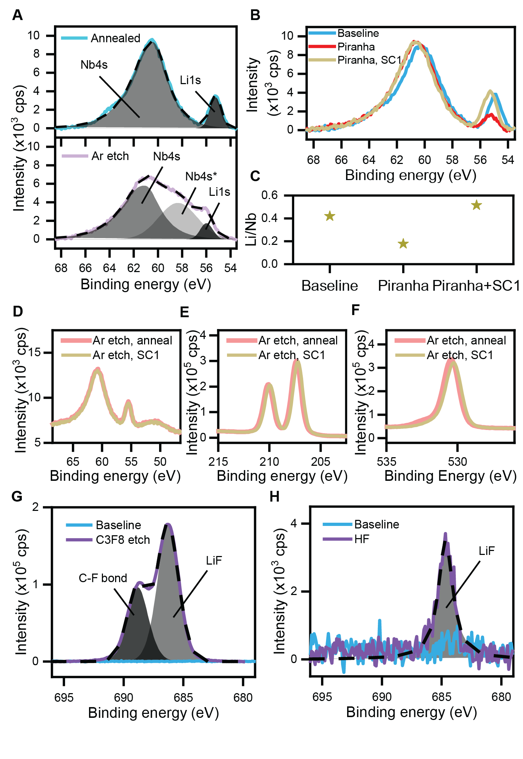
Supplementary Figure 2. Nanofabrication-induced modification of the TFLN surface chemistry. (A) High-resolution Li 1s XPS spectra of (bottom) Ar-etched TFLN compared to (top) an annealed baseline, showing the clear emergence of a broad third peak attributed to lattice damage, labelled Nb 4s*. The Nb 4s line overlaps with the Li 1s line. (B) Piranha solution strips surface Li, evident from the reduced Li 1s peak intensity. Standard chemical cleans such as SC-1 can restore the TFLN surface Li/Nb ratio, indicating that the Li deficiency is localized to the top 6-10 nm etched away by the clean. (C) Corresponding Li/Nb ratios after peak fitting. The baseline and SC-1 cleaned ratios are comparable to those reported in ²⁷. (D-F) XPS spectra without background subtraction of the (D) Li 1s/Nb 4s, (E) Nb 3d, and (F) O 1s lines in Ar-etched TFLN after annealing or cleaning in SC-1, showing restoration of the surface chemistry. (G) XPS spectra of the F 1s line after etching in a C₃F₈-containing reactive ion etch chemistry, showing the emergence of a metal fluoride peak (LiF_{x}) and C-F bonding from gas polymerization. (H) XPS spectra of the F 1s line after exposure to hydrofluoric acid, showing only the LiF_{x} peak.

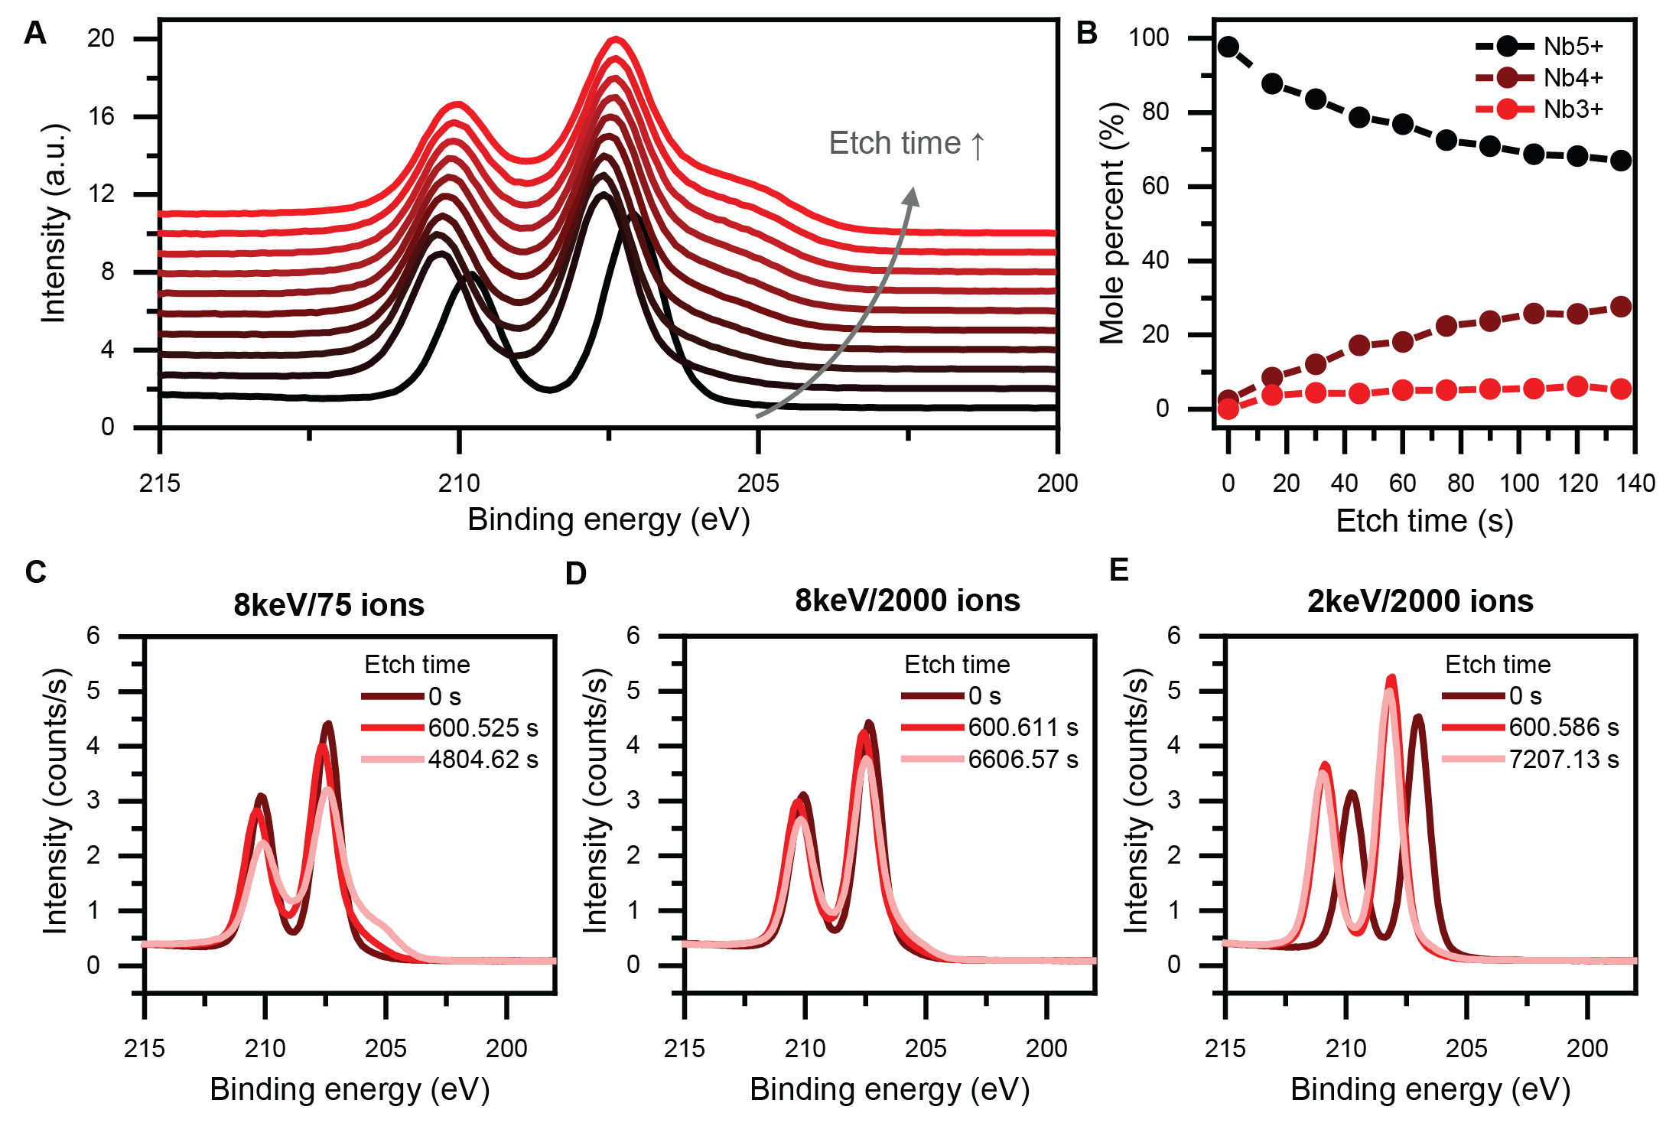
Supplementary Figure 3. Surface reduction of lithium niobate under different Ar ion milling conditions. (A) Waterfall plot of the Nb 3d XPS line with increasing etch time in a 4 keV single ion milling configuration, showing the emergence of side lobes characteristic of lower Nb oxidation states. (B) Corresponding reduced fraction of total niobium concentration [Nb^{x}]/[Nb] as a function of etch time. Identical scattering cross-sections are assumed for all the Nb oxidation states. (C-E) Nb 3d XPS lines after in-situ cluster ion milling with (C) 8 keV across 75 ions, (D) 8 keV across 2000 ions, and (E) 2 keV across 2000 ions. Slight reduction is seen for as low energies as 4 eV per ion (8keV/2000 ions). Negligible etching is seen for both the 8keV/2000 ions and 2keV/2000 ions conditions.

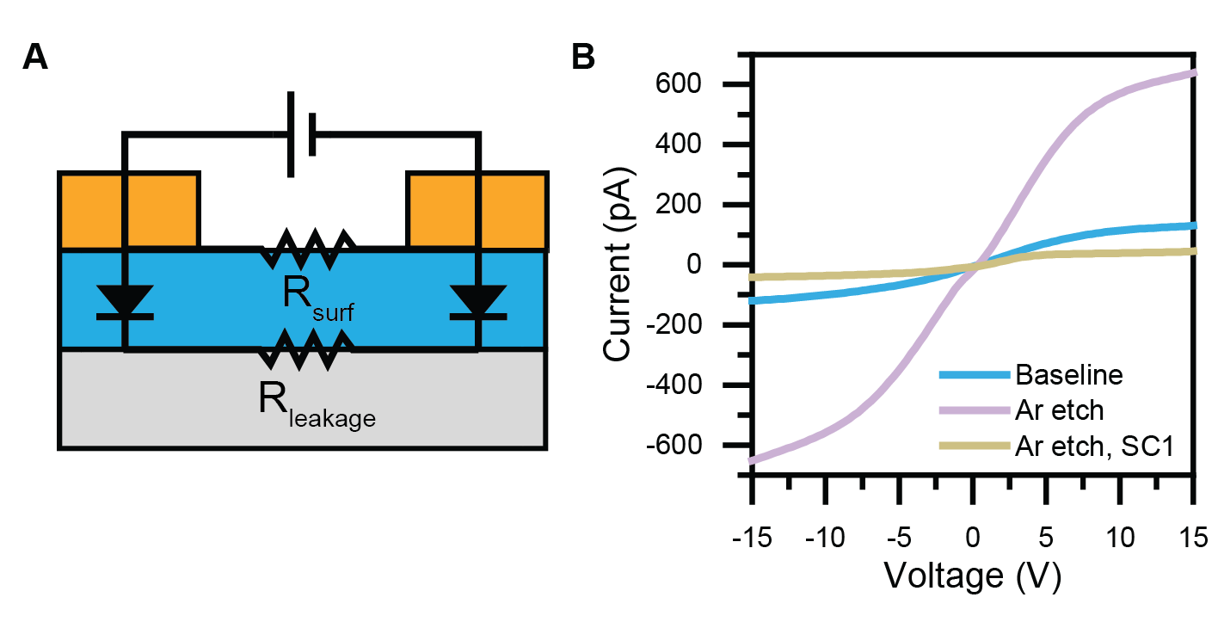
Supplementary Figure 4. Altered contact potential barriers in blanket-processed TFLN samples. (A) Circuit schematic for I-V measurements on blanket-processed TFLN, without any waveguide patterning by e-beam lithography. A surface shunt resistor has been added to model alternate conductivity paths that lead to deviation from perfect current saturation at high voltages. (B) I-V curves for a baseline sample that has only undergone solvent cleaning in acetone and isopropanol, compared to an Ar-ion etched sample with and without additional cleaning in SC-1 to remove the surface damage layer. No samples have undergone thermal annealing. The saturation current is clearly higher in the Ar-etched sample, indicating the partial elimination of dangling bonds or other trap states that could be pinning the contact barrier. Interestingly, after cleaning off the top layer the saturation current is even lower than the baseline sample, suggesting that “cleaner” interfaces do not necessarily lead to greater electronic transmission.

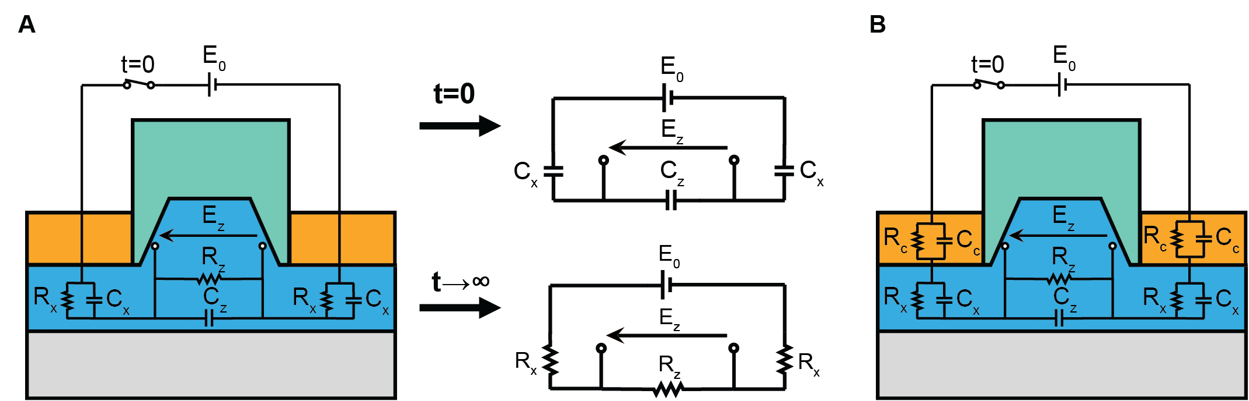
Supplementary Figure 5. Modeling inhomogeneities with RC-ladder network circuits. (A) Circuit schematic for a RC-ladder network supporting a single time constant, characterized by N=2 unique blocks RC blocks. At t=0, the voltage is determined by capacitive voltage division (i.e. by the relative dielectric constants). At t→∞, the voltage is determined by resistive voltage division (i.e. by the relative conductivities). This analysis is only valid if all elements in the circuit are linear, including the electrical connection between the drive and the RC-ladder network. (B) Circuit schematic for a RC-ladder network supporting two time constants, characterized by N=3 unique blocks RC blocks. These trends hold for higher values of N, for example originating from contact impedance R_{c}-C_{c} or from a defect layer.

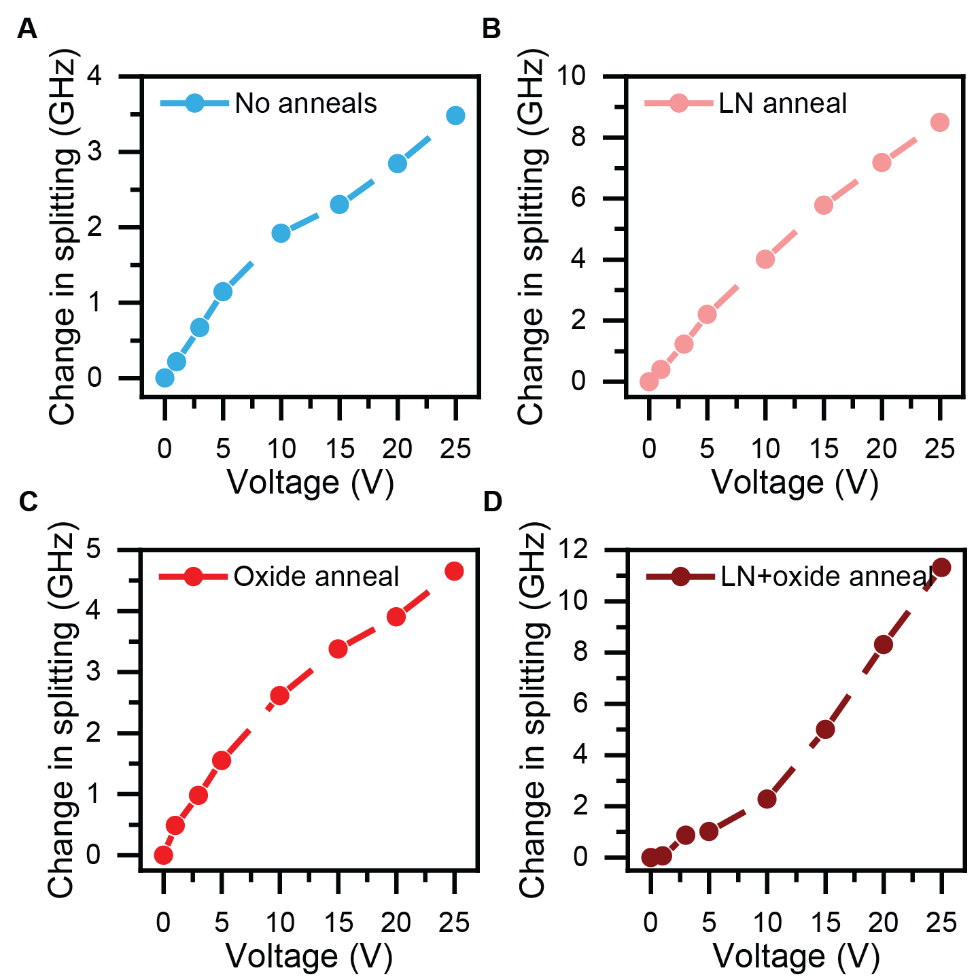
Supplementary Figure 6. Maintained linearity of Ar-etched contacts under different annealing conditions. (A-D) EO voltage dependence for TFLN modulators with SiO₂ top cladding that have experienced (A) no anneals, (B) only the LN anneal, (C) only the oxide anneal, and (D) both the LN and oxide anneals, prior to contact formation. Regardless of bulk conductivity changes incurred by different combinations of thermal annealing, (quasi)linearity is maintained in the EO response.

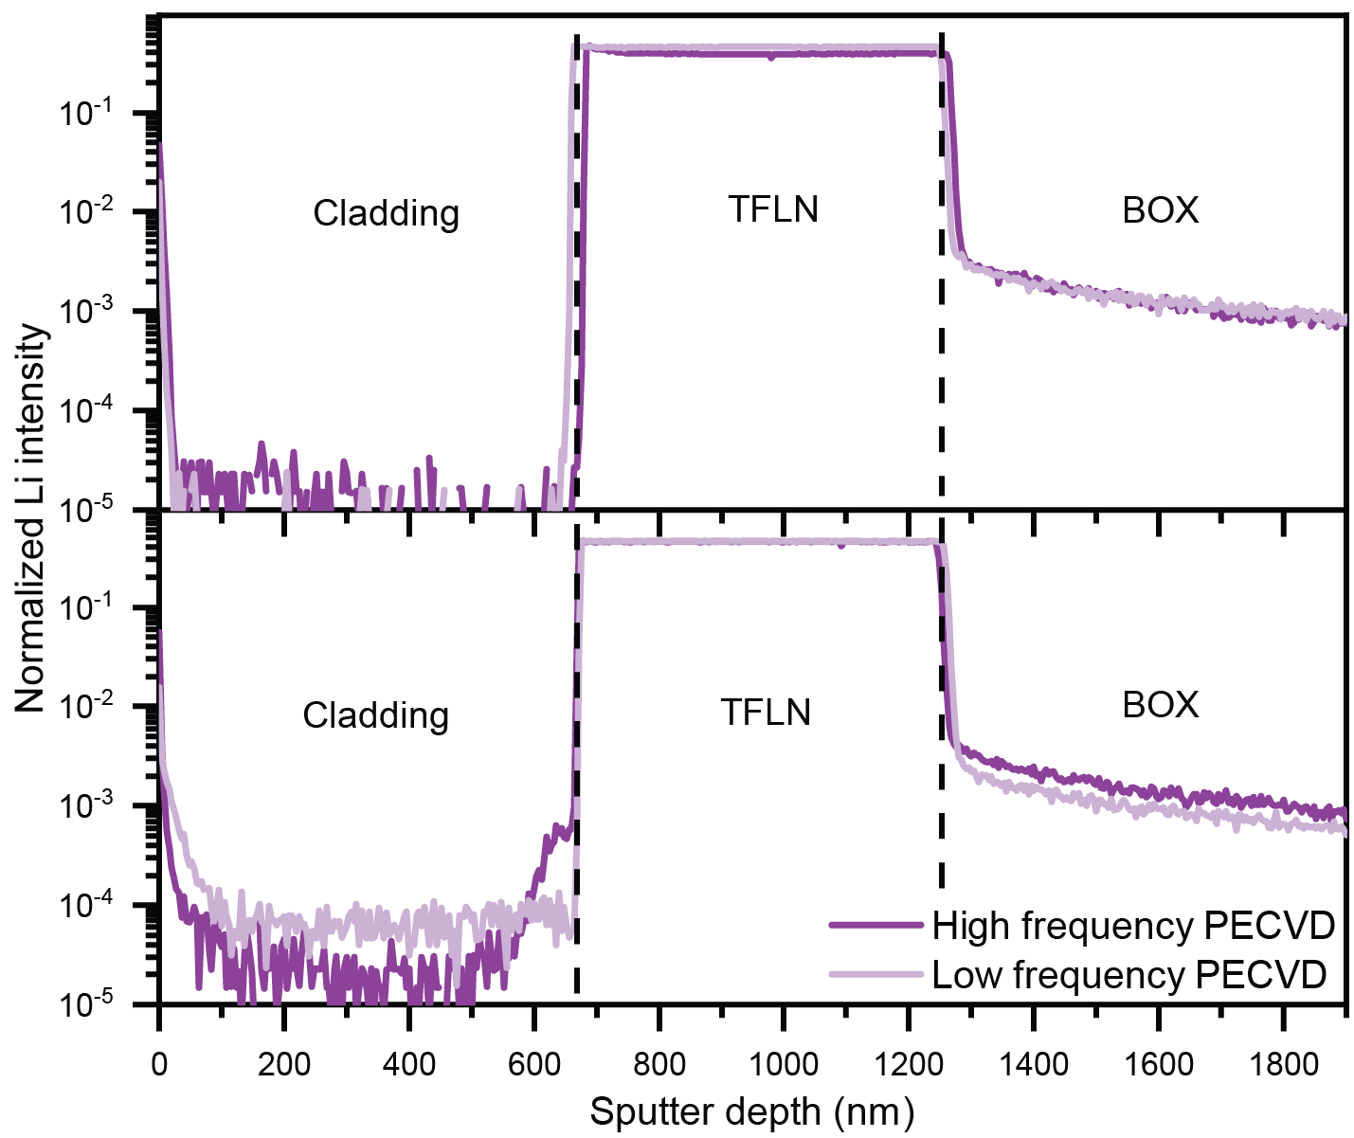
Supplementary Figure 7. Influence of cladding oxide deposition conditions on Li diffusion. SIMS traces showing the Li distribution in oxide-cladded samples (top) before annealing in the presence of cladding oxide, and (bottom) after annealing. The oxides examined were deposited by PECVD using either high frequency (13.56 MHz) or low-frequency (380 kHz) power supplies. Low-frequency PECVD oxide is less dense and exhibits a lithium distribution markedly different from high-frequency oxide, with an overall higher concentration throughout.

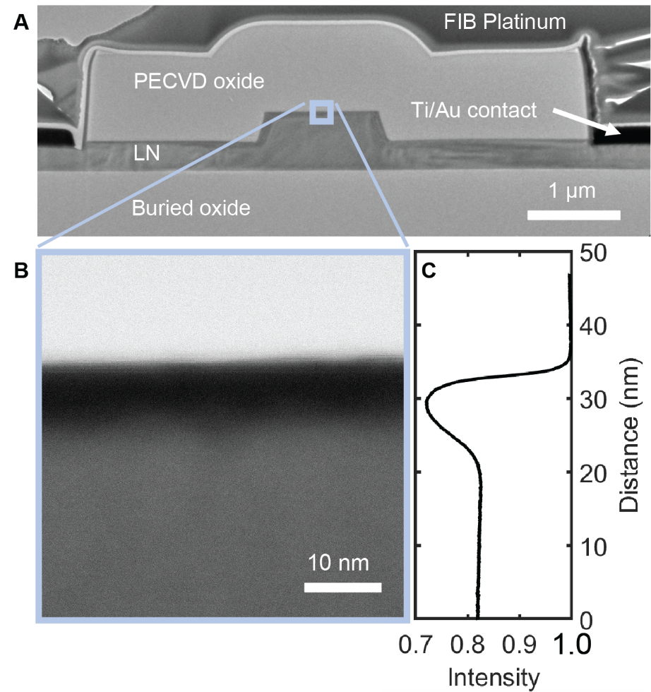
Supplementary Figure 8. Electron microscopy of the cladding-LN interface. (A) Scanning electron microscopy image of a cladded TFLN modulator cross-section that has experienced the oxide anneal. (B) Bright-field scanning transmission electron microscopy (STEM) zoomed into the boxed region in (A), showing a change in contrast at the interface between the cladding silica and the TFLN top surface. (C) Intensity profile vs depth extracted from the STEM imaging. Greater intensity (darker region in image) corresponds to higher mass density, which in TFLN is associated with Li vacancies.

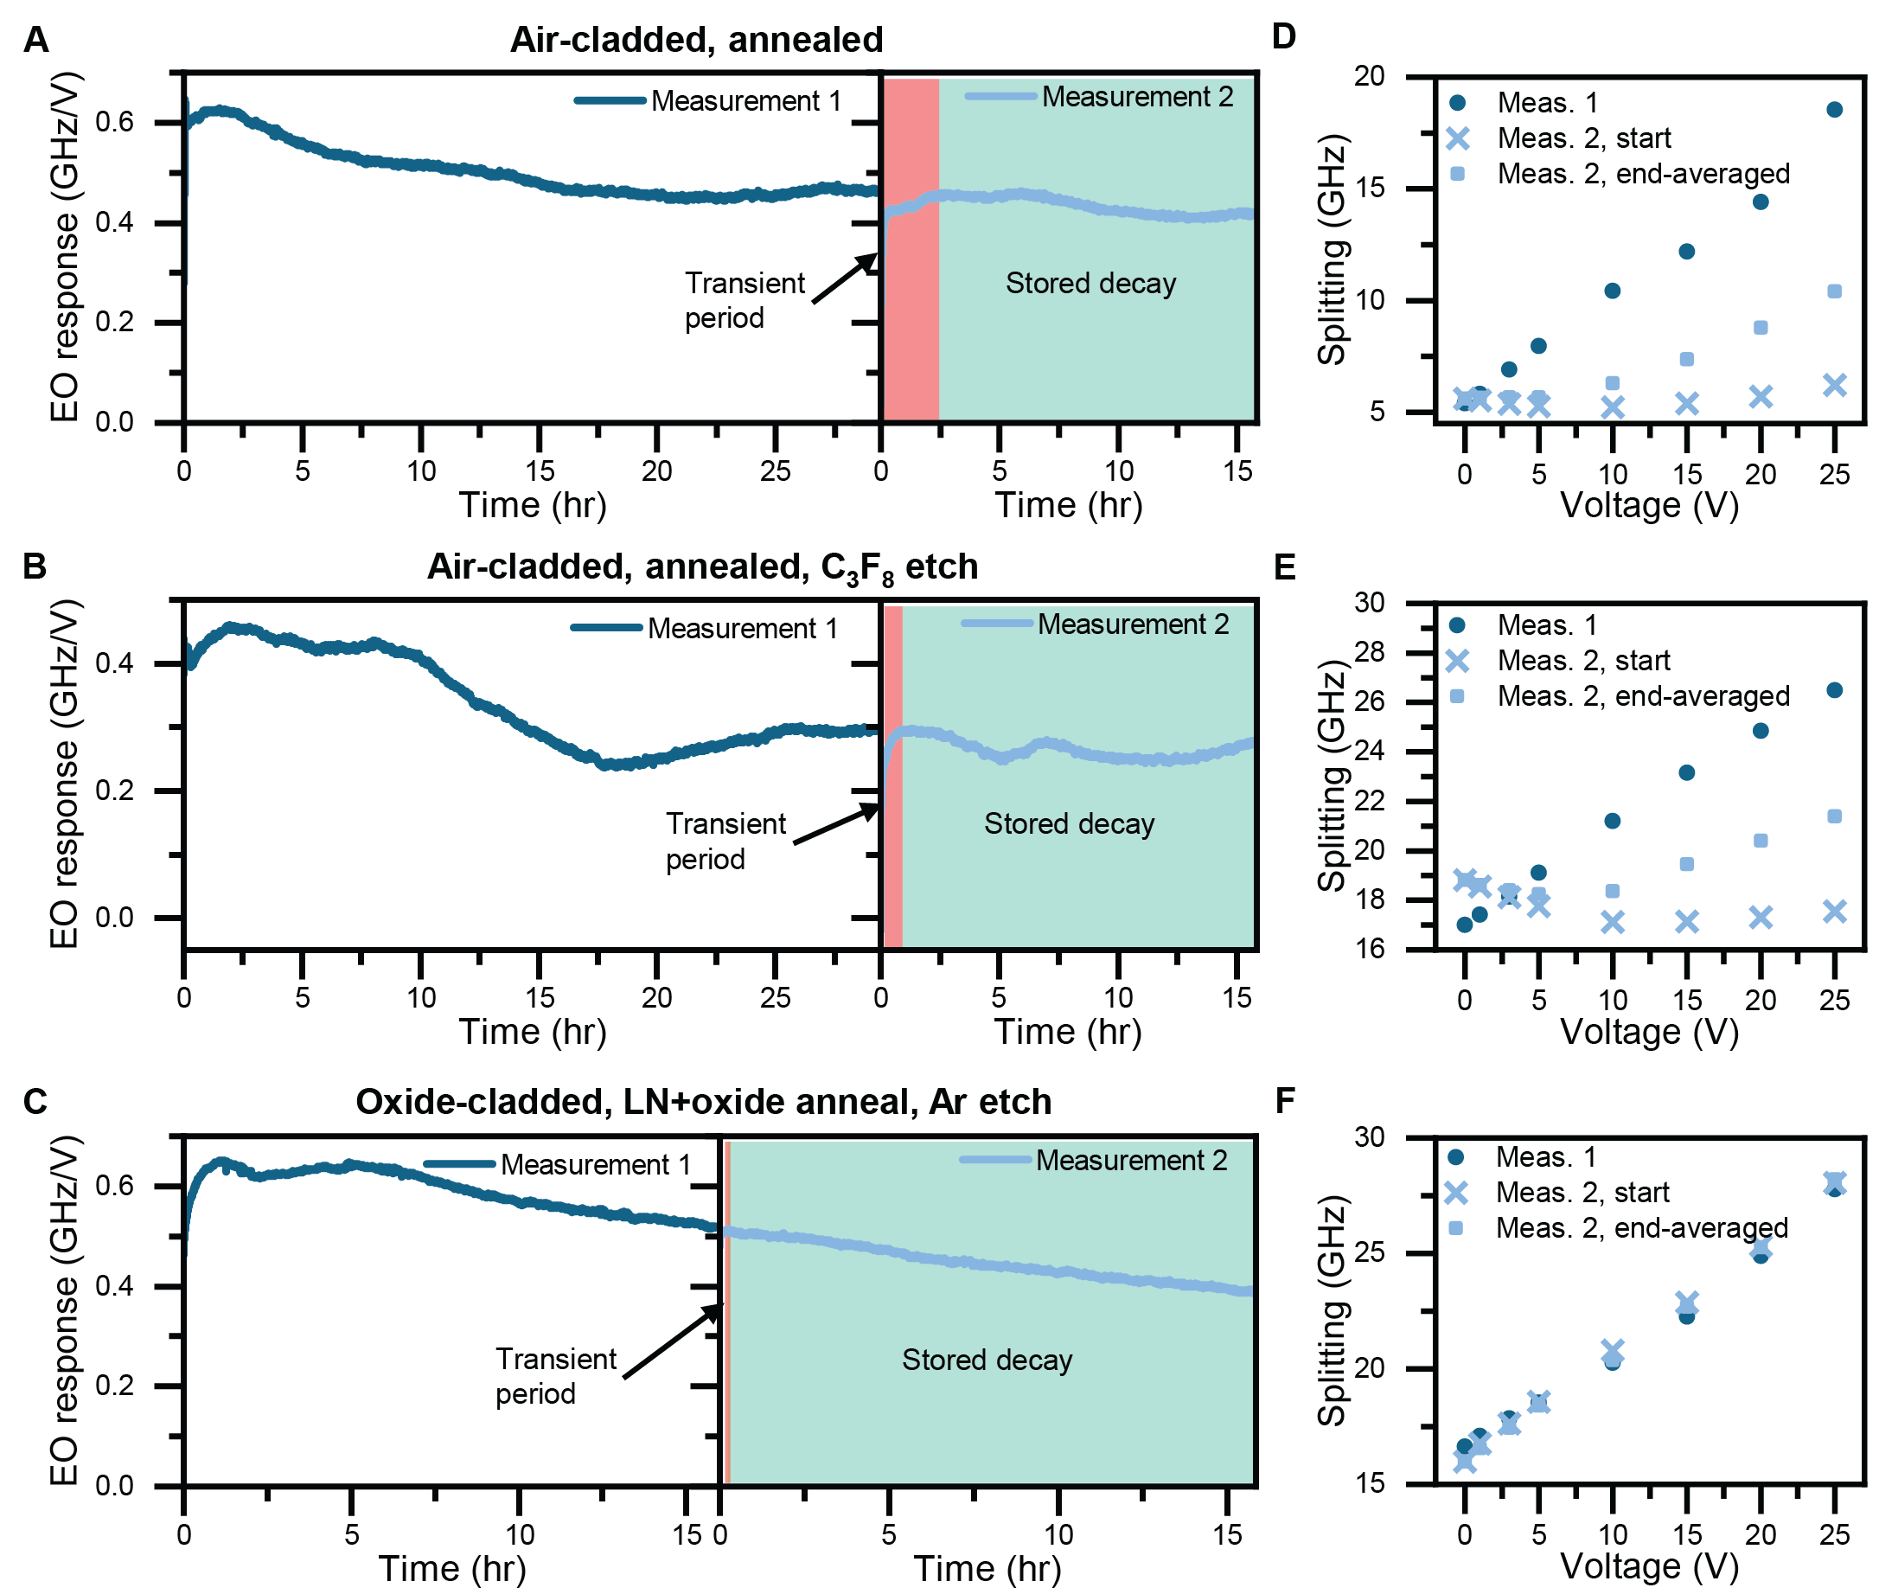Supplementary Figure 9. Hysteresis phenomena in TFLN electro-optics. (A-C) Consecutive dc drift measurements showing hysteresis occurring in the form of a stored decay across TFLN sample processing conditions, including (A) baseline air-cladded and annealed, (B) air-cladded, annealed, and C₃F₈-etched, and (C) oxide-cladded, LN+oxide annealed, and Ar-etched samples. Stored decay refers to dc drift that trends similar in magnitude to the final behavior of the previous drift, instead of reproducing the initial behavior. This occurs after an initial transient recovery period, whose duration we are currently unable to predict. All measurements occur <1 hour after the conclusion of the prior measurement. (D-F) EO voltage dependence before and after dc drift measurement for (D) baseline air-cladded and annealed, (E) air-cladded, annealed, and C₃F₈-etched, and (F) oxide-cladded, LN+oxide annealed, and Ar-etched samples. Characteristic phenomena include level shifting of the initial splitting and threshold shifting, possibly from stored charge. To summarize transients, Measurement 2 curves are plotted using both a single-point estimate immediately after voltage application (“Meas. 2, start”), and a 5-point average after ~30s (“Meas. 2, end-averaged”). Both baseline and C₃F₈-etched samples display unintuitive initial behavior that is non-monotonic with voltage and instead shifts the opposite direction predicted by the electro-optic effect.

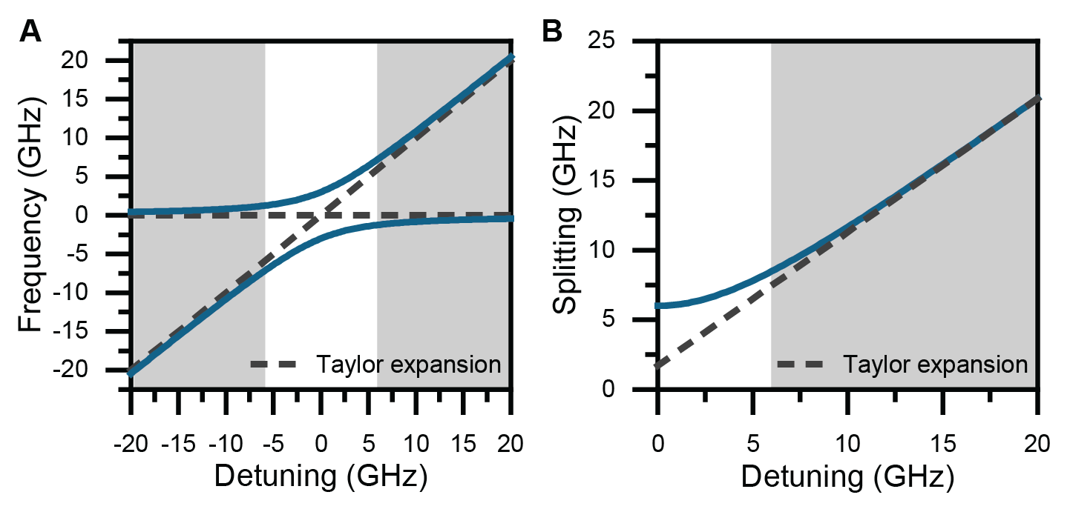
Supplementary Figure 10. Linearity of optical mode splitting in coupled ring resonators. (A-B) Simulated (A) avoided crossing and (B) optical mode splitting for characteristic parameters of our rings (FSR=40 GHz, 2µ=6 GHz). Grey regions indicate the operating regions of our experiments, where the behavior is well matched by a linear approximation.

