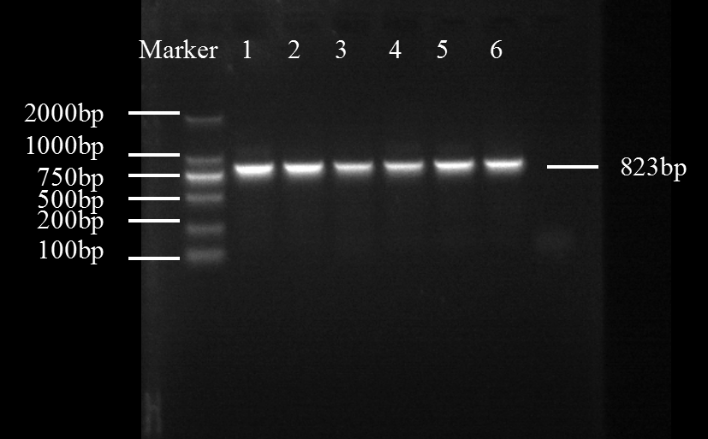
Fig.S1 Agarose gel electrophoresis of PCR products of ace gene for housefly

