Appendix 1: Saudi male height data synthesized from Noorwali and Aljaadi's [37] Review of anthropometric studies.
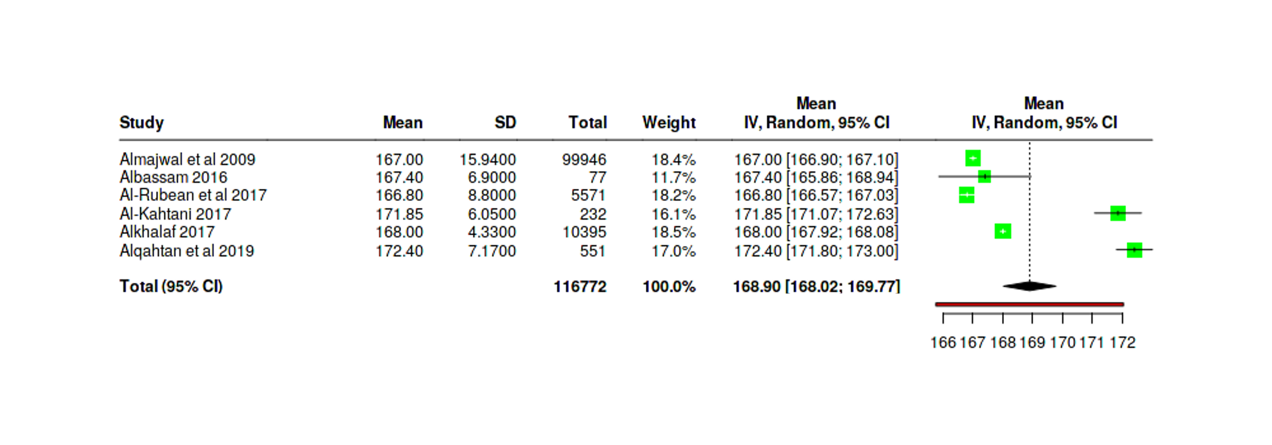

Appendix 2: Saudi female height data synthesized from Noorwali and Aljaadi's [37] Review of anthropometric studies.
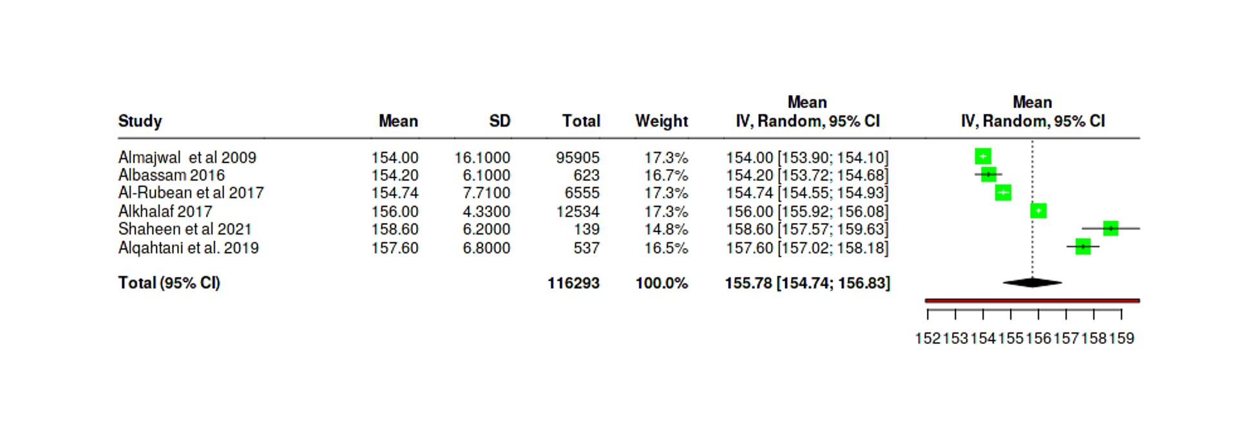

Appendix 3: Analysis of differences between targeted heights from previous Saudi studies and the reference range of the Saudi height from Mohammad El-Mouzan et al [28].
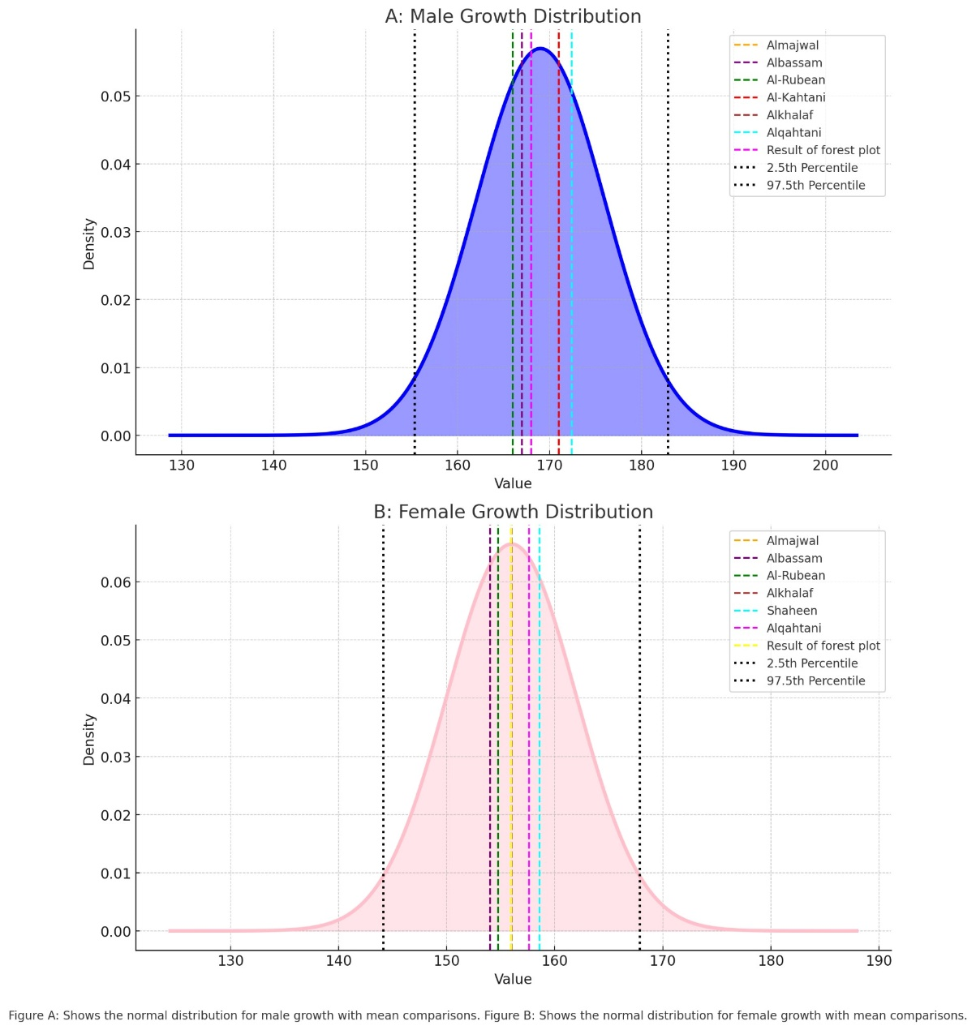

Appendix 4. Energy requirement reference range for Saudi infant
Age (months) | Energy requirement for Saudi boys  (kcal/d) |  |  |  |  |  |  |  |  |  | Energy requirement for Saudi girls  (kcal/d)
Age (months) | 2.5th percentile | 5th percentile | 10th percentile | 25th percentile | 50th percentile | 75th percentile | 90th percentile | 95th percentile | 97.5th percentile |  | 2.5th percentile | 5th percentile | 10th percentile | 25th percentile | 50th percentile | 75th percentile | 90th percentile | 95th percentile | 97.5th percentile
0 | 274 | 289 | 303 | 348 | 393 | 423 | 468 | 497 | 527 |  | 260 | 275 | 289 | 319 | 364 | 409 | 454 | 484 | 499
1 | 341 | 358 | 376 | 429 | 482 | 517 | 570 | 605 | 640 |  | 321 | 339 | 356 | 391 | 444 | 497 | 549 | 584 | 602
2 | 342 | 360 | 378 | 431 | 484 | 519 | 572 | 607 | 643 |  | 360 | 379 | 398 | 436 | 494 | 551 | 609 | 647 | 666
3 | 411 | 432 | 452 | 513 | 574 | 615 | 677 | 717 | 758 |  | 392 | 412 | 433 | 474 | 535 | 596 | 658 | 699 | 719
4 | 386 | 406 | 425 | 484 | 542 | 581 | 639 | 678 | 717 |  | 409 | 430 | 452 | 494 | 557 | 621 | 685 | 727 | 748
5 | 406 | 426 | 446 | 507 | 567 | 608 | 669 | 709 | 749 |  | 415 | 436 | 458 | 500 | 565 | 629 | 693 | 736 | 758
6 | 439 | 461 | 482 | 547 | 612 | 655 | 720 | 763 | 806 |  | 449 | 472 | 495 | 540 | 609 | 678 | 746 | 792 | 815
7 | 457 | 479 | 501 | 568 | 634 | 679 | 746 | 790 | 835 |  | 447 | 470 | 493 | 538 | 607 | 675 | 744 | 789 | 812
8 | 490 | 514 | 537 | 608 | 679 | 726 | 797 | 844 | 891 |  | 463 | 487 | 510 | 557 | 627 | 698 | 768 | 815 | 838
9 | 503 | 527 | 551 | 623 | 695 | 743 | 816 | 864 | 912 |  | 507 | 532 | 557 | 608 | 684 | 759 | 835 | 886 | 911
10 | 545 | 571 | 597 | 674 | 752 | 803 | 881 | 932 | 984 |  | 522 | 548 | 574 | 626 | 703 | 781 | 859 | 910 | 936
11 | 559 | 585 | 611 | 690 | 769 | 822 | 901 | 954 | 1006 |  | 530 | 556 | 582 | 635 | 713 | 792 | 871 | 923 | 949
12 | 565 | 592 | 618 | 698 | 778 | 831 | 911 | 964 | 1017 |  | 556 | 584 | 611 | 666 | 748 | 830 | 912 | 966 | 993

Appendix 5. Energy requirement reference range for Saudi children and adolescents
Age (Years) | Energy requirement for Saudi boys  (kcal/d) |  |  |  |  |  |  |  |  |  | Energy requirement for Saudi girls  (kcal/d)
Age (Years) | 2.5th Percentile | 5th Percentile | 10th Percentile | 25th Percentile | 50th Percentile | 75th Percentile | 90th Percentile | 95th Percentile | 97.5th Percentile |  | 2.5th Percentile | 5th Percentile | 10th Percentile | 25th Percentile | 50th Percentile | 75th Percentile | 90th Percentile | 95th Percentile | 97.5th Percentile
1 | 771 | 789 | 806 | 860 | 912 | 947 | 999 | 1034 | 1068 |  | 719 | 737 | 755 | 790 | 843 | 895 | 946 | 980 | 996
2 | 874 | 895 | 917 | 981 | 1045 | 1087 | 1149 | 1191 | 1232 |  | 817 | 839 | 860 | 903 | 965 | 1027 | 1088 | 1127 | 1147
3 | 954 | 977 | 1006 | 1063 | 1125 | 1213 | 1286 | 1330 | 1356 |  | 876 | 892 | 927 | 983 | 1049 | 1124 | 1203 | 1412 | 1280
4 | 1015 | 1044 | 1073 | 1148 | 1233 | 1321 | 1403 | 1458 | 1489 |  | 931 | 942 | 993 | 1052 | 1144 | 1227 | 1301 | 1333 | 1395
5 | 1071 | 1100 | 1146 | 1228 | 1319 | 1423 | 1532 | 1589 | 1643 |  | 992 | 1021 | 1069 | 1138 | 1225 | 1326 | 1423 | 1485 | 1535
6 | 1153 | 1180 | 1207 | 1319 | 1429 | 1535 | 1639 | 1745 | 1795 |  | 1039 | 1066 | 1148 | 1197 | 1352 | 1447 | 1537 | 1628 | 1669
7 | 1206 | 1234 | 1321 | 1370 | 1535 | 1695 | 1795 | 1893 | 1995 |  | 1122 | 1159 | 1196 | 1355 | 1444 | 1584 | 1716 | 1795 | 1834
8 | 1261 | 1319 | 1370 | 1511 | 1666 | 1844 | 1995 | 2141 | 2181 |  | 1199 | 1223 | 1246 | 1402 | 1534 | 1710 | 1828 | 1984 | 2018
9 | 1376 | 1400 | 1482 | 1641 | 1792 | 2016 | 2232 | 2364 | 2455 |  | 1246 | 1298 | 1403 | 1539 | 1669 | 1871 | 2018 | 2144 | 2174
10 | 1423 | 1479 | 1587 | 1739 | 1995 | 2229 | 2450 | 2620 | 2700 |  | 1350 | 1423 | 1540 | 1669 | 1834 | 2012 | 2208 | 2312 | 2365
11 | 1535 | 1587 | 1689 | 1893 | 2130 | 2426 | 2700 | 2852 | 2966 |  | 1520 | 1537 | 1645 | 1789 | 2018 | 2208 | 2359 | 2442 | 2522
12 | 1638 | 1689 | 1844 | 2037 | 2315 | 2657 | 2925 | 3104 | 3239 |  | 1624 | 1669 | 1792 | 1943 | 2174 | 2331 | 2501 | 2576 | 2601
13 | 1739 | 1844 | 1989 | 2226 | 2533 | 2846 | 3169 | 3359 | 3472 |  | 1750 | 1834 | 1902 | 2077 | 2276 | 2437 | 2576 | 2618 | 2641
14 | 1947 | 1989 | 2181 | 2402 | 2733 | 2860 | 3348 | 3545 | 3642 |  | 1865 | 1938 | 2026 | 2196 | 2370 | 2520 | 2606 | 2632 | 2632
15 | 2083 | 2181 | 2309 | 2615 | 2919 | 3250 | 3513 | 3936 | 3793 |  | 1932 | 2001 | 2100 | 2255 | 2405 | 2548 | 2619 | 2622 | 2610
16 | 2220 | 2055 | 2486 | 2721 | 3053 | 3371 | 3660 | 3750 | 3896 |  | 2001 | 2028 | 2157 | 2287 | 2460 | 2563 | 2615 | 2615 | 2592
17 | 2304 | 2443 | 2557 | 2835 | 3147 | 3476 | 3749 | 3890 | 3967 |  | 1990 | 2022 | 2179 | 2308 | 2467 | 2581 | 2617 | 2600 | 2570
18 | 2414 | 2519 | 2660 | 2944 | 3241 | 3563 | 3812 | 3947 | 4012 |  | 2028 | 2097 | 2174 | 2331 | 2482 | 2583 | 2611 | 2588 | 2550

Appendix 6. Energy requirement reference range for Saudi sedentary adult
age (years) | Energy requirement for Saudi males  (kcal/d) |  |  |  |  |  |  |  |  |  | Energy requirement for Saudi females  (kcal/d)
age (years) | 2.5th Percentile | 5th Percentile | 10th Percentile | 25th Percentile | 50th Percentile | 75th Percentile | 90th Percentile | 95th Percentile | 97.5th Percentile |  | 2.5th Percentile | 5th Percentile | 10th Percentile | 25th Percentile | 50th Percentile | 75th Percentile | 90th Percentile | 95th Percentile | 97.5th Percentile
18 | 1512.6 | 1552.8 | 1594.0 | 1664.6 | 1743.8 | 1823.8 | 1896.2 | 1932.8 | 1980.2 |  | 1200.0 | 1230.2 | 1264.5 | 1322.0 | 1387.5 | 1453.4 | 1513.5 | 1549.8 | 1581.5
19 | 1508.1 | 1548.3 | 1589.5 | 1660.0 | 1739.3 | 1819.3 | 1891.7 | 1928.3 | 1975.6 |  | 1195.5 | 1225.6 | 1259.9 | 1317.5 | 1383.0 | 1448.9 | 1509.0 | 1545.3 | 1577.0
20 | 1503.5 | 1543.7 | 1584.9 | 1655.5 | 1734.8 | 1814.8 | 1887.2 | 1923.8 | 1971.1 |  | 1191.0 | 1221.1 | 1255.4 | 1312.9 | 1378.4 | 1444.3 | 1504.4 | 1540.8 | 1572.5
21 | 1499.0 | 1539.2 | 1580.4 | 1651.0 | 1730.3 | 1810.2 | 1882.7 | 1919.2 | 1966.6 |  | 1186.4 | 1216.6 | 1250.9 | 1308.4 | 1373.9 | 1439.8 | 1499.9 | 1536.2 | 1567.9
22 | 1494.5 | 1534.7 | 1575.9 | 1646.5 | 1725.7 | 1805.7 | 1878.1 | 1914.7 | 1962.1 |  | 1181.9 | 1212.1 | 1246.4 | 1303.9 | 1369.4 | 1435.3 | 1495.4 | 1531.7 | 1563.4
23 | 1490.0 | 1530.2 | 1571.4 | 1641.9 | 1721.2 | 1801.2 | 1873.6 | 1910.2 | 1957.5 |  | 1177.4 | 1207.5 | 1241.8 | 1299.4 | 1364.9 | 1430.8 | 1490.9 | 1527.2 | 1558.9
24 | 1485.4 | 1525.6 | 1566.8 | 1637.4 | 1716.7 | 1796.7 | 1869.1 | 1905.7 | 1953.0 |  | 1172.9 | 1203.0 | 1237.3 | 1294.8 | 1360.3 | 1426.2 | 1486.3 | 1522.7 | 1554.4
25 | 1480.9 | 1521.1 | 1562.3 | 1632.9 | 1712.2 | 1792.1 | 1864.6 | 1901.1 | 1948.5 |  | 1168.3 | 1198.5 | 1232.8 | 1290.3 | 1355.8 | 1421.7 | 1481.8 | 1518.1 | 1549.8
26 | 1476.4 | 1516.6 | 1557.8 | 1628.4 | 1707.6 | 1787.6 | 1860.0 | 1896.6 | 1944.0 |  | 1163.8 | 1194.0 | 1228.3 | 1285.8 | 1351.3 | 1417.2 | 1477.3 | 1513.6 | 1545.3
27 | 1471.9 | 1512.1 | 1553.3 | 1623.8 | 1703.1 | 1783.1 | 1855.5 | 1892.1 | 1939.4 |  | 1159.3 | 1189.4 | 1223.7 | 1281.3 | 1346.8 | 1412.7 | 1472.8 | 1509.1 | 1540.8
28 | 1467.3 | 1507.5 | 1548.7 | 1619.3 | 1698.6 | 1778.6 | 1851.0 | 1887.6 | 1934.9 |  | 1154.8 | 1184.9 | 1219.2 | 1276.7 | 1342.2 | 1408.1 | 1468.2 | 1504.6 | 1536.3
29 | 1462.8 | 1503.0 | 1544.2 | 1614.8 | 1694.1 | 1774.0 | 1846.5 | 1883.0 | 1930.4 |  | 1150.2 | 1180.4 | 1214.7 | 1272.2 | 1337.7 | 1403.6 | 1463.7 | 1500.0 | 1531.7
30 | 1458.3 | 1498.5 | 1539.7 | 1610.3 | 1689.5 | 1769.5 | 1841.9 | 1878.5 | 1925.9 |  | 1145.7 | 1175.9 | 1210.2 | 1267.7 | 1333.2 | 1399.1 | 1459.2 | 1495.5 | 1527.2
31 | 1453.8 | 1494.0 | 1535.2 | 1605.7 | 1685.0 | 1765.0 | 1837.4 | 1874.0 | 1921.3 |  | 1141.2 | 1171.3 | 1205.6 | 1263.2 | 1328.7 | 1394.6 | 1454.7 | 1491.0 | 1522.7
32 | 1449.2 | 1489.4 | 1530.6 | 1601.2 | 1680.5 | 1760.5 | 1832.9 | 1869.5 | 1916.8 |  | 1136.7 | 1166.8 | 1201.1 | 1258.6 | 1324.1 | 1390.0 | 1450.1 | 1486.5 | 1518.2
33 | 1444.7 | 1484.9 | 1526.1 | 1596.7 | 1676.0 | 1755.9 | 1828.4 | 1864.9 | 1912.3 |  | 1132.1 | 1162.3 | 1196.6 | 1254.1 | 1319.6 | 1385.5 | 1445.6 | 1481.9 | 1513.6
34 | 1440.2 | 1480.4 | 1521.6 | 1592.2 | 1671.4 | 1751.4 | 1823.8 | 1860.4 | 1907.8 |  | 1127.6 | 1157.8 | 1192.1 | 1249.6 | 1315.1 | 1381.0 | 1441.1 | 1477.4 | 1509.1
35 | 1435.7 | 1475.9 | 1517.1 | 1587.6 | 1666.9 | 1746.9 | 1819.3 | 1855.9 | 1903.2 |  | 1123.1 | 1153.2 | 1187.5 | 1245.1 | 1310.6 | 1376.5 | 1436.6 | 1472.9 | 1504.6
36 | 1431.1 | 1471.3 | 1512.5 | 1583.1 | 1662.4 | 1742.4 | 1814.8 | 1851.4 | 1898.7 |  | 1118.6 | 1148.7 | 1183.0 | 1240.5 | 1306.0 | 1371.9 | 1432.0 | 1468.4 | 1500.1
37 | 1426.6 | 1466.8 | 1508.0 | 1578.6 | 1657.9 | 1737.8 | 1810.3 | 1846.8 | 1894.2 |  | 1114.0 | 1144.2 | 1178.5 | 1236.0 | 1301.5 | 1367.4 | 1427.5 | 1463.8 | 1495.5
38 | 1422.1 | 1462.3 | 1503.5 | 1574.1 | 1653.3 | 1733.3 | 1805.7 | 1842.3 | 1889.7 |  | 1109.5 | 1139.7 | 1174.0 | 1231.5 | 1297.0 | 1362.9 | 1423.0 | 1459.3 | 1491.0
39 | 1417.6 | 1457.8 | 1499.0 | 1569.5 | 1648.8 | 1728.8 | 1801.2 | 1837.8 | 1885.1 |  | 1105.0 | 1135.1 | 1169.4 | 1227.0 | 1292.5 | 1358.4 | 1418.5 | 1454.8 | 1486.5
40 | 1413.0 | 1453.2 | 1494.4 | 1565.0 | 1644.3 | 1724.3 | 1796.7 | 1833.3 | 1880.6 |  | 1100.5 | 1130.6 | 1164.9 | 1222.4 | 1287.9 | 1353.8 | 1413.9 | 1450.3 | 1482.0
41 | 1408.5 | 1448.7 | 1489.9 | 1560.5 | 1639.8 | 1719.7 | 1792.2 | 1828.7 | 1876.1 |  | 1095.9 | 1126.1 | 1160.4 | 1217.9 | 1283.4 | 1349.3 | 1409.4 | 1445.7 | 1477.4
42 | 1404.0 | 1444.2 | 1485.4 | 1556.0 | 1635.2 | 1715.2 | 1787.6 | 1824.2 | 1871.6 |  | 1091.4 | 1121.6 | 1155.9 | 1213.4 | 1278.9 | 1344.8 | 1404.9 | 1441.2 | 1472.9
43 | 1399.5 | 1439.7 | 1480.9 | 1551.4 | 1630.7 | 1710.7 | 1783.1 | 1819.7 | 1867.0 |  | 1086.9 | 1117.0 | 1151.3 | 1208.9 | 1274.4 | 1340.3 | 1400.4 | 1436.7 | 1468.4
44 | 1394.9 | 1435.1 | 1476.3 | 1546.9 | 1626.2 | 1706.2 | 1778.6 | 1815.2 | 1862.5 |  | 1082.4 | 1112.5 | 1146.8 | 1204.3 | 1269.8 | 1335.7 | 1395.8 | 1432.2 | 1463.9
45 | 1390.4 | 1430.6 | 1471.8 | 1542.4 | 1621.7 | 1701.6 | 1774.1 | 1810.6 | 1858.0 |  | 1077.8 | 1108.0 | 1142.3 | 1199.8 | 1265.3 | 1331.2 | 1391.3 | 1427.6 | 1459.3
46 | 1385.9 | 1426.1 | 1467.3 | 1537.9 | 1617.1 | 1697.1 | 1769.5 | 1806.1 | 1853.5 |  | 1073.3 | 1103.5 | 1137.8 | 1195.3 | 1260.8 | 1326.7 | 1386.8 | 1423.1 | 1454.8
47 | 1381.4 | 1421.6 | 1462.8 | 1533.3 | 1612.6 | 1692.6 | 1765.0 | 1801.6 | 1848.9 |  | 1068.8 | 1098.9 | 1133.2 | 1190.8 | 1256.3 | 1322.2 | 1382.3 | 1418.6 | 1450.3
48 | 1376.8 | 1417.0 | 1458.2 | 1528.8 | 1608.1 | 1688.1 | 1760.5 | 1797.1 | 1844.4 |  | 1064.3 | 1094.4 | 1128.7 | 1186.2 | 1251.7 | 1317.6 | 1377.7 | 1414.1 | 1445.8
49 | 1372.3 | 1412.5 | 1453.7 | 1524.3 | 1603.6 | 1683.5 | 1756.0 | 1792.5 | 1839.9 |  | 1059.7 | 1089.9 | 1124.2 | 1181.7 | 1247.2 | 1313.1 | 1373.2 | 1409.5 | 1441.2
50 | 1367.8 | 1408.0 | 1449.2 | 1519.8 | 1599.0 | 1679.0 | 1751.4 | 1788.0 | 1835.4 |  | 1055.2 | 1085.4 | 1119.7 | 1177.2 | 1242.7 | 1308.6 | 1368.7 | 1405.0 | 1436.7
51 | 1363.3 | 1403.5 | 1444.7 | 1515.2 | 1594.5 | 1674.5 | 1746.9 | 1783.5 | 1830.8 |  | 1050.7 | 1080.8 | 1115.1 | 1172.7 | 1238.2 | 1304.1 | 1364.2 | 1400.5 | 1432.2
52 | 1358.7 | 1398.9 | 1440.1 | 1510.7 | 1590.0 | 1670.0 | 1742.4 | 1779.0 | 1826.3 |  | 1046.2 | 1076.3 | 1110.6 | 1168.1 | 1233.6 | 1299.5 | 1359.6 | 1396.0 | 1427.7
53 | 1354.2 | 1394.4 | 1435.6 | 1506.2 | 1585.5 | 1665.4 | 1737.9 | 1774.4 | 1821.8 |  | 1041.6 | 1071.8 | 1106.1 | 1163.6 | 1229.1 | 1295.0 | 1355.1 | 1391.4 | 1423.1
54 | 1349.7 | 1389.9 | 1431.1 | 1501.7 | 1580.9 | 1660.9 | 1733.3 | 1769.9 | 1817.3 |  | 1037.1 | 1067.3 | 1101.6 | 1159.1 | 1224.6 | 1290.5 | 1350.6 | 1386.9 | 1418.6
55 | 1345.2 | 1385.4 | 1426.6 | 1497.1 | 1576.4 | 1656.4 | 1728.8 | 1765.4 | 1812.7 |  | 1032.6 | 1062.7 | 1097.0 | 1154.6 | 1220.1 | 1286.0 | 1346.1 | 1382.4 | 1414.1
56 | 1340.6 | 1380.8 | 1422.0 | 1492.6 | 1571.9 | 1651.9 | 1724.3 | 1760.9 | 1808.2 |  | 1028.1 | 1058.2 | 1092.5 | 1150.0 | 1215.5 | 1281.4 | 1341.5 | 1377.9 | 1409.6
57 | 1336.1 | 1376.3 | 1417.5 | 1488.1 | 1567.4 | 1647.3 | 1719.8 | 1756.3 | 1803.7 |  | 1023.5 | 1053.7 | 1088.0 | 1145.5 | 1211.0 | 1276.9 | 1337.0 | 1373.3 | 1405.0
58 | 1331.6 | 1371.8 | 1413.0 | 1483.6 | 1562.8 | 1642.8 | 1715.2 | 1751.8 | 1799.2 |  | 1019.0 | 1049.2 | 1083.5 | 1141.0 | 1206.5 | 1272.4 | 1332.5 | 1368.8 | 1400.5
59 | 1327.1 | 1367.3 | 1408.5 | 1479.0 | 1558.3 | 1638.3 | 1710.7 | 1747.3 | 1794.6 |  | 1014.5 | 1044.6 | 1078.9 | 1136.5 | 1202.0 | 1267.9 | 1328.0 | 1364.3 | 1396.0
60 | 1322.5 | 1362.7 | 1403.9 | 1474.5 | 1553.8 | 1633.8 | 1706.2 | 1742.8 | 1790.1 |  | 1010.0 | 1040.1 | 1074.4 | 1131.9 | 1197.4 | 1263.3 | 1323.4 | 1359.8 | 1391.5
61 | 1318.0 | 1358.2 | 1399.4 | 1470.0 | 1549.3 | 1629.2 | 1701.7 | 1738.2 | 1785.6 |  | 1005.4 | 1035.6 | 1069.9 | 1127.4 | 1192.9 | 1258.8 | 1318.9 | 1355.2 | 1386.9
62 | 1313.5 | 1353.7 | 1394.9 | 1465.5 | 1544.7 | 1624.7 | 1697.1 | 1733.7 | 1781.1 |  | 1000.9 | 1031.1 | 1065.4 | 1122.9 | 1188.4 | 1254.3 | 1314.4 | 1350.7 | 1382.4
63 | 1309.0 | 1349.2 | 1390.4 | 1460.9 | 1540.2 | 1620.2 | 1692.6 | 1729.2 | 1776.5 |  | 996.4 | 1026.5 | 1060.8 | 1118.4 | 1183.9 | 1249.8 | 1309.9 | 1346.2 | 1377.9
64 | 1304.4 | 1344.6 | 1385.8 | 1456.4 | 1535.7 | 1615.7 | 1688.1 | 1724.7 | 1772.0 |  | 991.9 | 1022.0 | 1056.3 | 1113.8 | 1179.3 | 1245.2 | 1305.3 | 1341.7 | 1373.4
65 | 1299.9 | 1340.1 | 1381.3 | 1451.9 | 1531.2 | 1611.1 | 1683.6 | 1720.1 | 1767.5 |  | 987.3 | 1017.5 | 1051.8 | 1109.3 | 1174.8 | 1240.7 | 1300.8 | 1337.1 | 1368.8
66 | 1295.4 | 1335.6 | 1376.8 | 1447.4 | 1526.6 | 1606.6 | 1679.0 | 1715.6 | 1763.0 |  | 982.8 | 1013.0 | 1047.3 | 1104.8 | 1170.3 | 1236.2 | 1296.3 | 1332.6 | 1364.3
67 | 1290.9 | 1331.1 | 1372.3 | 1442.8 | 1522.1 | 1602.1 | 1674.5 | 1711.1 | 1758.4 |  | 978.3 | 1008.4 | 1042.7 | 1100.3 | 1165.8 | 1231.7 | 1291.8 | 1328.1 | 1359.8
68 | 1286.3 | 1326.5 | 1367.7 | 1438.3 | 1517.6 | 1597.6 | 1670.0 | 1706.6 | 1753.9 |  | 973.8 | 1003.9 | 1038.2 | 1095.7 | 1161.2 | 1227.1 | 1287.2 | 1323.6 | 1355.3
69 | 1281.8 | 1322.0 | 1363.2 | 1433.8 | 1513.1 | 1593.0 | 1665.5 | 1702.0 | 1749.4 |  | 969.2 | 999.4 | 1033.7 | 1091.2 | 1156.7 | 1222.6 | 1282.7 | 1319.0 | 1350.7
70 | 1277.3 | 1317.5 | 1358.7 | 1429.3 | 1508.5 | 1588.5 | 1660.9 | 1697.5 | 1744.9 |  | 964.7 | 994.9 | 1029.2 | 1086.7 | 1152.2 | 1218.1 | 1278.2 | 1314.5 | 1346.2
71 | 1272.8 | 1313.0 | 1354.2 | 1424.7 | 1504.0 | 1584.0 | 1656.4 | 1693.0 | 1740.3 |  | 960.2 | 990.3 | 1024.6 | 1082.2 | 1147.7 | 1213.6 | 1273.7 | 1310.0 | 1341.7
72 | 1268.2 | 1308.4 | 1349.6 | 1420.2 | 1499.5 | 1579.5 | 1651.9 | 1688.5 | 1735.8 |  | 955.7 | 985.8 | 1020.1 | 1077.6 | 1143.1 | 1209.0 | 1269.1 | 1305.5 | 1337.2
73 | 1263.7 | 1303.9 | 1345.1 | 1415.7 | 1495.0 | 1574.9 | 1647.4 | 1683.9 | 1731.3 |  | 951.1 | 981.3 | 1015.6 | 1073.1 | 1138.6 | 1204.5 | 1264.6 | 1300.9 | 1332.6
74 | 1259.2 | 1299.4 | 1340.6 | 1411.2 | 1490.4 | 1570.4 | 1642.8 | 1679.4 | 1726.8 |  | 946.6 | 976.8 | 1011.1 | 1068.6 | 1134.1 | 1200.0 | 1260.1 | 1296.4 | 1328.1
75 | 1254.7 | 1294.9 | 1336.1 | 1406.6 | 1485.9 | 1565.9 | 1638.3 | 1674.9 | 1722.2 |  | 942.1 | 972.2 | 1006.5 | 1064.1 | 1129.6 | 1195.5 | 1255.6 | 1291.9 | 1323.6
76 | 1250.1 | 1290.3 | 1331.5 | 1402.1 | 1481.4 | 1561.4 | 1633.8 | 1670.4 | 1717.7 |  | 937.6 | 967.7 | 1002.0 | 1059.5 | 1125.0 | 1190.9 | 1251.0 | 1287.4 | 1319.1
77 | 1245.6 | 1285.8 | 1327.0 | 1397.6 | 1476.9 | 1556.8 | 1629.3 | 1665.8 | 1713.2 |  | 933.0 | 963.2 | 997.5 | 1055.0 | 1120.5 | 1186.4 | 1246.5 | 1282.8 | 1314.5
78 | 1241.1 | 1281.3 | 1322.5 | 1393.1 | 1472.3 | 1552.3 | 1624.7 | 1661.3 | 1708.7 |  | 928.5 | 958.7 | 993.0 | 1050.5 | 1116.0 | 1181.9 | 1242.0 | 1278.3 | 1310.0
79 | 1236.6 | 1276.8 | 1318.0 | 1388.5 | 1467.8 | 1547.8 | 1620.2 | 1656.8 | 1704.1 |  | 924.0 | 954.1 | 988.4 | 1046.0 | 1111.5 | 1177.4 | 1237.5 | 1273.8 | 1305.5
80 | 1232.0 | 1272.2 | 1313.4 | 1384.0 | 1463.3 | 1543.3 | 1615.7 | 1652.3 | 1699.6 |  | 919.5 | 949.6 | 983.9 | 1041.4 | 1106.9 | 1172.8 | 1232.9 | 1269.3 | 1301.0
81 | 1227.5 | 1267.7 | 1308.9 | 1379.5 | 1458.8 | 1538.7 | 1611.2 | 1647.7 | 1695.1 |  | 914.9 | 945.1 | 979.4 | 1036.9 | 1102.4 | 1168.3 | 1228.4 | 1264.7 | 1296.4
82 | 1223.0 | 1263.2 | 1304.4 | 1375.0 | 1454.2 | 1534.2 | 1606.6 | 1643.2 | 1690.6 |  | 910.4 | 940.6 | 974.9 | 1032.4 | 1097.9 | 1163.8 | 1223.9 | 1260.2 | 1291.9
83 | 1218.5 | 1258.7 | 1299.9 | 1370.4 | 1449.7 | 1529.7 | 1602.1 | 1638.7 | 1686.0 |  | 905.9 | 936.0 | 970.3 | 1027.9 | 1093.4 | 1159.3 | 1219.4 | 1255.7 | 1287.4
84 | 1213.9 | 1254.1 | 1295.3 | 1365.9 | 1445.2 | 1525.2 | 1597.6 | 1634.2 | 1681.5 |  | 901.4 | 931.5 | 965.8 | 1023.3 | 1088.8 | 1154.7 | 1214.8 | 1251.2 | 1282.9
85 | 1209.4 | 1249.6 | 1290.8 | 1361.4 | 1440.7 | 1520.6 | 1593.1 | 1629.6 | 1677.0 |  | 896.8 | 927.0 | 961.3 | 1018.8 | 1084.3 | 1150.2 | 1210.3 | 1246.6 | 1278.3
86 | 1204.9 | 1245.1 | 1286.3 | 1356.9 | 1436.1 | 1516.1 | 1588.5 | 1625.1 | 1672.5 |  | 892.3 | 922.5 | 956.8 | 1014.3 | 1079.8 | 1145.7 | 1205.8 | 1242.1 | 1273.8
87 | 1200.4 | 1240.6 | 1281.8 | 1352.3 | 1431.6 | 1511.6 | 1584.0 | 1620.6 | 1667.9 |  | 887.8 | 917.9 | 952.2 | 1009.8 | 1075.3 | 1141.2 | 1201.3 | 1237.6 | 1269.3
88 | 1195.8 | 1236.0 | 1277.2 | 1347.8 | 1427.1 | 1507.1 | 1579.5 | 1616.1 | 1663.4 |  | 883.3 | 913.4 | 947.7 | 1005.2 | 1070.7 | 1136.6 | 1196.7 | 1233.1 | 1264.8
89 | 1191.3 | 1231.5 | 1272.7 | 1343.3 | 1422.6 | 1502.5 | 1575.0 | 1611.5 | 1658.9 |  | 878.7 | 908.9 | 943.2 | 1000.7 | 1066.2 | 1132.1 | 1192.2 | 1228.5 | 1260.2
90 | 1186.8 | 1227.0 | 1268.2 | 1338.8 | 1418.0 | 1498.0 | 1570.4 | 1607.0 | 1654.4 |  | 874.2 | 904.4 | 938.7 | 996.2 | 1061.7 | 1127.6 | 1187.7 | 1224.0 | 1255.7
91 | 1182.3 | 1222.5 | 1263.7 | 1334.2 | 1413.5 | 1493.5 | 1565.9 | 1602.5 | 1649.8 |  | 869.7 | 899.8 | 934.1 | 991.7 | 1057.2 | 1123.1 | 1183.2 | 1219.5 | 1251.2
92 | 1177.7 | 1217.9 | 1259.1 | 1329.7 | 1409.0 | 1489.0 | 1561.4 | 1598.0 | 1645.3 |  | 865.2 | 895.3 | 929.6 | 987.1 | 1052.6 | 1118.5 | 1178.6 | 1215.0 | 1246.7
93 | 1173.2 | 1213.4 | 1254.6 | 1325.2 | 1404.5 | 1484.4 | 1556.9 | 1593.4 | 1640.8 |  | 860.6 | 890.8 | 925.1 | 982.6 | 1048.1 | 1114.0 | 1174.1 | 1210.4 | 1242.1
94 | 1168.7 | 1208.9 | 1250.1 | 1320.7 | 1399.9 | 1479.9 | 1552.3 | 1588.9 | 1636.3 |  | 856.1 | 886.3 | 920.6 | 978.1 | 1043.6 | 1109.5 | 1169.6 | 1205.9 | 1237.6
95 | 1164.2 | 1204.4 | 1245.6 | 1316.1 | 1395.4 | 1475.4 | 1547.8 | 1584.4 | 1631.7 |  | 851.6 | 881.7 | 916.0 | 973.6 | 1039.1 | 1105.0 | 1165.1 | 1201.4 | 1233.1
96 | 1159.6 | 1199.8 | 1241.0 | 1311.6 | 1390.9 | 1470.9 | 1543.3 | 1579.9 | 1627.2 |  | 847.1 | 877.2 | 911.5 | 969.0 | 1034.5 | 1100.4 | 1160.5 | 1196.9 | 1228.6
97 | 1155.1 | 1195.3 | 1236.5 | 1307.1 | 1386.4 | 1466.3 | 1538.8 | 1575.3 | 1622.7 |  | 842.5 | 872.7 | 907.0 | 964.5 | 1030.0 | 1095.9 | 1156.0 | 1192.3 | 1224.0
98 | 1150.6 | 1190.8 | 1232.0 | 1302.6 | 1381.8 | 1461.8 | 1534.2 | 1570.8 | 1618.2 |  | 838.0 | 868.2 | 902.5 | 960.0 | 1025.5 | 1091.4 | 1151.5 | 1187.8 | 1219.5
99 | 1146.1 | 1186.3 | 1227.5 | 1298.0 | 1377.3 | 1457.3 | 1529.7 | 1566.3 | 1613.6 |  | 833.5 | 863.6 | 897.9 | 955.5 | 1021.0 | 1086.9 | 1147.0 | 1183.3 | 1215.0

