Supplementary Appendix
Figure 1S cumulative of LRFS after surgery by treatment modality
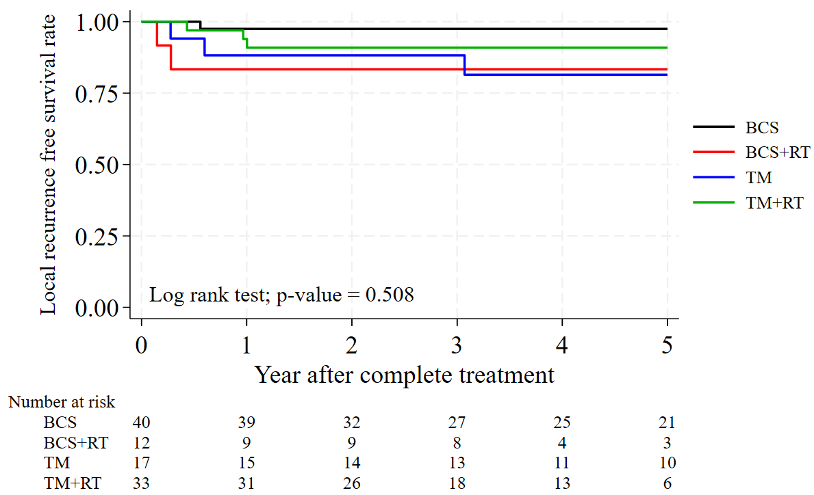

Table 1S Risk factor associated with LR for all patients
 | Univariate |  | Multivariate
 | HR (95% CI) | P-value | aHR (95% CI) | P-value
Subtypes
- Borderline | 1
- Malignant | 5.7 (1.22-27.36) | 0.027 | 12.85 (1.81-91.07) | 0.011
Age at diagnosis
- ≤ 50 | 1.54 (0.40-5.89) | 0.525
- > 50 | 1
Tumor size (cm), group
- < 10 | 1
- 10-15 | 1.22 (0.30-4.90) | 0.778
- >15 | 1.06 (0.21-5.31) | 0.945
Surgery
- BCS | 1
- TM | 1.42 (0.43-4.70) | 0.293
Treatment
- BCS | 1 | Ref | 1 | Ref
- BCS+RT | 4.12 (0.57-29.66) | 0.159 | 0.54 (0.07-4.34) | 0.562
- TM | 1 | Ref
- TM+RT | 0.53 (0.11-2.63) | 0.435
RT received
- No | 1
- Yes | 1.35 (0.40-4.55) | 0.626
Margin  - > 1 cm | 1 | ref
- < 1 cm | 0.61 (0.077-4.75) | 0.635
- Positive | 2.55 (0.31-20.51) | 0.380
Univariate and multivariate were evaluated with Cox regression model. Multivariate were developed by covariate with P< 0.2 from univariate.
Abbreviations :HR = Hazard ratio, aHR = adjusted Hazard ratio, BCS= breast conserving surgery, TM= total mastectomy, RT = Adjuvant radiation therapy, 3D= Three dimension conformal Radiotherapy , IMRT/VMAT= Intensity Modulated Radiation Therapy/Volumetric Modulated Arc Therapy, Fx = Fractions

Table 2S Risk factor associated with LR for malignant patient
 | Univariate
 | HR (95% CI) | P-value
Age at diagnosis
- ≤ 50 | 1.68 (0.42-6.75) | 0.461
- > 50 | 1
Tumor size (cm), group
- < 10 | 1
- ≥ 10 | 0.69 (0.18-2.57) | 0.581
Surgery
- BCS | 1
- TM | 0.60 (0.15-2.43) | 0.480
Treatment
- BCS | 1
- BCS+RT | 0.67 (0.06-7.41) | 0.744
- TM | 1 | Ref
- TM+RT | 0.25 (0.05-1.23) | 0.088
RT received
- No | 1
- Yes | 0.32 (0.09-1.21) | 0.093
Margin
- Negative | 1
- Positive | 1.48 (0.18-11.96) | 0.709
Univariate and multivariate were evaluated with Cox regression model. Multivariate were developed by covariate with P< 0.2 from univariate.
Abbreviations :HR = Hazard ratio, aHR = adjusted Hazard ratio, BCS= breast conserving surgery, TM= total mastectomy, RT = Adjuvant radiation therapy, 3D= Three dimension conformal Radiotherapy , IMRT/VMAT= Intensity Modulated Radiation Therapy/Volumetric Modulated Arc Therapy, Fx = Fractions

