Affordable Ultrasensitive Electrochemical Detection of PCA3 for Early Prostate Cancer Diagnosis

Divakar Raj¹, Shikha Wadhwa², Souradeep Roy¹ Arun Kumar³, Dhruv Kumar¹, Krishna Kant^{4,5}, Soodkhet Pojprapai⁶ *, Ashish Mathur⁷*

¹Allied Health Sciences, School of Health Sciences and Technology, UPES, Dehradun- 248007, India.

²Applied Science Cluster, School of Advance Engineering, UPES, Dehradun-248007, India.

³Mahavir Cancer Sansthan, and Research Centre, Phulwarisharif-801505, Patna, India.

⁴CINBIO, Universidade de Vigo, Campus Universitario Lagoas Marcosende, 36310 Vigo, Spain
⁵Department of Biotechnology, School of Engineering and Applied Sciences, Bennett University, Greater Noida, U.P., India.

⁶School of Ceramic Engineering, Institute of Engineering, Suranaree University of Technology, Nakhon Ratchasima 30000, Thailand.

⁷Centre for Interdisciplinary Research and Innovation (CIDRI), UPES, Dehradun-248007, India.

Corresponding Author:

Ashish Mathur: nanoashish@gmail.com
Soodkhet Pojprapai: soodkhet@g.sut.ac.th
Krishna Kant: Krishna.kant@uvigo.gal

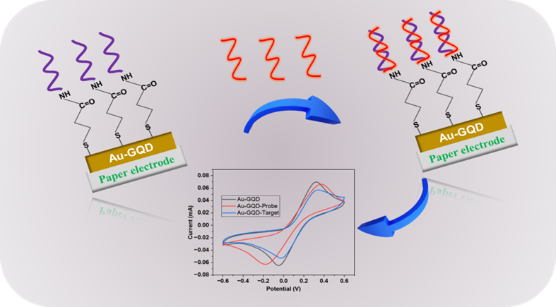
Ionic interaction of Au-GQD and PCA3 Probe:

Figure 1. Illustration of ionic interaction of Au-GQD nanohybrid with PCA3 probe and target DNA molecules.
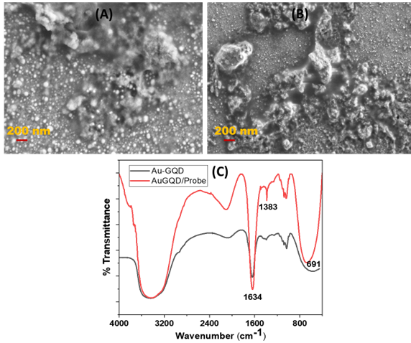
Surface characterization of SPE/Au-GQD/Probe

Figure 2. (A) & (B) SEM image at different position of SPE/Au-GQD/Probe. (C) FTIR spectra of SPE/Au-GQD/Probe.
The proposed sensing platform (SPE/Au-GQD) were treated with EDC-NHS to activate the carboxylic group present on nanohybrids. The modification leads immobilization of a single layer of probe DNA on the SPE/Au-GQD surface by forming an NHS ester bond. Further, the fabricated electrode SPE/Au-GQD/Probe is characterised by SEM, as shown in Figure 2. The surface immobilization of probe DNA can be observed by a large cluster of Au-GQD/EDC-NHS/Probe in the SEM picture. Recently, a similar kind of hypothesis was presented by Naghshgar et al. in 2024, the study employed an EDC-NHS couple to trigger the functional group for the efficient immobilization of probe DNA and the fabricated bioelectrode characterized by SEM ¹. FTIR spectrum as shown in Figure 2(C), The SPE/Au-GQD and SPE/Au-GQD/probe modified electrode showing DNA oligonucleotides peak range of (1634cm⁻¹ - 691cm⁻¹), the peak around 1634cm⁻¹ indicating presence of thymine and adenine, whenever the peak near 1400cm⁻¹demonstrates the presence of cytosine and guanine, overall, high marked bands confirmed the presence of DNA in FTIR spectra ².
Simulation study of Nyquist plot:
The concentration of electroactive species, charge transfer, mass transfer from the bulk liquid to the electrode interface, and the electrolyte's resistance are all examples of matter (redox species) electrode interactions in a typical electrochemical cell. Every one of these characteristics is defined by an electrical circuit. This analogous circuit aims to illustrate and evaluate each of the EIS system's components. Solution resistance (Rs), charge transfer resistance (Rct), and double-layer capacitance at the electrode surface (CdI).
Here, Rs correspond to bulk electrolyte resistance. The CPE (Constant Phase Element) is now implemented to model a non-uniform double-layer capacitance with surface heterogeneities. The capacitive or CPE impedance is calculated in the simulation as per equation ³ (presented in main manuscript). The bulk resistance Rs appears to increase from 1.62 kΩ to 1.82 kΩ as the PCA3 TDNA concentration is elevated from 100 fM to 100 nM, respectively. This is primarily due to the presence of a large amount of DNA strands, at 100 nM, in buffer electrolytes, which causes a hindrance to electron transport in bulk solution. Meanwhile, the high-frequency inherent bulk electrode resistance Rel and capacitance Cel at the Au-GQD/SPE interface were simulated to be approximately the same, as shown in Table 1(Main manuscript). Marked deviations are observed in the mid-low frequency region corresponding to interfacial electron transfer phenomena. Specifically, the charge transfer resistance was simulated to be the least (100 kΩ) in 100 fM PCA-3 TDNA, increasing by two times (200 kΩ) for 100 nM concentration. This situation may be attributed to the increased presence of biofilm complex due to DNA hybridization event on the SPE/Au-GQD/PDNA electrode surface at the latter concentration (100 nM). Consequently, the interface electron transport process from electrolyte to electrode experiences significant hindrance compared to the situation observed at 100 fM. A similar observation has been reported by Roy et al. in a previous study ⁴. A low degree of electron transfer at 100 nM PCA-3 is further accompanied by decreased double-layer capacitor charging as evidenced by less capacitive impedance of 0.3 s0.8/Ω ⁵. However, reducing the PCA-3 TDNA concentration to 100 fM results in the hybridization of comparatively less DNA strands, and hence faster electron transport accompanied by more significant double layer charging of 0.6 s0.8/Ω, which is two-fold increase.
References
1. Naghshgar, N., Hosseinzadeh, S., Derakhshandeh, A., Shaali, R. & Doroodmand, M. M. Introducing a portable electrochemical biosensor for Mycobacterium avium subsp. paratuberculosis detection using graphene oxide and chitosan. Scientific Reports 2024 14:1 14, 1–13 (2024).
2. Han, Y., Han, L., Yao, Y., Li, Y. & Liu, X. Key factors in FTIR spectroscopic analysis of DNA: the sampling technique, pretreatment temperature and sample concentration. Analytical Methods 10, 2436–2443 (2018).
3. Jorcin, J.-B., Orazem, M. E., Pébère, N. & Tribollet, B. CPE analysis by local electrochemical impedance spectroscopy. Electrochim Acta 51, 1473–1479 (2006).
4. Roy, S. et al. An Electroanalytical Paper-Based Wound Dressing Using ZIF-67/C3N4Nanocomposite towards the Monitoring of Staphylococcus Aureus in Diabetic Foot Ulcer. IEEE Sens J 21, 1215–1221 (2021).
5. Gupta, A. K. et al. Design and development of a portable resistive sensor based on α-MnO2/GQD nanocomposites for trace quantification of Pb(II) in water. IET Nanobiotechnol 15, 505–511 (2021).

