Supplementary Table 1. Comparison of model performance for the two intermediate models and the final models per CGM metric.
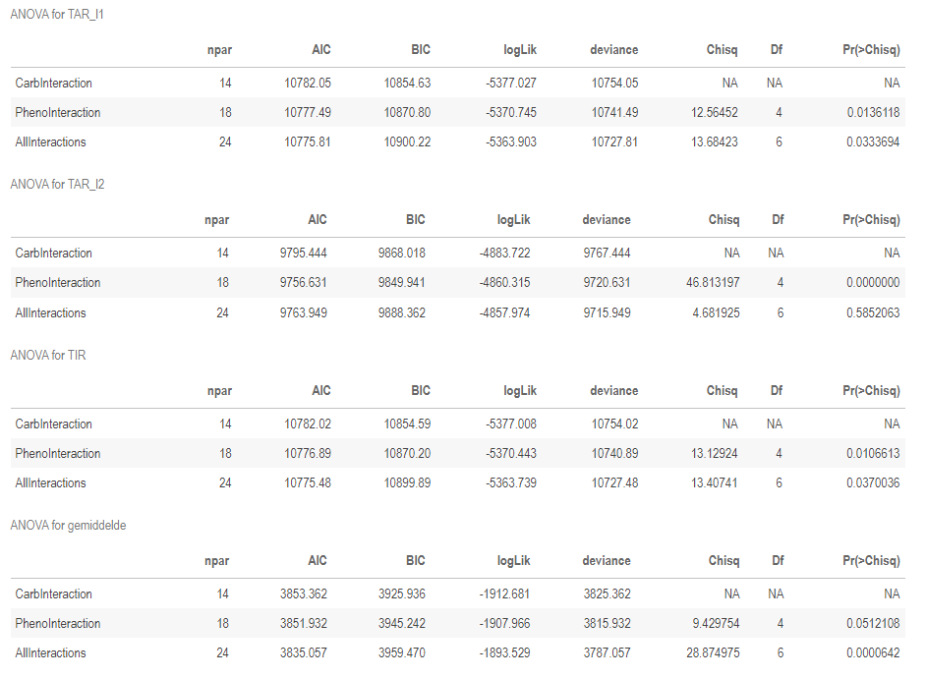
mean
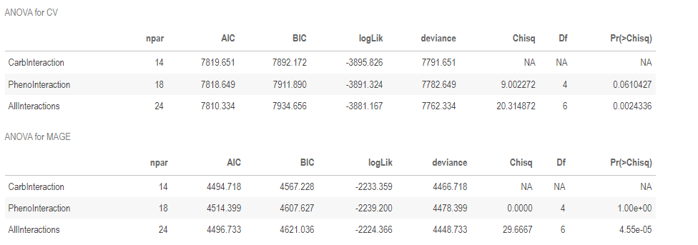
Note: Intermediate model 1 (CarbInteraction) included intercept, intervention and carbohydrate intake at baseline and their interactions as fixed factors and participant as random factor. Intermediate model 2 (PhenoInteraction) included intercept, intervention and diabetype and their interactions as fixed factors and participant as random factor. The full model (AllInteractions) included intercept, intervention and carbohydrate intake at baseline and diabetype and their 2-way interactions as fixed factors and participant as random factor. A significant p-value indicates the model fitted better as compared to the model directly above it in the same table.

Supplementary Table 2. Results from the null model: model coefficients for the linear mixed effect models including intercept, intervention and carbohydrate intake at baseline and their interactions as fixed factors and participant as random factor; bold indicates a significant increase or decrease as compared to the control period.
 | Mean  (mmol/L) | TIR  (%) | TAR – L1  (%) | TAR – L2  (%) | CV  (%) | MAGE  (mmol/L)
> 26% of calories as CHO at baseline
Intercept | 8.66 | 76.06 | 23.72 | 4.63 | 17.2 | 9.12
AD | -0.26 | 2.46 | -2.50 | 0.2 | 0.55 | -0.35
LC | -0.92 | 8.74 | -8.86 | -2.58 | -1.99 | -1.06
Med | 0.04 | -0.25 | -0.09 | 4.16 | 0.95 | 0.09
WaM | -0.29 | 3.54 | -3.69 | -0.21 | -0.09 | -0.36
<26% of calories as CHO at baseline
Change in intercept | -1.22 | 12.43 | -12.6 | -4.03 | -3.86 | -1.47
AD-CHO interaction | 0.25 | 0.25 | 0.06 | -0.52 | -1.24 | 0.26
LC- CHO interaction | 0.85 | -5.33 | 5.69 | 2.58 | 0.3 | 0.88
Med-CHO interaction | 0.58 | -4.26 | 4.85 | -3.36 | 2.66 | 1
WaM-CHO interaction | 0.13 | -2.49 | 2.67 | 0.54 | 0.06 | 0.10
CV = coefficient of variation; TIR = time in range (3.9-10.0 mmol/L); TAR L1 = time above range level 1 (10.0-13.9 mmol/L); TAR L2 = time above range level 2 (> 13.9 mmol/L); MAGE = mean amplitude of glucose excursions; AD = active day; LC = low carbohydrate; Med = Mediterranean diet; WaM = walk after meal; CHO = binary variable for < 26% of calories as carbohydrates at baseline.
Interpretation of coefficients – an example: The main effects in this table are the expected difference for participants with low carb intake at baseline compared to high carb intake at baseline, during the control period.
For an individual following LC, and consuming > 26% of calories as carbohydrates at baseline, the expected mean glucose = (Intercept) 8.66 + (LC:) -0.92 = 7.74.
For the same individual, but now consuming < 26% of calories as carbohydrates at baseline, mean glucose = 8.66 + (-0.92) + (<26% of calories as carbohydrate) -1.22 + (LC-CHO interaction:) 0.85 = 7.37

Supplementary Table3. Model coefficients of the final linear mixed effect models per diabetype; A) isolated impaired beta-cell function (PB-group), B) impaired beta-cell function and hepatic insulin resistance (PB-HIR group), and C) impaired beta-cell function and hepatic and muscle insulin resistance (PB-HMIR group).
A (PB group; n=16)
 | Mean  (mmol/L) | TIR  (%) | TAR – L1  (%) | TAR – L2  (%) | CV  (%) | MAGE  (mmol/L)
> 26% of calories as CHO at baseline
Intercept | 8.62 | 78.90 | 21.13 | 1.80 | 17.68 | 9.13
AD | -0.31 | 2.97 | -3.07 | 1.05 | 2.08 | -0.21
LC | -0.72 | 4.71 | -4.97 | 1.30 | -1.40 | -1.04
Med | -0.27 | 2.63 | -2.86 | 0.96 | 0.56 | -0.34
WaM | -0.29 | 3.81 | -4.11 | 2.37 | 0.22 | -0.34
<26% of calories as CHO at baseline
Change in intercept | -0.68 | -3.60 | 3.17 | 0.52 | -5.95 | -0.85
AD-CHO interaction | -0.20 | 14.02 | -13.85 | -3.29 | -0.40 | -0.27
LC- CHO interaction | 0.20 | 9.67 | -9.39 | -2.95 | 1.89 | 0.36
Med-CHO interaction | 0.65 | -5.23 | 5.50 | 0.83 | 4.18 | 1.42
WaM-CHO interaction | -0.79 | 16.50 | -16.42 | -4.39 | 2.76 | -0.79
B (PB-HIR group; n=30)
 | Mean  (mmol/L) | TIR  (%) | TAR – L1  (%) | TAR – L2  (%) | CV  (%) | MAGE  (mmol/L)
> 26% of calories as CHO at baseline
Intercept | 8.44 | 78.56 | 21.33 | 3.23 | 17.53 | 8.90
AD | -0.15 | 0.59 | -0.74 | 0.21 | 0.46 | -0.28
LC | -0.79 | 8.85 | -9.11 | -1.52 | -3.34 | -1.00
Med | -0.18 | 2.17 | -2.62 | 1.40 | 1.05 | -0.11
WaM | -0.13 | 4.15 | -4.46 | 0.74 | -0.34 | -0.28
<26% of calories as CHO at baseline
Change in intercept | -1.16 | 13.13 | -13.51 | -2.86 | -2.74 | -1.28
AD-CHO interaction | 0.15 | -0.79 | 1.38 | -0.42 | -2.10 | 0.18
LC- CHO interaction | 0.73 | -4.26 | 4.93 | 1.20 | -0.33 | 0.78
Med-CHO interaction | 0.80 | -6.05 | 6.88 | -1.49 | 1.43 | 0.99
WaM-CHO interaction | 0.01 | -2.87 | 3.56 | -0.96 | -1.66 | 0.04
C (PB-HMIR group; n=11)
 | Mean  (mmol/L) | TIR  (%) | TAR – L1  (%) | TAR – L2  (%) | CV  (%) | MAGE  (mmol/L)
> 26% of calories as CHO at baseline
Intercept | 10.25 | 57.07 | 42.94 | 14.85 | 15.77 | 10.72
AD | -0.58 | 5.51 | -5.81 | -3.93 | 0.60 | -0.72
LC | -1.78 | 17.24 | -17.46 | -11.91 | 0.34 | -1.69
Med | -0.31 | 3.59 | -4.45 | 1.19 | 1.12 | -0.32
WaM | -0.98 | 7.58 | -7.92 | -9.04 | 0.31 | -1.16
CV = coefficient of variation; TIR = time in range (3.9-10.0 mmol/L); TAR L1 = time above range level 1 (10.0-13.9 mmol/L); TAR L2 = time above range level 2 (> 13.9 mmol/L); MAGE = mean amplitude of glucose excursions; AD = active day; LC = low carbohydrate; Med = Mediterranean diet; WaM = walk after meal; CHO = binary variable for < 26% of calories as carbohydrates at baseline. Numbers in bold indicate significant increase or decrease as compared to the control period
Interpretation of coefficients – an example: The main effects in this table are for each diabetype, the expected difference for the subgroup with low carb intake at baseline compared to high carb intake at baseline, during the intervention periods compared to the control period.
For an individual following LC, and consuming > 26% of calories as carbohydrates at baseline, and part of the PB group, the expected daily mean glucose = (Intercept) 8.62 + (LC:) -0.72 = 7.90.
For the same individual, but now consuming < 26% of calories as carbohydrate at baseline, mean glucose = 8.62 + (-0.72) + (<26% of calories as carbohydrate) -0.68 + (LC-CHO interaction:) 0.20 = 7.42

Supplementary figure 1: Study design

