Leveraging the Synergistic Effects of Au/PANI/CuO Heterostructure for Enhanced Photoelectrochemical Water Splitting
Fahad Abdulaziz¹, Mohamed Zayed^{2*}, Salman Latif¹, Yassin A. Jeilani¹, Mohamed Shaban³, Raja Rama Devi Patel⁴, Hussein A. Elsayed⁵, Mohamed Rabia⁶, Ashour M. Ahmed^{7,8}

¹ Department of Chemistry, College of Science, University of Ha’il, Ha’il, 81451, Saudi Arabia (fah.alanazi@uoh.edu.sa)
² Nanophotonics and Applications Lab (NPA), Physics Department, Faculty of Science, Beni-Suef University, Beni-Suef 62514, Egypt.
³ Department of Physics, Faculty of Science, Islamic University of Madinah, P.O. Box 170, AlMadinah Almonawara 42351, Saudi Arabia
⁴ Department of Biology, College of Sciences, University of Ha’il, Ha’il 55473, Saudi Arabia
⁵ Department of Physics, College of Science, University of Ha'il, P. O. Box 2440, Ha'il, Saudi Arabia
⁶ Nanomaterials Science Research Laboratory, Chemistry Department, Faculty of Science, Beni-Suef University, Beni‑Suef, Egypt
⁷ Physics Department, College of Science, Imam Mohammad Ibn Saud Islamic University (IMSIU), Riyadh, 11623, Saudi Arabia
⁸ Physics Department, Faculty of Science, Beni-Suef University, Beni-Suef 62514, Egypt.

* Corresponding authors: m.zayed88ph@yahoo.com

Table S1. EDX composition elemental analysis of the pure CuO, Fe- PANI/CuO, and Au/ PANI/CuO photoelectrodes
Samples | Pure CuO | PANI/CuO | Au/PANI/CuO
Samples | (Wt. %, At. %) | (Wt. %, At. %) | (Wt. %, At. %)
Au | - | - | 24.58, 8.79
C | - | 18.45, 22.15 | 16.21, 21.02
N | - | 11.14, 12.12 | 9.11, 16.0
Cu | 36.88, 22.87 | 24.15, 15.21 | 11.82, 8.21
O | 40.9, 59.39 | 32.61, 40.2 | 29.92, 38.85
Si | 17.69, 14.86 | 10.52, 8.91 | 6.82, 5.98
Al | 0.76, 0.67 | 0.52, 0.39 | 0.3, 0.19
Ca | 3.77, 2.22 | 2.61, 1.02 | 1.24, 0.96

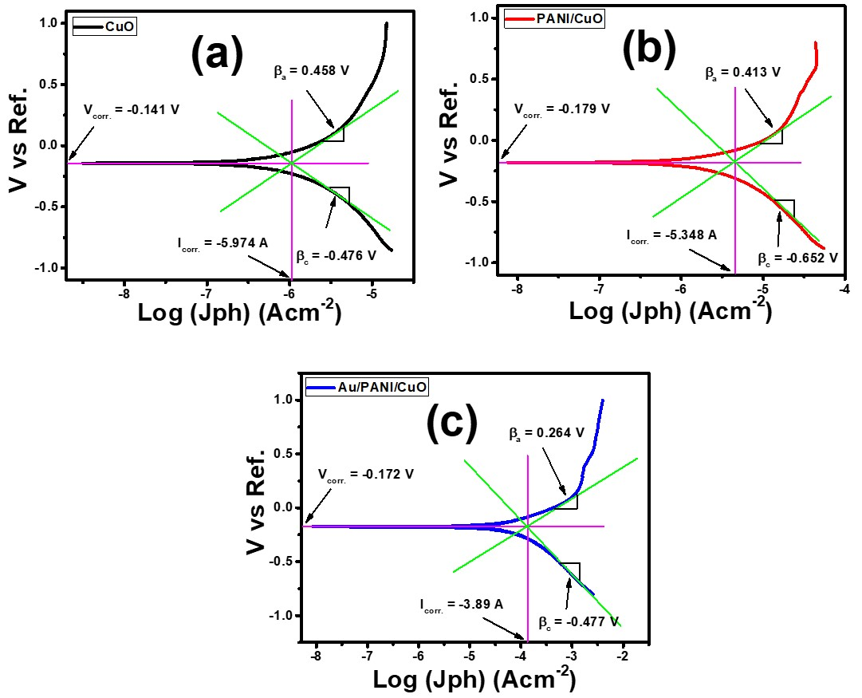
Figure S1. displays the Tafel plots for pure CuO, Fe- PANI/CuO, and Au/PANI/CuO photoelectrodes.

