  - Supporting Information

LAB-IN-A-FIBER DETECTION AND
CAPTURE OF CELLS

João C. Varela^{1, 2†*}, Achar V. Harish^{3, 4†}, Pawel Maniewski³, Timothy Gibbon⁴, Oana Tudoran^{1,5}, Rainer Heuchel⁶, Matthias Löhr⁶, Walter Margulis^{3, 7}, Aman Russom^{1, 2}, Fredrik Laurell³

¹Division of Nanobiotechnology, Department of Protein Science, Science for Life Laboratory, KTH Royal Institute of Technology, Solna, Sweden
²AIMES Center for the Advancement of Integrated Medical and Engineering Sciences at Karolinska Institutet and KTH Royal Institute of Technology, Stockholm, Sweden
³Department of Applied Physics, KTH Royal Institute of Technology, Stockholm, Sweden
⁴Research Institutes of Sweden (RISE), Stockholm, Sweden
⁵Department of Genetics, Genomics and Experimental Pathology, The Oncology Institute “Prof. Dr. Ion Chiricuta”, Cluj-Napoca, Romania
⁶Department of Cancer Medicine, Division for Upper GI, Karolinska University Hospital, Stockholm, Sweden;
⁷Catholic University of Rio de Janeiro PUC-Rio, Rio de Janeiro, Brazil
†These authors contributed equally to this work; *E-mail: joao.varela@scilifelab.se

Table S1: Components used to assemble the Lab-in-a-Fiber setup used for the detection and capture of cells.

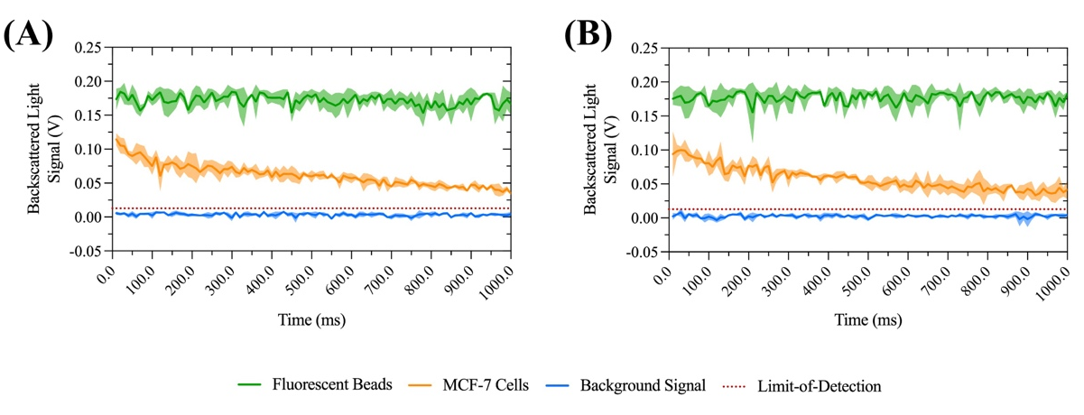
Figure S1: Fluorescent signal detected by the PMT detector (V) vs. time in a solution of (A) PBS buffer, and (B) DMEM cell culture media. The plots are average of 10 datapoints, each corresponding to 1 ms. The shaded areas correspond to the standard deviation (n = 3). Limit-of-Detection corresponds to the average value of the background signal plus three times the average standard deviation.

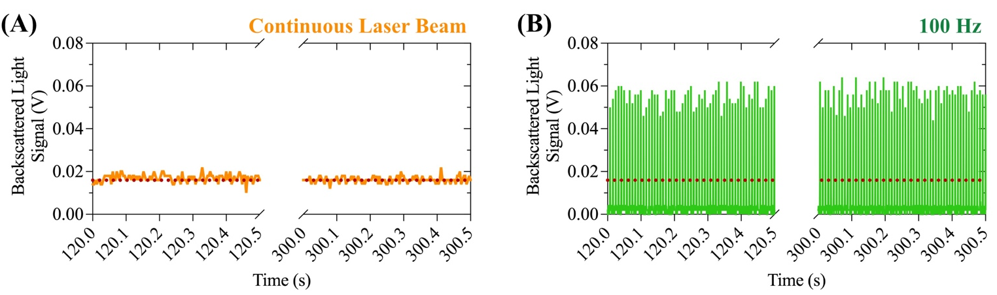
Figure S2: Detector signal from the PMT detector (V) after a period of two and five minutes using continuous exposure (A), or on-off modulated excitation (10% duty cycle) with a frequency of 100 Hz (B). Limit-of-Detection is the red-dotted line. It corresponds to the average value of the background signal plus three times the average standard deviation.

