Supplementary Material
Table S1. Definition of Parkinson's disease in UK Biobank study
Table S2. Characteristics of PD-associated SNPs in the UK Biobank
Table S3. Association between PD-PRS and incident PD
Table S4. Stratified analysis for the association between time spent in outdoor light (summer) and incidence of Parkinson's disease
Table S5. Stratified analysis for the association between time spent in outdoor light (winter) and incidence of Parkinson’s disease
Table S6. Stratified analysis for the association between time spent in outdoor light (average) and incidence of Parkinson’s disease
Table S7. Sensitive analysis for the association between time spent in outdoor light and incidence of Parkinson's disease, additionally adjusted for physical activity, vitamin D, and sleep patterns
Table S8. Sensitive analysis for the association between time spent in outdoor light and incidence of Parkinson's disease
Fig S1. Flow of participants in current study
Fig S2. The Curve of Density Distribution and Weighted Polygenic Risk Score
Fig S3. Directed acyclic graph (DAG) explaining the association between the exposures, the outcome, and covariates included in the analyses.
Fig S4. Associations of time spent in outdoor light time in summer (A), in winter (B), and on average (C) with the risk of Parkinson’s disease.

This supplemental material has been provided by the authors to give readers additional information about their work.

Table S1. Definition of Parkinson's disease in UK Biobank study
Diagnosis | Self-reported field | ICD 9 | ICD 10
Parkinson's Disease | 1262 | 332,3320,3321,3330 | G20, G21, G21.0, G21.1, G21.2, G21.3, G21.4, G21.8, G21.9, G22, G23.0, G23.1, G23.2, G23.3, G23.8, G23.9, G25.9, G26, G90.3
Abbreviations: ICD, International Classification of Diseases.

Table S2. Characteristics of PD-associated SNPs in the UK Biobank
SNP | Chr | EAF in 1000 Genomes | A1 | A2 | OR
rs10797576 | 1 | 0.137 | T | C | 1.12
rs10906923 | 10 | 0.306 | C | A | 0.93
rs11060180 | 12 | 0.450 | G | A | 0.90
rs11158026 | 14 | 0.307 | T | C | 0.91
rs11343 | 16 | 0.454 | T | G | 1.07
rs115185635 | 3 | 0.036 | C | G | 1.21
rs11724635 | 4 | 0.437 | C | A | 0.90
rs117896735 | 10 | 0.012 | A | G | 1.65
rs12456492 | 18 | 0.332 | G | A | 1.10
rs12497850 | 3 | 0.347 | G | T | 0.93
rs12637471 | 3 | 0.219 | A | G | 0.85
rs13294100 | 9 | 0.371 | T | G | 0.91
rs14235 | 16 | 0.397 | A | G | 1.08
rs143918452 | 3 | 0.996 | G | A | 0.68
rs1474055 | 2 | 0.881 | C | T | 0.83
rs1555399 | 14 | 0.544 | T | A | 1.09
rs17649553 | 17 | 0.232 | T | C | 0.78
rs199347 | 7 | 0.368 | G | A | 0.91
rs2280104 | 8 | 0.367 | T | C | 1.06
rs2414739 | 15 | 0.292 | G | A | 0.91
rs2694528 | 5 | 0.115 | C | A | 1.15
rs2740594 | 8 | 0.753 | A | G | 1.10
rs329648 | 11 | 0.327 | T | C | 1.09
rs34043159 | 2 | 0.352 | C | T | 1.07
rs34311866 | 4 | 0.199 | C | T | 1.23
rs353116 | 2 | 0.385 | T | C | 0.94
rs356182 | 4 | 0.375 | G | A | 1.33
rs35749011 | 1 | 0.976 | G | A | 0.58
rs3793947 | 11 | 0.463 | A | G | 0.93
rs4073221 | 3 | 0.132 | G | T | 1.11
rs4653767 | 1 | 0.315 | C | T | 0.92
rs4784227 | 16 | 0.265 | T | C | 1.08
rs591323 | 8 | 0.293 | A | G | 0.91
rs601999 | 17 | 0.699 | C | T | 0.93
rs62120679 | 19 | 0.324 | T | C | 1.08
rs6430538 | 2 | 0.488 | T | C | 0.89
rs6812193 | 4 | 0.398 | T | C | 0.91
rs76904798 | 12 | 0.132 | T | C | 1.16
rs78738012 | 4 | 0.106 | C | T | 1.14
rs8005172 | 14 | 0.424 | T | C | 1.08
rs8118008 | 20 | 0.596 | A | G | 1.07
rs823118 | 1 | 0.467 | C | T | 0.89
rs9275326 | 6 | 0.114 | T | C | 0.85
rs9468199 | 6 | 0.172 | A | G | 1.12
Abbreviations: Chr, chromosome; PD, Parkinson's disease; SNP, single nucleotide polymorphisms; EAF, effect allele frequency; OR, odds ratio.

Table S3. Association between PD-PRS and incident PD
 | Low PRS | Intermediate PRS | High PRS
HR (95% CI) | 1.00 (Ref.) | 1.25 (1.13, 1.39) | 1.80 (1.60, 2.02)
Abbreviation: PD, Parkinson's disease; HR, hazard ratio; 95% CI, 95% confidence interval; PRS, polygenic risk score.
Adjusted for first 10 principal components of ancestry, and genotype measurement batch.

Table S4. Stratified analysis for the association between time spent in outdoor light (summer) and incidence of Parkinson's disease
 | N | < 2 h/day | 2 to 3 h/day | > 3 h/day | P interaction
BMI |  |  |  |  | 0.947
< 25 | 125840 | 1.00 (Ref.) | 0.85 (0.67, 1.07) | 0.72 (0.57, 0.92)
≥ 25 | 249759 | 1.00 (Ref.) | 0.93 (0.79, 1.09) | 0.79 (0.67, 0.92)
Sex |  |  |  |  | 0.041
female | 201911 | 1.00 (Ref.) | 0.87 (0.72, 1.06) | 0.67 (0.55, 0.82)
male | 173688 | 1.00 (Ref.) | 0.94 (0.79, 1.13) | 0.86 (0.72, 1.03)
Age |  |  |  |  | 0.008
< 60 | 206140 | 1.00 (Ref.) | 1.01 (0.79, 1.28) | 1.02 (0.80, 1.31)
≥ 60 | 169459 | 1.00 (Ref.) | 0.86 (0.74, 1.01) | 0.71 (0.61, 0.83)
Occupation |  |  |  |  | 0.108
retired | 128642 | 1.00 (Ref.) | 0.83 (0.68, 1.01) | 0.67 (0.55, 1.81)
others | 245388 | 1.00 (Ref.) | 0.95 (0.80, 1.13) | 0.87 (0.73, 1.04)
Adjusted for age, sex, education, Townsend deprivation index, smoking status, alcohol consumption, body mass index, occupation, dietary pattern, vitamin D supplementation, use of sun/UV protection, PM_{2.5}, baseline hypertension, dyslipidaemia, cancer, cardiovascular disease, PRS, first 10 principal components of ancestry, and genotype measurement batch.

Table S5. Stratified analysis for the association between time spent in outdoor light (winter) and incidence of Parkinson’s disease
 | N | < 1 h/day | 1 to 2 h/day | > 2 h/day | P interaction
BMI |  |  |  |  | 0.148
< 25 | 125840 | 1.00 (Ref.) | 1.08 (0.87, 1.32) | 0.80 (0.62, 1.03)
≥ 25 | 249759 | 1.00 (Ref.) | 0.96 (0.84, 1.09) | 0.86 (0.74, 0.99)
Sex |  |  |  |  | 0.021
female | 201911 | 1.00 (Ref.) | 1.08 (0.92, 1.27) | 0.77 (0.62, 0.94)
male | 173688 | 1.00 (Ref.) | 0.93 (0.81, 1.08) | 0.87 (0.74, 1.02)
Age |  |  |  |  | 0.007
< 60 | 206140 | 1.00 (Ref.) | 1.24 (0.99, 1.54) | 1.24 (0.95, 1.62)
≥ 60 | 169459 | 1.00 (Ref.) | 0.93 (0.82, 1.05) | 0.78 (0.68, 0.90)
Occupation |  |  |  |  | 0.06
retired | 65653 | 1.00 (Ref.) | 0.91 (0.78, 1.05) | 0.73 (0.62, 0.87)
others | 286671 | 1.00 (Ref.) | 1.08 (0.92, 1.26) | 1.02 (0.84, 1.23)
Adjusted for age, sex, education, Townsend deprivation index, smoking status, alcohol consumption, body mass index, occupation, dietary pattern, vitamin D supplementation, use of sun/UV protection, PM_{2.5}, baseline hypertension, dyslipidaemia, cancer, cardiovascular disease, PRS, first 10 principal components of ancestry, and genotype measurement batch.

Table S6. Stratified analysis for the association between time spent in outdoor light (average) and incidence of Parkinson’s disease
 | N | < 1.5 h/day | 1.5-2.5 h/day | > 2.5 h/day | P interaction
BMI |  |  |  |  | 0.434
< 25 | 125840 | 1.00 (Ref.) | 1.04 (0.84, 1.28) | 0.80 (0.64, 0.99)
≥ 25 | 249759 | 1.00 (Ref.) | 0.96 (0.84, 1.10) | 0.83 (0.72, 0.95)
Sex |  |  |  |  | 0.132
female | 201911 | 1.00 (Ref.) | 0.95 (0.80, 1.13) | 0.74 (0.62, 0.89)
male | 173688 | 1.00 (Ref.) | 1.02 (0.87, 1.20) | 0.89 (0.76, 1.05)
Age |  |  |  |  | 0.009
< 60 | 206140 | 1.00 (Ref.) | 1.12 (0.90, 1.40) | 1.09 (0.87, 1.37)
≥ 60 | 169459 | 1.00 (Ref.) | 0.93 (0.81, 1.07) | 0.77 (0.67, 0.88)
Occupation |  |  |  |  | 0.033
retired | 65653 | 1.00 (Ref.) | 0.92 (0.77, 1.09) | 0.72 (0.61, 0.85)
others | 286671 | 1.00 (Ref.) | 1.02 (0.87, 1.12) | 0.95 (0.81, 1.12)
Adjusted for age, sex, education, Townsend deprivation index, smoking status, alcohol consumption, body mass index, occupation, dietary pattern, vitamin D supplementation, use of sun/UV protection, PM_{2.5}, baseline hypertension, dyslipidaemia, cancer, cardiovascular disease, PRS, first 10 principal components of ancestry, and genotype measurement batch.

Table S7 Sensitive analysis for the association between time spent in outdoor light and incidence of Parkinson's disease, additionally adjusted for physical activities, vitamin D, and sleep patterns
Time spent in outdoor light | Event/Total | HR (95% CI) | P Value
Summer
<2 h/day | 298 / 48668 | 1.00 (Ref.)
2 to 3 h/day | 1012 / 146765 | 0.93 (0.81, 1.06) | 0.251
>3 h/day | 1514 / 180166 | 0.81 (0.71, 0.93) | 0.002
Winter
<1 h/day | 417 / 71832 | 1.00 (Ref.)
1 to 2 h/day | 1660 / 218953 | 1.02 (0.92, 1.14) | 0.705
>2 h/day | 747 / 84814 | 0.91 (0.80, 1.03) | 0.152
Average
<1.5 h/day | 403 / 70375 | 1.00 (Ref.)
1.5 to 2.5 h/day | 1022/ 141577 | 1.01 (0.90, 1.13) | 0.911
>2.5 h/day | 1399 / 163647 | 0.87 (0.77, 0.98) | 0.024
Adjusted for age, sex, education, Townsend deprivation index, smoking status, alcohol consumption, body mass index, occupation, dietary pattern, vitamin D supplementation, use of sun/UV protection, PM_{2.5}, baseline hypertension, dyslipidaemia, cancer, cardiovascular disease, PRS, first 10 principal components of ancestry, genotype measurement batch, physical activities, vitamin D, and sleep patterns.

Table S8. Sensitive analysis for the association between time spent in outdoor light and incidence of Parkinson's disease
Time spent in outdoor light | exclude within 2 years |  | Fine-Gray Model
Time spent in outdoor light | HR (95% CI) | P Value | HR (95% CI) | P Value
Summer
<2 h/day | 1.00 (Ref.) |  | 1.00 (Ref.)
2 to 3 h/day | 0.91 (0.80, 1.04) | 0.161 | 0.91 (0.79, 1.03) | 0.145
>3 h/day | 0.78 (0.68, 0.89) | <0.001 | 0.77 (0.68, 0.88) | <0.001
Winter
<1 h/day | 1.00 (Ref.) |  | 1.00 (Ref.)
1 to 2 h/day | 1.01 (0.90, 1.13) | 0.879 | 0.99 (0.89, 1.11) | 0.906
>2 h/day | 0.86 (0.76, 0.98) | 0.021 | 0.85 (0.75, 0.96) | 0.011
Average
<1.5 h/day | 1.00 (Ref.) |  | 1.00 (Ref.)
1.5 to 2.5 h/day | 1.00 (0.99, 1.12) | 0.984 | 0.98 (0.88, 1.11) | 0.80
>2.5 h/day | 0.84 (0.74, 0.94) | 0.003 | 0.83 (0.73, 0.93) | 0.002
Abbreviation: HR, hazard ratio; 95% CI, 95% confidence interval.
Adjusted for age, sex, education, Townsend deprivation index, smoking status, alcohol consumption, body mass index, occupation, dietary pattern, vitamin D supplementation, use of sun/UV protection, PM_{2.5}, baseline hypertension, dyslipidaemia, cancer, cardiovascular disease, PRS, first 10 principal components of ancestry, and genotype measurement batch.

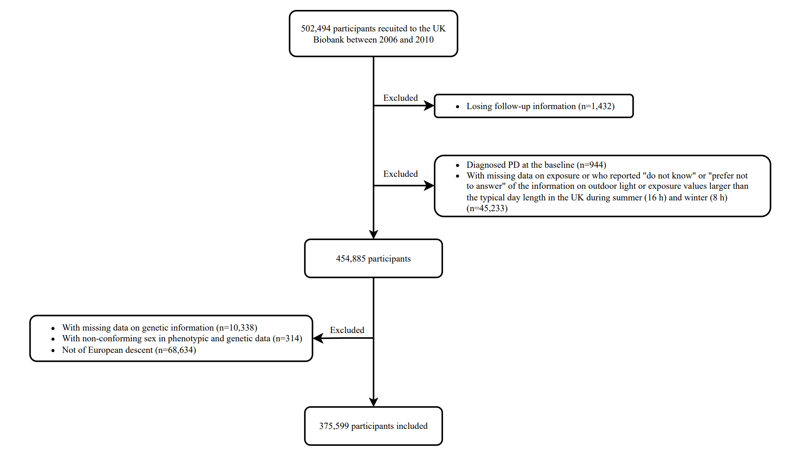
Fig S1. Flow of participants in current study

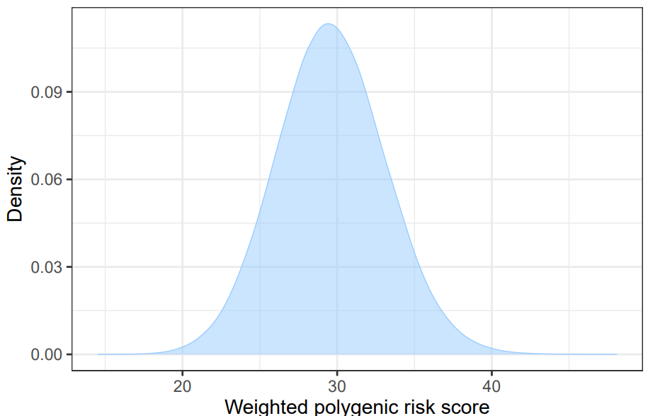
Fig S2. The Curve of Density Distribution and Weighted Polygenic Risk Score
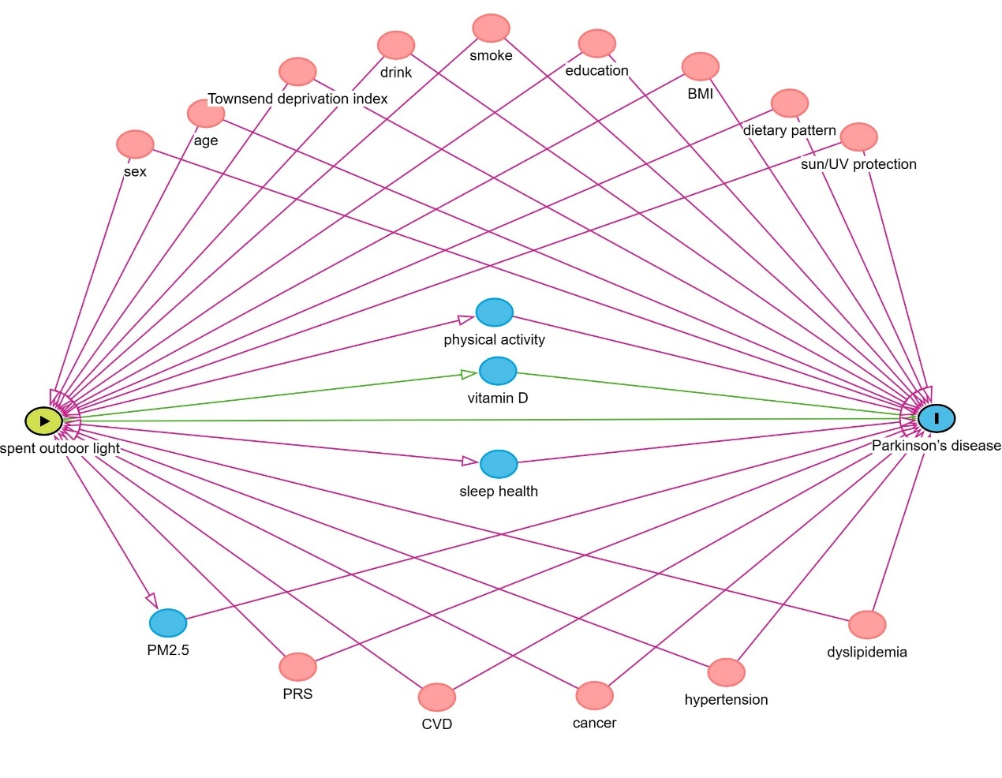
Fig S3. Directed acyclic graph (DAG) explaining the association between the exposures, the outcome, and covariates included in the analyses.
Sociodemographic characteristics (age, sex, ethnicity, education, and occupation), socioeconomic status (Townsend Deprivation Index), lifestyle factors (physical activity, sleep pattern, smoking, alcohol consumption, and usual diet), comorbidities (hypertension, dyslipidaemia, cardiovascular disease, and cancer) at the time of recruitment, vitamin D supplementation, and outdoor environmental-related variables (use of sun/UV protection and PM2.5) which may act as confounders or mediators or both in the association between time spent outdoor light and PD risk.
DAG was drawn using http://www.dagitty.

Fig S4. Associations of time spent in outdoor light time in summer (A), in winter (B), and on average (C) with the risk of Parkinson’s disease.

Adjusted for age, sex, education, Townsend deprivation index, smoking status, alcohol consumption, body mass index, occupation, dietary pattern, vitamin D supplementation, use of sun/UV protection, PM2.5, baseline hypertension, dyslipidaemia, cancer, cardiovascular disease, PRS, first 10 principal components of ancestry, and genotype measurement batch.

