Supplementary information
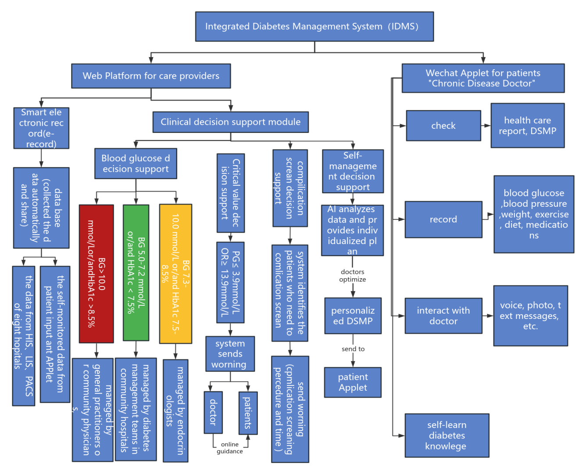
Fig. S1. Graphical illustration of the function of Integrated Diabetes Management System
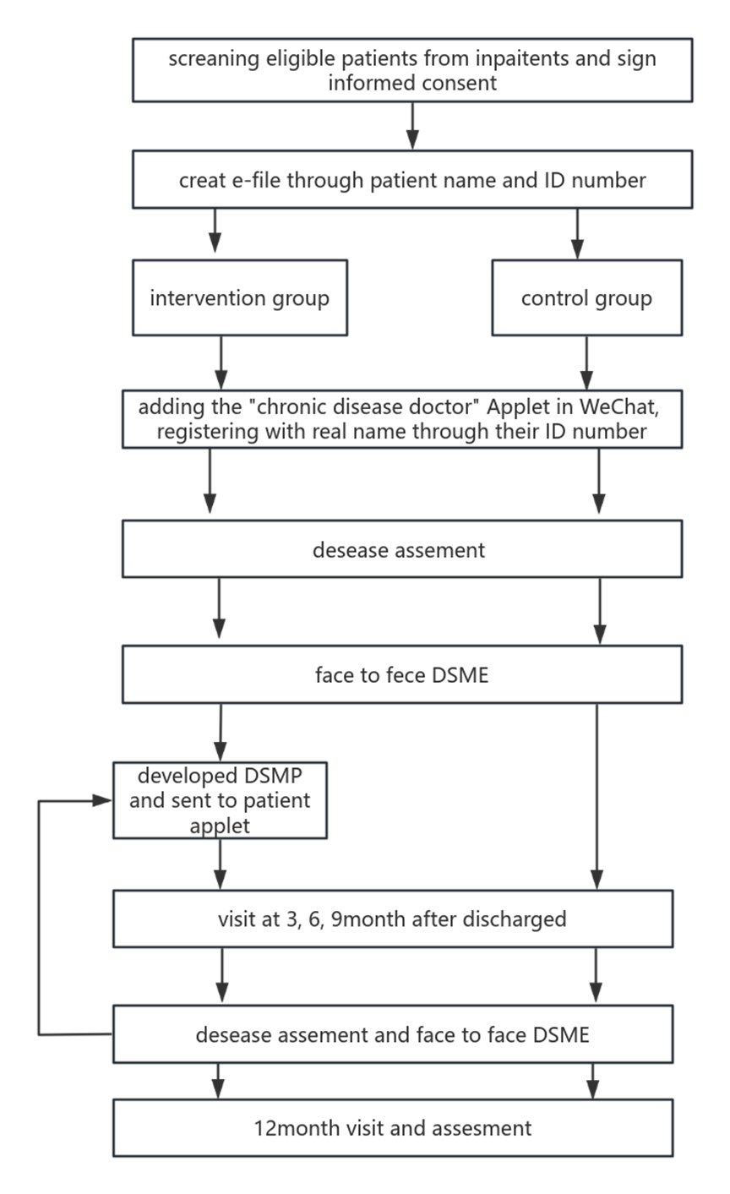
Fig. S2. Flow chart of the study.

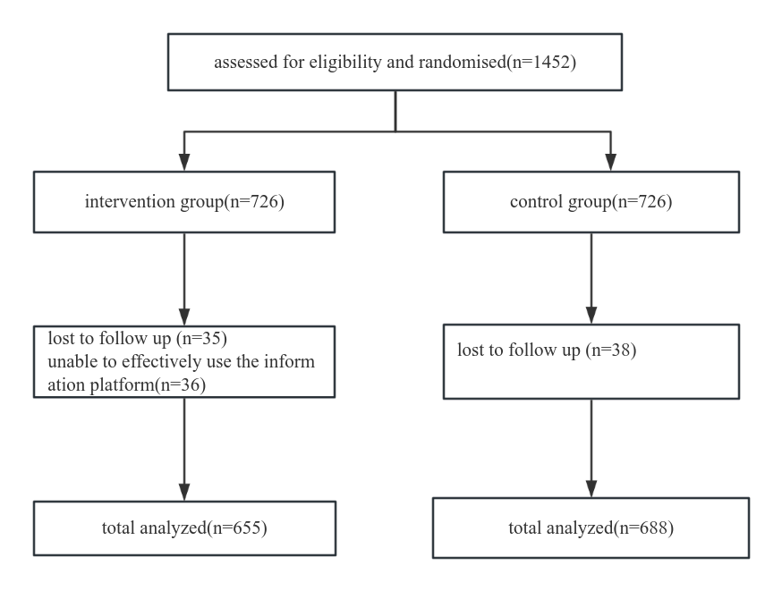
Fig.S3. trial registration flowchart

Table S1: evaluation of treatment effects in two groups during follow-up visits.
Variable | Intervention  (n=655) | Control  (n=688) | P
HbA1c（%）
Baseline | 10.0 ± 1.95 | 9.91 ± 2.07 | 0.425
3rd month | 8.08 ± 1.76* | 9.61 ± 1.87 | 0.000
6th month | 7.55 ± 1.63*¶ | 8.60 ± 1.69*¶ | 0.000
9th month | 7.08 ± 1.46*¶ † | 8.40 ± 1.56*¶ | 0.000
12th month | 7.18 ± 1.29*¶ † | 8.34± 1.57*¶ † | 0.000
FPG（mmol/L）
Baseline | 11.18 ± 4.72 | 11.08 ± 5.10 | 0.425
3rd month | 7.95 ± 2.54* | 8.95 ± 4.34* | 0.000
6th month | 6.91 ± 2.29*¶ | 9.42 ± 4.46* | 0.000
9th month | 6.37 ± 1.62*¶ † | 9.51 ± 3.98* | 0.000
12th month | 6.60 ± 1.66*¶ | 8.31 ± 3.04*¶†∅ | 0.000
f- SMBG | 63 ± 23 | 32 ± 16 | <0.05
incidence of hypoglycemia
grade I | 1.72% | 3.01 | <0.05
grade II | 0.27 | 0.80 | <0.05
BMI (kg/m²)
Baseline | 25.13±3.07 | 25.39±3.34 | 0.163
12th month | 23.92±2.69* | 25.24±3.49 | 0.000
UACR（mg/g）
Baseline | 104.25 ± 72.41 | 101.65 ± 49.84 | 0.455
12th month | 79.45 ± 41.55* | 137.90 ± 66.04* | 0.000
TG (mmol/L)
Baseline | 3.17 ± 3.81 | 3.16 ± 2.22 | 0.960
12th month | 1.65 ± 1.02* | 2.34 ± 1.38* | 0.000
TC (mmol/L)
Baseline | 4.79 ± 1.02 | 4.87 ± 1.92 | 0.154
12th month | 4.91 ± 1.28 | 5.77 ± 1.44* | 0.000
LDL (mmol/L)
Baseline | 3.21 ± 1.09 | 3.26 ± 1.08 | 0.384
12th month | 2.74 ± 0.94* | 3.10 ± 0.97 | 0.000
HDL (mmol/L)
Baseline | 1.27 ± 0.28 | 1.27 ± 0.29 | 0.91
12th month | 1.58 ± 0.63* | 1.21 ± 0.82 | 0.000
Abbreviations: CG, control group; CG, control group; HbA1c, Glycated Hemoglobin-A1c; BMI, body mass index; FPG, fasting plasma glucose; f-SMBG, frequency of self-monitoring blood glucose; TG, triglycerides; TC, total cholesterol; HDL, high-density lipoprotein cholesterol; LDL, low-density lipoprotein cholesterol; UACR, urine albumin creatinine ratio; *means compare with baseline P < 0.05; ¶means compare with 3rd month P < 0.05; †means compare with 6th month P < 0.05; ∅means compare with 9th month P < 0.05.

Table S2: Evaluation of reach treatment target rate and gender-stratified analysis.
Variable |  |  | Intervention(n=655) |  |  | Control(n=688)
 |  | Male  (n=304) |  | Female(n=351) |  |  | Male(n=376) | Female  (n=312)
HbA1c (%)
Baseline | 9% (57) | 9% (28) |  | 8% (29) | 9%(62) |  | 9%(35) | 9%(27)
12th month | 57% (373) | 52%(159) |  | 61%(214)* | 26%(179) |  | 27%(101) | 25%(78)
FPG (mmol/L)
Baseline | 23%(156) | 22%(68) |  | 25%(88) | 27%(186) |  | 26%(99) | 28%(87)
12th month | 68%(447) | 67%(203) |  | 70%(244) | 39%(265) |  | 39%(145) | 38%(120)
BMI
Baseline | 34%(221) | 31%(95) |  | 36%(126) | 31%(216) |  | 31%(116) | 32%(100)
12th month | 48%(317) | 46%(139) |  | 51%(178)* | 36%(246) |  | 39%(146) | 32%(100)
TG
Baseline | 23%(148) | 21%(65) |  | 24%(83) | 28%(193) |  | 29%(108) | 27%(85)
12th month | 70%(453) | 67%(204) |  | 71%(249) | 37%(253) |  | 39%(146) | 34%(107)
TC
Baseline | 41%(268) | 42%(129) |  | 40%(139) | 46%(314) |  | 42%(159) | 50%(156)
12th month | 38%(247) | 38%(117) |  | 37%(130) | 16%(112) |  | 19%(71)* | 13%(41)
LDL
Baseline | 34%(226) | 35%(106) |  | 34%(120) | 30%(205) |  | 32%(121)* | 27%(84)
12th month | 50%(328) | 49%(150) |  | 51%(178) | 31%(211) |  | 34%(129)* | 26%(82)
HDL
Baseline | 62%(405) | 84%(255)* |  | 43%(150) | 68%(470) |  | 89%(336)* | 43%(134)
12th month | 70%(457) | 85%(260)* |  | 56%(197) | 45%(313) |  | 66%(247)* | 21%(66)
f- SMBG | 12%(81) | 10%(30) |  | 15%(51)* | 1%(6) |  | 1%(3) | 1%(3)

Abbreviations: CG, control group; CG, control group; HbA1c, Glycated Hemoglobin-A1c; BMI, body mass index; FPG, fasting plasma glucose; f-SMBG, frequency of self-monitoring blood glucose; TG, triglycerides; TC, total cholesterol; HDL, high-density lipoprotein cholesterol; LDL, low-density lipoprotein cholesterol; * compared between gender in same group P<0.05.

Table S3: Evaluation of treatment compliance rate and age-stratified analysis.
Variable |  |  | Intervention(n=655) |  |  | control(n=688)
subgroup | Young  (n=52) | Middle  (n=361) |  | Elderly  (n=242) | Young  (n=84) |  | Middle  (n=349) | Old  (n=255)
HbA1c
Baseline | 4% (2) | 8% (28) |  | 11%  (27) | 5% (4) |  | 9% (30) | 11% (28)
12th month | 64% (33) * | 52% (188) |  | 63% (152) † | 26% (22) |  | 28% (98) | 23% (59)
FPG
Baseline | 19% (10) | 22% (81) |  | 27% (65) | 21% (18) |  | 26% (191) | 30% (77)
12th month | 79% (41) | 68% (246) |  | 66% (160) | 38% (32) |  | 35% (121) | 44% (112) †
BMI
Baseline | 27% (14) | 38% (138) |  | 29% (69) | 19% (23) |  | 35% (122) | 29% (75)
12th month | 46% (24) | 52% (186) |  | 44% (107) | 36% (30) |  | 34% (120) | 38% (96)
TG
Baseline | 31% (16) | 21% (80) |  | 21% (52) | 24% (20) |  | 28% (99) | 29% (74)
12th month | 62% (32) | 71% (257) |  | 68% (164) | 46% (39) |  | 36% (125) | 35% (89)
TC
Baseline | 50% (26) | 42% (151) |  | 38% (91) | 58% (49) |  | 42% (147) | 46% (118)
12th month | 42% (22) | 35% (126) |  | 41% (99) | 26% (22) *† |  | 15% (51) | 15% (39)
LDL
Baseline | 37% (19) | 34% (124) |  | 34% (83) | 38% (32) |  | 28% (99) | 29% (73)
12th month | 56% (29) | 49% (176) |  | 51% (123) | 25% (21) |  | 30% (104) | 34% (86)
HDL
Baseline | 67% (35) | 61% (220) |  | 62% (150) | 76% (64) |  | 71% (246) | 63% (160)
12th month | 79% (41) * | 44% (160) |  | 65% (156) † | 44% (37) |  | 50% (176) | 39% (100) †
f- SMBG | 12% (6) | 10% (35) |  | 17% (40) | 0 |  | 1% (3) | 1% (3)

Abbreviations: CG, control group; CG, control group; HbA1c, Glycated Hemoglobin-A1c; BMI, body mass index; FPG, fasting plasma glucose; f-SMBG, frequency of self-monitoring blood glucose; TG, triglycerides; TC, total cholesterol; HDL, high-density lipoprotein cholesterol; LDL, low-density lipoprotein cholesterol; UACR, urine albumin creatinine ratio; *young VS middle age subgroup p<0.05; ¶young VS old subgroup p<0.05; †middle age VS old subgroup p<0.05.

