Appendix I: Causal pathways between limited health literacy and health outcomes
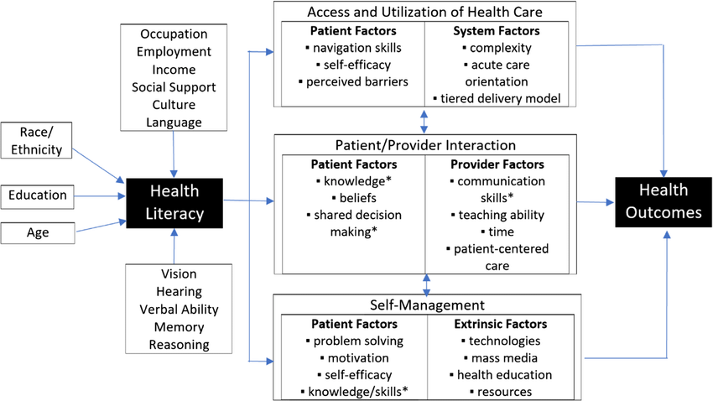
Source: Paasche-Orlow and Wolf, 2007. Reprinted by permission from PNG Publications, American Journal of Health Behavior, www.ajhb.org.

Appendix-II: Details of intervention sessions
Each session will be structured as follow:
- Re-cap of the previous session
- Content for the session
- Teach back technique/ Feedback
- Goal setting for the next session

Session Zero (T0): Creating the peer group, Informed consent, Base line assessment

Module1:Patient’s perspective of disease and medications
Sessions1,2,3 (T1, T2, T3)
- Rapport establishment followingCBPR model for understandingpatients’disease and medicationexperiences,effectiveness,andsideeffectsof themedicines, and barrierstoadheringtomedications, and
- Goal setting for the next session

Module2:Knowledge transfer of disease and medications
- Sessions4, 5,6 (T4, T5, T6)
- Knowledge transfer of disease, medications and its adherence to the participants, strategies to overcome barriers for medication adherence. To educate about diet, lifestyle, and exercise.
- Goal setting for the next session

Session7:Midterm evaluation (T7)

Module 3: Introduction of peer educator
- Sessions8 (T8)

Module 4: Reality orientation and sensitization program in collaboration with Peer educator and role of social support

- Sessions9,10, 11, 12 (T9, T10, T11, T12)

Session13:Midterm evaluation (T13)

Module5: Institutionalization of interventions
- Session14,15,16.17 (T14, T15, T16, T17)

Session18:Final evaluation (T18)

Session number | Aim | Content | Deliverystrategy
T1 | To establish rapport  Goal setting for the next session | Ice breaking by general introductions of the participants with each other  Inform participantsaboutthepurposeand procedure of thewhole intervention  Giveoneplanttoeachparticipant&ask them to adhere to  the care regimenfor the plant | Activelistening  Introductionofgroup anthem  Feedback
T2 | To understand the participant’s medication experiences, effectiveness and side effects of the drugs  To identify the misconception related to medication  Goal setting for the next session | Ask patients ondisease-andmedication-relatedinformationandmisinformation (if any),including the name,dosage, frequency,and timing, purpose ofeach medication,potential side effects,and specialadministrationconsiderations. | Activelistening  Group anthem  Feedback
T3 | To interact with each participant based on feedback from the previous session  Discussion about treatment burden and barriers to medication adherence  Goal setting for the next session | Encourage patients toexpress their feelingsand barriers to their medication adherence | Activelistening  Groupanthem  Feedback
T4 | To educate patientsabout disease and their medication  Discuss about the role and importance of medication adherence  Goal setting for the next session | Discuss about the symptoms, causes, management of hypertension and Diabetes  Empower patientswith knowledgeabout the importanceof medicationadherence and theconsequences ofnonadherence usingLinkercase | Active listening and teach back technique  Story telling withlinkercases  Group anthem  Feedback
T5 | Discuss the strategies to overcome barriers for medication adherence  Goal setting for the next session | Set goals and helpmake anindividualisedadherenceimprovement planbased on patients’expectations andpreferences.  Ask patients to selectthree skills they want to learn to improve health | Activelistening  Group anthem  Feedback
T6 | To educate the participants about diet, lifestyle, and exercise  Goal setting for the next session | Discussthedietaryhabit of all participants,asktheirfavouritefood  Discuss about healthyfood, exercise, and self-care  Ask the participant toget their plant in thenext session | Active listening and Teach back technique using Poster  Group anthem  Feedback
T7 | Mid-term evaluation | Participants will be asked to fill questionnaires.  Inspect the plant that how participants take care of the plant and adhere to care | 1.MMAS-8 questionnaire  2. EQ-5D questionnaire  3. AAHLS questionnaire  4. PSQ-8 questionnaire
T8 | Introduction of peer educator  Discuss the role of social support  Goal setting for the next session | Aware them about the role and importance of social support  Exploresocialsupport networks in  the management of hypertension and self-care. | Teach-back and  activelistening  Groupanthem  Feedback
T9 | Strengthening social support network in collaboration with peer educator  Goal setting for the next session | Peer educator will make a list of localresources and share with the participants (e.g.,medical careinstitutions, and,psychologicalsupportorganizations). | Mobilizing socialsupport  Group anthem  Feedback
T10 | Reality orientation programme in the collaboration with peer educator  Goal setting for the next session | Session will be started with the motivation speech by the peer educator and followed by the movie prepared by health care professionals | Movie  Group anthem  Feedback
T11 | Community sensitization programme in collaboration with peer educator  Goal setting for the next session | Participant with poorestcompliance acts as a doctorand participants with goodcompliance will be asked by the peer educator to act aspatients.  Reflectionoftheexperienceand summary of the Role-playingby the participants | Role play  Group anthem  Feedback
T12 | Strengthening group cohesiveness and bond with in self-help group  Goal setting for the next session | Peer educator and health care professional will plan a trip of the village with the participants  Ask the participant toget their plant in thenext session | Cooking&shoppingwith participant in theirlocalmarket  and farm visit  Group anthem  Feedback
T13 | Mid-term evaluation | Participants will be asked to fill questionnaires.  Inspect the plant that how participants take care of the plant and adhere to care | 1.MMAS-8 questionnaire  2. EQ-5D questionnaire  3. AAHLS questionnaire  4. PSQ-8 questionnaire
T14 | Awareness building and reinforcement by the peer educator | Peer educator will deliver a session on all the aspects of hypertension and diabetes | Peer educator session  Group anthem  Feedback
T15 | Health focused fun game activity conducted by peer educator in the presence of health professionals | Playing the game in which participants must put a capsule shaped ball into a mouth shaped box in 3 attempts | Fun game  Health line race  Group anthem  Feedback
T16 | Assessment of the knowledge gain by the participants during the previous sessions by peer educator in the presence of health professionals | The cards with pictures of different food items given to the participants. They have to sort out the healthy food card in the green colour box and the unhealthy food in the red colour box  Ask the participant toget their plant in thenext session | Food sorting game  Group anthem  Feedback
T17 | To know the experience of the participants of the intervention | Each participant will share their experience with the peer group  Inspect the plant that how participants take care of the plant and adhere to care | Sharing session  Group anthem  Feedback
T18 | Final evaluation | Participants will be asked to fill questionnaires. | 1.MMAS-8 questionnaire  2. EQ-5D questionnaire  3. AAHLS questionnaire  4. PSQ-8 questionnaire
Appendix III: Patient information sheet & consent form for participation in the study
Title of the project

Effect of peer-group therapy using community based participatory research (CBPR) model on medication adherence among patients of diabetes or hypertension: A multi-centric cluster randomized trial in rural settings across India
Principal investigator:
Dr.Pooja Reddy,
Prof & Head
Sri Aurobindo Medical College & PGI
Indore, Madhya Pradesh

Co-Investigators:

Dr. Anuja Jha
Associate Professor
Department of Pharmacology
Sri Aurobindo Medical College & PGI
Indore, Madhya Pradesh

Dr. Harshal Gupta
Associate Professor
Department of Community Medicine
Sri Aurobindo Medical College & PGI
Indore, Madhya Pradesh

Dr.Vivek Verma
Assistant Professor
Department of Statistics
Assam University
Silchar,Assam

Dr. Denny John,
Professor,
Faculty of Life and Allied Health Sciences
MS Ramaiah University of Applied Sciences
Bengaluru, Karnataka

We are inviting people to take part in a study that will evaluate ways to improve adherence inpatientswhohavehypertension or diabetes.Numerous research has demonstrated that putting interdisciplinary team-building interventions into practice improves adherence, which in turn improves health outcomes. Peer group therapy is one of those intervention.To make it evidence based, a study coordinated by Sri Aurobindo Medical College & PGI,Indorewith support of Indian Council of Medical Research is being carried out to determine the effect of peer group therapy on adherence among diabetics & hypertensive patients. If you agree toparticipate, you will be asked to agree to the researchers having access to your clinicalinformation,includingaccesstoyourmedicalrecord & personal information.Youalsowillbeagreeingtocome for follow up for 1 year & you can be contacted by study team during this period. You will be asked to fill questionnaire aboutyourhealthandmedicine taking habits during the study period.

Project investigators involved in this study at SAMC & PGI, Indore will take care of standard
operating procedures, collection, anonymization, of your data as per ICMR guidelines.

Purpose of the project:To evaluate the improvement in the medication adherence in diabetics & hypertensive patients due to peer group therapy. It will also evaluate improvement in health literacy and clinical outcome due to peer group therapy.
Explanation of procedures to be followed: If you meet the conditions for being included in the study, your demographic details, HbA1C & blood pressure will be measured. Approximately 5 ml (one teaspoon) of blood sample will be drawn by venipuncture. This will be done 4 times in a period of 12 months. These investigations will be performed at no cost to you. You will be asked to fill 3 questionnaire forms which will take around 15 minutes. For the first six months, you will be requested to attend peer group therapy twice a month, and then once a month for the following six months. A group of people with diabetes or hypertension who have trouble taking their medications will be organized for peer group therapy. Adherence challenges and solutions will be covered.
Expected Benefits:This study will help to develop guidelines & policies based on evidence to improve mediation adherence among chronic diseases like diabetes and hypertension in Indian settings. This will also improve the health literacy and quality of life.
Any risk to subject associated with the study: None
Maintenance of confidentiality of records:All medical records and research materials in which you are identified will be kept confidential and will not be made publicly available unless required by applicable law and or regulations. You understand that if the results of this study are published, no one will know you were a part of the study.
Rights to withdraw from this study
Taking part in this study is up to you. You may choose not to take part or you may leave the study at any time. Choosing not to take part or leaving the study will not result in any penalty. Your decision will not affect your access to medical care in the future.
Duration of the Study: Three years
Compensation: You will not be paid for your participation in the study
Monetary compensation
You will not receive any payment of any kind for your participation in this study.
Questions / patients' rights
You will be completely free to make inquiries during all of the stages of this study, raise any issue, and ask about any or all of your rights and obligations as a research subject, at any time during the course of this study. If you have any other questions about the study you should contact 9752114077, 7389544347 or any one of the investigators

INFORMED CONSENT FORM
Protocol/Study number:
Patient identification number for this trial:

Title of Project: “Effect of peer-group therapy using community based participatory research (CBPR) model on medication adherence among patients of diabetes or hypertension: A multi-centric cluster randomized trial in rural settings across India”
Name of Principal Investigator: Dr. Pooja Reddy
The contents of the information sheet dated............................... (Version)..................... that was provided have been read carefully by me/ explained in detail to me, in a language that I comprehend, and have fully understood the contents. I confirm that I have had the opportunity to ask questions.
The nature and purpose of the study and its potential risks / benefits and expected duration of the study, and other relevant details of the study have been explained to me in detail. I understand that my participation is voluntary and that I am free to withdraw at any time, without giving any reason, without my medical care or legal right being affected. I give permission for these individuals to have access to my records.
I understand that all medical records and research materials in which I am identified will be kept confidential and will not be made publicly available unless required by applicable law or regulations. I understand that if the results of this study are published, no one will know I am a part of the study.
Iagreetotakepartinabovestudy.

................................................ Date:
(Signature/LeftThumbImpression) Place:NameofParticipant:.................................................
Son/Daughter/Spouseof..........................................
Completepostaladdress:...........................................
Thisistocertifythataboveconsenthasbeenobtainedinmypresence.

......................................................................
SignatureofthePrincipalInvestigator Date

Place:

1.Witness–1 Witness–2
............................. .......................
Signature Signature

Name: Name:
Address: Address:

Serial No:
Village name (Address):
Village code: AB
Group: ControlIntervention
Village Number: 1 1 2 3 4

PATIENT’S PERSONAL DETAILS
Participation Identification Number: _ _ _ _ _ (5 alphanumeric code, 1st three will be the first 3 letters of the name of the village and last two will be serial number of the patient.)
Name:
Age:
Gender: Male Female
Education status: Illiterate
Primary School
Middle School
High School
Intermediate Graduate
Post Graduate

Occupation:Self-employed in agriculture
Self-employed in non-agriculture
Regular wage/salary earning in non-agriculture
Casual labour in agriculture
Casual labour in non-agriculture
Homemaker
Unemployed
Others

Family income:
Does patient have contact no? Yes No
Contact no. Self: Relative:
(10 digit mobile number only)

CLINICAL INFORMATION
Medical Condition present: Hypertension
Diabetes
Both Hypertension and diabetes
Duration of Disease:

Details of medication:
Name
Dose
Dosage:
Frequency:
Duration
Route of drug administration:
Any other comorbid condition:
CLINICAL PARAMETERS
S No. | Time | Blood Pressure |  | HbA1C
S No. | Time | Systolic | Diastolic | HbA1C
1 | T0
2 | T7
3 | T13
4 | T18

Date of collection:
Time of Collection:

MORISKY MEDICATION ADHERENCE SCALE (MMAS-8)

MMAS- 8 questions | Yes | No
Do you sometimes forget to take your [health concern] pills?
People sometimes miss taking their medications for reasons other than forgetting. Thinking over the past two weeks, were there any days when you did not take your [health concern] medicine?
Have you ever cut back or stopped taking your medication without telling your doctor, because you felt worse when you took it?
When you travel or leave home, do you sometimes forget to bring along your [health concern] medication?
Did you take your [health concern] medicine yesterday?
When you feel like your [health concern] is under control, do you sometimes stop taking your medicine?
Taking medication everyday is a real inconvenience for some people. Do you ever feel hassled about sticking to your [health concern] treatment plan?
How often do you have difficulty remembering to take all your medications?

Never/Rarely
Once in a while
Sometimes
Usually
All the time

EQ5-D scale
Q. पहले, मैंआपसेचलने-फिरनेकेबारेमेंपूछनाचाहूँगा/चाहूँगी।क्याआपकहेंगेकि:
1.आपकोचलने-फिरनेमेंकोईमुश्किलनहींहै?
2.आपकोचलने-फिरनेमेंहल्कीमुश्किलहै?
3. आपकोचलने-फिरनेमेंमध्यमदर्जेकीमुश्किलहै?
4. आपकोचलने-फिरनेमेंगंभीरमुश्किलहै?
5. आपचलने-फिरनेमेंअसमर्थहैं?

Q. अब, मैंआपसेआपकीअपनीदेखभालकेबारेमेंपूछनाचाहूँगा/चाहूँगी।क्याआपकहेंगेकि:
1. आपकोअपनेआपनहाने-धोनेयाकपड़ेपहननेमेंकोईमुश्किलनहींहै?
2. आपकोअपनेआपनहाने-धोनेयाकपड़ेपहननेमेंहल्कीमुश्किलहै?
3. आपकोअपनेआपनहाने-धोनेयाकपड़ेपहननेमेंमध्यमदर्जेमुश्किलहै?
4. आपकोअपनेआपनहाने-धोनेयाकपड़ेपहननेमेंगंभीरमुश्किलहै?
5. आपअपनेआपनहाने-धोनेयाकपड़ेपहननेमेंअसमर्थहैं?

Q. अब, मैंआपसेआपकीसामान्यगतिविधयों, जैसेकाम, पढ़ाई-लिखाई, घरकेकामकाज, पारिवारिकयाफुरसतकीगतिविधियोंकेबारेमेंपूछनाचाहूँगा/चाहूँगी।क्याआपकहेंगेकि:
1. आपकोअपनीसामान्यगतिविधियाँकरनेमेंकोईमुश्किलनहींहै?
2. आपकोअपनीसामान्यगतिविधियांकरनेमेंहल्कीमुश्किलहै?
3. आपकोअपनीसामान्यगतिविधियांकरनेमेंमध्यमदर्जेकीमुश्किलहै?
4. आपकोअपनीसामान्यगतिविधियांकरनेमेंगंभीरमुश्किलहै?
5. आपअपनीसामान्यगतिविधियांकरनेमेंअसमर्थहैं?

Q. अब, मैंआपसेआपकेदर्दयातकलीफकेबारेमेंपूछनाचाहूँगा/चाहूँगी।क्याआपकहेंगेकि:
1. आपकोकोईदर्दयातकलीफनहींहै?
2. आपकोहल्कादर्दयातकलीफहै?
3. आपकोमध्यमदर्जेकादर्दयातकलीफहै?
4. आपकोगंभीरदर्दयातकलीफहै?
5. आपकोबेहददर्दयातकलीफहै?

Q. अंतमें, मैंआपसेआपकीघबराहटयाउदासीकेबारेमेंपूछनाचाहूँगा/चाहूँगी।क्याआपकहेंगेकि:
1. आपघबराएहुए/घबराईहुईंयाउदासनहींहैं?
2. आपहल्केसेघबरायेहुए/घबराईहुईयाउदासहैं?
3. आपमध्‍यमरूपसेघबराएहुए/घबराईहुईंयाउदासहैं?
4. आपगंभीररूपसेघबराएहुए/घबराईहुईंयाउदासहैं?
5. आपबेहदघबराएहुए/घबराईहुईंयाउदासहैं?

अब, मैंपूछनाचाहूँगा/चाहूँगीकिआपबतायेकिआजआपकास्वास्थ्यकितनाअच्छायाखराबहै।
मैंचाहूँगा/चाहूँगीकिआपअपनेदिमागमें 0 से 100 नंबरकीएकखड़ीलाइनकीकल्पनाकरें।
(साक्षात्कारकर्ताध्यानदें: अगरआमने-सामनेसाक्षात्कारकियाजारहाहै, तोकृपयाउत्तरदाताको VAS लाइनदिखाएं।)लाइनकेसबसेऊपर 100 कामतलबहैसबसेअच्छास्वास्थ्यजिसकीआपकल्पनाकरसकतेहैं।लाइनकेसबसेनीचे 0कामतलबहैसबसेख़राबस्वास्थ्यजिसकीआपकल्पनाकरसकतेहैं।

PSQ-8
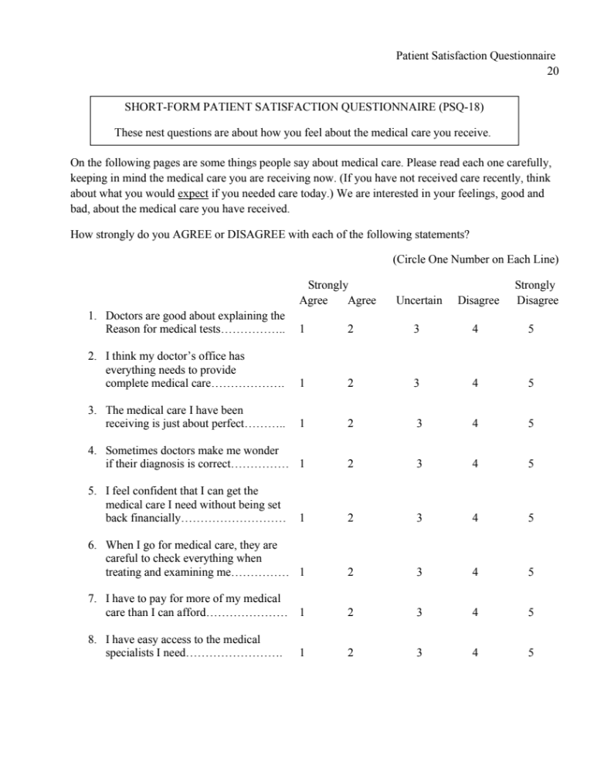

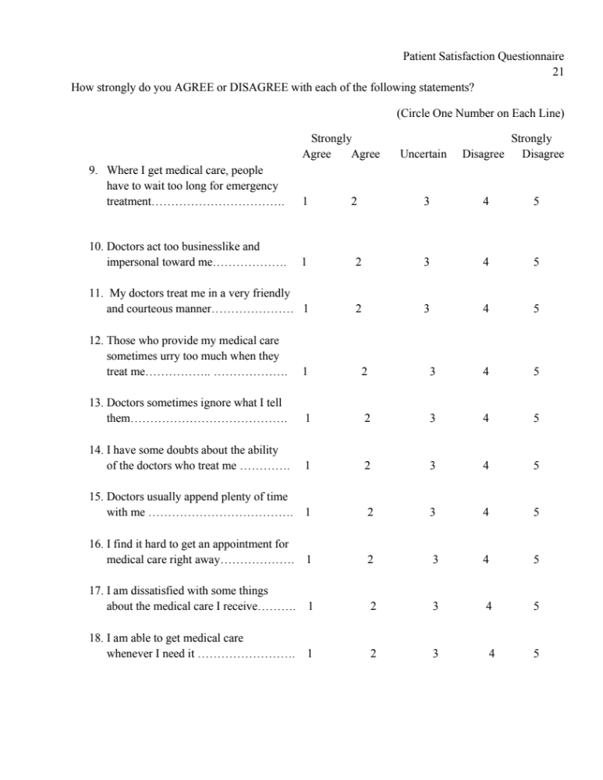

All Aspects of Health Literacy Scale (AAHLS)
Please tick one response only for each question by placing a tick in the box
If you prefer, a member of staff or the research team can read out questions to you
FQ1 | How often do you need someone to help you when you are given information to read by your doctor, nurse or pharmacist? |  | □ often | □ sometimes |  | □ rarely
FQ2 | When you need help, can you easily get hold of someone to assist you? |  | □ often | □ sometimes |  | □ rarely | □ not applicable
FQ3 | Do you need help to fill in official documents? |  | □ often | □ sometimes |  | □ rarely
ComQ1 | When you talk to a doctor or nurse, do you give them all the information they need to help you? |  | □ often | □ sometimes |  | □ rarely
ComQ2 | When you talk to a doctor or nurse, do you ask the questions you need to ask? |  | □ often | □ sometimes |  | □ rarely
ComQ3 | When you talk to a doctor or nurse, do you make sure they explain anything that you do not understand? |  | □ often | □ sometimes |  | □ rarely
CrQ1 | Are you someone who likes to find out lots of different information about your health? |  | □ often | □ sometimes |  | □ rarely
CrQ2 | How often do you think carefully about whether information makes sense in your particular situation? |  | □ often | □ sometimes |  | □ rarely
CrQ3 | How often do you try to work out whether information about your health can be trusted? |  | □ often | □ sometimes |  | □ rarely
CrQ4 | Are you the sort of person who might question your doctor or nurse’s advice based on your own research? |  | □ yes, definitely | □maybe/  sometimes |  | □ not really
Emp1 | Do you think that there plenty of ways to have a say in what the government does about health? |  | □ yes, definitely | □maybe/  sometimes |  | □ not really
Emp2 | Within the last 12 months have you taken action to do something about a health issue that affects your family or community? | □ yes |  |  | □no
Emp3 | What do you think matters most for everyone’s health? (tick one answer only) | □a) information and encouragement to lead healthy lifestyles |  |  | □b) good housing, education, decent jobs and good local facilities


WHODAS2.0
WORLDHEALTHORGANIZATIONDISABILITYASSESSMENTSCHEDULE2.0

12-itemversion,self-administered
Thisquestionnaireasksaboutdifficultiesduetohealthconditions.Healthconditionsincludediseasesor illnesses,otherhealthproblemsthat maybeshortorlonglasting,injuries, mentaloremotionalproblems, and problems with alcohol or drugs.

Thinkbackoverthepast30days andanswerthesequestions,thinkingabouthowmuchdifficulty you had doing the following activities. For each question, please circle only one response.

Inthepast30days,howmuchdifficultydidyouhavein:
S1 | Standingforlongperiodssuchas30minutes? | None | Mild | Moderate | Severe | Extreme orcannot do
S2 | Takingcareofyourhouseholdresponsibilities? | None | Mild | Moderate | Severe | Extreme orcannot do
S3 | Learning a new task, for example, learninghowtogettoanewplace? | None | Mild | Moderate | Severe | Extreme orcannot do
S4 | Howmuchofaproblemdidyouhave joining in community activities (for example,festivities,religiousorother activities)inthesamewayasanyone elsecan? | None | Mild | Moderate | Severe | Extreme orcannot do
S5 | Howmuchhaveyoubeenemotionallyaffected by your health problems? | None | Mild | Moderate | Severe | Extreme orcannot do
Inthepast30days,howmuchdifficultydidyouhavein:
S6 | Concentratingondoingsomethingfor tenminutes? | None | Mild | Moderate | Severe | Extreme orcannot do
S7 | Walkingalongdistancesuchasa kilometre [or equivalent]? | None | Mild | Moderate | Severe | Extreme orcannot do
S8 | Washingyourwholebody? | None | Mild | Moderate | Severe | Extreme orcannot do
S9 | Gettingdressed? | None | Mild | Moderate | Severe | Extreme orcannot do
S10 | Dealingwithpeopleyoudonotknow? | None | Mild | Moderate | Severe | Extreme orcannot do
S11 | Maintainingafriendship? | None | Mild | Moderate | Severe | Extreme orcannot do
S12 | Yourday-to-daywork? | None | Mild | Moderate | Severe | Extreme orcannot do
H1 | Overall,inthepast30days,howmanydayswerethese difficulties present? | Recordnumberofdays
H2 | Inthe past 30days, for how many days wereyoutotally unable to carry out your usual activities or work because of any health condition? | Recordnumberofdays
H3 | Inthepast30days,notcountingthedaysthatyouweretotally unable, for how many days did you cut back or reduce your usual activities or work because of any health condition? | Recordnumberofdays

