Supplementary File 1: Pre and Post Questionnaires
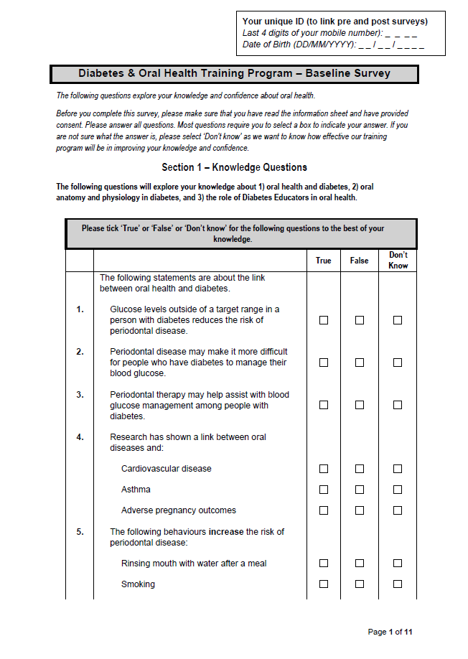
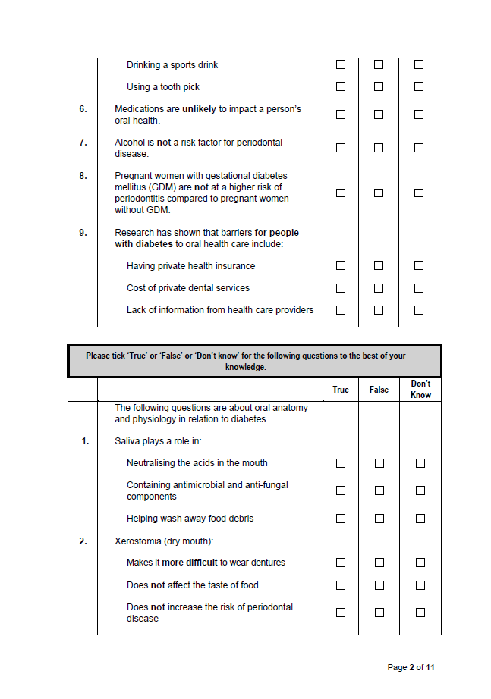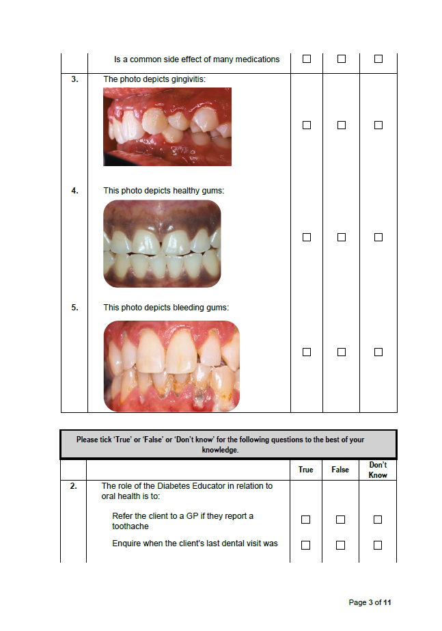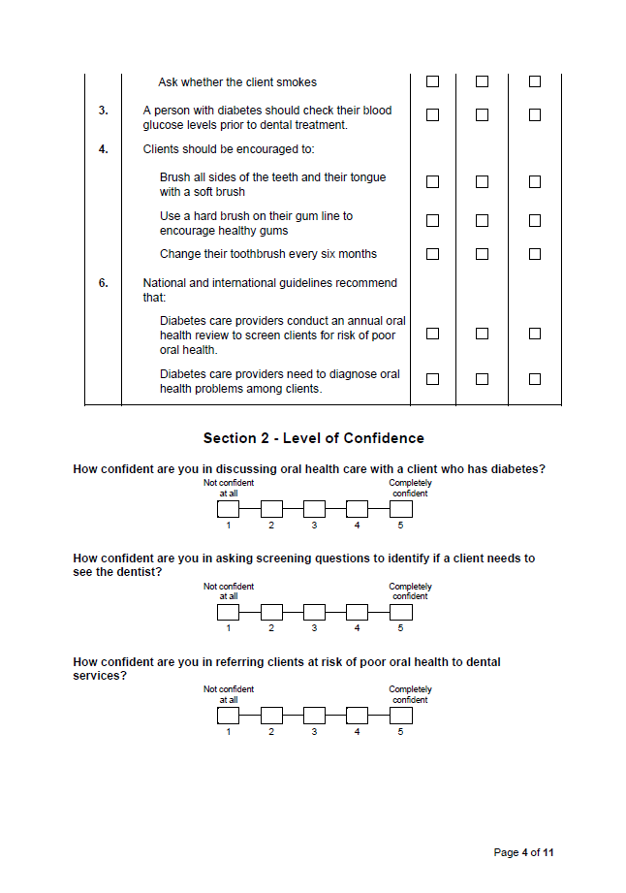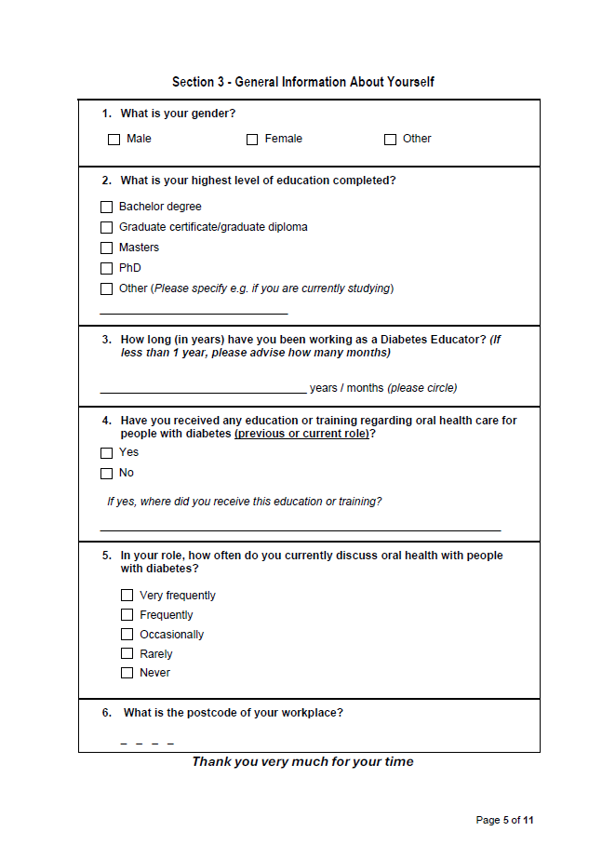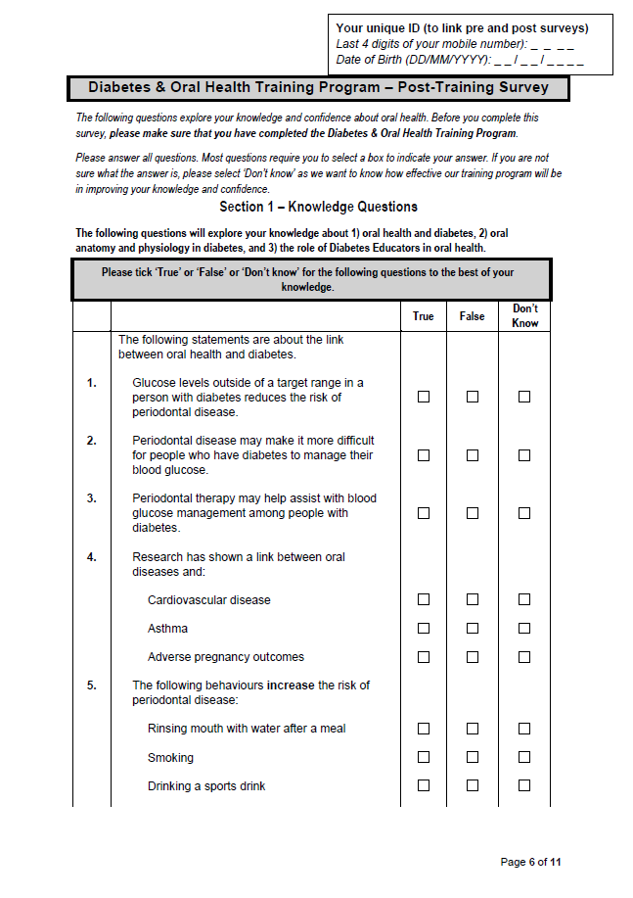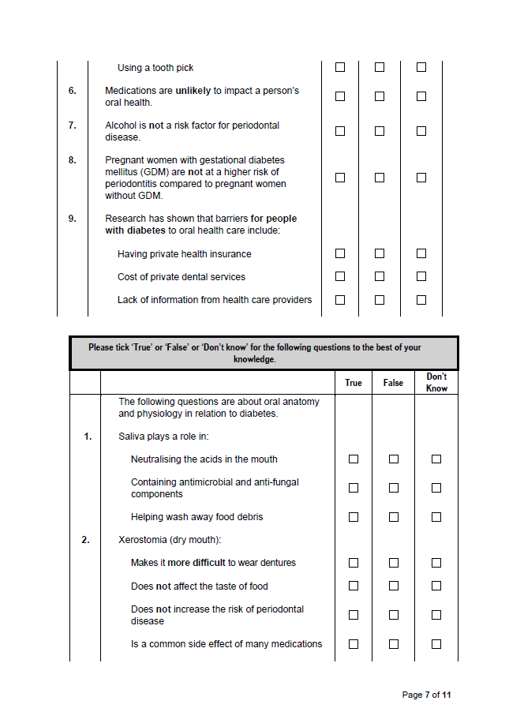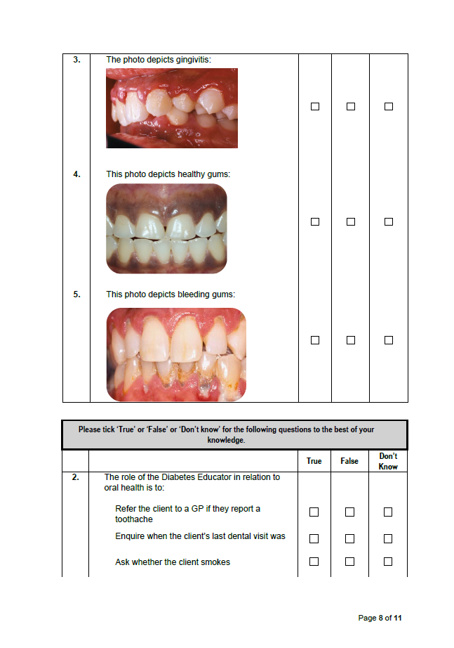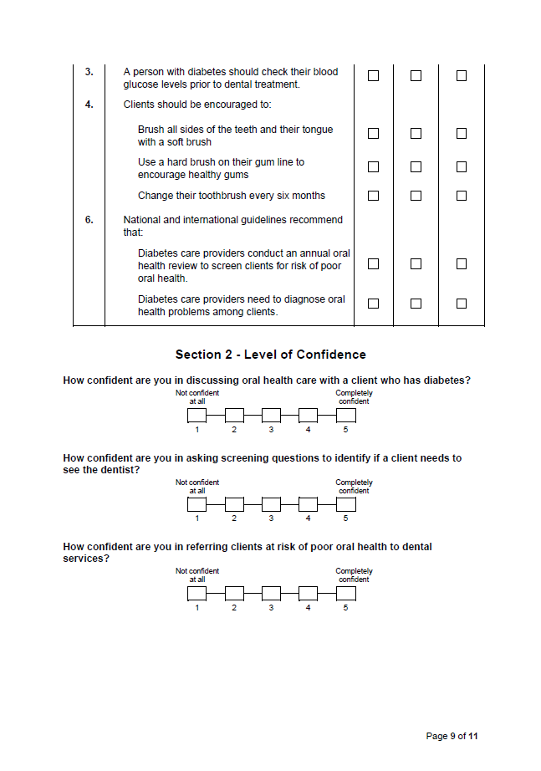

Supplementary File 2: Correct responses given by participants to individual knowledge questions pre and post-DIOH training

Questions | Pre N (%) | Post N (%) | % change
Glucose levels outside of a target range in a person with diabetes reduces the risk of periodontal disease. | 16 (76) | 21 (100) | +24
Periodontal disease may make it more difficult for people who have diabetes to manage their blood glucose. | 21 (100) | 21 (100) | -
Periodontal therapy may help assist with blood glucose management among people with diabetes. | 18 (86) | 21 (100) | +14
Research has shown a link between oral diseases and:
Cardiovascular disease | 16 (76) | 21 (100) | +24
Asthma | 5 (24) | 8 (38) | +14
Adverse pregnancy outcomes | 10 (48) | 18 (86) | +38
The following behaviours increase the risk of periodontal disease:
Rinsing mouth with water after a meal | 17 (81) | 20 (95) | +14
Smoking | 21 (100) | 21 (100) | -
Drinking a sports drink | 21 (100) | 21 (100) | -
Using a toothpick | 9 (43) | 9 (43) | -
Medications are unlikely to impact a person’s oral health. | 12 (57) | 21 (100) | +43
Alcohol is not a risk factor for periodontal disease. | 14 (67) | 19 (90) | +23
Pregnant women with gestational diabetes mellitus (GDM) are not at a higher risk of periodontitis compared to pregnant women without GDM. | 13 (62) | 21 (100) | +38
Research has shown that barriers for people with diabetes to oral health care include:
Having private health insurance | 6 (29) | 7 (33) | +4
Cost of private dental services | 19 (90) | 21 (100) | +9
Lack of information from health care providers | 16 (76) | 21 (100) | +24
Saliva plays a role in:
Neutralising the acids in the mouth | 18 (86) | 21 (100) | +14
Containing antimicrobial and anti-fungal components | 16 (76) | 21 (!00) | +24
Helping wash away food debris | 19 (90) | 21(100) | +10
Xerostomia (dry mouth):
Makes it more difficult to wear dentures | 19 (90) | 21 (100) | +10
Does not affect the taste of food | 17 (81) | 20 (95) | +14
Does not increase the risk of periodontal disease | 17 (81) | 21 (100) | +19
Is a common side effect of many medications | 19 (90) | 21 (100) | +10
The role of the Diabetes Educator in relation to oral health is to:
Refer the client to a GP if they report a toothache | 5 (24) | 12 (57) | +33
Enquire when the client’s last dental visit was | 20 (90) | 21 (100) | +10
Ask whether the client smokes | 21 (100) | 21 (100) | -
A person with diabetes should check their blood glucose levels prior to dental treatment. | 18 (86) | 20 (95) | +9
Clients should be encouraged to:
Brush all sides of the teeth and their tongue with a soft brush | 10 (48) | 21 (100) | +52
Use a hard brush on their gum line to encourage healthy gums | 17 (81) | 19 (90) | +9
Change their toothbrush every six months | 5 (24) | 12 (57) | +33
National and international guidelines recommend that:
Diabetes care providers conduct an annual oral health review to screen clients for risk of poor oral health. | 15 (71) | 21 (100) | +29
Diabetes care providers need to diagnose oral health problems among clients. | 5 (24) | 14 (67) | +43

Supplementary File 3: Participants feedback on the DIOH learning objective (Response scale of 1-5, where 1 = strongly disagree, 5 = strongly agree)

Learning Objective | Range | Mean (SD) | % of those who agreed to the statements
I have an increased awareness of the impact of oral health on diabetes management. | 3.00 - 5.00 | 4.48 (.75) | 86
I understand the bi-directional link between oral health and diabetes. | 3.00 - 5.00 | 4.48 (.75) | 86
I recognise additional factors that predispose poor oral health and barriers to oral health care. | 3.00 - 5.00 | 4.38 (.80) | 81
I can identify differences between a normal, healthy mouth and one that may be unhealthy. | 3.00 - 5.00 | 4.33 (.80) | 81

Supplementary File 4: Participants feedback on the DIOH training content (Response scale of 1-5, where 1 = strongly disagree, 5 = strongly agree)

Training content: | Range | Mean (SD) | % of those who agreed to the statements
The content was easy to understand. | 3.00 - 5.00 | 4.52 (.68) | 91
The material was relevant to my work. | 3.00 - 5.00 | 4.57 (.68) | 91
The screening tool is easy to use. | 3.00 - 5.00 | 4.52 (.60) | 95
The referral pathways would be appropriate to use. | 3.00 - 5.00 | 4.38 (.67) | 91
The length of the training was adequate. | 3.00 - 5.00 | 4.43 (.68) | 91
I would recommend this training to a colleague. | 3.00 - 5.00 | 4.48 (.68) | 90

