Supplementary Material

Supplementary Figures and Tables
Additional file Data S1. Survival rate, Body weight change of Normal and MRL/FAS^{lpr} mice
Additional file Data S2. Incidence of moderate to severe proteinuria in Normal and MRL/FAS^{lpr} mice
Additional file Data S3. Kidney and Spleen weight of Normal and MRL/FAS^{lpr} mice

Additional file Data S4. Concentration of anti-dsDNA in serum of Normal and MRL/FAS^{lpr} mice
Additional file Data S5. Histological scores of H&E-stained kidney tissues of Normal and MRL/FAS^{lpr} mice
Additional file Table S1. Body weight (BW) changes of Normal and MRL/FAS^{lpr} mice
Additional file Table S2. Proteinuria scores of Normal and MRL/FAS^{lpr} mice
Additional file Table S3. Proteinuria scores AUC of Normal and MRL/FAS^{lpr} mice
Additional file Table S4. Incidence of moderate to severe proteinuria in Normal and MRL/FAS^{lpr} mice
Additional file Table S5. Skin scores of Normal and MRL/FAS^{lpr} mice
Additional file Table S6. Skin scores AUC of Normal and MRL/FAS^{lpr} mice
Additional file Table S7. Lymphadenopathy scores of Normal and MRL/FAS^{lpr} mice
Additional file Table S8. Lymphadenopathy scores AUC of Normal and MRL/FAS^{lpr} mice
Additional file Table S9. Mean kidney, right kidney, left kidney and spleen weight of Normal and MRL/FAS^{lpr} mice
Additional file Table S10. Treg (CD3⁺CD4⁺CD25⁺ FoxP3⁺) cell subset proportion in the spleen of Normal and MRL/FAS^{lpr} mice
Additional file Table S11. Concentration of anti-dsDNA in serum of Normal and MRL/FAS^{lpr} mice
Additional file Table S12. Histological scores of H&E-stained kidney tissue – Glomerulonephritis
Additional file Table S13. Fluorescence intensity of IgG-stained kidney tissue

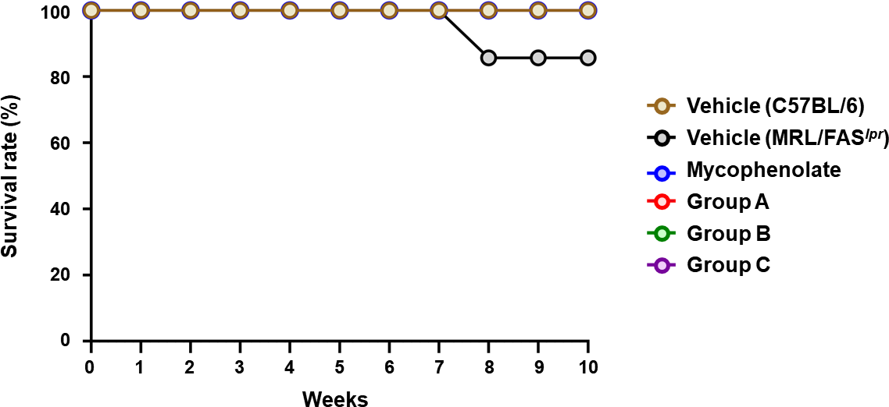
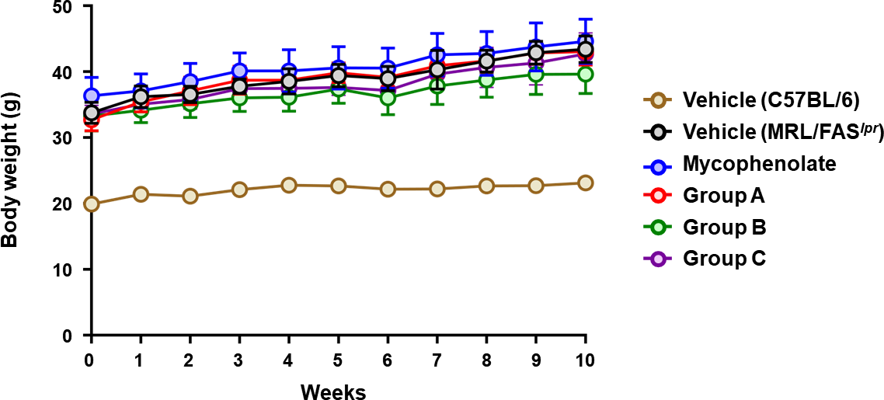
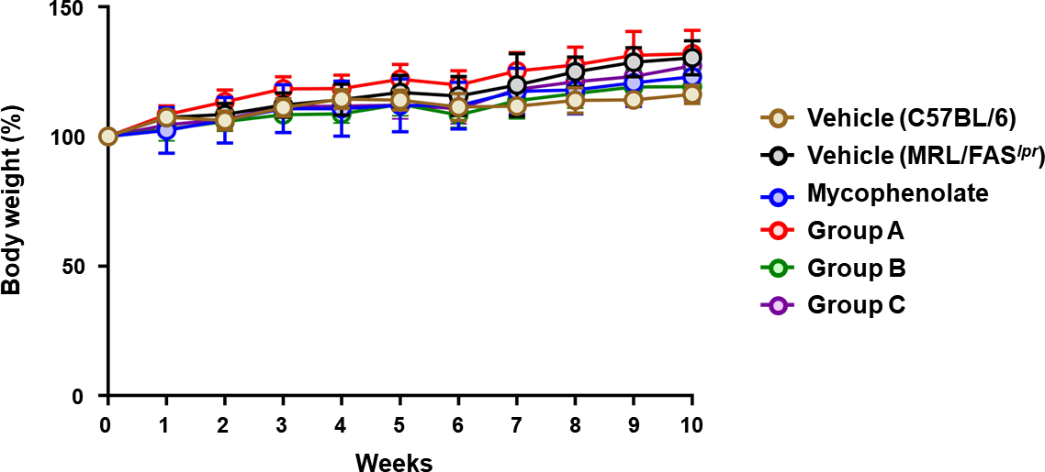
Supplementary Figures
A
B
C

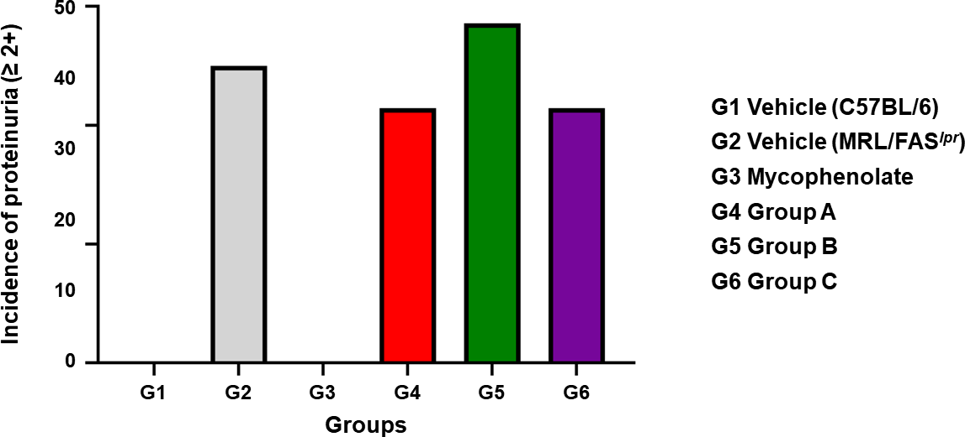
Additional file Data S1. Survival rate, Body weight change of Normal and MRL/FAS^{lpr} mice. A. Survival rates of Normal and MRL/FAS^{lpr} mice following treatment of indicated compounds for 10 weeks. The mice were grouped into C57BL/6 and MRL/FAS^{lpr} mice treated with Vehicle, B. Body weight changes (g) of Normal and MRL/FAS^{lpr} mice following treatment of indicated compounds for 10 weeks. C. Body weight changes (%) of Normal and MRL/FAS^{lpr} mice following treatment of indicated compounds for 10 weeks. The mice were grouped into C57BL/6 and MRL/FAS^{lpr} mice treated with Vehicle Mycophenolate (PO, QD), A (SC, TIW), B (SC, TIW), and C (SC, TIW). Data are expressed as the mean ± SD. * = P < 0.05, ** = P < 0.01, *** = P < 0.001 versus Vehicle (MRL/FASlpr).

Additional file Data S2. Incidence of moderate to severe proteinuria in Normal and MRL/FAS^{lpr} mice following treatment of indicated compounds for 10 weeks. The mice were grouped into C57BL/6 and MRL/FAS^{lpr} mice treated with Vehicle, Mycophenolate (PO, QD), A (SC, TIW), B (SC, TIW), and C (SC, TIW). Data are expressed as the mean ± SD. * = P < 0.05, ** = P < 0.01, *** = P < 0.001 versus Vehicle (MRL/FAS^{lpr}).

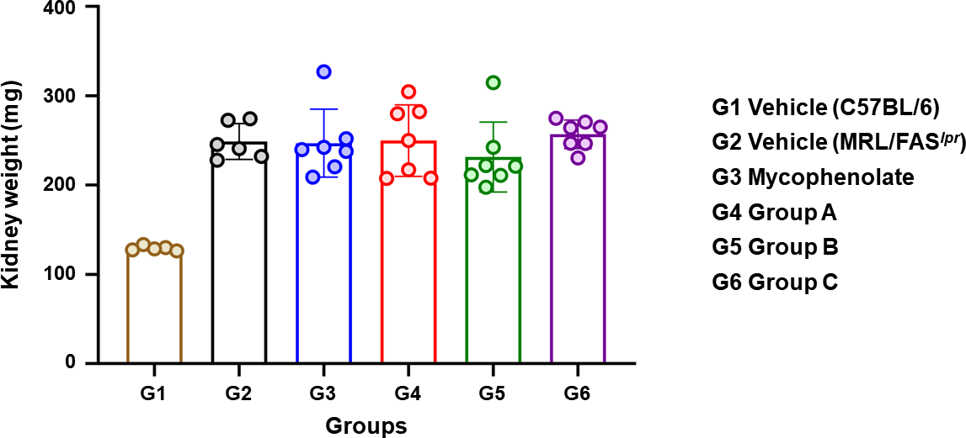
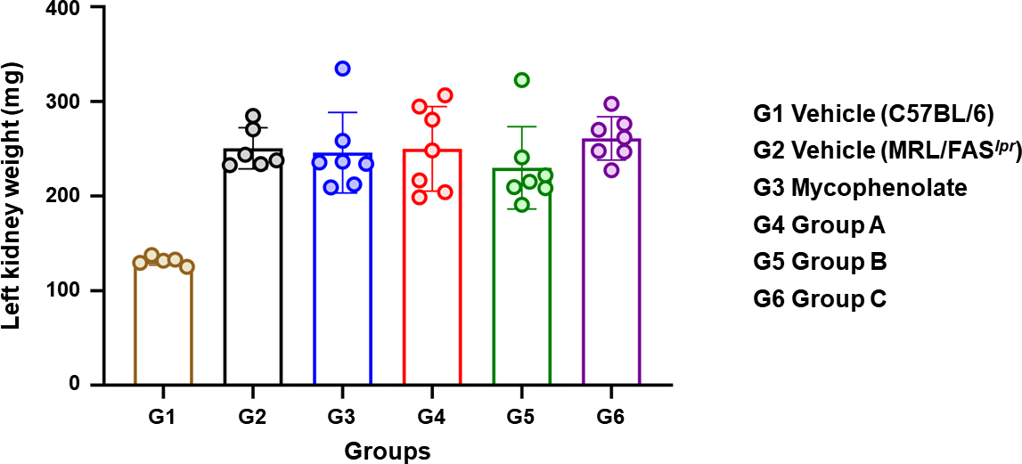
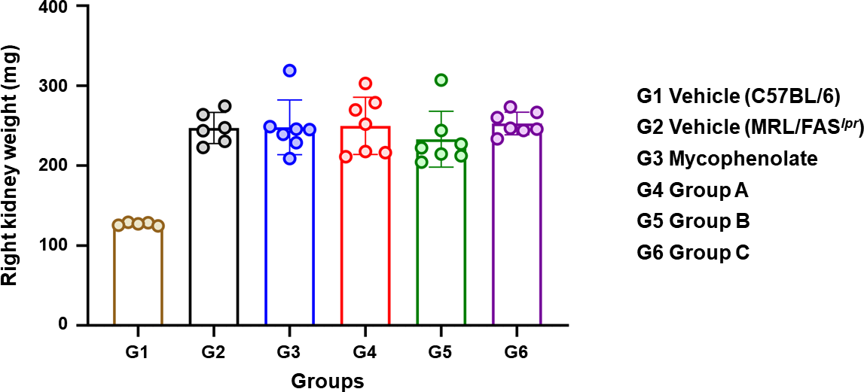
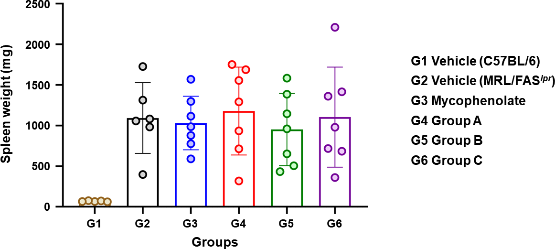
Additional file Data S3. Kidney and Spleen weight of Normal and MRL/FAS^{lpr} mice. Mean (A), left (B), right (C) kidney weight and Spleen weight of Normal and MRL/FAS^{lpr} mice following treatment of indicated compounds for 10 weeks. The mice were grouped into C57BL/6 and MRL/FAS^{lpr} mice treated with Vehicle, Mycophenolate (PO, QD), A (SC, TIW), B (SC, TIW), and C (SC, TIW). Data are expressed as the mean ± SD. * = P < 0.05, ** = P < 0.01, *** = P < 0.001 versus Vehicle (MRL/FAS^{lpr}). Data are expressed as the mean ± SD. * = P < 0.05, ** = P < 0.01, *** = P < 0.001 versus Vehicle (MRL/FAS^{lpr}).
A
B
C
D

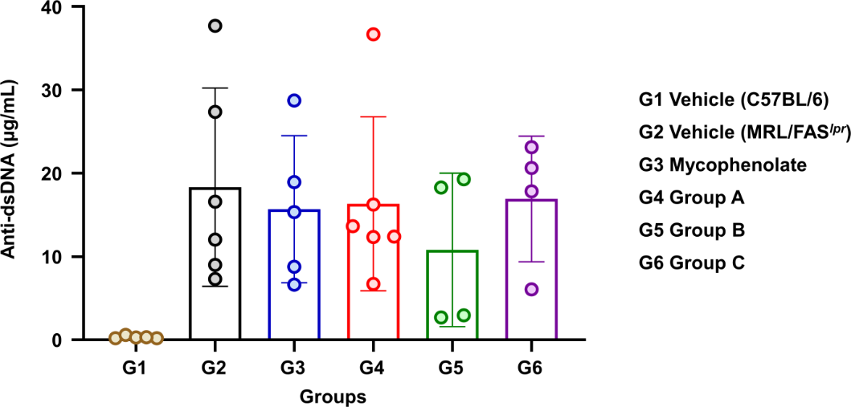
Additional file Data S4. Concentration of anti-dsDNA in serum of Normal and MRL/FAS^{lpr} mice following treatment of indicated compounds for 10 weeks. The mice were grouped into C57BL/6 and MRL/FAS^{lpr} mice treated with Vehicle, Mycophenolate (PO, QD), A (SC, TIW), B (SC, TIW), and C (SC, TIW). Data are expressed as the mean ± SD. * = P < 0.05, ** = P < 0.01, *** = P < 0.001 versus Vehicle (MRL/FAS^{lpr}). Data are expressed as the mean ± SD. * = P < 0.05, ** = P < 0.01, *** = P < 0.001 versus Vehicle (MRL/FAS^{lpr}).
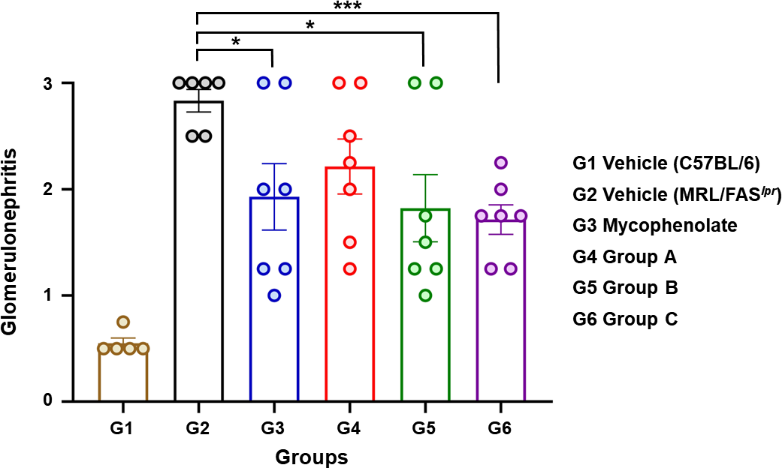

Additional file Data S5. Histological scores of H&E-stained kidney tissues of Normal and MRL/FAS^{lpr} mice following treatment of indicated compounds for 10 weeks. The mice were grouped into Normal (C57BL/6) and MRL/FAS^{lpr} mice treated with Vehicle, Mycophenolate, Group A, Group B, Group C. Data are expressed as the mean ± SEM. * = P < 0.05, ** = P < 0.01, *** = P < 0.001 versus Vehicle.

Supplementary Tables
Group | BW (Week 0) |  | BW (Week 10) |  | BW change (%, Week 10 as 100%)
Group | Mean | SD | Mean | SD | Mean | SD | P value vs Vehicle (MRL/FAS^{lpr}) | P value vs Mycophenolate  (MRL/FAS^{lpr})
[C57BL/6] Vehicle | 19.90 | 0.43 | 23.12 | 0.38 | 116.23 | 3.50 | NA | NA
[MRL/FAS^{lpr}] Vehicle | 33.76 | 1.59 | 43.42 | 2.02 | 130.29 | 6.61 | - | NA
[MRL/FAS^{lpr}] Mycophenolate | 36.36 | 2.81 | 44.61 | 3.37 | 123.01 | 8.89 | 0.5514 | -
[MRL/FAS^{lpr}] Group A | 32.70 | 1.67 | 43.04 | 2.07 | 131.91 | 9.06 | 0.9427 | 0.1036
[MRL/FAS^{lpr}] Group B | 33.27 | 2.25 | 39.64 | 2.93 | 119.25 | 6.85 | 0.2516 | 0.9924
[MRL/FAS^{lpr}] Group C | 33.57 | 1.31 | 42.70 | 3.19 | 127.26 | 9.40 | 0.8074 | 0.9975
Additional file Table S1. Body weight (BW) changes of Normal and MRL/FAS^{lpr} mice

Group | Proteinuria score (Week 10)
Group | Mean | SD | P value vs Vehicle (MRL/FAS^{lpr}) | P value vs Mycophenolate (MRL/FAS^{lpr})
[C57BL/6] Vehicle | 0.00 | 0.00 | NA | NA
[MRL/FAS^{lpr}] Vehicle | 1.75 | 0.42 | - | NA
[MRL/FAS^{lpr}] Mycophenolate | 0.57 | 0.19 | <0.0001 | -
[MRL/FAS^{lpr}] Group A | 1.50 | 0.96 | 0.2569 | 0.0076
[MRL/FAS^{lpr}] Group B | 1.21 | 0.49 | 0.1473 | 0.0172
[MRL/FAS^{lpr}] Group C | 0.93 | 0.35 | 0.0785 | 0.0373
* NA: Not Applied
Additional file Table S2. Proteinuria scores of Normal and MRL/FAS^{lpr} mice
Group | Proteinuria score AUC (Week 10)
Group | Mean | SD | P value vs Vehicle (MRL/FAS^{lpr}) | P value vs Mycophenolate (MRL/FAS^{lpr})
[C57BL/6] Vehicle | 6.70 | 0.30 | NA | NA
[MRL/FAS^{lpr}] Vehicle | 14.79 | 0.73 | - | NA
[MRL/FAS^{lpr}] Mycophenolate | 5.36 | 1.21 | < 0.0001 | -
[MRL/FAS^{lpr}] Group A | 10.89 | 1.81 | 0.0694 | 0.0280
[MRL/FAS^{lpr}] Group B | 10.25 | 0.80 | 0.0013 | 0.0055
[MRL/FAS^{lpr}] Group C | 9.82 | 0.76 | 0.0005 | 0.0089
* NA: Not Applied
Additional file Table S3. Proteinuria scores AUC of Normal and MRL/FAS^{lpr} mice

Group | Mean | P value vs Vehicle (MRL/FAS^{lpr}) | P value vs Mycophenolate (MRL/FAS^{lpr})
[C57BL/6] Vehicle | 0.00 | NA | NA
[MRL/FAS^{lpr}] Vehicle | 50.00 | - | NA
[MRL/FAS^{lpr}] Mycophenolate | 0.00 | 0.0332 | -
[MRL/FAS^{lpr}] Group A | 42.86 | 0.8166 | 0.0554
[MRL/FAS^{lpr}] Group B | 57.14 | 0.8166 | 0.0152
[MRL/FAS^{lpr}] Group C | 42.86 | 0.8166 | 0.0554
* NA: Not Applied
Additional file Table S4. Incidence of moderate to severe proteinuria in Normal and MRL/FAS^{lpr} mice
Group | Skin score (Week 10)
Group | Mean | SD | P value vs Vehicle (MRL/FAS^{lpr}) | P value vs Mycophenolate (MRL/FAS^{lpr})
[C57BL/6] Vehicle | 0.00 | 0.00 | NA | NA
[MRL/FAS^{lpr}] Vehicle | 1.75 | 0.42 | - | NA
[MRL/FAS^{lpr}] Mycophenolate | 0.57 | 0.19 | 0.0051 | -
[MRL/FAS^{lpr}] Group A | 1.50 | 0.96 | 0.9953 | 0.0137
[MRL/FAS^{lpr}] Group B | 1.21 | 0.49 | 0.7926 | 0.0917
[MRL/FAS^{lpr}] Group C | 0.93 | 0.35 | 0.0712 | 0.8776
* NA: Not Applied
Additional file Table S5. Skin scores of Normal and MRL/FAS^{lpr} mice

Group | Skin score AUC (Week 10)
Group | Mean | SD | P value vs Vehicle (MRL/FAS^{lpr}) | P value vs Mycophenolate (MRL/FAS^{lpr})
[C57BL/6] Vehicle | 0.00 | 0.00 | NA | NA
[MRL/FAS^{lpr}] Vehicle | 8.36 | 1.86 | - | NA
[MRL/FAS^{lpr}] Mycophenolate | 3.21 | 1.90 | 0.0003 | -
[MRL/FAS^{lpr}] Group A | 7.82 | 4.19 | 0.7583 | 0.0194
[MRL/FAS^{lpr}] Group B | 6.82 | 1.89 | 0.2741 | 0.0182
[MRL/FAS^{lpr}] Group C | 4.61 | 0.58 | 0.0005 | 0.0998
* NA: Not Applied
Additional file Table S6. Skin scores AUC of Normal and MRL/FAS^{lpr} mice
Group | Lymphadenopathy score (Week 10)
Group | Mean | SD | P value vs Vehicle (MRL/FAS^{lpr}) | P value vs Mycophenolate (MRL/FAS^{lpr})
[C57BL/6] Vehicle | 0.00 | 0.00 | NA | NA
[MRL/FAS^{lpr}] Vehicle | 2.75 | 0.27 | - | NA
[MRL/FAS^{lpr}] Mycophenolate | 2.00 | 0.41 | 0.2095 | -
[MRL/FAS^{lpr}] Group A | 2.21 | 0.70 | 0.8614 | 0.8121
[MRL/FAS^{lpr}] Group B | 1.79 | 0.76 | 0.0249 | 0.9076
[MRL/FAS^{lpr}] Group C | 1.76 | 0.57 | 0.0782 | 0.9954
* NA: Not Applied
Additional file Table S7. Lymphadenopathy scores of Normal and MRL/FAS^{lpr} mice

Group | Lymphadenopathy score AUC (Week 10)
Group | Mean | SD | P value vs Vehicle (MRL/FAS^{lpr}) | P value vs Mycophenolate (MRL/FAS^{lpr})
[C57BL/6] Vehicle | 0.00 | 0.00 | NA | NA
[MRL/FAS^{lpr}] Vehicle | 16.46 | 2.21 | - | NA
[MRL/FAS^{lpr}] Mycophenolate | 12.14 | 2.69 | 0.0065 | -
[MRL/FAS^{lpr}] Group A | 14.82 | 4.59 | 0.4103 | 0.2077
[MRL/FAS^{lpr}] Group B | 9.96 | 5.69 | 0.0158 | 0.3822
[MRL/FAS^{lpr}] Group C | 11.11 | 4.86 | 0.0218 | 0.6428
* NA: Not Applied
Additional file Table S8. Lymphadenopathy scores AUC of Normal and MRL/FAS^{lpr} mice
Group | Organ | Weight (Week 10)
Group | Organ | Mean | SD | P value vs Vehicle (MRL/FAS^{lpr}) | P value vs Mycophenolate (MRL/FAS^{lpr})
[C57BL/6] Vehicle | Mean kidney | 129.16 | 2.80 | NA | NA
[MRL/FAS^{lpr}] Vehicle | Mean kidney | 248.83 | 20.03 | - | NA
[MRL/FAS^{lpr}] Mycophenolate | Mean kidney | 246.89 | 38.10 | 0.9131 | -
[MRL/FAS^{lpr}] Group A | Mean kidney | 249.84 | 39.96 | 0.9561 | 0.8897
[MRL/FAS^{lpr}] Group B | Mean kidney | 231.44 | 39.24 | 0.3495 | 0.4694
[MRL/FAS^{lpr}] Group C | Mean kidney | 256.91 | 16.01 | 0.4352 | 0.5329
[C57BL/6] Vehicle | Left kidney | 126.98 | 1.97 | NA | NA
[MRL/FAS^{lpr}] Vehicle | Left kidney | 247.12 | 19.53 | - | NA
[MRL/FAS^{lpr}] Mycophenolate | Left kidney | 247.93 | 34.23 | 0.9601 | -
[MRL/FAS^{lpr}] Group A | Left kidney | 249.79 | 35.79 | 0.8739 | 0.9226
[MRL/FAS^{lpr}] Group B | Left kidney | 233.03 | 34.99 | 0.4012 | 0.4362
[MRL/FAS^{lpr}] Group C | Left kidney | 252.81 | 14.15 | 0.5548 | 0.7332
[C57BL/6] Vehicle | Right kidney | 131.34 | 4.56 | NA | NA
[MRL/FAS^{lpr}] Vehicle | Right kidney | 250.53 | 21.82 | - | NA
[MRL/FAS^{lpr}] Mycophenolate | Right kidney | 245.84 | 42.55 | 0.8125 | -
[MRL/FAS^{lpr}] Group A | Right kidney | 249.90 | 44.68 | 0.9754 | 0.8648
[MRL/FAS^{lpr}] Group B | Right kidney | 229.86 | 43.60 | 0.3163 | 0.5008
[MRL/FAS^{lpr}] Group C | Right kidney | 261.01 | 22.94 | 0.4190 | 0.4226
[C57BL/6] Vehicle | Spleen | 67.54 | 5.96 | NA | NA
[MRL/FAS^{lpr}] Vehicle | Spleen | 1092.57 | 435.45 | - | NA
[MRL/FAS^{lpr}] Mycophenolate | Spleen | 1030.13 | 329.97 | 0.7741 | -
[MRL/FAS^{lpr}] Group A | Spleen | 1178.64 | 541.63 | 0.7610 | 0.5471
[MRL/FAS^{lpr}] Group B | Spleen | 1094.26 | 408.70 | 0.9944 | 0.7522
[MRL/FAS^{lpr}] Group C | Spleen | 1103.44 | 616.62 | 0.9719 | 0.7862
* NA: Not Applied
Additional file Table S9. Mean kidney, right kidney, left kidney and spleen weight of Normal and MRL/FAS^{lpr} mice
Group | Treg cells (%)
Group | Mean | SD | P value vs Vehicle (MRL/FAS^{lpr}) | P value vs Mycophenolate (MRL/FAS^{lpr})
[C57BL/6] Vehicle | 10.15 | 0.66 | NA | NA
[MRL/FAS^{lpr}] Vehicle | 10.41 | 3.35 | - | NA
[MRL/FAS^{lpr}] Mycophenolate | 14.65 | 6.05 | 0.2652 | -
[MRL/FAS^{lpr}] Group A | 14.79 | 2.81 | 0.0915 | 0.9679
[MRL/FAS^{lpr}] Group B | 18.23 | 2.65 | 0.0105 | 0.3205
[MRL/FAS^{lpr}] Group C | 16.01 | 1.20 | 0.0198 | 0.6757
* NA: Not Applied
Additional file Table S10. Treg (CD3⁺CD4⁺CD25⁺ FoxP3⁺) cell subset proportion in the spleen of Normal and MRL/FAS^{lpr} mice

Group | Anti-dsDNA (μg/mL)
Group | Mean | SD | P value vs Vehicle (MRL/FAS^{lpr}) | P value vs Mycophenolate (MRL/FAS^{lpr})
[C57BL/6] Vehicle | 0.33 | 0.16 | NA | NA
[MRL/FAS^{lpr}] Vehicle | 18.33 | 11.90 | - | NA
[MRL/FAS^{lpr}] Mycophenolate | 15.69 | 8.82 | 0.6907 | -
[MRL/FAS^{lpr}] Group A | 16.35 | 10.44 | 0.7649 | 0.9134
[MRL/FAS^{lpr}] Group B | 10.81 | 9.21 | 0.3188 | 0.4450
[MRL/FAS^{lpr}] Group C | 16.92 | 7.55 | 0.8395 | 0.8311
* NA: Not Applied
Additional file Table S11. Concentration of anti-dsDNA in serum of Normal and MRL/FAS^{lpr} mice

Group | Glomerular scores
Group | Mean | SD | P value vs Vehicle (MRL/FAS^{lpr}) | P value vs Mycophenolate (MRL/FAS^{lpr})
[C57BL/6] Vehicle | 0.55 | 0.05 | NA | NA
[MRL/FAS^{lpr}] Vehicle | 2.83 | 0.11 | - | NA
[MRL/FAS^{lpr}] Mycophenolate | 1.93 | 0.31 | 0.0263 | -
[MRL/FAS^{lpr}] Group A | 2.21 | 0.26 | 0.0613 | 0.4941
[MRL/FAS^{lpr}] Group B | 1.82 | 0.32 | 0.0164 | 0.8136
[MRL/FAS^{lpr}] Group C | 1.71 | 0.14 | 0.0001 | 0.5419
* NA: Not Applied
Additional file Table S12. Histological scores of H&E-stained kidney tissue - Glomerulonephritis

Group | Intensity (Arbitrary unit, AU)
Group | Mean | SD | P value vs Vehicle (MRL/FAS^{lpr}) | P value vs Mycophenolate (MRL/FAS^{lpr})
[C57BL/6] Vehicle | 1.08 | 0.14 | NA | NA
[MRL/FAS^{lpr}] Vehicle | 21.29 | 2.18 | - | NA
[MRL/FAS^{lpr}] Mycophenolate | 4.06 | 1.18 | < 0.0001 | -
[MRL/FAS^{lpr}] Group A | 6.51 | 1.38 | 0.0001 | 0.2038
[MRL/FAS^{lpr}] Group B | 6.31 | 0.61 | < 0.0001 | 0.1162
[MRL/FAS^{lpr}] Group C | 6.03 | 0.86 | < 0.0001 | 0.2037
* NA: Not Applied
Additional file Table S13. Fluorescence intensity of IgG-stained kidney tissue

