Synthesis and Characterization of PVA Assisted Sr-Hydroxyapatite Using Hydrothermal Coupled Microemulsion Method
I. Vendaª, V. Thamizharasiª, and V. Collins Arun Prakash^{a*}
ª Department of Chemistry, Sacred Heart College (Autonomous), Tirupattur, Tirupattur Dist. Tamil Nadu-635 601, India.
Email: collinsnanobio@gmail.com, vendasugi@gmail.com.
Phone: 04179-225503: Mobile No: 9443448661; Fax; 04179-226423

Graphical Abstract
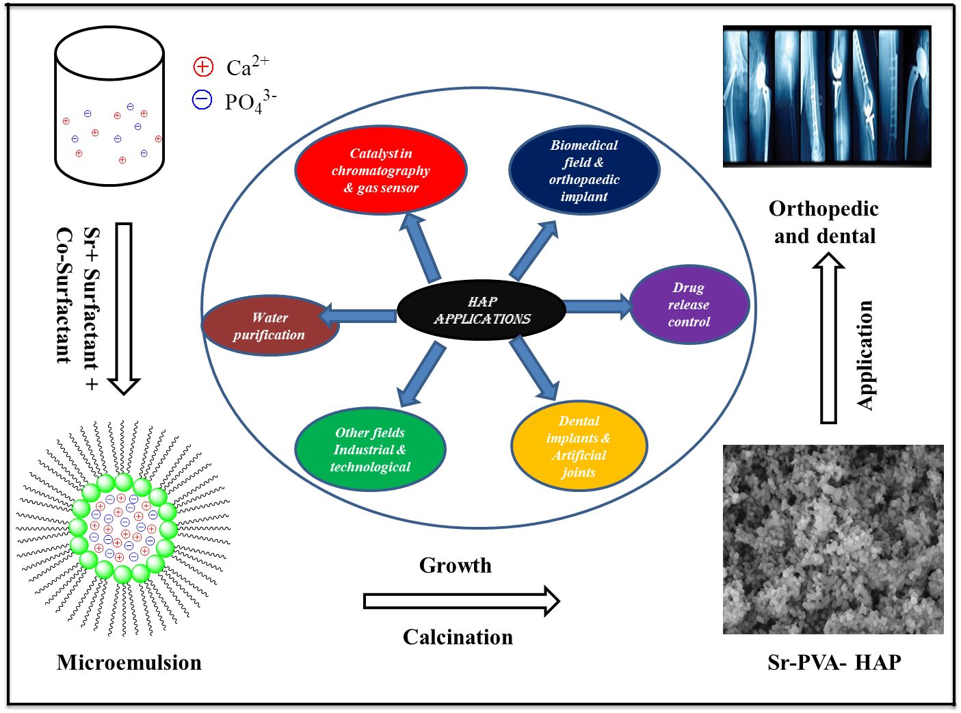
Graphical abstract for the formation of nano-hydroxyapatite

