Supplementary Material
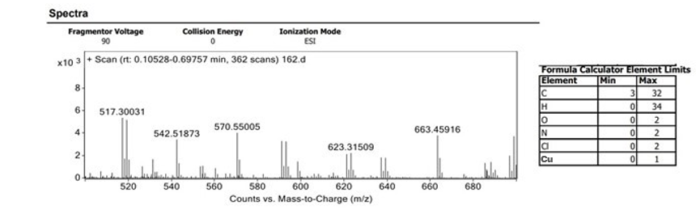
Fig. S1. Mass spectroscopy result of Imine-Copper Complex (4)
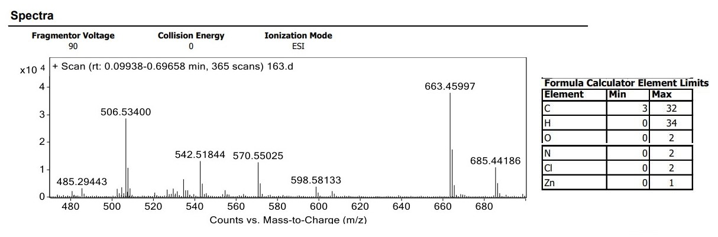
Fig. S2. Mass spectroscopy result of imin-Zinc Complex (5)

