Observations of the 2021/2022 La Niña mass coral bleaching event on the soft coral genus Sarcophyton at Magnetic Island (Australia)
Stefano Borghi^{1‡}, Riccardo Mandolini¹, Nicholas D. Briggs^{1,2}, Saara J. Wilson¹, Hillary A. Smith^{1,3}, Claudia Trave¹
¹College of Science and Engineering, James Cook University, Townsville QLD, Australia
²AIMS@JCU, James Cook University, Townsville QLD, Australia
³Centre for Marine Science and Innovation, School of Biological, Earth and Environmental Sciences, University of New South Wales, Kensington NSW 2052, Australia

Table S1. Estimated abundance of soft coral genera of Geoffrey and Alma Bay, Magnetic Island. Within each bay, soft coral genera were observed across three zones, such as inner-mid reef flat (IMRF), outer reef flat (ORF) and sandy reef slope (SRS).
Taxa | Visually-estimated abundance
Taxa | Geoffrey Bay | Alma Bay
O. Scleralcyonacea
Family Briareidae  Briareum | IMRF: -  ORF: Sporadic  SRS: Dominant | IMRF: -  ORF: Sporadic  SRS:Abundant
O. Malacalcyonacea
Family Melithaeidae  Melithaea | IMRF: -  ORF: -  SRS: Rare | IMRF: -  ORF: -  SRS: -
Iciligorgia | IMRF: Abundant  ORF: -  SRS: - | IMRF: -  ORF: -  SRS: -
Family Carijoidae  Carijoa | IMRF: -  ORF: -  SRS: Abundant | IMRF: -  ORF: -  SRS: -
Family Sarcophytidae  Sarcophyton | IMRF: Sporadic  ORF: Abundant  SRS: Dominant | IMRF: Sporadic  ORF: Abundant  SRS: Dominant
Lobophytum | IMRF: -  ORF: Abundant  SRS: Abundant | IMRF: Rare  ORF: Sporadic  SRS: Sporadic
Family Sinulariidae  Sinularia | IMRF: -  ORF: Sporadic  SRS: Abundant | IMRF: -  ORF: Sporadic  SRS: Abundant
Family Nephthygorgiidae  Nephthyigorgia | IMRF: -  ORF: -  SRS: Rare | IMRF: -  ORF: -  SRS: -
Family Nephtheidae  Umbellulifera | IMRF: -  ORF: -  SRS: Dominant | IMRF: -  ORF: -  SRS: -
Dendronephthya | IMRF: -  ORF: -  SRS: Sporadic | IMRF: -  ORF: -  SRS: Rare
Scleronephthya | IMRF: Rare  ORF: -  SRS: - | IMRF:  ORF: -  SRS: -
Family Paralcyoniidae  Studeriotes | IMRF: -  ORF: -  SRS: Sporadic | IMRF: -  ORF: -  SRS: Rare
Family Cladiellidae  Cladiella | IMRF: -  ORF: Sporadic  SRS: - | IMRF: -  ORF: -  SRS: -
Family Xeniidae  Xenia | IMRF: -  ORF: -  SRS: - | IMRF: -  ORF: Sporadic  SRS: -
Heteroxenia | IMRF: -  ORF: -  SRS: Rare | IMRF: -  ORF: -  SRS: -

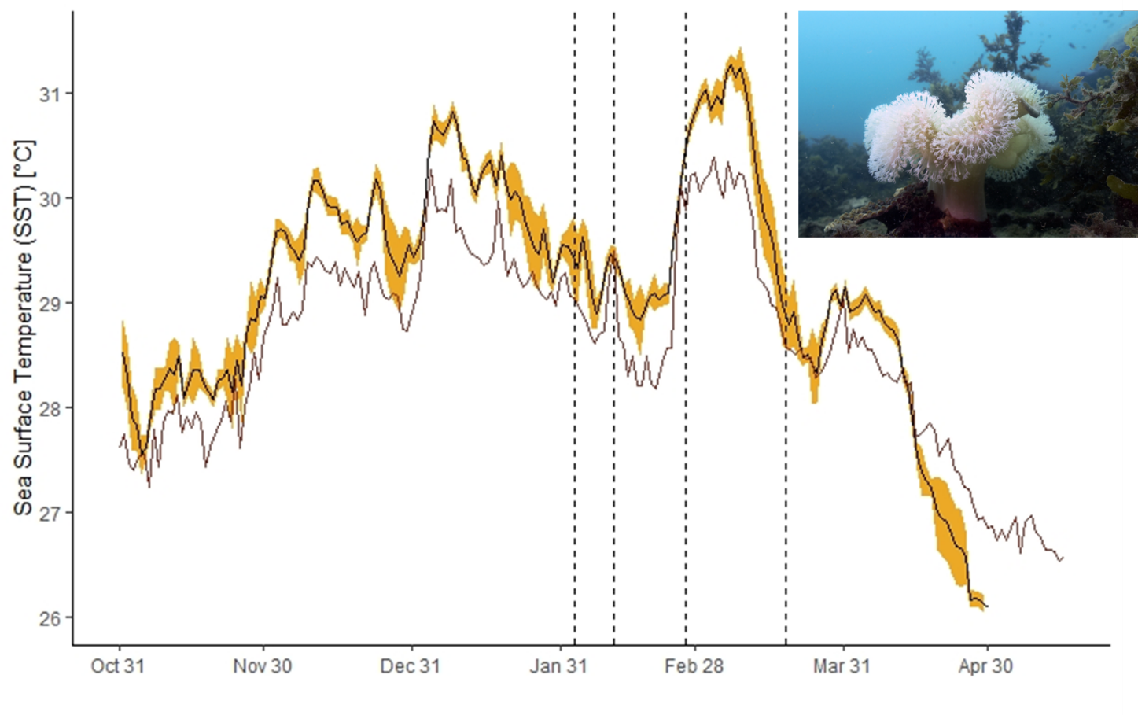
Figure S1. Comparison of satellite-derived SST measurements from the central GBR (mean SST; red line) and Geoffrey Bay (mean SST in black line, standard error in yellow shading). Vertical black dashed lines indicate survey dates.

