Supplementary Material
Change of the structure and assembly of bacterial and photosynthetic communities by the ecological engineering practices in Dianchi Lake
Dayi Zhang^{1,*}, Yucheng Xie², Yizhi Sheng³, Danni Li¹, Feng He⁴, Jinsong Du⁴, Longfei Jiang⁵, Chunling Luo⁵, Songqiang Deng², Guanghe Li¹
- School of Environment, Tsinghua University, Beijing 100084, China
- Research Institute for Environmental Innovation (Tsinghua-Suzhou), Suzhou 215163, China
- Department of Geology and Environmental Earth Science, Miami University, OH 45056, USA
- Water Environment Research Division, Kunming Dianchi & Plateau Lakes Institute, Kunming 650000, China
- State Key Laboratory of Organic Geochemistry, Guangzhou Institute of Geochemistry, Chinese Academy of Sciences, Guangzhou 510640, China

* Corresponding author
Dr Dayi Zhang
School of Environment, Tsinghua University, Beijing 100084, China
Email: zhangdayi@tsinghua.edu.cn
Tel: +86(0)10-62773232; Fax: +86(0)10-62795687

Table S1. Primers for bacteria and photoautotrophs.
Targets | Primers | Sequence (5’-3’) | Annealing temperature | Reference
Bacteria | 515F | GTGCCAGCMGCCGCGGTAA | 55°C | (Lane, 1991)
Bacteria | 907R | CCGTCAATTCMTTTRAGTTT | 55°C | (Lane, 1991)
Photoautotrophs | p23SrV-F | GGACAGAAAGACCCTATGAA | 55°C | (Lentendu et al., 2014; Sherwood and Presting, 2007)
Photoautotrophs | p23SrV-R | TCAGCCTGTTATCCCTAGAG | 55°C | (Lentendu et al., 2014; Sherwood and Presting, 2007)

Table S2. The relationship between co-occurrence ecological network modules and EFs.
Community | Location | Modules | Environmental factors*
Bacteria | Caohai | Module 1 | TP, TN, NO₃-N, PO₄-P, pH, DO, Cond
Bacteria | Caohai | Module 2 | TP, NH₃-N, NO₃-N, PO₄-P, pH, DO, T
Bacteria | Caohai | Module 3 | TN, NH₃-N, NO₃-N, pH, DO
Bacteria | Caohai | Module 4 | Chl a, pH, DO, T, Cond
Bacteria | Caohai | Module 5 | TP, NO₃-N, PO₄-P, T
Bacteria | Caohai | Module 6 | Chl a, TP, TN, NO₃-N, DO, T, Cond
Bacteria | Waihai | Module 1 | Chl a, TP, TN, NH₃-N, NO₃-N, PO₄-P, pH, Cond
Bacteria | Waihai | Module 2 | Chl a, NH₃-N, NO₃-N, PO₄-P, pH, Cond
Bacteria | Waihai | Module 3 | Chl a, TP, TN, NH₃-N, NO3-N, PO4-P, pH, DO, T, Cond
Bacteria | Waihai | Module 4 | Chl a, TP, TN, NH₃-N, NO₃-N, PO₄-P, pH, DO, Cond
Bacteria | Waihai | Module 5 | TP, TN, NH₃-N, NO₃-N, PO₄-P, pH, DO, Cond
Photoautotrophs | Caohai | Module 1 | Chl a, NO₃-N, T, Cond
Photoautotrophs | Caohai | Module 2 | TP, NO₃-N, PO₄-P, pH, DO, T
Photoautotrophs | Caohai | Module 3 | Chl a, NH₃-N, PO₄-P, pH, DO, Cond
Photoautotrophs | Caohai | Module 4 | TN, NH₃-N, pH, DO, Cond
Photoautotrophs | Caohai | Module 5 | TP, TN, NO₃-N, PO₄-P, T
Photoautotrophs | Waihai | Module 1 | Chl a, NH₃-N, NO₃-N, PO₄-P, pH, Cond
Photoautotrophs | Waihai | Module 2 | Chl a, TP, TN, NH₃-N, NO₃-N, PO₄-P, pH, Cond
Photoautotrophs | Waihai | Module 3 | Chl a, TP, TN, NH₃-N, NO₃-N, T, Cond
* with significant correlation (p<0.05).

Figure S1. Sampling sites in Dianchi Lake.

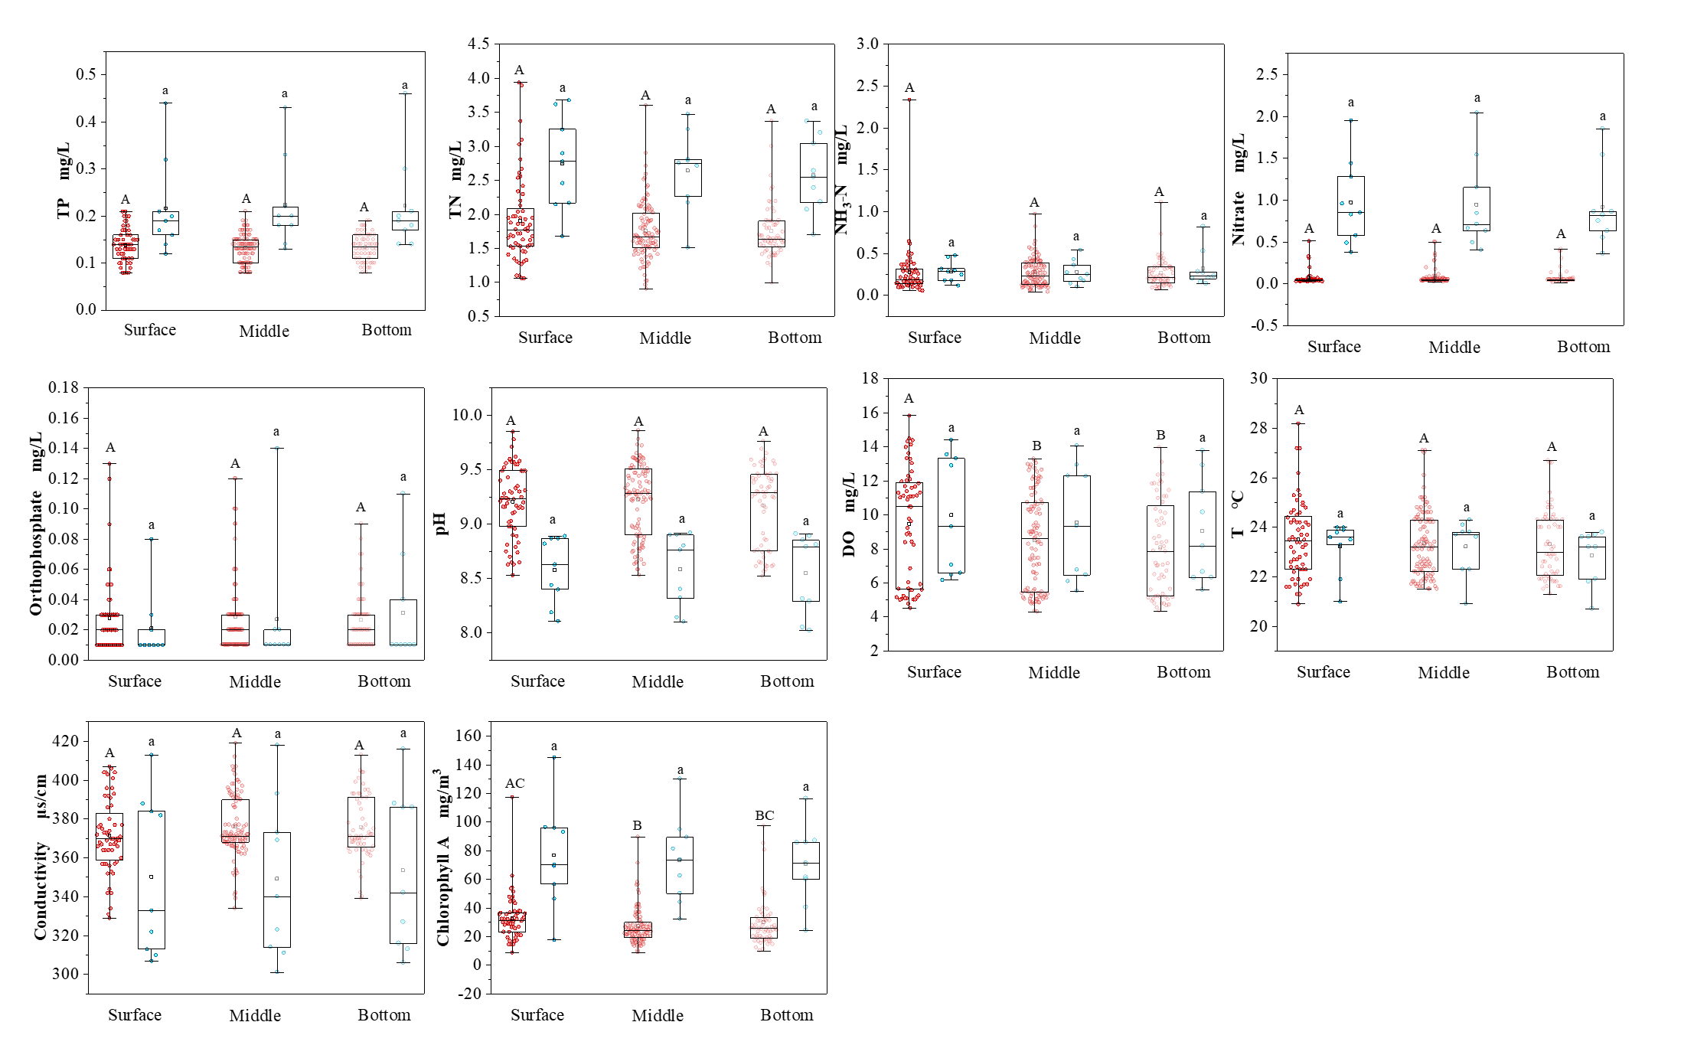
Figure S2. Water physiochemical properties at different sampling depth in Dainchi Lake. Red and blue dots represent samples from Waihai and Caohai, respectively.
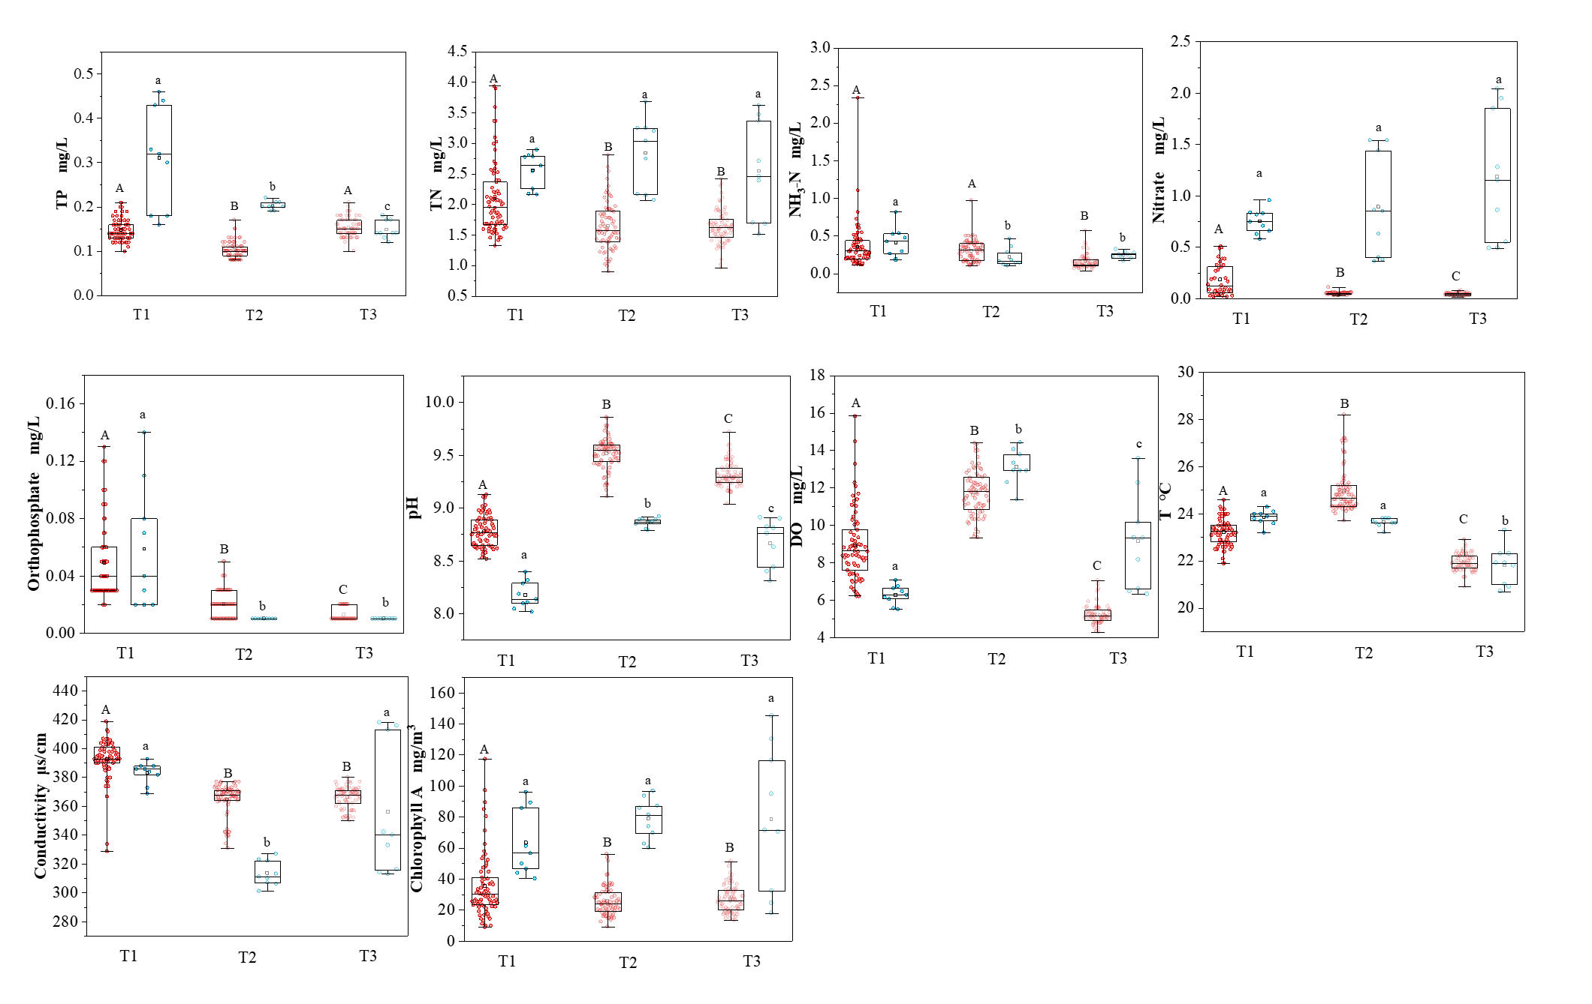
Figure S3. Water physiochemical properties at different sampling time in Dainchi Lake. Red and blue dots represent samples from Waihai and Caohai, respectively.
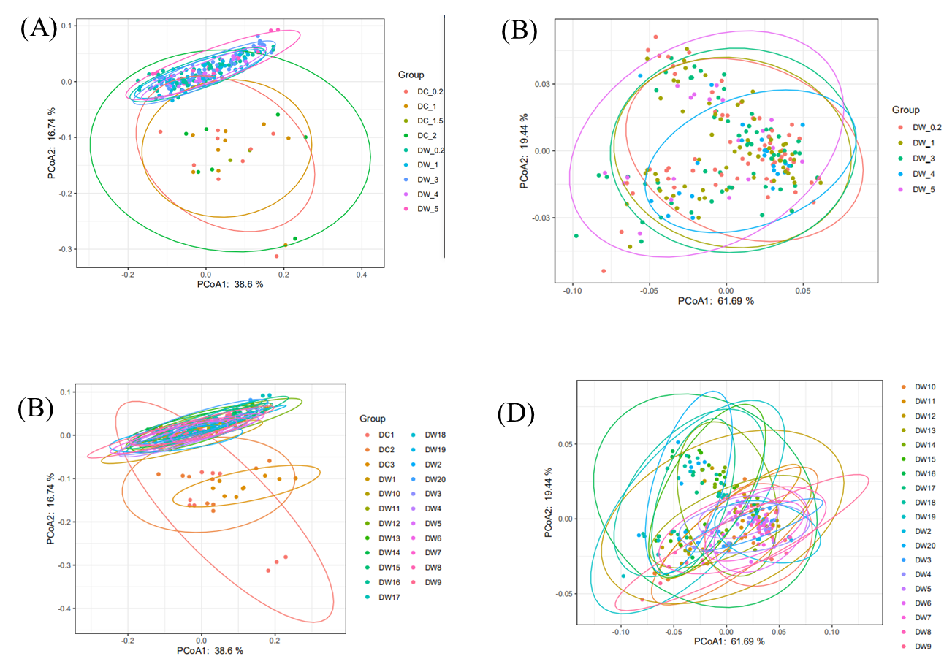
Figure S4. PCoA score plots for bacterial (A) and photoautotrophic community (B) between three sampling depths. PCoA score plots for bacterial (C) and photoautotrophic community (D) at different sampling sites.
Reference
Lane, D. 1991 16S/23S rRNA sequencing In: Nucleic Acid Techniques in Bacterial Systematics, pp. 115-175, John Wiley & Sons Inc., New York.
Lentendu, G., Wubet, T., Chatzinotas, A., Wilhelm, C., Buscot, F. and Schlegel, M. 2014. Effects of long-term differential fertilization on eukaryotic microbial communities in an arable soil: a multiple barcoding approach. Molecular Ecology 23(13), 3341-3355.
Sherwood, A.R. and Presting, G.G. 2007. Universal Primers Amplify a 23s Rdna Plastid Marker in Eukaryotic Algae and Cyanobacteria1. Journal of phycology 43(3), 605-608.

