Table 1 The clinical parameters at pre-treatment for each group^{x}
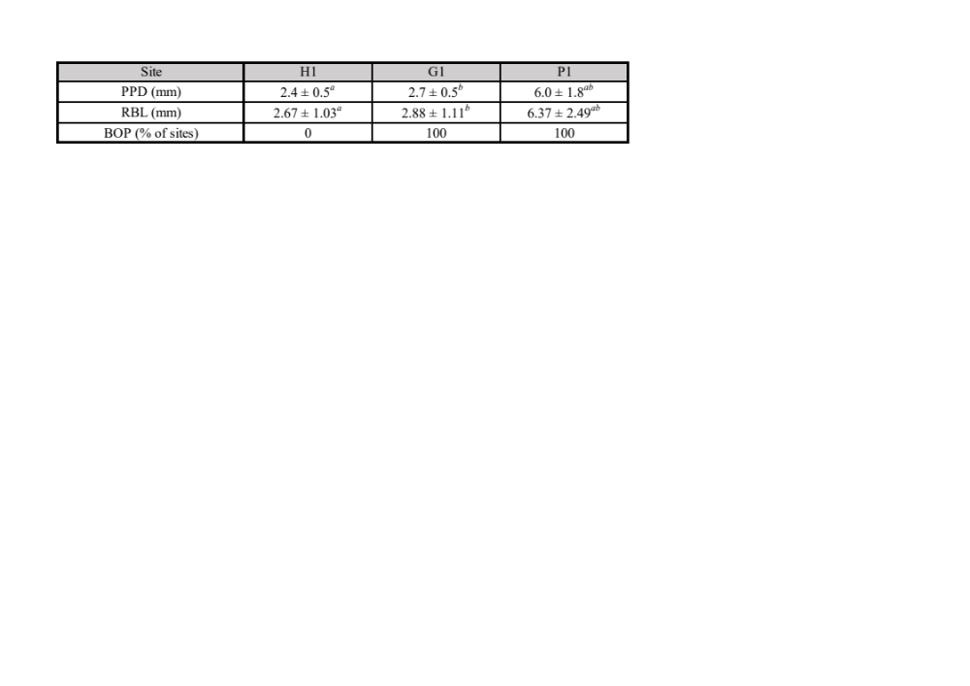
x Values represent means ± standard deviation. Healthy (H1), gingivitis (G1), and periodontitis (P1) sites were measured in the same participants (n = 42). Significant differences were observed between the groups marked with the same symbol (adjusted p < 0.05). PPD: probing pocket depth; RBL: radiographic bone loss; BOP: bleeding on probing. a Significant differences between H1 and P1. b Significant differences between G1 and P1.

Table 2 The clinical parameters for individuals sampled at pre- and post-treatment for each group^{x}
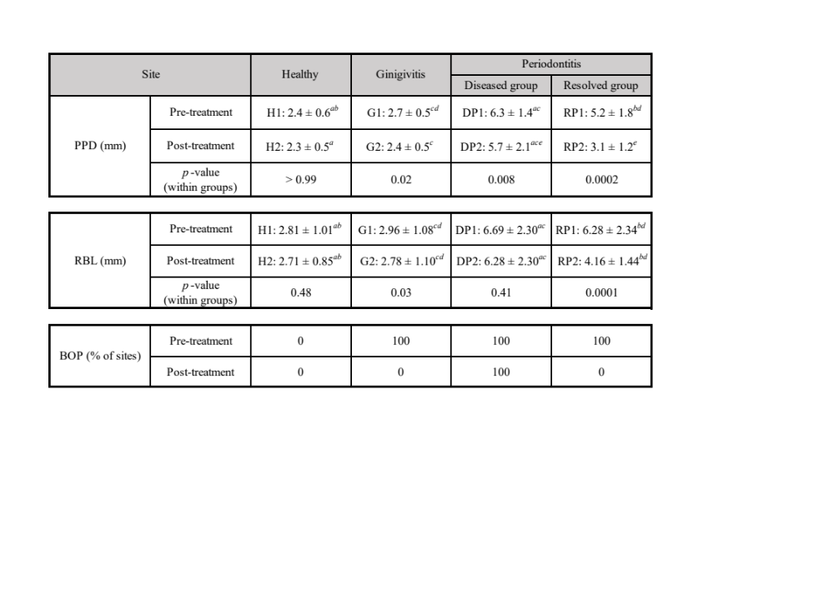
x Values represent means ± standard deviation. H, G, DP, and RP indicate healthy gingival tissue, diseased periodontitis, and resolved periodontitis, respectively. The number 1 after each group name represents pre-treatment and the number 2 represents post-treatment. Only samples with sufficient sequencing reads were used, resulting in 28, 26, 13, and 14 sites compared longitudinally and cross-sectionally in the H, G, DP, and RP groups, respectively. Significant differences were observed between the groups marked with the same symbol (adjusted p < 0.05). PPD: probing pocket depth; RBL: radiographic bone loss; BOP: bleeding on probing. a Significant differences between H and DP. b Significant differences between H and RP. c Significant differences between groups G and DP. d Significant differences between groups G and RP. e Significant differences between the DP and RP groups.

